John Barden

5/19/2024

Milestone One

Prof. Rodriguez

The 2D image I want to create in a 3D environment is the first working transistor experiment. There will be documented photos online for reference within the image there are clear basic and complex shapes. There is a plastic stand which is a rectangle with a square opening. This can be created with a single rectangle and a square removed to create the opening. Another way would be to create three different rectangle and overlap them to create the stand. At the top of the opening there is a cylinder and a cone of solder connected to the spring. The spring is multiple cylinders connected end-to-end, having the ends overlap would leave sharp edges, being able to bend the shape at the middle and connect them during a straight section would better represent the image. Lining up multiple cylinders will need to have reference to the previous cylinders' vertices to chain correctly. These connect to the plastic triangle with the same cylinder and cone for the spring connection, this can be duplicated and adjusted the position to recreate it. This connects to a triangle wedge that has two gold foil planes on either side of the wedge. The bottom material is a rectangle of germanium, there are some irregularities in the material. If there are enough vertices in the material, they can be transformed independently to create a more irregular shape. Another way would be adding additional shapes overlapping to mimic it.

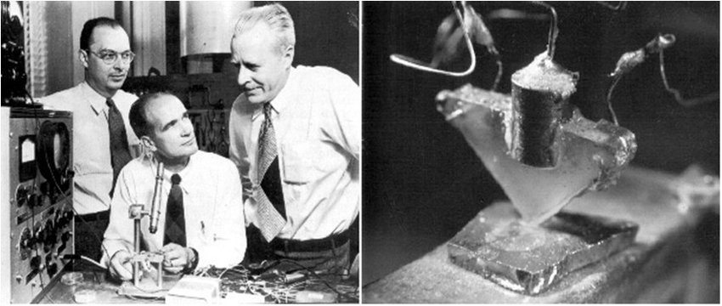

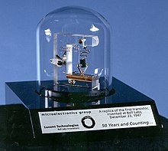

the free encyclopedia, W. (2001, January 15). *History of the transistor*. <https://en.wikipedia.org/wiki/History_of_the_transistor>