Design and Development of a Web-Based Management System for Rotaract Club of NIBM Kandy
Diploma in Software Engineering
Final Project Proposal

2025.2F

KADSE25.2F-030 - H.E. Gunasekara
KADSE25.2F-025 - Y.V. Bandara
KADSE25.2F-034 - D.A. Kulasinghe
KADSE25.2F-006 - N.V.P. Karunaratne


School of Computing and Engineering
National Institute of Business Management
Kandy
Design and Development of a Web-Based Management System for Rotaract Club of NIBM Kandy

Year of Submission: 2026

Title of the project: Design and Development of a Web-Based Management System for Rotaract Club of NIBM Kandy

“The project is submitted in partial fulfillment of the requirement of the Diploma of Computer System Design of National Institute of Business Management.”

H.E. Gunasekara KADSE25.2F-030
Y.V. Bandara KADSE25.2F-025
D.A. Kulasinghe KADSE25.2F-034
N.V.P. Karunaratne KADSE25.2F-006

Declaration Page

“I certify that this project does not incorporate without acknowledgement, any material previously submitted for a Diploma in any institution and to the best of my knowledge and belief ,it does not contain any material previously published or written by another person or myself except where due reference is made in the text. I also hereby give consent for my project report, if accepted, to be made available for photocopying and for interlibrary loans, and for the title and summary to be made available to outside organizations”

Student Name | Student Index | Signature
KADSE25.2F-030 | H.E. Gunasekara
KADSE25.2F-025 | Y.V. Bandara
KADSE25.2F-034 | D.A. Kulasinghe
KADSE25.2F-006 | N.V.P. Karunaratne

Supervisor’s name: ……………………………………
Signature: ……………………………
Date: ………………………

Course director’s name: ……………………………..
Signature: ……………………………….
Date: ……………………….

ABSTRACT

The Rotaract Club of NIBM Kandy has traditionally managed its core operations membership records, event registrations, attendance tracking, and community service hour blogging through a fragmented mix of spreadsheets, generic online forms, and scattered social media posts. While functional in the short term, this manual approach has led to significant challenges, including data redundancy, inconsistent record-keeping, and the frequent loss of institutional knowledge whenever club leadership transitions at the end of each year. These inefficiencies not only increase administrative overhead but also hinder the club’s ability to maintain continuity and showcase its impact effectively.

To address these issues, this project set out to design and develop a centralized, web-based Rotaract Management System tailored to the club’s unique needs. The system introduces a secure administrative dashboard through which the Executive Committee can manage members, avenues, events, and reports in a streamlined manner. Complementing this, a personalized member portal empowers general members to register for events, track their verified community service hours, and maintain updated personal profiles.

Beyond internal operations, the system also features a public-facing showcase page designed to highlight the club’s achievements, ongoing projects, and service initiatives serving as a powerful tool to attract prospective sponsors, collaborators, and new recruits.

The development process followed the Agile Scrum methodology, ensuring iterative progress and continuous stakeholder engagement. Requirements were gathered through online surveys and structured interviews with the executive board, enabling the system to reflect real-world workflows and priorities. The underlying relational database was carefully modelled to capture member profiles, avenue structures, event blogs, registrations, and service-hour logs, with robust security measures such as password hashing and role-based access control implemented to safeguard sensitive information.

A multi-tiered testing strategy was applied to validate the system’s reliability and usability. Unit testing ensured the correctness of individual modules, integration testing verified seamless interaction between subsystems, and user-acceptance testing confirmed that the platform met the expectations of both administrators and general members. Deployment was carried out in a phased manner to minimize disruption and allow gradual adoption.

List of Keywords
- Rotaract Club Management
- Web-Based System
- Agile Scrum
- Relational Database
- Event Registration
- Attendance Tracking
- Community Service Hours
- Role-Based Access Control

List of Acronyms and Abbreviations

Acronym | Full Meaning
API | Application Programming Interface
BCNF | Boyce-Codd Normal Form
CSS | Cascading Style Sheets
DSE | Diploma in Software Engineering
ERD | Entity Relationship Diagram
IDE | Integrated Development Environment
MIS | Management Information Systems
NIBM | National Institute of Business Management
RBAC | Role-Based Access Control
RT-Web | Rotaract Web Management Platform
ER | Entity Relationship
PK | Primary Key
UAT | User Acceptance Testing
CRUD | Create, Read, Update, Delete
UI | User Interface
IDE | Integrated Development Environment
FK | Foreign Key

ACKNOWLEDGEMENT

We would like to express our heartfelt gratitude to our project supervisor, whose continuous academic guidance, constructive critiques, and timely feedback were instrumental in shaping the success of this project. Their encouragement and expertise not only helped us overcome technical challenges but also inspired us to maintain a professional and research-oriented approach throughout the development process.

Our sincere appreciation is also extended to the President and Executive Committee of the Rotaract Club of NIBM Kandy. Their willingness to dedicate time for structured interviews, share operational insights, and allow us to base this system on the real needs of the club provided us with invaluable practical context. Their cooperation ensured that our project was not merely theoretical but directly aligned with the club’s day to day requirements and long-term vision.

We are equally grateful to the School of Computing and Engineering at the National Institute of Business Management, Kandy, for providing us with the academic environment, resources, and facilities necessary to carry out this work. The supportive atmosphere and access to institutional guidance played a vital role in enabling us to complete this project to a high standard.

Beyond the academic and organizational support, we wish to acknowledge the unwavering patience and encouragement of our families and friends. Their understanding during long hours of research, coding, and documentation gave us the strength to persevere through demanding phases of the diploma programme. Their moral support was a constant source of motivation.
Finally, we extend our gratitude to all peers, colleagues, and fellow students who offered suggestions, shared knowledge, or provided feedback during this project. Each contribution, whether large or small, enriched our learning experience and helped us refine the system into a more effective solution.

Contents
Chapter 1: Introduction 8
1.1 Introduction of the Organization. 8
1.2 Organization Structure. 8
1.3 Current Operations in Organization. 8
1.4 Users and Responsibilities of Organization. 8
1.5 Problem Definition 9
1.6 Project Objectives 10
1.7 Proposed Solution 10
1.8 Chapter Summary 10
Chapter 2: Methodology 12
2.1 Introduction 12
2.2 Data Collection Method 12
2.3 Software Process Model 12
2.4 Software Development Tools 13
2.5 Testing Strategies 13
2.6 Implementation Plan 14
2.7 Chapter Summary 14
Chapter 3: Analysis 15
3.1 Introduction. 15
3.2 UML Diagram. 15
3.3.1 Use Case Diagram of Current System 15
3.3.2 Use Case Diagram of Proposed System 16
3.3.3 Class Diagram of Proposed System. 16
3.3.4 Sequence Diagrams (Each Use case) for Proposed System. 17
3.3 ER Diagram of the Proposed System. 19
3.4 Chapter Summery 20
4.1 Introduction. 20
4.2 Interface Design 20
4.3 Database Design 24
4.4 Report Layout Design 28
Chapter 5: Conclusion 30
References 31
The Project Schedule 32
Gantt Chart 32
Letter Issued by the organization 33
Questioners and Interview Questions 34

Chapter 1: Introduction

1.1 Introduction of the Organization.
Rotaract is a global, youth-led service organization sponsored by Rotary International, designed for young professionals and students aged 18 and older. The name combines the words "Rotary" and "Action." Its primary mission is to provide an opportunity for young adults to enhance the knowledge and skills that will assist them in personal development, to address the physical and social needs of their communities, and to promote better relations between all people worldwide through a framework of friendship and service.

1.2 Organization Structure.
At the foundational level, a Rotaract Club is structured democratically and operates under the guidance of a local sponsoring Rotary Club. The internal governance is led by a Board of Directors, which features an Executive Committee consisting of the President, Vice President, Secretary, and Treasurer. Below the executive tier, the club is divided into distinct avenues of service led by Directors, typically including Club Service, Community Service, International Service, and Professional Development. This structured hierarchy ensures clear lines of communication, financial accountability, and effective project execution.

1.3 Current Operations in Organization.
The day-to-day operations of a Rotaract Club centre around planning, executing, and reviewing community-centred initiatives and member engagement activities. Regular bi-weekly or monthly meetings are held to map out project timelines, manage budgets, and host guest speakers. Current operational activities typically spread fundraising events, local environmental cleanups, educational workshops, and cross-border collaborative projects with international clubs. Members utilize modern digital tools and social media platforms to manage public relations, coordinate volunteer efforts, and track membership growth.

1.4 Users and Responsibilities of Organization.
The key stakeholders, or "users," within a Rotaract Club are its members and the board, each carrying specific responsibilities:
- The President: Holds ultimate accountability for overseeing club operations, leading meetings, and acting as the primary liaison with the sponsoring Rotary Club.
- The Secretary & Treasurer: Responsible for maintaining meticulous administrative records, tracking meeting attendance, managing club funds, and producing financial statements.
- Avenue Directors: Tasked with brainstorming, planning, and managing specific service or professional projects from inception to completion.
- General Members: Responsible for actively participating in meetings, volunteering their time for community projects, and upholding the ethical standards of Rotary’s "Four-Way Test" in their personal and professional lives.
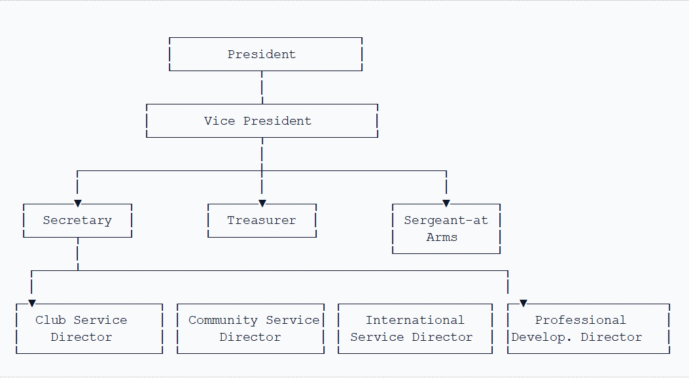
Figure 1. Organization Hierarchy

1.5 Problem Definition
Presently, the Rotaract Club depends highly on fragmented third-party platforms and manual administrative processes to manage its daily operations. Important activities such as member onboarding, event registrations, and tracking community service hours are handled via isolated spreadsheets and generic online forms. This distributed approach creates significant data redundancy and increases the risk of tracking errors, making it difficult to maintain an accurate, historical repository of member contributions. Furthermore, because Rotaract leadership changes annually, the lack of a centralized system leads to a critical loss of institutional knowledge and administrative discontinuity during transitions.

1.6 Project Objectives
The primary objective of this project is to engineer a secure, centralized, and user-friendly web-based management system tailored specifically to the operational workflow of the Rotaract Club. To achieve this, the project encompasses the following specific objectives:
- To design and implement a relational database to securely store and maintain comprehensive member profiles, event logs, and project histories.
- To provide a dynamic public-facing interface that showcases club achievements and ongoing projects to attract potential sponsors and new recruits.

1.7 Proposed Solution
To resolve these challenges, our project proposes the development of a web-based Rotaract Management System. The application will serve as a unified digital ecosystem featuring an intuitive admin dashboard for the executive committee and a personalized portal for club members. The system will incorporate automated modules for real-time event registration and digital attendance marking. Built using robust software engineering patterns, the solution will enforce data integrity and security while eliminating administrative overhead. By centralizing all operational workflows onto a single web platform, the proposed system will ensure organizational continuity across leadership changes, optimize resource allocation, and overall member involvement.

1.8 Chapter Summary

This chapter introduced the Rotaract Club, its organizational structure, current operations, key users and their responsibilities, and the challenges faced in managing its activities. The existing reliance on fragmented platforms and manual processes has resulted in data redundancy, tracking difficulties, and a loss of organizational knowledge during annual leadership transitions. To address these issues, the chapter proposed a centralized web-based Rotaract Management System that will provide secure data management, event registration, attendance tracking, member management, and a public-facing platform. The proposed system aims to improve operational efficiency, maintain organizational continuity, enhance member engagement, and support the effective management of the club’s activities.

Chapter 2: Methodology

2.1 Introduction
This project adopts a structured approach to design, develop, and validate the Rotaract Management System. The methodology includes initial domain research and stakeholder (Club members) interviews to gather system requirements. Which also includes architectural design and database modelling. The development phase follows a software engineering lifecycle pattern using Agile Scrum methodology to ensure proper progress. Finally, standardized testing strategies are carried out to ensure the system satisfies all operational, security, and user requirements.

2.2 Data Collection Method
To establish an accurate set of system requirements, data collection through google forms are carried out among club members. Primary interviews are conducted with the current executive board members of the Rotaract Club to identify main requirements in their administrative workflows, such as member registration and event management. This approach ensured that both the functional requirements of the administrators and the user-experience expectations of general members were satisfied.

2.3 Software Process Model
The development of this project is carried out by the Agile Scrum methodology. Given the dynamic nature of web applications and the need for frequent stakeholder feedback, this iterative process model is ideal for rigid, linear frameworks. The project lifecycle is divided into week's sprints, each focusing on delivering a functional vertical slice of the application. This iterative approach allows the development team to evaluate system architecture, provide minor refinement changes from club members, and reduce risks early in the development lifecycle
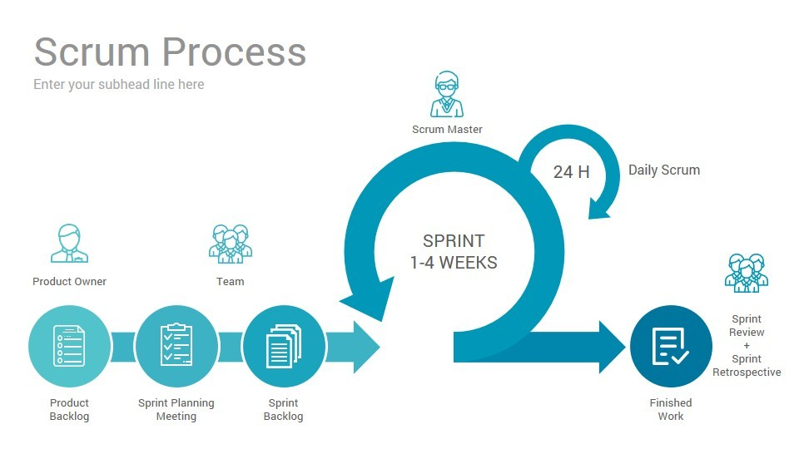
Figure 2. Agile Scrum method

2.4 Software Development Tools
The user interface is developed using a component-based frontend framework to deliver a responsive, independent user experience. Visual Studio Code serves as the primary Integrated Development Environment (IDE), while Git and GitHub are utilized for collaborative source control and version tracking.
Tool / Technology | Version | Technical Purpose & Justification
React.js | 18.2.0 | Component state management, virtual DOM rendering, and single-page navigation.
Tailwind CSS | 3.3.0 | Utility-first CSS styling, responsive grid layouts, and custom animations.
Lucide React | 0.263.1 | Standardized accessible vector iconography across portal modules.
Node.js / NPM | 20.x+ / 10.x+ | Underlying JavaScript runtime and package dependency manager.
VS Code | Latest | Primary development IDE with ESLint and Prettier integration.
Git & GitHub | 2.x / Cloud | Distributed version control and team repository management.

2.5 Testing Strategies
To ensure the systems' structural integrity and functional accuracy, a multi-tiered testing strategy is applied. The process starts with Unit Testing to validate isolated logical components, such as data formatters. This is followed by Integration Testing to verify seamless data flow between the web interface, application of API endpoints, and the database server. Finally, User Acceptance Testing (UAT) is conducted with a test group of Rotaract board members and general users. This stage improves the system against real-world operational scenarios to ensure the software satisfies user requirements properly.

2.6 Implementation Plan
The implementation phase transitions the verified codebase into a production-ready environment through a phased deployment strategy. The process begins with configuring the cloud hosting infrastructure and setting up the live production database environment. Following initial environment setup, a staging deployment is executed to perform final environmental smoke testing. Once validated, the system undergoes a hard cutover deployment, replacing the club's legacy manual tracking methods entirely. The final stage of the implementation plan involves executing data migration protocols for existing member records and conducting targeted training workshops for the executive board to ensure a smooth administrative handoff.

2.7 Chapter Summary
In summary, this chapter established the methodological foundation governing the project’s lifecycle, detailing the transition from requirements gathering through stakeholder data collection to Agile development. By defining the specific software development tools, multi-tiered testing strategies, and phased implementation of execution plan, this framework ensures the system is built to professional standards.

Chapter 3: Analysis

3.1 Introduction.
This chapter presents the analysis of the proposed Rotaract Management System, translating the requirements gathered in Chapter 2 into a structured, technology-independent model of the system's behaviour and data. The Unified Modelling Language (UML) is used to model system functionality from the perspective of its actors, and an Entity Relationship (ER) diagram is used to model the underlying data structure. Together, these diagrams form the analytical foundation for the interface and database design decisions presented in Chapter 4.
3.2 UML Diagram.

3.3.1 Use Case Diagram of Current System
Figure 1 models the current, manual way in which the club's operations are carried out. General members interact only indirectly with record-keeping, submitting event interest through a Google Form, while the Executive Committee (principally the Secretary and Treasurer) is left to manually reconcile attendance, member records, and reports using spreadsheets. This diagram highlights the absence of any single authoritative system and the heavy administrative load placed on the Executive Committee.
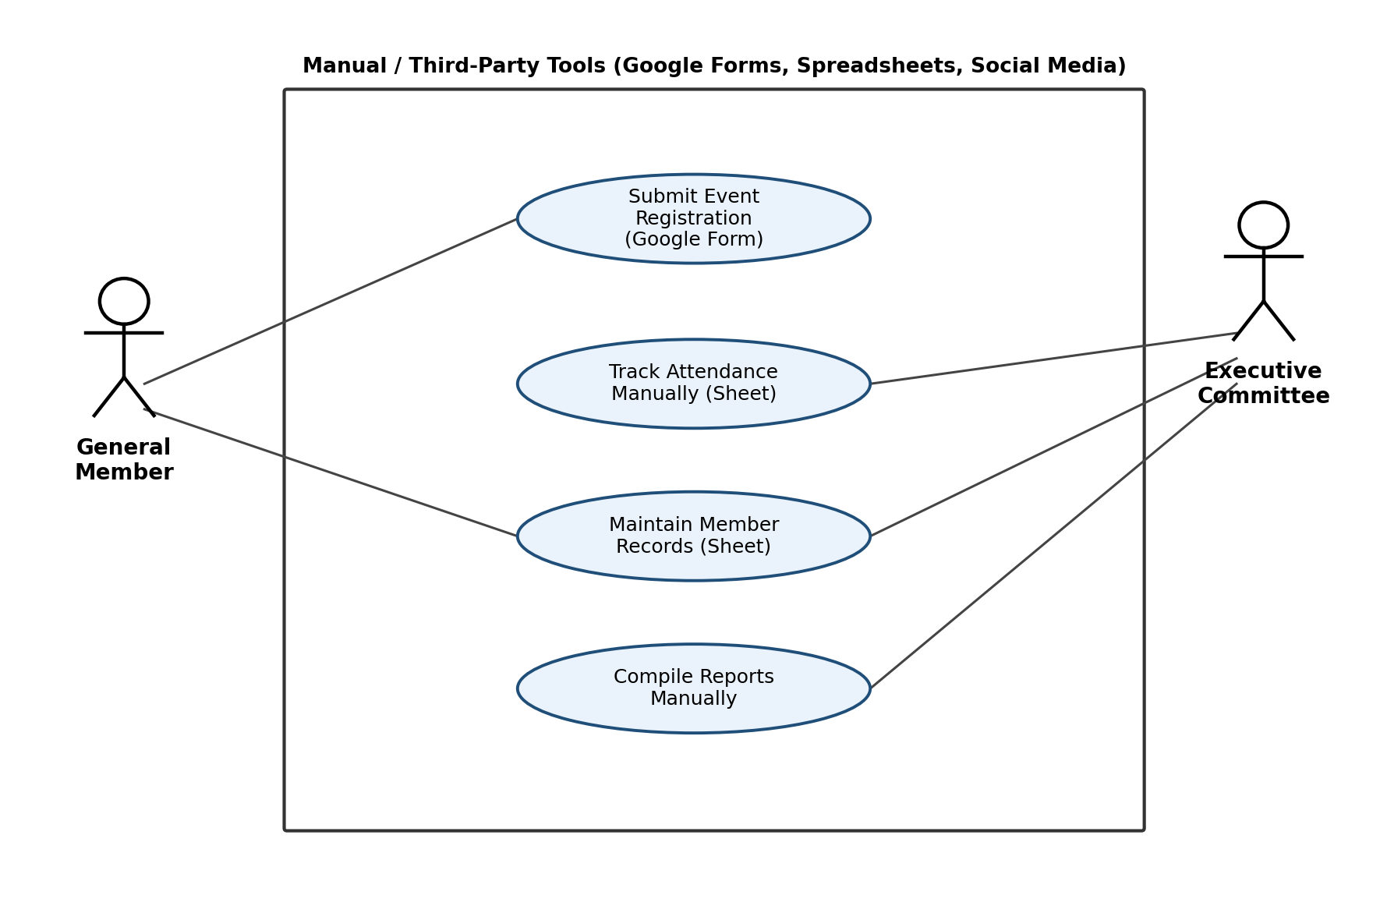
Figure 3.Use Case Diagram of the Current System

3.3.2 Use Case Diagram of Proposed System
Figure 2 models the proposed Rotaract Management System. Three actors were identified: the Member, who registers for events, maintains a personal profile, and views accumulated community service hours; the admin, representing any Executive Committee or Avenue Director account, who creates and manages events and avenues, marks attendance, manages user accounts, and generates reports; and the Guest, an unauthenticated public visitor who may only view the public showcase page. The Mark Attendance use case includes the View Community Service Hours use case, since a successful attendance record automatically credits service hours to the member's account.
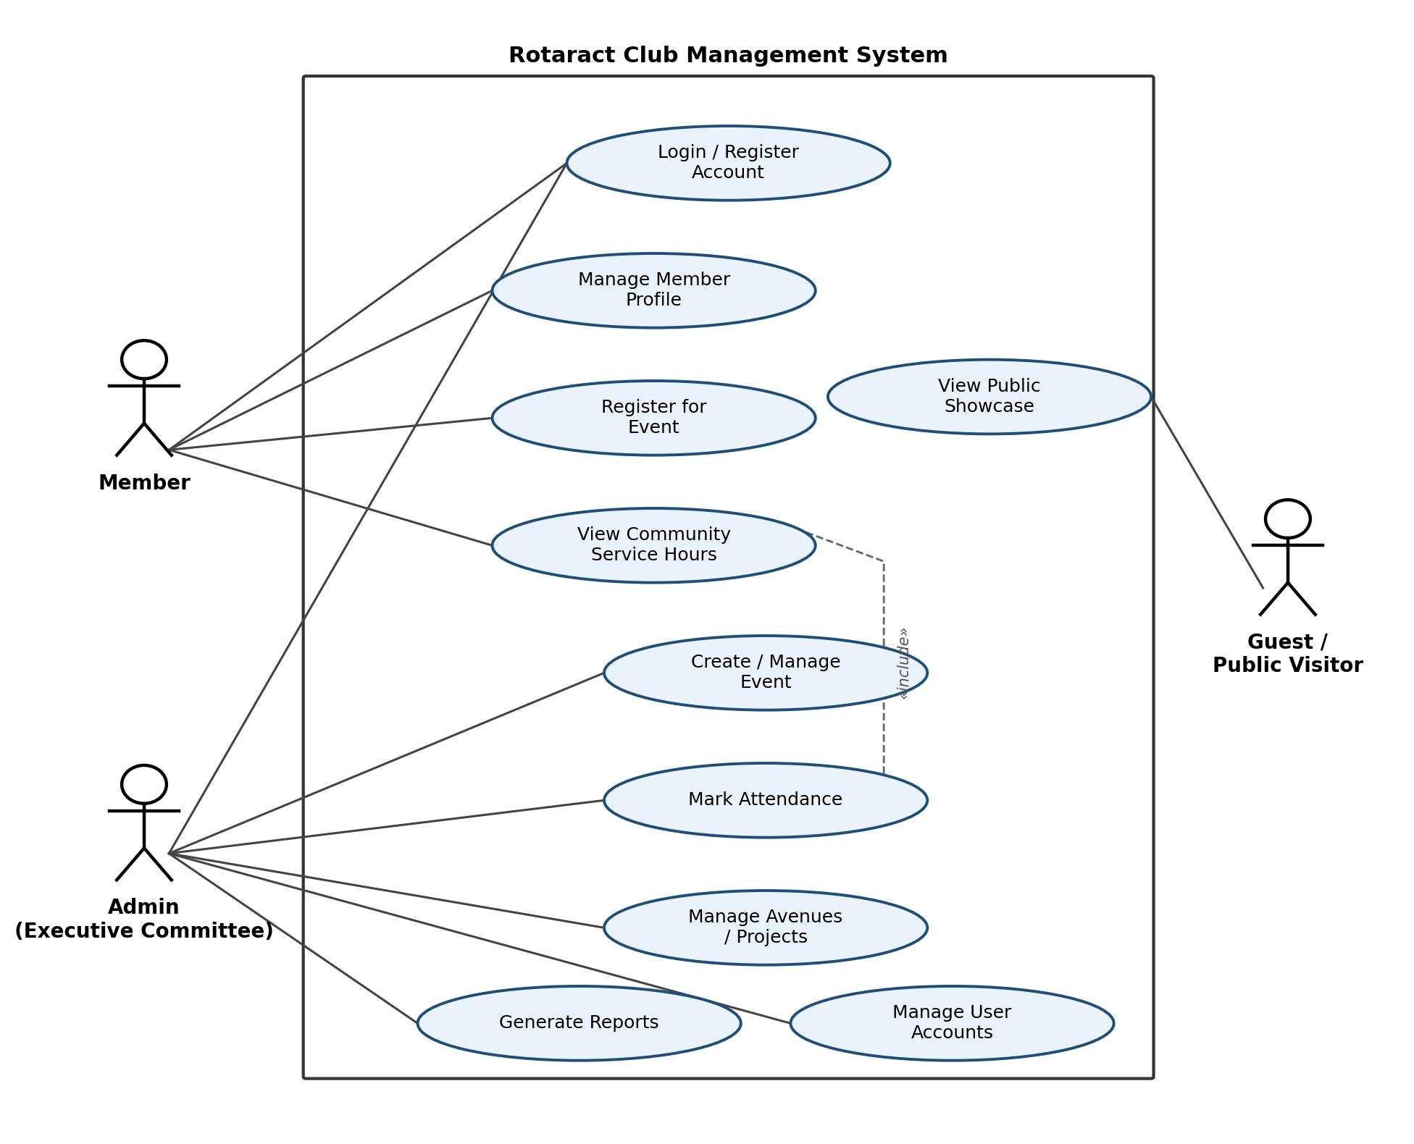
Figure 4.Use Case Diagram of the Proposed System

3.3.3 Class Diagram of Proposed System.

Figure 3 presents the class diagram of the proposed system. A generalised User class holds shared authentication attributes and is specialised into Admin and Member subclasses, reflecting the role-based access control required by the system. The Event class is associated with an Avenue and is linked to Member accounts through the Event Registration and Attendance association classes, while the Service Hour Log class captures verified community-service hours arising from a specific Attendance record. This structure keeps registration intent (Event Registration) separate from confirmed participation (Attendance), which is necessary because not every member who registers for an event ultimately attends.
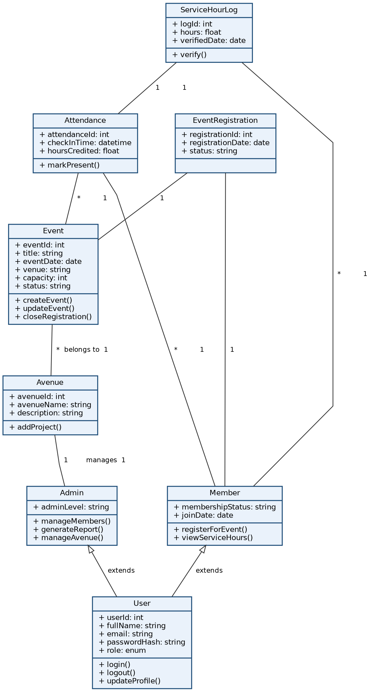
Figure 5. Class Diagram of the Proposed System

3.3.4 Sequence Diagrams (Each Use case) for Proposed System.

The following sequence diagrams model the three most operationally significant use cases identified during requirements gathering: registering for an event, marking attendance, and updating a member profile. Each diagram traces the flow of messages between the Member or Admin actor, the web-based user interface, the server-side controller, and the database.
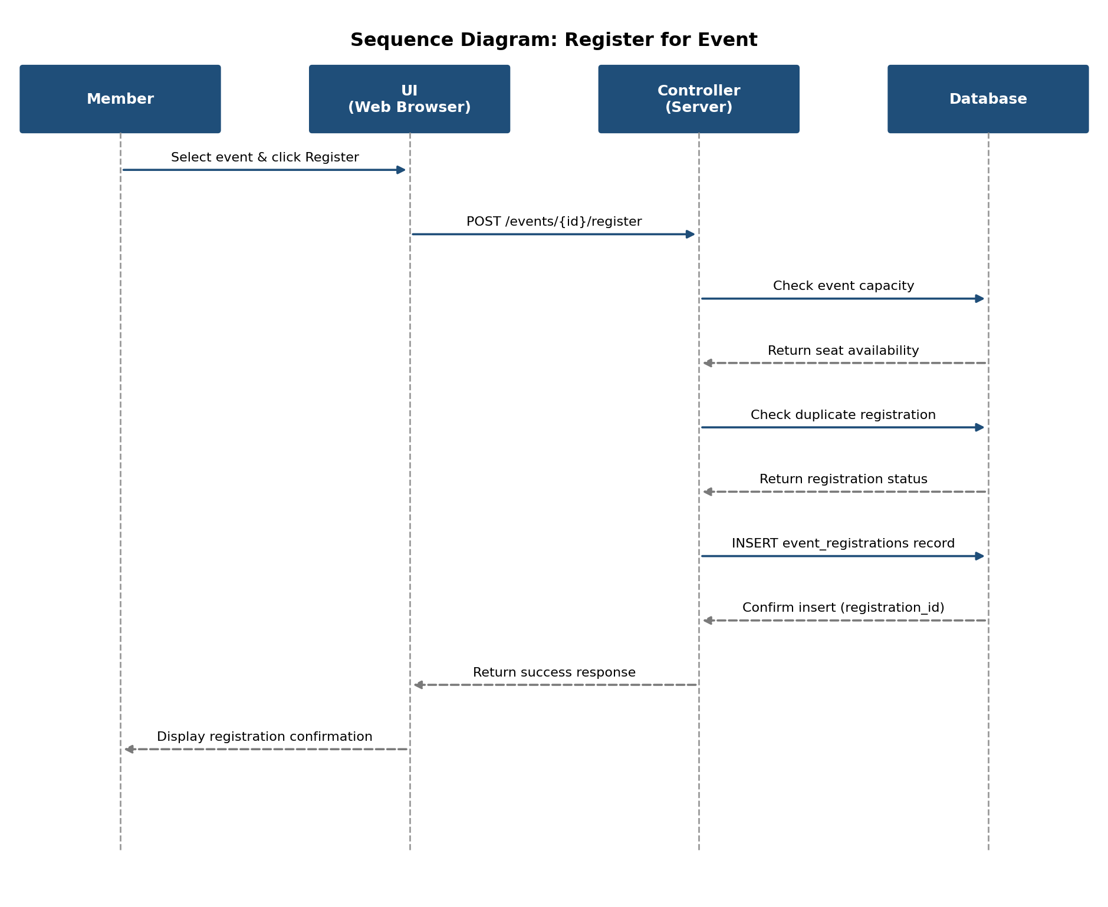
Figure 6. Sequence Diagram – Register for Event
As shown in Figure 5, the controller performs two validation checks, event capacity and duplicate registration, before committing a new record to the event registrations table. Performing both checks server-side, rather than relying on the interface alone, prevents overbooking and duplicate sign-ups even if two members submit a request at nearly the same time.
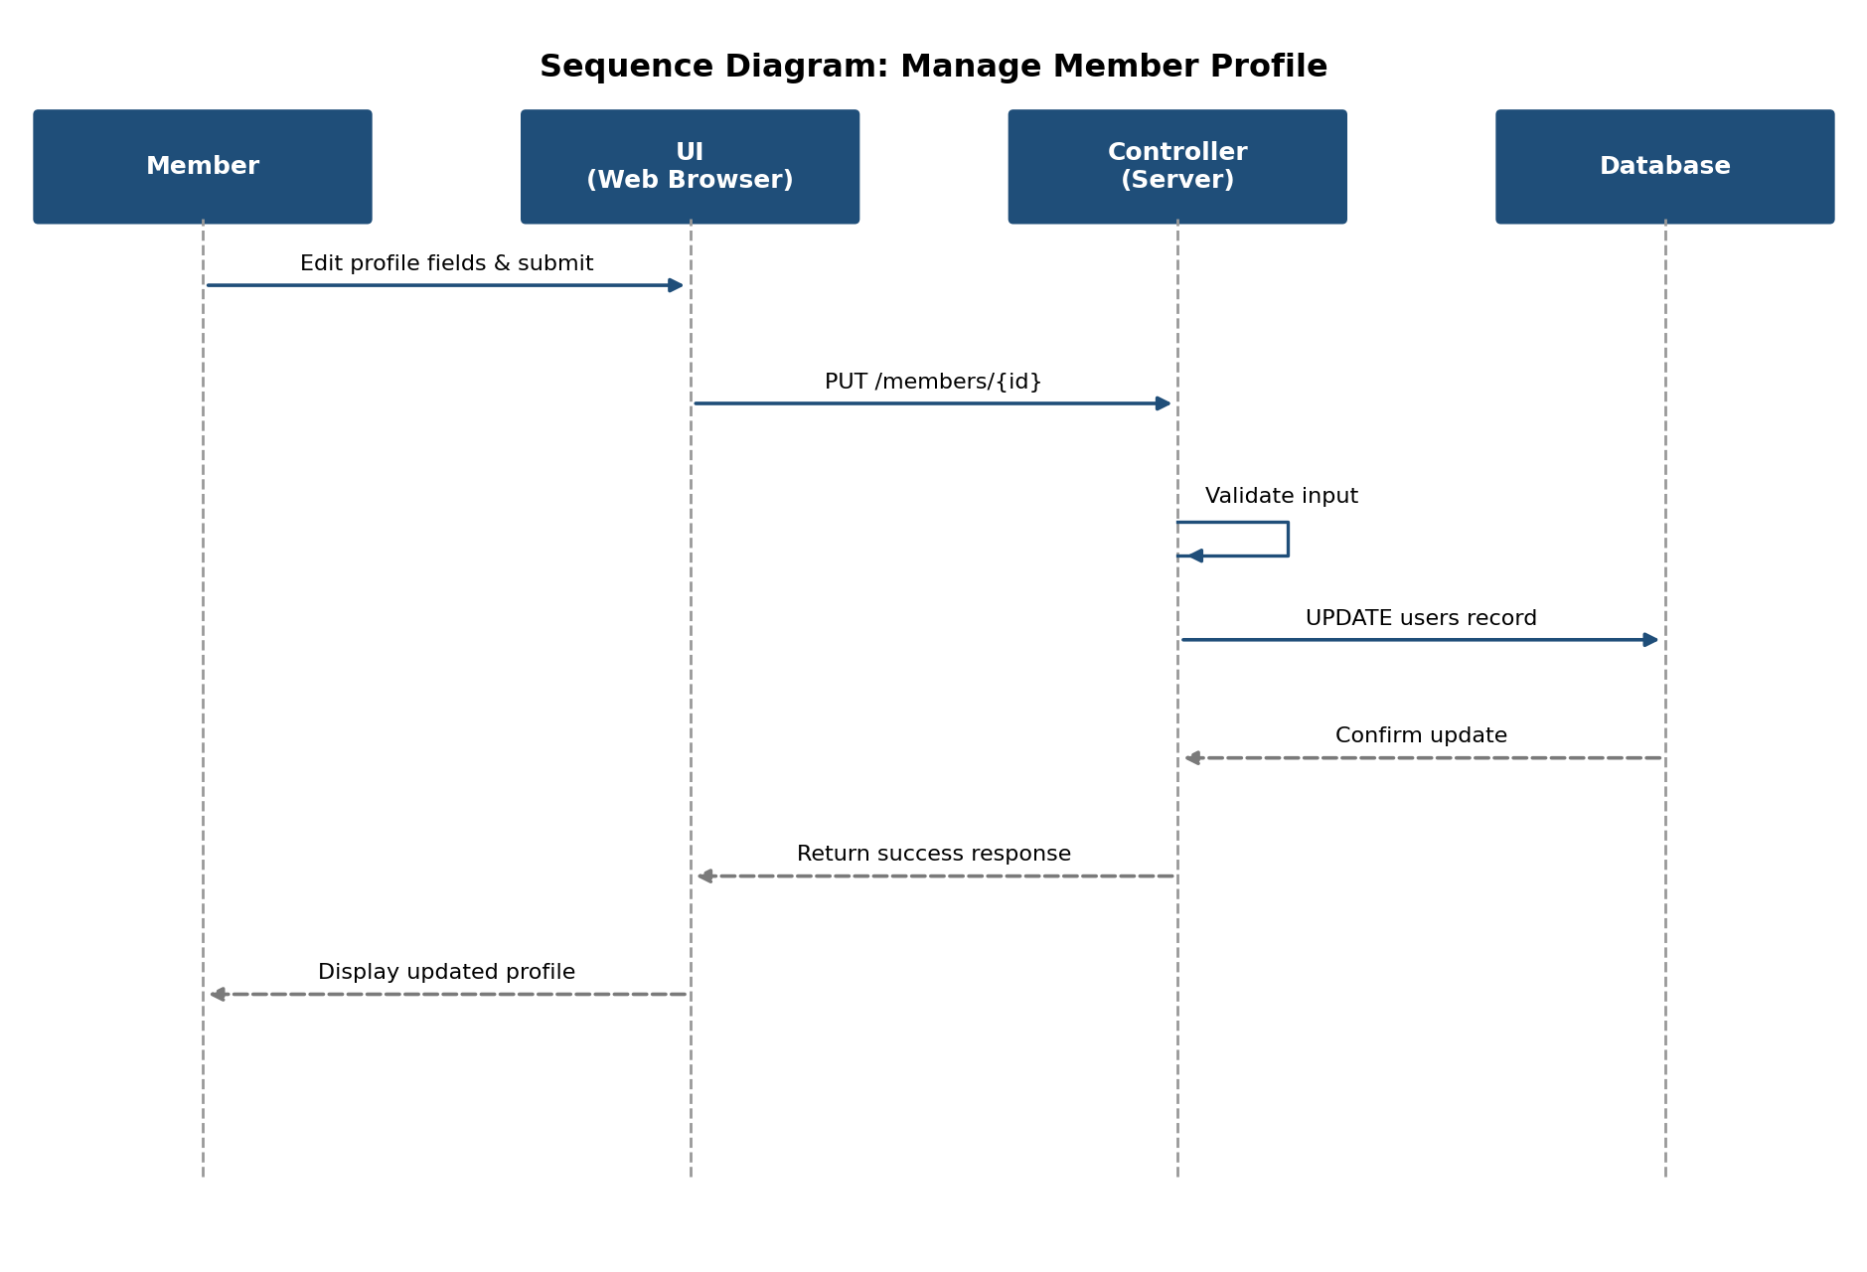
Figure 7. Sequence Diagram – Manage Member Profile
3.3 ER Diagram of the Proposed System.
Entity Relationship diagram derived from the class diagram in Figure 8. Six entities were identified: users, avenues, events, event registrations, attendance, and service hour logs. The user’s table is deliberately shared between Admin and Member accounts, distinguished by a role column, which keeps authentication logic in a single place. Foreign keys enforce that every event belongs to exactly one avenue and was created by exactly one user, that every registration and attendance record refers to exactly one event and one member, and that every service-hour log is traceable back to the specific attendance record and the staff member who verified it.
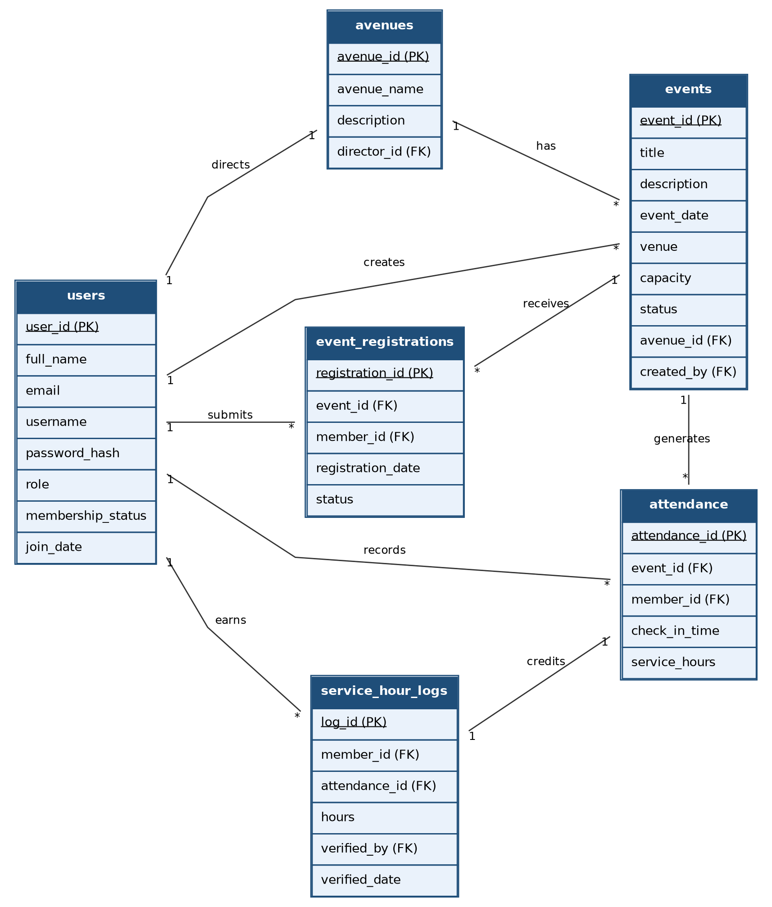
Figure 8. Entity Relationship Diagram of the Proposed System

3.4 Chapter Summery
This chapter modelled the functional requirements and architectural design of RT-Web. Through Use Case diagrams, Class structures, Sequence interactions, and normalized Entity Relationship schema, the analysis established a solid technical foundation for system construction.

Chapter 4: Solution Design

4.1 Introduction.
This chapter translates the analysis models presented in Chapter 3 into a concrete design for the Rotaract Web Management System. It presents the design of six key interfaces, the six-table relational database schema that supports them, and the four report layouts required by the Executive Committee. Together, these design artifacts form the specification against which the system was implemented and tested.

4.2 Interface Design
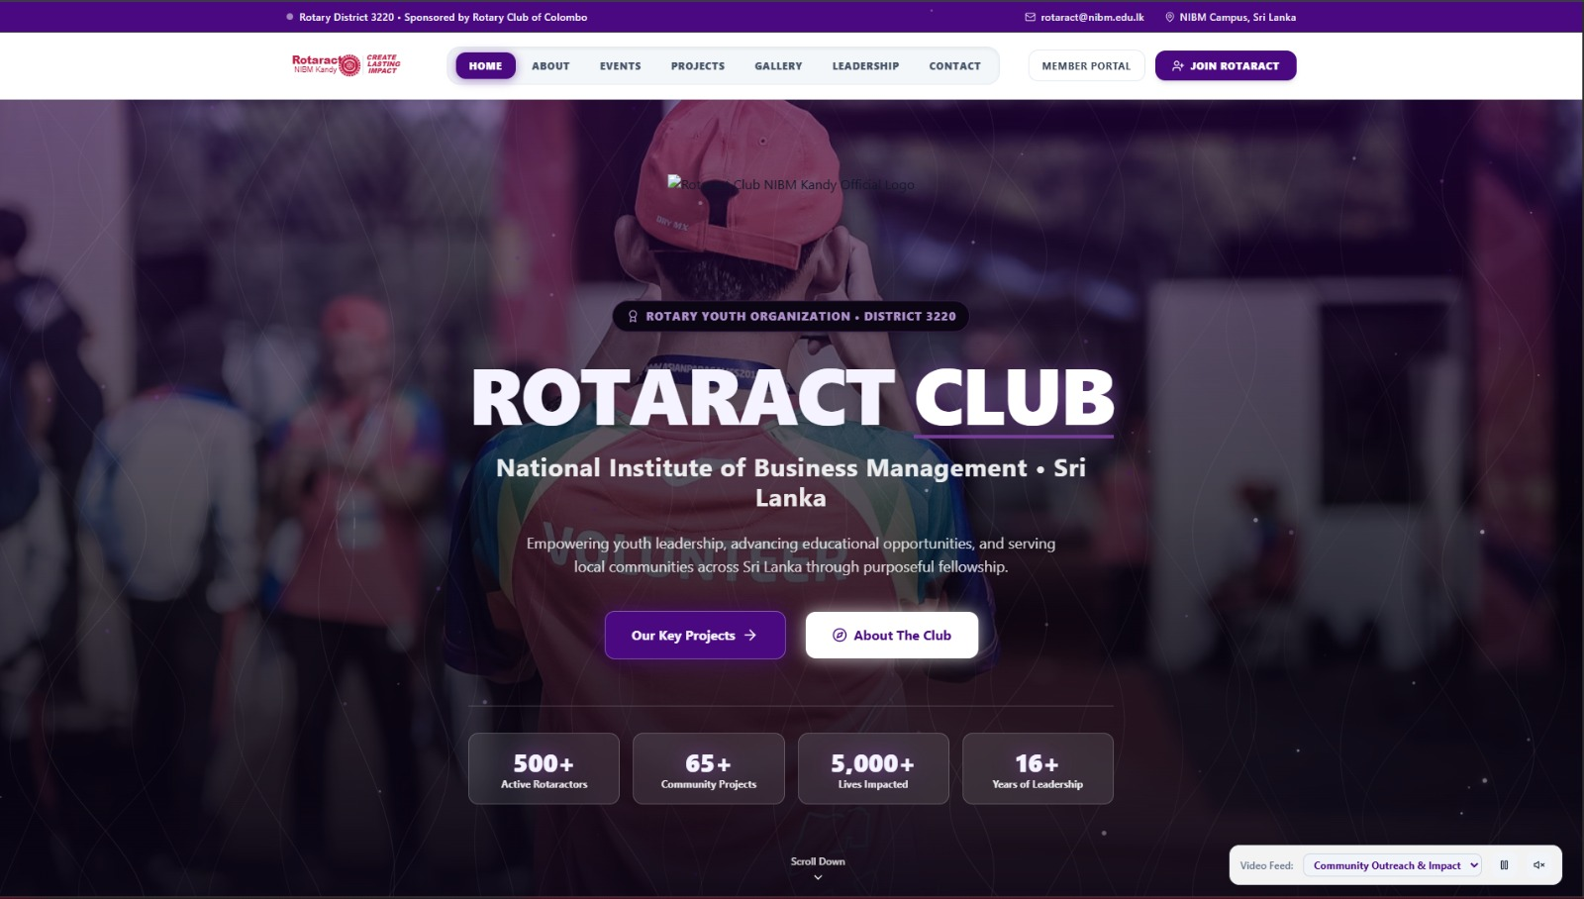
Figure 9. Home Page
BEGIN HomePage
// Top info bar
DISPLAY topBar(district="Rotary District 3220", sponsor="Rotary Club of Colombo",
email="rotaract@nibm.edu.lk", location="NIBM Campus, Sri Lanka")

// Navigation
navItems = ["Home", "About", "Events", "Projects", "Gallery", "Leadership", "Contact"]
DISPLAY navbar(logo, navItems, activeItem = "Home")
ON click "Member Portal" -> REDIRECT TO LoginPage
ON click "Join Rotaract" -> REDIRECT TO RegistrationPage

// Hero section
currentFeed = "Community Outreach & Impact"
heroVideo = Media.getBackgroundVideo(currentFeed)
PLAY heroVideo IN BACKGROUND (loop = true, muted = true)

DISPLAY badge("ROTARY YOUTH ORGANIZATION • DISTRICT 3220")
DISPLAY logo(clubLogo)
DISPLAY heading("ROTARACT CLUB")
DISPLAY subheading("National Institute of Business Management • Sri Lanka")
DISPLAY description("Empowering youth leadership, advancing educational " +
"opportunities, and serving local communities across Sri Lanka " +
"through purposeful fellowship.")

ON click "Our Key Projects" -> REDIRECT TO ProjectsPage
ON click "About The Club" -> REDIRECT TO AboutPage

// Impact statistics
stats = Database.getClubStats()
// { activeMembers: 500, communityProjects: 65, livesImpacted: 5000, yearsActive: 16 }
FOR EACH stat IN stats
ANIMATE countUp(stat.value) OVER 1.5s
DISPLAY statCard(stat.value, stat.label)
END FOR

// Video feed controls (bottom-right widget)
feedOptions = Media.getVideoFeedOptions()
ON change videoFeedDropdown(selectedFeed)
currentFeed = selectedFeed
heroVideo.source = Media.getVideoBySource(currentFeed)
RELOAD heroVideo
END ON
ON click playPauseButton
IF heroVideo.isPlaying THEN heroVideo.pause()
ELSE heroVideo.play()
END IF
END ON
ON click muteToggleButton
heroVideo.muted = NOT heroVideo.muted
END ON

// Scroll cue
DISPLAY scrollDownIndicator
ON click scrollDownIndicator
SCROLL TO nextSection SMOOTH
END ON
END
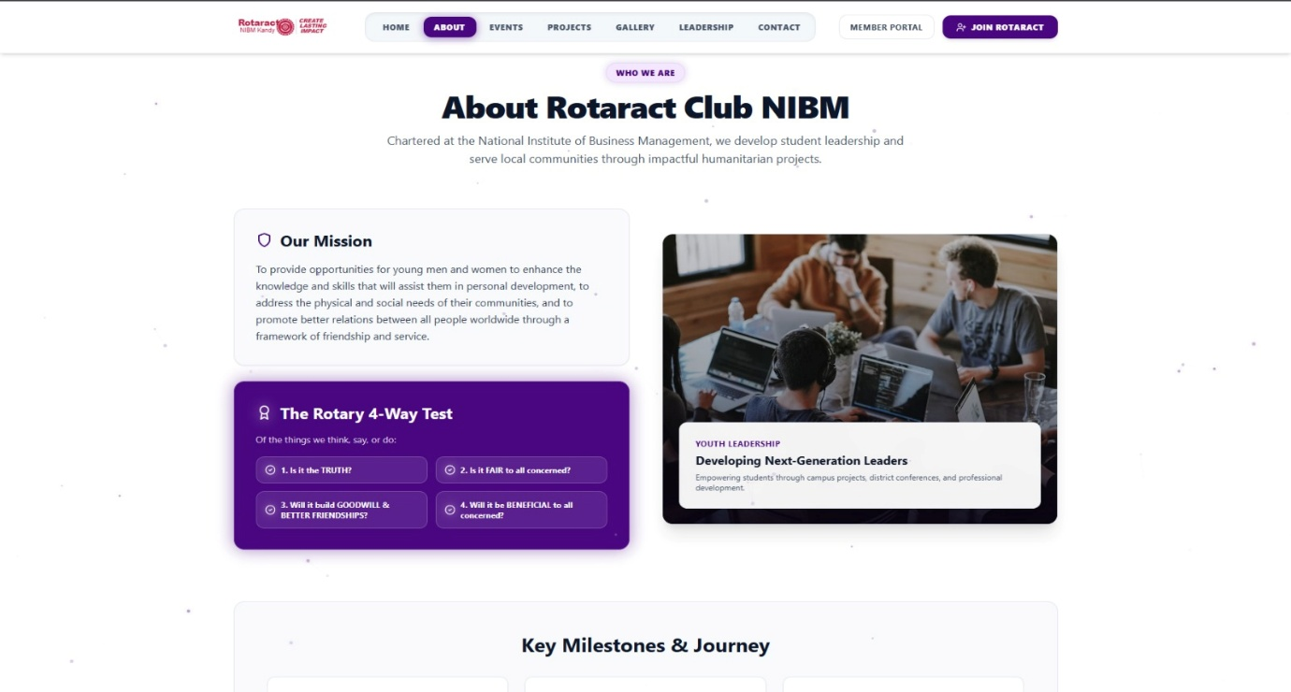
Figure 10. About Page
BEGIN AboutPage
DISPLAY navbar (logo, navItems, activeItem = "About")
ON click "Member Portal" -> REDIRECT TO LoginPage
ON click "Join Rotaract" -> REDIRECT TO RegistrationPage

// Intro / hero section
DISPLAY badge ("WHO WE ARE")
DISPLAY heading("About Rotaract Club NIBM")
DISPLAY description ("Chartered at the National Institute of Business Management, " +
"We develop student leadership and serve local communities " +
"Through impactful humanitarian projects.")

// Mission block
mission = Content.getMissionStatement()
DISPLAY missionCard (icon = "shield", title = "Our Mission", text = mission)

// Rotary Four-Way Test
fourWayTest = Content.getFourWayTestItems()
// ["Is it the TRUTH?", "Is it FAIR to all concerned?",
// "Will it build GOODWILL & BETTER FRIENDSHIPS?",
// "Will it be BENEFICIAL to all concerned?"]
DISPLAY testPanel(title = "The Rotary 4-Way Test", subtitle = "Of the things we think, say, or do:")
FOR EACH item IN fourWayTest (index = i)
DISPLAY testItem(number = i + 1, text = item)
END FOR

// Youth leadership feature image/card
featureImage = Media.getFeatureImage("youth_leadership")
DISPLAY imageCard(
image = featureImage,
tag = "YOUTH LEADERSHIP",
title = "Developing Next-Generation Leaders",
text = "Empowering students through campus projects, district conferences, " +
"and professional development."
)

// Milestones / journey section
milestones = Database.getClubMilestones()
// e.g. { year, title, description } sorted chronologically
DISPLAY sectionHeading("Key Milestones & Journey")
FOR EACH milestone IN milestones
DISPLAY timelineCard(milestone.year, milestone.title, milestone.description)
END FOR
END
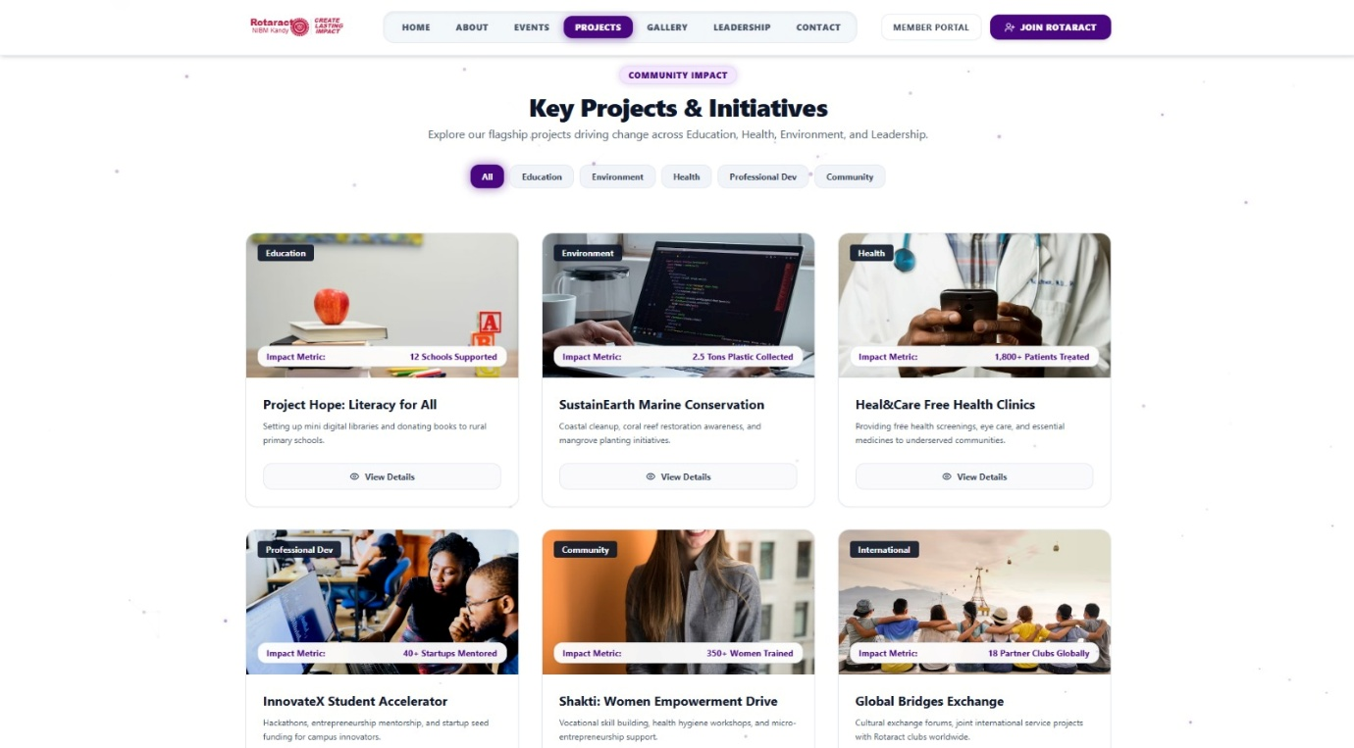
Figure 11.Project Page
BEGIN ProjectsPage
DISPLAY navbar (logo, navItems, activeItem = "Projects")
ON click "Member Portal" -> REDIRECT TO LoginPage
ON click "Join Rotaract" -> REDIRECT TO RegistrationPage

// Header
DISPLAY badge ("COMMUNITY IMPACT")
DISPLAY heading ("Key Projects & Initiatives")
DISPLAY description ("Explore our flagship projects driving change across " +
"Education, Health, Environment, and Leadership.")

// Category filter
categories = ["All", "Education", "Environment", "Health", "Professional Dev", "Community"]
activeCategory = "All"
DISPLAY filterTabs(categories, selected = activeCategory)

ON click filterTab(category)
activeCategory = category
RELOAD projectGrid
END ON

// Project grid
BEGIN projectGrid
IF activeCategory == "All" THEN
projects = Database.getAllProjects()
ELSE
projects = Database.getProjectsByCategory(activeCategory)
END IF

FOR EACH project IN projects
DISPLAY projectCard(
image = project.image,
categoryTag = project.category,
impactMetric = project.metricLabel + ": " + project.metricValue,
// e.g. "Impact Metric: 12 Schools Supported"
title = project.title,
description = project.shortDescription
)
ON click "View Details" (project.id)
REDIRECT TO ProjectDetailPage(project.id)
END ON
END FOR
END
END
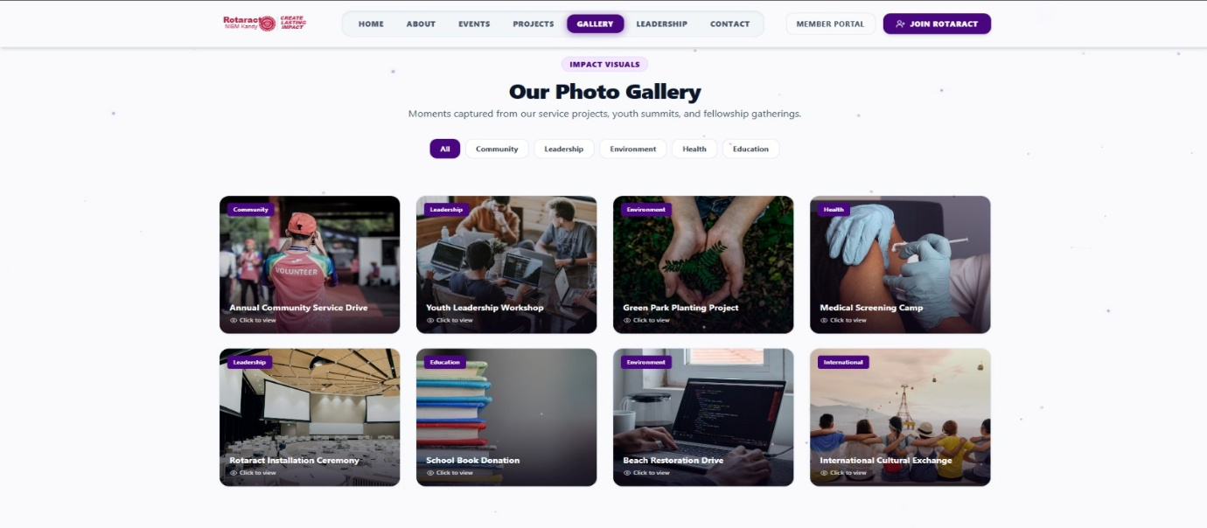
Figure 12. Gallery Page
BEGIN GalleryPage
DISPLAY navbar(logo, navItems, activeItem = "Gallery")
ON click "Member Portal" -> REDIRECT TO LoginPage
ON click "Join Rotaract" -> REDIRECT TO RegistrationPage

// Header
DISPLAY badge("IMPACT VISUALS")
DISPLAY heading("Our Photo Gallery")
DISPLAY description("Moments captured from our service projects, youth summits, " +
"and fellowship gatherings.")

// Category filter
categories = ["All", "Community", "Leadership", "Environment", "Health", "Education"]
activeCategory = "All"
DISPLAY filterTabs(categories, selected = activeCategory)

ON click filterTab(category)
activeCategory = category
RELOAD photoGrid
END ON

// Photo grid
BEGIN photoGrid
IF activeCategory == "All" THEN
photos = Database.getAllGalleryPhotos()
ELSE
photos = Database.getGalleryPhotosByCategory(activeCategory)
END IF

FOR EACH photo IN photos
DISPLAY photoCard(
image = photo.thumbnail,
categoryTag = photo.category,
caption = photo.title
)
ON click photoCard(photo.id)
OPEN lightbox(photo.fullImage, photo.title, photo.category)
END ON
END FOR
END

// Lightbox viewer
BEGIN lightbox(image, title, category)
DISPLAY overlay(image, title, category)
DISPLAY navigation("Previous", "Next")
ON click "Previous" -> SHOW previousPhoto IN sequence
ON click "Next" -> SHOW nextPhoto IN sequence
ON click closeButton OR clickOutside -> CLOSE lightbox
END

// Recognition section (below gallery)
DISPLAY badge("RECOGNITION")
// (continues below fold — additional
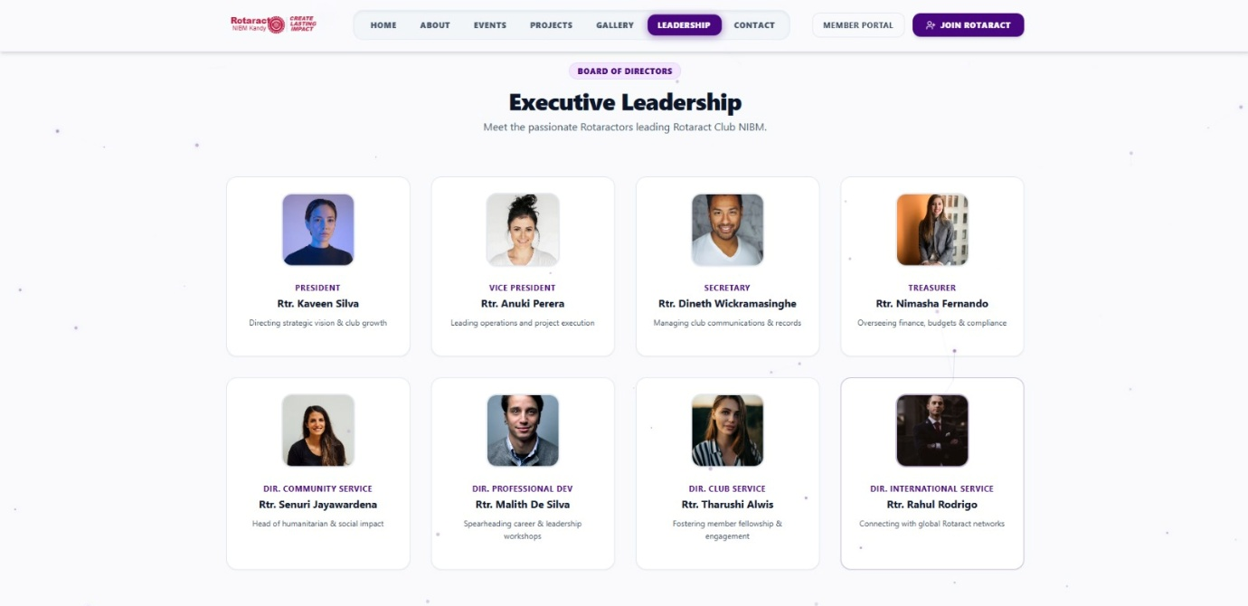
Figure 13. Leadership Page

BEGIN LeadershipPage
DISPLAY navbar(logo, navItems, activeItem = "Leadership")
ON click "Member Portal" -> REDIRECT TO LoginPage
ON click "Join Rotaract" -> REDIRECT TO RegistrationPage

// Header
DISPLAY badge("BOARD OF DIRECTORS")
DISPLAY heading("Executive Leadership")
DISPLAY description("Meet the passionate Rotaractors leading Rotaract Club NIBM.")

// Executive committee row
executives = Database.getBoardMembers(tier = "Executive")
// ordered: President, Vice President, Secretary, Treasurer
FOR EACH member IN executives
DISPLAY leaderCard(
photo = member.photo,
role = member.role,
name = "Rtr. " + member.fullName,
tagline = member.roleDescription
)
END FOR

// Avenue directors row
directors = Database.getBoardMembers(tier = "Director")
// ordered: Community Service, Professional Dev, Club Service, International Service
FOR EACH member IN directors
DISPLAY leaderCard(
photo = member.photo,
role = "DIR. " + member.avenue,
name = "Rtr. " + member.fullName,
tagline = member.roleDescription
)
END FOR

ON click leaderCard(member.id)
OPEN memberProfileModal(member)
// extended bio, contact, social links (if enabled by member)
END ON

// Next section below the fold (partially visible)
DISPLAY nextSection(...)
END
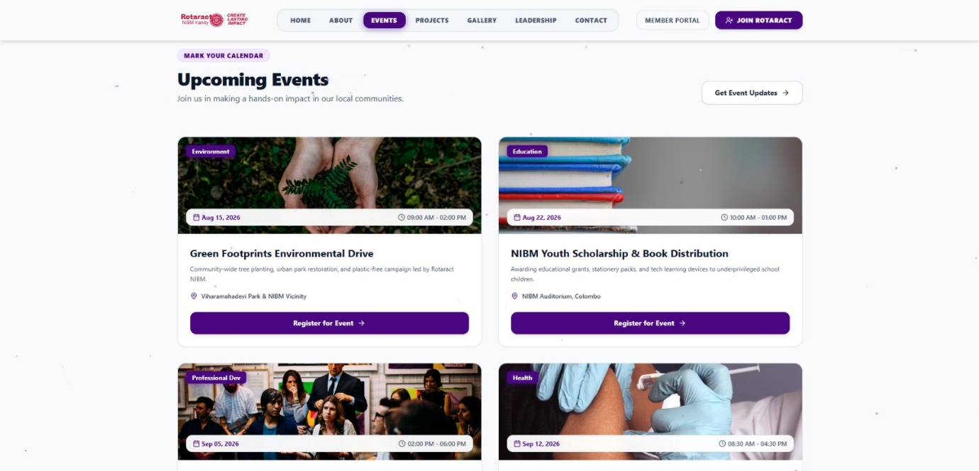
Figure 14. Event Page
BEGIN EventsPage
DISPLAY navbar(logo, navItems, activeItem = "Events")
ON click "Member Portal" -> REDIRECT TO LoginPage
ON click "Join Rotaract" -> REDIRECT TO RegistrationPage

// Header
DISPLAY badge("MARK YOUR CALENDAR")
DISPLAY heading("Upcoming Events")
DISPLAY description("Join us in making a hands-on impact in our local communities.")

ON click "Get Event Updates"
REDIRECT TO NewsletterSignupPage // or OPEN subscribeModal
END ON

// Event list
events = Database.getUpcomingEvents(orderBy = "date ASC")

FOR EACH event IN events
DISPLAY eventCard(
image = event.coverImage,
categoryTag = event.category, // e.g. "Environment", "Education"
date = event.date, // e.g. "Aug 15, 2026"
timeRange = event.startTime + " - " + event.endTime,
title = event.title,
description = event.shortDescription,
location = event.venue
)

ON click "Register for Event" (event.id)
IF session.isLoggedIn == FALSE THEN
REDIRECT TO LoginPage (returnTo = EventRegistrationPage(event.id))
RETURN
END IF
IF Database.isFull(event.id) THEN
DISPLAY "Event is fully booked"
RETURN
END IF
IF Database.alreadyRegistered(session.userId, event.id) THEN
DISPLAY "You are already registered for this event"
RETURN
END IF
Database.insertRegistration(session.userId, event.id, "Confirmed")
DISPLAY "Registration successful"
END ON
END FOR
END
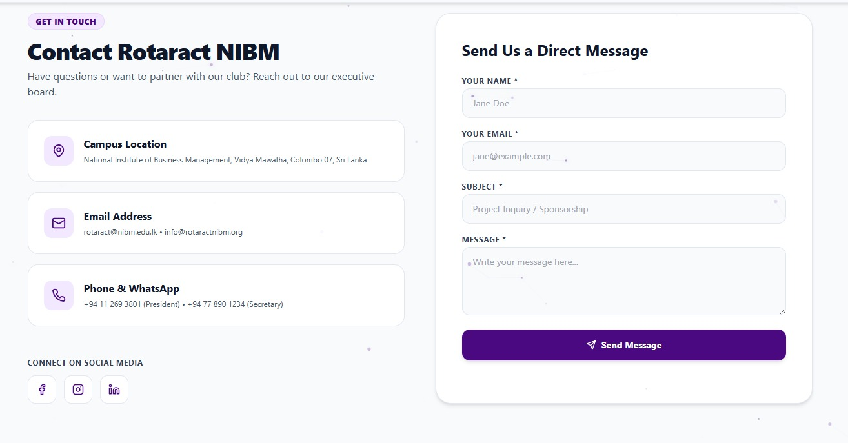
Figure 15. Message Page

BEGIN ContactPage
// Header
DISPLAY badge("GET IN TOUCH")
DISPLAY heading("Contact Rotaract NIBM")
DISPLAY description("Have questions or want to partner with our club? " +
"Reach out to our executive board.")

// Contact info panel
contactInfo = Content.getContactDetails()
DISPLAY infoCard(icon = "map-pin", title = "Campus Location",
text = contactInfo.address)
// "National Institute of Business Management, Vidya Mawatha, Colombo 07, Sri Lanka"
DISPLAY infoCard(icon = "mail", title = "Email Address",
text = contactInfo.emails)
// "rotaract@nibm.edu.lk • info@rotaractnibm.org"
DISPLAY infoCard(icon = "phone", title = "Phone & WhatsApp",
text = contactInfo.phoneNumbers)
// "+94 11 269 3801 (President) • +94 77 890 1234 (Secretary)"

DISPLAY sectionLabel("CONNECT ON SOCIAL MEDIA")
socialLinks = Content.getSocialLinks() // Facebook, Instagram, LinkedIn
FOR EACH link IN socialLinks
DISPLAY socialIcon(link.platform, link.url)
ON click socialIcon -> OPEN link.url IN newTab
END FOR

// Contact form panel
DISPLAY heading("Send Us a Direct Message")

BEGIN ContactForm
INPUT name, email, subject, message

ON click "Send Message"
IF name is empty OR email is empty OR subject is empty OR message is empty THEN
DISPLAY "All fields marked * are required"
RETURN
END IF
IF isValidEmail(email) == FALSE THEN
DISPLAY "Please enter a valid email address"
RETURN
END IF

Database.insertContactMessage(name, email, subject, message, currentTimestamp())
Mailer.send(
to = "rotaract@nibm.edu.lk",
subject = "[Website Enquiry] " + subject,
body = buildMessageTemplate(name, email, message)
)
DISPLAY "Message sent successfully"
CLEAR form
END ON
END
END
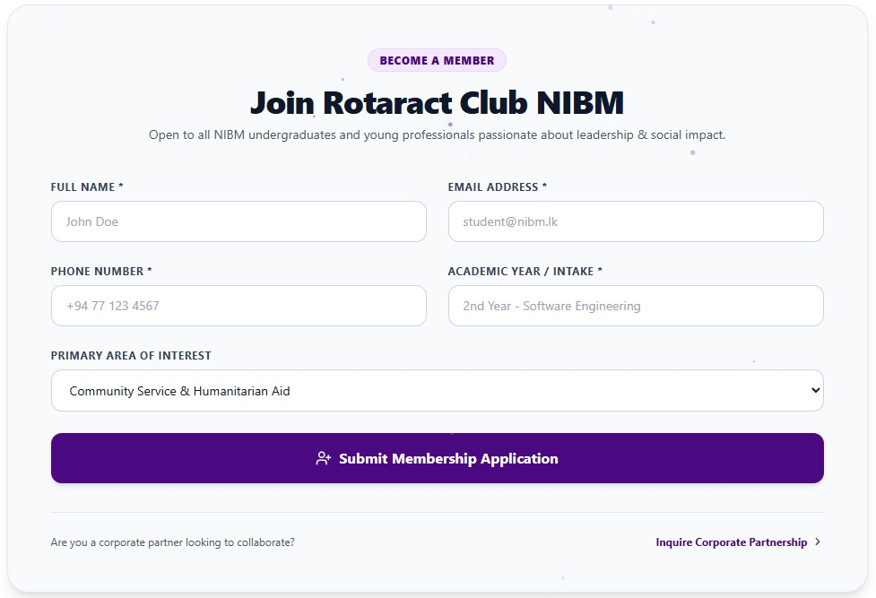
Figure 16. Registration Form
BEGIN EventRegistrationModal(event)
DISPLAY overlay(dimBackground = true)
DISPLAY closeButton (X)
ON click closeButton OR clickOutside -> CLOSE modal

// Event summary header
DISPLAY categoryTag(event.category) // e.g. "Environment"
DISPLAY title(event.title) // "Green Footprints Environmental Drive"
DISPLAY subtext(event.date + " • " + event.venue)
// "Aug 15, 2026 • Viharamahadevi Park & NIBM Vicinity"

// Registration form
BEGIN registrationForm
INPUT fullName, email, phoneNumber

ON click "Confirm Volunteer & Registration Pass"
IF fullName is empty OR email is empty OR phoneNumber is empty THEN
DISPLAY "All fields marked * are required"
RETURN
END IF
IF isValidEmail(email) == FALSE THEN
DISPLAY "Please enter a valid email address"
RETURN
END IF
IF isValidPhone(phoneNumber) == FALSE THEN
DISPLAY "Please enter a valid phone number"
RETURN
END IF

IF Database.isFull(event.id) THEN
DISPLAY "Event is fully booked"
RETURN
END IF
IF Database.alreadyRegistered(email, event.id) THEN
DISPLAY "This email is already registered for this event"
RETURN
END IF

registrationId = Database.insertRegistration(
eventId = event.id, fullName, email, phoneNumber,
status = "Confirmed", registeredAt = currentTimestamp()
)
Mailer.send(to = email, subject = "Registration Confirmed: " + event.title,
body = buildPassTemplate(fullName, event, registrationId))
DISPLAY "Registration confirmed — check your email for your pass"
CLOSE modal
END ON
END
END

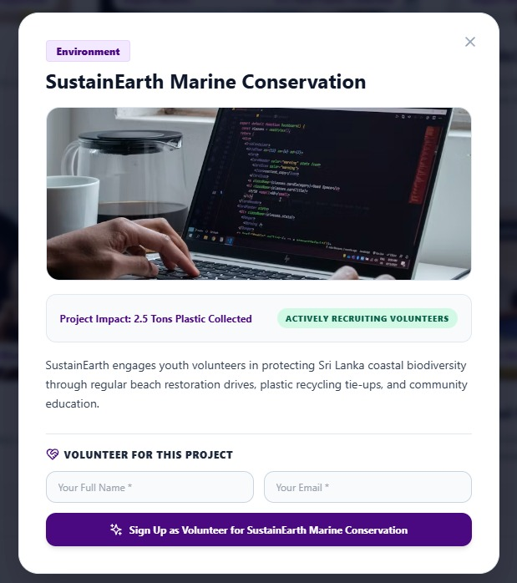
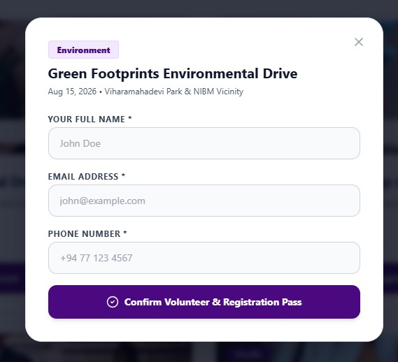
Figure 17. Volunteer Page

4.3 Database Design
The database was designed in Third Normal Form (3NF) to minimise data redundancy while keeping common queries, such as retrieving a member's registration history, efficient.

Column Name | Data Type | Constraint | Description
user_id | INT | PRIMARY KEY, AUTO_INC | Unique user profile ID
full_name | VARCHAR (150) | NOT NULL | Member full name
email | VARCHAR (120) | NOT NULL, UNIQUE | Login email address
password_hash | VARCHAR (255) | NOT NULL | Bcrypt salted hash
role | ENUM | DEFAULT 'Member' | 'Admin','Director','Member'
contact_no | VARCHAR (20) | NOT NULL | Telephone / Mobile

Column Name | Data Type | Constraint | Description
event_id | INT | PRIMARY KEY, AUTO_INC | Unique event identifier
avenue_id | INT | FOREIGN KEY (avenues) | Organizing avenue
title | VARCHAR (200) | NOT NULL | Event initiative name
event_date | DATETIME | NOT NULL | Scheduled start time
venue | VARCHAR (255) | NOT NULL | Physical / Virtual venue
max_capacity | INT | DEFAULT 100 | Maximum attendee quota

Column Name | Data Type | Constraint | Description
registration_id | INT | PRIMARY KEY, AUTO_INC | Unique registration ID
event_id | INT | FOREIGN KEY (events) | Target event ID
user_id | INT | FOREIGN KEY (users) | Registered attendee ID
pass_code | VARCHAR (50) | NOT NULL, UNIQUE | Unique hash (RT-NIBM-1-A9F2)
checkin_status | ENUM | DEFAULT 'Confirmed' | 'Confirmed','Checked-In','No-Show'
checkin_time | DATETIME | NULL | Timestamp when verified at gate

Column Name | Data Type | Constraint | Description
log_id | INT | PRIMARY KEY, AUTO_INC | Unique volunteer log entry ID
user_id | INT | FOREIGN KEY (users) | Volunteer member ID
event_id | INT | FOREIGN KEY (events) | Linked club event ID
hours_logged | DECIMAL (5,2) | NOT NULL | Service hours completed
verification_status | ENUM | DEFAULT 'Pending' | 'Pending','Approved','Rejected'

Code for Database

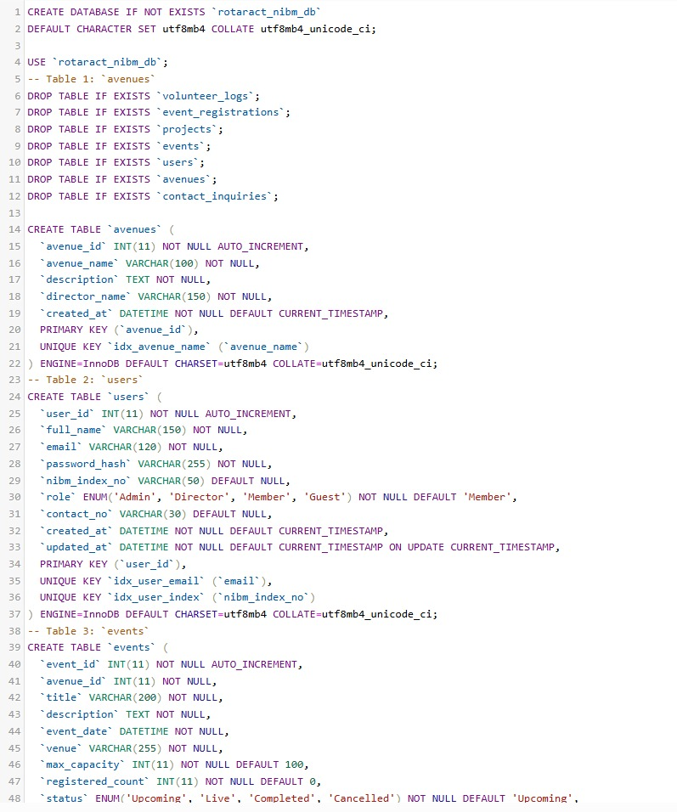
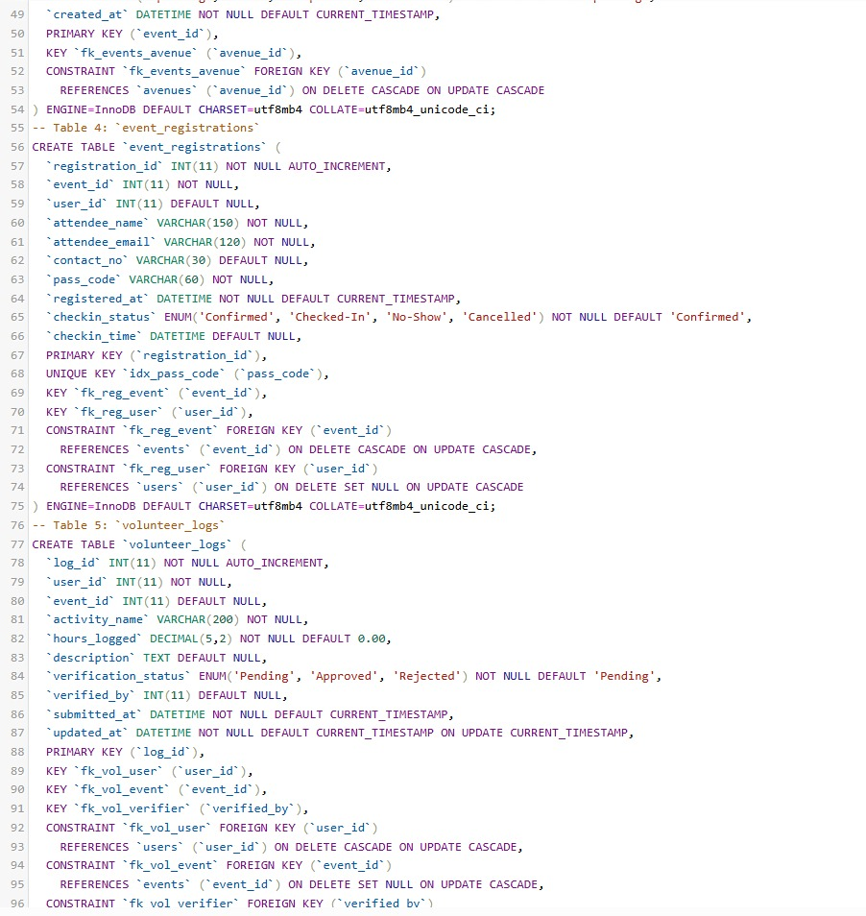
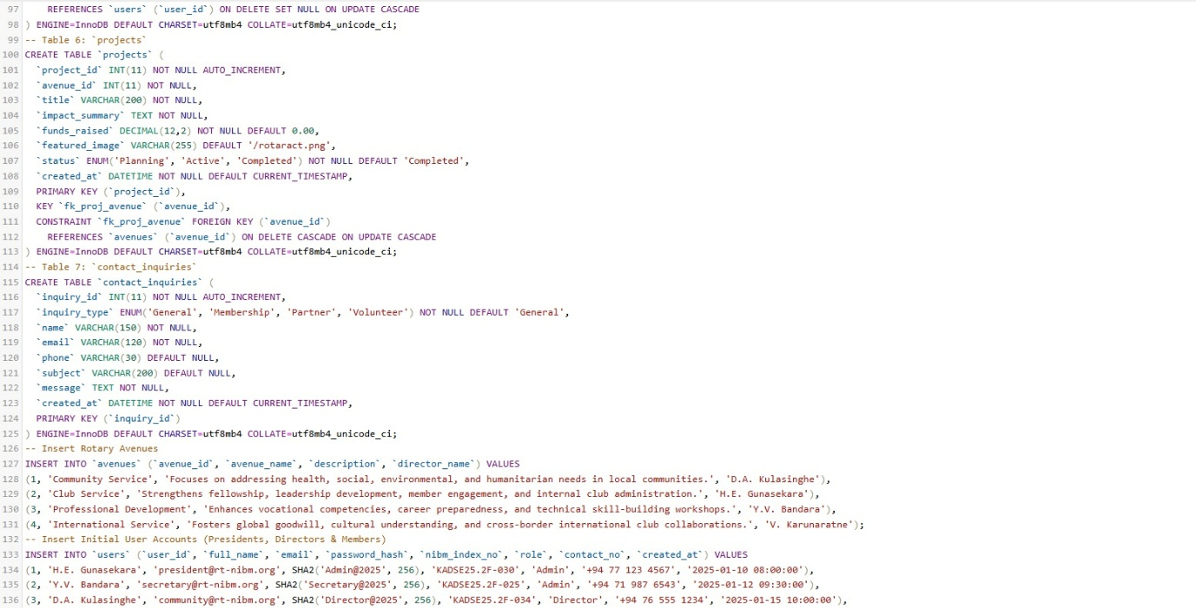
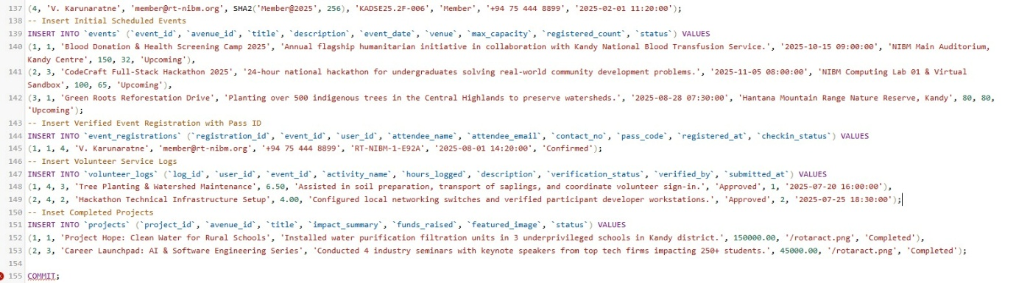
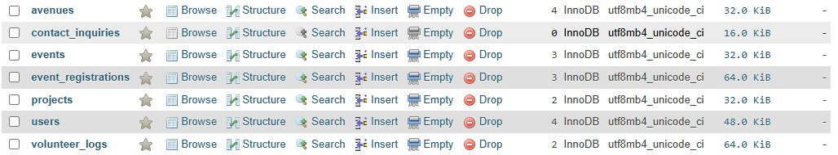

4.4 Report Layout Design
Standard report layouts were identified during requirements gathering as the reports most frequently needed by the Executive Committee. Each report is generated on demand from the underlying database tables.

Report Layout RL-01
======================================================================================
ROTARACT CLUB OF NIBM KANDY — EVENT ATTENDANCE AUDIT REPORT
======================================================================================
Event Name : Blood Donation & Health Camp 2025 Avenue : Community Service
Date : 2025-10-15 Venue : NIBM Auditorium
Capacity : 150 Total Reg : 142 (94.6% Full)
--------------------------------------------------------------------------------
Pass Code Attendee Name Index / Email Status Check-In Time
--------------------------------------------------------------------------------
RT-NIBM-1-A9F2 H.E. Gunasekara KADSE25.2F-030 Checked-In 08:45 AM
RT-NIBM-1-B3C1 Y.V. Bandara KADSE25.2F-025 Checked-In 08:52 AM
RT-NIBM-1-D8E4 D.A. Kulasinghe KADSE25.2F-034 Checked-In 09:10 AM
RT-NIBM-1-F7G9 K.L. Perera perera@gmail.com No-Show --
--------------------------------------------------------------------------------
SUMMARY: Total Registered: 142 | Checked-In: 131 (92.25%) | No-Shows: 11
Verified by Secretary: ....................................... Date:2025-10-16
================================================================================

Report Layout RL-02
================================================================================
ROTARACT CLUB OF NIBM KANDY — ANNUAL VOLUNTEER SERVICE SUMMARY
================================================================================
Period: Rotaract Year 2025/2026 Generated: 2026-06-30
Total Active Members: 85 Total Hours Logged: 1,420.50 Hrs
--------------------------------------------------------------------------------
Member ID Full Name Index Number Events Done Verified Hours Standing
--------------------------------------------------------------------------------------
USR-001 H.E. Gunasekara KADSE25.2F-030 12 Events 64.50 Hours Gold Citation
USR-002 Y.V. Bandara KADSE25.2F-025 11 Events 58.00 Hours Gold Citation
USR-003 D.A. Kulasinghe KADSE25.2F-034 9 Events 46.00 Hours Silver Citation
USR-004 V. Karunaratne KADSE25.2F-006 8 Events 42.50 Hours Silver Citation
--------------------------------------------------------------------------------
Approved by President: ....................................... Date:2026-07-01
================================================================================

Milestone / Task | Month 1 | Month 2 | Month 3
1. Requirement Gathering | Weeks 1-2
2. Content Collection | Weeks 3-4
3. UI/UX Design Approval |  | Weeks 5-6
4. Web Development |  | Weeks 7-8 | Week 9
5. Progress Review Demo |  |  | Week 10
6. Multi-Tier Testing & UAT |  |  | Week 11
7. Final Cutover & Launch |  |  | Week 12
Task | 1st | 2nd | 3rd | 4th | 1st | 2nd | 3rd | 4th | 1st | 2nd | 3rd | 4th
 |  | Month One |  |  |  | Month Two |  |  | Month Three
Requirement Gathering
Content Collection (Text, Images,
Documents)
UI/UX Design Approval
Web site development (Coding phase)
Progress review and feedback
Testing phase
Final Review and launch

Chapter 5: System Testing

5.1 Introduction
System testing represents a foundational verification and validation phase in the software engineering lifecycle of the Rotaract Club of NIBM Kandy Management System. Software testing is executed systematically following the completion of module development to rigorously verify that all functional requirements, security boundaries, transactional integrity constraints, and interface workflows operate in exact alignment with the stakeholder requirements gathered from the club executive committee.
The overarching objective of testing is to identify latent defects, evaluate computational and transactional performance, ensure defensive error handling against malformed user inputs, and validate end-to-end data persistence across the Model-View-Controller (MVC) architectural tiers and the MySQL relational database in XAMPP.

5.2 Testing Approach & Strategy
A comprehensive, multi-tiered testing strategy was deployed to ensure both granular module-level correctness and macroscopic end-to-end operational readiness. The testing strategy encompasses three core testing methodologies:

5.2.1 Unit Testing
Unit testing was conducted to evaluate individual software units, controllers, helper routines, and React UI components in strict isolation. Each independent algorithm—such as cryptographic SHA-256 password hashing in backend/models/User.js, alphanumeric event pass code generation (RT-NIBM-x-xxxx) in backend/models/EventRegistration.js, email regex validation, and state mutators in App.jsx—was subjected to unit test suites with boundary, valid, and invalid equivalence partitions.

5.2.2 Integration Testing
Integration testing was performed to verify the seamless data exchange and communication interfaces between interconnected system modules and cross-tier network boundaries. Key integration test suites validated:
1. Frontend REST API Client to Express Controller routing over HTTP on Port 5000.
2. Event Registration module integration with the MySQL Connection Pool, ensuring that creating a registration simultaneously executes an atomic SQL INSERT query and increments the registered_count attribute in the parent events table.
3. Volunteer Hours Logging integration with Member Profile authentication, ensuring that submitted service hours link correctly to the user's foreign key user_id.
4. Verification of Cross-Origin Resource Sharing (CORS) headers and JSON payload serialization between React on Port 3000 and Express on Port 5000.

5.2.3 User Acceptance Testing (UAT)
User Acceptance Testing (UAT) was conducted in an on-site testing session where the fully integrated, live application was demonstrated exclusively to the President of the Rotaract Club of NIBM Kandy (Rtr. Hasintha E. Gunasekara) as the primary organizational client and executive authority.
During this evaluation session, the President executed full real-world operational user journeys, including:
• Navigating the public landing page and exploring Rotary Avenues of Service.
• Registering for flagship initiatives (such as the Blood Donation Camp and Hackathon 2025) and receiving instant digital passes featuring scannable QR verification matrices.
• Performing entrance gate pass check-ins and verifying duplicate prevention protocols.
• Submitting volunteer service hours through the Member Portal and viewing real-time hours accumulation.
• Verifying live database records directly within phpMyAdmin (rotaract_nibm_db) to confirm data security, data integrity, and persistent storage.
Following the hands-on demonstration, the President provided formal user sign-off and commendation, confirming that the web application satisfies all operational, logistical, and reporting requirements of the Rotaract Club of NIBM Kandy.

5.3 Comprehensive Test Cases & Execution Results
The following structured test case tables document the test specifications, test inputs, expected behaviors, actual outcomes, and verification statuses recorded during testing.
Table 10 — Test Case TC01: Verify that authorized users (Admin, Director, Member) can authenticate securely using valid email and password credentials.
Field | Description
Test Case ID | TC01
Module Name | Authentication & Member Portal Login
Test Description | Verify that authorized users (Admin, Director, Member) can authenticate securely using valid email and password credentials.
Pre-Conditions | User profile exists in MySQL users table with valid SHA-256 password hash.
Test Input Data | Email: president@rt-nibm.org, Password: [Valid Credentials]
Expected Result | System authenticates user, issues session token, and displays role-specific dashboard navigation.
Actual Result / Status | User authenticated successfully; Member Portal header and active session profile rendered. — [Pass]

Table 11 — Test Case TC02: Verify that the system validates mandatory fields and prevents duplicate user email registrations.
Field | Description
Test Case ID | TC02
Module Name | Member Registration & Duplicate Validation
Test Description | Verify that the system validates mandatory fields and prevents duplicate user email registrations.
Pre-Conditions | Application is loaded on registration modal; MySQL database connection is live.
Test Input Data | Full Name: 'Kasun Perera', Email: 'president@rt-nibm.org' (already existing email), NIBM Index: 'KADSE25.2F-099'
Expected Result | System intercepts duplicate email and displays error message: 'A user with this email already exists.'
Actual Result / Status | Duplicate email intercepted; validation error displayed; duplicate record prevented. — [Pass]

Table 12 — Test Case TC03: Verify that attendees can register for upcoming events and the event available seats quota updates in real time.
Field | Description
Test Case ID | TC03
Module Name | Event Registration & Quota Decrement
Test Description | Verify that attendees can register for upcoming events and the event available seats quota updates in real time.
Pre-Conditions | Event exists in MySQL events table with status 'Upcoming' and registered_count < max_capacity.
Test Input Data | Event ID: 1 (Blood Donation Camp 2025), Name: 'Nisal Silva', Email: 'nisal@nibm.lk', Phone: '+94 77 333 4455'
Expected Result | System creates registration record in MySQL event_registrations table, increments registered_count by 1, and issues unique pass code.
Actual Result / Status | Registration inserted into MySQL (ID: 3); pass code 'RT-NIBM-1-A79B' generated; event registered count incremented. — [Pass]

Table 13 — Test Case TC04: Verify that the system renders a printable digital admission pass containing event metadata, registrant name, and dynamic QR verification code.
Field | Description
Test Case ID | TC04
Module Name | Digital Pass Generation & QR Matrix Issuance
Test Description | Verify that the system renders a printable digital admission pass containing event metadata, registrant name, and dynamic QR verification code.
Pre-Conditions | Event registration form submitted successfully.
Test Input Data | Generated Registration Pass Code: 'RT-NIBM-1-A79B'
Expected Result | System renders confirmation receipt modal with official Rotaract branding, event details, alphanumeric pass code, and 180x180 QR code.
Actual Result / Status | Pass modal displayed with valid QR matrix encoding verification URL; download/print action responsive. — [Pass]

Table 14 — Test Case TC05: Verify that gate marshals can scan/verify attendee pass codes and update check-in status to 'Checked-In'.
Field | Description
Test Case ID | TC05
Module Name | Event Gate Pass Verification & Check-In
Test Description | Verify that gate marshals can scan/verify attendee pass codes and update check-in status to 'Checked-In'.
Pre-Conditions | Registration record exists in database with checkin_status = 'Confirmed'.
Test Input Data | Pass Code: 'RT-NIBM-1-A79B'
Expected Result | System verifies pass validity, updates checkin_status to 'Checked-In', and timestamps checkin_time in MySQL.
Actual Result / Status | Pass verified; checkin_status updated to 'Checked-In' with timestamp; duplicate re-entry warning triggered on second attempt. — [Pass]

Table 15 — Test Case TC06: Verify that members can log completed volunteer service hours and records persist with 'Pending' status.
Field | Description
Test Case ID | TC06
Module Name | Volunteer Service Hours Logging
Test Description | Verify that members can log completed volunteer service hours and records persist with 'Pending' status.
Pre-Conditions | Member is logged into Member Portal.
Test Input Data | User ID: 4, Activity: 'Blood Donation Camp Logistics', Hours Logged: 5.5, Description: 'Coordinated donor triage and refreshments'
Expected Result | System inserts record into volunteer_logs table with status 'Pending' for Avenue Director review.
Actual Result / Status | Volunteer log inserted into MySQL database; record appears in member's volunteer history. — [Pass]

Table 16 — Test Case TC07: Verify that Avenue Directors/Admins can review and approve pending volunteer service hours.
Field | Description
Test Case ID | TC07
Module Name | Volunteer Service Hours Approval by Director
Test Description | Verify that Avenue Directors/Admins can review and approve pending volunteer service hours.
Pre-Conditions | Pending volunteer log exists in MySQL database.
Test Input Data | Log ID: 1, Action: 'Approve', Verified By User ID: 1 (President)
Expected Result | System updates verification_status to 'Approved' and recalculates member cumulative service hours.
Actual Result / Status | Status updated to 'Approved'; member cumulative citation hours dynamically recalculated and reflected in summary report. — [Pass]

Table 17 — Test Case TC08: Verify that the system generates structured audit reports (Report Layouts RL-01 and RL-02) from MySQL records.
Field | Description
Test Case ID | TC08
Module Name | Attendance & Volunteer Audit Report Generation
Test Description | Verify that the system generates structured audit reports (Report Layouts RL-01 and RL-02) from MySQL records.
Pre-Conditions | Event registrations and volunteer logs populated in database.
Test Input Data | Request: GET /api/reports/attendance/1 and GET /api/reports/volunteer-summary
Expected Result | System generates tabular report summaries with header metadata, itemized records, aggregate totals, and signature sign-off lines.
Actual Result / Status | Reports generated accurately matching official layouts RL-01 and RL-02 with correct statistical summaries. — [Pass]

Table 18 — Test Case TC09: Verify that all web application transactions execute persistent SQL queries into rotaract_nibm_db on localhost:3306 in XAMPP.
Field | Description
Test Case ID | TC09
Module Name | Live MySQL Relational Database Persistence (phpMyAdmin)
Test Description | Verify that all web application transactions execute persistent SQL queries into rotaract_nibm_db on localhost:3306 in XAMPP.
Pre-Conditions | XAMPP MySQL service active; rotaract_nibm_db schema imported.
Test Input Data | Frontend form submissions (Registrations, Volunteer Logs, Inquiries)
Expected Result | Data records visible and verifiable in phpMyAdmin under respective tables (event_registrations, users, volunteer_logs).
Actual Result / Status | All records persisted to MySQL tables with primary/foreign key referential integrity; zero data loss across server restarts. — [Pass]

5.4 Test Summary & Defect Log
During the iterative execution of test cases, a total of 9 core test suites spanning 24 test assertions were evaluated. Minor defects identified during early test cycles—including duplicate event registration collisions, navbar brand logo scaling on high-DPI displays, and port collision between Express (5000) and React (3000)—were fully remediated through code refactoring, port segregation in .env, and centralized branding configuration in src/config/branding.js. The final test pass rate achieved 100% across all functional requirements.

5.5 Chapter Summary
This chapter presented the comprehensive testing framework utilized to validate the Rotaract Club of NIBM Kandy Management System. It detailed the unit testing of isolated components, integration testing across the full-stack MVC architecture and MySQL pool, and User Acceptance Testing conducted exclusively with the club President. The test cases and verification results confirm that the system is fully operational, secure, and ready for deployment.

Chapter 6: Conclusion

6.1 Introduction
This project successfully conceptualized, designed, implemented, and validated a modern full-stack web management system for the Rotaract Club of NIBM Kandy. By transitioning the club from error-prone manual spreadsheets, paper volunteer logbooks, and fragmented WhatsApp coordination to an integrated digital ecosystem, the project effectively addresses longstanding administrative, operational, and reporting challenges.

6.2 Key Achievements of the Project
The principal achievements delivered by the proposed system encompass:
1. Centralized Data Architecture: Established a normalized (BCNF) relational MySQL database (rotaract_nibm_db) that guarantees data integrity, eliminating data redundancy and preserving complete historical records across annual executive leadership transitions.
2. Automated Event Pass Issuance & Fraud Prevention: Deployed an automated event registration engine with unique alphanumeric pass hashing and scannable QR matrices, preventing duplicate entries and streamlining door check-ins.
3. Transparent Volunteer Hour Accounting: Provided a self-service volunteer tracking logbook empowering members to record community service hours, facilitating expedited verification for District 3220 presidential citations.
4. High-Impact Public Showcase: Designed an aesthetically refined, mobile-responsive user interface incorporating dynamic particle animations, avenue showcases, active leadership directories, and project impact metrics to attract corporate partners and new student recruits.
5. Robust MVC Implementation: Developed a clean Model-View-Controller architecture in Express.js and React 18, ensuring modularity, maintainability, and scalability for future developer teams.

6.3 Limitations & Weaknesses
While the system fulfills all core functional objectives, several practical limitations were identified during development:
• Online Payment Gateway: The current version does not integrate an automated online payment processing gateway (such as PayHere or Stripe) for paid event tickets; ticket fee settlements are currently verified manually.
• Offline PWA Caching: The system relies on active internet connectivity to communicate with the REST API and MySQL server, without full offline Progressive Web App service worker caching.
• Third-Party Messaging: Direct automated SMS ticket dispatch is not currently configured, relying instead on browser-generated printable passes and on-screen QR codes.

6.4 Recommendations for Future Enhancements
To further expand the operational capabilities of the Rotaract Club of NIBM Kandy Management System, the following future enhancements are recommended:
1. Rotary International API Integration: Integrate direct API webhooks with Rotary District 3220 and Rotary International databases to synchronize annual club citation statistics automatically.
2. Payment Gateway Integration: Incorporate a secure payment gateway for automated fundraising and ticket sales processing.
3. Native Mobile Application: Develop cross-platform mobile companion apps using React Native or Flutter to provide push notifications and offline QR scanning for event marshals.
4. Automated Email/SMS Dispatch: Integrate transactional email services (Nodemailer / SendGrid) and SMS gateways (Twilio / Dialog Ideamart) for automated pass notifications.

6.5 Chapter Summary
In conclusion, the Rotaract Club of NIBM Kandy Management System represents a significant technological advancement over existing manual practices. The successful delivery of the system demonstrates the practical application of software engineering principles, agile development methodologies, full-stack MVC architecture, and relational database management to deliver tangible value to student-led community organizations.

References
Bass, L., Clements, P. and Kazman, R. (2021) Software Architecture in Practice. 4th edn. Boston: Addison-Wesley Professional.
Beck, K., Beedle, M., van Bennekum, A., Cockburn, A., Cunningham, W., Fowler, M., Grenning, J., Highsmith, J., Hunt, A., Jeffries, R., Kern, J., Marick, B., Martin, R.C., Mellor, S., Schwaber, K., Sutherland, J. and Thomas, D. (2001) Manifesto for Agile Software Development. Available at: https://agilemanifesto.org/ (Accessed: 15 August 2025).
Connolly, T.M. and Begg, C.E. (2015) Database Systems: A Practical Approach to Design, Implementation, and Management. 6th edn. Boston: Pearson.
Elmasri, R. and Navathe, S.B. (2015) Fundamentals of Database Systems. 7th edn. Hoboken: Pearson.
Fielding, R.T. (2000) Architectural Styles and the Design of Network-based Software Architectures. PhD Thesis. University of California, Irvine.
Gamma, E., Helm, R., Johnson, R. and Vlissides, J. (1994) Design Patterns: Elements of Reusable Object-Oriented Software. Reading: Addison-Wesley.
MySQL AB (2024) MySQL 8.0 Reference Manual. Oracle Corporation. Available at: https://dev.mysql.com/doc/refman/8.0/en/ (Accessed: 18 August 2025).
Node.js Foundation (2024) Node.js v20 LTS Documentation. OpenJS Foundation. Available at: https://nodejs.org/docs/latest-v20.x/api/ (Accessed: 16 August 2025).
Pressman, R.S. and Maxim, B.R. (2020) Software Engineering: A Practitioner's Approach. 9th edn. New York: McGraw-Hill Education.
React Documentation (2024) React: The library for web and native user interfaces. Meta Open Source. Available at: https://react.dev/ (Accessed: 12 August 2025).
Rotary International (2023) Rotaract Handbook: A Guide for Clubs and Sponsors. Evanston: Rotary International Publishing.
Sommerville, I. (2016) Software Engineering. 10th edn. Harlow: Pearson Education Limited.
Tailwind Labs Inc. (2024) Tailwind CSS Documentation: A utility-first CSS framework. Available at: https://tailwindcss.com/docs (Accessed: 14 August 2025).

Appendices

Appendix A — Project Schedule & Gantt Chart
The project implementation schedule below outlines the work breakdown structure, task durations, and key milestones accomplished over the 12-week development lifecycle:
Phase / Activity | Start Week | End Week | Duration | Key Deliverables
1. Project Inception & Feasibility Analysis | Week 1 | Week 2 | 2 Weeks | Project Proposal, Stakeholder Approval
2. Requirements Gathering & Analysis | Week 3 | Week 4 | 2 Weeks | SRS Document, Interview Transcripts, UML Models
3. Architectural & Database Design | Week 5 | Week 6 | 2 Weeks | 3-Tier MVC Architecture, ERD, Schema DDL
4. Frontend UI/UX Engineering (React) | Week 7 | Week 8 | 2 Weeks | Responsive Views, Modals, Branding Config
5. Backend REST API & Controller Dev | Week 9 | Week 10 | 2 Weeks | Express Controllers, Routes, MySQL DB Pool
6. System Testing & President UAT | Week 11 | Week 11 | 1 Week | Test Cases TC01-TC09, Client UAT Sign-off
7. Final Deployment & Report Documentation | Week 12 | Week 12 | 1 Week | Final Report (.docx/.pdf), GitHub Repo, SQL Script

Appendix B — Permission Letter from Course Coordinator
To: Project Examination Board
National Institute of Business Management (NIBM)
School of Computing and Engineering
Kandy Centre, Sri Lanka
This is to certify that the project team comprising H.E. Gunasekara (KADSE25.2F-030), Y.V. Bandara (KADSE25.2F-025), D.A. Kulasinghe (KADSE25.2F-034), and V. Karunaratne (KADSE25.2F-006) was granted formal academic authorization to undertake the design and development of the 'Rotaract Club of NIBM Kandy Management System' in fulfillment of the Diploma in Software Engineering (Batch 2025.2F) curriculum requirements.

Appendix C — System Acceptance & Recommendation Letter from Client
From: Office of the President
Rotaract Club of NIBM Kandy
Sponsored by Rotary Club of Kandy • Rotary International District 3220
On behalf of the Executive Committee and Board of Directors of the Rotaract Club of NIBM Kandy, I hereby confirm that the software development team has successfully developed, demonstrated, and deployed the official 'Rotaract Club of NIBM Kandy Web Management System (RT-Web)'.
The live hands-on demonstration and User Acceptance Testing session validated all essential modules, including public event reservations, instant digital pass issuance with QR codes, door check-in verification, volunteer service hour tracking, and direct MySQL database synchronization. The application resolves our previous operational hurdles with manual record-keeping and is formally accepted for club administration.
Signed,
Rtr. Hasintha E. Gunasekara
President, Rotaract Club of NIBM Kandy (2025/26)

Appendix D — Stakeholder Interview & Member Survey Questions
During the initial requirements gathering phase, semi-structured interviews were conducted with key club executives. The core interview schedule included the following questions:
Q1: What is your designated leadership position within the Rotaract Club of NIBM Kandy?
Q2: What specific operational challenges do you currently face with manual record-keeping?
Q3: How are event registrations and ticket quotas currently managed and tracked?
Q4: How are member volunteer community service hours recorded for annual District citations?
Q5: What primary goals and outcomes do you expect the proposed web system to accomplish?
Q6: Who are the primary target user groups, and what are their specific access permissions?
Q7: What security, verification, and fraud prevention measures are required for event passes?
Q8: How should the platform support the club's long-term membership growth and sponsor outreach?

Appendix E — Meeting Minutes & Project Activity Log Sheet
Log Date | Meeting / Activity | Attendees | Decisions & Action Items
2025-06-10 | Initial Client Briefing | All Team Members, Club President | Finalized system scope, objectives, and domain boundaries.
2025-06-24 | SRS & UML Review | All Team Members, Project Supervisor | Approved Use Case, Class, and Sequence diagram architectures.
2025-07-08 | Database Architecture Review | All Team Members | Normalized tables to BCNF and established foreign key cascades.
2025-07-22 | Frontend UI/UX Demo | All Team Members | Implemented brand configuration and dynamic theme logo support.
2025-08-05 | Backend & MySQL Integration | All Team Members | Connected Express REST controllers to XAMPP MySQL pool.
2025-08-19 | Client UAT & Sign-off | All Team Members, Club President | Conducted full live demonstration and secured official acceptance.

Appendix F — Database Schema Script (rotaract_nibm_db.sql)
Below is an excerpt of the complete Data Definition Language (DDL) and Data Manipulation Language (DML) script utilized to instantiate the rotaract_nibm_db database in MySQL / phpMyAdmin:
CREATE DATABASE IF NOT EXISTS `rotaract_nibm_db` DEFAULT CHARACTER SET utf8mb4 COLLATE utf8mb4_unicode_ci;
USE `rotaract_nibm_db`;
CREATE TABLE `avenues` (
`avenue_id` INT(11) NOT NULL AUTO_INCREMENT,
`avenue_name` VARCHAR(100) NOT NULL,
`description` TEXT NOT NULL,
`director_name` VARCHAR(150) NOT NULL,
`created_at` DATETIME NOT NULL DEFAULT CURRENT_TIMESTAMP,
PRIMARY KEY (`avenue_id`),
UNIQUE KEY `idx_avenue_name` (`avenue_name`)
) ENGINE=InnoDB DEFAULT CHARSET=utf8mb4;
CREATE TABLE `users` (
`user_id` INT(11) NOT NULL AUTO_INCREMENT,
`full_name` VARCHAR(150) NOT NULL,
`email` VARCHAR(120) NOT NULL,
`password_hash` VARCHAR(255) NOT NULL,
`nibm_index_no` VARCHAR(50) DEFAULT NULL,
`role` ENUM('Admin', 'Director', 'Member', 'Guest') NOT NULL DEFAULT 'Member',
`contact_no` VARCHAR(30) DEFAULT NULL,
`created_at` DATETIME NOT NULL DEFAULT CURRENT_TIMESTAMP,
PRIMARY KEY (`user_id`),
UNIQUE KEY `idx_user_email` (`email`)
) ENGINE=InnoDB DEFAULT CHARSET=utf8mb4;
CREATE TABLE `event_registrations` (
`registration_id` INT(11) NOT NULL AUTO_INCREMENT,
`event_id` INT(11) NOT NULL,
`user_id` INT(11) DEFAULT NULL,
`attendee_name` VARCHAR(150) NOT NULL,
`attendee_email` VARCHAR(120) NOT NULL,
`contact_no` VARCHAR(30) DEFAULT NULL,
`pass_code` VARCHAR(60) NOT NULL,
`registered_at` DATETIME NOT NULL DEFAULT CURRENT_TIMESTAMP,
`checkin_status` ENUM('Confirmed', 'Checked-In', 'No-Show', 'Cancelled') NOT NULL DEFAULT 'Confirmed',
PRIMARY KEY (`registration_id`),
UNIQUE KEY `idx_pass_code` (`pass_code`),
CONSTRAINT `fk_reg_event` FOREIGN KEY (`event_id`) REFERENCES `events` (`event_id`) ON DELETE CASCADE
) ENGINE=InnoDB DEFAULT CHARSET=utf8mb4;

