sparklyr

### sparklyr — R interface for Apache Spark 의 설치와 사용법

* CentOS 6.7
* 사전 준비

sudo yum -y install libcurl-devel

install.packages("sparklyr" , repos = 'http://cran.nexr.com')

library(sparklyr)  
# spark_install(version = "1.6.2")  
  
if (nchar(Sys.getenv("SPARK_HOME")) < 1) {  
 Sys.setenv(SPARK_HOME = "/home/goodmit/spark")  
}  
sc <- spark_connect(master = "local")

#### Reading Data

install.packages("dplyr", repos = "http://cran.nexr.com" )  
install.packages("nycflights13", repos = "http://cran.nexr.com" )  
install.packages("Lahman" , repos = "http://cran.nexr.com" )

library(dplyr)

##   
## Attaching package: 'dplyr'

## The following objects are masked from 'package:stats':  
##   
## filter, lag

## The following objects are masked from 'package:base':  
##   
## intersect, setdiff, setequal, union

library(nycflights13)  
  
iris_tbl <- copy_to(sc, iris)

## The following columns have been renamed:  
## - 'Sepal.Length' => 'Sepal_Length' (#1)  
## - 'Sepal.Width' => 'Sepal_Width' (#2)  
## - 'Petal.Length' => 'Petal_Length' (#3)  
## - 'Petal.Width' => 'Petal_Width' (#4)

flights_tbl <- copy_to(sc, nycflights13::flights, "flights")  
batting_tbl <- copy_to(sc, Lahman::Batting, "batting")

src_tbls(sc)

## [1] "batting" "flights" "iris"

#### Using dplyr

# filter by departure delay  
flights_tbl %>% filter(dep_delay == 2)

## Source: query [?? x 19]  
## Database: spark connection master=local[1] app=sparklyr local=TRUE  
##   
## year month day dep_time sched_dep_time dep_delay arr_time  
## <int> <int> <int> <int> <int> <dbl> <int>  
## 1 2013 1 1 517 515 2 830  
## 2 2013 1 1 542 540 2 923  
## 3 2013 1 1 702 700 2 1058  
## 4 2013 1 1 715 713 2 911  
## 5 2013 1 1 752 750 2 1025  
## 6 2013 1 1 917 915 2 1206  
## 7 2013 1 1 932 930 2 1219  
## 8 2013 1 1 1028 1026 2 1350  
## 9 2013 1 1 1042 1040 2 1325  
## 10 2013 1 1 1231 1229 2 1523  
## # ... with more rows, and 12 more variables: sched_arr_time <int>,  
## # arr_delay <dbl>, carrier <chr>, flight <int>, tailnum <chr>,  
## # origin <chr>, dest <chr>, air_time <dbl>, distance <dbl>, hour <dbl>,  
## # minute <dbl>, time_hour <dbl>

delay <- flights_tbl %>%   
 group_by(tailnum) %>%  
 summarise(count = n(), dist = mean(distance), delay = mean(arr_delay)) %>%  
 filter(count > 20, dist < 2000, !is.na(delay)) %>%  
 collect()

install.packages('ggplot2', repos = 'http://cran.nexr.com')

# plot delays  
library(ggplot2)  
ggplot(delay, aes(dist, delay)) +  
 geom_point(aes(size = count), alpha = 1/2) +  
 geom_smooth() +  
 scale_size_area(max_size = 2)

## `geom_smooth()` using method = 'gam'

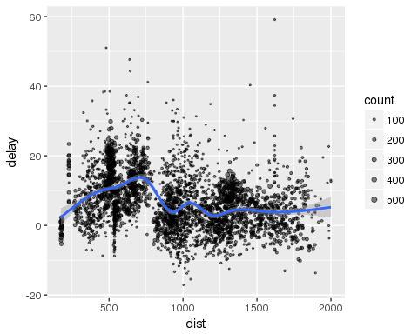

### spark + R 의 장점

* Spark에서 병렬처리가 가능하도록 구현한 머신러닝 LIB을 사용하고, 결과를 R의 시각화 패키지로 보여줌.

#### K-Means Clustering

kmeans_model <- iris_tbl %>%  
 select(Petal_Width, Petal_Length) %>%  
 ml_kmeans(centers = 3)  
  
# print our model fit  
print(kmeans_model)

## K-means clustering with 3 clusters  
##   
## Cluster centers:  
## Petal_Width Petal_Length  
## 1 0.246000 1.462000  
## 2 2.037500 5.595833  
## 3 1.342308 4.269231  
##   
## Within Set Sum of Squared Errors = 31.37136

predicted <- sdf_predict(kmeans_model, iris_tbl) %>% collect  
  
table(predicted$Species, predicted$prediction)

##   
## 0 1 2  
## setosa 50 0 0  
## versicolor 0 2 48  
## virginica 0 46 4

# plot cluster membership  
sdf_predict(kmeans_model) %>%  
 collect() %>%  
 ggplot(aes(Petal_Length, Petal_Width)) +  
 geom_point(aes(Petal_Width, Petal_Length, col = factor(prediction + 1)),  
 size = 2, alpha = 0.5) +   
 geom_point(data = kmeans_model$centers, aes(Petal_Width, Petal_Length),  
 col = scales::muted(c("red", "green", "blue")),  
 pch = 'x', size = 12) +  
 scale_color_discrete(name = "Predicted Cluster",  
 labels = paste("Cluster", 1:3)) +  
 labs(  
 x = "Petal Length",  
 y = "Petal Width",  
 title = "K-Means Clustering",  
 subtitle = "Use Spark.ML to predict cluster membership with the iris dataset."  
 )

