Plugin *MultiAssign*

Documentation

¨

|  |  |
| --- | --- |
| Date of Release: | Date |
| Document-Version: | 1.0 |
| Plugin-Version | 1.2.00 and above |
| Author: | Fabian Schmid, studer + raimann ag |

|  |  |  |
| --- | --- | --- |
| Version | Author | Changes |
| 1.0 | Fabian Schmid | First Release |

Table of contents

1 Introduction 3

2 Installation 3

3 Usage of the Plugin 3

# Introduction

The ILIAS-Plugin MultiAssign allows an ILIAS-User to assign another ILIAS-User to multiple Courses. This functionality can be reserved to one or more global roles. A User only can assign others to courses where he has he the right for member-modifications.

# Installation

## Install Router

The Subscription-Plugin needs a Router-Service to work. Please install the Service first:

You start in your ILIAS root directory

cd Services

git clone https://github.com/studer-raimann/RouterService.git Router

Switch to the setup-Menu of your Installation and perform a Structure-reload in the Tab Tools. this can take a few moments. After the reload has been performed, you can install the plugin.

## Install Plugin

Start at your ILIAS root directory

mkdir -p Customizing/global/plugins/Services/UIComponent/UserInterfaceHook/

cd Customizing/global/plugins/Services/UIComponent/UserInterfaceHook/

git clone https://github.com/studer-raimann/MultiAssign.git

As ILIAS administrator go to "Administration->Plugins" and install/activate the plugin.

# Usage of the Plugin

## Configure Plugin

As ILIAS administrator go to "Administration->Plugins" and click ‘Configure’ in the MultiAssign-Action-menu.

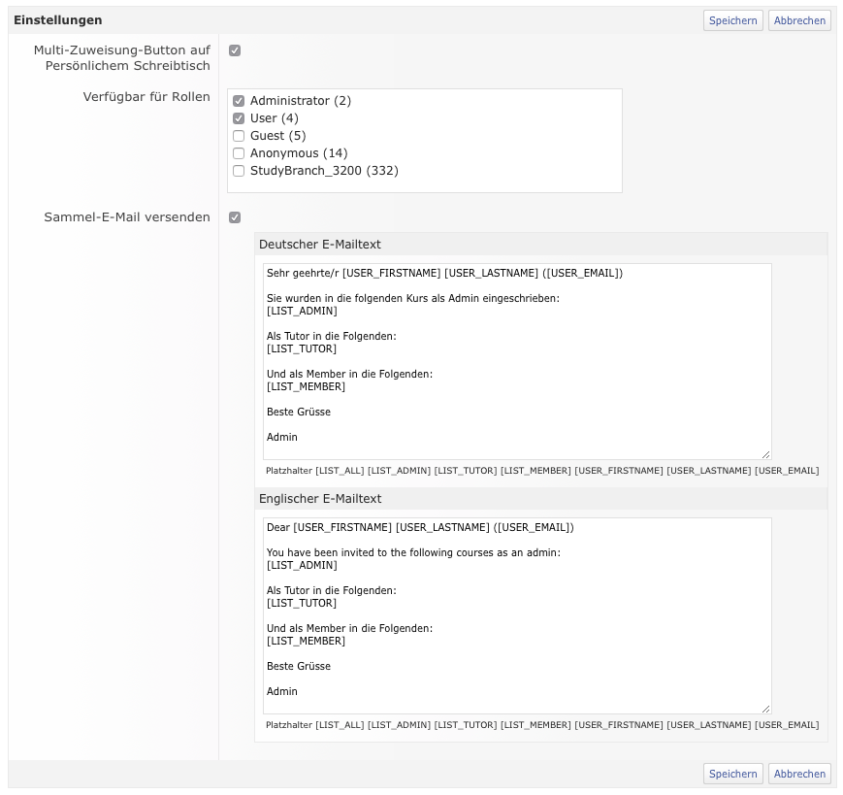

## Usage

### Personal Desktop

If your User Account is in at least on oft he configures Roles and the option “Multi-Assign-Button on Personal Desktop” is activated you see the new Button “Assign User” on your Personal Desktop. Click the Button to switch to the MultiAssign-Overview. 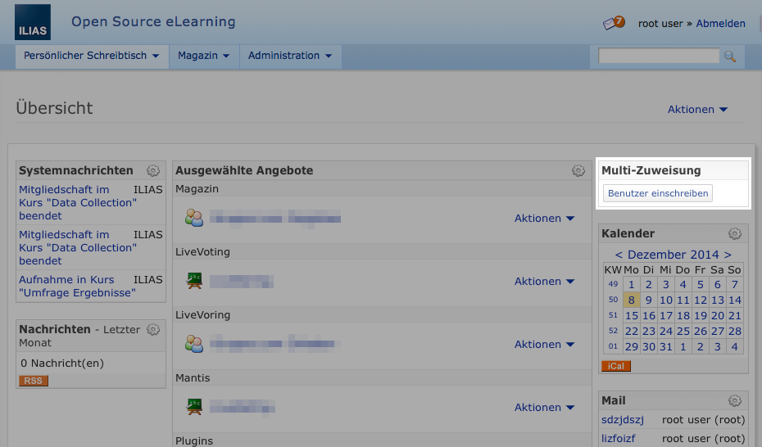

### Search for user

In the first screen you can search the user databse and select the desired User-Account.