Plugin *Subscription*

Documentation

¨

|  |  |
| --- | --- |
| Date of Release: | Date |
| Document-Version: | 2.0 |
| Plugin-Version | 2.3.2 and above |
| Author: | Fabian Schmid, studer + raimann ag |

|  |  |  |
| --- | --- | --- |
| Version | Author | Changes |
| 1.0 | Martin Studer | First Release |
| 2.0 | Fabian Schmid | Updatet Documentation for new Community Release Verison 2.3.0 |

Table of contents

1 Introduction 4

2 Feature Overview 4

3 Installation 4

3.1 Install Router 4

3.2 Install Plugin 4

4 Usage of the Plugin 5

4.1 Configure Plugin 5

4.2 Usage 6

4.2.1 ILIAS Course - Subscription with e-mail list 6

4.2.2 Paste the e-mail addresses of the users you like to assign 6

4.2.3 Assign users to the course 7

4.2.4 E-mail invitation 8

# Introduction

The Mass Subscription adds a new subtab to the members view of a course. There you can enter a list of e-mail addresses or matriculation-numbers that are separated in any way (spaces, commata, new lines, etc) allowing you to quickly invite many users from e.g. an excel table to a ILIAS course.

# Feature Overview

|  |  |
| --- | --- |
| PL-Version | Changes |
| 1.0.0 | - Insert a list of E-Mailadresses and find existing accounts or send invitations to non-existing |
| 2.0.0 | - Use Matriculation Numbers for User-Mapping  - New User-Interface  - New Subscription Links when using E-Mails |
| 2.3.0 | - Deactivate the Plugin in Subtrees  - Use Subscription in Groups |

# Installation

ILIAS 4.4 does not include ActiveRecord. Therefore please install the latest Version of ActiveRecord before you install the plugin:

Start at your ILIAS root directory

mkdir -p Customizing/global/plugins/Libraries/

cd Customizing/global/plugins/Libraries

git clone https://github.com/studer-raimann/ActiveRecord.git

## Install Router

The Subscription-Plugin needs a Router-Service to work. Please install the Service first:

You start in your ILIAS root directory

cd Services

git clone https://github.com/studer-raimann/RouterService.git Router

Switch to the setup-Menu of your Installation and perform a Structure-reload in the Tab Tools. this can take a few moments. After the reload has been performed, you can install the plugin.

## Install Plugin

Start at your ILIAS root directory

mkdir -p Customizing/global/plugins/Services/UIComponent/UserInterfaceHook/

cd Customizing/global/plugins/Services/UIComponent/UserInterfaceHook/

git clone https://github.com/studer-raimann/Subscription.git

As ILIAS administrator go to "Administration->Plugins" and install/activate the plugin.

# Usage of the Plugin

## Configure Plugin

As ILIAS administrator go to "Administration->Plugins" and click ‘Configure’ in the Subscription-Action-menu.

|  |  |
| --- | --- |
| Macintosh HD:Users:fschmid:Desktop:Bildschirmfoto 2014-12-09 um 17.11.37.png | Configure you Plugin for your needs. The Subscription-Plugin can be activated for courses and groups. You can use E-Mailadresses and/or Matriculation-Numbers for User-Searches.  The E-Mailfunctionality allows the invited user to create a ILIAS-Accounts (if activated).  First- and Lastnames of existings Users can be hidden.  Deactivate the Subscription-Plugin in some Subtrees of the Repository. |

## Usage

### ILIAS Course - Subscription with e-mail list

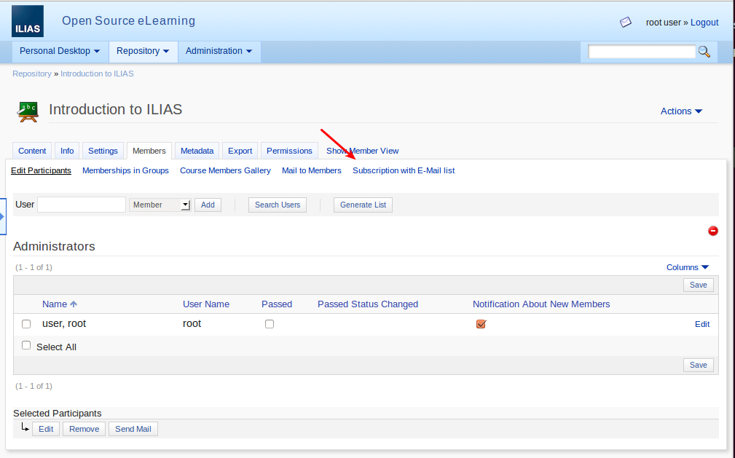

### Paste the e-mail addresses of the users you like to assign

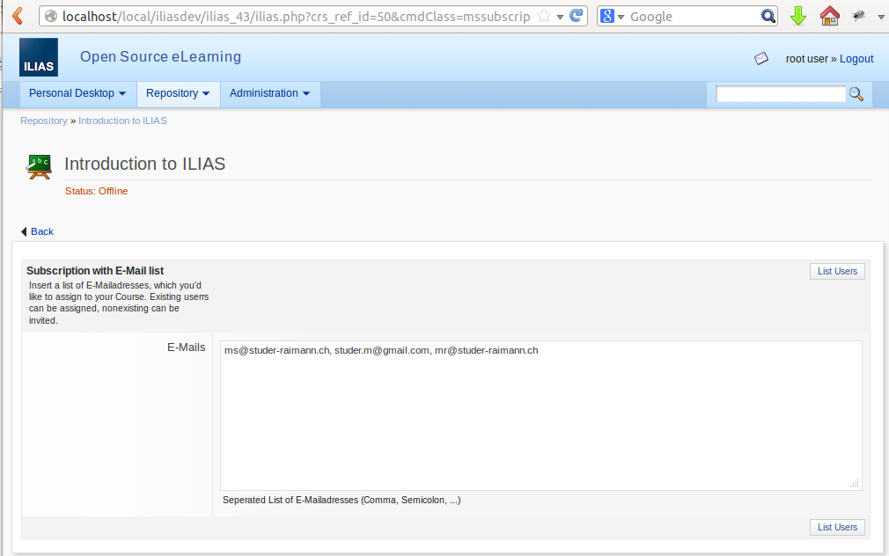

### Assign users to the course

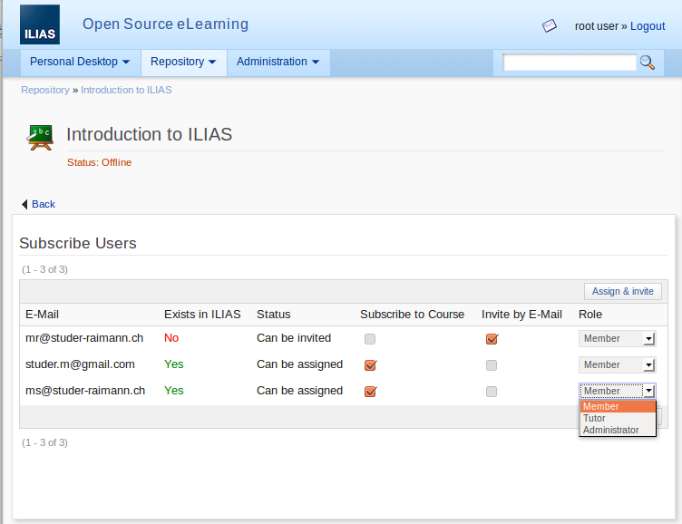

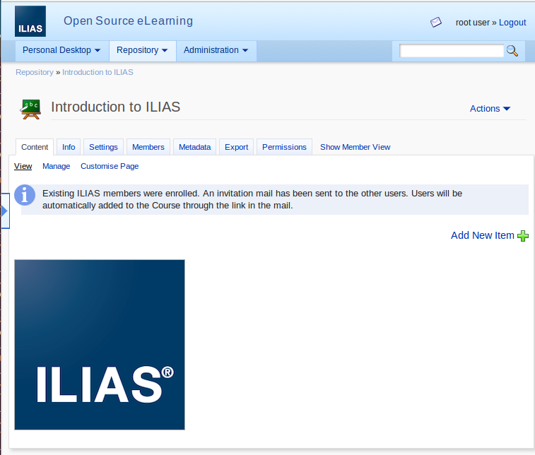

### E-mail invitation

Users with no ILIAS-Account get an individual invitation link to the ILIAS Course. After they have registered to ILIAS, they have access to the ILIAS course.

