Plugin *SystemNotification*

Documentation

¨

|  |  |
| --- | --- |
| Date of Release: | Date |
| Document-Version: | 1.1 |
| Plugin-Version | 1.1.0 and above |
| Author: | Fabian Schmid, studer + raimann ag |

|  |  |  |
| --- | --- | --- |
| Version | Author | Changes |
| 1.0 | Fabian Schmid | Community Release |
| 1.1 | Fabian Schmid | Support for ILIAS 5 |

Table of contents

1 Introduction 4

2 Installation 4

3 Usage of the Plugin 5

3.1 Add new Notification 5

3.2 Edit or delete Notifications 6

4 Screenshots 6

# Introduction

The System-Notification-Plugin allows ILIAS-Administrators to publish system wide notifications about maintenance or other information. The plugin is easy to configure and brings some possibilities to customize the notifications (such as own CSS-classes for each type of Notification).

If necessary, the plugin can prevent users from logging into ILIAS.

# Installation

## Install ActiveRecord (Only needed in ILIAS 4.4)

ILIAS 4.4 does not include ActiveRecord. Therefore please install the latest Version of active record before you install the plugin:

Start at your ILIAS root directory

mkdir -p Customizing/global/plugins/Libraries/

cd Customizing/global/plugins/Libraries

git clone https://github.com/studer-raimann/ActiveRecord.git

## Install the plugin

Start at your ILIAS root directory

mkdir -p Customizing/global/plugins/Services/UIComponent/UserInterfaceHook/

cd Customizing/global/plugins/Services/UIComponent/UserInterfaceHook/

git clone https://github.com/studer-raimann/SystemNotifications.git

As ILIAS administrator go to "Administration->Plugins" and install/activate the plugin.

# Usage of the Plugin

In the ILIAS Plugin Administration click the Actions-menu of the SystemNotifiation-Plugin and select „Edit configuration“.

## Add new Notification

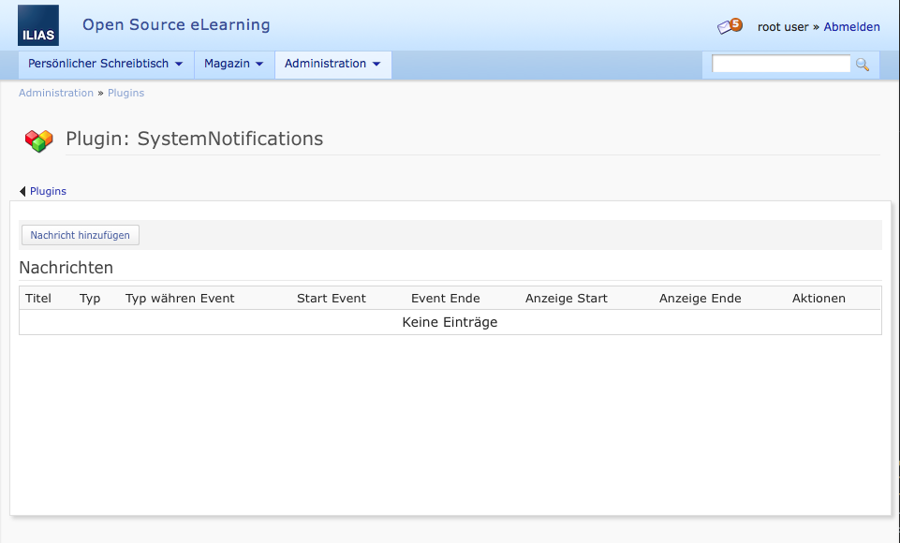

Click „Add new Notification“ and fill in all information about the Notification-Event:

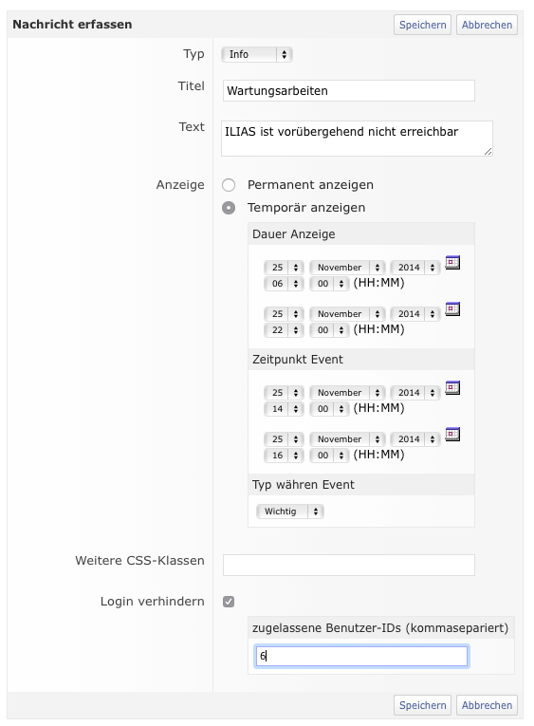- Type: Info (blue), Warning (orange) or Fatal (red)

- Titel and Description

- Display: Permanent or in a specific period of time.[1]

- Additional CSS-Classes

- Prevent User-Login (and allow login for some   
 User-IDs

## Edit or delete Notifications

Use the Actions-Menu of a Notification-entry to edit or delete it.

# Screenshots

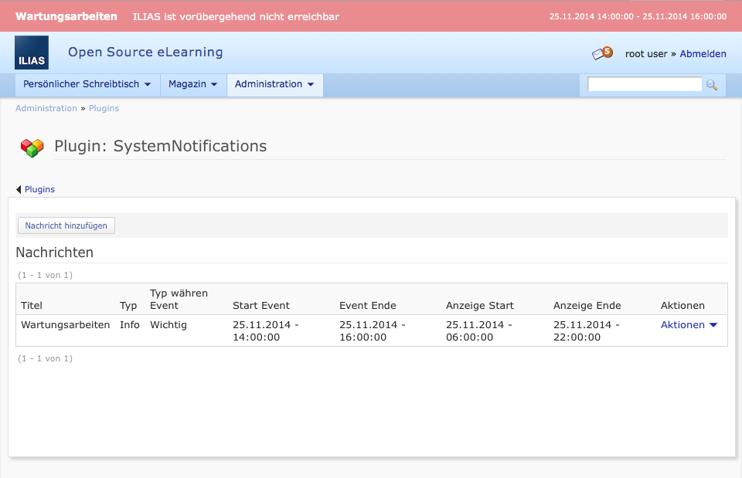

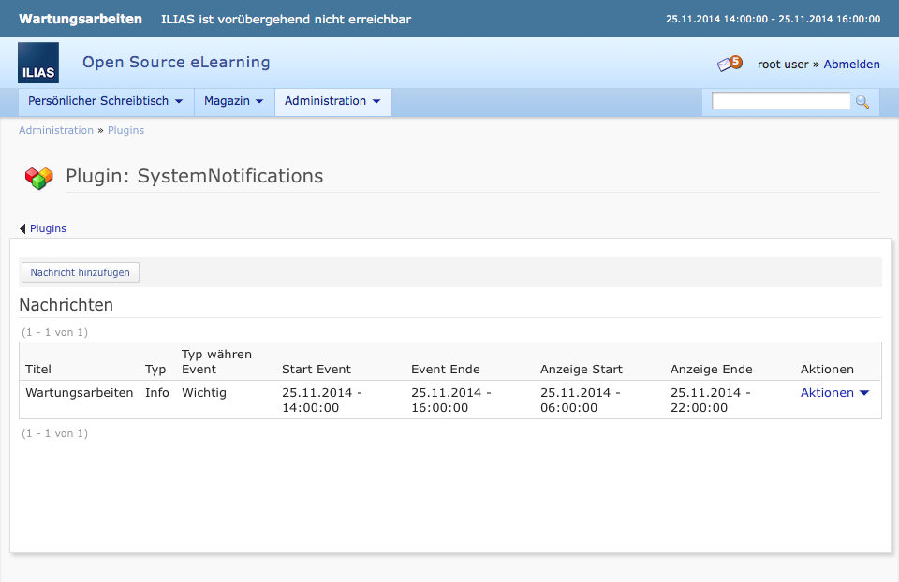

1. The Notification can be displayed before the event starts. The Notification-Type applies tot he periods before and after the event. Use the „Type during event“ setting to switch the Notification-Type during the event’s period.