Customer Segmentation and Segment Specific Product Association Mining
  - Online Retail Customer Analytics
IT3091 Machine Learning
Guided Data Track
Group 2026 DS 10
Sri Lanka Institute of Information Technology
Group members
IT24102621 Lakshitha Dilshan J.K.P.
IT24103380 Nirmani K.H.D.T.
IT24103655 Palliyaguruge C.T.
IT24103526 Senaratne P.A.R.T.
Final Group Report
September 2026

Executive Summary
This project identifies commercially meaningful customer groups and product relationships for a UK-based online retailer. The decision need is practical: determine which customers should receive loyalty, retention or reactivation treatment, and which products should be promoted together within each group. The analysis uses the UCI Online Retail transaction dataset and connects customer-level clustering to invoice-level association mining.
After documented quality controls, 391,150 customer-linked merchandise rows representing 4,334 customers and 18,402 invoices were used for segmentation and segment-specific basket analysis. A five-cluster K-Means model using log-transformed Recency, Frequency and Monetary features with StandardScaler was selected. It achieved a silhouette score of 0.319, Davies-Bouldin index of 0.983 and strong stability (mean seed ARI 0.985; mean resampling ARI 0.931). The solution balanced statistical quality with usable cluster sizes and business interpretation.
The five segments are Hibernating Low Value, Recent Low Engagement, At Risk Regular, Loyal High Value and Champions. Champions represent only 8.26% of customers but 53.83% of revenue, while Hibernating Low Value customers represent 26.21% of customers and 3.50% of revenue. Segment-specific FP-Growth produced 2,361 practical rules after multi-metric filtering. Forty diverse recommendations were retained, eight per segment, for targeted bundles, cross-selling and lifecycle campaigns.
The principal recommendation is to deploy segment-specific rather than uniform marketing: protect Champions through VIP retention and premium bundles; grow Loyal High Value customers through relevant cross-sells; reactivate At Risk Regular customers using familiar product families; use low-cost onboarding prompts for Recent Low Engagement customers; and apply selective win-back offers to Hibernating Low Value customers. These are decision-support insights, not causal guarantees, and should be A/B tested before broad deployment.

Contents
1 Business Problem and Analytical Design
2 Workflow and Decision Governance
3 Data Understanding and Quality
4 Preprocessing and Feature Engineering
5 Modelling Strategy and Comparison
6 Evaluation Validation and Critical Judgement
7 Segment Profiles and Business Value
8 Segment Specific Association Mining
9 Recommendations Limitations and Responsible Use
10 Reproducibility and AI Use Transparency
11 Conclusion
References
Appendices

1 Business Problem and Analytical Design

1.1 Stakeholder and decision need
The stakeholder is a marketing and merchandising team at a UK-based non-store online retailer. Historical transactions contain evidence about purchase recency, purchasing occasions, customer value and products bought together, but they do not directly state which customers require retention or which bundles should be promoted. The project therefore converts transaction history into an interpretable decision structure.

1.2 Lenses tasks and outputs
Element | Definition
Primary lens | Customer segmentation for lifecycle marketing and value management
Secondary lens | Product association and bundling within each final segment
Segmentation unit | One identified customer
Association unit | One valid purchase invoice represented by product presence
Primary output | Validated five-segment customer assignment and segment profiles
Secondary output | Ranked segment-specific product recommendations
Decision question | Which segments merit loyalty, retention or reactivation action, and which products should be cross-sold within each segment?

1.3 Objectives and success criteria
- Preserve raw evidence while creating task-specific valid purchase datasets.
- Create reproducible customer features with explicit units and leakage controls.
- Compare an interpretable RFM baseline and at least three clustering alternatives.
- Select a model using internal metrics, stability, cluster balance and business meaning rather than a single score.
- Mine robust, interpretable product rules separately for each segment.
- Translate results into actionable recommendations with risks and validation needs.

2 Workflow and Decision Governance
Figure 1 End to end analytical workflow
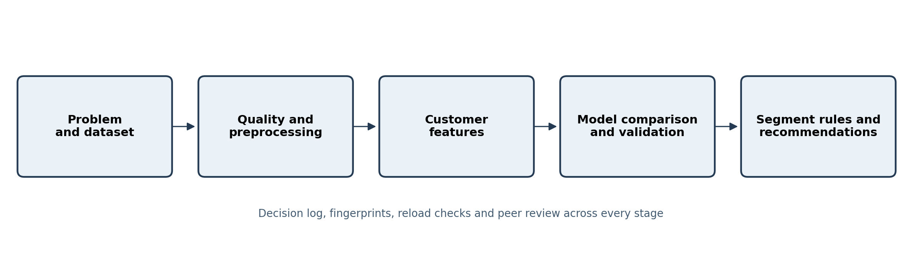
The workflow deliberately separates customer modelling from basket modelling. Customer records are aggregated only after purchase validation; association mining returns to invoice-product presence and then attaches the validated segment assignment. This prevents a row-level transaction from being mistaken for either a customer or a basket.

2.1 Team responsibilities
Member | ID | Core responsibility
Lakshitha Dilshan J.K.P. | IT24102621 | Data understanding, preprocessing and quality assurance
Nirmani K.H.D.T. | IT24103380 | Feature engineering, transformation and handover
Palliyaguruge C.T. | IT24103655 | Clustering, model comparison, stability and profiling
Senaratne P.A.R.T. | IT24103526 | Association mining, rule evaluation and recommendations

2.2 Decision governance
Thirty-eight decisions were recorded with the alternatives considered, selection rationale, evidence, impact, responsible member and reviewer. Examples include preserving a task-specific basket dataset, retaining genuine extreme customers while using transformations, rejecting high-silhouette but operationally unusable models, selecting five clusters for actionable detail, and validating association rules across four support thresholds. This log makes judgement visible rather than presenting the final method as inevitable.

3 Data Understanding and Quality

3.1 Dataset identity
Attribute | Value
Dataset | Online Retail
Provider | UCI Machine Learning Repository
Period | 1 December 2010 to 9 December 2011
Raw rows | 541,909 transaction lines
Fields | InvoiceNo, StockCode, Description, Quantity, InvoiceDate, UnitPrice, CustomerID, Country
Geography | Transactions from multiple countries; UK dominates
Raw-file handling | Original file preserved; identity verified with SHA-256 fingerprint

3.2 Row meaning and variable roles
Variable | Role | Data quality relevance
InvoiceNo | Invoice identifier | C prefix signals cancellation; repeated values are valid line items
StockCode | Product identifier | Preferred to variable descriptions; reviewed administrative codes separately
Description | Product label | Missing and inconsistent text limits interpretation
Quantity | Count | Negative values indicate returns or adjustments
InvoiceDate | Timestamp | Final month is partial; supports recency and time analysis
UnitPrice | Numeric value | Non-positive prices cannot represent positive purchase revenue
CustomerID | Customer identifier | Missing IDs cannot be reliably assigned or imputed
Country | Category | Strong UK imbalance limits geographic generalisation

3.3 Material data issues and implications
Issue | Evidence | Analytical response
Missing customer identity | 135,080 rows (24.93%) | Exclude from customer segmentation and segment-linked rules; do not fabricate IDs
Exact duplicates | 5,268 additional rows (0.97%) | Retain one exact copy; do not remove repeated invoice numbers generally
Cancellations and returns | 9,288 cancellation rows; 10,624 negative-quantity rows | Preserve separately; exclude from positive purchase models
Non-positive prices | 2,517 rows | Exclude from positive revenue calculations
Product naming variation | 217 StockCodes have multiple cleaned descriptions | Use StockCode as stable product key and canonical descriptions for reporting
Extreme valid purchases | Top 1% of customers generate 32.20% of revenue | Retain, transform, scale and test stability rather than delete automatically
Partial final month | Data ends 9 December 2011 | Retain for recency but avoid treating it as a complete month
Geographic imbalance | UK: 91.45% of valid rows; 84.59% of valid revenue | Do not make broad geographic claims; consider UK-only sensitivity later

These controls reflect the task: missing CustomerID is acceptable for overall merchandise basket analysis but not for customer segmentation. Similarly, administrative codes may affect billed value yet are unsuitable as merchandise products. Separate datasets preserve useful evidence without forcing one universal cleaning rule onto incompatible analytical units.

4 Preprocessing and Feature Engineering

4.1 Purchase validation audit
Step | Rule | Removed | Rows after
C01 | Remove additional exact duplicate rows | 5,268 | 536,641
C02 | Exclude C-prefixed cancellation invoices | 9,251 | 527,390
C03 | Retain rows with Quantity greater than zero | 1,336 | 526,054
C04 | Retain rows with UnitPrice greater than zero | 1,176 | 524,878
C05 | Retain valid purchases with an identified CustomerID | 132,186 | 392,692
C06 | Exclude reviewed administrative StockCodes from the primary customer merchandise dataset | 1,542 | 391,150

The final primary customer merchandise dataset contains 391,150 positive, customer-linked merchandise lines. A broader merchandise basket dataset retains transactions without CustomerID where invoice-product association remains meaningful. Returns, adjustments and reviewed administrative records are retained separately for audit and sensitivity analysis.

4.2 Feature design
Feature | Definition | Use
Recency | Days between 10 December 2011 and latest valid purchase | Core clustering feature
Frequency | Distinct valid purchase invoices per customer | Core clustering feature
Monetary | Sum of positive merchandise line value | Core clustering feature
ProductDiversity | Distinct purchased StockCodes | Enhanced candidate and profiling
AverageBasketSize | Mean merchandise units per purchase invoice | Enhanced candidate and profiling
TotalQuantity | Total merchandise units | Profiling; excluded from core due redundancy
AverageOrderValue | Mean value per invoice | Profiling
TenureDays | First-to-latest purchase span | Profiling; strongly related to frequency
AverageDaysBetweenPurchases | Mean gap for repeat customers | Profiling; missing by definition for 1,505 one-purchase customers

4.3 Transformation scaling leakage and outliers
RFM and behavioural measures were strongly right-skewed: Monetary skewness was 19.58 and ProductDiversity skewness was 6.92. Log1p transformations reduced those values to approximately 0.40 and -0.24 respectively, reducing domination by genuine wholesale customers without deleting them. Raw and transformed feature sets were retained so the effect could be compared rather than assumed.
Scaling was performed inside each clustering configuration. StandardScaler and RobustScaler were compared rather than storing one permanently scaled dataset. Customer aggregation used only records on or before the dataset end, and no downstream cluster label or recommendation was used to construct input features. Because this is unsupervised historical segmentation rather than predictive forecasting, conventional label leakage does not apply; nevertheless, task boundaries and the fixed analysis date prevent future information or output labels from entering the inputs.

5 Modelling Strategy and Comparison

5.1 Baseline and alternatives
Method | Role | Key assumption or trade-off
Quartile RFM scoring | Interpretable baseline | Transparent but imposes discretised thresholds and limited interaction structure
K-Means | Centroid-based candidate | Efficient and interpretable; sensitive to scale, skew and k
Agglomerative clustering | Hierarchical alternative | Can reveal nested structure; linkage choice matters
Gaussian mixture model | Probabilistic alternative | Allows soft membership; assumes mixture distributions
DBSCAN | Density-based alternative | Finds noise and irregular groups; sensitive to epsilon and density variation

The experiment grid covered core and enhanced feature sets, raw and log-transformed representations, two scalers, K-Means k values, alternative algorithms and DBSCAN parameter combinations. In total, 192 unique clustering experiments were evaluated. This exceeds a nominal three-alternative comparison and exposes sensitivity to both algorithm choice and preprocessing.
Figure 2 K-Means configuration comparison
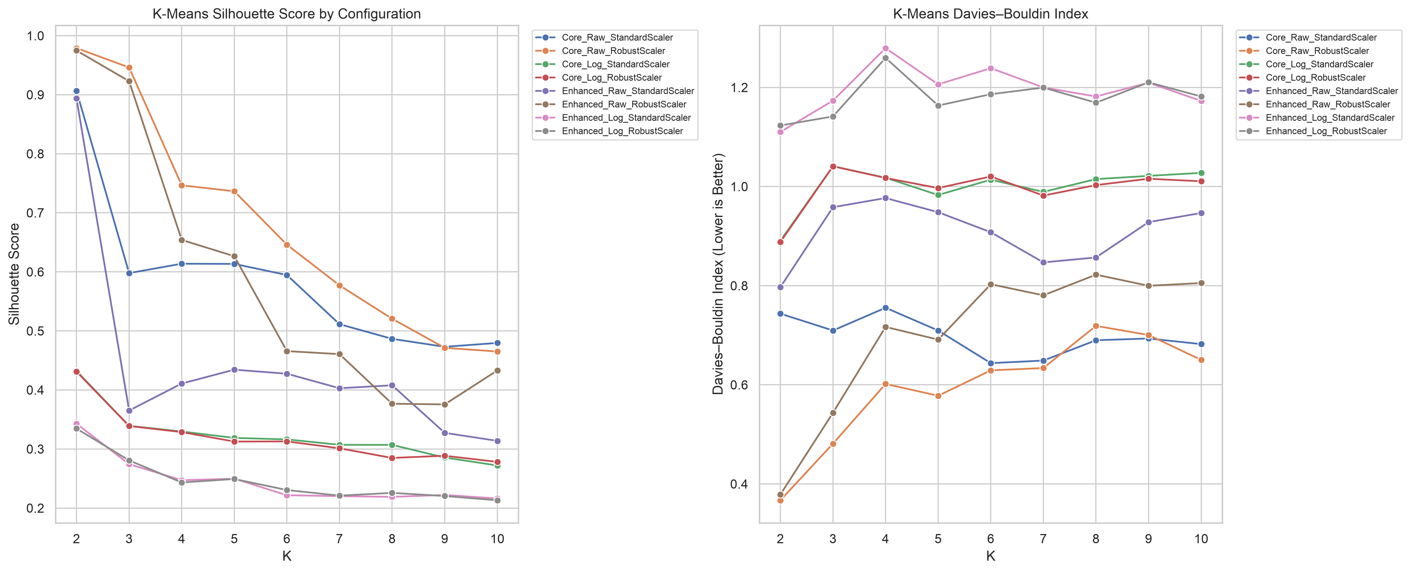

5.2 Critical model selection
The highest silhouette score was not automatically selected. Raw-feature solutions obtained apparently excellent separation by isolating tiny groups of extreme customers; one placed 99.82% of customers in a single cluster. Such a solution is statistically attractive but commercially unusable. The team therefore combined silhouette, Davies-Bouldin, Calinski-Harabasz, cluster-size balance, noise percentage, stability and interpretability.
Candidate | k | Silhouette | DB index | Smallest | Largest | Seed ARI | Resample ARI
KMeans_Core_Log_Standard_k3 | 3 | 0.339 | 1.041 | 17.4% | 43.1% | 0.996 | 0.974
KMeans_Core_Log_Standard_k4 | 4 | 0.330 | 1.018 | 16.1% | 36.9% | 0.981 | 0.943
KMeans_Core_Log_Standard_k5 | 5 | 0.319 | 0.983 | 8.3% | 26.2% | 0.985 | 0.931

The k=3 candidate had the highest silhouette and strongest stability, but k=5 retained competitive validation metrics while providing finer, actionable lifecycle distinctions and cluster sizes between 8.26% and 26.21%. The selected configuration was therefore K-Means with five clusters on log-transformed core RFM features using StandardScaler, random_state 42 and n_init 20.
Figure 3 Candidate profile comparison supporting the five-cluster choice
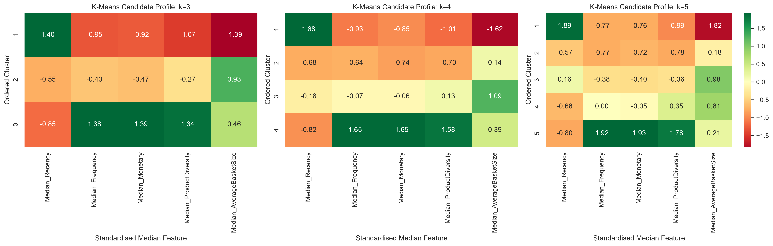

5.3 Selected model metrics
Metric | Result | Interpretation
Silhouette | 0.319 | Moderate separation in behavioural data
Davies-Bouldin | 0.983 | Approximately one; assessed with other criteria
Calinski-Harabasz | 3,231.0 | Useful relative compactness and separation indicator
Mean seed ARI | 0.985 | Assignments highly consistent across random seeds
Mean resampling ARI | 0.931 | Strong consistency over repeated 80% samples
Minimum resampling ARI | 0.818 | Worst tested sample remained substantially aligned
RFM baseline ARI | 0.361 | Only moderate agreement with quartile labels
RFM baseline NMI | 0.488 | Related but not equivalent information structure

6 Evaluation Validation and Critical Judgement

6.1 Stability and sensitivity
Ten random seeds tested initialization sensitivity and thirty repeated 80% customer samples tested whether moderate sample changes altered the segmentation. Adjusted Rand Index was used because it measures agreement between assignments while correcting for chance. The selected model achieved a mean seed ARI of 0.985 and mean resampling ARI of 0.931, with a minimum resampling ARI of 0.818.
Figure 4 Candidate stability across random seeds
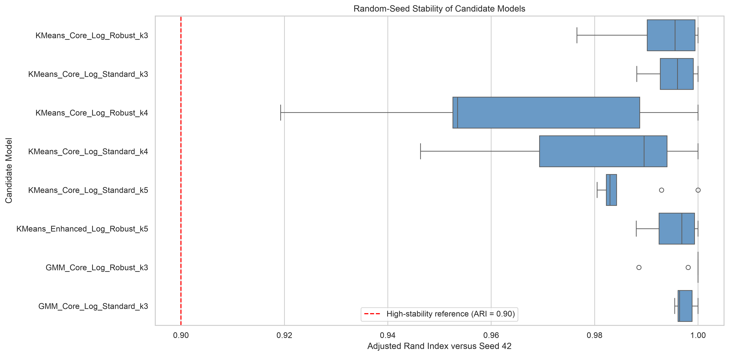
Figure 5 Candidate stability under customer resampling
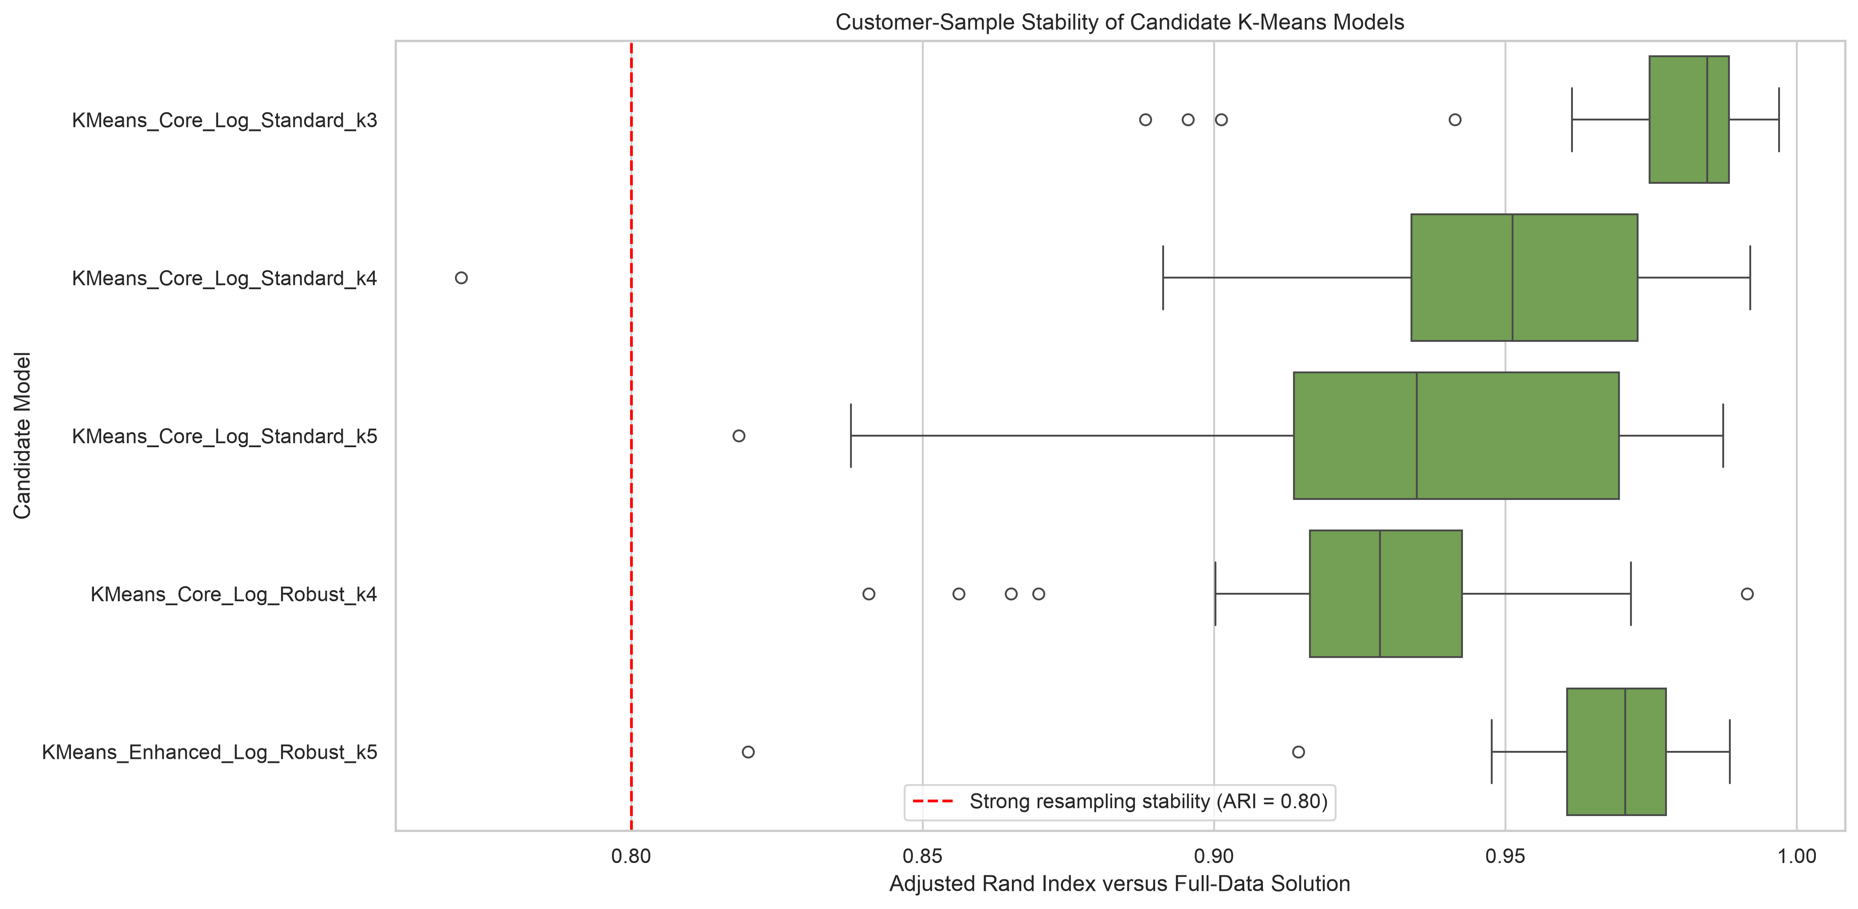

6.2 Honest interpretation
A silhouette score of 0.319 does not indicate perfectly separated natural classes. Retail behaviour is continuous, and customers near cluster boundaries may reasonably resemble more than one segment. The value of the five-cluster solution lies in its reproducibility, operational balance and interpretable profiles, not a claim that five objectively true customer types exist. Cluster labels are descriptive names assigned after original-scale profiling; they are not observed ground-truth outcomes.
No train-test accuracy is reported because clustering and association mining are unsupervised descriptive tasks. Validation instead uses stability, preprocessing sensitivity, alternative algorithms, cluster balance, association-rule support experiments and transparent thresholding. Future business evaluation should add out-of-time validation and controlled campaign experiments.
Figure 6 DBSCAN parameter search and density-based comparison
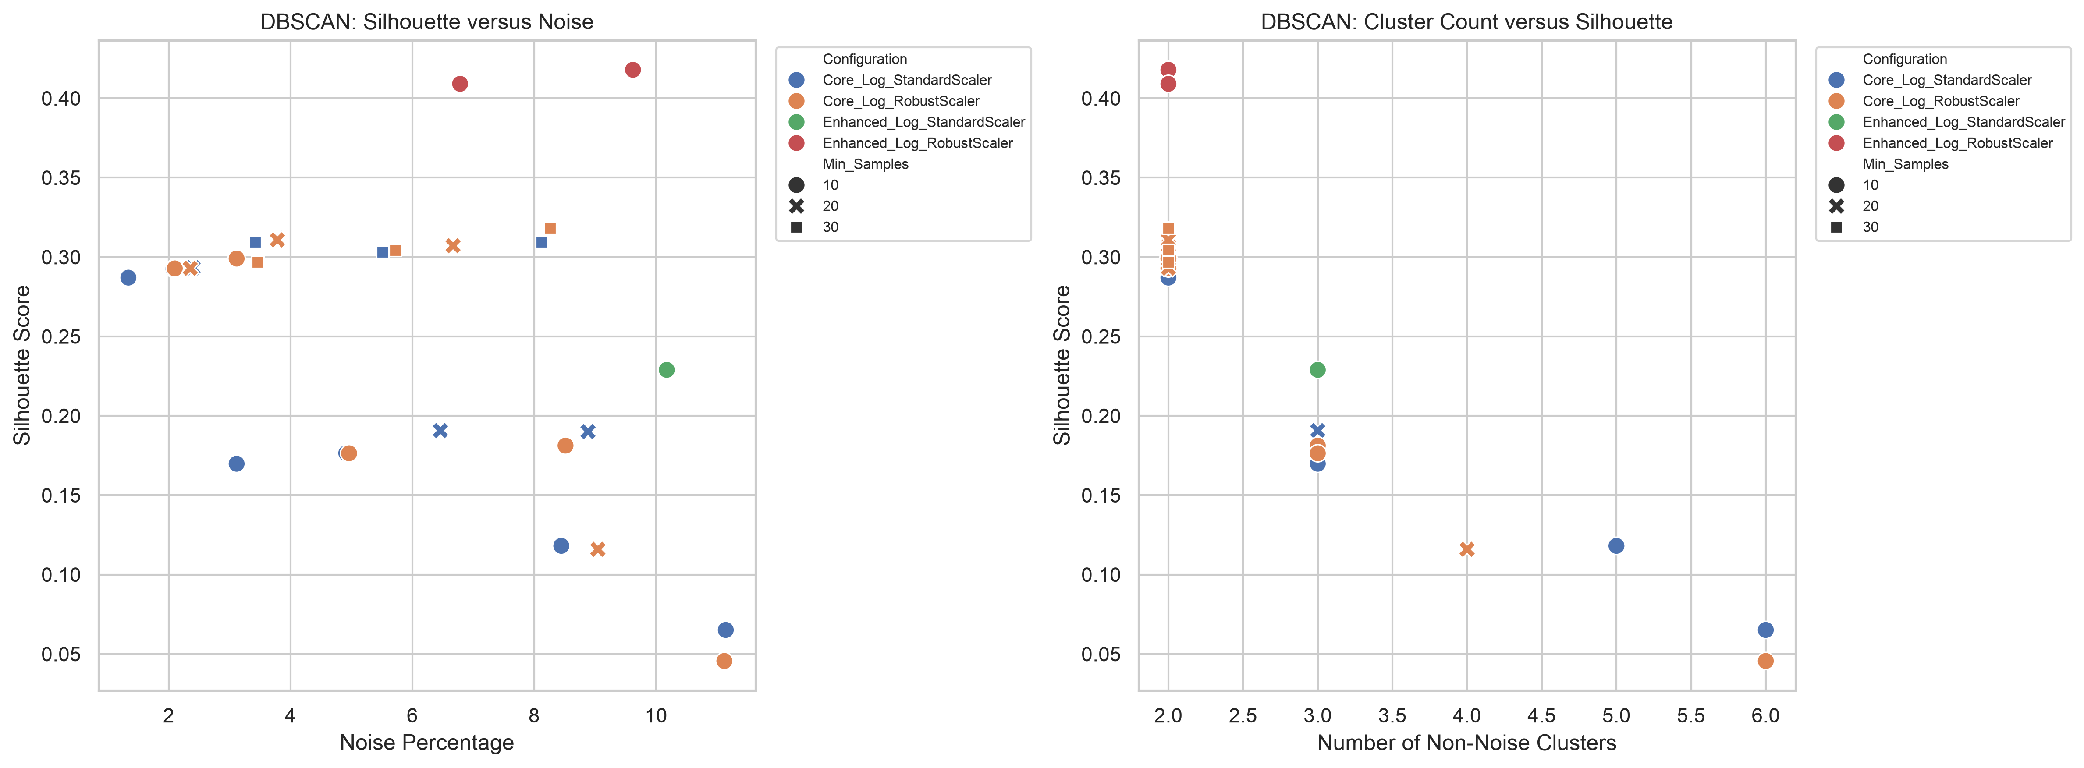

7 Segment Profiles and Business Value
Segment | Customers | Customer share | Revenue share | Median R | Median F | Median M
Hibernating Low Value | 1,136 | 26.21% | 3.50% | 219 | 1 | GBP 239
Recent Low Engagement | 869 | 20.05% | 3.67% | 26 | 1 | GBP 336
At Risk Regular | 1,006 | 23.21% | 16.28% | 83 | 3 | GBP 981
Loyal High Value | 965 | 22.27% | 22.71% | 17 | 5 | GBP 1,717
Champions | 358 | 8.26% | 53.83% | 8 | 15 | GBP 5,795

Figure 7 Customer share compared with revenue share
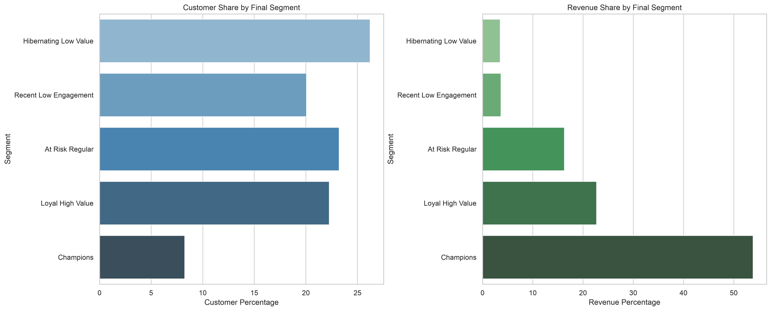

7.1 Segment interpretations
Hibernating Low Value. Large inactive group with low frequency and value. Broad expensive incentives are unlikely to be efficient; use selective win-back tests and low-cost reminders.
Recent Low Engagement. Recently active but mostly single-purchase customers. Use onboarding, second-purchase prompts and simple complementary offers while interest is current.
At Risk Regular. Previously regular and meaningful-value customers with deteriorating recency. Prioritise personalised reactivation using familiar categories and time-limited bundles.
Loyal High Value. Recent repeat purchasers with substantial value and tenure. Reinforce loyalty, cross-sell relevant ranges and prevent migration into the at-risk group.
Champions. Smallest group but dominant revenue contributor. Protect through VIP service, premium access and carefully targeted high-confidence bundles; avoid unnecessary discounting.
Figure 8 Two-dimensional PCA view of final customer segments
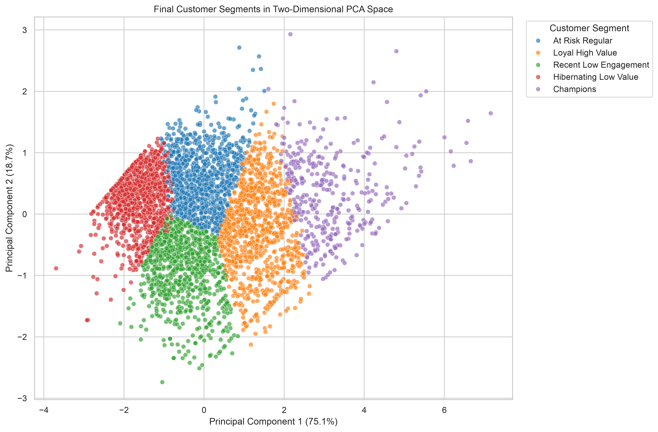

8 Segment Specific Association Mining

8.1 Basket construction and FP-Growth
Each valid segment-linked invoice was encoded as a sparse Boolean product-presence basket. Duplicate invoice-product pairs were collapsed, so multiple units of the same product did not inflate co-occurrence. The five baskets contained 1,364 to 7,183 invoices and densities below 0.72%, which supported sparse FP-Growth. A maximum itemset length of three maintained interpretability.
The initial minimum support was adaptive: max(1%, 20 / segment invoices). Rules initially required confidence of at least 0.30 and lift of at least 1.20. Practical filtering then required at least 25 supporting invoices, confidence at least 0.40, lift at least 1.50 and positive leverage. This combination counters the tendency of confidence to favour popular consequents and lift to exaggerate rare relationships.
Segment | Invoices | Practical rules | Median count | Median confidence | Median lift | Max lift
Hibernating Low Value | 1,365 | 19 | 30 | 0.694 | 12.77 | 25.79
Recent Low Engagement | 1,364 | 26 | 32 | 0.570 | 12.92 | 26.33
At Risk Regular | 3,073 | 550 | 37 | 0.586 | 18.83 | 72.67
Loyal High Value | 5,417 | 839 | 69 | 0.559 | 10.72 | 70.04
Champions | 7,183 | 927 | 91 | 0.551 | 9.41 | 53.81

Figure 9 Association-rule comparison across customer segments
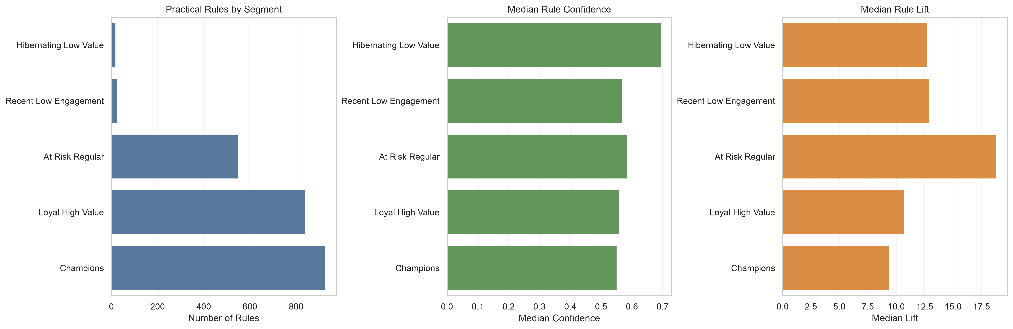

8.2 Support sensitivity and recommendation selection
Support thresholds of 0.008, 0.010, 0.0125 and 0.015 were compared for every segment, producing 20 experiments. Lower support substantially increased rule volume and maximum lift but also increased the risk of unstable rare patterns. At stricter thresholds, approximately 24% to 54% of the 1% baseline rules remained, depending on segment. The 1% baseline was retained as a balance between coverage and evidence, followed by the absolute 25-invoice practical filter.
Figure 10 Association-rule support sensitivity
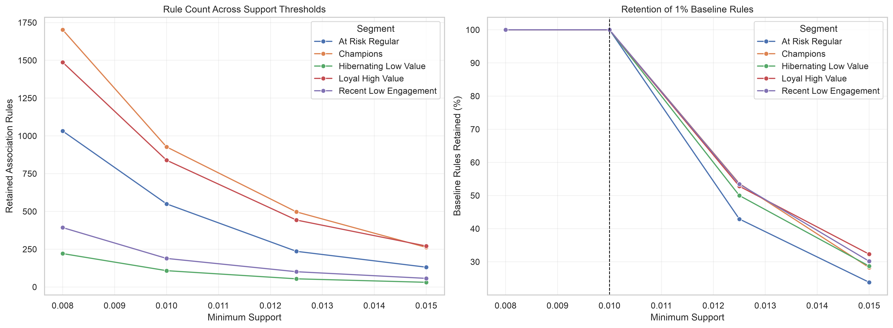
The initial process retained 3,129 rules; 2,361 passed practical filters. A percentile-based rule score balanced support, confidence, lift and leverage. To avoid a final list dominated by multiple rules recommending the same item, eight high-quality rules with distinct consequent products were selected for each segment, resulting in 40 recommendations.

8.3 Illustrative recommendations
Segment | If basket contains | Recommend | Confidence | Lift | Channel
At Risk Regular | HERB MARKER BASIL | HERB MARKER MINT | 0.977 | 66.74 | Personalised email or direct campaign
Champions | GREEN REGENCY TEACUP AND SAUCER | ROSES REGENCY TEACUP AND SAUCER | 0.826 | 16.95 | VIP communication and premium campaigns
Hibernating Low Value | GREEN REGENCY TEACUP AND SAUCER | ROSES REGENCY TEACUP AND SAUCER | 0.735 | 18.92 | Email or low-cost digital campaign
Loyal High Value | WOODEN STAR CHRISTMAS SCANDINAVIAN | WOODEN HEART CHRISTMAS SCANDINAVIAN | 0.794 | 24.99 | Loyalty programme and personalised offers
Recent Low Engagement | WOODEN TREE CHRISTMAS SCANDINAVIAN | WOODEN STAR CHRISTMAS SCANDINAVIAN | 0.843 | 12.92 | Post-purchase email or website recommendation

9 Recommendations Limitations and Responsible Use

9.1 Stakeholder action plan
Segment | Priority action | Measurement
Champions | VIP retention, premium access and high-confidence complementary bundles | Repeat rate, margin, retention and bundle attachment
Loyal High Value | Relevant cross-selling and loyalty recognition | Frequency, basket value and segment migration
At Risk Regular | Personalised reactivation using previously purchased product families | Reactivation and incremental revenue versus control
Recent Low Engagement | Second-order prompts and low-friction bundles | Second-purchase conversion within 30 to 60 days
Hibernating Low Value | Selective low-cost win-back campaigns; suppress after repeated non-response | Cost per reactivated customer and unsubscribe rate

Deployment should start as controlled pilots. For each segment, randomly assign eligible customers to treatment and control groups, hold the targeting window fixed, and measure incremental conversion, revenue, margin and opt-out rates. Product rules should be refreshed periodically and blocked where inventory, margin, seasonality or brand constraints make the bundle unsuitable.

9.2 Limitations and risks
- The dataset covers roughly one year for one retailer and ends with an incomplete month; results may not generalise across periods, retailers or economic conditions.
- Missing CustomerID excludes 24.93% of raw rows from customer-level modelling, so anonymous buyers are not represented in segments.
- The UK dominates the data. Segment meaning and product relationships may differ in smaller countries.
- Clusters are descriptive and boundary assignments are uncertain; segment labels should not be treated as immutable identities.
- Association rules show co-occurrence, not causality. High lift does not prove that recommending one item causes purchase of another.
- No product margin, stock, promotion exposure, returns cost or customer contact history is available, limiting profit and causal interpretation.
- Thresholds and business priorities require monitoring as product ranges and customer behaviour change.

9.3 Responsible use
The analysis uses transaction identifiers and behavioural aggregates, not sensitive personal characteristics. CustomerID should remain access-controlled and should not be exposed in campaign reports. Marketing frequency caps, opt-out rights and fairness checks across available non-sensitive operational groups should be enforced. The model should support human decisions rather than automatically deny benefits or impose adverse treatment.

10 Reproducibility and AI Use Transparency

10.1 Reproducible package
Control | Evidence
Dataset identity | UCI source, DOI, metadata and SHA-256 fingerprint
Execution order | Five numbered notebooks from data understanding to association mining
Environment | requirements.txt plus Python and environment records
Determinism | Fixed random seed 42 where applicable; K-Means n_init 20
Data handovers | Validated row counts, schemas, uniqueness assertions and reload checks
Output integrity | Fingerprints for processed datasets, clustering outputs and association outputs
Decision traceability | Thirty-eight logged decisions with evidence and reviewers
Report consistency | Metrics and figures in this report are drawn from versioned documentation outputs

Recommended execution order: 01 data understanding and EDA; 02 data cleaning and preprocessing; 03 customer feature engineering; 04 customer segmentation and clustering; 05 segment-specific association mining. Generated datasets are rebuilt locally from the verified raw file rather than committed as large opaque artifacts.

10.2 AI use declaration
Generative AI tools were used as a support aid for code debugging, explanation, document structuring and language refinement. Group members remained responsible for selecting the business question, validating data assumptions, executing notebooks, reviewing outputs, choosing analytical methods, interpreting results and approving recommendations. AI suggestions were checked against notebook assertions, recorded metrics, output fingerprints and the decision log. No AI-generated claim was accepted solely because it appeared plausible. This use is declared to distinguish assistance from accountable analytical judgement.

11 Conclusion
The project demonstrates a defensible, integrated data-mining workflow. It begins with a precise stakeholder decision, preserves data provenance, creates task-specific datasets, compares a transparent baseline with multiple clustering algorithms, validates stability and converts segment-specific product co-occurrence into practical recommendations. The selected five-cluster K-Means model is not claimed to be mathematically perfect; it is selected because it is stable, balanced enough to operate, interpretable and useful for downstream targeting.
The strongest commercial implication is concentration: Champions account for 53.83% of revenue while representing 8.26% of customers. At the same time, the large Hibernating Low Value group requires cost discipline, and At Risk Regular customers warrant targeted reactivation. The 40 final product rules provide concrete bundle candidates, but value should be confirmed through controlled experiments using incremental revenue, margin and customer-experience measures.

References
Calinski, T. and Harabasz, J. (1974) ‘A dendrite method for cluster analysis’, Communications in Statistics, 3(1), pp. 1–27.
Chen, D. (2015) Online Retail. UCI Machine Learning Repository. doi:10.24432/C5BW33.
Davies, D.L. and Bouldin, D.W. (1979) ‘A cluster separation measure’, IEEE Transactions on Pattern Analysis and Machine Intelligence, PAMI-1(2), pp. 224–227.
Ester, M., Kriegel, H.-P., Sander, J. and Xu, X. (1996) ‘A density-based algorithm for discovering clusters in large spatial databases with noise’, Proceedings of KDD, pp. 226–231.
Han, J., Pei, J. and Yin, Y. (2000) ‘Mining frequent patterns without candidate generation’, Proceedings of ACM SIGMOD, pp. 1–12.
Hubert, L. and Arabie, P. (1985) ‘Comparing partitions’, Journal of Classification, 2, pp. 193–218.
MacQueen, J. (1967) ‘Some methods for classification and analysis of multivariate observations’, Proceedings of the Fifth Berkeley Symposium, pp. 281–297.
Rousseeuw, P.J. (1987) ‘Silhouettes: a graphical aid to the interpretation and validation of cluster analysis’, Journal of Computational and Applied Mathematics, 20, pp. 53–65.

Appendix A Notebook and Evidence Map
Notebook | Primary evidence
01 data understanding and EDA | Dataset identity, dictionary, missingness, duplicates, returns, geography and temporal patterns
02 data cleaning and preprocessing | Audited filters, task-specific datasets, handover checks and fingerprints
03 customer feature engineering | RFM and behavioural features, transformations, quality summaries and manifests
04 customer segmentation and clustering | Baseline, 192 experiments, stability, profiles, assignments and figures
05 segment-specific association mining | Sparse baskets, FP-Growth, sensitivity, 2,361 practical rules and 40 recommendations

Appendix B Rubric Coverage Map
Rubric criterion | Report evidence
Business framing and task | Sections 1 and Executive Summary
Workflow and decision log | Section 2 and decision_log.csv
Data understanding and quality | Section 3 and data dictionary/EDA log
Preprocessing and feature engineering | Section 4 and preprocessing/feature summaries
Strategy and comparison | Section 5: baseline, four algorithms and 192 experiments
Evaluation and critical judgement | Section 6: multiple metrics, stability and honest interpretation
Recommendation limitations and value | Sections 7 to 9
Reproducibility and AI transparency | Section 10 and fingerprint outputs

