|  |  |  |
| --- | --- | --- |
| **ID** | **NAME** | **TOPIC** |
| **30399** | **TITHI NAYAK** | **Flowchart** |
| **31134** | **ANKIT PANT** | **Wake Word Activation**  **Navigation Command** |
| **30393** | **SAGAR CHOUDHARY** | **Climate Control**  **Media and radio** |
| **31251** | **RITIKA CHOPRA** | **Phone call via voice** |
| **30381** | **THANUJA M** | **Message dictation** |
| **30396** | **ASIMA NAYAK** | **Vehicles status inquiry** |

**🚗 Use Case Design: Voice Recognition in Automotive HMI**

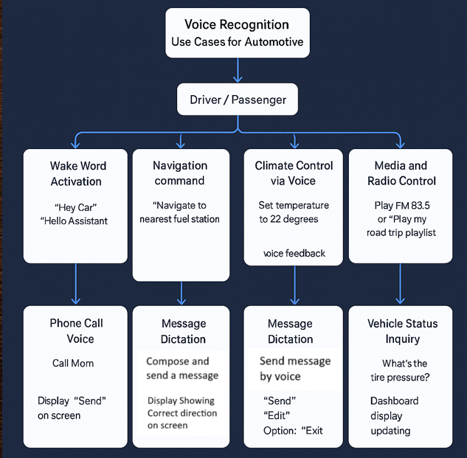

**✅ Use Case 1: Wake Word Activation**

| **Element** | **Description** |
| --- | --- |
| **Actor** | Driver / Passenger |
| **Goal** | Activate voice system |
| **Trigger** | “Hey Car” / “Hello Assistant” |
| **HMI** |  |

* LED ring glows on infotainment screen
* Short confirmation tone
* “I’m listening” prompt appears on screen

**✅ Use Case 2: Navigation Command**

| **Element** | **Description** |
| --- | --- |
| **Actor** | Driver |
| **Goal** | Set route via voice |
| **Trigger** | “Navigate to nearest fuel station” |
| **HMI** |  |

* Map interface opens
* Voice feedback: “Fuel station 2.4 km ahead. Starting navigation.”
* Screen shows route summary
* Option to cancel/change via voice: “Cancel navigation” |

**✅ Use Case 3: Climate Control via Voice**

| **Element** | **Description** |
| --- | --- |
| **Actor** | Driver |
| **Goal** | Adjust AC using voice |
| **Trigger** | “Set temperature to 22 degrees” |
| **HMI** |  |

* Voice: “Temperature set to 22 degrees.”
* AC panel on screen reflects change
* Optional tone for confirmation
* Allows adjustment: “Increase fan speed” |

**✅ Use Case 4: Media and Radio Control**

| **Element** | **Description** |
| --- | --- |
| **Actor** | Driver / Passenger |
| **Goal** | Control music, radio, podcasts |
| **Trigger** | “Play FM 93.5” or “Play my road trip playlist” |
| **HMI** |  |

* Audio switches
* Visual update on infotainment screen
* Voice feedback: “Playing FM 93.5”
* Hands-free command: “Next song” or “Volume down” |

**✅ Use Case 5: Phone Call via Voice**

| **Element** | **Description** |
| --- | --- |
| **Actor** | Driver |
| **Goal** | Make a hands-free call |
| **Trigger** | “Call Mom” |
| **HMI** |  |

* Voice: “Calling Mom…”
* Display: Contact card on screen
* Option: “Cancel call”
* End call via “Hang up” |

**✅ Use Case 6: Message Dictation**

| **Element** | **Description** |
| --- | --- |
| **Actor** | Driver |
| **Goal** | Send text message |
| **Trigger** | “Send message to Rahul: I’m 10 minutes late” |
| **HMI** |  |

* Voice reads back message
* Screen shows message with “Send” / “Edit” options
* Feedback: “Message sent”
* Error handling: “I didn’t catch that. Please repeat.” |

**✅ Use Case 7: Vehicle Status Inquiry**

| **Element** | **Description** |
| --- | --- |
| **Actor** | Driver |
| **Goal** | Ask about vehicle info |
| **Trigger** | “What’s the tire pressure?” |
| **HMI** |  |

* Voice: “Front left tire pressure is 32 PSI.”
* Dashboard display updates
* Allows follow-up: “And battery level?”