**The 2016 Election:**

**An Aberration?**

**Jacob Rosen**

**May 9, 2018**

**SDS 358**



**Introduction**

**Objective:** Which economic or cultural variable best predicts Republican electoral outcome? How well would a House model work on the Presidential election and vice-versa?

* I am examining Republican electoral margin and outcome
* The predictors are difference from national median income (E) and percentage of population that is foreign-born (C), black (C), on public insurance (E), and working in manufacturing (E)
* I want to compare the effects of cultural and economic factors on Republican election results and examine if the election was an aberration

**Hypotheses:** The cultural variables will be better predictors than the economic variables and the models will be better predictors than chance alone.

**Data**

**Sample:** Demographic data from the 2016 American Community Survey

* Observations are at the level of House district- 435 total
* ACS is sent to 1 in 6 houses
* The ethnic variables are out of total population
* The manufacturing variable is out of 16 years or older working age population
* The income variable is in thousands of dollars
* The public insurance variable is out of non-institutionalized adults
* All predictors are mean-centered

**Analysis**

**Analysis Method:** Multiple Linear Regression and Binary Logistic Regression

* The analysis was done in in R Studio
* 5 outliers having the highest Cook’s Distance were removed for the election margin models
* The model predicting election margin was a multiple linear regression model; run using lm()
* The model predicting election outcome was a binary logistic regression model; run using glm(, family= “binomial”)
* The predict() function was used to create the values that the observations were compared to

**Descriptives**

|  |  |  |  |  |  |  |
| --- | --- | --- | --- | --- | --- | --- |
| **LOG Response Variable** | **Mean** | **SD** |  | **MLR Response Variable** | **Mean** | **SD** |
| House Margin (log) | -1.312 | 49.972 |  | House Margin (mlr) | -1.06 | 50.014 |
| Pres Margin (log) | -3.237 | 33.696 |  | Pres Margin (mlr) | -3.086 | 33.826 |
|  |  |  |  |  |  |  |
| **LOG Predictor** | **Mean** | **SD (mean-centered)** |  | **MLR Predictor** | **Mean** | **SD (mean-centered)** |
| Black % | 12.56 | 13.91 |  | Black % | 12.51 | 13.755 |
| Foreign-Born % | 13.499 | 11.422 |  | Foreign-Born % | 13.176 | 10.817 |
| Manufacturing % | 10.277 | 4.877 |  | Manufacturing % | 10.234 | 4.723 |
| Median Income Difference ($1000) | 3.538 | 16.377 |  | Median Income Difference ($1000) | 3.657 | 16.366 |
| Publicly Insured % | 35.554 | 7.415 |  | Publicly Insured % | 35.497 | 7.377 |

**Trump only won 6 less districts than House Republicans; 230 to 236.**

**MLR Results**

|  |  |  |  |  |  |  |
| --- | --- | --- | --- | --- | --- | --- |
| **HOUSE MODEL** | **Estimate** | **Std. Error** | **t value** | **Pr(>|t|)** |  |  |
| (Intercept) | -1.86697 | 1.80537 | -1.034 | 0.302 |  |  |
| blacks_p | -1.14273 | 0.14322 | -7.979 | 1.39E-14 |  |  |
| manufacturing_p | 0.02429 | 0.42918 | 0.057 | 0.955 |  |  |
| medincdiff_k | -0.73088 | 0.17282 | -4.229 | 2.88E-05 | **R^2 = 44.72%** |  |
| public_ins_p | -1.72719 | 0.34115 | -5.063 | 6.17E-07 |  |  |
| foreign_p | -2.28468 | 0.19892 | -11.486 | < 2e-16 | **F(5, 424) = 68.61** | **p<2e-16** |
|  |  |  |  |  |  |  |
| **PRES MODEL** | **Estimate** | **Std. Error** | **t value** | **Pr(>|t|)** |  |  |
| (Intercept) | -3.72812 | 0.95287 | -3.913 | 0.000106 |  |  |
| blacks_p | -1.0578 | 0.07559 | -13.994 | < 2e-16 |  |  |
| manufacturing_p | 0.09326 | 0.22652 | 0.412 | 0.680753 |  |  |
| medincdiff_k | -0.53561 | 0.09121 | -5.872 | 8.70E-09 | **R^2 = 66.34%** |  |
| public_ins_p | -0.98386 | 0.18006 | -5.464 | 7.95E-08 |  |  |
| foreign_p | -1.86016 | 0.10499 | -17.718 | < 2e-16 | **F(5, 424) = 167.1** | **p<2e-16** |

**House and Presidential Electoral Margin by Foreign-Born %**

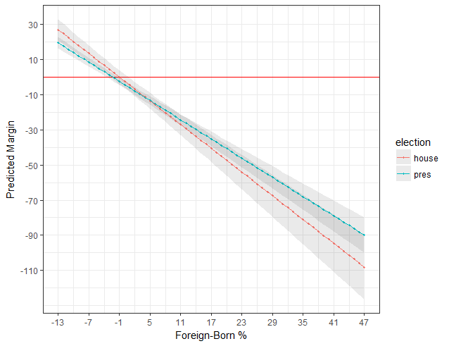

**MLR Assumptions**

**Assumptions:** The residual vs fitted plot was used to check homoskedasticity- passed (House on left, Pres on right). The Cook’s Distance plot was used to check outliers. No predictor had a VIF above 5.

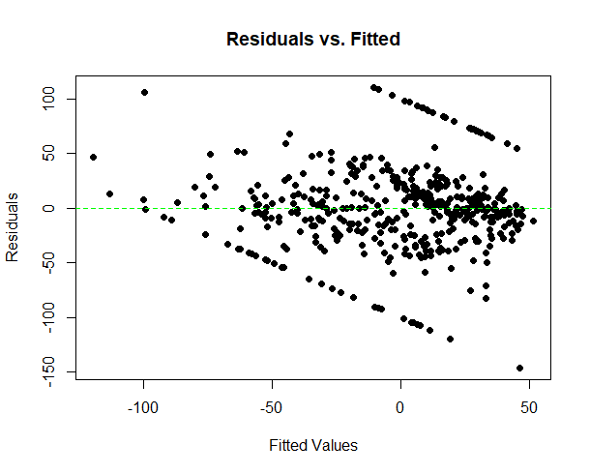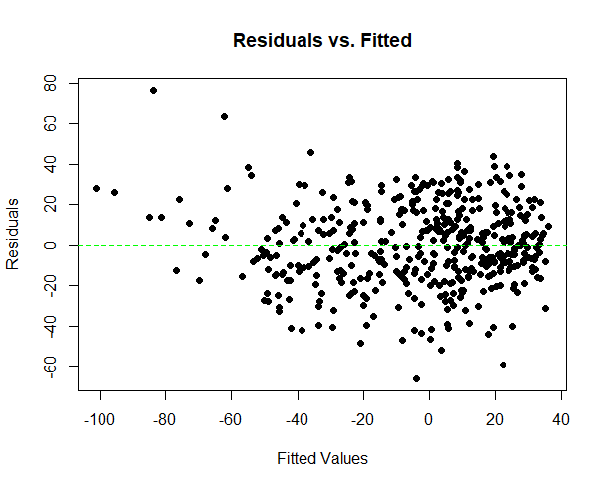

**LOG Results**

|  |  |  |  |  |  |  |
| --- | --- | --- | --- | --- | --- | --- |
| **HOUSE MODEL** | **Odds Ratio** | **Conf. Int.** | **z value** | **Pr(>|z|)** |  |  |
| (Intercept) | 1.059 | (.818, 1.369) | 0.433 | 0.6647 |  |  |
| blacks_p | 0.938 | (.916, .959) | -5.576 | 2.46E-08 |  |  |
| manufacturing_p | 1.049 | (.987, 1.114) | 1.551 | 0.1209 |  |  |
| medincdiff_k | 0.972 | (.948, .996) | -2.26 | 0.0238 | **pseudo-R^2 = 50.0%** | |
| foreign_p | 0.876 | (.844, .908) | -7.041 | 1.90E-12 |  |  |
| public_ins_p | 0.899 | (.857, .943) | -4.365 | 1.27E-05 | **LR Chi^2(5) = 203.58** | **Pr(> chi2) <0.0001** |
|  |  |  |  |  |  |  |
| **PRES MODEL** | **Odds Ratio** | **Conf. Int.** | **z value** | **Pr(>|z|)** |  |  |
| (Intercept) | 0.812 | (.597, 1.106) | -1.318 | 0.187621 |  |  |
| blacks_p | 0.922 | (.899, .946) | -6.226 | 4.78E-10 |  |  |
| manufacturing_p | 1.001 | (.935, 1.073) | 0.045 | 0.964499 |  |  |
| medincdiff_k | 0.945 | (.917, .974) | -3.726 | 0.000194 | **pseudo-R^2 = 61.3%** | |
| foreign_p | 0.825 | (.785, .868) | -7.507 | 6.05E-14 |  |  |
| public_ins_p | 0.876 | (.829, .926) | -4.693 | 2.69E-06 | **LR Chi^2(5) = 267.32** | **Pr(> chi2) <0.0001** |

**House and Presidential Predicted Electoral Outcome by Foreign-Born %**

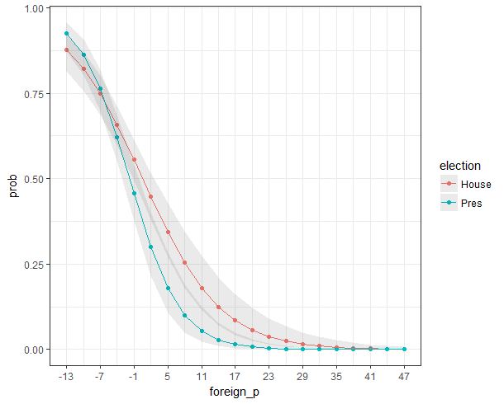

**Model Predictions**

* Using the Presidential model to predict House electoral margin:

**R^2 = 30.51%** (*Note- non-competitive districts have a margin of 100)

* Using the House model to predict Presidential electoral margin:

**R^2 = 98.13%**

* Using the Presidential model to predict House electoral outcome: **80.46%** accurate; compared to 54.25% accuracy of guessing all win
* Using the House model to predict Presidential electoral outcome: **80.92%** accurate; compared to 52.87% accuracy of guessing all win

**Discussion**

* The cultural variables, foreign and black population %, were overall better predictors than the economic variables
* Manufacturing was never significant
* The models were fairly good at predicting the outcome for the other type of election

**Conclusion:** Within the constraints of the models, he evidence suggests that cultural factors, specifically Foreign-born % (-2.28, t(424)=-11.49, p<.05) (OR=.825, z=-7.51, p<.05), played a larger role in influencing the Republican Presidential and House victory than economic factors. Further, insofar as any two election types are different (due to differences in candidates, consequences, etc.), at least compared to the House election Trump’s victory does not seem like an aberration.

**Looking Ahead**

* This project’s data was current but had large margins of error
* For a future study, decennial census data would be more representative of the actual population, though in my opinion the models would probably not change much
* For House electoral margin, there should be a better way to calculate a margin for when one party is unopposed in the general election; perhaps make estimates based off of primary or presidential election results
* This project’s predictor variables were meant to represent culture and economics
* By itself, manufacturing % was actually significant; its non-significance when put in with other predictors probably made it a confounding variable
* How best to represent these factors is unclear, but a future study should have empirical justification for using certain demographic information as predictors
* Personally, I would replicate this study for the 2012 election and then compare it to the 2016 results. This would shed light on changes in voting behavior

**References**

* Demographic Data: US Census Bureau <https://www.census.gov/mycd/?st=42&cd=10>
* Presidential Election Results: Daily Kos <https://www.dailykos.com/stories/2012/11/19/1163009/-Daily-Kos-Elections-presidential-results-by-congressional-district-for-the-2012-2008-elections>
* House Election Results: CNN Politics <https://www.cnn.com/election/2016/results/house>