102.

[SELECT](http://localhost/phpmyadmin/url.php?url=https://dev.mysql.com/doc/refman/5.5/en/select.html) [AVG](http://localhost/phpmyadmin/url.php?url=https://dev.mysql.com/doc/refman/5.5/en/group-by-functions.html#function_avg)( `ar`) AS Átlag FROM `autok`

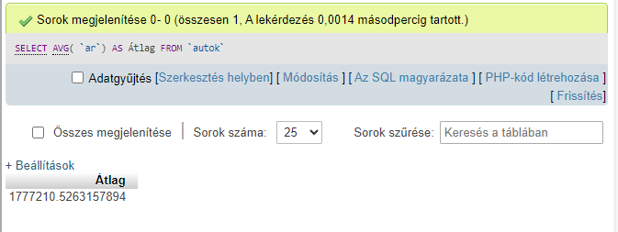

103.

?

104.

[SELECT](http://localhost/phpmyadmin/url.php?url=https://dev.mysql.com/doc/refman/5.5/en/select.html) [COUNT](http://localhost/phpmyadmin/url.php?url=https://dev.mysql.com/doc/refman/5.5/en/group-by-functions.html#function_count)(*) AS Autók_száma FROM `autok`

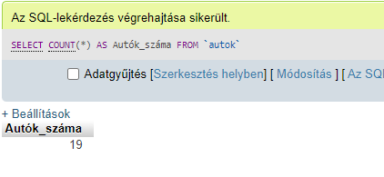

105.

[SELECT](http://localhost/phpmyadmin/url.php?url=https://dev.mysql.com/doc/refman/5.5/en/select.html) `tipus_nev`, [AVG](http://localhost/phpmyadmin/url.php?url=https://dev.mysql.com/doc/refman/5.5/en/group-by-functions.html#function_avg) (`futott_km`) AS Kilóméteróra FROM `autok` GROUP BY tipus_nev

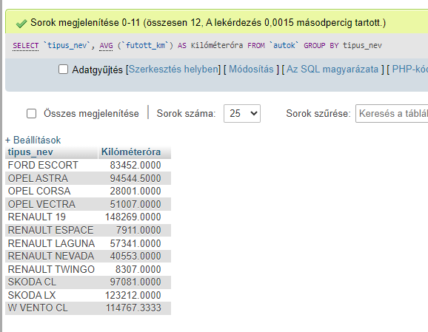

106.

[SELECT](http://localhost/phpmyadmin/url.php?url=https://dev.mysql.com/doc/refman/5.5/en/select.html) [MAX](http://localhost/phpmyadmin/url.php?url=https://dev.mysql.com/doc/refman/5.5/en/group-by-functions.html#function_max)(fizetes) - [MIN](http://localhost/phpmyadmin/url.php?url=https://dev.mysql.com/doc/refman/5.5/en/group-by-functions.html#function_min)(fizetes) AS Külömbség FROM `alkalmazott`

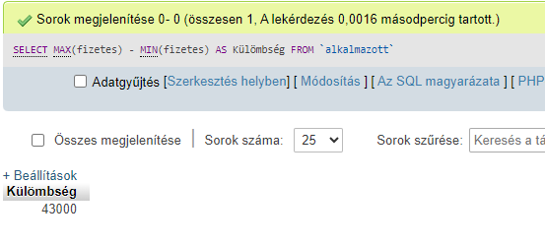

107.

[SELECT](http://localhost/phpmyadmin/url.php?url=https://dev.mysql.com/doc/refman/5.5/en/select.html) `tipus_nev`, [COUNT](http://localhost/phpmyadmin/url.php?url=https://dev.mysql.com/doc/refman/5.5/en/group-by-functions.html#function_count)(`allapot`) as Kiadhatók_száma, [AVG](http://localhost/phpmyadmin/url.php?url=https://dev.mysql.com/doc/refman/5.5/en/group-by-functions.html#function_avg)(`ar`) AS Kiadhatók_árának_átlaga FROM `autok` WHERE `allapot` = "F" GROUP BY tipus_nev;

