Game Design Document

Fill up the following document

1. Write the title of your project.

Bloxel Laser Race

1. What is the goal of the game?

To go to the top of the platforms and not get shot by your enemy.

1. Write a brief story of your game.

Two player will attempt to go to the top of various platforms, the platform will be different types like and moving platforms and more. There will be powerups to shoot your enemy or go up faster. There will be a health bar too and coins will be added. Game Over if the opponent reaches the top or if the camera moves up too much.

1. Which are the playing characters of this game?

* Playing characters are the ones who respond to the user based on the input from the user.
* Cars, monkeys, dinos, wizards, etc., are the playing characters in the game.

|  |  |  |
| --- | --- | --- |
| Number | Character Name | What can this character do? |
| 1 | Player 1 | This is the first main character |
| 2 | Player 2 | This will be the second main character |

1. Which are the Non-Playing Characters of this game?

* Non-Playing characters are the ones that don't have an action or behavior when the user interacts with the game.
* Hurdles, stones, bananas, coins, etc., are non-playing characters in the game.

|  |  |  |
| --- | --- | --- |
| Number | Character Name | What can this character do? |
| 1 | Platform | A solid non moving platform for the player to stand on |
| 2 | Moving Platform | A horizontally moving platform that moves |
| 3 | Spike Platform | A platform with spikes that reduce your health |
| 4 | Speed Powerup | A power up that makes you move up faster |
| 5 | Laser Powerup | A powerup that lets you shoot 3 lasers |
| 6 | Lasers | Something to hurt your enemy |
| 7 | Coins | To earn points |

Draw your imagination of this game. What does this game look like?

* Draw the game either on your computer or on paper.
* Add images of the game scenes to show each of the playing and non-playing characters at least once.

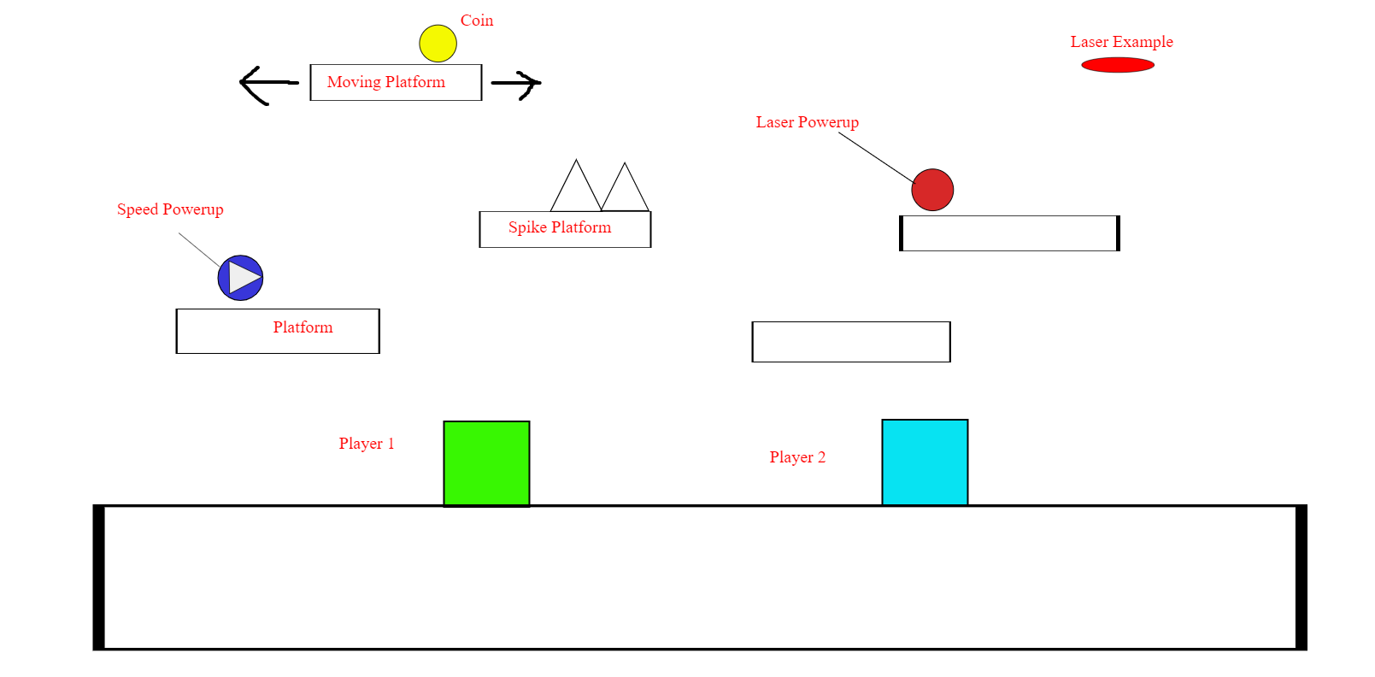

How do you plan to make your game engaging?

Adding lasers will help keep the players on their toes and engaged. Also by adding spikes the players will have to be on the look out.Coins and powerups can also make the game more engaging.