Apsis VR — Sprint 1 UX Design Specification
Login Page Restyle and Team Members Page
Project: COSC2408 Programming Project 1 — Capstone
Client: Apsis VR Melbourne
Sprint: Sprint 1 / Mock Sprint
Prepared by: Chungheng Vong — UX Designer

1. Purpose
This document defines the UX requirements, design artefacts, edge-case behaviour, and acceptance criteria for the Sprint 1 feature. The feature consists of a visual restyle of the existing Login page and the creation of a Team Members page. It provides the team with a shared reference for implementation, testing, review, and handover.

2. Scope

2.1 In Scope
- Reuse and build on the existing RMIT Garage boilerplate.
- Restyle the existing Login page.
- Create one additional page named Team Members or Team Information.
- Display the additional page in the left sidebar directly below Dashboard.
- Update visual styling, including layout, colours, typography, buttons, and spacing.
- Ensure the Login and Team Members pages are usable on desktop and mobile devices.
- Handle missing images, long text, and multiple team members.

2.2 Out of Scope
- Changes to authentication, login process, validation, or session handling.
- New functionality outside the Login and Team Members pages.
- Changes to backend logic unless separately approved by the team and client.

3. User Profile

Primary User — Draft for Validation
An authenticated Apsis VR staff member who uses the internal dashboard and needs to identify team members, understand their roles, and access team information quickly.
Validation note: Confirm with the client whether the intended dashboard user is Apsis VR staff, management, customers, or another group. Update this profile before final BA approval.

User Needs
- A clear and visually consistent Login page.
- An easy-to-find Team Members page in the dashboard navigation.
- Clear member information: name, role, image, and short description.
- A layout that works on desktop and mobile devices.
- Content that remains readable when images are unavailable or text is long.

4. Primary User Story
As an authenticated Apsis VR staff member, I want to select Team Members from the dashboard sidebar and view each person’s photo, name, role, and blurb so that I can understand who is in the team and their responsibilities.

5. User Flow

Primary Flow
User opens application → User views styled Login page → User enters valid existing credentials → Existing authentication succeeds → Dashboard opens → User selects Team Members in the sidebar → Team Members page opens → User views team heading and member information.

Missing-Image Flow
A team-member photo is missing or fails to load → System displays the approved placeholder image.

6. Login Page Requirements
The Login page must receive a refreshed visual design that aligns with the existing dashboard while preserving all existing login functionality.
Element | Requirement | Display rule
Login form | Required | Keep all existing fields and controls
Authentication | Required | Existing behaviour must remain unchanged
Validation and sessions | Required | Existing behaviour must remain unchanged
Colours | Required | Match the dashboard visual system
Typography | Required | Use a clear and consistent hierarchy
Buttons | Required | Match dashboard button style
Responsive design | Required | Usable on desktop and mobile

- Changes are visual only.
- Do not change authentication, validation, session handling, or login logic.
- Retain all existing required Login page fields and actions.
- Ensure readable labels, clear form controls, and accessible contrast.
- Use styling consistent with the dashboard and Team Members page.

7. Team Members Page Requirements
The Team Members page lets an authenticated user view the team and understand each member’s role and background.
Field | Type | Requirement | Display rule
Team Members navigation | Navigation item | Required | Display in left sidebar directly below Dashboard
Team name | Text | Required | Display as the main page heading
Team member photo | Image | Required | Display beside or above member details
Team member name | Text | Required | Display full name prominently
Team member role | Text | Required | Display below the member name
Team member blurb | Text | Required | Display beneath the role
Placeholder image | Image | Required | Use when a photo is missing or broken
Responsive layout | Layout | Required | Work on desktop and mobile

- Each member must have a separate, recognisable section or card.
- Each section must contain populated name, role, photo, and blurb content.
- Images must fit a consistent frame and must not stretch or distort.
- The page must remain usable as more member sections are added.

Scenario | Expected behaviour
Photo is too large or too small | Crop the image to the frame. Do not stretch or distort it.
Photo is missing or broken | Display the approved placeholder image.
Numerous team members are added | Maintain a clear responsive layout; permit scrolling without damaged styling.
Blurb contains many characters | Wrap text within its content area without clipping or overlap.
Team-member name is long | Wrap text within the member section without breaking layout.
Team-member role is long | Wrap text within the member section without breaking layout.
Mobile screen size | Use a readable responsive layout, such as a single-column member-card layout.
Sidebar is constrained on mobile | Team Members remains discoverable through a collapsed-menu or mobile-navigation pattern.

9. Low-Fidelity Wireframes
Create and review these frames before producing final mock-ups:
- Login page — desktop.
- Team Members page — desktop.
- Team Members page — mobile.
- Missing-photo / placeholder-image state.
- Long-content state for name, role, or blurb.

10. Final Mock-Ups
- Styled Login page — desktop and mobile.
- Team Members page — desktop and mobile.
- Placeholder-photo state.
- Long-text state.
Both pages must use a shared visual system: consistent colour palette and contrast, typography and hierarchy, form fields, buttons, cards, border radius, spacing, sidebar navigation, and responsive behaviour.
Final Figma mock-ups: [Insert link]

11. UX Acceptance Criteria

AC01 — Login Page Styling
- Existing login authentication remains unchanged.
- Existing login validation and session behaviour remain unchanged.
- The Login page styling is consistent with the dashboard design.
- Existing Login page fields and required actions remain visible and usable.
- The Login page is usable on desktop and mobile.
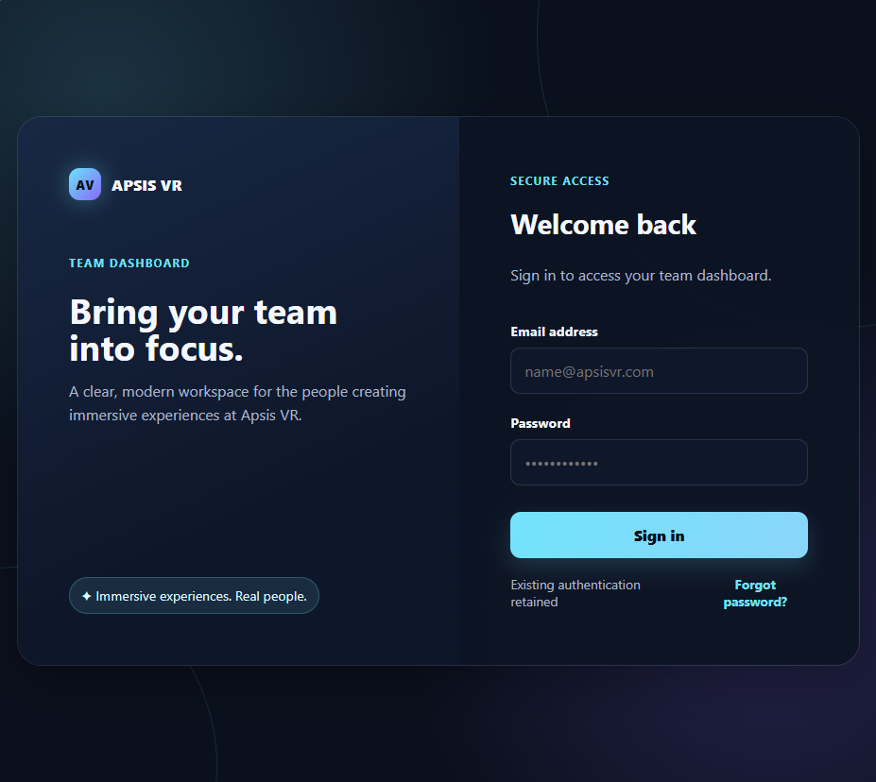

AC02 — Team Members Navigation
- A Team Members or Team Information item appears directly below Dashboard in the sidebar.
- Selecting the navigation item opens the Team Members page.
- Photos must crop to fit without stretching or distortion.
- Long names, roles, and blurbs must wrap without breaking the layout.
- The layout must remain usable when numerous team members are displayed.

AC03 — Team Members Page
- The page displays the team name as the main heading.
- Each team member has a section containing name, role, photo, and blurb.
- Each team-member section has populated content.
- A placeholder image is used when an image is missing or broken.
- Images crop to fit their container without distortion.
- Long names, roles, and blurbs wrap cleanly.
- The layout remains usable with many team members.
- The Team Members page is usable on desktop and mobile.
