Key Points:
- A statistical framework based on "Sequence Event Pair" vector analysis and Gaussian Mixture Models fitting is proposed to quantify aftershock migration.
- Comparative analysis found that the 2008 Wenchuan earthquake (tectonically dominated) exhibited a bidirectional migration pattern strictly controlled by fault strike, whereas the 2019 Changning earthquake (fluid related) displayed a unidirectional, weak migration pattern associated with fluid diffusion.
- The proposed method is generalizable and the quantitative metric can be used to distinguish between types of earthquake causation.

Quantifying Directionality and Temporal Evolution of Aftershock Spatial Migration: A Statistical Approach Based on Gaussian Mixture Models

Ke Jia^{1*}, Yuechen Yao¹, Shiyong Zhou², Jiancang Zhuang³, Changsheng Jiang⁴

1 School of Automation, Northwestern Polytechnical University, Xi’an 710129, China
2 School of Earth and Space Sciences, Peking University, Beijing 100871, China
3 The Institute of Statistical Mathematics, 10-3 Midori-Cho, Tachikawa, Tokyo 190-8562, Japan
4 Institute of Geophysics, China Earthquake Administration, No.5 Minzu Daxue Nan Road, Haidian District, Beijing 100086, China
*Corresponding authors: jk@nwpu.edu.cn

Abstract
- Brief summary of the research objectives, methodology, and key findings.

1. Introduction
The study of aftershocks is a critical aspect of seismology, as these secondary seismic events can significantly impact affected regions following a major earthquake, particularly in areas where infrastructure has already been compromised (refs). Understanding the spatial migration of aftershocks is essential for assessing seismic hazards and understanding earthquake mechanisms. Previous researchers have shown that aftershocks are controlled by their mainshocks (Cattania et al., 2014; Churchill et al., 2024; Jia, 2020) or afterslip (Peng and Zhao, 2009), but the mechanism and control factors are still unclear (refs). Moreover, lack of quantitively measuring spatial migration of aftershocks limits the in-depth study related to aftershocks.

The relationship between aftershocks and their mainshocks has been extensively studied, with research focusing on spatial distributions, underlying mechanisms, and statistical modeling (refs). Rubin and Gillard (2000) and Rubin (2002) analyze aftershock asymmetry along the San Andreas Fault. They observe a preferential northwest distribution of aftershocks, attributed to material contrasts across the fault and rupture dynamics. These studies suggest that aftershock asymmetry is primarily influenced by fault material properties rather than random distribution. Wössner et al. (2006) investigate the relationship between aftershock locations and mainshock fault properties. They find that aftershocks are more likely to occur in low-slip regions (less than one-third of maximum slip) and areas of increased shear stress, with a stronger correlation to low-slip regions than stress drop patterns. Neo et al. (2021) examines 12 California earthquakes (Mw ≥ 5.4) and concludes that aftershock zone areas provide a reasonable first-order approximation of mainshock rupture areas. However, the authors caution against using aftershock ratios for precise predictions due to variability and uncertainties, emphasizing the roles of Coulomb stress change and afterslip in aftershock distributions. Churchill et al. (2024) explores spatial relationships between coseismic slip, aseismic afterslip, and aftershock density across seven significant continental earthquakes (Mw 6.0–7.6). Their findings reveal significant variability in these relationships, challenging the assumption of universal patterns and highlighting the complexity of aftershock-mainshock dynamics. The study underscores the need for improved resolution in slip models and aftershock data.

Advancements in data collection and modeling have further refined understanding of aftershock migration. Helmstetter and Sornette (2002) introduced a model describing aftershock spatial distributions as a function of distance from the mainshock, while Zhuang et al. (2002) used point process models to analyze temporal and spatial clustering. Recently, development of spatial temporal ETAS model is proposed to analyze seismicity of fluid-involved earthquakes (Guo et al., 2023; Jia et al., 2020). Kagan (2004) and Hauksson et al. (2012) highlights directional tendencies in aftershock migration, often aligned with mainshock rupture direction, though variability in these patterns remains an area of active investigation.

Despite these advancements, gaps remain in our understanding of aftershock spatial migration, particularly regarding the quantification of migration patterns and the factors influencing directional tendencies. This study aims to address these gaps by providing a comprehensive analysis of aftershock migration, contributing to the existing body of knowledge in seismology.

This article aims to explore the spatial migration patterns of aftershocks, focusing on three key objectives: quantifying aftershock spatial migration and testing the directional tendencies of aftershock migration, and examining the relationship between types of mainshock and the subsequent aftershock migration. By employing a straightforward statistical method and analyzing extensive seismic data, this research seeks to provide insights into the mechanisms driving aftershock spatial migration and their implications for earthquake preparedness and response. Findings of this study will contribute to the broader understanding of seismic activity and may inform future research and policy decisions regarding earthquake risk management.

2. Methodology
We propose a simple method to quantify aftershock spatial migration. For simplicity, depth information is ignored, and the problem is simplified from 3D to 2D. Because the horizontal component of the focal mechanism solution typically dominates the rupture direction, and because horizontal location accuracy in most catalogs is currently far better than vertical accuracy, 2D projection is robust in capturing the main migration trend. First, we pair earthquakes using two different approaches (Figure 1): the mainshock-aftershock pair and the sequence event pair. The former pairs the mainshock with each aftershock and the latter pairs one event with its subsequent event. Then, each pair is marked with an arrow from the first event to the second event, representing the directivity of earthquake pair. The directivity of earthquake pair is measured relative to the East direction.

Given a certain seismic catalog, a lot of directivities of earthquake pairs can be obtained. Then, a histogram is calculated to quantify the distribution of directivities, and a Gaussian Mixed Model (GMM) (refs) is applied to fit the distribution. Here, we use an automatic algorithm (refs.) to find the number of peaks in the histogram (refs). Finally, we obtain several fitted GMMs with their means and standard deviations. Note that, these two pairing approaches lead two different results. The means of fitted GMMS represent average directivities of the aftershock spatial migration and their standard deviations represent dispersion. In this study, we mainly focus on the migration directivity of aftershocks, but we can also calculate migration distance and speed (or other related information, e.g., directivity change) using those earthquake pairs. We will discuss this point in the Discussion section.
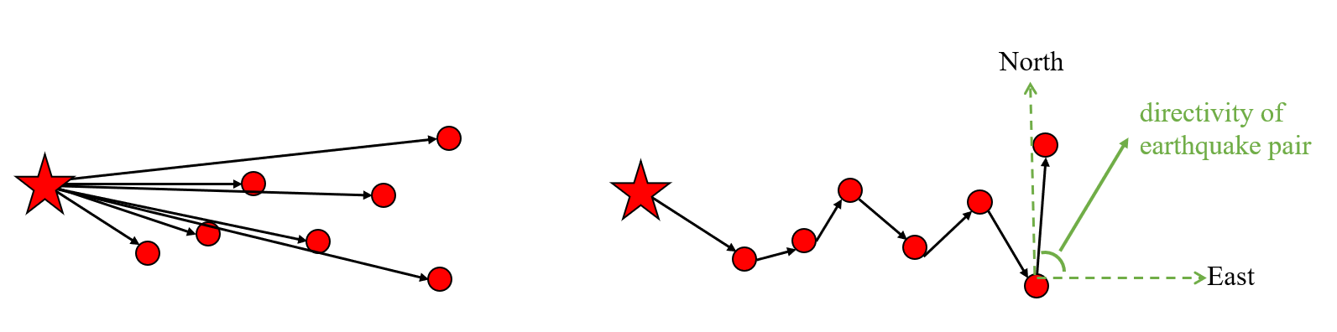

Histogram and GMM model figure
Figure 1. Flowchart of quantifying aftershock spatial migration. (a) Diagram of earthquake pairs and their directivity. The red star represents the mainshock and the red circles represent aftershocks. The black arrows represent earthquake pairs. The directivity of earthquake pair is measured relative to the East direction. (b) histogram of directivities of earthquake pairs, and the fitting results of the GMM.

3. Data
We use two earthquakes as examples to show our proposed method (Figure 2). One is the 2008 Wenchuan earthquake and another one is the 2019 Ms 6.0 Changning earthquake. The former one is a tectonic event and the later one is regarded as fluid-involved event (refs). We also aim to investigate whether aftershock migration differs in those two types of earthquakes.

Aftershock relocation catalogs of the 2008 Wenchuan and 2019 Changning earthquake are from Chen et al. (2009) and Yi et al. (2019), respectively. Chen et al. (2009) used the double-difference method to relocate aftershocks of the Wenchuan earthquake from May 12, 2008, to October 31, 2008, resulting in a relocated aftershock catalog with over 2,600 aftershocks. The relocated results indicate that the Wenchuan earthquake sequence originates at the southern edge of the Pengguan Massif and extends northeastward over approximately 350 km, with a width of 20–30 km. The spatial distribution of aftershocks displays significant inhomogeneity, which can be segmented into smaller sectors.

Yi et al. (2019) relocated the early events of the Ms 6.0 Changning earthquake sequence, spanning June 17 to 22, 2019, by applying the multi-step location technique. The distribution of 610 aftershocks with M_{L}≥1.5 from the relocated Changning sequence shows that the aftershock area extends in a NW-SE direction, approximately 25 km long and 5 km wide. The focal depths of the sequence range from 0 to 10 km, with an average depth of about 3.2 km, but spatially exhibit a characteristic of being deeper in the west and shallower in the east. The Changning Ms 6.0 earthquake is located at the southeastern end of the aftershock area and exhibits a unilateral rupture.

Figure 2. Aftershock distributions of the 2008 Wenchuan and 2019 Changning earthquakes. The colors represent directivities of aftershock migration.

4. Results
4.1 Synthetic experiments
We conduct a series of synthetic experiments to test the proposed method (Figure S1-S5). Details can be found in the supporting information material. The basic idea is that the mainshock-aftershock pairs can be used in a single fault, but it can hardly capture directivities for multiple faults (especially in case of multiple faults with different strike) (Figure S4 and S5). The sequence event pair can be used in both a single fault and multiple faults cases (Figure S2-S5). It can be seen from Figure S2-S5 that the amplitudes of the fitted GMMs represent the number of earthquake pairs in every detected peak (directivity of aftershock migration). This feature poses a possibility of quantifying aftershock migration for different cases.

4.2 Case studies of the 2008 Wenchuan and 2019 Changning earthquakes
We apply the proposed method in two case studies, namely the 2008 Ms 8.0 Wenchuan and 2019 Ms 6.0 Changning earthquakes. We set the cutoff magnitudes to be 1.5 and 1.0 for the Wenchuan and changning sequences, respectively. We focus on the sequence event pairs due to its capability of capturing multiple directivities. The spatial distribution of directivities of aftershocks are shown in Figure 2 with different colors. We plot the histogram of directivities of aftershock migrations of those two earthquakes (Figure 3) and fit the distribution using the GMM. Then, the average direction of aftershock migration can be obtained from the fitting parameters (means of the fitted GMMs).
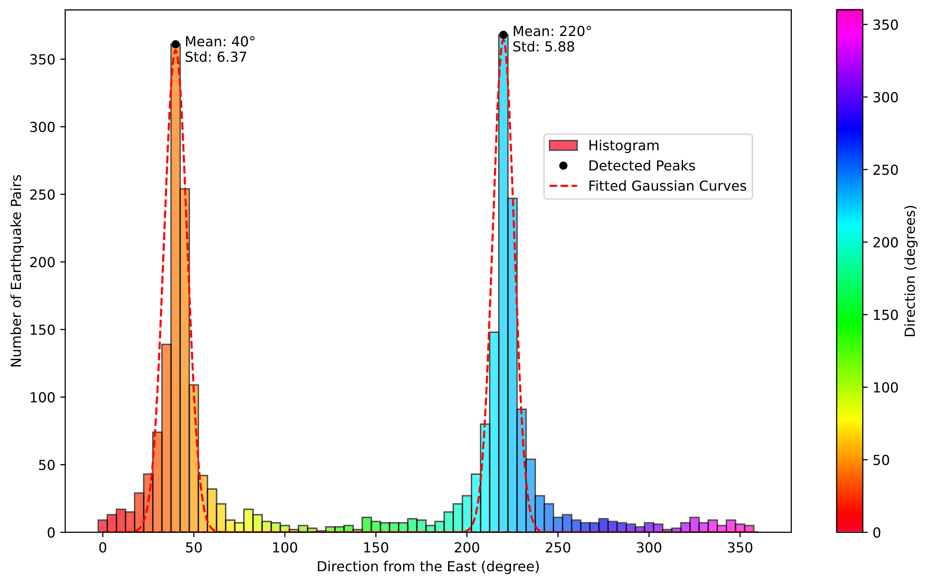
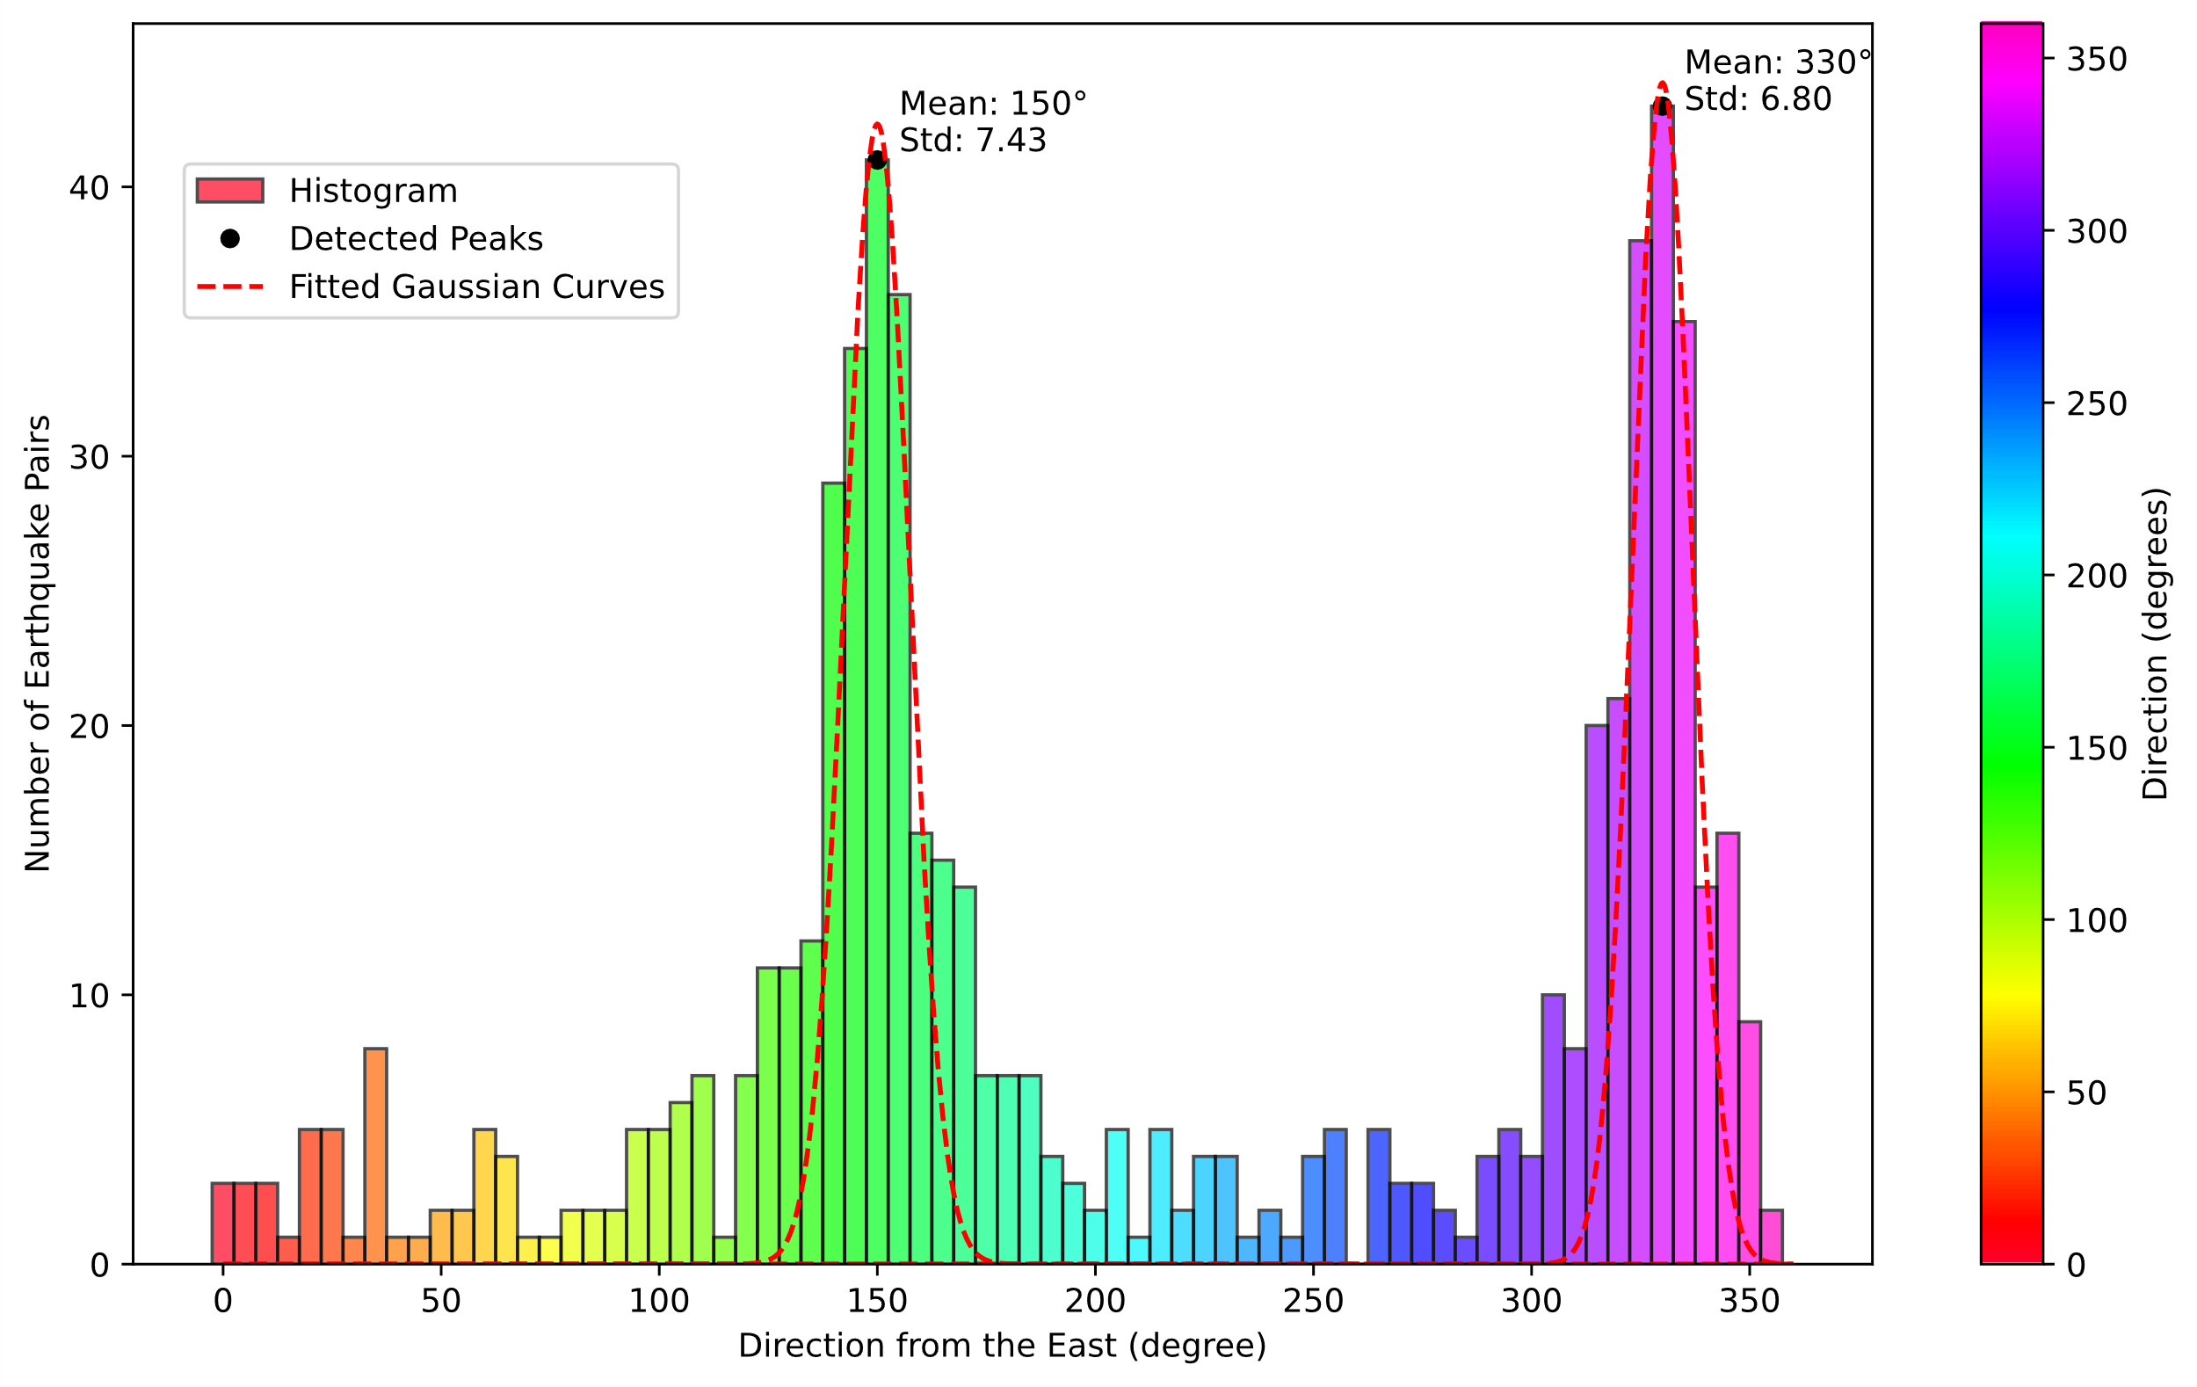
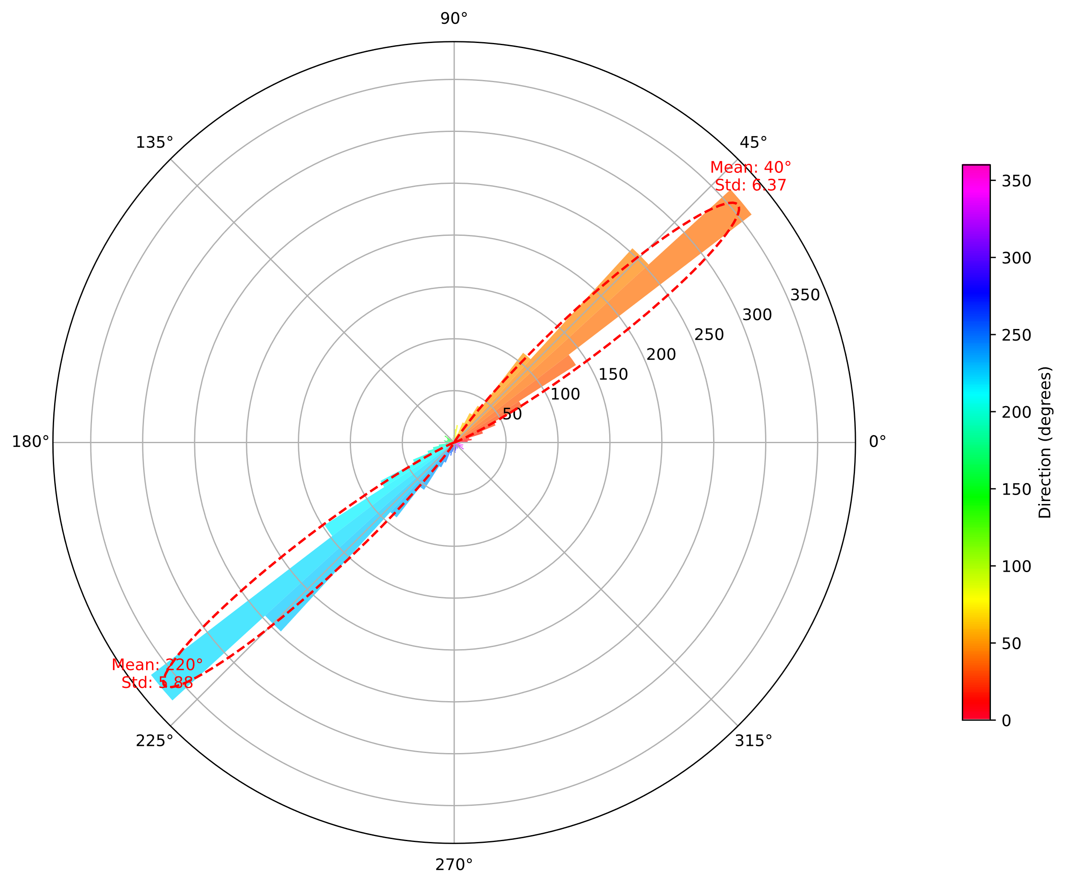
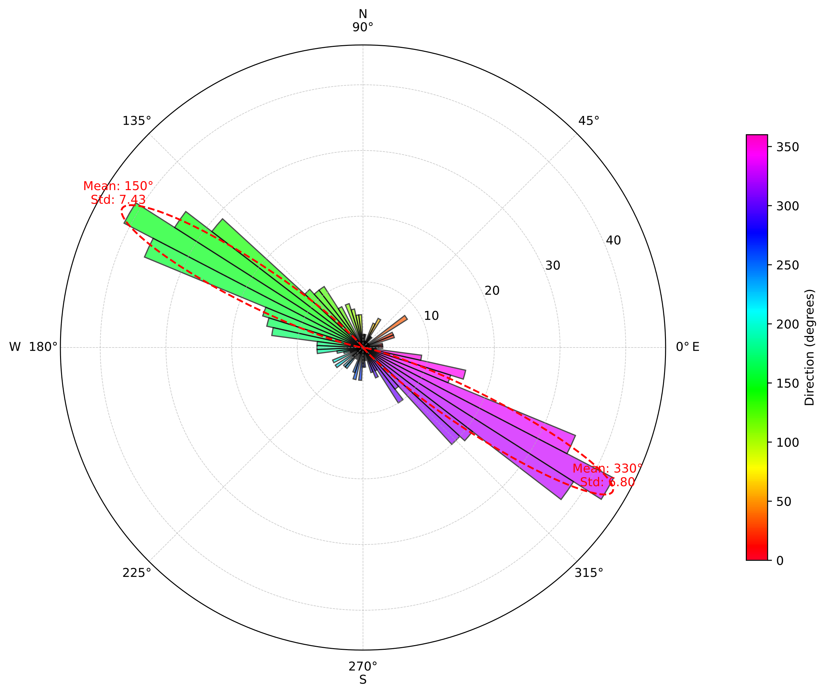

Figure 3. Histogram of directivities of aftershock migrations of the 2008 Wenchuan and 2019 Changning earthquakes. The red curves represent fitting results of the GMM. (a) The 2008 Wenchuan earthquake. (b) The 2019 Changning earthquake. (c) The 2008 Wenchuan earthquake in polar coordinate. (d) The 2019 Changning earthquake in polar coordinate.

From Figure 2 and 3, it can be seen that the Wenchuan earthquake shows two main directivities of aftershock migration, namely the northeastern (40°) and southwestern directions (220°). Those two directions are consistent with strike angle of the source fault of the Wenchuan earthquake.

The amplitudes of these two peaks are nearly same, which means that aftershocks of the Wenchuan earthquake migrate at both sides of the source fault with almost same number. We conduct a synthetic test using randomly distributed aftershocks on the same source fault of the Wenchuan earthquake to check if the observed aftershocks are random distributed (Figure Sn). From the synthetic test, we find that the distribution of aftershock migration by using the randomly distributed aftershocks is similar with that of observed aftershocks.

Ratios of numbers of earthquake pairs in different directions can also be calculated. We select earthquake pairs located in a window centering in the mean direction. Here the window length is set to be 30°, and other possible lengths are also tested and discussed in supporting information (Figure Sn), but the basic conclusion remains the same. Then, the temporal changes of these ratios are calculated and shown in Figure 4.

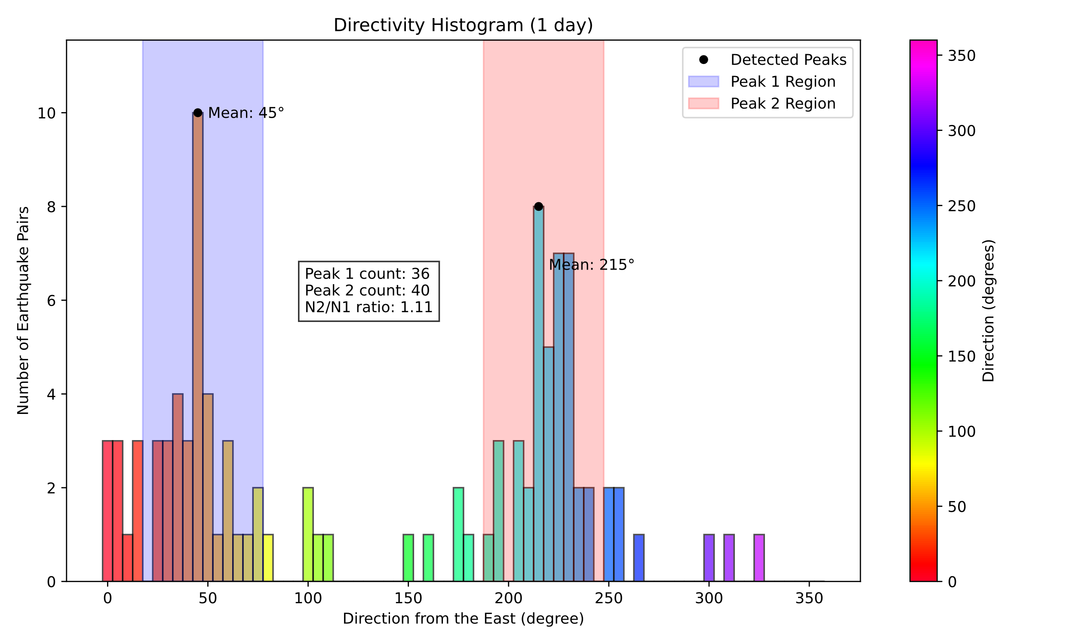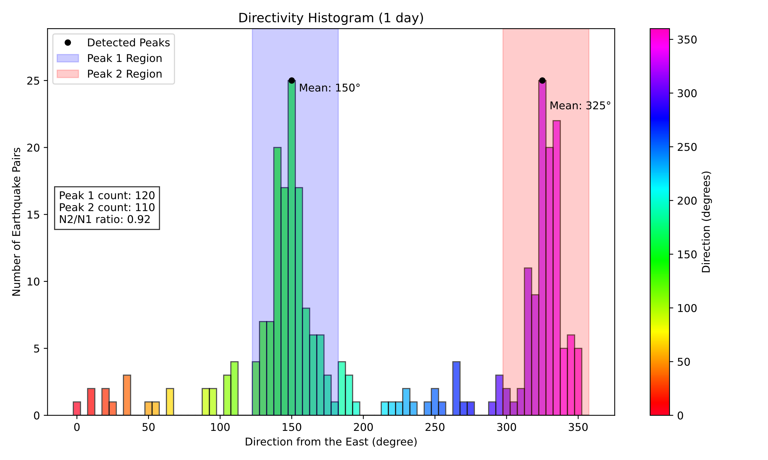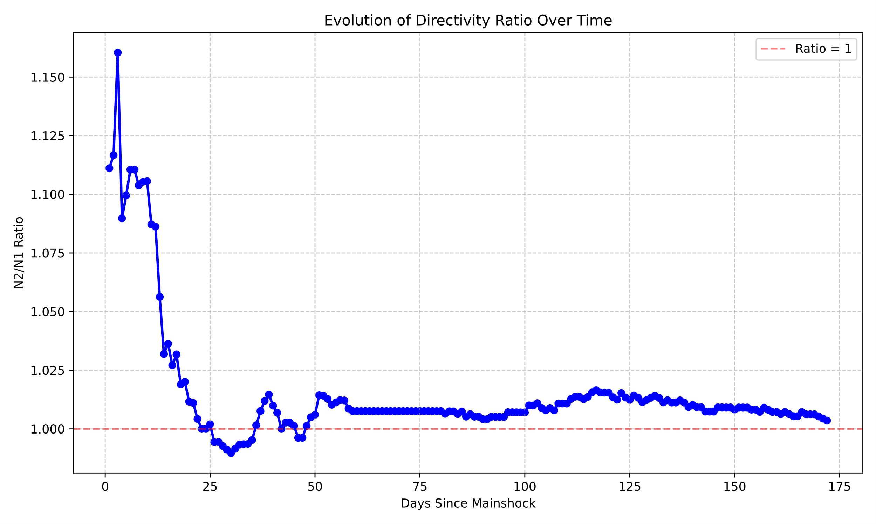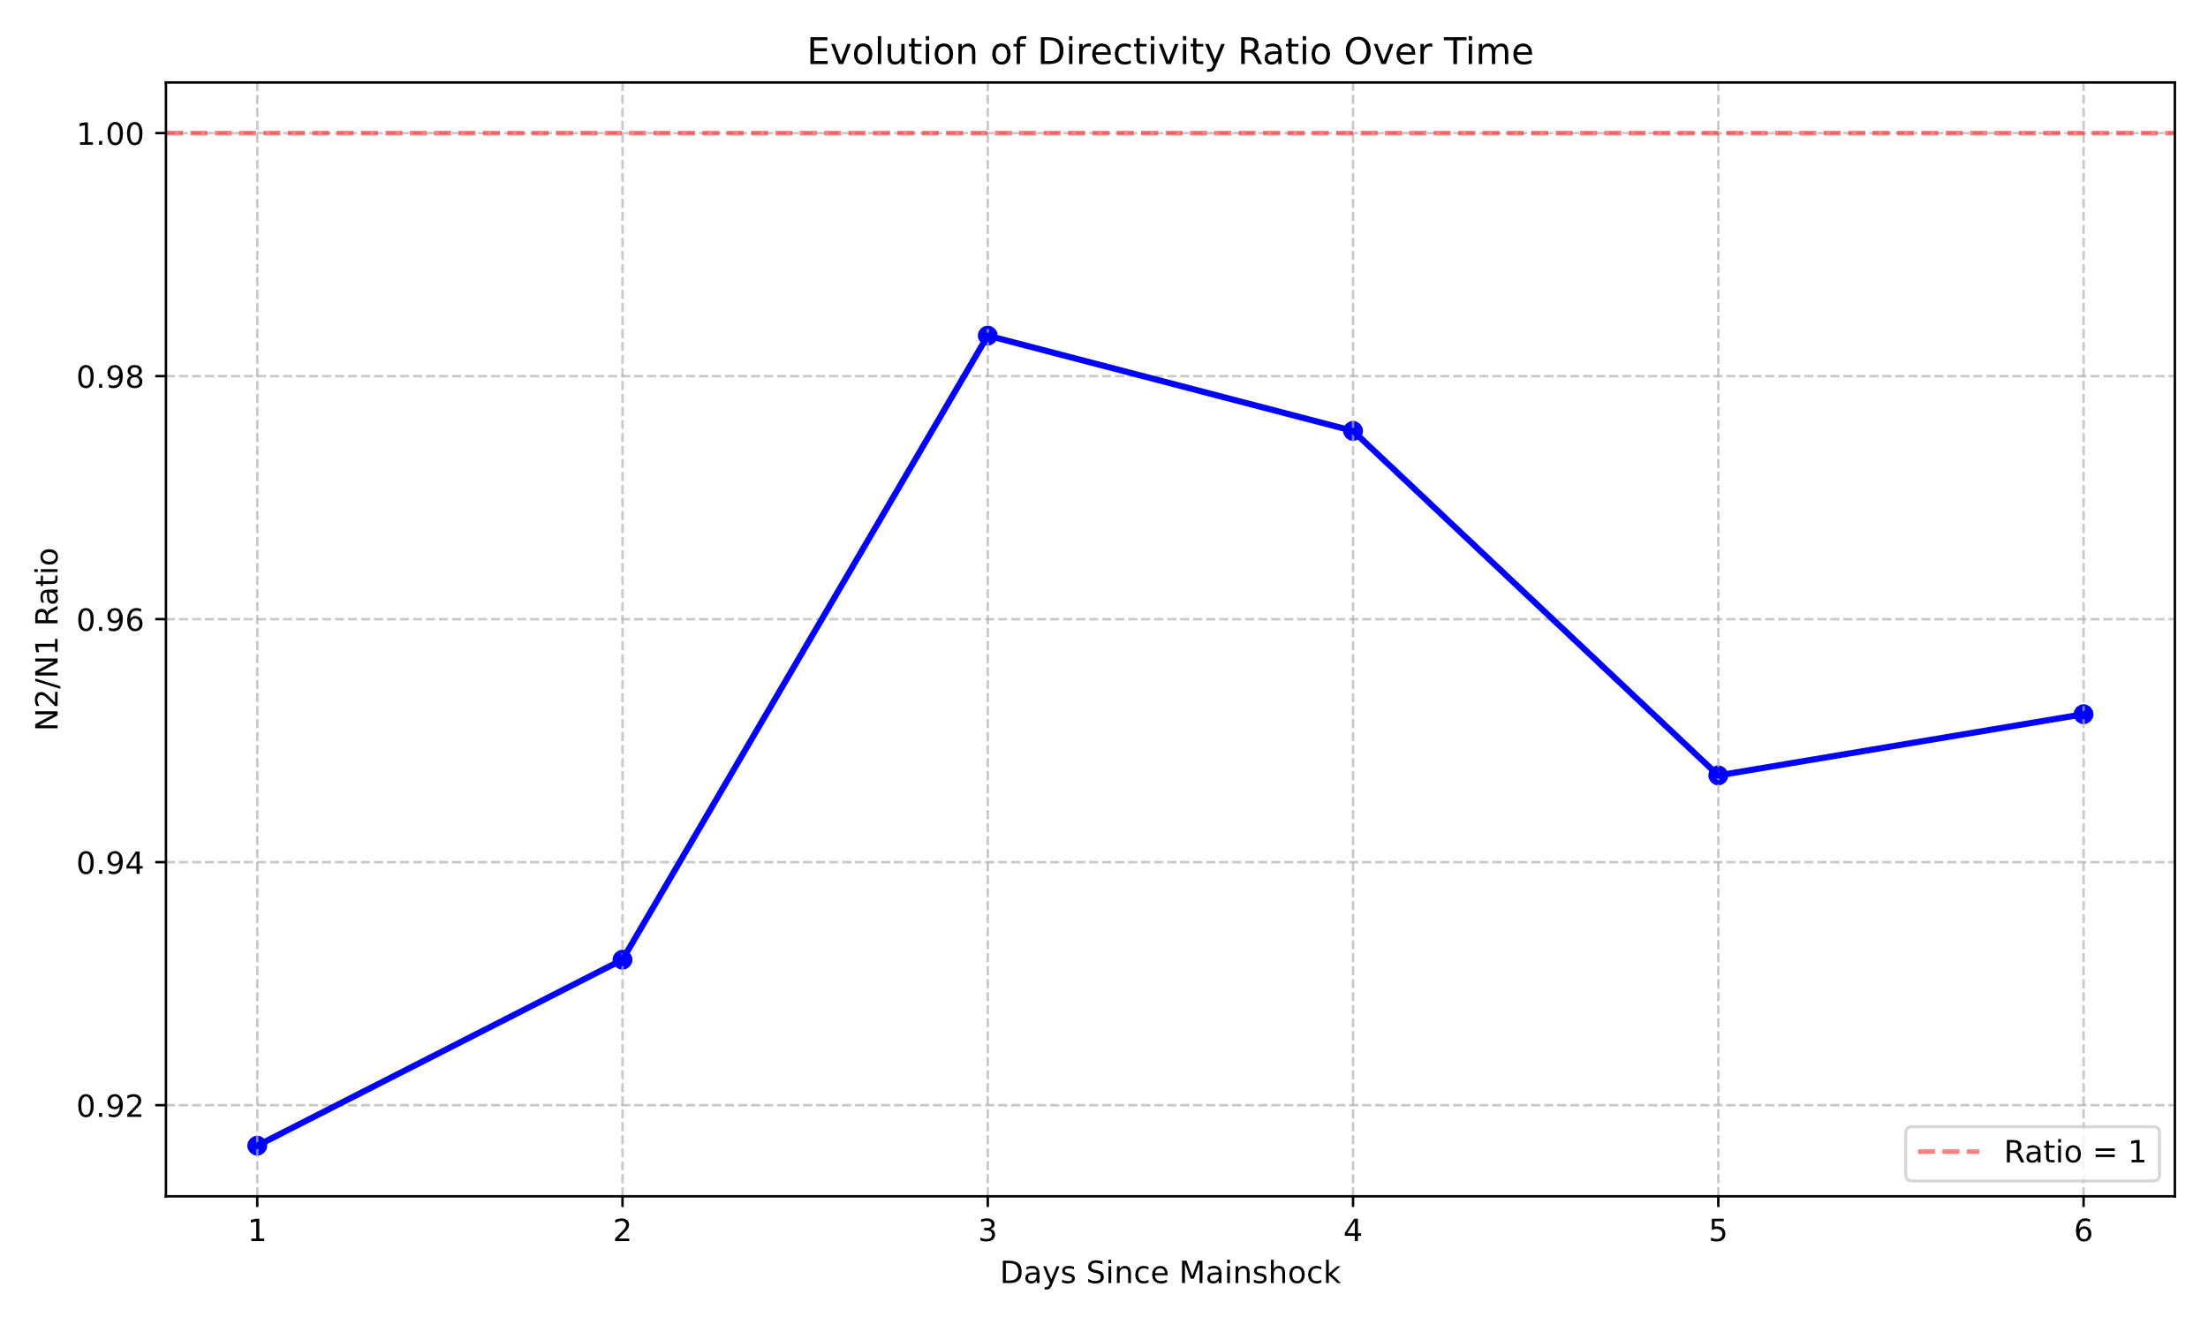
Figure 4. (a) and (b) Ratios of numbers of earthquake pairs in peak directions for the first day after the mainshock as examples showing how the ratios are calculated. (c) and (d) Their temporal evolution for the 2008 Wenchuan and 2019 Changning earthquakes.

From Figure 4, it can be seen that the N2/N1 ratio (number of earthquake pairs in).
To assess whether the observed deviation of the directivity ratio (N2/N1) from unity is statistically significant or merely a result of random fluctuation, we calculated the 95% confidence intervals based on the binomial distribution. Assuming a null hypothesis where migration in both directions is equally probable ($p=0.5$), the standard error of the ratio depends on the total number of event pairs in each time window. As shown in Figure 4c, for the Wenchuan earthquake, the ratio significantly exceeds the 95% confidence bounds during the first ~25 days, confirming that the dominance of the northeastward migration is a physical feature rather than a sampling artifact. Conversely, the fluctuations observed after 30 days largely fall within the confidence interval, indicating a transition to a random, isotropic distribution. This statistical validation supports our conclusion that the directional migration is a transient feature limited to the early post-seismic phase.

Based on the evidence from Figure 3 and 4, we infer that the aftershocks of the 2008 Wenchuan earthquake show a spatial migration from southwest (215°) to northeast (45°) at the early stage of the aftershock sequence (~25 days). Then they are randomly distributed along the source fault after ~25 days since the occurrence of the mainshock, with on obvious tendency of migration. This finding is not consistent with previous studies, which imply that mainshock-aftershock sequences usually do not show spatial migration pattern (Vidale and Shearer, 2006), they typically happen throughout the entire aftershock area right after the mainshock. The 2019 Changning earthquake shows a weak migration direction from southeast (325°) to northwest (150°). This might be due to the involved fluid or the swarm behavior (refs). We will discuss this point in the Discussion section in detail.

5. Discussion
5.1 Distinct Migration Patterns: Tectonic Control vs. Fluid Diffusion
Our study reveals two fundamentally different spatial migration modes corresponding to tectonic and fluid-involved earthquakes. For the 2008 Wenchuan earthquake, the aftershock migration is strongly bidirectional (NE 40° and SW 220°), strictly aligned with the strike of the Longmen Shan fault zone. This high degree of directionality, characterized by small standard deviations in the GMM fitting, suggests that the migration is governed principally by the static Coulomb stress transfer along the rupture plane. The nearly equal amplitude of migration in both directions indicates a bilateral rupture effect typical of large tectonic events.

In contrast, the 2019 Changning earthquake exhibits a weaker migration tendency with a dominant direction from SE to NW. Unlike the sharp fault-controlled pattern in Wenchuan, the Changning sequence shows greater dispersion. This observation aligns with the hypothesis that the Changning sequence is driven by fluid injection or salt mining activities. Fluid diffusion in fractured media is generally isotropic but can exhibit preferential flow paths due to local permeability anisotropy. The "weak" migration directionality observed here likely reflects the complex interaction between pore pressure diffusion and the pre-existing fracture network, distinct from the linear stress triggering of tectonic faults.

5.2 Implications for understanding aftershock migration.
Our findings offer a new perspective on the debate regarding aftershock migration. Chen & Shearer, 2011 observed bursts exhibit seismicity migration. This is in contrast to typical main shock aftershock sequences, which usually do not exhibit spatial migration behavior [Vidale and Shearer, 2006], they tend to occur across the entire aftershock region immediately after the mainshock. They also show that the migration velocities range from 0.008 to 0.8 km/hour, with about 65% below 0.1 km/hour, lower
than typical creep rates and aseismic slip rates [Lohman and McGuire, 2007; Roland and McGuire, 2009]. The study employs a weighted L1-norm inversion method to quantify migration parameters, revealing that swarms often migrate in a linear fashion, consistent with aseismic slip along pre-existing fault zones. While previous studies (Vidale and Shearer (2006)) suggested that typical mainshock-aftershock sequences show little spatial migration, our method demonstrates that directional migration does exist but may be masked by the randomness of background seismicity. By employing the Sequence Event Pair method and GMM decomposition, we can effectively extract these coherent migration signals from complex seismic clusters

The spatial pattern of aftershock-like sequence shows little temporal evolution, with events occurring consistently throughout the sequence and showing limited migration (Chen and Shearer, 2011; Chen et al., 2012; Vidale and Shearer, 2006). This means that aftershock-like clusters typically occur right after the main shock and exhibit minimal spreading over time. They also stated that most warm-like clusters show some degree of spatially coherent time evolution, typically manifesting as outward spreading or lateral movement from a point of initiation. However, the differences between swarm-like and aftershock-like behaviors are not always clear (Vidale and Shearer, 2006). Our results indicate that, when appropriate quantification tools (GMM) are used, temporal migration features hidden beneath randomness can be captured. And we infer that this is a piece of supplement to previous research, not a contradiction.

- Migration distance and speed
Speed differences between pore pressure driven, slow slip driven and fluid driven earthquake sequences.
Backward earthquake ruptures

5.3 Implications for Catalog Assessment and Foreshock Studies
With the advancements in artificial intelligence technology in seismology, particularly in phase identification and localization, an increasing number of high-precision earthquake catalogs have been obtained. However, the assessment of the accuracy of these catalogs currently relies mainly on expert experience. A commonly used evaluation method is to observe whether the relocated earthquake catalog is closer to the fault that generated the earthquakes. Our proposed method may provide an objective means of assessing the quality of earthquake catalogs. In the fitted GMM model parameters, the standard deviation can be understood as the dispersion of earthquake pairs, which can serve as an indirect quantitative indicator for evaluating the quality of earthquake catalogs.

Comprehending the nucleation process and foreshocks associated with earthquakes, particularly significant and damaging ones, is essential for effective earthquake prediction and seismic hazard reduction. However, the underlying physical mechanisms responsible for earthquake nucleation and foreshock generation remain a topic of debate (McLaskey, 2019; Peng and Lei, 2024). In those representative models of foreshocks (preslip model, cascade model, rate-dependent cascade-up model, fluid-driven model and migratory slow-slip model), a typical difference is that they might have different spatial migration of foreshocks. This is because that the physical mechanisms of those models are different, namely elastic stress changes, aseismic slip and fluid flows. Our proposed method can be applied to foreshock studies to quantify spatial migration of foreshocks and to distinguish various mechanism of foreshock models.

5.4 Limitations
The main limitation of our proposed method is that it only considers the two-dimensional migration of seismic activity without utilizing depth information. The reason is that accurate seismic depth information is often difficult to obtain, and its use may introduce bias. As more high-quality seismic catalogs become available, those with high-precision depth information can provide insights into the migration patterns of seismic activity in three-dimensional space, requiring only an extension of our model into three dimensions.

At the same time, our model simplifies the temporal migration characteristics of seismic activity by analyzing its spatial migration features solely based on the sequentially ordered earthquakes in the earthquake catalog, while ignoring information such as the time intervals between earthquakes. The difficulty in this aspect lies in the fact that temporal migration of earthquakes is often coupled with spatial migration, making it challenging to quantify both simultaneously. Future research will further explore models that can quantify both temporal and spatial migration patterns concurrently.

6. Conclusion
- Summary of key findings.
- Contributions of the study to the field of seismology.
We propose a simple method to quantify spatial migration of aftershocks. First, we pair earthquakes in earthquake sequences and calculate their directivities. Then, we count numbers of those directivities using histograms. The GMM is applied to fit the distribution of those directivities, and the means of the fitted results represent average direction of aftershock migration. The proposed method is tested using two different types of earthquake sequences, namely the 2008 Wenchuan earthquake (tectonic event) and the 2019 Changning earthquake (fluid-involved event). We have found that xxx. This study demonstrates that the directional migration of aftershocks is an effective feature for distinguishing earthquake types and an effective statistical measure for differentiating between different foreshock or nucleation mechanisms.

Data and Resources
The relocated aftershock catalogs of the 2008 Wenchuan and 2019 Changning earthquakes are obtained from Chen et al. (2009) and Yi et al. (2019). Other data needed to evaluate the conclusions in the article are presented in the article and/or the supplementary material. Some figures were prepared using Generic Mapping Tools version 6.5.0 (Wessel et al., 2019). The supplemental material provides additional information of synthetic experiments. The code used in this study is available on Github (https://github.com/JKbear/SeisMig2D).

Acknowledgement
The authors thank Xiaodong Song, Zhigang Peng, Haoran Meng, Yicun Guo, Yujiang Li, Kai Deng and Pingen Li for their helpful comments and suggestions. The authors also thank Guixi Yi and Jiuhui Chen for providing their relocated catalog of the Changning sequence. This research is funded by the National Natural Science Foundation of China (42274068, U2039204), the Special Fund of the Institute of Geophysics, China Earthquake Administration (DQJB25Z03), and the Shanghai Sheshan National Geophysical Observatory (Grant No. SSOP202207).

References
Cattania, C., S. Hainzl, L. Wang, F. Roth, and B. Enescu (2014), Propagation of Coulomb stress uncertainties in physics‐based aftershock models, Journal of Geophysical Research, 119(10), 7846-7864.
Chen, J., Q. Liu, S. Li, B. Guo, Y. Li, J. Wang, and S. Qi (2009), Seismotectonic study by relocation of the Wenchuan Ms 8.0 earthquake sequence, Chinese Journal of Geophysics, 52(2), 390-397.
Chen, X., and P. M. Shearer (2011), Comprehensive analysis of earthquake source spectra and swarms in the Salton Trough, California, Journal of Geophysical Research: Solid Earth, 116(B9), doi:https://doi.org/10.1029/2011JB008263.
Chen, X., P. M. Shearer, and R. E. Abercrombie (2012), Spatial migration of earthquakes within seismic clusters in Southern California: Evidence for fluid diffusion, Journal of Geophysical Research: Solid Earth, 117(B4), doi:https://doi.org/10.1029/2011JB008973.
Churchill, R., M. Werner, J. Biggs, and Å. Fagereng (2024), Spatial relationships between coseismic slip, aseismic afterslip, and on‐fault aftershock density in continental earthquakes, Journal of Geophysical Research: Solid Earth, 129(1), e2023JB027168.
Guo, Y., J. Zhuang, and H. Zhang (2023), Detection and characterization of earthquake swarms in Nankai and its association with slow slip events, Journal of Geophysical Research: Solid Earth, 128(3), e2022JB025984.
Hauksson, E., W. Yang, and P. M. Shearer (2012), Waveform relocated earthquake catalog for southern California (1981 to June 2011), Bulletin of the Seismological Society of America, 102(5), 2239-2244.
Helmstetter, A., and D. Sornette (2002), Diffusion of epicenters of earthquake aftershocks, Omori's law, and generalized continuous-time random walk models, Physical Review E, 66(6), 061104, doi:10.1103/PhysRevE.66.061104.
Jia, K. (2020), Modeling the Spatiotemporal Seismicity Patterns of the Longmen Shan Fault Zone Based on the Coulomb Rate and State Model, Seismological Research Letters.
Jia, K., S. Zhou, J. Zhuang, C. Jiang, Y. Guo, Z. Gao, S. Gao, Y. Ogata, and X. Song (2020), Nonstationary Background Seismicity Rate and Evolution of Stress Changes in the Changning Salt Mining and Shale‐Gas Hydraulic Fracturing Region, Sichuan Basin, China, Seismological Research Letters.
Kagan, Y. Y. (2004), Short-term properties of earthquake catalogs and models of earthquake source, Bulletin of the Seismological Society of America, 94(4), 1207-1228.
McLaskey, G. C. (2019), Earthquake initiation from laboratory observations and implications for foreshocks, Journal of Geophysical Research: Solid Earth, 124(12), 12882-12904.
Neo, J. C., Y. Huang, D. Yao, and S. Wei (2021), Is the aftershock zone area a good proxy for the mainshock rupture area?, Bulletin of the Seismological Society of America, 111(1), 424-438.
Peng, Z., and X. Lei (2024), Physical mechanisms of earthquake nucleation and foreshocks: cascade triggering, aseismic slip, or fluid flows?, Earthquake Research Advances, 100349.
Peng, Z., and P. Zhao (2009), Migration of early aftershocks following the 2004 Parkfield earthquake, Nature Geoscience, 2(12), 877-881.
Rubin, A. M. (2002), Aftershocks of microearthquakes as probes of the mechanics of rupture, Journal of Geophysical Research: Solid Earth, 107(B7), ESE 3-1-ESE 3-16.
Rubin, A. M., and D. Gillard (2000), Aftershock asymmetry/rupture directivity among central San Andreas fault microearthquakes, Journal of Geophysical Research: Solid Earth, 105(B8), 19095-19109.
Vidale, J. E., and P. M. Shearer (2006), A survey of 71 earthquake bursts across southern California: Exploring the role of pore fluid pressure fluctuations and aseismic slip as drivers, Journal of Geophysical Research: Solid Earth, 111(B5).
Wessel, P., J. F. Luis, L. a. Uieda, R. Scharroo, F. Wobbe, W. H. Smith, and D. Tian (2019), The generic mapping tools version 6, Geochemistry, Geophysics, Geosystems, 20(11), 5556-5564.
Wössner, J., D. Schorlemmer, S. Wiemer, and P. M. Mai (2006), Spatial correlation of aftershock locations and on‐fault main shock properties, Journal of Geophysical Research: Solid Earth, 111(B8).
Yi, G., F. Long, M. Liang, M. Zhao, S. Wang, Y. Gong, H. Qiao, and J. Su (2019), Focal mechanism solution and seismogenic structure of the 17 June 2019 M6.0 Sichuan Changning earthquake sequence, Chinese J Geophys (in Chinese), 62(9), doi:10.6038/cjg2019N0297.
Zhuang, J., Y. Ogata, and D. Vere-Jones (2002), Stochastic Declustering of Space-Time Earthquake Occurrences, Journal of the American Statistical Association, 97(458), 369-380, doi:10.1198/016214502760046925.

