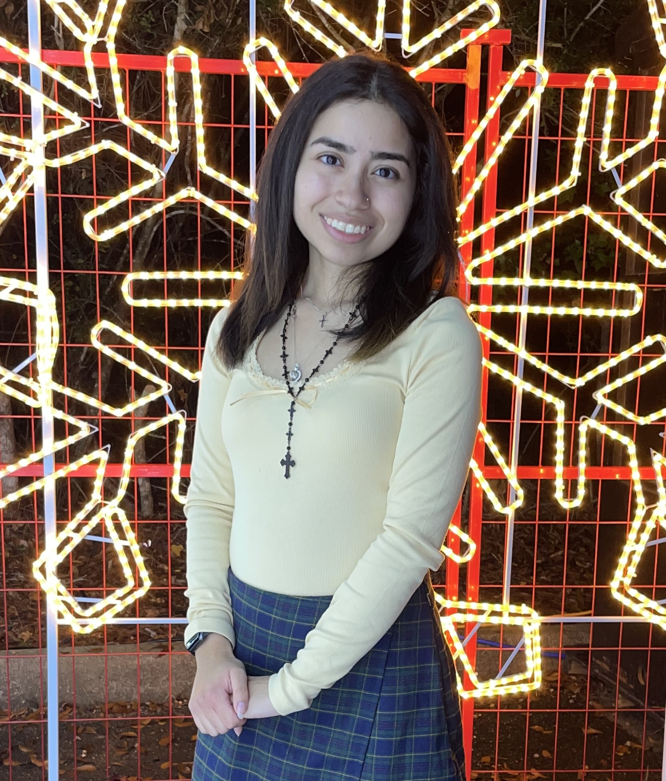
Paris | 8327765655 | phevperez99@gmail.com

About Me
I love coding, reading the Bible, and learning languages.

Work Experience
Lone Star College 2021 - 2026
Student

Work Experience
Goodson Middle School 2025 - 2026
Volunteer

Work Experience
CVS Pharmacy 2020 - 2021
Pharmacy Technician

Skills
- HTML, CSS, JavaScript, React, Python, Postgres, PHP
- Angular, Jasmine, Jest, Tailwind

