FIRE & CHILLI 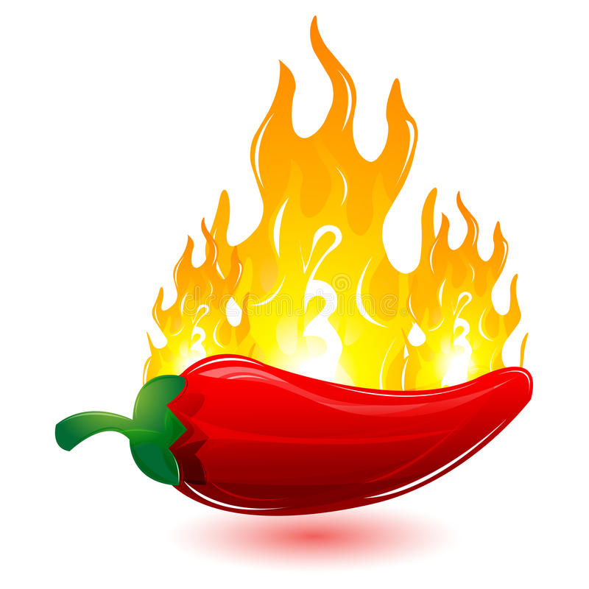

VEG NON-VEG

DISH PRICE DISH PRICE

H/F H/F

Veg. Chowmein 30/50 Chicken chowmein 50/80

Hakka noodles 50/80

singa