BRNO UNIVERSITY OF TECHNOLOGY
VYSOKÉ UČENÍ TECHNICKÉ V BRNĚ

FACULTY OF INFORMATION TECHNOLOGY
FAKULTA INFORMAČNÍCH TECHNOLOGIÍ

DEPARTMENT OF INFORMATION SYSTEMS
ÚSTAV INFORMAČNÍCH SYSTÉMŮ

Security and Performance Testbed for Simulation of Proof-of-Stake Protocols
Bezpečnostní a výkonnostní analýza proof-of-stake protokolů

Master thesis
Diplomová práce

AUTHOR Bc. Jan Kotráš
AUTor práce

VEDOUCÍ PRÁCE Mgr. Kamil Malinka, Ph.D.
SUPERVISOR

BRNO 2020

Abstract

Abstrakt

Keywords

Klíčová slova

Reference
Kotráš, Jan: Security and Performance Testbed for Simulation of Proof-of-Stake Protocols. Brno, 2020. Master Thesis. Brno University of Tech-
nology, Faculty of Information Technology. Supervisor Mgr. Kamil Malinka, Ph.D.
Blockchains & Simulation: Security and Performance Testbed for Simulation of Proof-of-Stake Protocols

Declaration
Hereby I declare that this bachelor’s thesis was prepared as an original author’s work under
the supervision of Mr. XMgr. Kamil Malinka, Ph.D. The supplementary information was provided by Mr. Ing. Ivan Homoliak Ph.D. All the relevant information sources, which were used during preparation of this thesis, are properly cited and included in the list of references.

……………………
Jan Kotráš
xx.května 2020

Acknowledgements
Here it is possible to express thanks to the supervisor and to the people which provided
professional help (external submitter, consultant, etc.).

Content
Content 1
1 Introduction 3
2 Consensus Protocols 4
2.1 Proof-of-work 5
2.2 Proof-of-stake 7
2.3 Proof-of-burn 8
2.4 Proof-of-capacity 9
2.5 Proof-of-authority 9
3 Consensus protocols testbeds 9
3.1 Studied properties 10
3.1.1 Implementation properties 10
3.1.2 Behaviour properties 10
3.1.3 Vulnerabilities 11
3.2 Actual exists testbeds 13
3.2.1 Bitcoin simulator 13
3.2.2 StrongChain Demo 13
3.2.3 SimBlock 13
3.2.4 Framework - Evaluating PoW Consensus Protocols's Security 14
3.2.5 The balance attack, proof-of-work testbed 14
4 Problem definition (motivation) 16
5 Proof of stake algorithms 17
5.1 Casper 17
5.2 Algorand 19
5.3 Ouroboros 21
5.4 Ouroboros Praos 22
5.5 Tezos 23
5.6 Actual other proof-of-stake protocols 23
5.7 Protocols comparison 23
6 Design 27
6.1 Design idea 27
6.2 Network part design 29
6.3 Consensus part design 31
6.4 Design of comparison – metrics 32
7 Implementation 33
7.1 Source code organization 33
7.2 Core models 34
7.3 Fee model 36
7.4 Communication model 36
7.4.1 Messages 36
7.4.2 Network 37
7.5 Ouroboros implementation 38
7.5.1 Implementation 38
7.5.2 Evaluation 39
7.6 Algorand implementation 39
7.6.1 Implementaion 39
7.6.2 Evaluation 40
8 Tesbed results 41
8.1 Simulator description 41
8.2 Network part simulations 41
8.3 Performance compare 43
8.4 Scalability comparison 44
Bibliography 47
List of appendix 49
Appendix A 50

Introduction

Nowdays the word „blockchain“ is common known, especialy thankfully cryptocurrency Bitcoin.
A lot of people connect Bitcoin and blockchain together, but the right definition that Bitcoin is the cryptocurrency implemented on the base of blockchain.
Blockchain is cuite new technogy with huge potential, that look for it‘s application. The potential is based on the decentralization. Blockchain is now widely used in the cryptocurrencies, but there will come out new types of application in the financial sector, electorinic elections, midical and so on.
In the blockchain is not exist any centralized authority. But for credibility of the blockchain network there must be some regulations and policy of a blockchain trafic. For regulate tranfic in the chain the block chain use consensul protocols. The most known algorithm is proof-of-work protocol, which is used in many applicaitons. But that protocol has some disadvantages, that I will talk about in the first chapter of the thesis. The second most know protocol is proof-of-stake. Proof-of-stake is trying to improved some disdvantages of the proof-of-work. Proof-of-stake is currently used in some blockchain aplications.
For implemented proof-of-work protocols already exist some theoretical and pracitical comparision, but for proof-of-stake protocols there now more comparisions. So, the target of that thesis is go thought proof-of-work protocol. Explain it‘s functionalty and compared them and create simulation testbed. In the [x] is results of simulation comparision.
In the [x] you can found intruduction in the work of blockchain network and ledger. [x] chapter is about most know proof-of-stake protocols and it‘s properties. Next chapter threat about implemntation of simulation testbed. And the last part discuss about result of simualtion and theoretical comparision.

Idea:

Replication
can have many roles [63, 25, 41], but blockchains replicate data only for resilience, not for scalability

Consensus Protocols
Blockchain is a distributed continously growing database. In the blockchain network does not exist a central authority. Blockchain network consists of participants (nodes). Every node can add some information to the blockchain database. Consensus protocols is described by algorithms. Consensus algorithms describe the validation of adding data into blockchain database.
There are 3 types of blockchain network we know about [1]. Permissionless blockchain like Bitcoin, where anybody can assign to network of blockchain, write/read an information. The second type is permissioned blockchain, where you can become a member only by given permissions. That permissions can be given by network, without central authority, although it can be. Third type is private blockchain, which is created for private domain or group of nodes. This thesis focuses on the permissionless blockchain. For reaching the consensus in this type of blockchain network there are used consensus protocols. There is no possibility of central direction of a network. On the other hand, in this type of consensus protocols there are more problems connected to consensus.

- Individual node can drop down and consensus protocol has to resolve it.
- Consensus protocol works above some network, so there is a possibility of interrupting the connection.
- Fair distribution of votes in the consencus.
- Consensus protocol has to be secure and resistant against attacks.
- Consensus protocols ensure, that the blockchain‘s data become immutable.

Consensus in blockchain can be established in many ways. Consensus is based on multiple entities that may not trust each other. Basic idea is to reach consensus by voting nodes of network. Participants of blockchain communicate over the network and cooperate together to construct consensus without central authority. That idea is based on the public election, so if 51% will agre, the consensus is valid. Problem is how to divide the power of votes into nodes. And this is the main difference between consensus protocols. Some of them are based on the CPU power – proof-of-work. Another one, proof-of-stake, is based on the amount of „money“ that node own.
Consensus protocols is a cornerstone of every blockchain technology. Almost all properties are based on the implementation of consencus . In the stacked model of blockchain we can find the consensus layer in the lower layers (Ilustration - https://www.researchgate.net/figure/An-ITS-Oriented-Blockchain-Model_fig4_332320425).
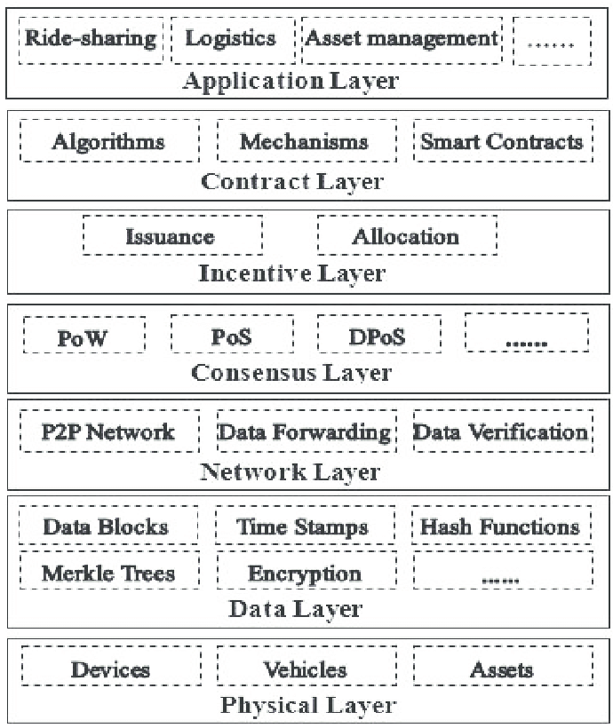

Proof-of-work
One of the consensus protocols proof-of-work is based on the physical resources “(Nodes) vote with their CPU power, expressing their acceptance of valid blocks by working on extending them and rejecting invalid blocks by refusing to work on them. Any needed rules and incentives can be enforced with this consensus mechanism” [2]. The idea of proof-of-work protocol was firstly published in 1993 by Cynthia Dwork and Moni Naor and was later applied by Satoshi Nakamoto in the Bitcoin paper in 2008.
Division of votes among all nodes is accomplished by resolving the mathematical puzzle. All blocks of blockchain ledger cointain some data like identification of previous block, sender, receiver and transaction data. The goal of the mathematical puzzle is to calculate SHA-256 hash (or any other hash algorithm) of the block. Proof-of-work adds some requirements on the transaction hash. One and main requirement: a hash produced by miners (miner is a node that wants to participate on the consensus) has to be lower than number or equal to it, which is setted by blockchain network. To reach that format the proof-of-work protocols add one field into blockchain block called „Nonce“. Nonce is a 32 bit number (Ilustration). The goal of miners is to choose nonce‘s value into hash that is equal or lower than target hash chosen by network. Nonce is the only value that can be changed by miner in the blockchain block. There is not any sophisticated method how to calculate nonce‘s value. The only way is to use brute force method.
Every block also contain „target“ hash information, which define maximum value of the produced hash. Final hash is a 256 bit number. Basically final hash starts with few zero „0“ numbers. Count of zeros is determined by blockchain network. By count of zeros the network can control difficulty of nonce calculation. The 32-bit size of the nonce means that there are four billion possible combinations. However, technically, it is much higher due to something called the extra nonce [3].
Practical example of nonce calculation is below [4].
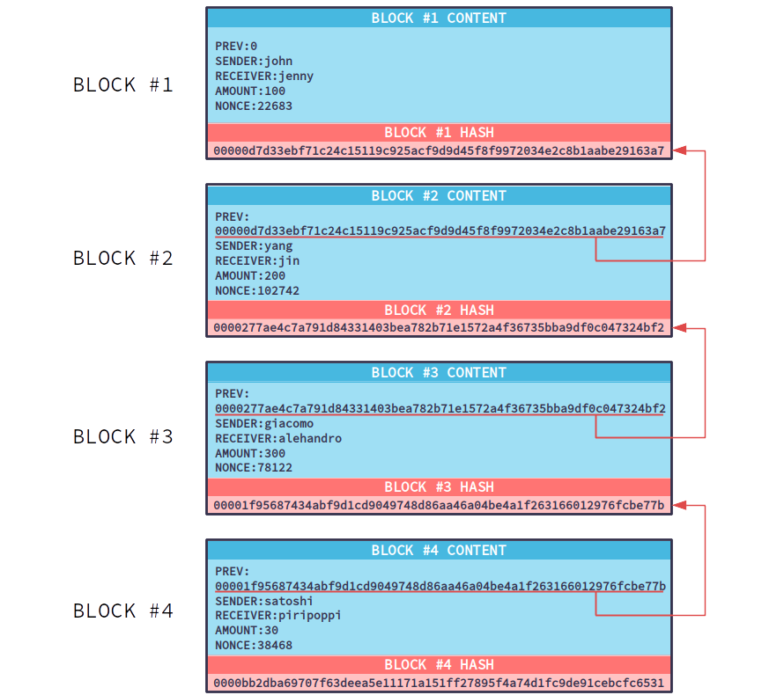
Illustration 1: Blockchain structure(https://medium.com/@julianrmartinez43/understanding-proof-of-work-part-1-586d7ee6b014)
Proof-of-work algorithm is mostly used in cryptocurencies. But there are some disadvantages of this protocol.
- 51% attack -
The history of blockchain is not changeable, because actual block points to previous block by its hash and that block points to his ancestor and so on. If you want to change some block, you have to recalculate all following confirmed blocks. In context of proof-of-work protocol, it is possible, if you have majority of network performance. If anybody owns that perfomance, he is able to create fraudulent blocks of transactions for himself while invalidating the transactions of others in the network.
- Electricity consumation
Another disadvantage is electricity consumption. During the calculation of mathematical puzzle a CPU or any other device only tries to calculate right nonce‘s number. That is processed by brutal force method. Brutal force method is not effective, so almost every elecricity is consumed by useless results of nonce‘s value.

Proof-of-stake
„Proof of Stake (PoS) concept states that a person can mine or validate block transactions according to how many coins he or she holds. This means that the more Bitcoin or altcoin owned by a miner, the more mining power he or she has.“[5]
First idea was published in the bitcointalk forum [6]. Motivation of that protocol was to save huge amount of the compution power and in the perfect way also to create more safe algorithm.
In the proof-of-stake protocol do not exist miners, but transaction validation is done by validators. Validator does not have to mine new blocks, validators only validate new blocks of blockchain database. Validator‘s power is limited by percentage of token that her or his ownership of stake. For example, validator has 1 percentage of money (token), he is able to validate theoretically 1% of the transactions. 1% only thereoretically because it depends on specific proof-of-stake algorithm and used method (Ilustration).
The main idea is based on the percentage of validator ownership. However, the idea has one big disadvantage. If the network detects, that validator (forger) validated fraudulent transactions, there is no punishment. In this way, the next improve is: The validator sends his money to the stack (stake) and starts doing the validation. When the network detects a suspicious behaviour, the forger node will lose a part of its stake.
In the proof-of-stake do not exist rewards for making blocks. The validator takes transaction fee for every validated transaction as reward for validating the transaction.
The proof-of-stake algorithms use a pseudo-random election process to select a node as the validator of the next block, based on combination of factors that could include: the staking age, randomization and the node’s wealth. The most used algorithms for chosing validator are: ‚Randomized Blockchain Selection‘ and ‚Coin Age Selection‘ [7]. In the ‚Randomized Blockchain Selection‘ the validators are selected by combination of amount of stake and by the lowest hash value. Second one, ‚Coin Age Selection‘ algorithm chooses, how long is their token waiting and number of coins that are staked. Practically, it can be calculated like multiplying the number of days by number of coins in the stake.
Proof of stake algorithm is now used in some cryptocurencies like:
- Ok cash
- NAV coin
- NEO
- ARK
- LISK
- PIVX
- Cardano

But more disscussed theme in nowadays cryptocurrencies and proof-of-stake protocols is the Ethereum cryptocurrency. This cryptocurrency plans to change used consensus algorithm. Ethereum actualy uses proof-of-work protocol, on the other hand, the implementators plan to migrate to proof-of-stake protocol. For that purpose the Ethereum should be divided into two separate cryptocurrencies. The first one is called Ethereum version 1.x with „old“ proof-of-work algorithm and the second one Ethereum 2.0, which will be hard fork of Ethereum 1.x with proof-of-stake consensus algorithm[8].
On the list blockchain protocols (cryptocurrency), each cryptocurrency has its own set of rules and properties for what the implementors of cryptocurrency think that is the best solution and combination of rules for them application.
This is a reason why we can find more wide types of solutions than in the proof-of-wrok protocols context. This thesis is focused on the differences in next chapteers.

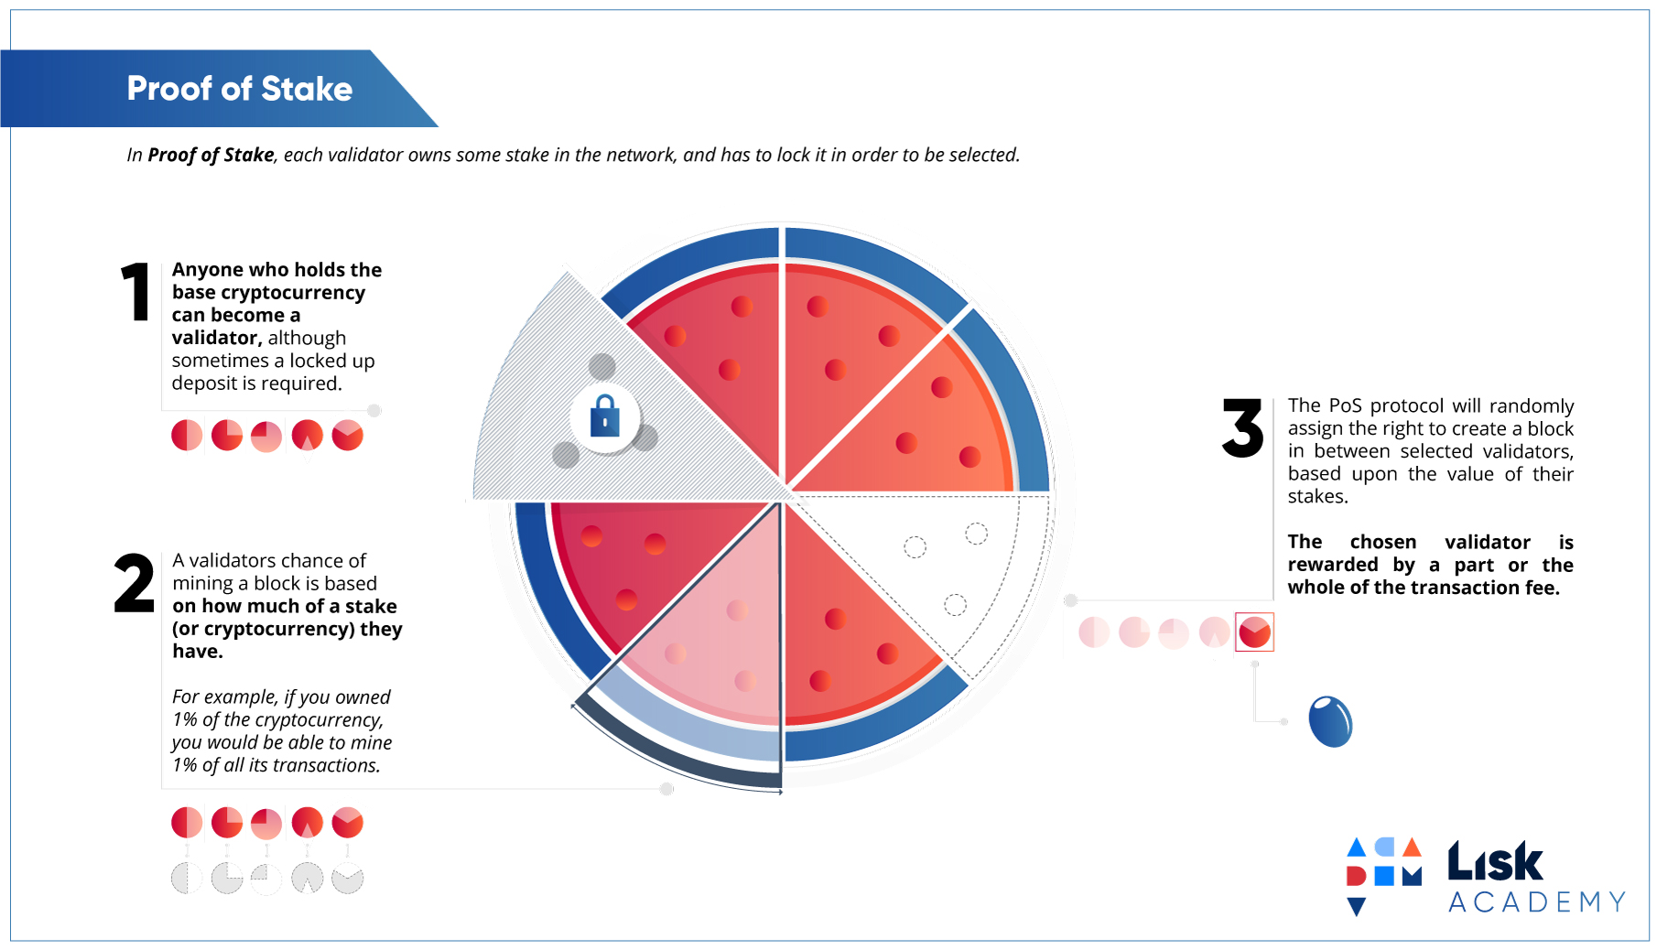
Illustration 2: Proof of stake validator selection (https://lisk.io/content/5-academy/2-blockchain-basics/4-how-does-blockchain-work/7-proof-of-stake/8-pos-infographic.jpg)

Proof-of-burn
Proof-of-burn is alternative approach for proof-of-stake or proof-of-work protocols. Proof-of-burn. as the new alternative, is being tested. Proof-of-burn was designed as more suitable alternative of the proof-of-work protocol. It is also popularly called proof-of-work without energy waste.
That consensus protocol is based on the burning (destroying) coins, that can be termed like virtual currency tokens. The basic idea was published by Iain Stewart, the designer of proof-of-burn algorithm - „Burnt coins are mining rigs. Essentially, a miner burns his/her coins to buy a virtual mining rig that gives him/her the power to mine blocks. The more coins burned by the miner, the bigger the ensuing virtual mining rig“ [9].
Burning of coins is processed by sending coin to un-specdable address [10] also called „eater address“ . Those addresses are randomly generated without private key. Thankfully, that address has not any private key associated with it, there is no way how to get to „burned“ coins. Sending the tokens to burn does not consume many resources and it encourses that the network is still alive and active.
Participants can burn token from other blockchain technogies. So, it is possible to burn coins based on the proof-of-work protocol in the proof-of-burn algorithm. Thankfully, proof-of-burn inherits cons and pros of the algorithm that is used for burnd coins.
The idea of the proof-of-burn technique is that users are willing to undergo a short-term loss for long-term investment by burning a cryptocurrency. Burned coins grant the right to write blocks in the proportion to the burned virtual tokens. Basically, if you burn more coins, then you have more right to mine blockchain block. Participants of burning can be rewarded for their activities.
Practically, proof-of-burn is used in the algorithm named Slimcoin [11]. Slimcoin actually combines three algorithms – proof-of-work, proof-of-stake and proof-of-burn. Proof-of-work prepares coins for burning. Proof-of-stake manages mining rights, and the whole system follows proof-of-work ideas. In Slimcoin, the burn of coins does not give rights to the next block, but you can get a chance to receive blocks in future time period – about a year.

Proof-of-capacity
Proof-of-capacity is also called proof-of-space. It is based on the same idea like proof-of-work protocol. Protocol calculates the nonce‘s value to satisfy a requirements to the final hash.
But the proof-of-capacity does not use CPU or any other hardware to keep calculating, which means trying to find the right value of nonce. Proof-of-capacity tries to use the node hard-drive volume. Proof-of-capacity uses node hard-drive to save list of possible solutions of the hash activities. That is calculated before mining activity comes. Bigger size of hard-drive = the node can store more possible solutions and it has higher chance to win mining reward, resolve mathematical puzzle.
Mining in the proof-of-capacity protocol is divided into two parts. First called ploting and second one mining. During the first part, the protocol calculates files, exactly plot files. Each file contains large number of precalculated hashes. In the second part, the protocol starts mining. Mining is being processed on the incoming data with support of the saved plot files. The protocol cooperates with hard-drive and tries to find right solution based on the precalculated files.
Proof-of-capacity protocols have less elecricity consumption than clasic proof-of-work algrorithm. Some literature says, that the proof-of-capacity consumes only 1% of elecricity, compared to proof-of-work algorithm. Other benefit is a price of hardware. Hard-drives are much more cheaper then expensive ASIC hardware.
Burstcoin [12] is a cryptocurrency used by proof-of-capacity.

Proof-of-authority
Proof-of-authority protocols are validated and approved transactions for future block made by validators. Validators allow putting the transaction in the block.
Proof-of-authority protocols are based on the reputation. That algorithm was inspired by the proof-of-stake algorithm, where nodes stake their coins. In the proof-of-authority nodes stake their reputation instead. Becoming a validator can be long process, because future validator has to invest their reputation in the stake. In that context, new node does not have enough reputation, or has only little reputation, so it is prety challenging to become a validator. It‘s long-term process.
Protocol is more suitable for private blockchain protocols, which are used in private networks. That can be used in certain business and corporations, especially for high perfomance and precondition of high trustability of network nodes.

Consensus protocols testbeds
This chapter is divided into two parts, first part of chapter is about consensus protocol‘s properties and vulnerabilities. Second part is about existing testbeds.
In introduction I explain what a testbed is. Testbed is a process and a way how to test and verify some scientific theories or new technologies. Testbed can be implemented as some hardware testing or software testing. In this thesis I will use software testing. Software testbed is a method for testing new ideas and approving some preconditions. Software testbed is implemented like isolated software, that simulates behavior of new software future running enviroment. Testbed is based on the proof of concept.

Studied properties
Each of consensus protocol has own implementation with another motivational idea. Some protocols are focused on the performance, some on the anonymity and other to security. We have different approaches how to compare those protocols and its properties. Each subsection of this chapter describes different point of view to properties.
Properties are focused on the bases of blockchain consensus protocols, especially proof-of-stake protocols. Declared properties will be used in next chapters for specific protocols comparison.

Implementation properties
In the context of proof-of-stake consensus protocols we can divide consensus algorithms into 3 groups by used type of blocks validation [13].
Lottery based protocols – These protocols are based on running lottery when output is leader or commiter which will validate next new block for the blockchain database. During processing of lottery, the majority of process is doing into nodes internally. This leads to the biggest advantage – small traffic over network. Protocol often uses ‚The Follow the Satoshi algorithm‘. Nevertheless, the biggest disadvantage of the lottery based protocols is a chance of electing more nodes as leaders and then creation of multiple blocks with same height = forks. Forks might potentially lead to some attacks – described in section 3.1.3.
Voting based protocols – Voting based protocols use another approach than lottery based protocols. New attached block is not validated by leader, but all participants are voting, new block is produced only collaboratively. But that voting needs a lot of network communication. Protocol that uses voting approach, almost always includes Byzantine fault tolerant (BFT) protocols. In the opposite, in the voting based protocol is very low probability of forks creation, for example Algorand.
Combination – In fact, practically strictly lottery based or voting based protocols do not exist a lot. Practical used protocol is trying to combine pros of all approaches to get better consensus protocol. For example in Algorand, which uses BTF, all nodes are not voting (more in next chapter).

Behaviour properties
Behaviour of every consensus protocol depends on the selected technology, implementation, features and other parameters. But for the consensus protocols‘ comparison we need some general metrics. Protocols can be evaluated by that. There is a list of metrics [14] used in practise:
- Scalability – determines property of protocols, how protocol reacts to increasing/decreasing number of participants. Some protocols can be designed for dedicated scale number of participants. Scalability also describes change of other properties like throughput or security in case of changing number of participants. There is no value or measurment. Scalability is described in words.
- Throughput – describes perfomance of protocol. Throughput represents the number of transactions per second. Measurment of throughput may have some assumptions. Throughput vary over protocols. Throughput highly depends on the type of consensus protocol (Byzantine Fault-tolerand, The Follow the Satoshi,…)
- Security – expresses security of a protocol. It describes susceptibility/defensibility on some vulnerabilities. Form of security is verbal description based on the theoretical models.
- Privacy – privacy expresses the protocol‘s property, how a protocol works with privacy users‘ data and how much of privacy data are published. Also, privacy describes traceability of coin owners. Anonymity is a part of the privacy description. Privacy is in word description.
- Failure-tolerance – property of protocols, how protocols deal with some network issue. For example participant network outage, connection problems, etc.. That property is a word described property, but it can be stated in some, for example percentage of participant that can fail.
- Liveness – ensures that honestly generated transaction has been available for other network nodes. Liveness is stated as an amout of time until generated transaction is available for other network nodes.
- Safety – ensures honest node accepts a transaction than other honest nodes accept this transaction.
- Finality – Finality depended on the safety. Finality expresses time or depth of the accepted block in blockchain history, when the block can not be removed or overturned.
- Energy efficiency – ratio between electricity consumption and completed work. Theoretically, it might be calculated like watt per transaction. But really, protocols are mostly strictly divided into two groups: poorly efficient (proof-of-work) and efficient (proof-of-stake).
- Immutability – property of protocol and generated blockchain, that can not be easily modified.
- Decentralization – decribes, if the protocol depends on some type of centralization (authority). If it does, how? Also decribes, if all participants have same influence to consensus.

Vulnerabilities
This subchapter describes basic blockchain vulnerabilities while focusing on the consensus protocol‘s vulnerabilities, especially proof-of-stake vulnerabilities. Subchapter does not focus on completed list, but focuses mainly on discussed problems. The goal is to describe types of vulnerabilities that will be compared in next chapters and testbeds.

- 51% vulnerability – is the most known type of blockchain attack. Attack consists of one attacker, who owns more than 50% of voting (mining – depends on consencus context) power. That power might be owned by more nodes, but practically, nodes belong to one dishonest behaviour.
It is hard to avoid 51% attack, because consensus protocols assume some percentage of honest nodes. Exactly more than 50% honest users, or 2/3 in BTF (Byzantine fault tolerant) protocols. But in contrast, when the attack is detected, the value of cryptocurrency gets rapidly low.
- Double-Spending Attack – the second one most known type of blockchain attack through all types of blockchain, consensus protocols. The attack refers to a consumer, who uses the same cryptocurrency coin multiple times for outcome transaction. The attack is usually a consequence of 51% attack. This type of attack has higher impact to protocols with lower finality.
- Breaking Network Assumptions – some protocols assume synchronized communication or any other assumptions. An attacker tries to break those assumptions. It is hard to defend, because protocols assume this properties of network.
- Time De-Synchronization Attacks – some consensus protocols are based on physical time. For example, Ouroboros need division of physical time into epochs and slosts (Next Chapter). Epochs and slots are identified by the division. An attacker tries to break system time to break participant‘s nodes synchronization.
- Selfish Mining – vulnerability theoretically possible in proof-of-stake protocols (need predictable randomness for election) [15], but practically realized in proof-of-resouce protocols. The attacker builds part of chain on his own and tries to publish it into public chain. Because attacker knows part of chain he made, he can mine without any additional effort.
- Nothing-at-Stake – it is proof-of-stake‘s specific vulnerability. The vulnerability can occur, if there is a fork in chain of blocks. When the fork occurs, the miners (validators) can perform work on both chains. And that could theoretically make double-spending problem. The attacker creates a fork and performs double-spending attack. The rest of miners are mining in their best self-interest – mine both chains. So, the chain, that becomes a part of public blockchain, is highly depended on the attacker‘s mining, because other miners are mining on both chains of fork, as well. This attack is highly proof-of-stake specific attack, because node (validator) can validate more branches together without risking its stake. It is trying to increase its chance to be rewarded.
- Grinding Attack – type of attack, where the attacker tries to increase his chance of being selected in the future. The attacker tries to find combination of different parameters (depended of consensus protocol). For example, if election process of proof-of-stake protocol is depended on a hash of previous block, then attacker can use that dependence for a future election‘s participants. New randomless for each election process, like VRF process, is the way how to avoid this type of the attack.
- Fake stake – proof-of-stake specific attack. Voting power of the one participant‘s conclusion is depended on its stake. The attack/problem is based on validation of participant‘s stake, that should be increasing along the chains, which are getting longer. During validation, the attacker might claim, that they own more stake than they actually do [13].

Actual exists testbeds
Between existed testbed exits some testbed or studies that are trying to compare or simulated protocol properties. Almost all testsbed are focused on the proof-of-work protocols. Only few studies focused on the proof-of-stake protocols, because proof-of-stake approach is only few years old.
In this chapter I go through testbed that focused on the proof-of-work and proof-of-stake protocols. I describe them minutely and I highlight properties that can be used for my designed testbed.

Bitcoin simulator
Bitcoin simulator [16] is an instance of framework [17], which uses a bitcoin network instance.
Framework consists of two key parts. First, a blockchain instance, and a blockchain security model. Blockchain instance can be theoretically classical proof-of-work blockchains like bitcoin, litecoin, ethereum (with PoW). Output of concrete instance blockchain simulation is a block rate that is used like input for security model based on Markov Decision Processes (MDP) for double-spending and selfish mining.
First part – blockchain instance captures dynamic setting of clasical proof-of-work protocols properties – number of nodes, number of blocks in simulation, block size, and more [16]. To reach more realistic simulation, the framework implements network layer simulation by advertisement - based information propagation, unsolicited block pushes, the relay network, the sendheader propagation mechanism among others.
Security model – second part. Extended Markov Decision Processes (MDP) is used as a model. By this process is determined optimal adversarial strategies. In the opposite, it determines combination of different blockchain setting, that leads to high vulnerability, especially double-spending attack and selfish mining.
Framework for network simulation uses NS-3 network simulator [18]. NS-3 is a discrete event simulator for system that is based on the internet network. NS-3 supports all ordinary network protocols. The simulator focuses on easy simulations with sufficiently realistic behaviour for classical purposes.

StrongChain Demo
Simulator, [19] that ilustrates communication between nodes in realtime. Simulator is based on basic internal blockchain implementation by account/balance model [20].
Purpose of the simulator is just to demonstrate some features a vulnerabilities by proof-of concept, like selfish mining. On the other hand, the simulator demonstrates, how real simulator can be implemented without any sophisticated tools nor any other frameworks. The simulator is based on the basic Python libraries.

SimBlock
It is a simulator developed in July 2019, that supports simulating of behaviour of about 10 000 nodes with using a single PC. Simulator is Java based and the code is publicly available on the internet [21]. Simulator currently supports Bitcoin, Litecoin and Dogecoin network.
Simulator is focused on performance and throughput testing. The result of simulatoin [22] is compared with simulator [17]. The SimBlock divides accounts into regions (like America, Asia, …), where the delay can be configured. The simulator is based on pure Java programming language and ordinary libraries. There is no frameworks of third parties.
SimBlock is an event-driven simulator. Each participant of simulator (blockchain node) comunicates with other nodes by ordinary P2P communication. The node generates messages and mining events. The simulator reacts on those events. The simulator uses internal instance of blockchain algorithms. Output is in the JSON format and it is challenging for human to read it. However, the implementators of Simblock also developed visualiser – simblock-visualizer. That visualize layout of nodes around the world and communication each other (Ilustration).
Simblock was implemented like proof-of-work simulator for blockchains like Bitcoin. But in the last months (October 2019) we could see some work on proof-of-stake simulation in Git history.
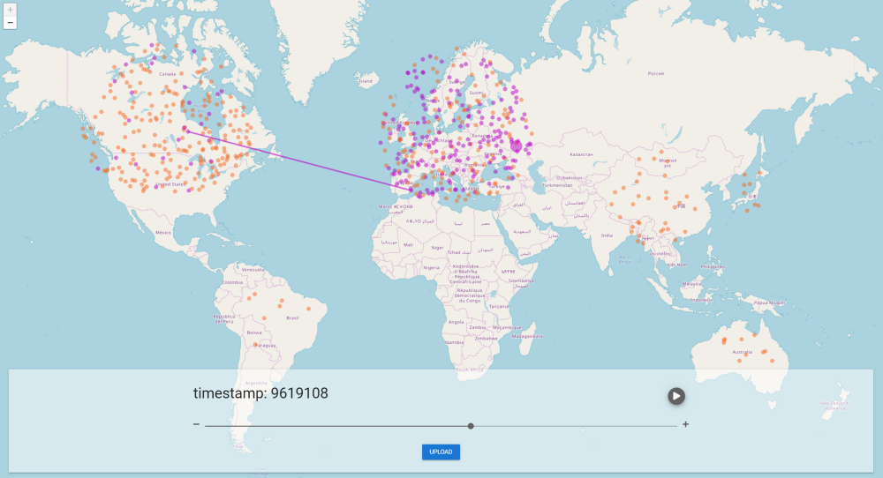
Illustration 3: Simblock visualization via SimBlock-visualizer

Framework - Evaluating PoW Consensus Protocols's Security
Framework for evaluation proof-of-work protocols security [23]. Framework code calculates optimal strategies of different proof-of-work protocols. Calculations are based on the models that are defined as a mathematical functions. Each part of model (mathematical function or equation) defines evaluation of some blockchain property or vulnerability, these functions define evalution metrics. Security model is based on the Markov decision processes.
The framework is trying to focus on proof-of-work protocols vulnerabilities, identifying them and evaluating them. It is based on evaluation analyzed behaviour of protocols in defined condition with defined setting. Output of analysis is measurment of protocol‘s vulnerabilities in the context of the defined pre-conditions. The analysis also creates basement for suggested improvements.
The whole framework is based on calculations, framework is not a simulation of protocol instances. The framework was implemented in the Matlab with support of the MDP toolbox for Matlab. A code of the framework is available for public [24].

The balance attack, proof-of-work testbed
Mostly frameworks, testbeds are focusing on the performance of a throughtput. Christopher Natoli and Vincent Gramoli identified new form of attack called the balance attack . This attack may lead to double-spending vulnerability. The paper [25] is about the balance attack, that is discovered in the proof-of-work blockchain approach.
The attack is tested against more used proof-of-work aproaches like Nakamoto’s consensus protocol and GHOST consensus. Nakamoto‘s protocol is used in Bitcoin cryptocurrency and GHOST is used in Ethereum cryptocurrency. This two cryptocurrencies or technologies is a part of these testbeds and compared to each other.
But I did not focus on this paper to proof-of-work or the balance attack. I focused on metric, how they are rating security issues, as I mentioned in chapter before. Security vulnerabilities are often defined only by word, or, authors declare, that the implemented protocol in not vulnerable against the attack. But in this paper, security is declared numerically. Rating is based on graphical representation of blockchain database. The balance attack stands on some type of blockchain forks. We can assume, that blockchain database is forked more times and graph seems like tree.
We can find the rating on the page 6 and 7 of the paper. Their rating of the balance attack vulnerability is made of comparison between the number of block mined by attacker and whole number of mined blocks. Basically, if difference with some probability is bigger than number of attacker‘s mined blocks, then there is a potential of the balance attack.
By defined relationship they can compare protocols and settings of one protocols, too. It is a good inspiration to metrics that will be declared in next chapters.

Problem definition (motivation)
As I mentioned in chapter before, we know lots of types of consensus protocol types. Every type of the protocol has its own advantages and disadvantages. Also, every type of the protocol can be better in specific usage than other protocol. In this thesis I will focus on the proof-of-stake type of consensus protocols.
Actually, proof-of-work type of consensus protocols are used most often. Proof-of-work protocols are widely used, because proof-of-work protocols used to be protocols that guarantee general targets of the blockchain network, like throughput, safety, scalability,.... But actually, the proof-of-work type of consensus comes to an edge of its properties. The biggest disadvantage of proof-of-work protocols are (propeties are related mainly to Bitcoin implementation proof-of-work consensus):
- Efficiency – Proof-of-work type of consensus has huge problems with efficiency. Protocol calculates a lot of calculations, but only an insignificant part of them are effective calculations. Other calculations are there only for construction of the proof-of-work type of the consesus. That leads to high electric consumption of the whole network.
- Perfomance – performance, or troughput of the network, is limited. Limitation of the throughtput is made because of security parameters – We can improve throughput but with worse security as a consequence.
- Finality – in the proof-of-work protocols it might create lots of forks. That property is highly limited for marking block as finished.

Mentioned disadvantages motivate lots of blockchain network implementators to try other consensus approaches. As the best alternative to proof-of-work protocols seems to be proof-of-stake protocols. Proof-of-stake protocols declare better properties (mainly mentioned) than proof-of-work protocols. This is the main reason, why this thesis focuses on the proof-of-stake consensus protocols.
In the proof-of-stake protocols field exist a few approaches how to implement them. The approaches are described in the previous chapter. In the previous chapter there are also discussed advantages and disadvantages of particular approaches.
In nowadays exists only theoretical comparison between proof-of-stake implementation approaches. Also, exists only a theoretical comparison between speficic proof-of-stake protocols. There are no testbeds or simulations that compare proof-of-stake approaches. But thanks to practical comparison of protocols, we can find new strategies of implementations, new potential problems or other properties of protocols, to make it better.
As the solution of that I will create proof-of-stake testbed inspired by proof-of-works testbeds. In the testbed I will compare a few proof-of-stake protocols. I will study specific protocols‘ behaviour in specific situations. I will focus on the declared properties of the protocols. As the result of testbed based comparison, I will get data based on the metrics that will declare protocols suitable.
Result will be used for improvement of proof-of-stake protocols. Result should give us the answer for question, „which protocol is better and why“, or „when is this protocol better than other and why“. Based on the result I can create suggestion to get better actual protocols, or I can design brand new proof-of-stake protocol.
As other result of thesis, a proof-of-stake community gains a testbeds with simulator. The simulator will include 3 proof-of-stake protocols instances and the simulator will be opened to new protocols instances. Thanks to that, implementators on new proof-of-stake protocol will be able to compare new protocol with existing protocols. Also, implementators will be able to compare configurations of this new protocol.

Proof of stake algorithms
In this part of thesis I will write about specific proof-of-stake algorithms. At first, the chapter will tell something about protocols. The chapter describes precisely a few proof-of-stake protocols. It will describe properties of algorithms like throughput, scalability, security, privacy, failure-tolerance, liveness, safety, finality, etc. In the second part of that chapter there is a sumarization and a comparison of the protocols.
The goal of all consensus protocols is to resolve conclusion above block of blockchain validation - approval. In this way are designed all proof-of-stake protocols. First idea was introduced in the thread of the BitcoinTalk forum [6]. First idea assumption that a set of nodes in the system is static. But that idea disagrees with idea for cryptocurencies.
Proof-of-stake‘s next problem is a subjectivity for new validation nodes. By subjectivity I mean, when the node joins into network, it has only a little amount of information about whole network. So its decisions are based on subjective judgment – two different nodes can make another decisions, because their decisions are based on different information. In contrast, proof-of-work does not has this problem, beacuse the proof-of-work network is based on the objective decisions. For preventing from this problem the proof-of-stake protocols can use these types of mechanisms:

- Limitaion of validating nodes – only currently bonded nodes.
- Withdrawal of stake must go through some period. Often called „thawing“ period
- Forbid reverting blocks that were created before some length of blockchain.

Basically, blockchain network is designed as peer to peer networks where all peers participate in the protocol equally to another peers. Network and protocol designs guatentee, that one node can participate in another nodes. But in some ways the network based on proof-of-stake protocol may have same trait of the server-peer network. That is because from all participants of network there is list of chosen nodes (based on it‘s stake), that will validate transactions processed by network. That trait of network depends on the validators choice and various types of proof-of-stake have different approaches to choose.
At the beginning, the proof-of-stake protocols was designed as the voting power of validator is calculated from amount of currency that the validator owns. But Vitalik, in July 2014. described a problem called „nothing-at-stake“ [26]. The problem presents this scenario: validators can effectively break safety by voting for multiple conflicting blocks at a given block height without incurring cost for doing so. It the other language. The system (network) is not punish validator for volting for moretimes to the different forks of blockchain new blocks. In the concept proof-of-work networks the validators (minners) is punnished by disribution it‘s minning power to two, or more, forks that only one will be selected and others will rejected. So also minning power used for that forks will be wasted. That problem is in lot of proof-of-stake protocols be solved by „slashing“.
Validator is allowed to vote for blockchain block which stands on its deposit. If voted block is finally approved, than the validator gets back their deposit and validator is rewarded by transaction fee. On the other hand, if voted block will not be finally approved, then the validator‘s deposit is slashed.

Casper
Casper is a proof-of-stake protocol for Ethereum cryptocurency. Casper is used in Ethereum named version 2, which migrates from proof-of-work algorithm to the proof-of-stake. Casper‘s protocol‘s family is divided into two separed algorithms. First, „Casper the Friendly Finality Gadget“ (FFG) [27] is a form of hybrid proof-of-stake/proof-of-work system. FFG is determined for migration the Ethereum to the world of proof-of-stake networks. In the base, the FFG uses more stategy from proof-of-work protocols. So there is not much information in this chapter about it. And the proof-of-stake strategy is used to reach more scalability and lower energy consumption. Second one, Casper “the Friendly Ghost (TFG)“ and Casper „Friendly Binary Consensus (CBC)“ are pure proof-of-stake algorithms [28]. They are implemented by Vlad Zamfir . CBC or TFG are planned as a final protocol for the Ethereum network. Both protocols are long term projects and now they are in process of development.
Casper protocols can be also called Bounded proof-of-stake (BPoS) consensus protocols. „They lock up part of their stake for a certain amount of time (like a security deposit), and in return they get a chance proportional to that stake to select the next block. Their voting power in the protocol is proportional to the amount of stake they are willing to lock up. Once the deposit is in place, it cannot be removed until a specified amount of time has passed. If these users are dishonest, they forfeit their deposit along with the privilege of participating in the consensus process.“ [29]
One of the Casper‘s family opinions is that Casper favours availability over consistency. Casper adopts a loking mechanism of stake. That means: the validator‘s stake is locked for certain period of time in order to prevent invalid behaviour of validator. This is the main solution of „nothing-at-stake“ problem. Another issue, which Casper implements, is an approval of new validators by old validators. Approval of new network‘s validators ensures more trustworthy of whole network.
A key goal of Casper is achieving “economic finality”. A block of blockchain is economically finalized, when block is a part of the blockchain forever or the block is denied and the actors voting that finalized blocks are penalized.
Economic finality in Casper is attained by validators‘ deposit. The deposit is submitted by validators. Thanks to the deposit, the validators can participate in voting the blockchain blocks. Finally, if the block was economically finalized, then the validators get back their deposit together with transaction fee. On the other hand, if block will be denied, then the validator‘s deposit is slashed.
Next feature for economic finality: Casper has unique feature that Casper has parameterizable safety tresholds. By that functionality, one validator can have different tresholds for economic finality. Also Casper do not limit quantity of active validators instead of some other proof-of-stake protocols like Tendermint, whict limit that one.
Very discussed issue of consensus protocols is performance. On the other hand the validators (in context of PoW - miners) are working only on validation of transactions. The validators earn only transaction fees, so their income is limited by their permability. That means, the validators have a direct influence to increase permability of the network. However, the network perfomance is limited by slower validators during the sync.
Casper‘s protocols come from a second category called Byzantine fault tolerant based proof-of-stake protocols. It follows some rules which guarantee safety and liveness, and Byzantine Fault Tolerance up to 1/3 of validators.
The biggest advantage of Casper, like proof-of-stake, is that attackers can be identified and their deposit can be destroyed immediately.

Properties at a glance:
- Available - Casper’s nodes may have their blocks fork until they come to consensus.
- Asynchronously safe.
- Live - Casper’s decisions can be live in partial synchrony, but are not live in asynchrony.
- Cartel-resistant - Casper’s entire premise is built upon resisting an oligopolistic attacker so no colluding set of validators can overtake the protocol.
- Safety - Depends on each validator’s estimate safety treshold.

Algorand
Algorand [30] is the first permissionless or permissioned pure proof-of-stake based blockchain. Algorand is an open source project developed mainly by MIT engineers lead by Silvio Micali [29]. Main idea is to build simple and fast consensus protocol and blockchain above them. This the motivation, why the Algorand bases on pure proof-of-stake algorithm - the creators of Algorand say it is protocol „without any complications“. Algorand has developed from 2017 and first launch was in June 2019. The whole consensus in the Algorand is created by expanded Byzantine consensus.
Some blockchain protocols suffer from balance against latency and confidence in a transactions. For example, for high confidence we need long latency and conversely. Algorand try to break dependency confidence to latency. Algorand fosuses on radical improvement a latency (performace) against actual existing blockchain protocols.
Key of whole Algorand is the new block generation use „new and fast Byzantine agreement protocol“ alsa called like „BA*“ [30]. This BA expands from classical message-passing Byzantine consensus with focusing on the performance and speed. BA* consists of 3-step loop. The BA* with more than 2/3 of the honest players ends in every loop with agreement by probability 1/3. This limitation the BA* inherits from classical Byzantine consensus protocols. The player is a randomly selected user among the set of all users. The set of players of BA* is much smaller than set of all users, the set of players is subset of all users. Selection of players is local - made, randomly among all users based on the user‘s stake weights. And this is the main property of the Algorand proof-of-stake views. For election of user, the BA* use verifiable random function (VRFs) [31] in private and non-interactive way. The computing is based on user‘s private key and public information of the blockchain. Since player is selected in private way, and adversary does not know who is a part of set selected users.
Each loop of the BA* consists of steps. For each step the algorithm randomly selects the set of players from sets of all users. Also, members of actual step do not know the next set of players, thankfully, there is no way, how to secretly pass internal value. Each step of the algorithm consists of players repeatedly exchanging the boolean value. All players‘ steps are not synchrony, so each player can process the loop at different times.
BA* works above gossip network. That network is similar to Bitcoin network. Network is used by players (small set of randomly selected users). Player owns public and private key. Private key uses gossip network to sign all messages. That ensures messages cannot be forged. Gossip protocol is communicating over the TCP protocol. Image (Ilustration) shows, how are players selected and then passed into gossip network with final consensus broadcasting.

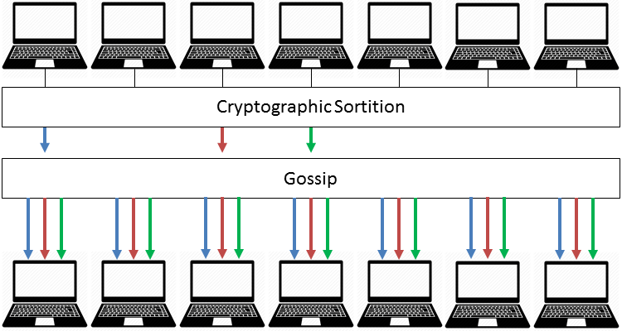
Illustration 4: Algorand players selection

Although the Algorand is based on public decentralized network, it still has some properties of centralization, especially in early stages. One of them are tokens. In the early stages, the founder holds a set of tokens, which is not more than 49%, and uses them to moderate network with only few users. When the count of user increases, the percentage of founder‘s token decrease. By that point the implementator ensures network security in early stages.
Algorand‘s transaction history can‘t fork with overwhelmingly high probability and it avoids double-spending problem. That probability is very low ( it is about 10⁻¹⁸). Traditional blockchain protocols support „forking“ of the blockchain ledger. After that can exist two short parallel forks of blockchain history according to different users. After several blocks of chain have been added, we can be sure that all blocks are the same for all users. Algorand users can rely on the payments contained in the new block as soon as the block appears. This approach highly supports time of transaction process.
Although network almost can‘t generate fork, the network implements various fork resolution procedures inspired by proof-of-work algorithms.
Because of using the BA*, avoiding fork argeement and others properties, the Algorand do not need any mining or mining strategies. Users, especially players of agreement, do not stake their tokens (money) so algorand does not need any mining reward. The function of network is based only on users and BA*.
Practically, Algorand is able to create new block of the blockchain in less than 40 seconds in experiments. Algorand is based on theoretical [32] and practical tests [33].

Algorand assumes for its work some theoretical values like:
- more than 2/3 of players are honest
- Blockchain fork is less than 10⁻¹⁸

Algorand properties:

- Throughput – was only tested. 1Mbyte block of transactions with 50,000 users was confirmed in 22 seconds. That is cca 2200 transactions per sec.
- Scalability – Algorand achieves high scalability by choosing a players (committee) for each BA* round. Impact on perfomance depend of size of committee. In Algorand persists problem with joining new user to existing network. New user has to fetch all existing blocks.
- Security - Algorand uses for security VRF function. Algorand is also based on asynchronous cypher methods. Algorand assumes, that 2/3 of users are honest, but Algorand does not actually implement some type of punishment for dishonest users. Hight part of security is also based on the non-fork implements and short steps of each consensus round.
- Privacy – Privacy is based on private keys. Users do not keep any private values except privacy key. Privacy key is used for signatures.
- Fault-tolerant – BA* protocol is inherited from classical BA protocols, that are fail-tolerant and benefit Algorand implement technique - Lazy Honesty [30]

Ouroboros
Ouroboros is a proof-of-stake protocol, which uses election algorithm The Follow the Satoshi (FTS) validator‘s selection. Ouroboros is actually used in Cardano cryptocurrency.
The process of the Ouroboros consensus is based on the discreet division of real time into epochs and the epoch into slots. Practically, an epoch has 10*k slots, where slot‘s size is about minutes and k is a security parameter [34]. Each slot of epoch has its own voted leader.
Ouroboros uses cryptographic flow named publicly verifiable secret sharing (PVSS) [35]. By using PVSS, stakeholders create committee and vote new epoch leaders. Each stakeholder publishes secret random number. That number will be revealed during the epoch. At the end of actual epoch, a final public random number will be combined and determines each slot‘s leader for next epoch. The process is divided into this phases:

- Committee formation – each stakeholder processes first part of PVSS scheme. Each stakeholder (committee member) creates random number privately.
- Commit phase - each stakeholder processes second part of PVVS scheme. Stakeholder commits this encrypted number by stakeholder‘s public key. Stakeholder sends a message to other commitee members. So each committee member should receive messages from other members.
- Reveal phase – Each member sends an „opening“ phrase to other members and the members are available to open a secret – reveal random number.
- Recovery phase – a group of members can contain some adversary. In this phase, committee members check who has not revealed their number. And if some members have not revealed the number, the member posts his number to them once again.
- Create seed – By combining (XOR) all secrect numbers we create a seed for FTS algorithm.

Those procedures explained above ensure unbiasedness during committee voting. Seed will be used for FTS algorithm. FTS algorithm needs randomness and seed is that randomness.
FTS collects all the smallest atomic pieces of coin, in the Cardono cryptocurrency called „Lovelace“ and their owners that is owned by stakeholder. FTS randomly selects one Loverlace and its owner becomes a slot leader. This part is a base of proof-of-stake behaviour, because more coins stakeholder owns, then higher probability stakeholder‘s selection.
To reduce a count of commit messages and to make protocol faster, the ouroboros limits size of committee member by minimal stake limit. The number of PVSS messages is in the m² category, where m is a committee size.
All messages sent in the Ouroboros network are synchronous. There is a chance of attack [36] against Ouroboros if condition of synchronous network is not accomplished. But phases of seed creation can‘t be asynchronous, because of security reasons and a chance of unbiasedness selection of leader.

Ouroboros properties:
- Throughput – has been only tested yet. The result was 257.6 trancation/sec [37] with assumption mentioned in the paper.
- Scalability – Scalability of Ouroboros should be well, mainly because of limited committee size. But that claim is not practically confirmed.
- Security - Ouroboros is high secure blockchain consensus algorithm. Firstly, Ouroboros implementation focuses on security. Basic types of blockchain attacks were tested in [37]
- Privacy – Ouroboros does not focus on privacy primarily.
- Liveness – Liveness is ensured and based on theoretical calculations. Value is dynamic by protocol configuration. But pracitically is depended on multiple slot‘s time (minutes)
- Finality - Finality is ensured and based on theoretical calculations.

Ouroboros Praos
Clasical Ouroboros is sometimes described as an evidence of proof-of-stake algorithms security. Ouroboros Praos [36] is an improvement of ordinary Ouroboros, which is based on pracitical experiences. Ouroboros Praos uses the same division of time into epochs and slots like ordinary Ouroboros.
For randomness Ouroboros Praos uses a verifiable random function (VRF) instead of PVSS. VRF generates pseudo-random number based on an input – private key and other chain-based input. Anyone with a pair public key/ private key can verify, that the number was produced by chain-based input. It also verifies, that pseudo-random number was not produced before.
Agreed nonce is used as chain-based input for each epoch. Nonce is produced by VRF values in block headers of the previous epoch. For each slot of the epoch all participants calculate random number by VRF. If the number is less than value proportional to their stake, then the participant becomes a leader for that slot. It is possible that more participants, or none, become leader of a slot. Code below shows, how this process works [38].

Code 1: Pseudocode - VFR + leader selection
T = calculateMyThreshold(myAmountOfStake)
foreach 1..nSlots -> i:
y, proof = VRF(myPrivateKey, concat(epochNonce, i, "TEST"))
if y < T:
getReadyToGenerateBlockAt(i, y, proof)
Described process is main difference between Praos and classical Ouroboros. Participants are not limited by their stake to become a leader. Anyone with some stake can become a leader. On the other hand, by that process, there can be more leaders to one slot. And when more leaders are elected in the one slot, they will create a fork of blockchain, even if leaders are honest. That can lead to some vulnerabilities.

Ouroboros Praos properties:
- Throughput – is not mentioned
- Scalability – a little bit better than Ouroboros, by another voting process
- Security - Ouroboros Praos is not vulnerable against grinding attack, than ordinary Ouroboros
- Privacy – Praos uses VRF, slot leader is not known publicly ahead of time. But that property is used more for security benefit than privacy
- Liveness – same as Ouroboros

Tezos
Tezos [39] is a decentralized blockchain that uses a proof-of-stake model for consensus. Consensus mechanism in Tezos does not have its own name. In this subchapter, I will call it Tezos as consensus protocol name.
Tezos algorithm uses „liquid proof of stake“ LPoS, liquid democracy model. Model is based on direct and representative democracy, that floudily changes. Validators are called bakers and validation process is called baking – baking blocks.
At the beggining, people vole for other people directly. Influence of voting is based on stake - number of own tokens. That voted people (delegated) can vote for other people by their own tokens and also by assigned tokens. If a person does not like their own voted delegate, then a person takes back own vote. Described process is also found in Delegated proof-of-stake DPoS. The Processes are ilustrated below (Ilustrace) by [40].
To became a baker (validator), a baker must hold at least a roll of tokens (roll corresponding to 10 000 tokens). Each block of the blockchain is baked by baker and signed by 32 other random bakers. If blockchain is sucessfully baked and signed, then the succesful baker gets a reward.

Actual other proof-of-stake protocols
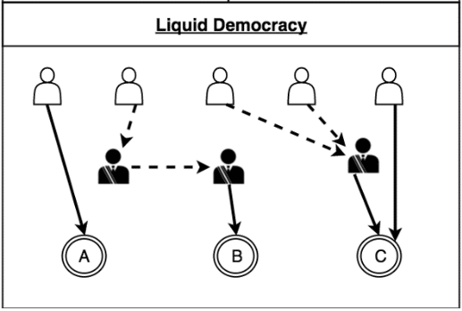
Illustration 5: Liquid Democracy
NEO – [41] is a blockchain, where its consensus is based on combination of delegation and Byzantine Fault-tolerand algorithm called delegated Byzantine Fault-tolerand protocol. NEO throughput is about 1000 transaction/sec. Difference from DpoS: stakeholder can vote validators at any time.
Lisk - [42] use little bit modified proof-of-stake consensus mechanism. Mechanism is called delegated proof-of-stake. Throughput is 25 transaction/sec.

Protocols comparison
This chapter is a summary of protocols comparison. Comparison is based on theoretical information, that is described above. Also, information is based on the papers cited in bibliography part of paper, and the paper [43]. In some part of table is cited short explanation why the protocol has those properties.
First table (Table1) compares protocols in fundemental properties like throughput, security, etc..Second table (Table 2) is focused on vulnerability comparison, some information in that table is based only on theoretical information, because a vulnerability of protocols has not been practically confirmed.

Table 1: Protocols properties comparision

Table 2: Protocols vulnerability comparision

Design
The goal of this thesis is a real comparison of proof-of-stake protocols, to evaluate cons and pros and propose possible improvements. For that purpose, a testbed will be created. This chapter will describe suggestion of a testbed‘s solution. Chapter is divided into few separed parts. First part is about basic testbed idea and base architecture. Second part of the chapter explains concrete suggestions of a solution. And, the third part mentions some used technologies and technigues.

Design idea
In third chapter, I was talking about stack model of block technology. I will use this model for basic design. The stack model consists of few layers, from physical (network) layer to application layer. Layer of consensus protocols lay between them. For design purposes, I separated the stack model into 3 parts (Illustration).
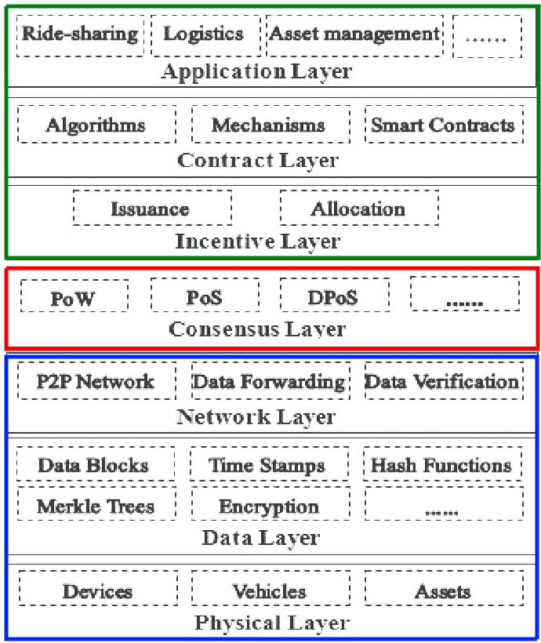
Illustration 6: Stack model divisition
First, blue part in the illustration consists of layers under consensus layer. These layers care about networking, communication nodes between themselves, encryption and so on. That layer ensures foundations of consensus layer. In the context of testbed, the layer is dispensable for implementation. Second layer is consensus layer, coloured red in the illustration. This part is whole centre of the implemented testbed. Last, third part, are layers above consensus layer. These layers get some practical sense to blockchain technology. This part contains some specific cryptocurrencies algorithms, smart contract implementation, etc. In the highest layer of this part, we can found user‘s applications for blockchain technology using.
As a part of simulation (testbed) I will create simulator to simulate bottom, blue, part of stack model. In real world, the blockchain technologies, especially blockchain techlonologies, which use proof-of-stake algorithms, communicate over the internet network. Internet is a huge, non-foreknow network. Internet is almost always ilustrated like some network – cloud. Blockchain uses internet network like medium for communication, but the blockchain technology builds own network topology above it.
Proof-of-stake protocols use blockchain network, which is built over internet network, it is P2P (peer-to-peer) network. So, in the simulation does not necessary to simulate internet network, it is possible to simulate only P2P network. This decision leads to some cons and pros. Disadvantage of the decision is a loss of some connectivities with real world using. Simulation looses unexpected behaviour of internet network and delay in communication, especially in communication across geographically distant continents. On the other hand, huge positive is that the testbeds will be more focused on the main topic - consensus protocols. Internet simulation can add some unexpected and non-deterministic behaviour of implemented testbeds.
Those informations above lead to implementation of only P2P. P2P network will be implemented as simple TCP based network. Network will not pay attention to any of complicated parts like routers, switches, etc. All nodes will have its own connection to all other nodes- ilustration.
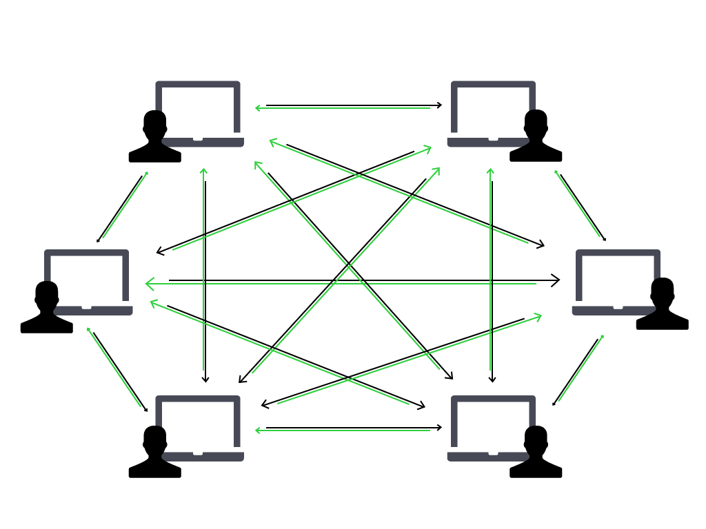
Illustration 7: Peer-to-Peer Network (https://cdn.steemitimages.com/DQmZAFtWv5imtESqJdab7kZiCycT5FMKutoda2yvtBR6Ds2/peer-to-peer-network-1.png)
The second, red part, is a layer of the consensus protocols. Layer implements specific proof-of-stake protocols. We can assume, that every node in the P2P network is a participant of blockchain network. So basically, it is possible to implement same proof-of-stake behaviour on each node. On this base, I can instantiate same behaviour on every network node.
For the implementation more proof-of-stake protocols in one simulator, it needs to create some procedure to simulate all of them. For testbed of one protocol, it is possible to start specific design and programming now, because in paragraphs above i demonstrated basic way of imlementation. But testbed, which will be dedicated for more protocols, needs to create design for that. Layers of networking are solved. I can focus only on the consensus layer design. The main idea is to separate common properties, implement them like base of consensus layer. That is create base interface for implementation of various proof-of-stake protocols. Simple idea is demostrated, with selected protocols and using of network layer, in the (ILUSTRATION).
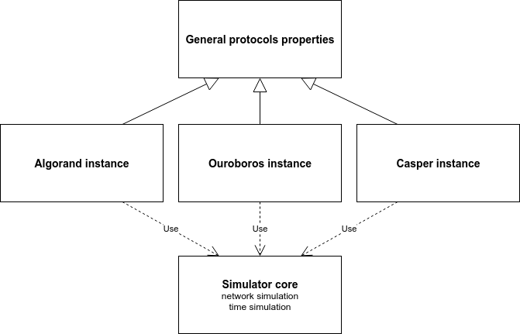
Illustration 8: Basic idea of consensus layer design
Part above, green part, does not need any design or implemetation, beacuse I focus on the results of consensus layer. Instead of that part (layer), I will create metrics, that will evaluate results of the testbed. Based on the evaluated results I can create comparison and design improvements of actual protocols. Specific metrics and way of evaluation is decribed in the chapter below.

Network part design
In the previous chapter I indicated the way of design of the network part of the blockchain stack. All things considered: Common idea is to build point-to-point network and simulate higher layers of the stack model above it.
In process of designing I was looking for a framework or library that perfectly supports simulations of various types of network. On the other way, it will be enough, if library supports only IPv4 and mesh topology. Also, in the list of requirements is a possibility to implement its own behaviour of each participant of network. Next requirement, but not strict requirement, is that a framework will be implemented in the Python programming language or it will contain Python API. That python requirements originate in my experience with Python programming language. Frameworks fulfilling requirements are Mininet [44] and NS-3 simulator [18]. For implementation of the testbeds, I decide to use NS-3 simulator, especially for its bigger users group.
NS-3 is a discrete-event network simulator. NS-3 is a free software under GNU GPLv2 licence. Simulator focuses on the networking simulation. It supports simulation, from simple networking like point-to-point topology, to complex topologies that can contain devices like switch, router, wifi AP, etc. Big advantage is: the simulator bases on the discrete event, that enables to run simulator in simulation time, not in real time.
The framework is a complex network simulator. It puts together a small parts (layers) to final simulation. The framework is implemented like connection network layer into functional unit. At the beggining, some implementations create physical layer of network – nodes, topology. And next implementations create next network layers that can use implementations from lower layers. On the last application layer, it forms applications to nodes. All these parts are implemented in the core of simulator. A specific implementation of simulation only uses layers and connects them into functional unit. In the testbeds, I will use that procedure too but at the end, I will implement my own proof-of-stake specific applications for nodes of network.
NS-3 is implemented in the C++ programming language [45], but it provides API for python programming language. The API can be used only for simulations that uses already implement parts, devices, nodes in the core of framework. For own implementation of the testbeds I need to redefine behaviour of nodes, and this code is available only in C++ source code. So implementation of testbed will be written in the C++ programming language.
As the physical design of topology I decided to use bus topology. Desicion is made with regard to NS-3 simulator. Implementation of more than 10 nodes in the mesh topology is quite complicated, because every node need x-1 ports where x is a count of nodes. Bus topology is almost same like designed topology mesh. But in the bus topology does not exist dedicated physical connection between two nodes (Ilustration) . In the bus topology, every node has one port, that is connected to common line. In the routing, bus topology does not change routing against mesh topology. Nodes can communicate directly with each other.
For routing I will use classical IPv4 stack. By usign IPv4 stack, I will avoid any network specific problems. Theoreticaly, the IPv4 stack is possible to observe milions of nodes, but practically, it depends on the simulator performance. In the design I suppose simulation from hundred to a few thousand nodes.
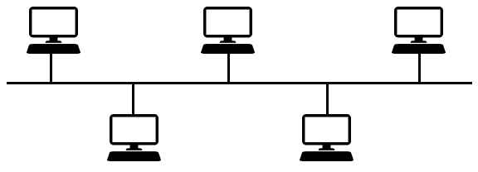
Illustration 9: Bus topology - https://1.bp.blogspot.com/-DWD0kH2Ag4Y/XQR9Fmqi5VI/AAAAAAAAACs/me70TxvwhHsuRAGFxLNeIi0brKPJTaiuwCLcBGAs/s1600/bus.png

Consensus part design
For testbed I chose protocols: Casper – the Friendly Ghost, Algorand, Ouroboros. The selection is based on the previous chapters. These protocols are representative of different aproaches of the proof-of-stake consensus. Also, protocols declare different behavior in various states. By this decision I expect high differences in the comparison. It will highlight the possitive and negative of its approach, and it will lead to final recommendation of proof-of-stake protocol‘s design and implementation.
There is a small repetation of three protocol properties and differences from chapters above.
- Casper (TFG)
  - BFT based protocol
  - Locked deposit
  - Voluntary size of the deposit
  - Not limited count of validators
  - Scalable
- Algorand
  - BFT based protocol - BA*
  - Deposit = count of owner tokens
  - Limited count of validators – commitee size
  - Random selection of commitee
  - VRF function
  - Very high scalability
  - 1000 transaction/sec
  - Liveness – lower minutes
- Ouroboros
  - FTS based protocol
  - Deposit = count of owner tokens
  - Use PVSS flow
  - Selection of validators – FTS
  - 257 transaction/sec
  - High scalability
  - Liveness – minutes

As it was defined already NS-3 simulator divides whole simulator implementation into layers. Simulator contains the application layer part, where consensus protocols is implemented. The implementation of proof-of-stake protocols can be divided into three parts: Data part of the blockchain implementation, common properties of proof-of-stake and blockchain, specific properties of protocol. By the data part of blockchain is defined the data stored in the blockchain – whole blockchain composite by blocks and transactions – blockchain database. The division is based on a pre-condition that the implementation of data part of blockchain is same for all protocols. If that pre-condition will be broken during implementation, it is possible to implement required feature into data part of blockchain without any influence on other protocols, other protocols will not be using this feature.
Data part of blockchain is designed like classical blockchain structure (Ilustration). Same part of structure will be abstract. For examle, for testbeds, it is not need to contain some specific data. In the context of selected C++ programing language, that the blockchain is designed like class that contains a vector of block class instances.
Common properties will be implemented in the base class for specific proof-of-stake protocols. Common properties will contain regular transaction generation, receiving new block, receiving new transaction and other properties, that are common for each proof-of-stake protocol. Also, in the common properties will be calculated with every node‘s stake, every node will hold its stake.

Jak budu implementovat – consensus part
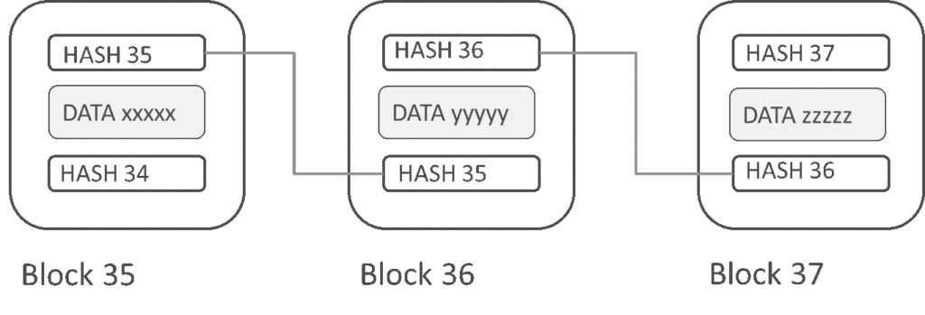
Illustration 10: Blockchain scheme (https://blog.trendmicro.com/wp-content/uploads/2018/03/blog-1024x349.png)

Design of comparison – metrics
The testbed properties, defined in the chapter above, will be compared and researched. There are properties defined from an other prespective. Properties are converted in the way, that allows to express properties as a number. By that, it is possible to get number result of specific protocols and it is able to compare them, and visualize in tables or graphs.
- Throughput – is defined like a count of flowed blocks through network per defined time. In the testbed I will be calculating the count of transaction per second. Troughput comparison of protocols will be based on same network‘s pre-conditions. For example, same network size, same count of network participants. As a pre-condition, it calculates same behavior of network participants – count of honest/dishonest participants. The metric acquires positive number from 0 to theoretically infinity.
- Scalability – Metric, that express scalability of blockchain network, which is related to the throughput. It explores influent size of network (count of participants) to performance. In the scalability, it will no calculate with dishonest participants. By discovered relation throughput x scalability is defined scalability in that thesis.
- Security – In basic there is defined 8 type of proof-of-stake attacks 11. I define the security of the protocol like count of attacks that the protocol is resist against. The security metric acquires number on a scale 0 to 8, where 8 is the best result, protocol resists against all defined attacks.
- Privacy – Privacy defines, if data in blockchain are visible to all nodes or public. Privacy will not be the main goal of protocol‘s comparison - of the pratical part of thesis (testbed).
- Failure-tolerance – It defines, that a protocol is resistant against breaking pre-condition to network part (layer). In testsbed, there was not defined numeric metricts that describes it. But a part of tests and comparisons will be fail-tolerance resistance testing.
- Liveness – It was defined above 10. The liveness states as amout of time till generated transaction will be available for other network nodes. In that context, the testbed will compare the protocols.
- Safety – A research of safety in the testbed will be calculated like boolean value – True/False. The value depends on the safety definition above 10. That means: if procotol complies the definition, then value is True else it is False.
- Finality – In the context of implemented testbeds, the finality is defined like time, after that the block is finally accepted, and there is no way how to change or delete block and its data from blockchain database.

Implementation
This chapter is about implementation of the testbed. The whole implementation process is divided into 3 parts. First part is an implementation of core of the testbed, we can call it framework. Second part is about an implementation of two selected protocols *(Mainly, because of the complicated implementation reasons it was implemented only). Third part focuses on validation of implemented testbed against the real protocol implementations.
I will write about these three parts in this chapter, but before that, I will describe detail technical solutions with NS-3 silumator connection.

Source code organization
NS-3 simulator‘s implementation divides into modules. Some of the modules are core modules for base simulator running. We can find there basic implemetation like simulation of the discrete time, logging, base network communication, etc. Other modules uses or extends functionality of base modules and create applications for specific purpoases, like point-to-point communication, wifi network, etc.
Every of this modules contains source code, that implements functionality of module. Moreover, almost every module has some runable examples of using module or runable tests. Programators can inspire there because in examles are mostly main functions of module showed. One module can use functionality of other modules. So, wifi module uses core modules, log modules, etc..
The way of implementation our testbed into NS-3 is based on the module source code organization. The testbed is designed like one module of the NS-3 simulator. The testbed module is called „proof-of-stake-testbed“. This module uses other modules for communication, logging,.... By that, the source code of the testbed stands alone. The source code is separated directly from NS-3 simulator. This also creates other benefits like comfortable using of version control system.
Module of the ns-3 simulator is organized as a directory. Our implemented module is based on the existing modules of NS-3 simulator. So, the module is designed and implemented in this directory structure [34]:
- docs – Documentation folder. Contains document about testbed.
- model – main folder of the testbed functionality. We can find there almost all source code. Directory is divided into logical parts:
  - core models – source code for testbed basement, called framework. There are source codes of blockchain functionalities and basic applications for work with blockchain.
  - Ouroboros models – extended core models and implemented Ourobors protocol behaviour.
  - Algorand models - extended core models and implemented Algorand protocol behaviour.
  - Casper models - extended core models and implemented Casper protocol behaviour.
- Helper – It is directory that contains supportive source codes for models. We can find there network factories=blockchain factories. Directory is also divided into logical parts:
  - Core helpers
  - Ouroboros helpers
  - Algorand helpers
  - Casper helpers
- test – Source code for tests
- utils – Source code for independent functionality. Supports funcitons and other independent programs.
- examples – Code of runable examples of the testbed. Directory contains implemented applications that create field for comparative perfomance, security, scalability, and other explored properties of protocols.
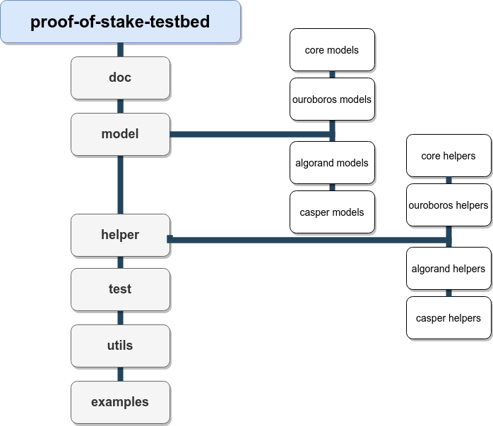
Illustration 11: Module structure

Core models
Code models are source codes that provide basic functinality of blockchain and provide basement for implementation of specific proof-of-stake protocols.
This list of models is logically divided into 3 parts. Blockchain simulation, proof-of-stake base application, helpers.
Blockchain simulation is a necessary way of implementation of blockchain database in the context of the thesis. Blockchain database is implemented by OPP. Base structure is showed here [35] in the class diagram. The structure is composed by three elements BlockChain, Block and Transaction.
Blockchain is a main element that will be created in every instance for each network node. Blockchain provides interface for working with whole blockchain database. Blockchain instance contains all blockchain blocks. Saving block into database is implemented like two-dimensional vector by C++. By that , it creates chain depencency of blocks and also fork support. So, the database of block is NxN sized vector. Length of the vector expresses block dependence between each other and height of the vector are forks of blockchain support.
Block is an element created in every round of consensus protocol. Block is mainly created by validator(s). Block contains transactions added by validator.
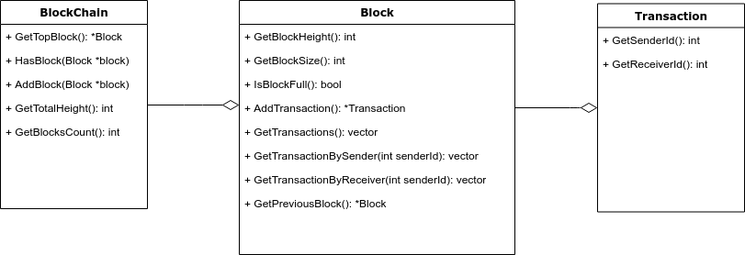
Illustration 12: Blockchain class diagram
In the design chapter I introduced a structure of the organization NS-3 applications. For reminder, Application is a program running on the network node. In the TCP/IP stack model the application is on the top level – client application.
Application of proof-of-stake is an application that extends clasical NS-3 application. It creates an abstract class that provides basic functionality for proof-of-stake protocols‘ simulation. Generalized functionality of proof-of-stake protocols are implemented there. By the abstract application it creates protocol‘s specific application for Algorand, Ouroboros and others proof-of-stake protocols. Abstract application ensures basic operations with blockchain. For example, abstract application ensures receiving new transactions. But, the abstract application does not ensure protocol specific behaviour, like voting for leader in Ouroboros protocol.

List of properties that provide abstract application:
- Receives messages – receives message and resolves a type of messsage.
- Receives transactions – process after receiving transaction.
- Generation of transaction – random generation of new transactions.

In the abstract application, there are implemented only receiving messages and resolving a type of message. If abstract application does not know the type of message, then abstract application lets parse message by specific protocol application.
One type of messages, that abstract application parse, is a transaction message type. Transaction is received, saved in the node and broadcasted to other know nodes.
Abstract application provides a generation of transaction. Generation of transaction is based on random generation. Generated transaction is sent broadcastly. Actually, it is possible to setup frequency of generation in two ways. It is possible to generate transaction with frequency by classical random C++ function or by possion distribution. Both ways of generation support setting main parameters in config file.
- For random function it is possible to setup maximal time of two generated transaction delay.
- For poisson distribution it is possible tu setup mean value.
Core helpers. In the implementaion there is created one main element that lightens the implementation of client‘s applications. If we think of ordinary proof-of-stake programs, than program has to solve lots of complicated things. Especially, things relate to decentralized way of communication. The way how to lighten the implementation is a creation of main element.
As a solution, I implemented the „helper“. Helper is an one instance of class, singleton. Every application (node) in the testbed has its own access to this helper [link to image]. Helper is independent to implementation of applications. Helper provides only interface for questions, tasks, which can be complicated implemented in node. Helper supervises consistency. For example, I can demonstrate the function of helper on the node question, „How many coins has node number 5?“. In the decentralized way it is quite complicated question. Node has to go through its local blockchain copy and calculate node stack. Also, the node has to deal with some problems with sychronization. But, if node has access to helper, it asks the helper. Helper stores this data locally and returns answer clearly, without any synchronization problems, because helper provides same data for every node – sigleton.
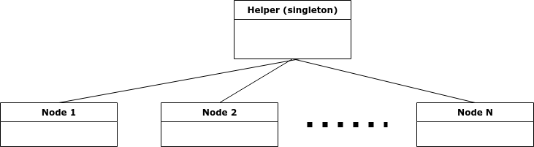
Illustration 13: Helper structure

Fee model
//TODO

Communication model

Messages
NS-3 simulator supports the comunication between nodes classical string messages. But, for our communication I need to transfer more structured data, like sending new transactions, blocks, parts of blockchain and others.
For sending structured data like text we decided to use JSON format. The decision of using JSON format was based on the property, that JSON is human-readable.
Base structure of JSON is:
Drawing 2: JSON message structure
{
type: 12,
timestamp: 1588490943,
…..
other_data
…..
}

Every message contains two required fields – type, timestamp. Type field demostrates a type of message. Type is an integer. By the value of type field we can sort message. Second parameter is a timestamp. Value of timestamp field is classical unix timestamp. Field contains a value of message created time. Also, a message has another specific field. The message has other fields depending on the type of message.
JSON is a string with special syntax. It can be created like classical string without any support of programming language. But, creating and updating JSON as a plain string is quite complicated and uncomfortable. For better programator comfort it is preferable to use some library that is supplied by user (programmer) friendly interface to work with JSON.
For this testbeds and simulator was chosen library RapidJSON [46]. RapidJSON is a parser/generator of JSON for C++ programming language. NS-3 supports adding libraries to source code of simulator. So, RapidJSON library was added to simulator by NS-3 documentation.
In the source code, every JSON serializable and JSON deserializable message (transaction, block,…) implements two methods. Methods ToJSON and FromJSON. Method ToJSON, creates rapidjson document instance with filled data. Rapidjson document instance can convert to the string. Method FromJSON is a static method. It receives rapidjson document as a parameter and returns the instance of deserialized object.

Network
In the design chapter I designed bus topology network. This type of network is suitable for tuning implementation of consensus protocols. Also, this type of network is suitable for small or specific consensus protocol tests. This is because bus topology network is characterized by straight and expected behaviour, without any network complications, because every node of the network can contact other node directly.
But this bus topology network is not suitable for more complex simulations of blockchain technology. Bus topology network absents some type of unexpected behaviour arcross the network communication.
As more complex network topology I introduce two network topologies - on the [Ilustration] and [Ilustration].
First network is compound by N local networks. Local network contains M nodes. Implemented network supports 254 nodes on each local network, but practically, I use local networks with size about 8 nodes. Local networks are connected together by one node of each local network. This creates the whole network topology. Edge nodes, that connect local network together, are critical nodes. I can investigate behavior of network without proper function of this nodes. Network addressing is based on the IPv4. Address space is 192.168.0.0 with mask 255.255.255.0. That means, we can create 254 networks, and every sub-network with 254 nodes. So, thereoretically we can create and run 64 516 nodes. Practically, that count is a little bit lower, because some nodes are not only in one network. However, as a precondition for testbed, the count of possible nodes is sufficient.
Second network type is compound by N nodes. Each node has a connection to another X random node. To be exact, X = 8. This type of network is called distributed network. Address space is 192.168.0.0 with mask 255.255.0.0. It is possible to create N nodes by that, where N=64 516/X. Network is resistant against the fail of nodes. This type of network is highly used in the blockchain simulations.

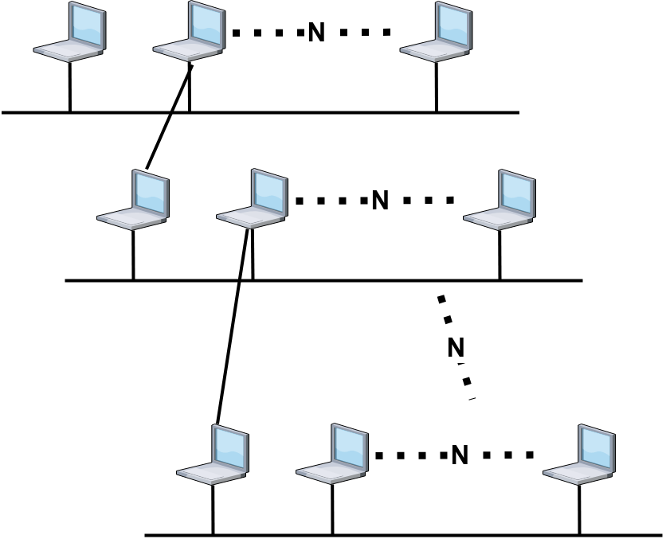
Illustration 14: Network version 2

Ouroboros implementation
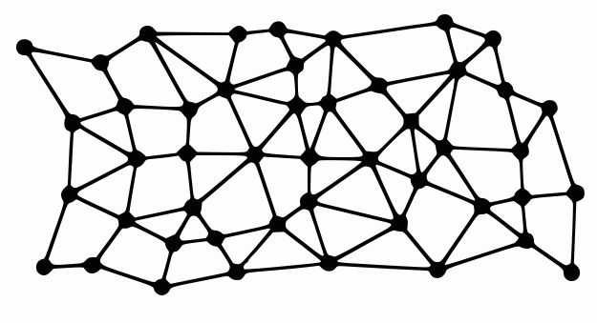
Illustration 15: Network version 2 - distributed

Implementation
For ouroboros implementation into testbeds it needs to follow three steps. Ouboroboros application creation, Ouroboros helper creation, extension types of messages.
Ouroboros consensus protocol is compound by four protocol‘s steps [link to previous chapter]. Commitment phase, Reveal phase, Recovery phase, Follow the satoshi phase. All these phases (steps) are implemented into the Ourobors simulation. But, some parts of implementaion are lightened against the original implementation of the protocol. All changes of lightweights are described below.
In the commitment phase, the node creates secret, encrypts it and broadcasts it to other nodes. In our implementation the generation of secret does by random function. So secret is pseudo-random integer. In original code, the secret is encrypted by RSA. In my implementation the secret is not encrypted and it is plain broadcasted. That is the main part of lightweight, with minimal inpact to results. When other nodes receive a secret, nodes save it and broadcast it to other nodes. By that, the secret spreads over the whole network. All nodes save that secret. The secret will be used in the future phases. Especially in the fourth phase for FTS algorithm.
Second, revealed phase is left out in our implementation, beacause in our implementation secrets are not encrypted. Also third phase is lighweighted.
Fourth phase is a phase, where Follow the satoshi algorithm is used. In our implementation, Follow the satoshi algorithm is lightened. For lightening the FTS implementation, it uses services of global helper (described above). Helper generates a leader of slot by pseudo random and by selection of one coin (Lovelace). Owner of this coin becomes a leader for slot. Helper in basic implementation generates only one leader for one slot. Helper saves that leader of slot is this node. So, when another node wants to know, who is leader of some slot, then helper returns that value from its internal memory.
All messages that go through simulation system are extended by one type of message = message type that contains secret value.

Evaluation
Here, I evaluate proper implementation of the Ouroboros protocol. I chose a few main properties. These properties will be compared - paper Ouroboros definition between my Ouroboros implementation. As main properties of Ouroboros protocol implemenation I chose:
- Ouroboros is a symetric protocol.
- Ouroboros is enable to create blockchain forks.
- Ouroboros uses FTS (Follow the satoshi) algorithm.
For evaluation - if protocol is symetric, then I can focus on generation of new block and the way, how protocol‘s specific messages are sent. In basic setting of the implemented protocol, the protocol produces new block every 4 seconds (dependent on the basic setting). If setting is unusual, blocks are still generated regularly. Also, Ouroboros messages‘ behavior is symetric, seeds are sent regularly. Implemented protocol is synchronized by slot and epoch number, that is in almost every message through the protocol process.
Ouroboros protocol is able to create forks. Next point of evaluation is = if implemented Ouroboros protocol is able to create some blockchain forks. During the basic testing, the implemented protocols create some two way forks, because I can enable creating two leaders for one protocol loop for different parts of network. By that, the blockchain fork will be created and protocol will be able to continue with these forks. By the procedure was proved, that implemented protocol is able to create and work with blockchain forks.
Ouroboros practically uses the FTS algorithm. But, in my implementation of the Ouroboros, Ouroboros does not use FTS algorithm. In my implementation of leader selection was not used pure original FTS, but for selection of leader I use centralized helper element, that simulates FTS algorithm. I do not compare this solution by any type of perfomance influence to whole implementation. I only suppose, that the FTS does not need any communication. It needs only seed as an input and as an output the FTS produces leader of loop. Same input and output has my central solution of leader selection. I establish solution of FTS as resolved on this idea.

Algorand implementation

Implementaion
Process of the Algorand node is a asynchronous process with few steps. Steps are:
- block proposal
- soft vote
- certify vote
Algorand functionality is based on the two concepts, Variable Random Function and Paticipant Keys. Implementation of this two concepts is discused bellow.
In the white paper We can found that Algorand process is defined like more accounts on one node. In our implementaion we neglect this and I crete only one account in one node.
Implementaion of Algorand extends simulator basement. It exteds it – application extension, helper extension, message types extension with Algorand specific messages.
Algorand helper extends base helper that propose function of node stack manipulation. Algorand helper uses that function and on that function it creted support for VRF simulation. So that means, VRF is not implemented in the applications but VRF is simulated by the centralized way. Helper create commitee members, that originaly based on the VRF, and propose them to applications (nodes). This apporoach provides central control over commitee members creation and we can easilly manipulate with them.
Algorand application extends base application. Application implements all three steps of Algorand process – block proposal, soft vote, certify vote. Application propose new block, but that does not every application. Application that propose new blocks is based on the Algorand helper and it‘s silumation of VRF.
Next two steps, soft and certify vote steps, are also based on the helper decisions. After sucess proccess of voting, all applications is able to add proposed blocks to blockchain. Algorand protocol contain some other phases, like recovery phase. These phases are not implemented in our testbed. Testbed contains only main part of algorand process. Also in the implementation you can not found advanced cryptographic procedure like Partipant Key.

Evaluation
There I describe evaluation of the proper Algorand implementation. For evaluation I choose main properties of the protocol. That properties are based on the Algorand white paper.
- Algorand use BFT* protocols
- Algorand is an asymetrics protocol
- In the algorand is almost impossible to create blockchain forks
- Algorand is composed of phases – block proposal, soft vote, certify vote
- Algorand use VRF function
Defined Algorand protocol is an asymetrics protocol. Each node of network should not be in synchronization with other nodes. So, there is not synchronization of nodes agains phases of protocol. Implementation of protocol support all asynchronization. Each sended message contains phase and loop number. By that, the receiver works asynchronize again other nodes. Additionally, in the Algorand protocol is setted timeout for received messages of defined phase, this is for high finnality.
Algorand protocol is composed by three main phases, that implement partly BFT* protocol. Our implementation of Algorand protocol is also composed of that main phases. Phases are implemented separettly to support protocol asynchronization property. Each node start phases individualy by its clocks, and each node react individualy to phases by received message.
Implemented Algorand protocol during test has not any trend to create blockchain forks. So, that point of main Algorand properties is accomplish.
Algorand use for commitee selection the VRF algorith. By VRF function is secret withou any communication among the users (nodes). VRF is running by node and by that node know if is will be part of commite. In our implemementation the VRF is replaced by solution with centralied way of solution. Principle is almost same like solution of FTS in other implemented protocols (for example Ouroboros). For selection of commitee the implemented Algorand protocol use centralized helper element. VRF function for its calculation do not need any comunicate, also the helper is not need any communication. Helper and calculation of VRF can be described by patthern Singleton. There is exist only one helper instance that provide calculation of VRF and controll calculation each other nodes.

Tesbed results
This chapter contains results of the testbeds. Subchapters are logically divided. First subchapter writes about testbed setting, used HW and simulator basic properties for using. Second subchapter focuses on the simulations on the network part of simulator. And last subchapters describe simulations of Ouroboros and Algorand protocols. In every part is a discussion that discuss about protocols advantages based on the observation.

Simulator description
For simulations I primary use my notebook with configuration: Intel Core i5-7200 2,5Ghz, 32GB RAM. This notebook was enought powerfull for simulations that will be described lower. But for advanced simulation I suppose to use more powerfull HW, especially for get lower simulation‘s time.
During simulation the simulator was able to simulate less than 2000 nodes effectively. More nodes leads to too higher HW requirements. When I simulated the biggest network of all simulations, the simulator used about 10 GB of the RAM memory and one real second process 1/48,2 of simulation‘s second.
I observed simulator behavior and requirements through all performed simulations, and there are properties of simulator by user side:
- One simulation is able to run on only one CPU core – one runned simulation uses for its running only one CPU core. The simulator NS-3 is not support parallelization. It little bit restrict using of simulator, because parallelization can lead to more faster simulations. But in practical way I can run more simulations separately at same time and create parallelization manually.
- RAM consumption – simulations with bigger networks (1000+ nodes) need quite lot of RAM memory, especially if decentralized network is used in the simulation. It was tested that simulator needs approx 8-16GB to simulate 2000 nodes network, dependent on the protocol setting.
- Average real time vs. simulation time. I observed that average proportion between real time vs. simulation time is about 1/22.3 on the network with 512 nodes. It means one simulated second takes 22.3 seconds in real time.

Network part simulations
Before simulations of specific proof-of-stake protocols I simulated behaviour of network part of the simulator. In the simulations I observed behaviour of network, especially when I change network size or when I select some nodes and turn them off – simulation of fail state.
Observing of network was based on the number - number of hops. This number is defined like number of nodes that message goes through, till it reach end of its journey. This number was observed on the broadcast sending. In the simulation I observe every message that goes through system and I note max number of hops and average number of hops and I use that number in graphs.
Next two graphs show us behaviour of decentralized network:
- Graph 1 [42] illustrate relation between network size and number of hops. We can see that relation between network size and number of hops is linear.
- Graph 2 [42] illustrate relation between number of failed nodes vs. number of hops. We can see that the decentralized network is resistant against node failed and number of hops per message is not radically change.

Graph 1: Network size x hops number
Graph 2: Count of failed nodex x hops number
//TODO some conclusion about network part

Performance compare
I ran simulations that their goal was to compare Ouroboros and Algorand protocol, by the perfomance side. Simulations simulate basic process in the network and I observed performance of individual protocols. In the network was not any attacks, breaking assumption, node fails, etc. During simulations I observed setting of protocols and its influence to the performance.
As basic result I found out, that performance of protocol is highly dependent on the protocol setting. I can explain it on the block size parameter, that has one of the most influence to the protocol‘s performance. As result I create two graphs [43][44], that visualize this influence. We can see that the dependency between block size and performance is almost linear, especially in the lower numbers of block size.
Almost same behavior I observe when I change any other protocols setting. For example when I change slot size in the Ouroboros protocol, that it has almost same influence to the performance results. When I set slot number lower, It lead to the higher performance, because protocol as whole, generates blocks in higher frequency.
The result that mentioned above may lead to edge setting of individual protocols, where all parameters of protocol setting will be set for higher performance. But this way of protocol setting highly probably can cause attack issues and vulnerabilities. So, the implementators of protocol have to test protocol and choose right combination and balancing of protocol setting.
Graph 3: Algorand performance (block size dependency)
Graph 4: Ouroboros performance (block size dependency)

Scalability comparison
Simulation for comparison of the protocols scalability I based on the change of perfomance and change of the network load. I observe change of network perfromance ( Transactions/sec) and I observe change count of messages that go through network when I increace number on nodes in the network. On this results we can base next ideas in the scalability issues.
Change of network load was observed on the two metrics. First metric is count of messages that nodes sent into network. Second metrics is count of messages that all nodes received together. The number of received messages should be same or higher then number of sent messages. Especially, in this type of network where it is used broadcast quite often. By observing that two parameters I can indicate trend of changing network load. On the trend I can base next speculating and comparing of protocols.
In the graphs I show results based on the network load. First graph [45] is graph that represent results of Algorand protocol and the second [45] represent results of Ouroboros protocol.
We can see almost same trend in both protocols. Same trend with unexpected behaviour in last measurment. This unexpected beahaviour is based in bigger change of transaction generation, because simulation was not able to simulate 512 nodes with top level number of transaction generation. So, for any type of conclusion I skip this last measurment for conclusion of general beahaviour or trend.
At the first sight We can say that the Ouroboros and Algorand have almost same behavior in the scalability property. But by closer look, We can see that Algorand has more scalability issues than Ouroboros. That is behause on the top result, Algorand generate more 5% more messages than Ouroboros and Algorands‘ nodes receive more 5% messages than Ouboros‘ nodes. I can seem that 5% is not big number. But I have to that almost 50% of network traefik is generation of new transations by random nodes.
So, based on the network load I was culclude that Algorand is little bit whorse in the scalability property that Ouroboros. I can assign that property to leaders group creation and volting in that group with compare to FTS protocol. But, that was only one compare of scalability. Lets look onto compare based on the perfomance.

Graph 5: Algorand scalability
Next step of scalability compare is comparison by throughput. I observe throughput of protocols (Algorand and Ouroboros). This Comparison has same setting as previous comparison. So at the last measurment we can see unexpected result explained before.
Graph 6: Ouroboros scalability
Graph [46] (Algorand) and graph [47] (Ouroboros) ilustrate results of observing both protocols with vary network size. Again, We can see almost same trent in protocols results each other. But is this results I can divire results into two groups.
First group i result in the lower network size. There we can see that the Algorand has better results and preformance against Ouroboros protocol. I attach this result to Algorand straight behaviour and straih goal to create and finalize blockchain block.
On the second group are results that show Ouroboros higher troughput agains Algorand protocol. We almost againg attach that result to Algorand necessity to create and use commitee. Algorand in my testbed has lower throughput againt Ouroboros about 20%.
Graph 7: Algorand scalability
Graph 8: Ouroboros scalability
Summary, In my testbed the Ourobors has better result for scalability issues. But I have tu mentioned that result was based on the basic network without any network complications, attacks, forks of blockchain and other. So, on the this result I can express that the Ouroboros is better for pure network and its scalability. This is base on sipliest way of block volting. On the other way Ourobors can has problems in pracitical networks, and there the Algorand can be much better than Ouroboros protocol. An it by Algorand more sophisticated way of block creating.

Bibliography

(1) https://drops.dagstuhl.de/opus/volltexte/2017/8016/pdf/LIPIcs-DISC-2017-1.pdf.
(2) https://git.dhimmel.com/bitcoin-whitepaper/.
(3) https://coincentral.com/what-is-a-nonce-proof-of-work/.
(4) https://github.com/danielefavi/blockchain-hash-block-calculator/blob/master/hash.php.
(5) https://www.investopedia.com/terms/p/proof-stake-pos.asp.
(6) https://bitcointalk.org/index.php?topic=27787.0.
(7) https://hackernoon.com/blockchain-algorithms-101-a-introduction-to-consensus-protocols-c00f884a01fb.
(8) https://docs.ethhub.io/.
(9) https://en.bitcoin.it/wiki/Proof_of_burn.
(10) https://eprint.iacr.org/2019/1096.pdf.
(11) http://slimco.in/.
(12) Burstcoin.
(13) https://medium.com/@dsl_uiuc/fake-stake-attacks-on-chain-based-proof-of-stake-cryptocurrencies-b8b05723f806.
(14) https://www.researchgate.net/publication/336734516_The_Security_Reference_Architecture_for_Blockchains_Towards_a_Standardized_Model_for_Studying_Vulnerabilities_Threats_and_Defenses.
(15) A survey of key evolving cryptosystems.
(16) http://arthurgervais.github.io/Bitcoin-Simulator/index.html.
(17) https://eprint.iacr.org/2016/555.pdf.
(18) https://www.nsnam.org/documentation/.
(19) https://github.com/ivan-homoliak-sutd/strongchain-demo.
(20) https://eprint.iacr.org/2018/262.pdf.
(21) https://dsg-titech.github.io/simblock/.
(22) https://arxiv.org/pdf/1901.09777.pdf.
(23) https://www.esat.kuleuven.be/cosic/publications/article-3005.pdf.
(24) https://github.com/nirenzang/PoWSecurity.
(25) https://arxiv.org/pdf/1612.09426.pdf.
(26) https://blog.ethereum.org/2014/07/05/stake/.
(27) https://arxiv.org/abs/1710.09437.
(28) https://github.com/ethereum/research/blob/master/papers/CasperTFG/CasperTFG.pdf.
(29) https://www.algorand.com/.
(30) https://arxiv.org/pdf/1607.01341.pdf.
(31) https://en.wikipedia.org/wiki/Verifiable_random_function.
(32) https://arxiv.org/pdf/1905.04463.pdf.
(33) https://people.csail.mit.edu/nickolai/papers/gilad-algorand-eprint.pdf.
(34) https://www.cardano.org/.
(35) https://en.wikipedia.org/wiki/Publicly_Verifiable_Secret_Sharing.
(36) https://eprint.iacr.org/2017/573.pdf.
(37) https://eprint.iacr.org/2016/889.pdf.
(38) https://medium.com/unraveling-the-ouroboros/introduction-to-ouroboros-1c2324912193.
(39) https://arxiv.org/pdf/1909.08458.pdf.
(40) https://blockgeeks.com/guides/what-is-tezos/.
(41) https://docs.neo.org/.
(42) https://lisk.io/.
(43) https://arxiv.org/pdf/1711.03936.pdf.
(44) http://mininet.org/.
(45) https://isocpp.org/.
(46) https://rapidjson.org/.

List of appendix

Appendix A

