
Date



Name” |  | Roll no & Sec’
Dept” |  | Gender'
Semester |  | D.O.B'
Batch* |  | Hosteller/DS”
Email^
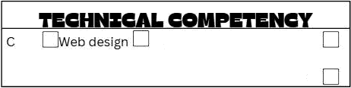
Photoshop
Android
Java
Pyrhon
Video editing
Flutter
I agree to abide by the rules and regulations of Microsoft Campus Club regarding student membership and functioning of the club.
Note: Amount to be paid for membership is T3DO for 3 years.

FOR OFFIBE USE ONLY

Recommended for membership
FACULTY ADVISOR SIGNATURE. NAME OF FACULTY.

Th:s is W ack=O/feoge chat. s a member of I ICC d'a“ing acace+me y .
Dace:

