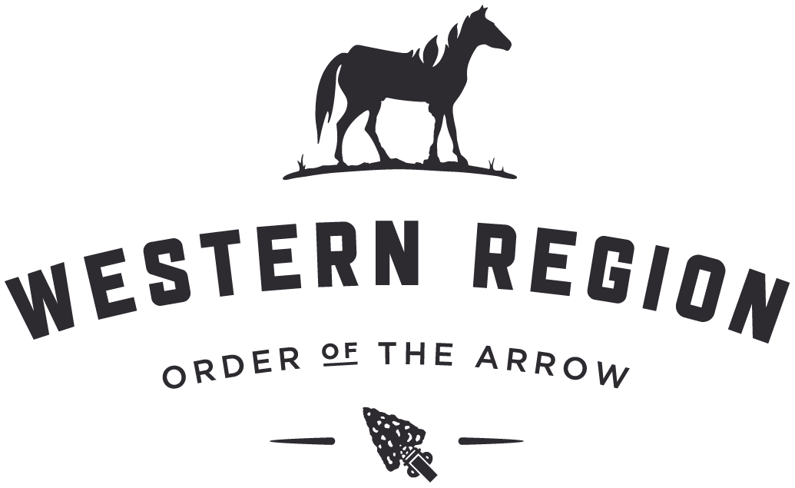

February 2017

SURGE Update

Supporting Units through Really Great Elections

This word document is a resource to be used when preparing the documents referred to in the SURGE presentation. It includes text for the sample letters and handouts that can be cut and pasted into your Chapter or Lodge documents, letter head or emails.

To create your own customized letter head, go to this URL and follow the instructions.

<http://www.oa-bsa.org/pages/content/order-of-the-arrow-brand-guidelines>

If you have any questions, comments or suggestions, please send them to [SURGE@oa-bsa.org](mailto:SURGE@oa-bsa.org).

Thank you so much for your interest in building really great relationships with your LDS units.

The Surge Team

**SAMPLE SCOUTMASTER LETTER**

[INSERT DATE]

To: Scoutmaster

From: Order of the Arrow, Tahosa Lodge, Spirit Eagle Chapter, Pioneer Trails District

Subject: Annual Unit Elections

Dear [INSERT NAME]

The Order of the Arrow (OA) is Scouting’s National Honor Society. It recognizes those Scouts and Scouters who best exemplify the Scout Oath and Law in their daily lives. All Boy Scout troops and Varsity Scout teams are strongly encouraged to hold an election to nominate and induct Scouts and Scouters into the OA. The Order of the Arrow will send a trained team to your troop or team meeting place to conduct an election that typically takes 20 to 30 minutes.

The Youth Membership Qualifications to join the Order of the Arrow are the following:

1. A Scout must hold the First Class rank or higher, be under the age of 21, and be registered as an active member of your troop or team.
2. With the approval of his leader, and the fulfillment of the camping requirement below, the youth may be nominated for election. Please verify qualifications before the night of the unit election.
3. Youth must have experienced 15 nights of Boy Scout camping approved and under the auspices and standards of the Boy Scouts of America. The 15 nights must include one long-term camp consisting of at least five consecutive nights of overnight camping. Only five nights of the long-term camp may be credited toward the 15-night camping requirement. The remaining 10 nights must be overnight, weekend, or other short-term camps of no more than three nights each.

Please take six minutes now and watch this video to learn more about the importance of the OA in LDS units and to see what we would like to show to your unit prior to your OA election: <https://youtu.be/5DSYktGo-h8>

Please email us at (insert email) or call at (insert phone number) to arrange for your OA Unit Election today! I can also discuss Adult Membership Qualifications or any other questions you may have when you do. I know you would not want the boys of your unit to miss out on the exciting opportunity and honor that comes with membership in Scouting’s National Honor Society.

Yours in Scouting,

[AS APPROPRIATE OR NEEDED]

Lodge or Chapter Chief Unit Elections Chairman Lodge or Chapter Adviser

Email Email Email

Phone Phone Phone

**SAMPLE STAKE LETTER**

[INSERT DATE]

To: Members of the [INSERT GROUP] Presidency,

From: Order of the Arrow, [INSERT YOUR CHAPTER OR LODGE INFORMATION]

Dear [INSERT NAME]

Perhaps you were a member of the Order of the Arrow as a youth or you have a friend who was. Now is the time to help the young men in your Stake experience membership in the Order of the Arrow (OA), Scouting’s National Honor Society. The Order recognizes those Scouts and Scouters who best exemplify the Scout Oath and Law in their daily lives. All Boy Scout troops and Varsity Scout teams are strongly encouraged to hold an annual election to nominate and elect Scouts and Scouters into the OA. The Order of the Arrow will send a trained team to your unit’s meeting place to conduct an election that typically takes 20 to 30 minutes.

The Youth Membership Qualifications to join the Order of the Arrow are the following:

1. A Scout must hold the First Class rank or higher, be under the age of 21, and be registered as an active member of your troop or team.
2. With the approval of his leader, and the fulfillment of the camping requirement below, all qualified youth may be nominated and elected.
3. Youth must have experienced 15 nights of Boy Scout camping approved and under the auspices and standards of the Boy Scouts of America. The 15 nights must include one long-term camp consisting of at least five consecutive nights of overnight camping. Only five nights of the long-term camp may be credited toward the 15-night camping requirement. The remaining 10 nights must be overnight, weekend, or other short-term camps of no more than three nights each.

Please take six minutes now and watch this video to learn more about the importance of the OA in LDS units and see what we would like to show your units prior to their OA election: <https://youtu.be/5DSYktGo-h8>

Please help us arrange OA Unit Elections in your Stake. I would be happy to discuss Adult Membership Qualifications or any other questions you may have. I know you would not want the boys of your units to miss out on the exciting opportunity and honor that comes with membership in Scouting’s National Honor Society.

Yours in Scouting,

[INSERT NAME AND POSITION]

[INSERT CONTACT INFORMATION]

Section 3: Conversation Script Handout

The following is a script of a sample conversation between an OA Election Team Member and

a Unit Leader:

OA Member: Hello, this is [ NAME] calling from the Order of the Arrow, Scouting’s National

Honor Society. May I speak with [Unit Leader Name]?

Unit Leader: This is [Unit Leader].

OA Member: Hello, [Unit Leader]. How are you doing this evening?

Unit Leader: I’m doing well.

OA Member: Great! I am calling to find out if you received our email/mailing that we sent a

couple weeks ago, specifically about selecting members of your unit to be inducted into the Order of the Arrow.

Unit Leader: Yes, we received it. I have a few questions.

OA Member: Great! What questions can I answer for you?

>answer questions, be prepared to discuss both youth and adult membership requirements<

OA Member: When could we come conduct a unit election for your troop/team?

Unit Leader: We will have a unit meeting next Wednesday, August 15th at 7:00 PM.

OA Member: That sounds great. Could you please prepare a list of eligible Scouts in your unit? Also, please encourage everyone to attend this meeting, both youth and adults.

Unit Leader: Yes, I will be sure to do that.

OA Member: Great. Could you please confirm the address where we will be meeting?

Unit Leader: 30 S Main Street, Centerville, Utah

OA Member: Great. Do you have equipment available to show a video during the meeting?

Unit Leader: Yes, we have everything available.

>If not be prepared to bring what is needed with you<

OA Member: Great! We will see you on Wednesday at 7:00 PM.

To create your own customized letter head, go to this URL and follow the instructions.

<http://www.oa-bsa.org/pages/content/order-of-the-arrow-brand-guidelines>

Then choose

[DOWNLOAD THE LETTERHEAD WITH CUSTOMIZABLE LOGO](http://www.oa-bsa.org/uploads/branding/OA_Letterhead_Template.docx) (WORD, 820 KB)

INSTRUCTIONS:

To create a letterhead for your specific lodge, section or region, please follow these instructions:

1. Go to the [OA Brand Guidelines](http://www.oa-bsa.org/pages/content/order-of-the-arrow-brand-guidelines) online and use the OA Signature Generator to create your custom sub-brand logo.
2. Double-click the header area of this document, and then click the Order of the Arrow, BSA logo image.
3. Right-Click the image and select “Change Picture…”
4. In the “Choose Picture” dialogue box, upload the custom sub-brand logo image you generated earlier on the OA website.
5. Click “Insert” and the new logo should replace the placeholder one.
6. When you are done, delete this instruction text and begin using your custom letterhead template.