**Question 1**

C. Refer to 2018320250.sh

D. Refer to screenshots below. (both tests conducted on virtual machine; right: GNOME Terminal)

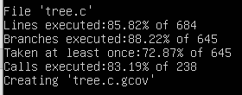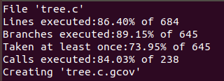

E. All functions were covered by the script.

a. Refer to 2018320250.sh

b. Ensure that tree.c and 2018320250.sh are within in the same directory. Simply execute the command ./2018320250.sh in the terminal (assumed to be bash) in the directory with the aforementioned files (ensure that the user has sufficient permissions to run the file; there will be further discussion on permissions and their impact on testing the shell script below). Running the same script twice will increase coverage when other files are not present (due to branches taken when files already exist), even though they were included in the submitted zip file.

Note that some common programs such as gcc, mkdir, ln etc. are assumed to be available to the user.

It is preferable to execute the bash script on a computer where the directory /dev has sufficiently many files of different file types to maximise coverage (i.e. the script was mostly tested and developed on a physical machine, in addition to a virtual machine running a full Ubuntu installation; minimalistic settings may reduce coverage).

The script also runs on the parent directory .. for some of the test cases, hence executing the bash script in an appropriate directory may ease the reproduction of results.

While branch coverage was increased by testing the program under situations whose reproduction would require superuser privileges (i.e. by running chmod on certain files to test the program or by running the program on directories that may be inaccessible to the user etc.), the availability of such privilege was not assumed. Hence, there may be minor discrepancies in coverage when run on the machine used for grading.

However, minimal permissions such as those required to create files and directories were in fact assumed and are necessary to extend coverage to certain functions in the program (cf. the submitted bash script).

c. Screenshots of output below; both are screenshots of tests run on the virtual machine; minor discrepancies may exist due to differences in set-up, permissions, terminal colours etc.



=> statements executed: **591** (out of 684) (right)

d. Refer to screenshots above. Both are tests run on the virtual machine; minor discrepancies may exist due to differences in set-up, permissions, terminal colours etc.

=> branches executed: **575** (out of 645); branches taken at least once: **477** (out of 645) => 575 – 477 = **99** branches executed but not taken (right)

e. While a test case can be constructed in such a way that an arbitrary number of test cases is run, when the number of commands is restricted to one, the most effective test case was the test case where multiple options were used at the same time:

./tree -adlfiqNpugsDFtxASnC -H . -L 50 -R -o logs/log . ..

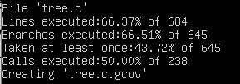

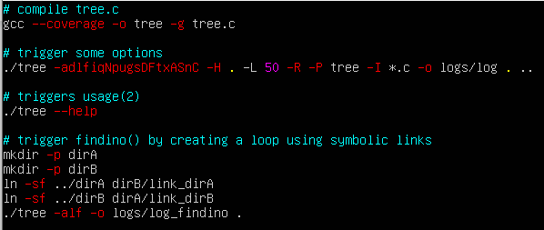f. Through some ablation testing (non-exhaustive), the three cases in 2018320250_t.sh achieved the greatest branch coverage:

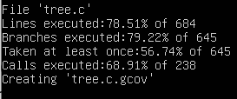

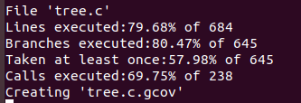

g. All functions were covered by the script.

h. All functions were covered by the script.