**CSc 102 Project Proposal Guidelines**

**Outcast Games**

Jonathan Gouws - 19G4436

Thabo Sifumba – 19S1606

Phil – 19M5303

1. Title: *Tales Of Valhalla*
2. Background and motivation.

This game is based on *Hearthstone* which is a strategy card game that models card collecting games such as *Yu-Gi-Oh!* (Konami Cross Media NY, 1996)*. Hearthstone* is an easy to play card game that is played between two players with a deck of 30 cards (Heathstone Gamepedia, 2019) that a player builds before the beginning of a match. Although *Hearthstone* is easy to play, it requires complex strategy to play. And has a reasonably large rule set, since each card in the game has its own characteristics. The cards in *Hearthstone* are divided into four main groups namely minion, spell, hero and weapon cards (Hearthstone Gampedia, 2019). At the beginning of the game each player has a health bar and a Mana bar.The aim of the game is to exhaust your opponent’s health by playing cards and then using the cards’ abilities. Mana is used to play cards, preventing unlimited actions being performed in a single turn.

This game is an attempt to mix a game like *Hearthstone* with another strategy game, namely chess (FIDE, 2018). Instead of having an open field for cards to be played on *Tales Of Valhalla* will have a board. This is an attempt to add an additional layer of strategy to the game and decrease the sense of luck of the draw that can be felt while playing *Hearthstone*. The board will have a nexus on each side. A player wins by destroying the nexus, which is achieved by attacking it until it has no health left.

The cards will be divided into three classes, namely avatars, structures and spells. Avatars will only be allowed to be placed on the first column of the board that is closest to the player’s nexus and will have to be moved up the board to attack the enemy’s nexus. Structures will be allowed to be placed anywhere on the half of the board that is closest to the player’s nexus, however structures cannot be moved once placed. Spells can be cast on any tile of the board.   
  
This variation will mostly be adopted in the proposed game. Most of the rules will be adopted from hearthstone, and a similar Mana system will be introduced with a Mana bar rather than Mana stones.

1. The aim of this project is to create a card game that requires a high level of strategy and planning to play well. An important feature of this card game is to keep the exiting feel of luck of the draw that is prominent in standard card games while maintaining the sense that skill is required to win, and that the outcome of the game was not determined by luck. The game has a somewhat complex rule set since the rules are not general and vary from card to card.
2. This project aims to implement a card game in Java with the following milestones: The first is to code a data structures for cards that can keep track of special features of each card. And after that a class that can contain a group of 30 cards known as a deck. Exactly two players can play this game at a time including a computer player. Therefore, either a human or computer player can make a move and the program will keep track of the states with a game state manager. An easy to use GUI will be designed to make the game both more attractive and more playable. This this work will be presented for assessment in the form of GitHub code and a Project Document, which will include the revision and extension of this proposal. The extensions will include a walkthrough of the steps through the SDLC that our group followed, and a Visual Guide that shows the game in action and can possibly be used as a tutorial.

|  |  |  |  |  |  |
| --- | --- | --- | --- | --- | --- |
| Activity | Predecessor | Time Estimates (days) | | | Expected Time |
| Optimistic | Normal | Pessimistic |  |
| Create Card Structures. | - | 1 | 2 | 4 | 2.333 |
| Create Deck Class. | Card Structures. | 2 | 4 | 7 | 4.333 |
| Create base GUI for game. | - | 1 | 2 | 3 | 2 |
| Design Cards. | - | 3 | 5 | 8 | 5.333 |
| Add effects for GUI. | Create base GUI for game. | 6 | 8 | 11 | 8.333 |
| Create a game state manager. | Deck Class and  GUI. | 7 | 10 | 12 | 9.666 |
| Create Menu. | - | 3 | 6 | 10 | 6.333 |
| Create menu utilities. | Menu. | 5 | 8 | 11 | 8 |
| Add more Cards. | Card Structures. | 6 | 8 | 12 | 8.666 |

Gantt chart, red lines indicate the critical nature of task.

2. SDLC:

In the production of this game, it was decided that an agile model should be used. The reason for using the agile model was due to a lack of time, and the full requirements of the program were not known upfront. The idea was to implement things as required, so that a working project, regardless of its complexity could be made before the deadline.

Specifically, the scrum model was chosen. The scrum model seemed to be the most appropriate for our intents, and it is a relatively easy model to follow, when compared to other iterative models. The scrum builds in regular meetings. This allowed the development to implement things as required and we could have regular meetings to make decisions to decide what would be the best way to implement the next requirements of each stage of an iteration.

The group discussed the project frequently, every three or so days for small implementations. We had meetings every two weeks to discuss the next stage of the project.

1. Visual Guide:

When the game launches the first screen that the user will see is screen one:

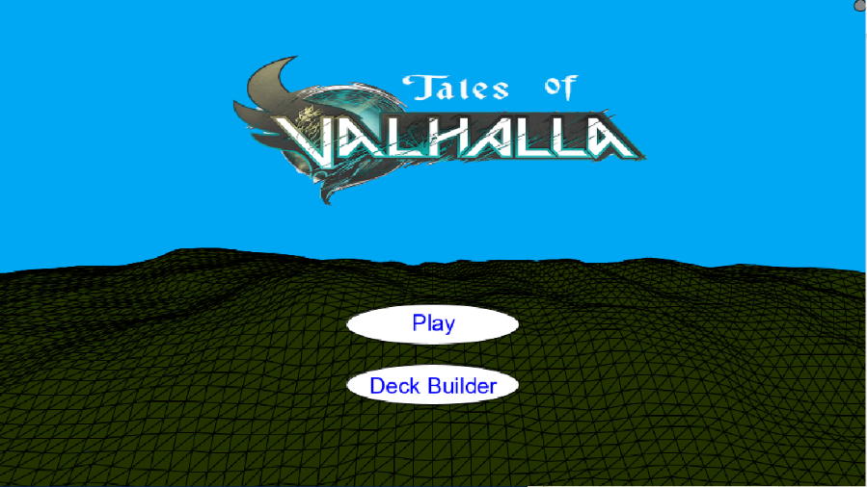**Screen one:**

From Screen One the user has three options. The first is to click the circle in the top right corner of the screen: This will close the game.

The second option is to click play. A click on play will take the user to Screen two.

The third option is to click on Deck Builder. A click the button with the text Deck Builder on it will take the user to Screen… .

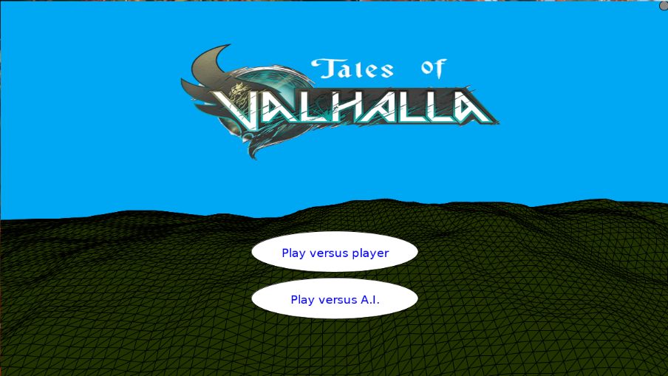**Screen two:**

This is the screen where the user can decide what game they want to play.

From Screen Two the user has three options. The first is to click the circle in the top right corner of the screen: This will close the game.

The next option is to click the button that says, “Play versus player”. This will launch two games, one for each player. For now, if the game is being run on a system with multiple monitors the two game will launch on two different screens, otherwise, both games will launch on the same screen. This takes the user to Screen three.

The third option is to click the button with “Play versus A.I.” on it. The click on this button will launch one game where the user can play versus the games built in Artificial intelligence. This takes the user to Screen 3.

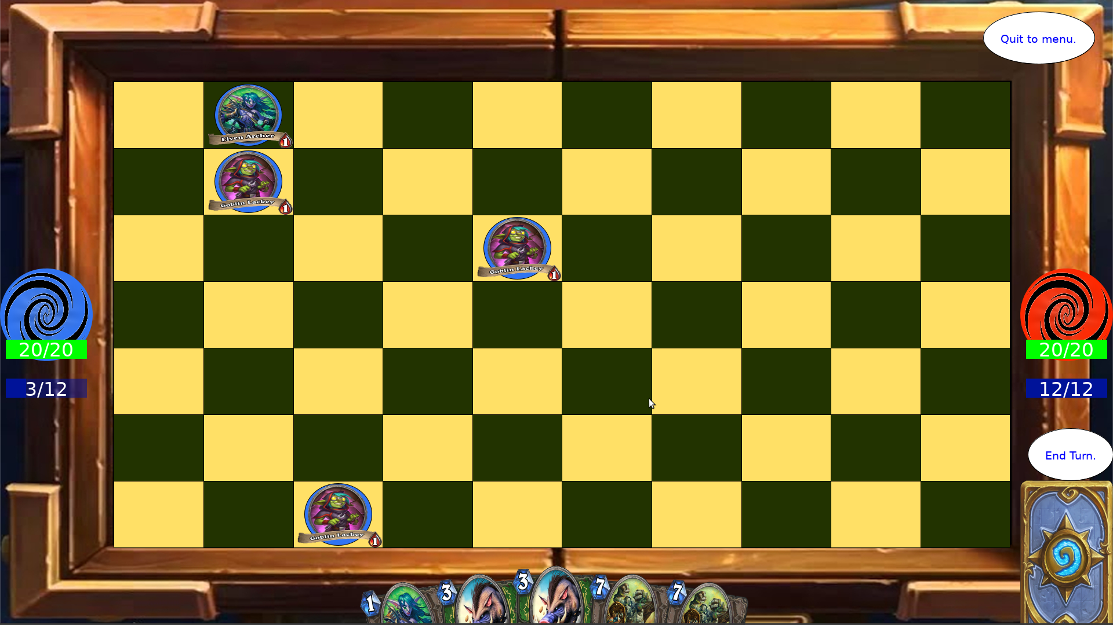**Screen three:**

This is the game screen, where the game is played. There are many options on this screen.

The user can click the button that has quit to menu written on it. This will take the user to Screen One.

The player can click on the deck (back of the card) in the bottom right hand corner of the screen, hold and drag the card to their hand. This will draw a card from the players deck.

The player can then click on a card in their hand that they have drawn and drag it to the board the card can thus be played to the board. The card can only be played on the column closest to the players nexus.

A card that has been played on the beard can be clicked to select the card.

Once a card is selected the options for which squares the card can move to will be shown. The player can the click the square that they want the card to move to.

When a card is selected, if there is another card in its vicinity the selected card can attack the card in the card’s vicinity. This is done when the user clicks the card that must be attacked.

If the opponent’s nexus is in attack range of a selected card, the player can do damage to the nexus, which will take the player’s health down. The game ends when a player’s heath becomes zero. The player with zero health loses.

After the player has made all the moves that they desire to make, they can click the button that has the text “End Turn” on it that will end the players turn and begin the next player’s turn, allowing that player to play.

# References

FIDE. (2018, January 1). *FIDE Laws Of Chess.* Retrieved from FIDE Rules Commission: http://rules.fide.com/images/stories/Laws_of_Chess_2018_-_EB_approved_-_clean_version.pdf

Hearthstone Gampedia. (2019, May 19). *Card*. Retrieved from Hearthstone Wiki: https://hearthstone.gamepedia.com/Card

Heathstone Gamepedia. (2019, July 22). *Deck*. Retrieved from Hearthstone Wiki: https://hearthstone.gamepedia.com/Deck

Konami Cross Media NY. (1996). *Yu-Gi-Oh! Cards*. Retrieved from Yu-Gi-Oh!: https://www.yugioh.com/cards