Question-2.R
Jean Kotze
2026-11-12
library(stopwords)
## Warning: package 'stopwords' was built under R version 4.6.1
library(tm)
## Warning: package 'tm' was built under R version 4.6.1
##
## Attaching package: 'tm'
## The following object is masked from 'package:stopwords':
##
## stopwords
library(topicmodels)
## Warning: package 'topicmodels' was built under R version 4.6.1
library(wordcloud)
## Warning: package 'wordcloud' was built under R version 4.6.1
## Loading required package: RColorBrewer
## Warning: package 'RColorBrewer' was built under R version 4.6.1
library(RColorBrewer)
library(ggplot2)
#Question 2.1
file2textprep <- function(file_name) {
t_file <- file(file_name, "r")
text <- readLines(t_file, warn = FALSE)
close(t_file)
text_rep <- ""
n <- length(text)
for (i in 1:n) {
text_line <- text[i]
#lowercase
text_line <- tolower(text_line)
#remove non letters
text_line <- stringr::str_replace_all(text_line, "[^a-zA-Z\\s]", " ")
#remove unneccesary whitespace
text_line <- stringr::str_replace_all(text_line, "[\\s]+", " ")
#remove leading and trailing whitespace
text_line <- trimws(text_line, which = c("both"))
if (nchar(text_line) > 1) {
text_rep <- paste(text_rep, text_line, sep = " ")
}
}
text_rep <- trimws(text_rep, which = c("both"))
word_list <- stringr::str_split(text_rep, " ")[[1]]
stop_words <- stopwords("en")
n_sw <- length(stop_words)
for (i in 1:n_sw) {
indexes <- which(word_list == stop_words[i])
if (length(indexes) > 0){
word_list <- word_list[-indexes]
}
}
bag_of_words <- unique(word_list)
res <- list("bag" = bag_of_words, "words" = word_list)
return(res)
}
prefix <- "D:\\Eduvos Honours\\Big Data Analytics Techniques\\Project 2\\Code\\news\\sa_news\\news_"
filenames <- c("1.txt", "2.txt", "3.txt", "4.txt", "5.txt",
"6.txt", "7.txt", "8.txt", "9.txt", "10.txt")
nDoc <- length(filenames)
text_list <- c()
file_list <- c()
for (i in 1:nDoc) {
file_name <- paste(prefix, filenames[i], sep = "")
DocWords <- file2textprep(file_name)
text_line <- paste(DocWords$bag, collapse = " ")
text_list <- append(text_list, text_line)
file_list <- append(file_list, filenames[i])
}
#Dataframe
df <- data.frame(file_name = file_list, content = text_list, stringsAsFactors = FALSE)
corpus <- Corpus(VectorSource(df$content))
dtm <- DocumentTermMatrix(corpus)
#Question 2.2
num_topics <- 5
lda_model <- LDA(dtm, k = num_topics, control = list(seed = 42))
topic_probs <- posterior(lda_model)$terms
topic_dfs <- list()
terms <- terms(lda_model,10)
for(i in 1:num_topics) {
topic_df <- data.frame(term = terms[, i], probability = as.numeric(topic_probs[i, terms[, i]]))
topic_df <- topic_df[order(-topic_df$probability), ]
topic_dfs[[paste("Topic ", i)]] <- topic_df
}
#List top 5 words and their probability
for (i in 1:num_topics) {
cat("\nTopic", i, ":\n")
print(head(topic_dfs[[paste("Topic ", i)]], 5))
}
##
## Topic 1 :
## term probability
## 1 according 0.009584665
## 2 gov 0.009584665
## 3 july 0.009584665
## 4 said 0.009584665
## 5 sanews 0.009584665
##
## Topic 2 :
## term probability
## 1 also 0.00456621
## 2 continue 0.00456621
## 3 gov 0.00456621
## 4 july 0.00456621
## 5 said 0.00456621
##
## Topic 3 :
## term probability
## 1 ensuring 0.0078125
## 2 gov 0.0078125
## 3 july 0.0078125
## 4 said 0.0078125
## 5 sanews 0.0078125
##
## Topic 4 :
## term probability
## 1 african 0.00990099
## 2 gov 0.00990099
## 3 july 0.00990099
## 4 said 0.00990099
## 5 sanews 0.00990099
##
## Topic 5 :
## term probability
## 1 also 0.003717472
## 2 business 0.003717472
## 3 end 0.003717472
## 4 expected 0.003717472
## 5 former 0.003717472
#Question 2.3
#Word cloud
for(i in 1:num_topics) {
topics <- topic_dfs[[i]]
par(mar = c(1, 1, 4, 1))
wordcloud(words = topic_df$term,
freq = topic_df$probability,
min.freq = 1,
max.words = 30,
random.order = FALSE,
rot.per = 0.35,
colors = brewer.pal(8, "Dark2")
)
title(main = paste("Word Cloud - Topic", i))
}
## Warning in wordcloud(words = topic_df$term, freq = topic_df$probability, :
## expected could not be fit on page. It will not be plotted.
## Warning in wordcloud(words = topic_df$term, freq = topic_df$probability, :
## general could not be fit on page. It will not be plotted.
## Warning in wordcloud(words = topic_df$term, freq = topic_df$probability, : made
## could not be fit on page. It will not be plotted.
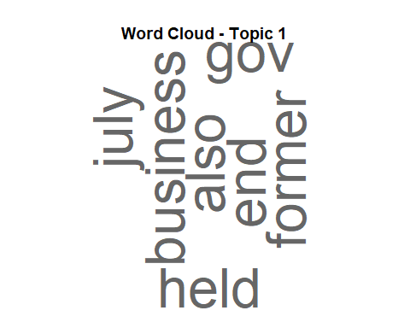
## Warning in wordcloud(words = topic_df$term, freq = topic_df$probability, :
## general could not be fit on page. It will not be plotted.
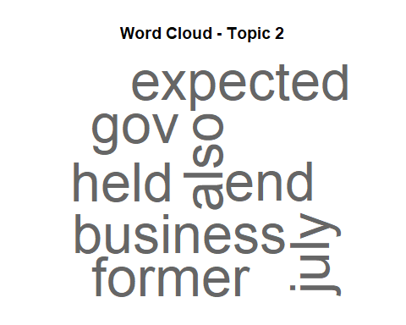
## Warning in wordcloud(words = topic_df$term, freq = topic_df$probability, :
## general could not be fit on page. It will not be plotted.
## Warning in wordcloud(words = topic_df$term, freq = topic_df$probability, : made
## could not be fit on page. It will not be plotted.
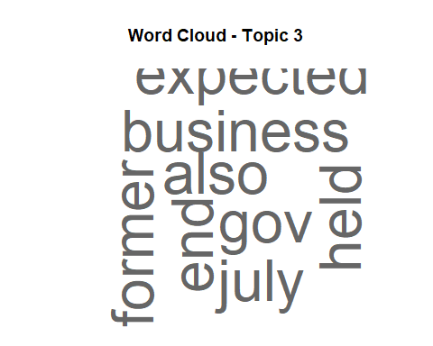
## Warning in wordcloud(words = topic_df$term, freq = topic_df$probability, :
## expected could not be fit on page. It will not be plotted.
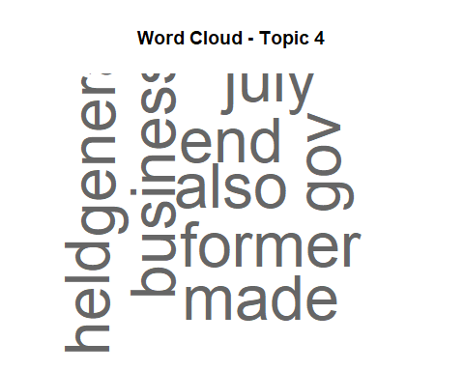
## Warning in wordcloud(words = topic_df$term, freq = topic_df$probability, :
## general could not be fit on page. It will not be plotted.
## Warning in wordcloud(words = topic_df$term, freq = topic_df$probability, : made
## could not be fit on page. It will not be plotted.
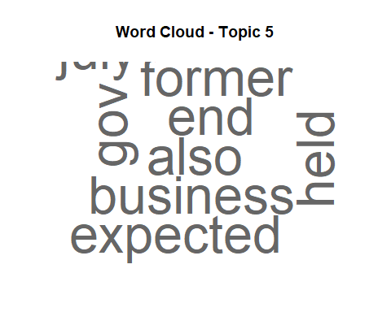
#Word importance per topic
for (i in 1:num_topics) {
topic_df <- topic_dfs[[i]][1:10, ]
p <- ggplot(topic_df,
aes(x = reorder(term, probability),
y = probability)) +
geom_col(fill = "steelblue") +
labs(
title = paste("Top 10 Words - Topic", i),
x = "Word",
y = "Probability"
)
print(p)
}


