OrthoHMM2: HMM-centered orthology inference
Jacob L. Steenwyk

Abstract
Orthology inference balances recovery of divergent homologs against separation of paralogs, and different benchmarks emphasize different aspects of this trade-off. OrthoHMM2, an HMM-centered inference workflow with phylogenetic refinement, was evaluated against six comparator configurations using OrthoBench, Quest for Orthologs (QfO), and a supplementary Three Kingdoms marker reference. Controlled experiments tested sequence-weighted family profiles, alignment-aware recruitment, local joint-tree rescue, and selective HMMER validation. Canonical OrthoHMM2 achieved OrthoBench F1 of 0.741061, compared with 0.727365 for full OrthoFinder 3.1.5, through higher precision but lower recall. OrthoFinder had higher VGNC, SwissTrees, and TreeFam-A F1. Among 12 complete-vector configurations, five OrthoHMM2 configurations and full OrthoFinder were nondominated on the three primary F1 objectives. This descriptive frontier did not imply statistical superiority. Small standalone OrthoHMM2 improvements had paired uncertainty intervals spanning zero, and both tested combinations failed to improve on their weighting-only constituents. These results locate OrthoHMM2 on a benchmark-dependent accuracy frontier while supporting unchanged defaults rather than a universal accuracy or efficiency advantage.

Introduction
Orthologs descend from speciation events, whereas paralogs descend from gene duplication. Similarity is therefore evidence for homology, not sufficient evidence for orthology. OrthoFinder integrates sequence comparison with phylogenetic inference (David M. Emms and Kelly 2019; David M. Emms et al. 2026a, 2026b), while profile HMMs offer a complementary way to represent family-level sequence conservation (Eddy 2011). The original OrthoHMM preprint introduced an HMM-based orthogroup inference framework (Steenwyk et al. 2024). OrthoHMM2 extends that framework with built-in HMM search, family-profile recruitment, and optional phylogenetic refinement. The present study evaluates this development implementation and controlled alternatives, rather than reanalyzing the original preprint’s implementation.
Group recovery, ortholog-pair recovery, and functional conservation measure different properties of orthology predictions, which complicates comparisons based on a single summary score. To distinguish these properties, the present analysis locates OrthoHMM2 among the observed trade-offs using Pareto dominance. A configuration is dominated when another is at least as good on every specified objective and strictly better on at least one. This definition makes both the chosen objectives and the comparison set consequential. The primary comparison combines curated group recovery with two QfO reference-pair tests, retaining functional conservation and more limited reference panels as separate evidence.

Results

HMM-centered inference and controlled improvements
The workflow combines sequence-supported homology search, family-profile recruitment, candidate-family expansion, and phylogenetic inference (Fig. 1). Separate experiments evaluated position-based sequence weighting, aligned-residue recruitment evidence, bounded local joint-tree rescue, and HMMER remeasurement of ambiguous candidates before testing a combination of weighting and projection repair. The controls separate profile construction, candidate generation, score measurement, and decision-rule changes. An HMM match alone never establishes orthology.

OrthoHMM2 trades recall for precision on OrthoBench
Canonical OrthoHMM2 achieved weighted group F1 of 0.741061, precision 0.817705, and recall 0.677553. Full OrthoFinder 3.1.5 achieved F1 of 0.727365, precision 0.660651, and recall 0.809066 (Fig. 2). Thus, the higher OrthoHMM2 F1 reflects a precision-recall trade-off rather than uniform superiority. Henikoff weighting reached the highest observed OrthoBench F1, 0.741965, but its improvement over canonical was only 0.090379 percentage points. Clustered Henikoff weighting and projection repair achieved 0.741947 and 0.741424, respectively. These are experimental configurations, not newly recommended defaults.

The frontier depends on the evaluation objective
On the three primary objectives, OrthoBench, VGNC, and SwissTrees F1, six of 12 configurations were nondominated, comprising canonical OrthoHMM2, both retained weighting variants, projection repair, retained phylogenetic OrthoHMM2, and full OrthoFinder (Fig. 3; Supplementary Table S2). Five points represent OrthoHMM2 configurations, not five independent tools. Their frontier membership arises from different compromises among benchmarks; it does not establish a single best configuration.
The pairwise projections clarify this distinction. Full OrthoFinder was the only nondominated configuration when VGNC and SwissTrees F1 were considered together, exceeding every evaluated OrthoHMM2 configuration on both. Adding OrthoBench introduces a competing objective and places OrthoHMM2 configurations on the frontier. When supporting TreeFam-A and supplementary Three Kingdoms F1 were added, nine configurations became nondominated, including the sequence-only OrthoFinder checkpoint, SonicParanoid, and OrthoMCL. Frontier membership is therefore sensitive to objective choice and cannot substitute for biological interpretation or independent validation.

Resource measurements are descriptive, not an efficiency frontier
The retained matched-resource panel reviewed 27 sequential attempts on nested 4-, 8-, and 12-proteome datasets. Twenty-five attempts produced measurements; 24 were eligible under the original review rules, and six of nine method/size cells contained all three eligible repeats (Fig. 4). At eight proteomes, median native elapsed times were 20.6 minutes for retained high-sensitivity OrthoHMM2, 33.3 minutes for retained phylogenetic OrthoHMM2, and 19.0 minutes for full OrthoFinder. These are shared-host observations with unknown, potentially method-dependent contention. They do not establish isolated speedups, asymptotic scaling, or costs of the new weighted configurations. An accuracy-runtime frontier would require measurements from the same configurations and cannot be inferred from cached incremental campaign costs.

QfO separates orthology recovery from functional conservation
Full OrthoFinder had higher VGNC, SwissTrees, and TreeFam-A F1 than canonical OrthoHMM2, with values of 0.988546 versus 0.902068, 0.848413 versus 0.831348, and 0.791918 versus 0.615778, respectively (Fig. 5; Supplementary Fig. S1). Canonical OrthoHMM2 had higher EC, GO, and FAS conditional means of 0.965382, 0.490236, and 0.763725, compared with 0.936130, 0.469548, and 0.691422 for full OrthoFinder. These means summarize different assessed pair populations, not matched-population accuracy effects. FAS eligibility counts are not its numerical sample sizes. The supplementary Three Kingdoms result also favored full OrthoFinder, 0.988582 versus 0.872133, but evaluates a restricted marker reference rather than a genome-scale assessment of orthology.

Small-dataset generation timing
On three complete bacterial proteome files containing 6432 proteins, median elapsed time was 275.3 seconds for the original v0.1.0 implementation, 20.6 seconds for OrthoHMM2 sensitive, and 41.4 seconds for OrthoHMM2 with inferred phylogenetic refinement (Fig. 6). Observed ranges were 274.3-275.3, 20.5-21.0, and 41.1-41.4 seconds, respectively. Ratios of original to modern elapsed-time medians were 13.38 for sensitive mode and 6.65 with phylogeny. Initial homology search accounted for most of the original runtime, with a median of 272.9 seconds compared with 13.5 and 13.3 seconds in the two OrthoHMM2 configurations. These shared-host measurements describe three technical repeats per configuration, not an isolated or equal-accuracy speedup. The small bacterial dataset does not establish general scalability.

Profile refinement did not support a new default
The unadjusted paired OrthoBench F1 intervals for Henikoff, clustered Henikoff, and projection repair included zero, spanning [-0.050123, 0.331771], [-0.062645, 0.335866], and [-0.036216, 0.154189] percentage points (Supplementary Fig. S2). Effects across benchmarks were mixed. Species-normalized weighting and the strict alignment guard failed their original advancement gates. Local rescue left all 70 reference-family scores unchanged. Both builtin and HMMER anchor reselection exceeded the allowed recall loss; HMMER measurement without reselection matched projection repair alone.
A registered six-arm weighting/projection experiment reproduced all four constituent controls. Both combinations exceeded canonical F1 but fell below their corresponding weighting-only controls, reaching 0.741784 versus 0.741965 and 0.741628 versus 0.741947. Neither advanced to QfO or Three Kingdoms. Failed executions and unrun endpoints remain explicit in Supplementary Table S1 and are not treated as negative biological results or zero scores.

Discussion
OrthoHMM2 achieved higher precision and F1 but lower recall than full OrthoFinder on OrthoBench, whereas full OrthoFinder had higher F1 on the principal QfO reference-pair tests. These differences place both methods on the frontier when OrthoBench and the primary QfO objectives are considered together. Higher functional similarity among a smaller or differently selected prediction set does not overturn that comparison.
Sequence weighting changed recruitment, but the observed gains did not transfer uniformly. More restrictive alignment evidence can remove true relationships, and more sensitive scoring does not ensure that anchor reselection improves orthology. The failed combinations show that individually promising changes need not be additive. Accordingly, production defaults remain unchanged and the three standalone candidates remain experimental.
All primary panels were exposed during development. The frontier is a descriptive reanalysis of those results, not independent confirmation or a statistical test of superiority. Reference families can share evolutionary history, and predicted groups can join families; bootstrap exchangeability is therefore an approximation. TreeFam is supporting evidence, Three Kingdoms is marker-limited, and functional annotations and FAS sampling impose further population-selection limitations. No suitable strictly independent panel was admitted after the candidate freeze. These limitations narrow the conclusions without invalidating the controlled negative results.

Methods

Implementation and configurations
OrthoHMM2 names the development framework evaluated here. Historical run identifiers retain their original OrthoHMM names and source revisions; this naming does not designate a new released package version or a rerun of those configurations.
Initial built-in search uses local maximum-path match/insert/delete scoring with BLOSUM62 emissions and fixed transition costs. Its approximate significance filter is not a demonstrated HMMER-calibrated E-value. Family profiles learn match emissions from alignments while retaining uniform transition costs; they are not equivalent to HMMER Plan7 profiles. Recruitment requires member-score thresholds and sequence-supported anchors. Phylogenetic refinement expands candidate families, infers alignments and trees, and applies the recorded orthology/paralogy rules. The code and per-run bindings, including parameter values and external commands, are retained in the completed campaign archive; historical runs retain their own revisions. Canonical denotes the experimental matched collection, not the shipping default or the retained phylogeny result collection. New full-proteome experiments used sequential 16-CPU/128-GiB allocations; the separate historical resource panel used the 32-CPU allocations described below.
Henikoff-style weights use per-column contributions of 1/(r*n), where r is the number of observed residue types and n is the count of the sequence’s residue type (Henikoff and Henikoff 1994). Contributions are averaged over nonmissing positions and normalized to the actual sequence count or an effective cluster count. Clusters use single linkage at 62% aligned identity normalized by the shorter nonmissing length. Alignment-aware experiments distinguish aligned residues from bounding spans. Local rescue examines bounded neighboring families with explicit reconciliation and duplication constraints. Selective HMMER 3.4 validation separates measurement from anchor reselection (Eddy 2011). Original protocols fix advancement and stopping criteria; benchmark labels and GO/EC/FAS annotations are not runtime inputs.
Comparators are full and sequence-only OrthoFinder 3.1.5, SonicParanoid 2.0.9 (Cosentino, Sriswasdi, and Iwasaki 2024), ProteinOrtho 6.3.6 (Klemm, Stadler, and Lechner 2023), FastOMA 0.3.5 (Majidian et al. 2025), and OrthoMCL 1.4 (Li, Stoeckert, and Roos 2003). FastOMA used a supplied OrthoFinder species tree. The sequence-only OrthoFinder output is a clustering checkpoint, not a finalized alternative phylogenetic workflow. QfO submissions retain native pairs or group-derived cross-species pairs as recorded; these output semantics are not interchangeable. Competitor rows are retained evidence, not fresh reruns during the final improvement campaign. Some historical comparator rows lack complete transitive executable or input-consumption provenance; current fingerprints do not reconstruct missing run receipts.

Benchmarks and estimands
OrthoBench comprises 12 proteomes, 251378 proteins, and 70 curated reference groups (David M. Emms and Kelly 2020). Evaluation retains its recorded weighted group-recovery precision, recall, and F1. The corrected QfO panel comprises 78 proteomes and 984137 proteins, with versioned references and identifier mappings (A. M. Altenhoff et al. 2016, 2020; A. Altenhoff et al. 2024). VGNC, SwissTrees, and TreeFam-A supply reference-pair F1; EC and GO retain the QfO adaptation of Schlicker similarity as conditional means (A. M. Altenhoff et al. 2016; Schlicker et al. 2006), and feature architecture similarity (FAS) is reported separately (Dosch et al. 2023; A. Altenhoff et al. 2024). Their arithmetic mean is not an accuracy endpoint. Three Kingdoms contains 443217 proteins from 12 proteomes; its reference comprises 2035 genes in 255 BUSCO-derived families (Manni et al. 2021). Its group co-membership scorer includes within-species pairs and does not evaluate false positives involving nonreference genes. Native ownership, benchmark coverage, assessed relations, and numerical sample counts remain distinct in the source tables.

Pareto analysis and uncertainty
The main comparison set contains all 12 distinct configurations with complete eight-endpoint vectors. Only documented repeated canonical controls are collapsed for plotting; all 29 original rows remain available. For objective set J, configuration a dominates b if a_j >= b_j for every j in J and a_j > b_j for at least one j. All objectives in the accuracy frontiers are maximized. Computation uses unrounded values; exact ties do not dominate one another. Three-dimensional membership and two-dimensional projections are computed separately. Dashed plot segments mark the boundary between observed points, not achievable interpolated configurations.
The primary objectives are OrthoBench, VGNC, and SwissTrees F1. The five-F1 sensitivity analysis adds TreeFam-A and Three Kingdoms. EC/GO/FAS means and resource measurements are excluded. This reporting analysis was defined after the benchmark results were known and was not preregistered. Uncertainty estimates retain the original 100000 paired reference-family resamples and phase-specific Bonferroni adjustments without new resampling. These are not campaign-wide selection corrections. Frontier membership has no inferred confidence level; dependent gene pairs are not treated as independent replicates.

Resource panel and reproducibility
The resource panel allocates 32 native CPUs and 128 GiB per run on the local Threadripper PRO 7995WX. It retains three planned repeats per method/size combination and all exclusions, including two pre-native aborts. Median/range summaries require three eligible repeats. Wall time covers the native command; CPU measures its task-subtree bracket including wrapper work; peak memory covers the native step including its launcher, not algorithm-only process RSS. Preparation, conversion, and scoring are outside the native timer. Taxon composition changes with dataset size, and contention is neither removed nor quantified as a correction. These historical configurations are not assigned the accuracy or costs of the new weighted experiments.

Generation timing protocol
A separate comparison used the three smallest proteome files in the retained five-proteome bacterial set, comprising 6432 proteins without sequence subsampling. File selection preceded timing. OrthoHMM1 denotes the unchanged original v0.1.0 tag; OrthoHMM2 denotes the frozen development implementation, evaluated in high-sensitivity mode with and without inferred phylogenetic refinement. The timing archive identifies both source revisions and all inputs.
Three fresh executions per configuration followed a balanced sequential order on the same 16 eligible physical cores. The original CLI used four concurrent phmmer searches with four compute threads each; its subsequent graph and MCL stages retained four workers. OrthoHMM2 used 16 CPUs with four threads per search worker. Both used BLOSUM62 and the nominal 0.0001 significance threshold, without assuming equivalent score calibration or accuracy. Native elapsed time included startup and orthogroup inference but excluded optional sequence-file exports and post-run validation. Initial search time was measured separately.
Admission required a successful native exit, complete metrics, and exactly one assignment of every input protein. All nine directional phmmer tables also required completion markers. An initial pilot failed with an obsolete MCL dependency; the final panel used compatible MCL 22-282 and repeated every search in fresh output directories. The failed and interrupted pilot attempts remain recorded but contribute no timing observations. Other host jobs were not stopped, and eligible cores were not exclusively reserved. Medians and observed ranges describe technical repeats on one small dataset, not confidence intervals, isolated speedups, or an equal-accuracy comparison.

Data and code availability
OrthoHMM2 is available at https://github.com/JLSteenwyk/orthohmm. The companion package includes the manuscript, original vector figures, full-precision score table, plotted coordinates, exact frontier membership and dominators, all timing attempts, references, executable plotting code, and SHA256 manifests. Figures can be regenerated from the included snapshot without raw proteomes. The campaign archive additionally records large-artifact locations, versions, commands, seeds, failed-run history, and source/native/score checks. The package is a manuscript draft, not a public archival deposition; no deposition DOI or submission approval is asserted.

Declarations
Jacob L. Steenwyk is the sole author. No new experimental organisms or participant data were generated for this reporting analysis.

References
Altenhoff, Adrian M, Brigitte Boeckmann, Salvador Capella-Gutierrez, Daniel A Dalquen, Todd DeLuca, Kristoffer Forslund, Jaime Huerta-Cepas, et al. 2016. “Standardized Benchmarking in the Quest for Orthologs.” Nature Methods 13 (5): 425–30. https://doi.org/10.1038/nmeth.3830.
Altenhoff, Adrian M, Javier Garrayo-Ventas, Salvatore Cosentino, David Emms, Natasha M Glover, Ana Hernández-Plaza, Yannis Nevers, et al. 2020. “The Quest for Orthologs Benchmark Service and Consensus Calls in 2020.” Nucleic Acids Research 48 (W1): W538–45. https://doi.org/10.1093/nar/gkaa308.
Altenhoff, Adrian, Yannis Nevers, Vinh Tran, Dushyanth Jyothi, Maria Martin, Salvatore Cosentino, Sina Majidian, et al. 2024. “New Developments for the Quest for Orthologs Benchmark Service.” NAR Genomics and Bioinformatics 6 (4): lqae167. https://doi.org/10.1093/nargab/lqae167.
Cosentino, Salvatore, Sira Sriswasdi, and Wataru Iwasaki. 2024. “SonicParanoid2: Fast, Accurate, and Comprehensive Orthology Inference with Machine Learning and Language Models.” Genome Biology 25 (1): 195. https://doi.org/10.1186/s13059-024-03298-4.
Dosch, Julian, Holger Bergmann, Vinh Tran, and Ingo Ebersberger. 2023. “FAS: Assessing the Similarity Between Proteins Using Multi-Layered Feature Architectures.” Bioinformatics 39 (5): btad226. https://doi.org/10.1093/bioinformatics/btad226.
Eddy, Sean R. 2011. “Accelerated Profile HMM Searches.” PLOS Computational Biology 7 (10): e1002195. https://doi.org/10.1371/journal.pcbi.1002195.
Emms, David M., and Steven Kelly. 2019. “OrthoFinder: Phylogenetic Orthology Inference for Comparative Genomics.” Genome Biology 20 (1): 238. https://doi.org/10.1186/s13059-019-1832-y.
Emms, David M, and Steven Kelly. 2020. “Benchmarking Orthogroup Inference Accuracy: Revisiting Orthobench.” Genome Biology and Evolution 12 (12): 2258–66. https://doi.org/10.1093/gbe/evaa211.
Emms, David M., Yi Liu, Laurence Belcher, Jonathan Holmes, and Steven Kelly. 2026a. “OrthoFinder: Improved Phylogenetic Orthology Inference with Enhanced Accuracy and Scalability.” Nature Methods 23 (7): 1327–33. https://doi.org/10.1038/s41592-026-03126-6.
———. 2026b. “Author Correction: OrthoFinder: Improved Phylogenetic Orthology Inference with Enhanced Accuracy and Scalability.” Nature Methods 23 (10): 2110. https://doi.org/10.1038/s41592-026-03238-z.
Henikoff, Steven, and Jorja G. Henikoff. 1994. “Position-Based Sequence Weights.” Journal of Molecular Biology 243 (4): 574–78. https://doi.org/10.1016/0022-2836(94)90032-9.
Klemm, Paul, Peter F. Stadler, and Marcus Lechner. 2023. “Proteinortho6: Pseudo-Reciprocal Best Alignment Heuristic for Graph-Based Detection of (Co-)orthologs.” Frontiers in Bioinformatics 3 (December): 1322477. https://doi.org/10.3389/fbinf.2023.1322477.
Li, Li, Christian J. Stoeckert Jr., and David S. Roos. 2003. “OrthoMCL: Identification of Ortholog Groups for Eukaryotic Genomes.” Genome Research 13 (9): 2178–89. https://doi.org/10.1101/gr.1224503.
Majidian, Sina, Yannis Nevers, Ali Yazdizadeh Kharrazi, Alex Warwick Vesztrocy, Stefano Pascarelli, David Moi, Natasha Glover, Adrian M. Altenhoff, and Christophe Dessimoz. 2025. “Orthology Inference at Scale with FastOMA.” Nature Methods 22 (2): 269–72. https://doi.org/10.1038/s41592-024-02552-8.
Manni, Mosè, Matthew R Berkeley, Mathieu Seppey, Felipe A Simão, and Evgeny M Zdobnov. 2021. “BUSCO Update: Novel and Streamlined Workflows Along with Broader and Deeper Phylogenetic Coverage for Scoring of Eukaryotic, Prokaryotic, and Viral Genomes.” Molecular Biology and Evolution 38 (10): 4647–54. https://doi.org/10.1093/molbev/msab199.
Schlicker, Andreas, Francisco S Domingues, Jörg Rahnenführer, and Thomas Lengauer. 2006. “A New Measure for Functional Similarity of Gene Products Based on Gene Ontology.” BMC Bioinformatics 7 (1): 302. https://doi.org/10.1186/1471-2105-7-302.
Steenwyk, Jacob L, Thomas J. Buida III, Antonis Rokas, and Nicole King. 2024. “OrthoHMM: Improved Inference of Ortholog Groups Using Hidden Markov Models.” Preprint. openRxiv. https://doi.org/10.1101/2024.12.07.627370.

Figure 1. HMM-centered workflow and experimental interventions
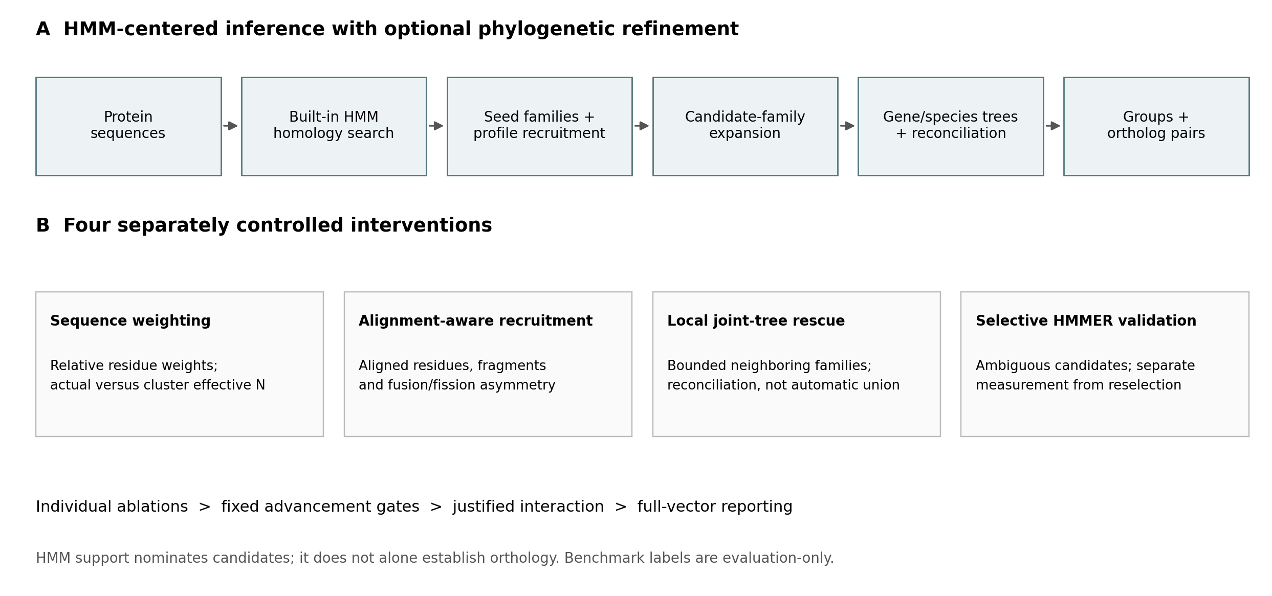
A, Sequence-supported search and family-profile recruitment precede candidate expansion and phylogenetic refinement. This conceptual diagram distinguishes the optional phylogenetic workflow from sequence-only outputs. B, The four separately controlled interventions target profile construction, alignment evidence, local tree analysis, and ambiguous-candidate scoring. Individual ablations precede the registered interaction. The figure describes the evaluated architecture; it does not imply that all interventions improved accuracy or are enabled by default.

Figure 2. OrthoBench group recovery and precision-recall trade-off
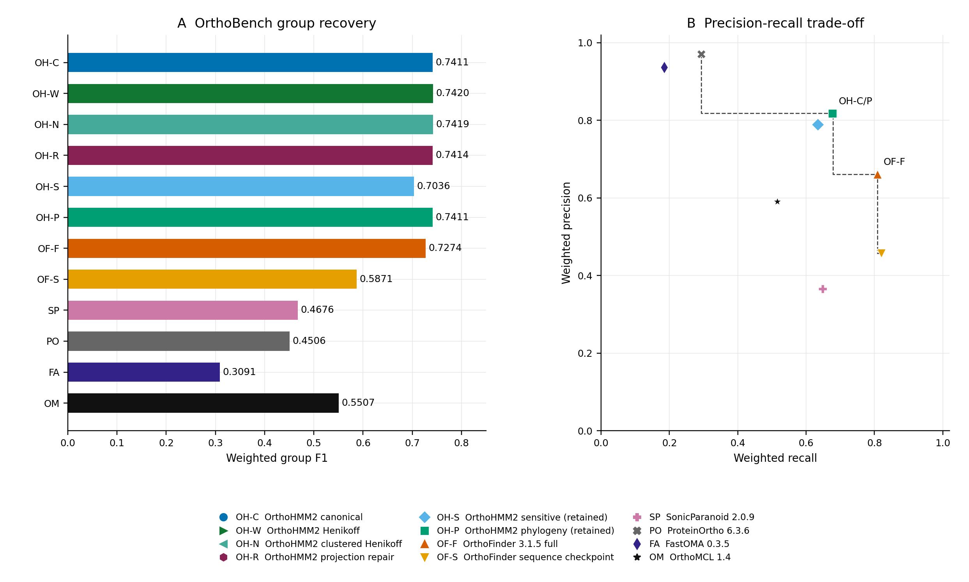
A, Weighted group F1 for all 12 complete-vector configurations. Bars start at zero. B, Their corresponding weighted precision and recall. Dashed segments mark the observed point-estimate frontier. The canonical OrthoHMM2 configuration has higher precision but lower recall than full OrthoFinder. Symbols retain the same meanings across figures. Small development differences are not independent accuracy gains; paired contrasts appear in Supplementary Fig. S2. Some points coincide; OH-C/P labels the identical canonical and retained-phylogeny OrthoBench coordinates. OB, OrthoBench; OH, OrthoHMM2; OF, OrthoFinder; SP, SonicParanoid; PO, ProteinOrtho; FA, FastOMA; OM, OrthoMCL. OH-C/W/N/R denote canonical, Henikoff, clustered Henikoff, and projection repair; OH-S/P denote retained sensitive/phylogenetic configurations. OF-S is a sequence-only checkpoint.

Figure 3. Where OrthoHMM2 lies on the accuracy frontier
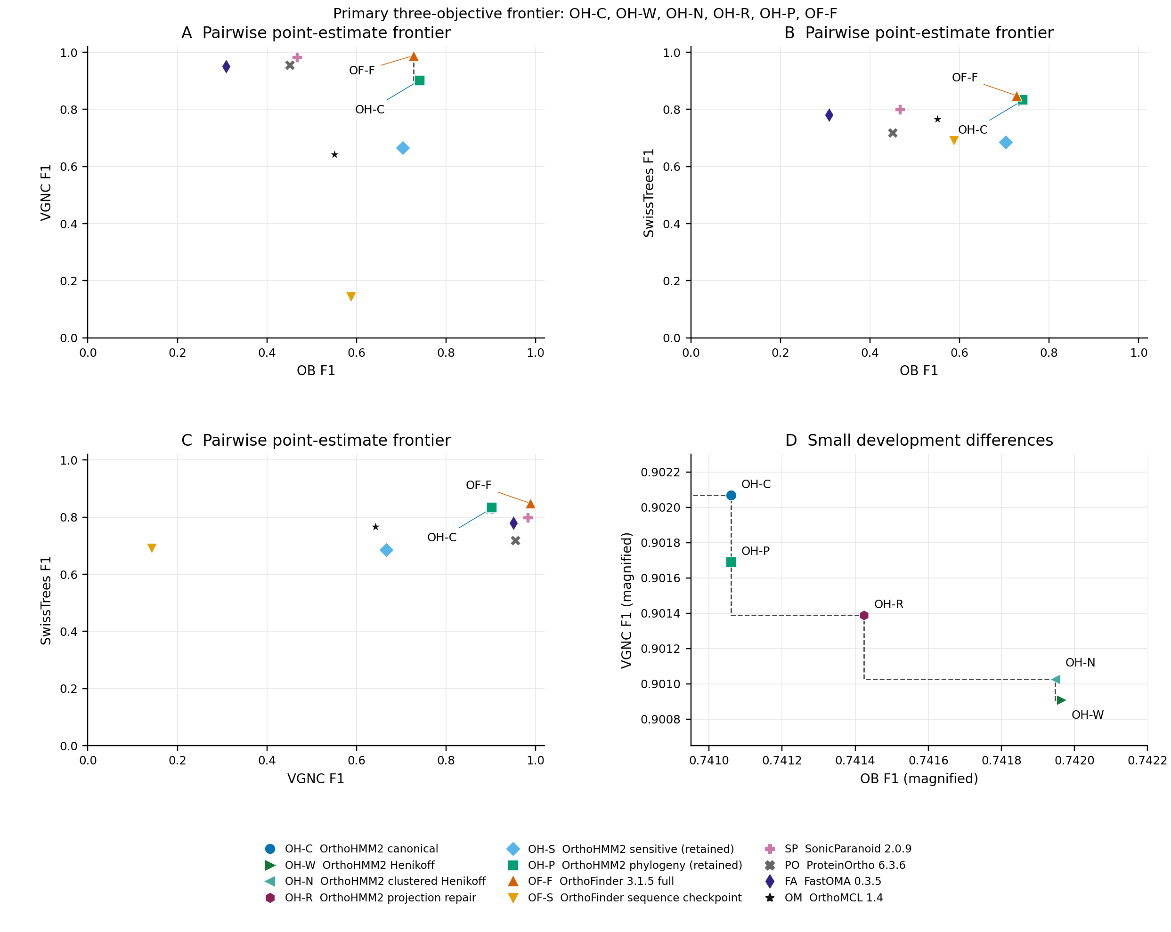
A-C, Pairwise projections of the primary objectives. All axes maximize F1; the top right is favorable. Dashed steps mark boundaries among observed nondominated points, not attainable interpolations. Full OrthoFinder is the sole nondominated configuration in the VGNC-SwissTrees projection. D, Magnification of the small differences among OrthoHMM2 development configurations; its truncated axes do not depict uncertainty. Primary three-objective membership is calculated independently of these projections and exported in Supplementary Table S2. Membership is descriptive and depends on the comparison set, objectives, and point estimates.

Figure 4. Shared-host resource measurements
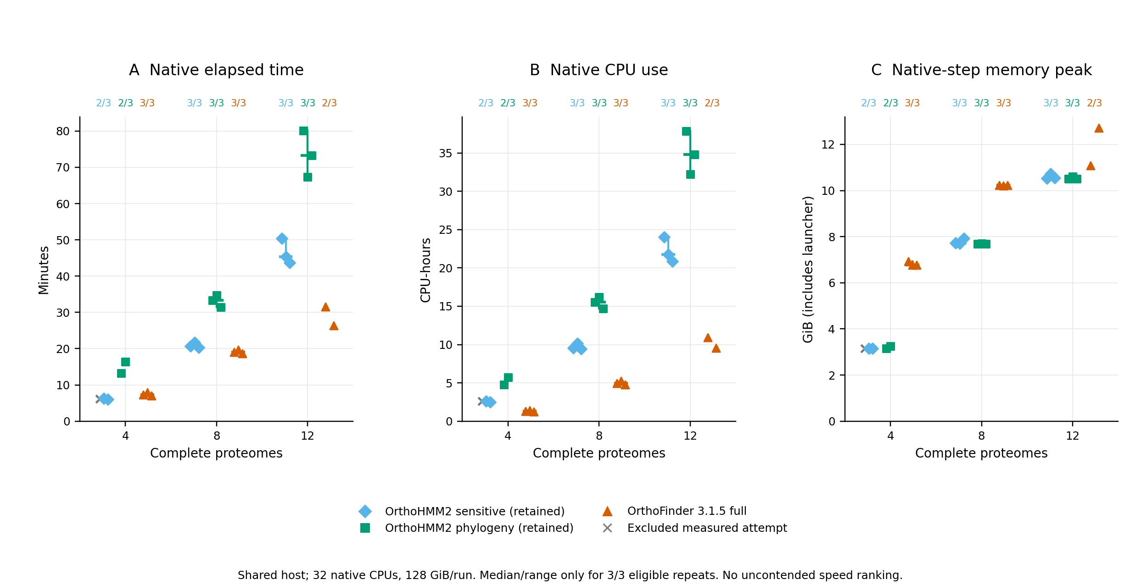
A-C, Native elapsed time, native-task-subtree CPU use, and native-step peak memory on nested 4-, 8-, and 12-proteome datasets. Symbols show measured attempts; gray crosses show excluded measured attempts. Two pre-native aborts have no plotted resource value and remain missing in Supplementary Table S3. Labels give eligible repeats out of three. Median ticks and observed range bars appear only for complete three-repeat cells; ranges are not confidence intervals. All 27 attempts were reviewed, 25 produced measurements, and 24 were eligible. Contention is unknown and potentially method dependent. The panel does not establish isolated comparative efficiency, and no costs for weighted OrthoHMM2 configurations are inferred from it.

Figure 5. QfO orthology and conditional functional conservation
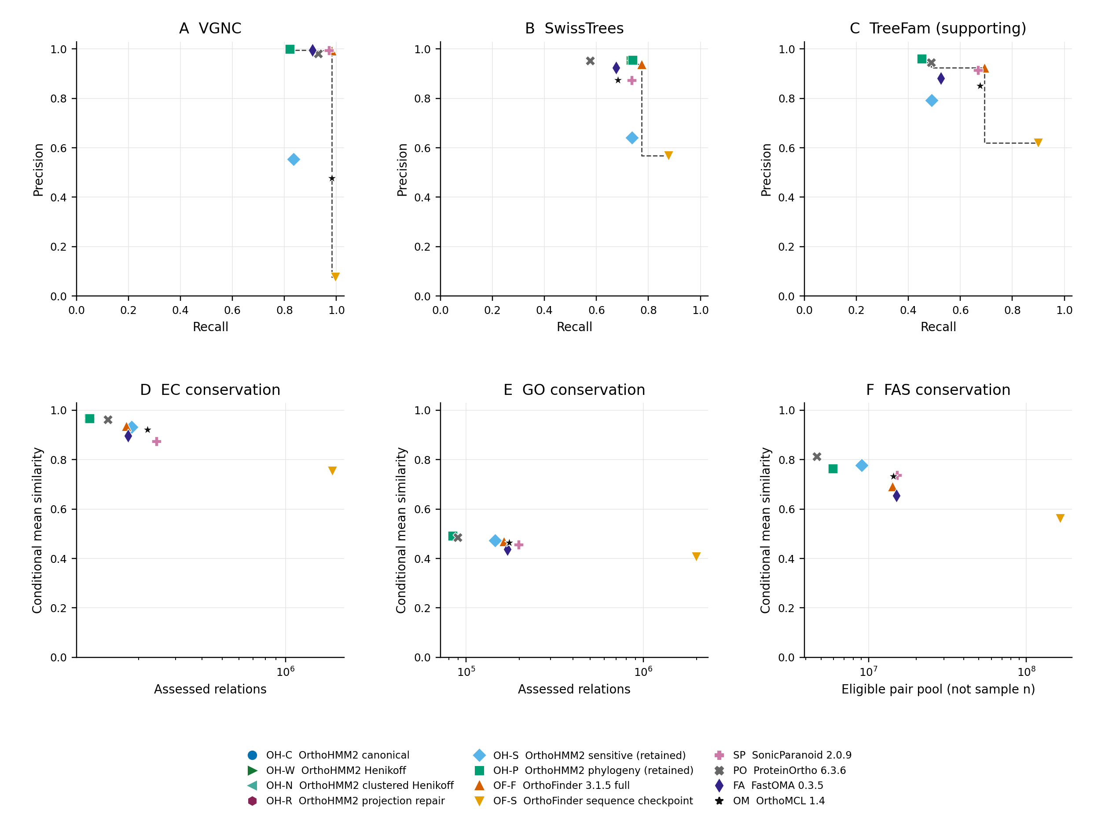
A-C, VGNC, SwissTrees, and supporting TreeFam-A precision versus recall, with observed point-estimate frontiers. These frontiers are not the F1-F1 frontier in Fig. 3. D-F, EC, GO, and FAS conditional mean similarity versus recorded assessed or eligible pair populations, on logarithmic population axes. Higher means among differently selected pairs do not establish greater orthology accuracy. The FAS eligible pool is not its numerical sample size. No accuracy frontier is assigned to functional panels. Points have no invented independent-pair uncertainty; heterogeneous native error conventions are not pooled. Published OrthoFinder figures guide the types of panels, not their numerical inputs; unrun species-tree discordance tests are absent. Some configurations have coincident or visually overlapping coordinates; the exported coordinate table preserves their distinct identities and values.

Figure 6. Small-dataset runtime across OrthoHMM generations
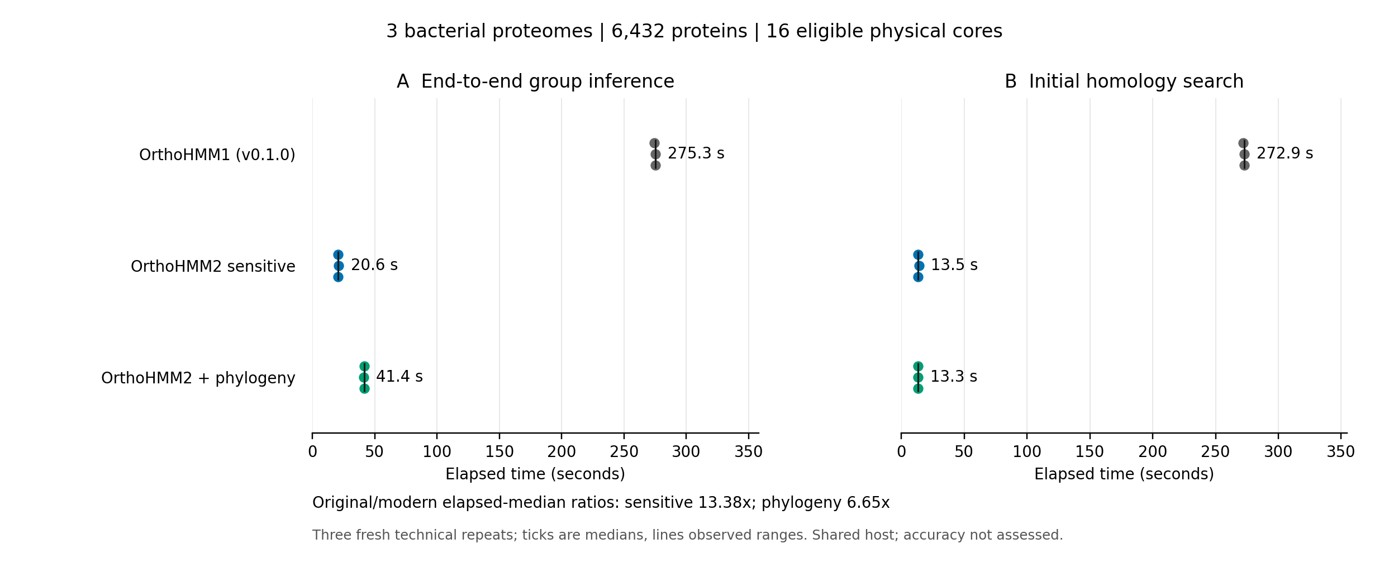
A, Native elapsed time through completed orthogroup inference, including startup but excluding optional sequence-file exports. B, Initial homology search time. Each configuration has three fresh sequential runs on the same 6432 proteins from three complete bacterial proteome files. Points show every repeat, ticks medians, and lines observed ranges, not confidence intervals. Original/modern ratios divide their elapsed-time medians. OrthoHMM1 is the unchanged v0.1.0 tag using phmmer and MCL; the OrthoHMM2 configurations use built-in high-sensitivity search and Leiden, with optional inferred phylogeny. All runs have the same 16-core affinity limit. Original nested search uses four workers with four compute threads each, while its later graph/MCL stages retain four workers. OrthoHMM2 uses 16 CPUs and four threads per search worker. This shared-host comparison does not assume equal outputs or accuracy, and does not establish general scalability. Supplementary Table S5 retains all nine admitted attempts; the separate failed pilot is not included in ratios.

Supplementary Figure S1. All eight reported endpoints
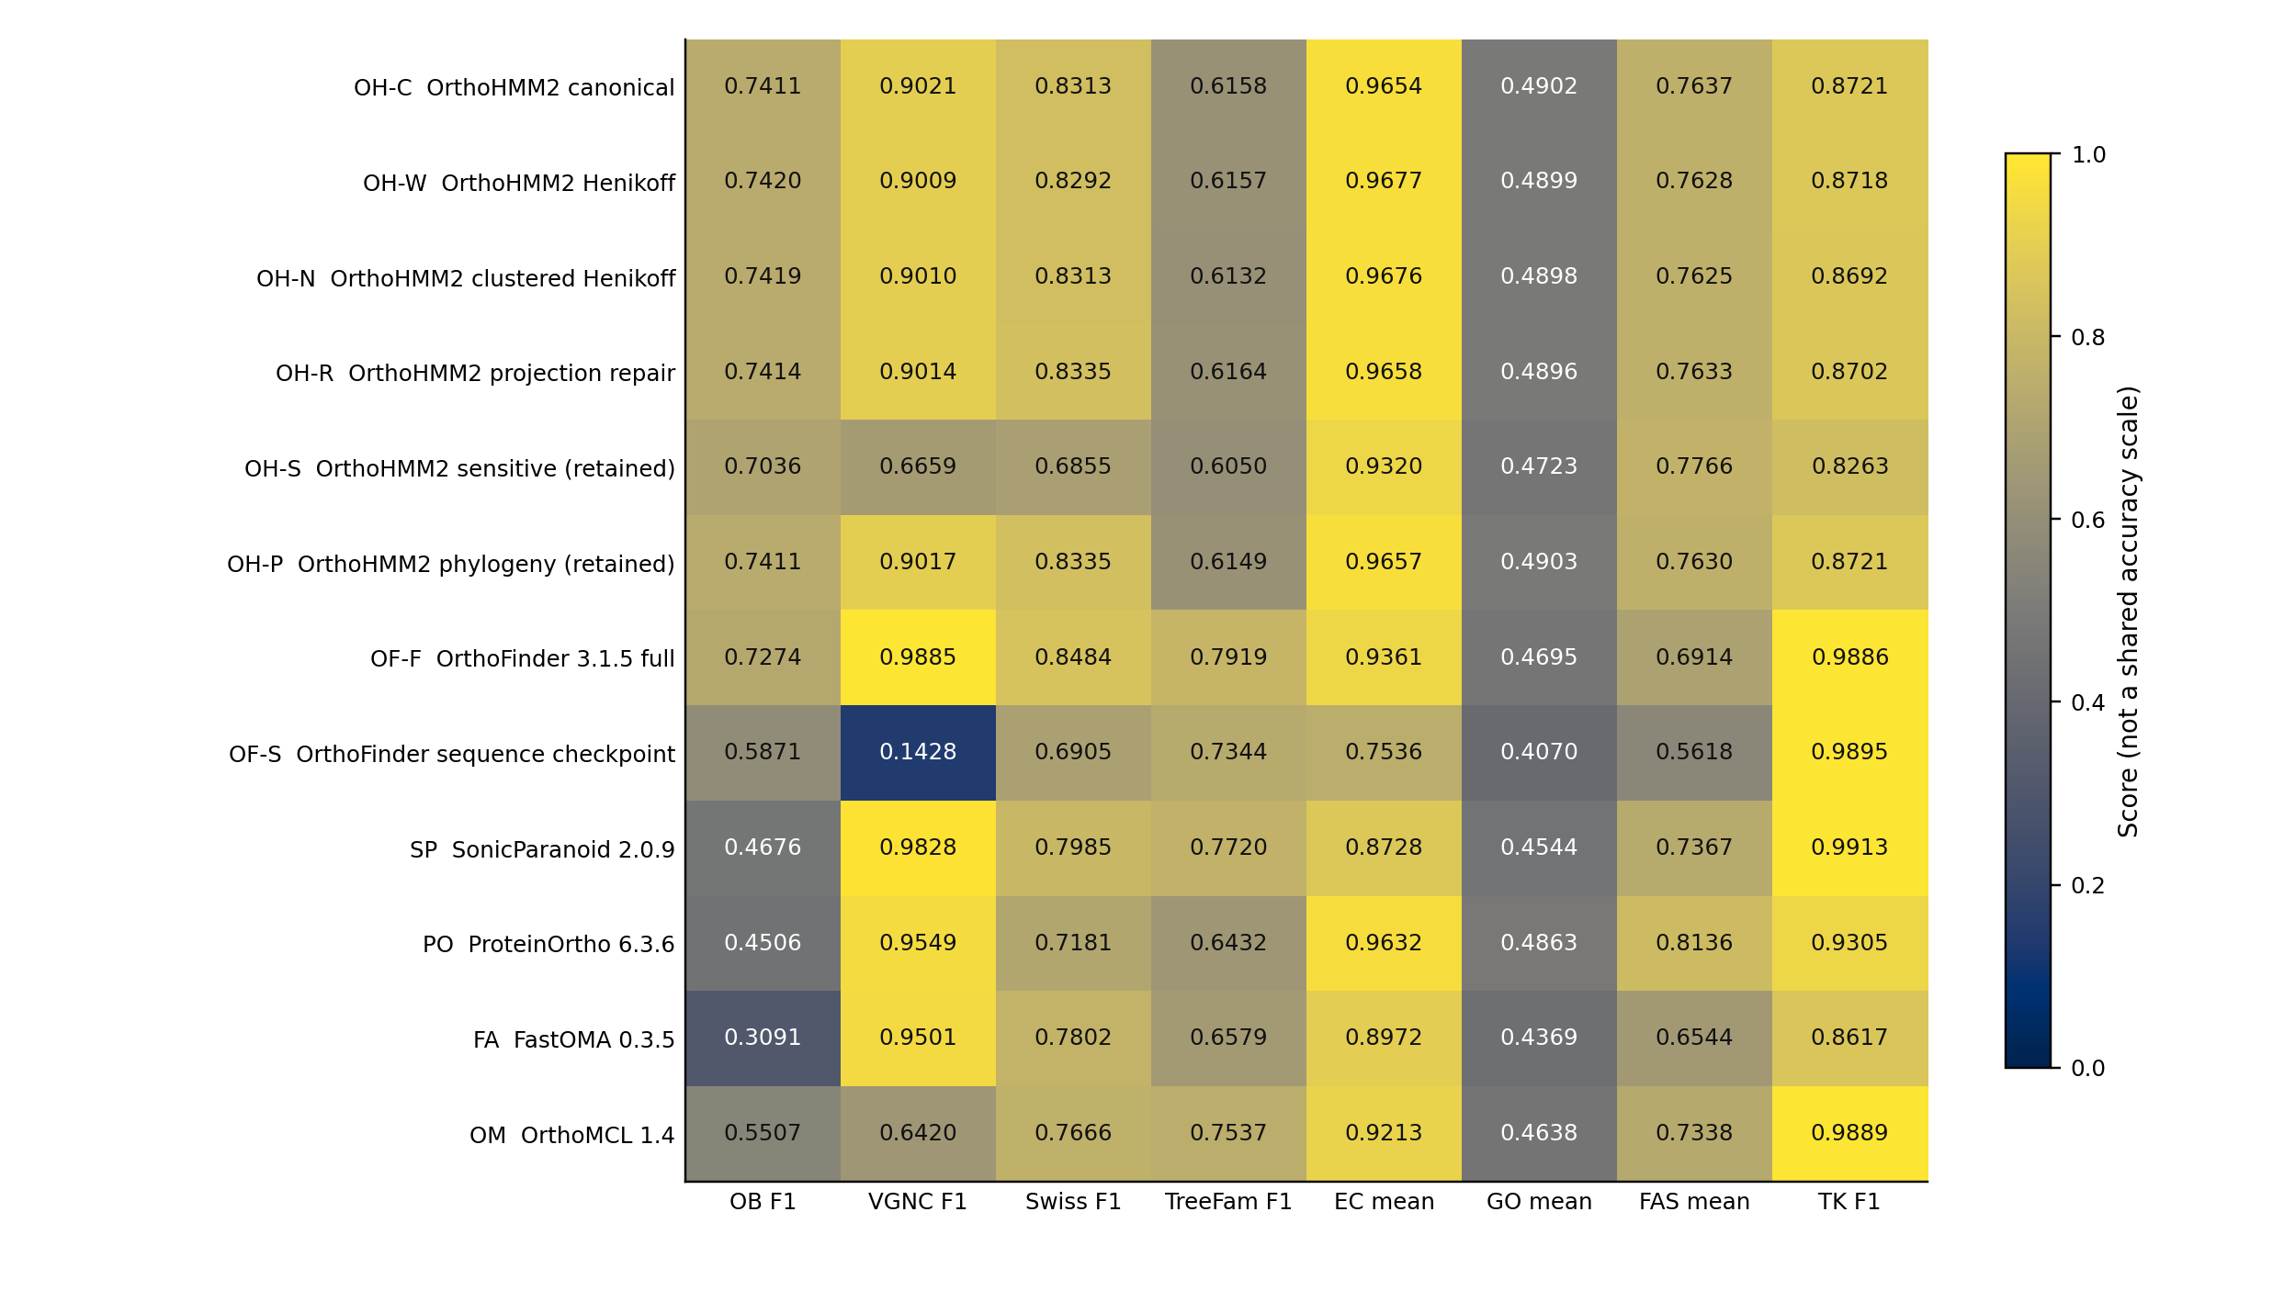
All 12 complete-vector configurations, shown on a common numerical 0-1 range for compact display. Colors are not a shared biological accuracy scale, and columns are not averaged or ranked together. EC, GO, and FAS are conditional means. TreeFam is supporting evidence; Three Kingdoms is marker-limited supplementary evidence. Supplementary Table S1 retains all 29 original configuration/control/history rows, including explicit NA endpoints.

Supplementary Figure S2. Original paired OrthoBench uncertainty
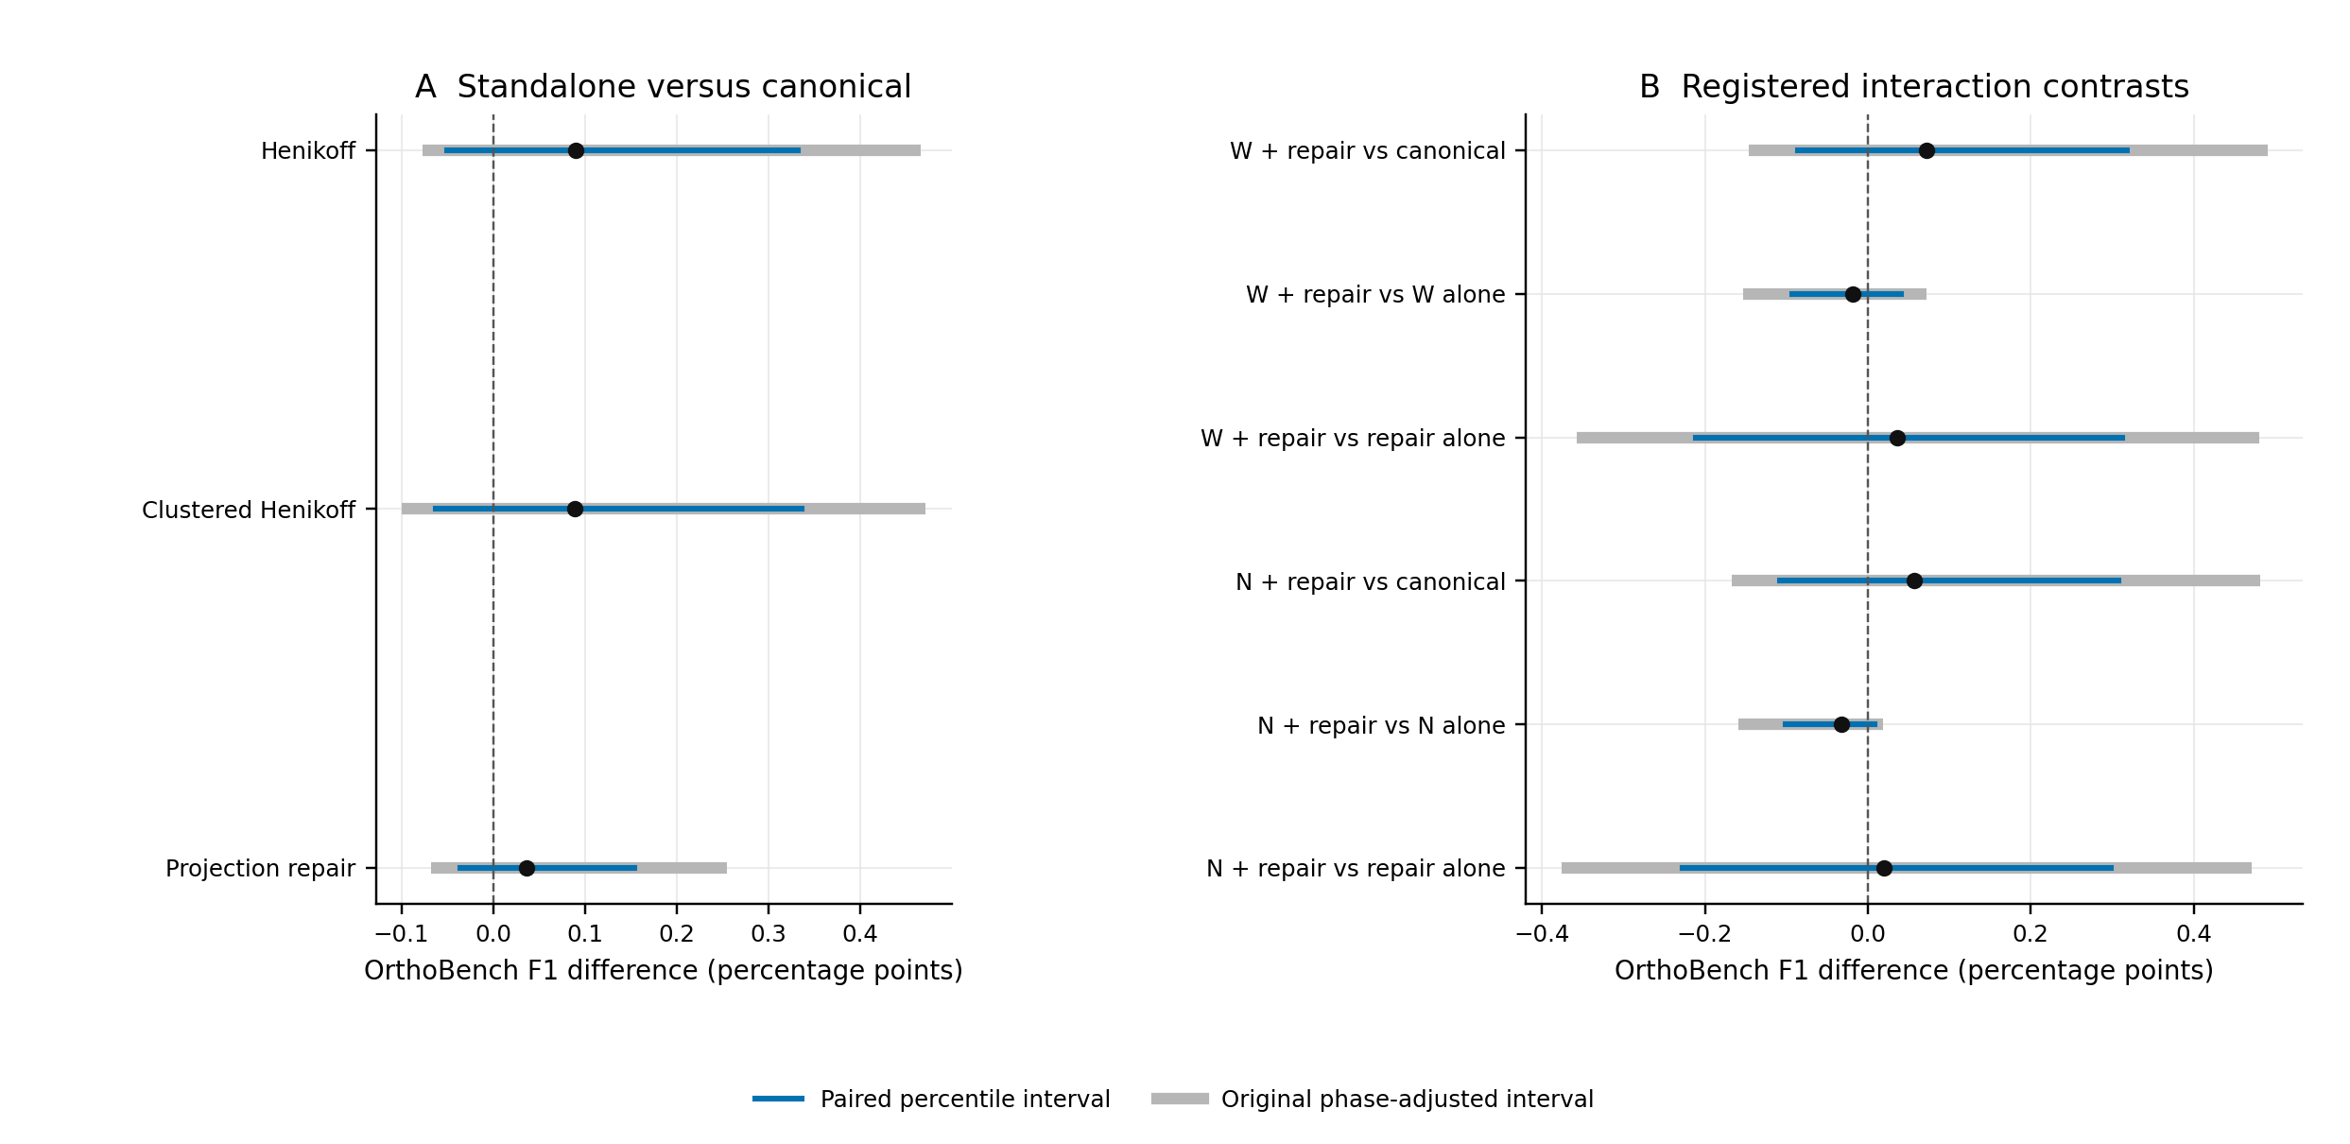
A, The three standalone candidates relative to canonical. B, The six registered interaction contrasts. Points are F1 differences in percentage points. Blue intervals are paired percentile intervals; gray intervals retain the original phase-specific Bonferroni tail adjustments (nine weighting, 24 projection-recovery, and 18 interaction endpoints). All reuse the saved 100000 paired reference-family resamples. These are development-exposed, phase-qualified intervals, not campaign-wide selection corrections or confidence sets for Pareto membership. Zero-spanning intervals do not establish equivalence. W and N denote Henikoff and clustered Henikoff.

