Use Creation Workshop:

Download Free version here: [file](https://drive.google.com/open?id=0Bzke6lBHG_z5U0EwVmpfT3Y5SG8)

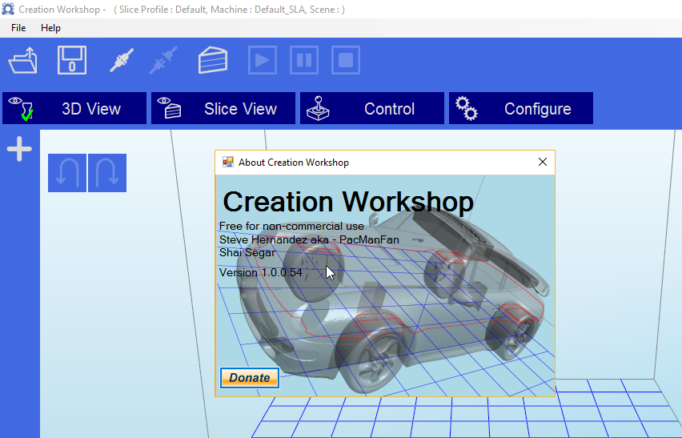

Import File:

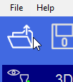

Add Base:

1.

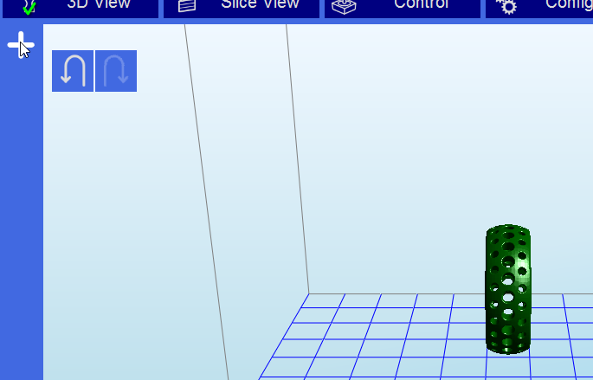

2.

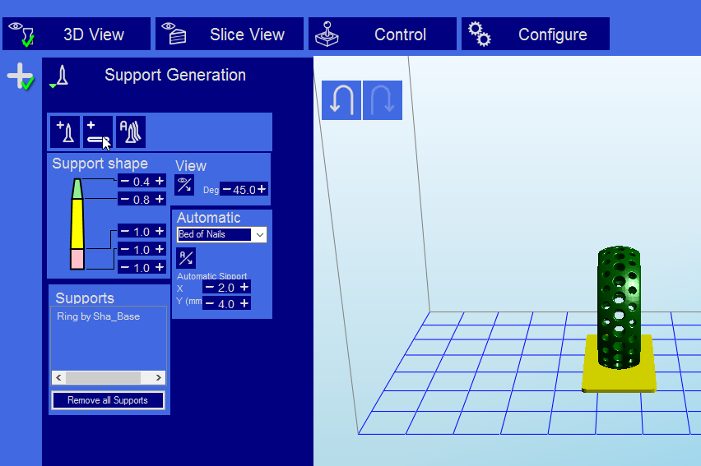

Export:

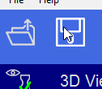

Select STL format

