**Assignment #1: Warm up**

**Group 2**

Members:

Nick-Heinrich Phiri Pfeiffer, Julian Lenz, Faro Schäfer, Andreas Mirlach

**Table of Contents**

1 Task 1

2 Task 1

3 Task 2

4 Task 2

5 Task 2

# Task

*Compute the first and the second derivatives of f (x) analytically.*

$$f\left(x\right)=\sin\left(nx\right);n=2$$

1rst derivative: $f^{'}\left(x\right)=n*cos⁡(nx)$

2nd derivative $f^{''}\left(x\right)=-n^{2}*\sin\left(nx\right)$

# Task

*Compute the first derivative of f (x), namely ∂f /∂x, numerically on x ∈ [0, 2π]. Assume periodic boundaries. Use central, upwind and downwind difference schemes. Choose different resolutions h. Comment on what you observe.*

Boundary: $[0;2π]$

Backward Difference Scheme (Upwind):

Forward Difference Scheme (Downwind):

Central Difference Scheme:

Resolutions: [10,20,30,50,70,100,1000,10000]

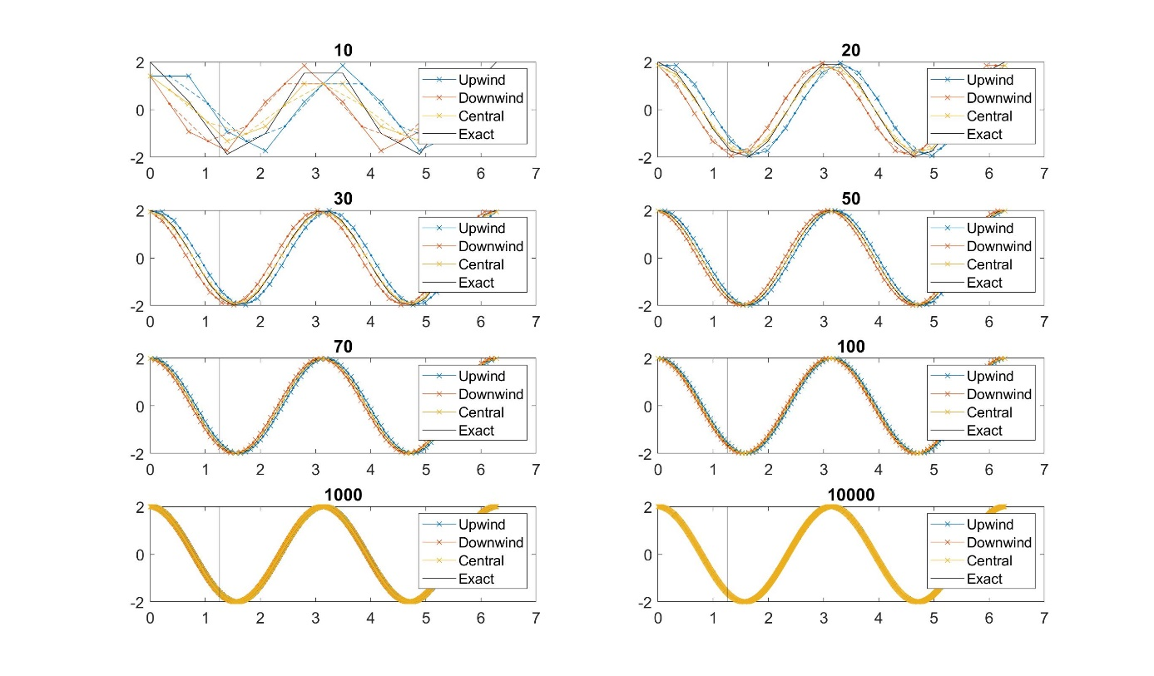

Comment:

We observe an approximation to the analytical function with increasing resolution.

# Task

*Compute the second derivative of f (x), namely ∂ 2f /∂2x, numerically on x ∈ [0, 2π]. Assume periodic boundaries. Use central difference scheme. Choose different resolutions. Comment on what you observe.*

Resolutions: [10,20,30,50,70,100,1000,10000]

Comment:

We observe again an approximation with increasing resolution to the analytical function.

# Task

*Use a linear interpolation scheme to compute the function values at the middle of the grid points. Use different resolutions. Comment on what you observe.*

# Task

*For tasks 2, 3 and 4, plot the error versus resolution for a given position x = 2π/5. Error plots are done in logarithmic scale, i.e. the logarithm of the relative error Erel is plotted versus the logarithm of grid spacing h. Comment on the slope of the curves you obtain.*

Comment:

Slope of error of central difference scheme is steeper. Error iss maller.

Curve of Upwind and Downwind scheme merge into one value with increasing resolution.