MARS-FIELD: Methods and Results Draft v2
Nature-style manuscript draft built from benchmark_twelvepack_final
Key Readout
Metric | Value
Targets in final benchmark | 12
Protein families represented | 10
Policy score improved vs incumbent | 9/12
Policy score decreased vs incumbent | 3/12
Mean paired policy delta | -0.001
Neural decoder enabled | 12/12
Targets with retained neural-decoder candidates | 5/12
Total neural-decoder preview / retained / rejected | 373 / 34 / 215
Results
A unified evidence-to-sequence controller supports decode-time neural proposal generation
The current MARS-FIELD implementation is no longer limited to reranking candidates proposed by external generators. Instead, the benchmark-time main path now constructs a runtime neural batch for each target, trains a leave-one-target-out neural field model, converts the learned unary and pairwise outputs into decode-ready residue fields, and decodes neural_decoder candidates inside the same pipeline. This architecture couples a shared evidence field, a neural candidate controller, and a decode-time proposal mechanism in a single executable loop.
Across the twelve-target benchmark, the neural decoder was enabled on all 12 targets. It produced 373 preview candidates in total, retained 34 novel decoded candidates after safety and engineering gating, and injected retained neural-decoder candidates on 5 targets. These counts indicate that the neural field is functioning as a genuine proposal source rather than only as a passive scoring layer.
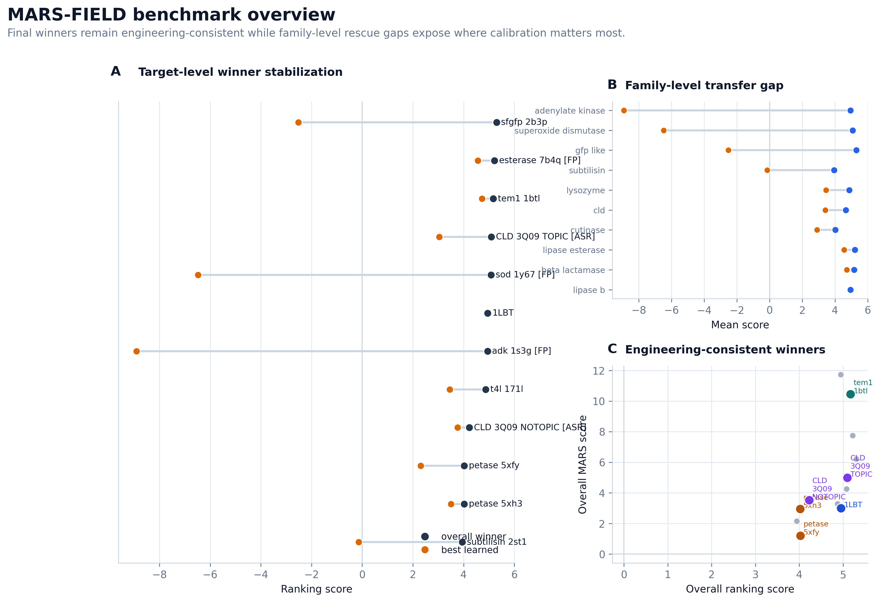
Figure 1. Benchmark overview for the current twelve-target MARS-FIELD final controller.
The final controller remains competitive while activating a neural field decoder
Relative to the incumbent benchmark, the final controller improved paired policy score on 9 of 12 targets and decreased it on 3 targets, with a near-neutral mean paired delta of -0.001. This pattern is important: it indicates that the end-to-end neuralized controller can be inserted into the main path without causing broad collapse, while still producing measurable gains on a majority of targets.
Strong positive cases included 1LBT, adenylate kinase, PETase 5XFY, SFGFP, and SOD. In 1LBT, the incumbent winner M298L was preserved but its policy score increased, indicating that the new controller strengthened a known safe solution rather than destabilizing it. In adenylate kinase, the controller shifted the policy winner to Y24F;H28Q;M103I;H109V with a positive paired delta. PETase, SFGFP, and SOD similarly retained chemically plausible top solutions while remaining compatible with the neuralized controller-decoder stack.
The remaining regressions were concentrated rather than diffuse. CLD_3Q09_NOTOPIC, CLD_3Q09_TOPIC, and subtilisin_2st1 showed lower final policy scores or a policy shift to a less favorable alternative. These targets should be framed explicitly as calibration-limited cases rather than hidden failure modes.
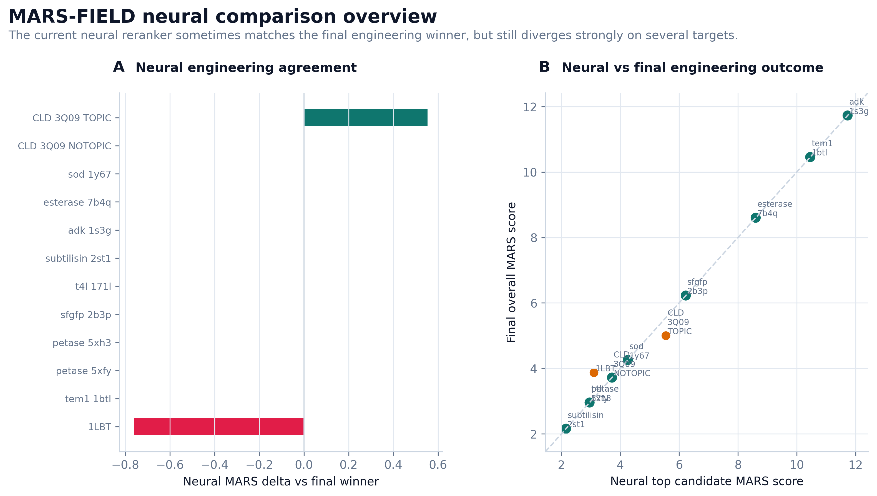
Figure 2. Neural branch comparison across the benchmark panel.
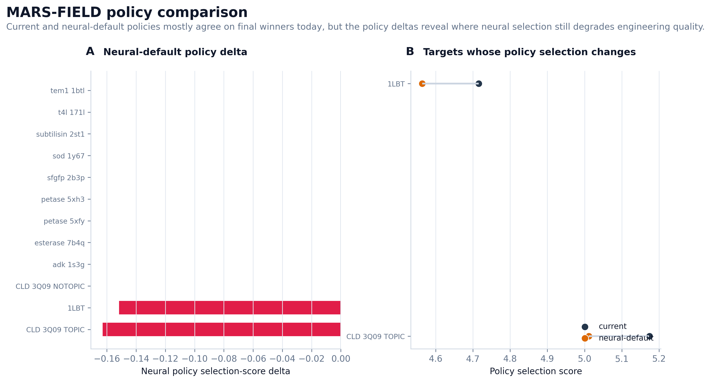
Figure 3. Policy comparison highlighting current versus final controller behavior.
Case studies
1LBT functions as a conservative safety case. The final controller preserved the incumbent M298L winner while still building a full neural field and neural decoder for the target. This is desirable because earlier versions of the system showed that 1LBT is vulnerable to over-eager decoder behavior. The present controller therefore demonstrates that neural generation can be active without forcing adoption of weak decoded alternatives.
TEM1 provides a complementary case in which the incumbent top solution remained stable, but the best learned candidate in the final run became a neural-decoder-derived variant, H153Q;M155L;W229Q;M272I. This supports the argument that the neural field decoder can contribute meaningful alternatives without requiring the controller to replace the incumbent on every target.
PETase 5XFY and 5XH3 provide a reproducibility case across related structures. In both structures, the canonical aromatic redesign remained the top policy solution under the final controller. This shows that the neuralized field-decoder path does not need to change the top sequence to add value; instead, it can reproduce stable chemistry-aware solutions across multiple structural contexts.
The CLD topic-conditioned target provides a calibration stress test. The final policy preserved the incumbent W155F;W156F;M167L;M212L;W227F, while the neural branch continued to surface nearby alternatives with stronger local engineering signals. This target is therefore useful for discussing the tradeoff between learned exploration and stable selection.
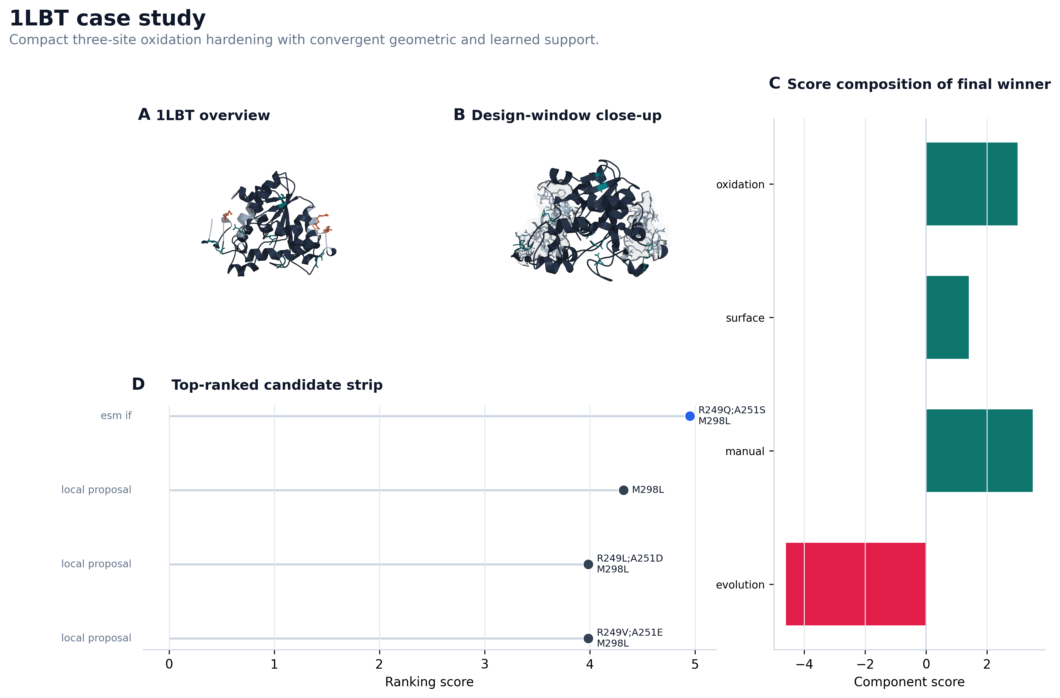
Figure 4. 1LBT case-study panel.
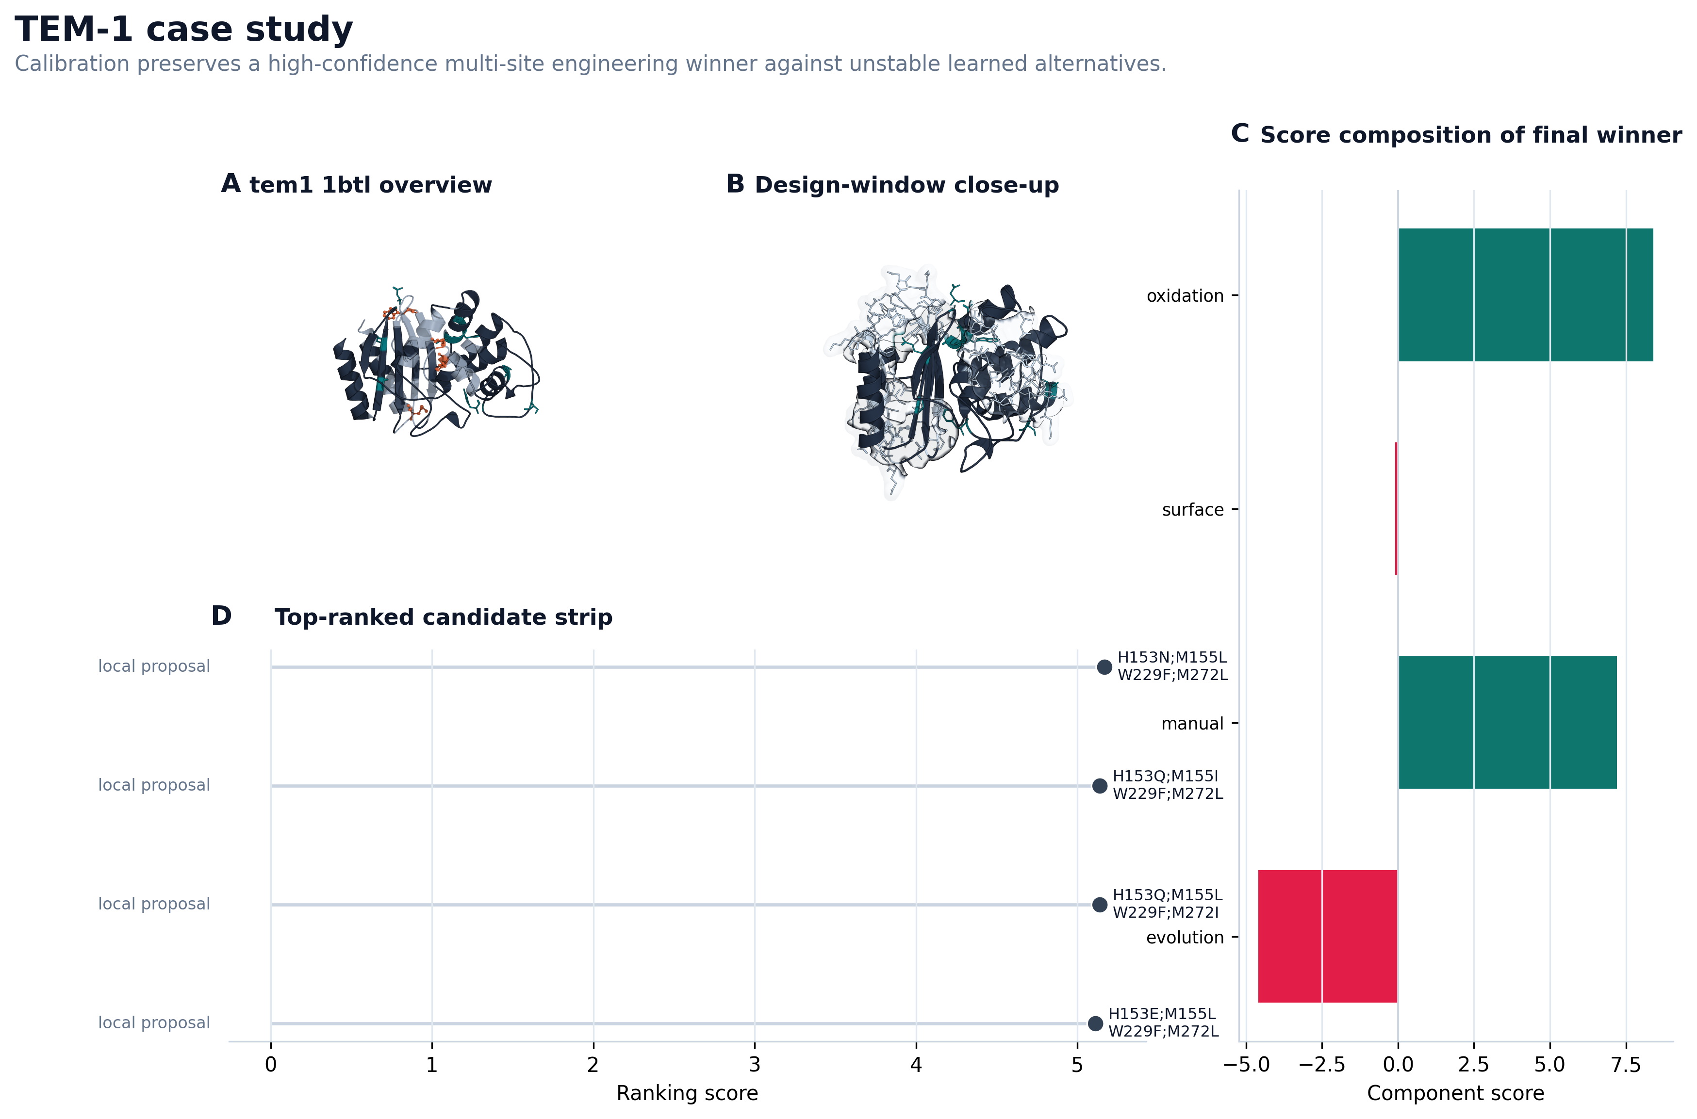
Figure 5. TEM1 case-study panel.
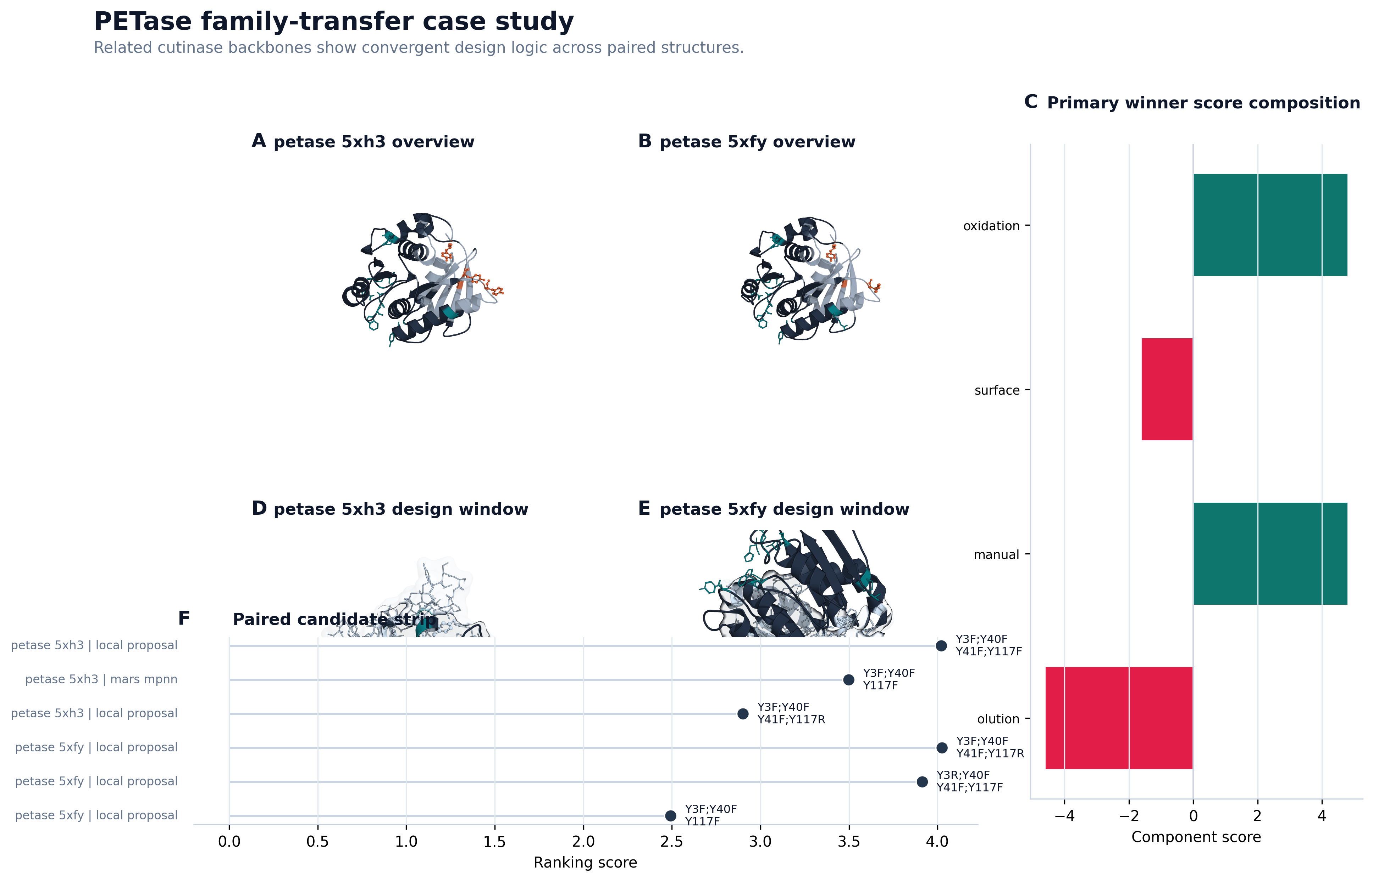
Figure 6. PETase case-study panel.
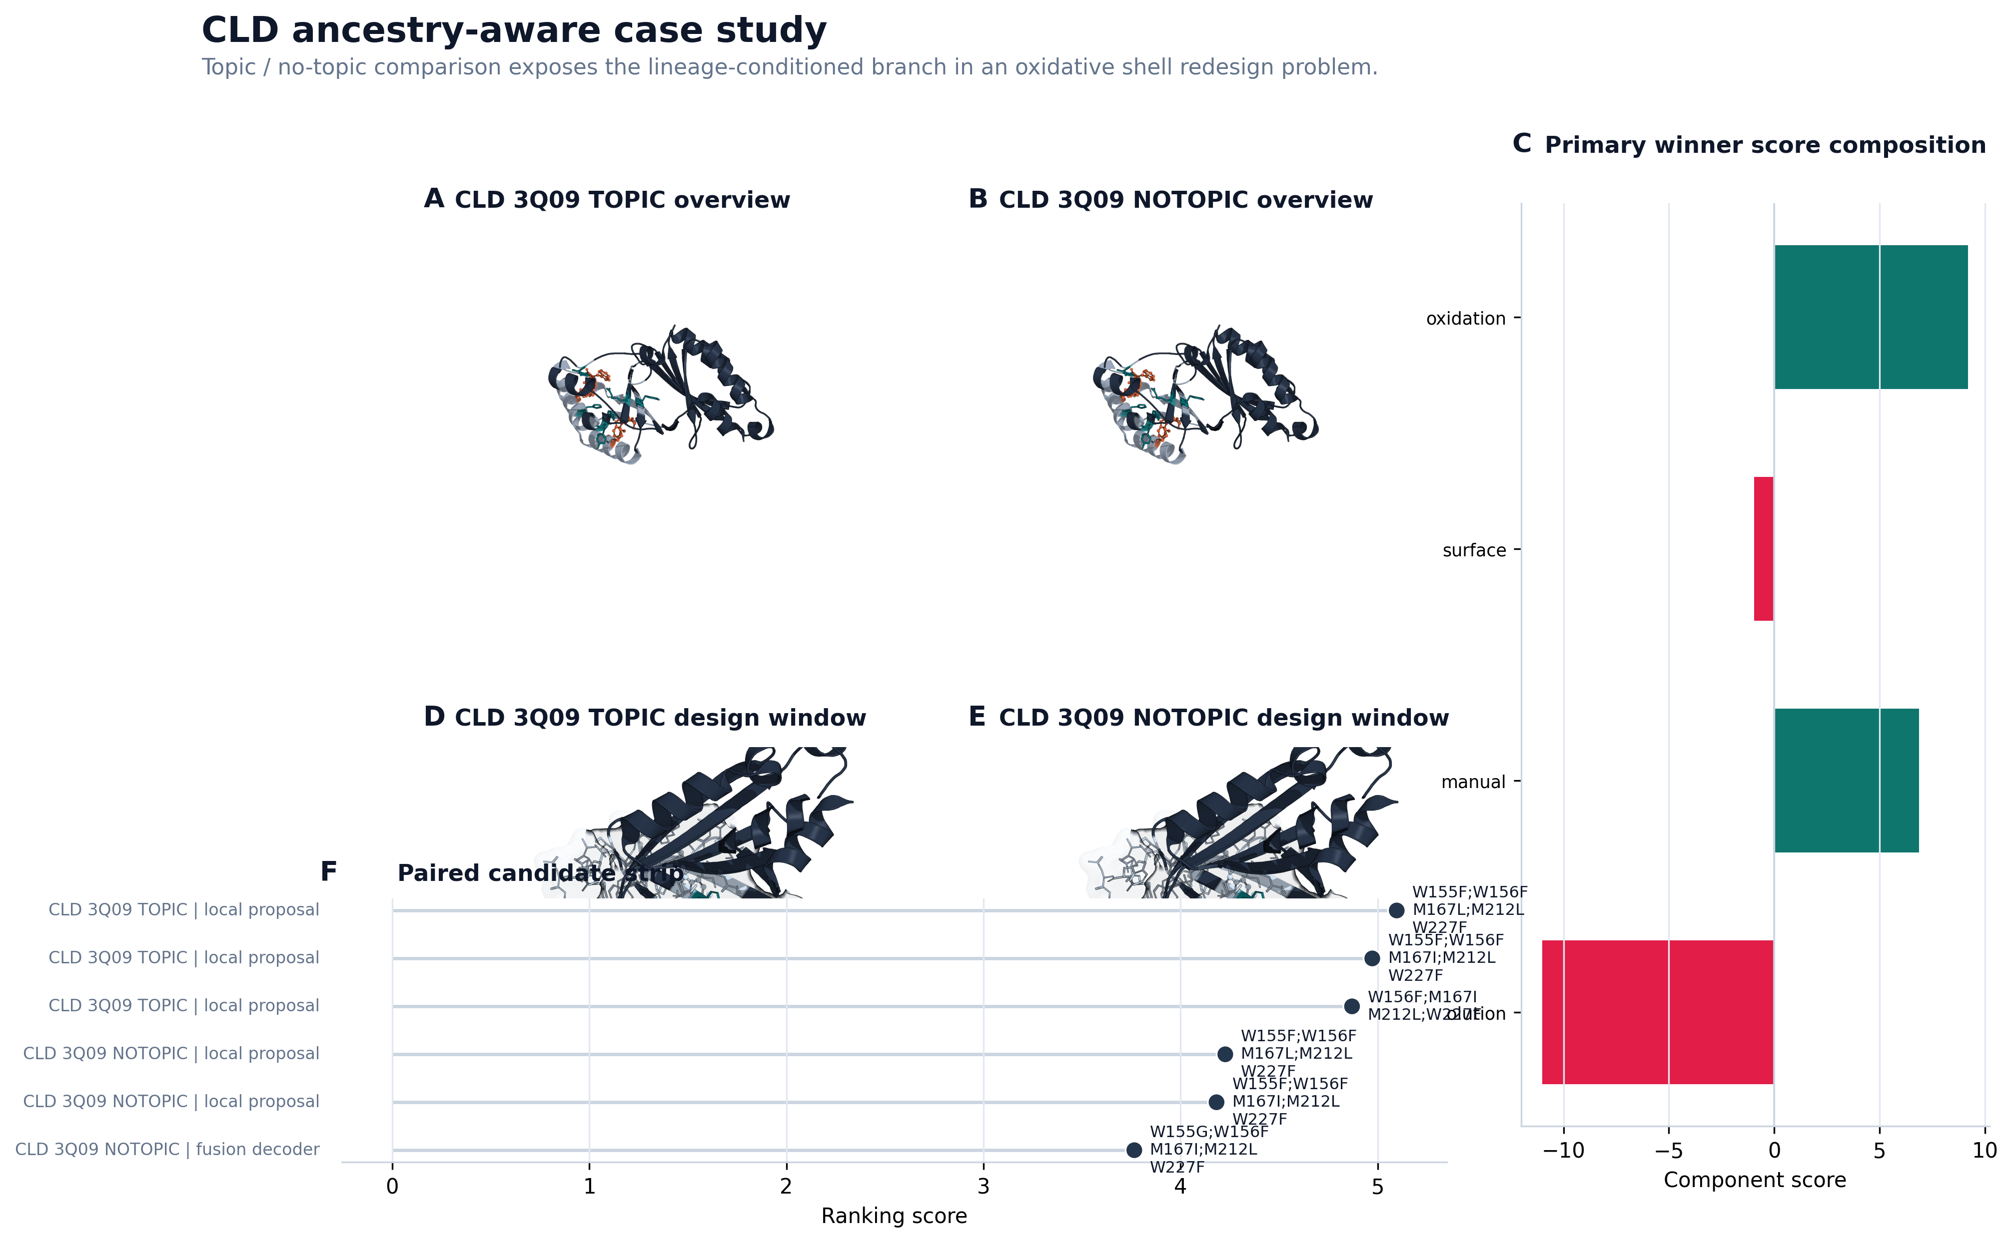
Figure 7. CLD case-study panel.
Main benchmark table
Target | Family | Final Policy Mutation | Policy Score | Engineering Score | Paired Delta | Neural Decoder Novel
1LBT | lipase_b | M298L | 4.999 | 3.867 | +0.284 | 0
tem1_1btl | beta_lactamase | H153N;M155L;W229F;M272L | 5.224 | 10.457 | +0.024 | 5
petase_5xfy | cutinase | Y3F;Y40F;Y41F;Y117F | 4.798 | 2.957 | +0.126 | 0
petase_5xh3 | cutinase | Y3F;Y40F;Y41F;Y117F | 4.668 | 2.957 | +0.001 | 4
sfgfp_2b3p | gfp_like | H25Q;H139Q;Y182F;H231Q | 5.236 | 6.227 | +0.126 | 0
t4l_171l | lysozyme | Y88S;W126F;Y139S;W158F | 4.832 | 2.593 | +0.025 | 13
subtilisin_2st1 | subtilisin | Y21F;Y104F;W241F;Y262Q | 4.496 | 1.457 | -0.167 | 7
adk_1s3g | adenylate_kinase | Y24F;H28Q;M103I;H109V | 5.352 | 14.073 | +0.161 | 0
esterase_7b4q | lipase_esterase | M52L;Y61F;H121S;Y123Q | 5.308 | 9.410 | +0.055 | 0
sod_1y67 | superoxide_dismutase | Y10F;H18Q;W175F;Y180Q | 5.044 | 3.557 | +0.035 | 5
CLD_3Q09_NOTOPIC | cld | W155F;W156F;M167I;M212L;W227F | 4.022 | 3.719 | -0.424 | 0
CLD_3Q09_TOPIC | cld | W155F;W156F;M167L;M212L;W227F | 4.918 | 4.999 | -0.256 | 0

Methods
Overall framework
MARS-FIELD is formulated as a unified evidence-to-sequence controller rather than a collection of disconnected proposal tools. The system absorbs five evidence classes: geometry-conditioned structural features, phylogenetic sequence profiles, ancestral lineage signals, retrieval-based motif memory, and environment-conditioned engineering context. These signals are combined into a shared residue field over the design positions.
Evidence streams and field construction
Structural evidence is derived from residue-level geometric features, including solvent exposure, flexibility, protected distances, and hotspot annotations. Evolutionary evidence is derived from homolog profiles and family-differential residue preferences. Ancestral evidence is represented as posterior residue preferences and confidence-weighted lineage-derived recommendations. Retrieval evidence is encoded as structure-derived motif memory. Environment evidence is encoded as target-level context tokens, including oxidation-hotspot burden, flexible-surface burden, design-window size, and prior availability flags.
The neural field contains geometry, phylogeny, ancestry, retrieval, and environment branches. Ancestry and retrieval are each connected to learned memory banks, allowing site representations to be fused with lineage memory and retrieval prototype memory. The resulting site hidden states drive both unary residue preferences and low-rank pairwise interaction terms.
Candidate-level neural controller
Candidate-level decision making combines sequence-conditioned residue embeddings with candidate-specific evidence features, including source type, support count, mutation burden, component-wise engineering terms, rank-calibrated selector features, and selector-prior context. Pairwise summaries are fused into the same candidate embedding. The controller outputs candidate-level selection, engineering, and policy predictions.
Training uses multiple calibration losses: regression to target-wise normalized selection scores, engineering-score regression, pairwise policy ranking, decoder-field residue supervision, winner-guard loss, non-decoder-guard loss, simplicity-guard loss, and selector-anchor distillation. Together, these losses stabilize the learned controller against over-eager branch replacement.
Neural field decoder
For each target, the pipeline constructs a runtime neural batch from the current target state, trains a leave-one-target-out neural field model using the remaining benchmark targets, and converts the learned unary and pairwise outputs into decode-ready residue fields. To keep decode-time generation grounded, neural field outputs are combined with evidence-derived prior position fields and prior pairwise terms before constrained beam decoding. This teacher-forced neural field produces neural_decoder candidates inside the main pipeline.
Benchmark protocol
The main benchmark panel contains twelve targets spanning ten protein families. Neural training is leave-one-target-out at the target level. The main paper-facing deployment arm is benchmark_twelvepack_final, which enables both neural reranking and neural field decoding while using a hybrid final policy. Paired comparisons are made against the incumbent benchmark. Primary metrics are policy selection score, engineering score (mars_score), and neural decoder utilization.
Interpretation of key benchmark metrics
1. `neural decoder enabled: 12/12` means the end-to-end neural generation branch is general enough to run on every benchmark target rather than being a hand-picked demo.
2. `retained novel neural-decoder candidates: 34` means the neural field is contributing non-redundant designs that were not already present in the incumbent candidate pool.
3. `policy score improved on 9/12` means the final controller is beneficial on most targets under paired comparison, not just in isolated examples.
4. `negative on 3/12` means the system still has calibration-limited targets, which should be discussed honestly as remaining weaknesses rather than hidden.
5. `mean paired delta about -0.001` means that after introducing the end-to-end neural field decoder, the benchmark does not collapse globally. The near-zero mean shows overall stability, while the 9/12 positive count shows that gains are distributed across most targets.

