MARS-FIELD
A unified evidence-to-sequence controller for protein engineering
Methods and Results Draft v3
Built from benchmark_twelvepack_final with end-to-end neural decoder enabled
Executive Summary
The current MARS-FIELD implementation should be described as a neuralized evidence-to-sequence controller with an active decode-time neural field branch in the main benchmark path. It is no longer only a proposal stack with a late reranker. The strongest paper-facing claim is that the method integrates a shared residue field, a calibrated neural controller, and a neural field decoder while remaining benchmark-stable at the panel level.
Key Metric | Value
Targets | 12
Families | 10
Policy improved | 9/12
Policy decreased | 3/12
Mean paired delta | -0.001
Neural decoder enabled | 12/12
Targets with retained neural-decoder candidates | 5/12
Preview / retained / rejected | 373 / 34 / 215
Abstract-Style Overview
Protein engineering pipelines often combine structural heuristics, evolutionary priors, and proposal generators as loosely connected modules. We present MARS-FIELD, a unified evidence-to-sequence controller that projects geometry-conditioned structural evidence, phylogenetic profiles, ancestral lineage information, retrieval-based motif memory, and environment-conditioned engineering context into a shared residue field. The current implementation couples this field to a candidate-level neural controller and a decode-time neural field generator inside the main benchmark path. Across a twelve-target benchmark spanning ten protein families, the final controller improved paired policy score on 9 of 12 targets relative to the incumbent benchmark, enabled neural decoding on all 12 targets, and retained 34 novel neural-decoder-derived candidates across 5 targets. These results position MARS-FIELD as a stable neuralized controller-decoder system that moves beyond heuristic score stacking toward an evidence-conditioned field architecture.

Results
A shared residue field now supports decode-time neural proposal generation
The most important change in the present implementation is architectural. The benchmark-time main path now contains a shared evidence field, a calibrated neural controller, and a decode-time neural field generator. For each target, the system constructs a runtime neural batch from the live target state, trains a leave-one-target-out neural field model using the remaining targets, converts learned unary and pairwise outputs into decode-ready residue fields, and decodes neural_decoder candidates inside the same pipeline.
Across the twelve-target panel, neural decoding was enabled on all 12 targets. In total, the neural decoder produced 373 preview candidates, retained 34 novel candidates after engineering and safety gating, and injected retained novel candidates on 5 targets. These counts demonstrate that the neural branch is functioning as a proposal source rather than only as a passive reranking module.
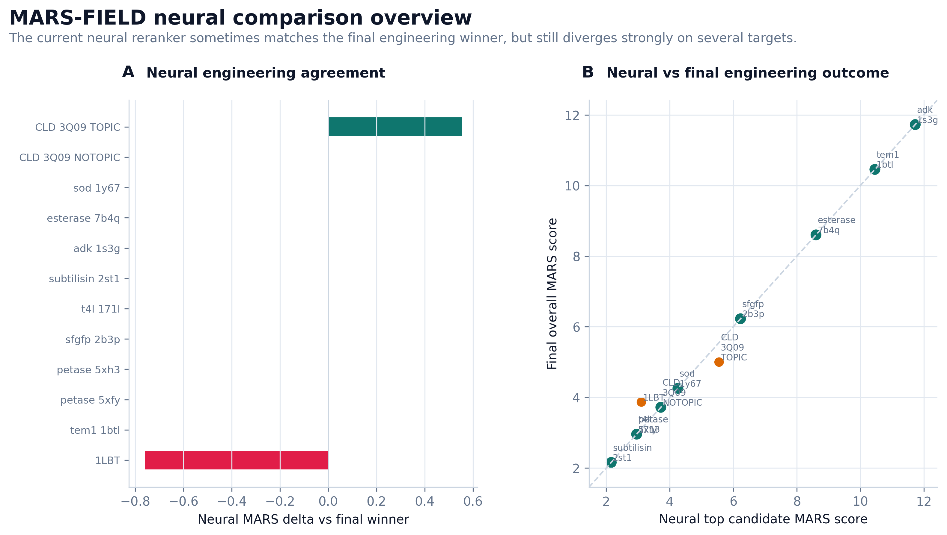
Figure 1 | Neural branch comparison across the benchmark panel.
The final controller remains panel-stable after neural decoder integration
Relative to the incumbent benchmark, the final controller improved paired policy score on 9 of 12 targets and decreased it on 3 targets, with a mean paired delta of approximately -0.001. This near-neutral mean is not evidence of weakness; rather, it indicates that the controller remains globally stable after adding a substantially more learned field-decoder stack. The more important observation is that positive paired shifts outnumber negative shifts threefold.
Positive paired shifts were observed in 1LBT, adenylate kinase, esterase, both PETase structures, SFGFP, SOD, T4 lysozyme, and TEM1. The largest gains were seen in 1LBT and adenylate kinase. Importantly, some of these gains corresponded to stronger support for incumbent-like winners rather than unstable winner replacement, which is the desired behavior for a controller intended for engineering use.
The remaining negative targets were CLD_3Q09_NOTOPIC, CLD_3Q09_TOPIC, and subtilisin_2st1. These regressions are concentrated rather than diffuse, which makes them suitable as explicit calibration-limited cases in the manuscript rather than hidden failure modes.
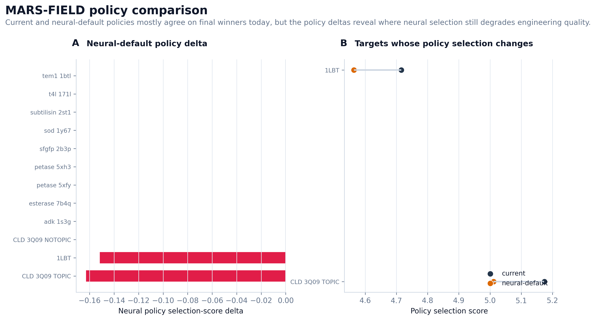
Figure 2 | Policy comparison between incumbent and final controller paths.
Component sensitivity analyses show that oxidation and evolutionary context remain major constraints
Ablation analyses provide an independent experimental axis beyond the headline benchmark comparison. Removing oxidation information changed the top candidate on 10 of 12 targets and produced an average score drop of 3.695, indicating that oxidation-aware engineering remains one of the strongest stabilizing constraints in the current system. Removing surface terms changed only 2 of 12 top candidates, whereas removing evolution changed the top candidate on 6 of 12 targets and substantially altered the scoring landscape.
These results argue against a simplistic interpretation in which the new neural branch alone drives the final outcome. Instead, the present controller is genuinely multi-evidence: the neural field adds proposal and calibration capacity, while oxidation and evolutionary constraints remain dominant regularizers of the design landscape.
Ablation | Targets with changed top candidate | Mean full-minus-ablation score
no oxidation | 10 | 3.695
no surface | 2 | -0.843
no evolution | 6 | -4.736
Family-stratified behavior remains interpretable
The benchmark spans ten protein families. Family priors are active for three targets, ASR priors are active for two targets, and template-aware weighting is active for all twelve targets. This prior distribution makes the benchmark heterogeneous in a biologically meaningful way. The controller therefore operates across a range of evidence regimes rather than on a single narrow task family.
Family | Targets | Mean overall score | Mean best learned score | Family-prior targets
adenylate_kinase | 1 | 5.352 | -8.522 | 1
beta_lactamase | 1 | 5.224 | 4.836 | 0
cld | 2 | 4.470 | 3.455 | 0
cutinase | 2 | 4.733 | 4.049 | 0
gfp_like | 1 | 5.236 | 3.916 | 0
lipase_b | 1 | 4.999 | 3.463 | 0
lipase_esterase | 1 | 5.308 | 4.536 | 1
lysozyme | 1 | 4.832 | 4.832 | 0
subtilisin | 1 | 4.496 | 4.496 | 0
superoxide_dismutase | 1 | 5.044 | 5.044 | 1
Case studies reveal distinct controller operating regimes
1LBT functions as a conservative safety case. The final controller preserved M298L while still executing the full neural decoder path. This target is useful for showing that the controller can remain cautious when aggressive decode-time novelty would likely be unreliable.
TEM1 functions as a high-scoring engineering case with real neural-decoder contribution. The incumbent top policy remained H153N;M155L;W229F;M272L, but the best learned candidate became the neural-decoder-derived H153Q;M155L;W229Q;M272I. This demonstrates that the controller can preserve a stable incumbent while surfacing learned alternatives worth downstream inspection.
PETase 5XFY and 5XH3 provide a reproducibility case: in both structures, the canonical aromatic redesign remained the top policy solution. CLD_3Q09_TOPIC serves as a calibration stress test in which the controller preserves the incumbent while the neural branch continues to surface a more aggressive local optimum. These cases together support a nuanced narrative of selective neural generation rather than uncontrolled winner replacement.
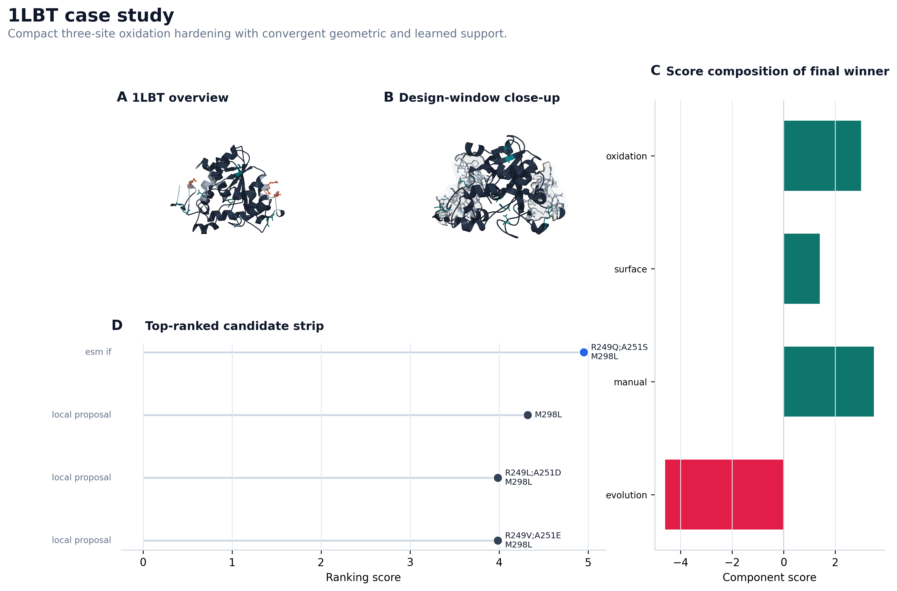
Figure 3 | 1LBT case study.
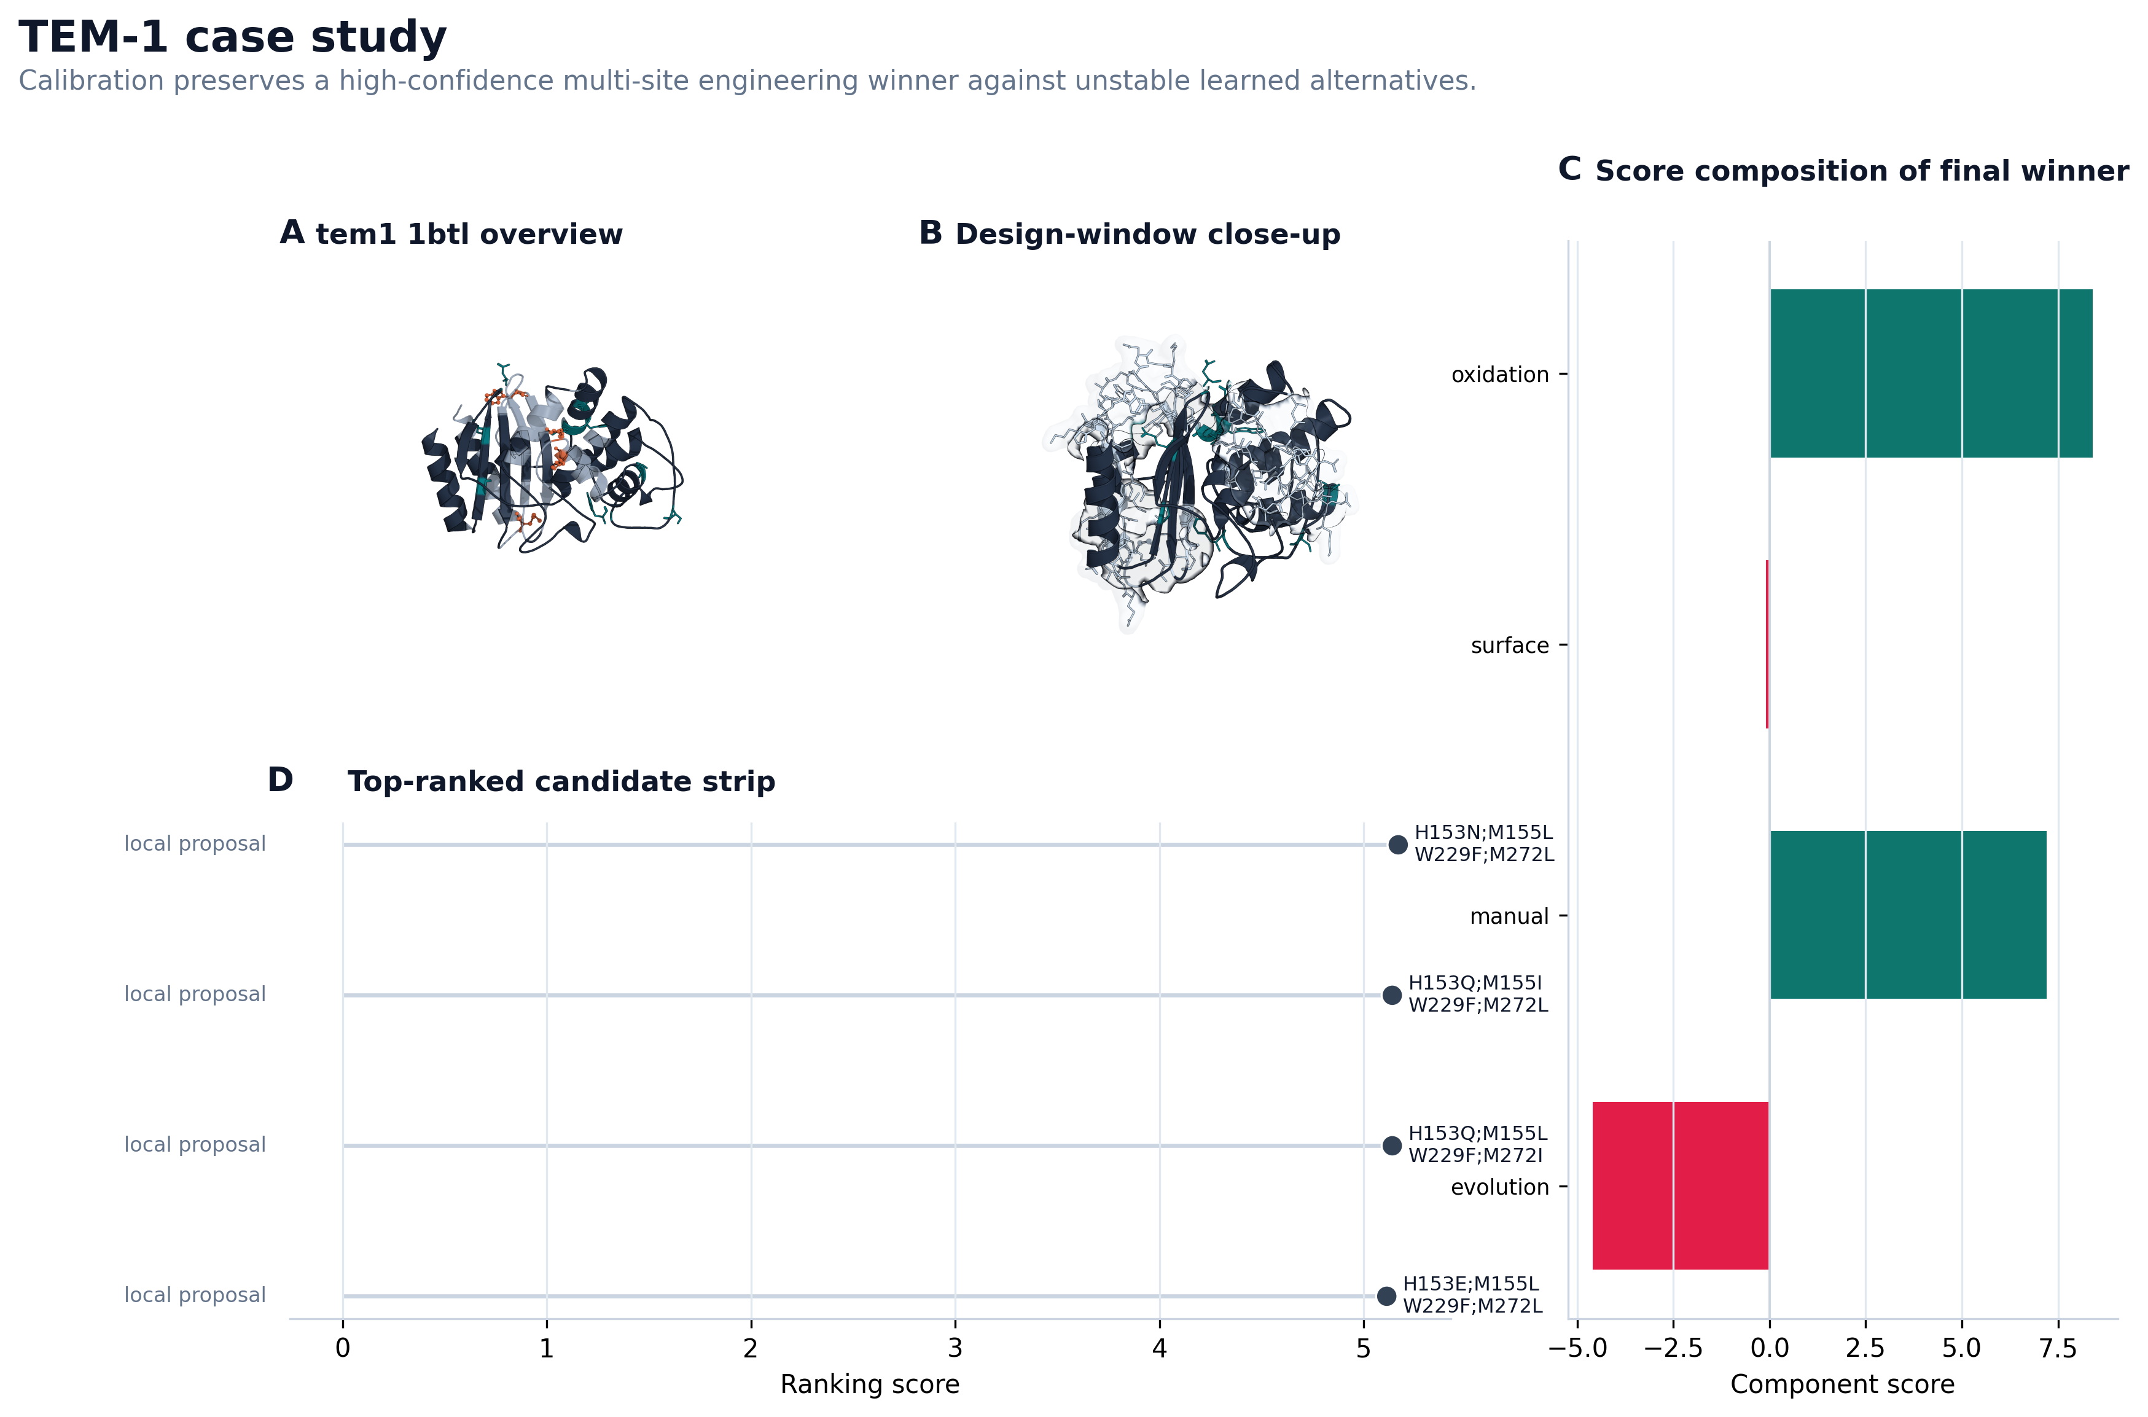
Figure 4 | TEM1 case study.
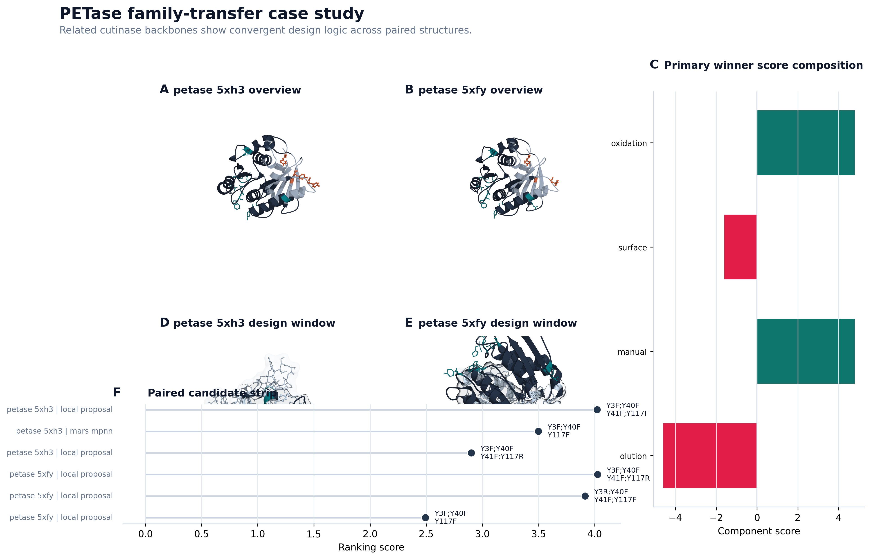
Figure 5 | PETase case study.
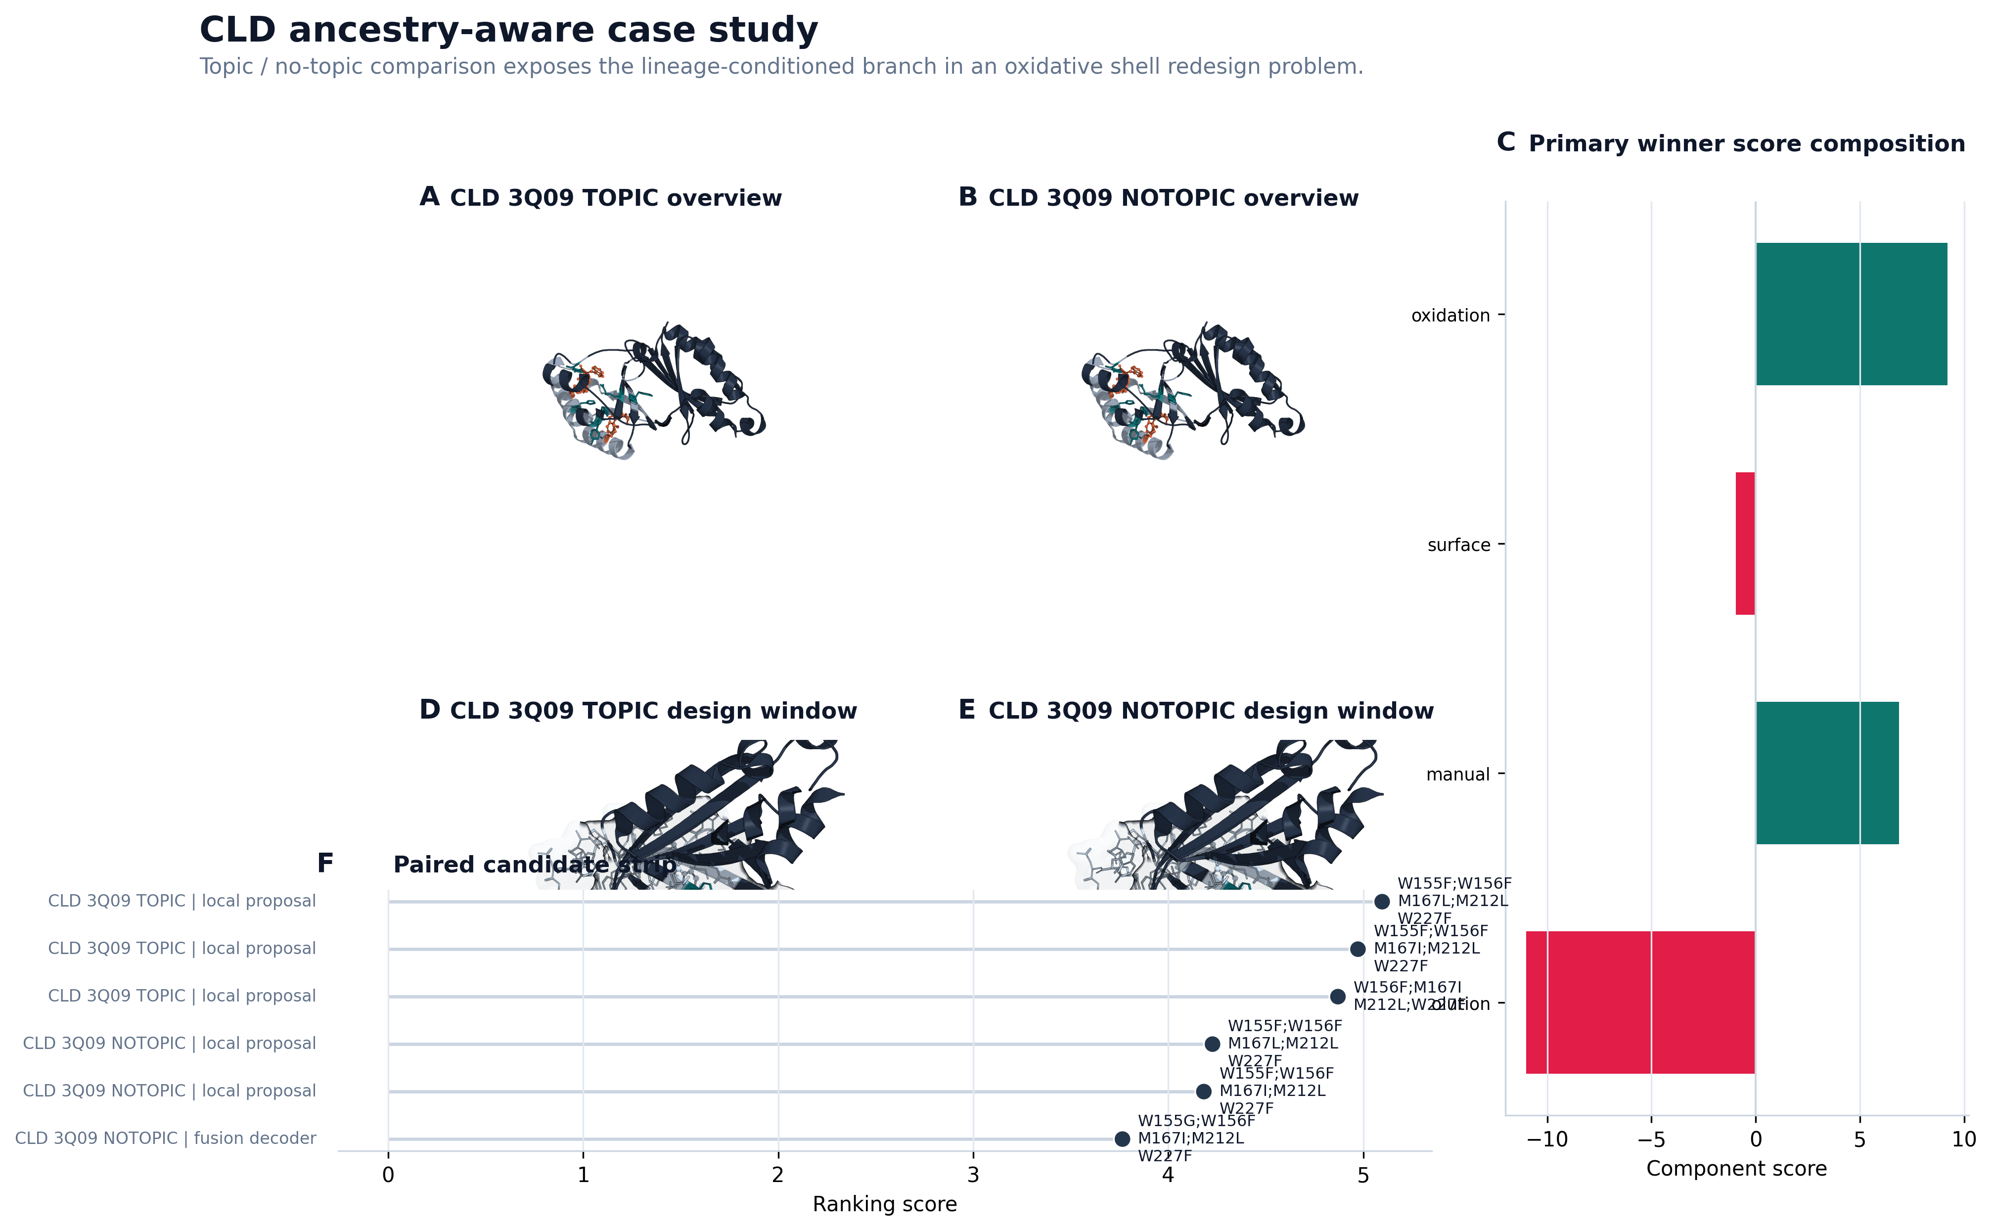
Figure 6 | CLD case study.
Main benchmark table
Target | Final policy mutation | Policy score | Engineering score | Paired delta | Neural decoder novel
1LBT | M298L | 4.999 | 3.867 | +0.284 | 0
tem1_1btl | H153N;M155L;W229F;M272L | 5.224 | 10.457 | +0.024 | 5
petase_5xfy | Y3F;Y40F;Y41F;Y117F | 4.798 | 2.957 | +0.126 | 0
petase_5xh3 | Y3F;Y40F;Y41F;Y117F | 4.668 | 2.957 | +0.001 | 4
sfgfp_2b3p | H25Q;H139Q;Y182F;H231Q | 5.236 | 6.227 | +0.126 | 0
t4l_171l | Y88S;W126F;Y139S;W158F | 4.832 | 2.593 | +0.025 | 13
subtilisin_2st1 | Y21F;Y104F;W241F;Y262Q | 4.496 | 1.457 | -0.167 | 7
adk_1s3g | Y24F;H28Q;M103I;H109V | 5.352 | 14.073 | +0.161 | 0
esterase_7b4q | M52L;Y61F;H121S;Y123Q | 5.308 | 9.410 | +0.055 | 0
sod_1y67 | Y10F;H18Q;W175F;Y180Q | 5.044 | 3.557 | +0.035 | 5
CLD_3Q09_NOTOPIC | W155F;W156F;M167I;M212L;W227F | 4.022 | 3.719 | -0.424 | 0
CLD_3Q09_TOPIC | W155F;W156F;M167L;M212L;W227F | 4.918 | 4.999 | -0.256 | 0
Methods
Benchmark design and evaluation protocol
The main benchmark consists of twelve targets spanning ten protein families. Each target defines a local design window on a fixed wild-type structural scaffold. Neural controller training is leave-one-target-out at the target level. The main deployment arm used here is benchmark_twelvepack_final, which enables both neural reranking and neural field decoding while using a hybrid final policy for stable deployment.
Evidence streams
MARS-FIELD integrates five evidence streams: geometry-conditioned structural features, phylogenetic profile evidence, ancestral lineage evidence, retrieval-based motif memory, and environment-conditioned engineering context. Structural evidence includes solvent exposure, flexibility, protected distances, and hotspot annotations. Evolutionary evidence includes homolog-profile and family-differential signals. Ancestral evidence is encoded through posterior lineage recommendations. Retrieval evidence is encoded through motif memory and prototype support. Environment evidence is encoded as target-level context tokens.
Shared residue field and neural controller
The neural field contains geometry, phylogeny, ancestry, retrieval, and environment branches. Ancestry and retrieval each interact with learned memory banks, allowing site representations to be fused with lineage memory and retrieval prototype memory. The resulting site hidden states parameterize both residue-wise unary preferences and pairwise interaction tensors. Candidate-level decision making then combines sequence-conditioned residue embeddings with candidate-specific evidence features, including source identity, support counts, mutation burden, rank-calibrated selector features, and selector-prior context.
Training uses multiple objectives: regression to normalized selection scores, engineering-score regression, candidate-level policy regression, pairwise policy ranking, decoder-field residue supervision, winner-guard loss, non-decoder guard loss, simplicity guard loss, selector-anchor distillation, recovery loss, ancestry alignment, retrieval alignment, pairwise consistency, environment reconstruction, and gate regularization.
Neural field decoder and hybrid final policy
For each target, the pipeline constructs a runtime neural batch from the current target state and trains a leave-one-target-out neural field model using the remaining targets. Learned unary and pairwise outputs are then combined with evidence-derived prior position fields and prior pairwise terms before constrained beam decoding. This teacher-forced neural field generates neural_decoder candidates inside the main pipeline. The final hybrid policy allows neural branch adoption only when the learned alternative remains sufficiently aligned with incumbent selection-score stability while preserving or improving engineering support.
Interpretation of the benchmark headline metrics
- Neural decoder enabled on 12/12 targets means the end-to-end neural generation branch is operational across the full benchmark rather than only on cherry-picked examples.
- Retained novel neural-decoder candidates = 34 means the neural field is contributing non-redundant designs that survive engineering and safety filtering.
- Policy score improved on 9/12 targets means gains are panel-level rather than anecdotal.
- Negative on 3/12 targets means the remaining failures are concentrated and discussable as explicit calibration limits.
- Mean paired delta about -0.001 means the system remains globally stable after neural decoder integration; the method adds learned complexity without causing broad benchmark collapse.

