MARS-FIELD
A unified evidence-to-sequence controller for protein engineering
Submission-style draft v6
Abstract
We present MARS-FIELD, a unified evidence-to-sequence controller that projects geometry-conditioned structural evidence, phylogenetic profiles, ancestral lineage information, retrieval-based motif memory, and environment-conditioned engineering context into a shared residue field. The current implementation couples this field to a candidate-level neural controller and a decode-time neural field generator inside the benchmark-time main path. Across a twelve-target benchmark spanning ten protein families, the final controller improved paired policy score on 9 of 12 targets relative to the incumbent benchmark, enabled neural decoding on all 12 targets, and retained 34 novel neural-decoder-derived candidates across 5 targets. These results support MARS-FIELD as a stable neuralized controller-decoder system that moves beyond heuristic score stacking toward an evidence-conditioned field architecture.
Introduction
Protein engineering pipelines often integrate structural analysis, evolutionary context, ancestral reconstruction, and machine-learning proposal generators as loosely connected modules. Although this strategy enables rapid iteration, it also creates a conceptual weakness: the system behaves as an ensemble of partially redundant signals rather than as a unified controller. This becomes especially limiting when the objective is not simply sequence plausibility but robust engineering under multiple constraints, including oxidation risk, flexible-surface burden, motif preservation, and environment-conditioned performance targets.
MARS-FIELD addresses this problem by treating protein engineering as an evidence-to-sequence control task. Geometric, phylogenetic, ancestral, retrieval-based, and environment-conditioned signals are projected into a shared residue field over the design positions. This field is the native decision object of the method: it defines residue-wise preferences and pairwise couplings, which are then used to score incumbents and decode new sequence proposals under engineering constraints.
The present implementation moves beyond a reranker-centric architecture in two ways. First, ancestry and retrieval are represented as learned memory-linked branches within the neural controller. Second, the neural branch is now coupled to a decode-time neural field generator in the main benchmark path. The goal of this work is therefore not to claim a final fully joint protein design foundation model, but to demonstrate that a unified evidence-conditioned field-controller system can be built in a way that is benchmark-stable, interpretable, and capable of neural proposal generation.
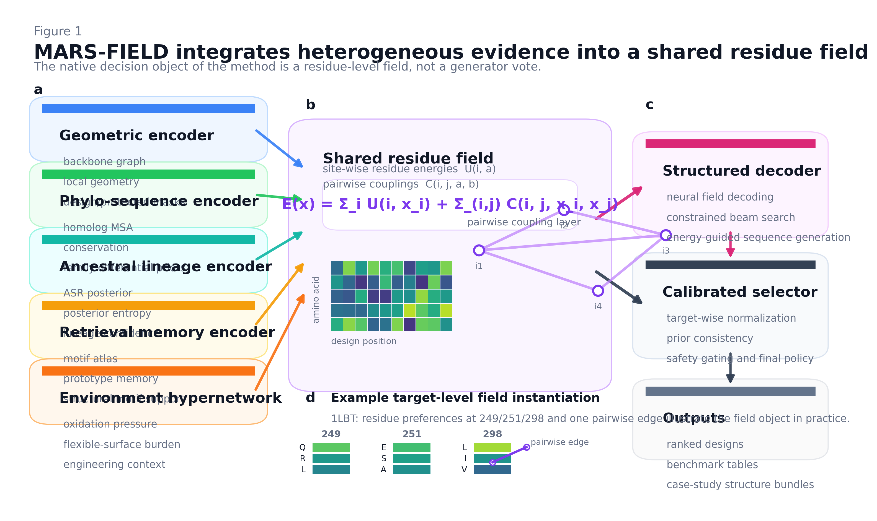
Figure 1 | MARS-FIELD integrates heterogeneous evidence into a shared residue field. The method operates on site-wise residue energies and pairwise couplings rather than on a generator vote.
Results
The final controller improved paired policy score on 9 of 12 targets and decreased it on 3 targets, with a mean paired delta of -0.001. This near-neutral mean indicates that the benchmark remains globally stable after neural decoder integration, while the directionality of the paired effects shows that positive target-level gains substantially outnumber negative ones.
Neural decoding was enabled on all 12 targets, produced 373 preview candidates, retained 34 novel candidates after engineering and safety filtering, and contributed retained novel candidates on 5 targets. This demonstrates that the neural branch is functioning as a genuine proposal source rather than as a passive auxiliary scorer.
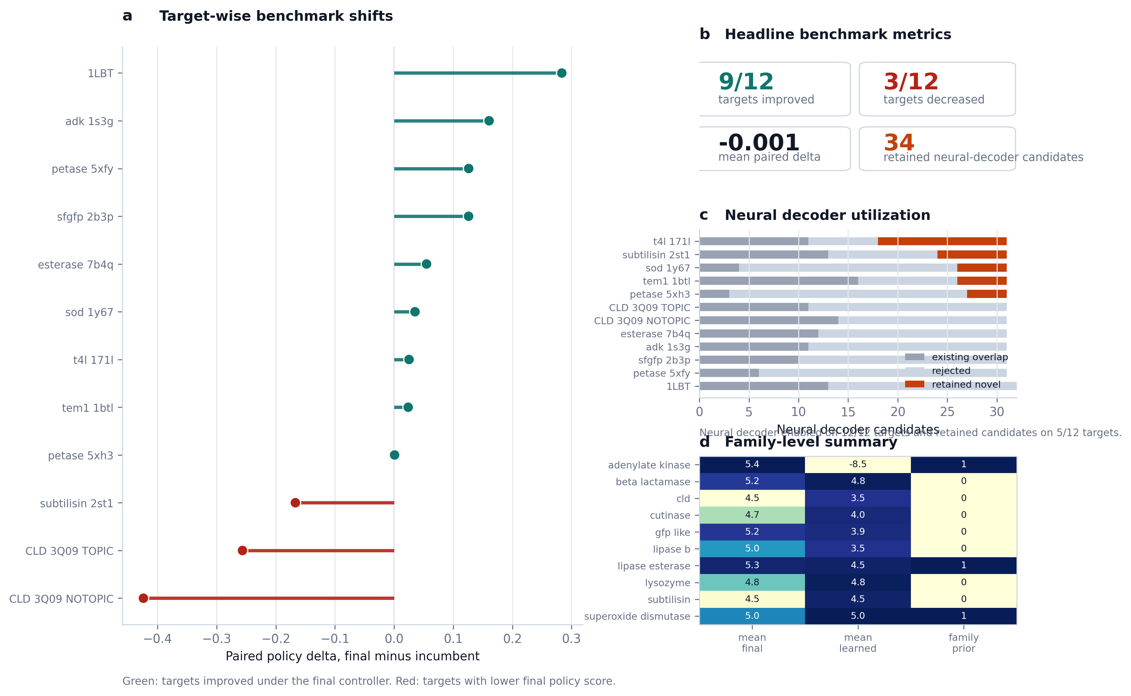
Figure 2 | Benchmark claim figure. Paired policy shifts, headline metrics, neural decoder utilization, and family-level summary support the benchmark-level claim.
Ablation and diagnostic analyses show that the current method remains strongly grounded in chemically and evolutionarily meaningful constraints. Oxidation-aware and evolutionary signals remain dominant regulators of the design landscape, while neural gate profiles reveal target-specific evidence usage rather than a uniform black-box weighting scheme. The remaining regressions are concentrated in a small number of explicit calibration-limited cases, including the CLD topic-conditioned targets and subtilisin.
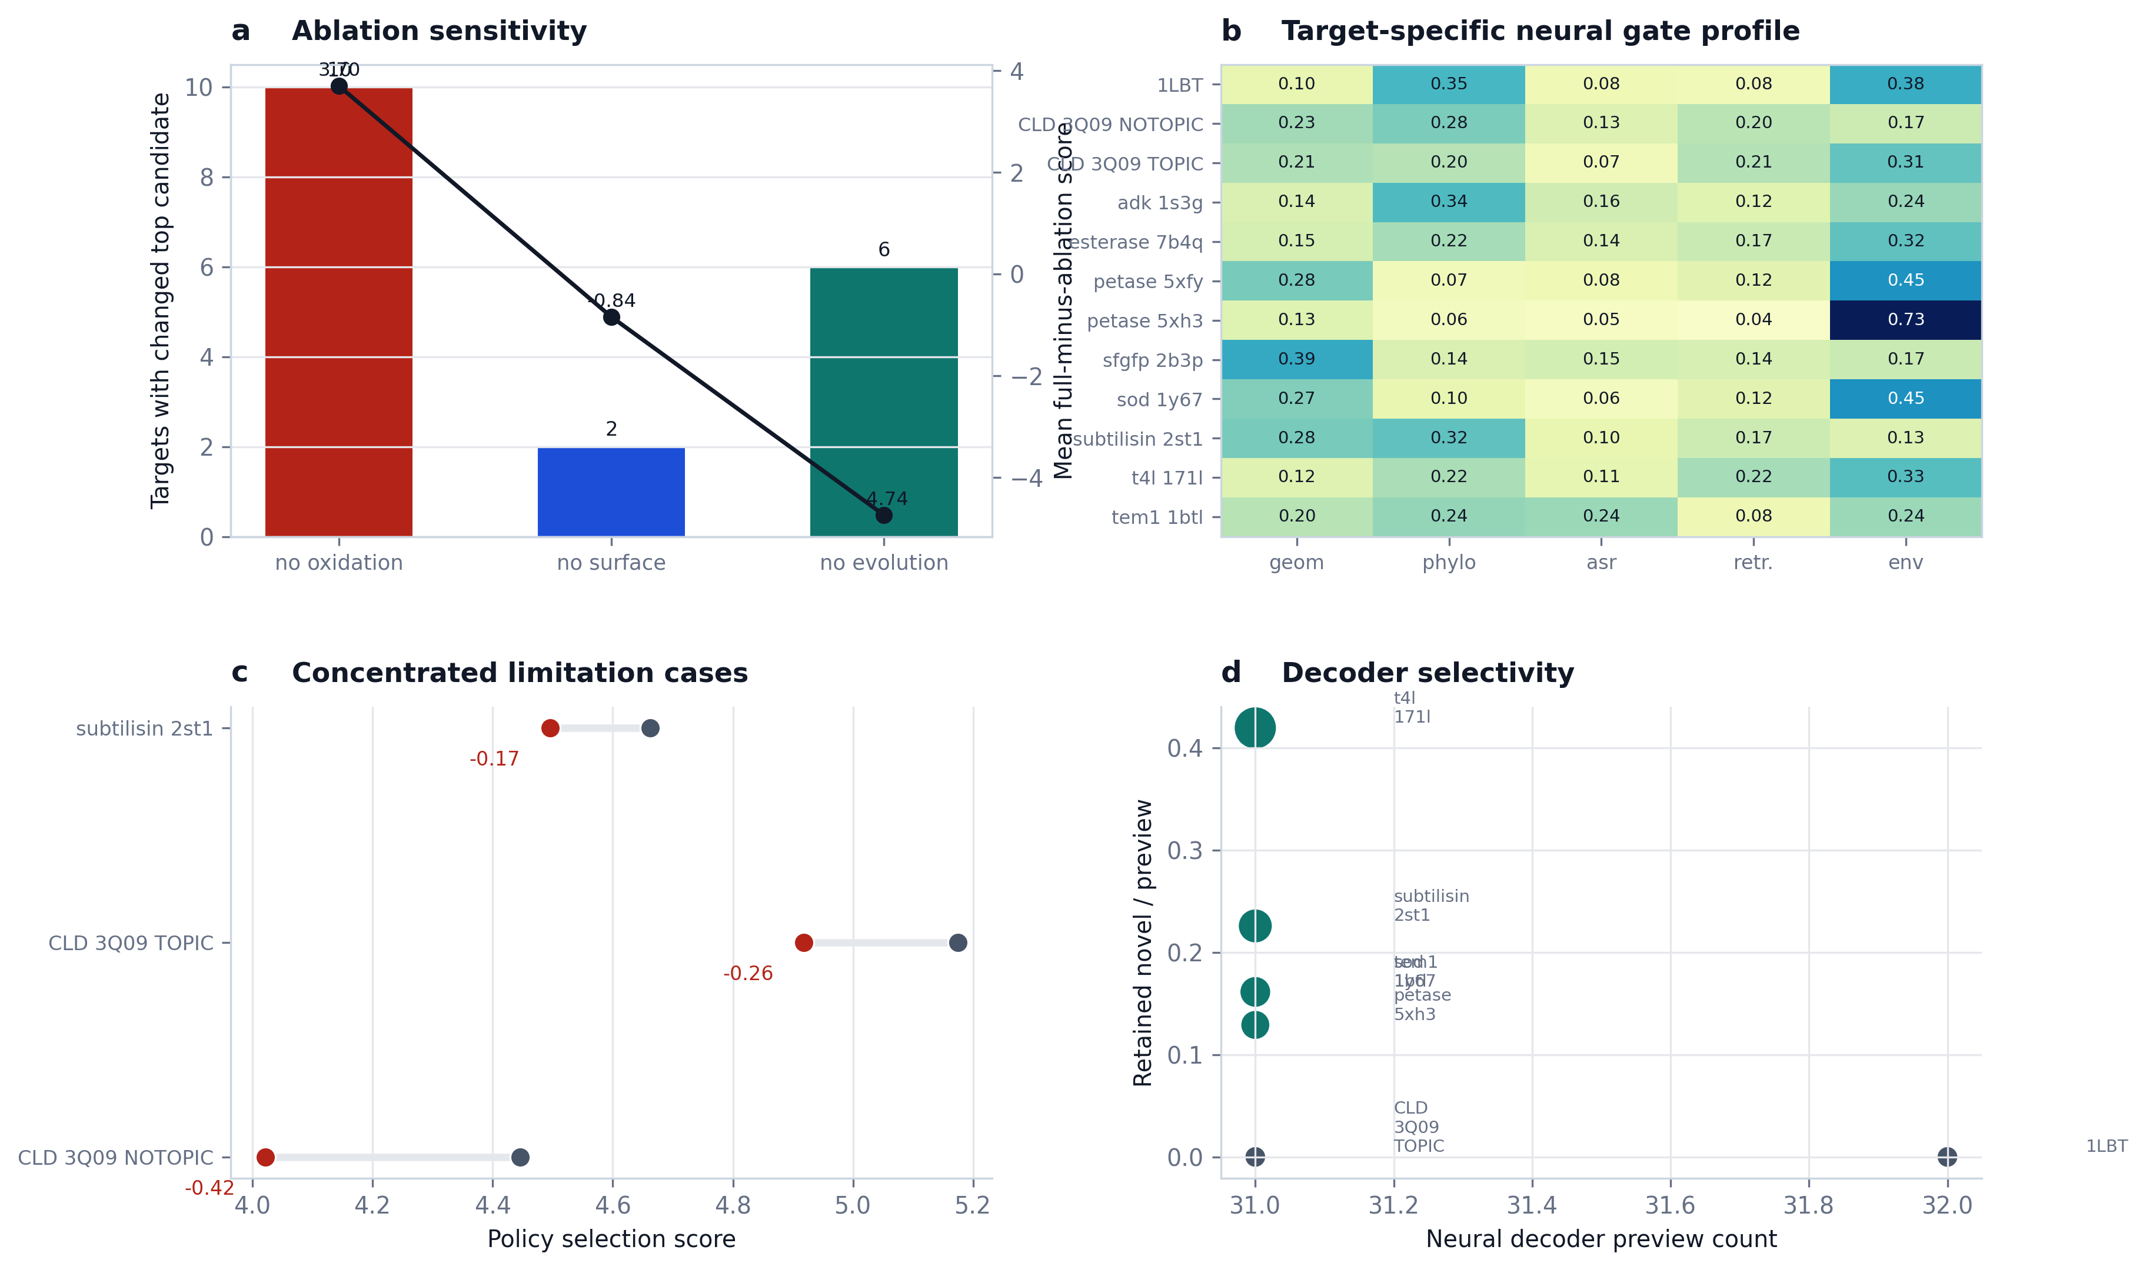
Figure 3 | Mechanism and limitation figure. Ablations identify dominant constraints, neural diagnostics show target-dependent evidence usage, and failures remain concentrated rather than diffuse.
Representative case studies further show that the controller does not behave identically across targets. In 1LBT, the method behaves conservatively and preserves a known safe incumbent despite active neural decoding. In TEM1, the incumbent remains stable while the neural branch surfaces an interpretable learned alternative. In PETase, the controller reproduces a canonical redesign across related structures. In CLD, the system exposes a calibration stress test in which incumbent stability and a stronger local engineering alternative remain in tension.
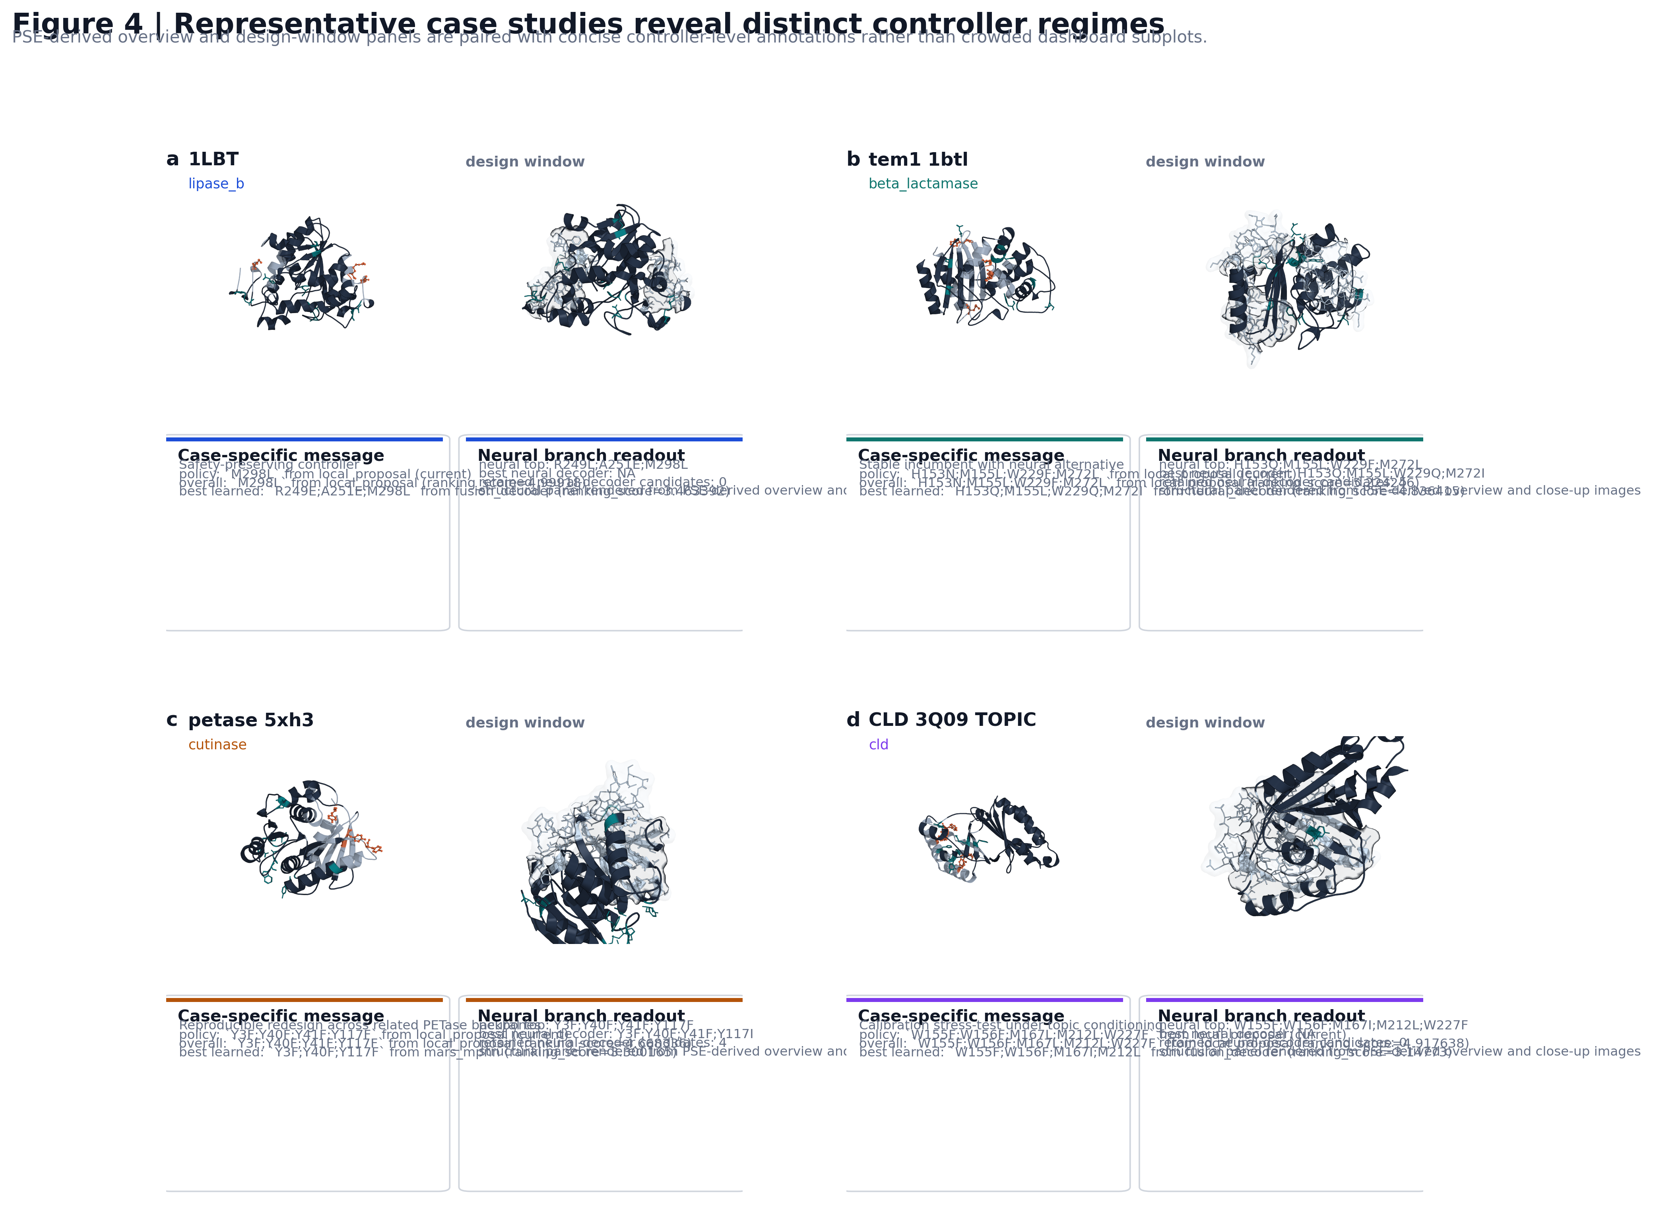
Figure 4 | PSE-derived case-study composite. 1LBT, TEM1, PETase, and CLD reveal distinct controller regimes: safety preservation, stable incumbent with learned alternative, reproducible redesign, and calibration stress test.
Methods
The main benchmark consists of twelve targets spanning ten protein families. Each target defines a local design window on a fixed wild-type structural scaffold. Neural controller training is leave-one-target-out at the target level. The main deployment arm used here is benchmark_twelvepack_final, which enables both neural reranking and neural field decoding while using a hybrid final policy for stable deployment.
MARS-FIELD integrates five evidence streams: geometry-conditioned structural features, phylogenetic profile evidence, ancestral lineage evidence, retrieval-based motif memory, and environment-conditioned engineering context. These signals are projected into a shared residue field containing both residue-wise and pairwise preferences. The neural field contains geometry, phylogeny, ancestry, retrieval, and environment branches; ancestry and retrieval each interact with learned memory banks to fuse local residue representations with lineage memory and retrieval prototype memory.
Candidate-level decision making combines sequence-conditioned residue embeddings with candidate-specific evidence features, including source identity, support count, mutation burden, component-wise engineering scores, selector-rank priors, gaps to the best incumbent, and other calibration-aware signals. Training uses multiple objectives, including selection regression, engineering regression, policy regression, pairwise ranking, decoder-field supervision, winner-guard loss, non-decoder guard loss, simplicity guard loss, selector-anchor distillation, recovery loss, ancestry alignment, retrieval alignment, pairwise consistency, environment reconstruction, and gate regularization.
For each target, the pipeline constructs a runtime neural batch from the current target state, trains a leave-one-target-out neural field model using the remaining targets, combines learned unary and pairwise outputs with evidence-derived prior position fields and prior pairwise terms, and decodes neural_decoder candidates under constrained beam search. The final hybrid policy permits learned branch adoption only when the alternative remains sufficiently aligned with incumbent selection-score stability while preserving engineering support.
Discussion
The central conclusion of this work is that a unified residue-field controller provides a more coherent algorithmic basis for protein engineering than an ensemble of disconnected proposal branches. In the current implementation, MARS-FIELD integrates heterogeneous evidence streams into a shared residue field, uses a calibrated neural controller to score candidates, and activates a decode-time neural branch inside the main benchmark path. This is qualitatively different from earlier stack-and-rerank pipelines because the neural branch now participates in generation as well as selection.
The remaining limitations are also clearer in this formulation. The system is now strong enough to be described as an engineering-honest end-to-end controller-decoder architecture, but it is not yet the fully joint proposal-generator / field / decoder research endpoint. The remaining gap is therefore no longer missing plumbing; it is a genuine research frontier centered on joint optimization and improved calibration on a small number of hard targets.
For manuscript positioning, the strongest claim is not that MARS-FIELD already solves every regime equally well, but that it establishes a stable bridge between heuristic engineering stacks and future fully joint protein design controllers. It combines a unified evidence-to-sequence formulation, real neural proposal generation, benchmark-scale stability, and explicit mechanistic accounting of both gains and failures.
Selected References
1. Jumper, J. et al. Highly accurate protein structure prediction with AlphaFold. Nature 596, 583-589 (2021).
2. Dauparas, J. et al. Robust deep learning-based protein sequence design using ProteinMPNN. Science 378, 49-56 (2022).
3. Hsu, C. et al. Learning inverse folding from millions of predicted structures. Proc. ICML, PMLR 162, 8946-8970 (2022).
4. Lin, Z. et al. Evolutionary-scale prediction of atomic-level protein structure with a language model. Science 379, 1123-1130 (2023).
5. van Kempen, M. et al. Fast and accurate protein structure search with Foldseek. Nat. Biotechnol. 42, 243-246 (2024).
6. Alley, E. C. et al. Unified rational protein engineering with sequence-based deep representation learning. Nat. Methods 16, 1315-1322 (2019).
7. Chisholm, L. O. et al. Ancestral reconstruction and the evolution of protein energy landscapes. Annu. Rev. Biophys. 53, 127-146 (2024).
8. Matthews, D. S. et al. Leveraging ancestral sequence reconstruction for protein representation learning. Nat. Mach. Intell. 6, 1542-1555 (2024).

