MARS-FIELD
A unified evidence-to-sequence controller for protein engineering
Submission-style draft v7
Main Figures
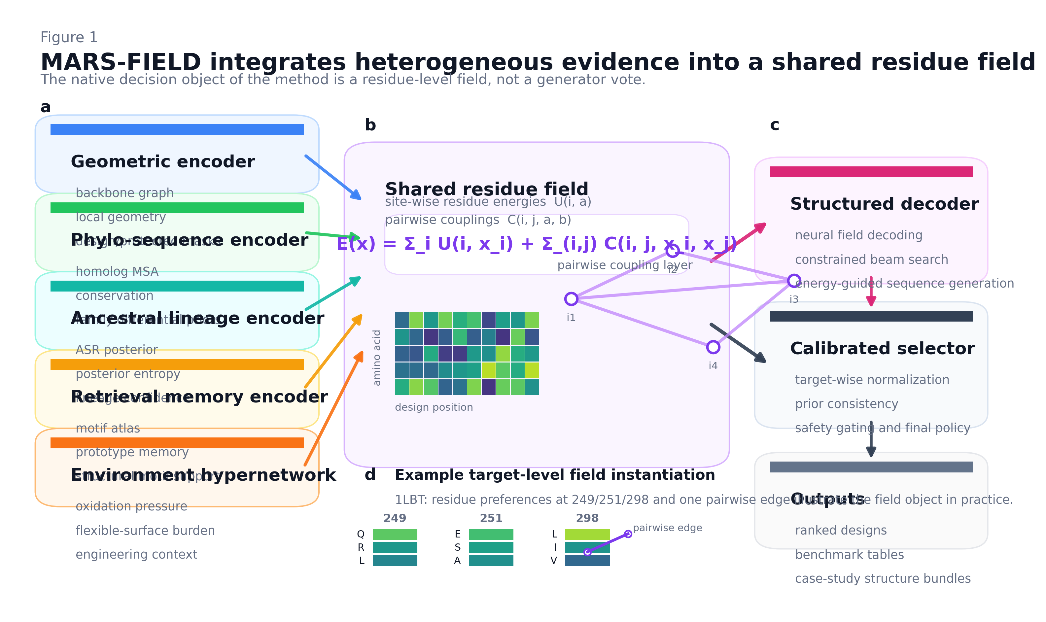
Figure 1 | MARS-FIELD integrates heterogeneous evidence into a shared residue field.
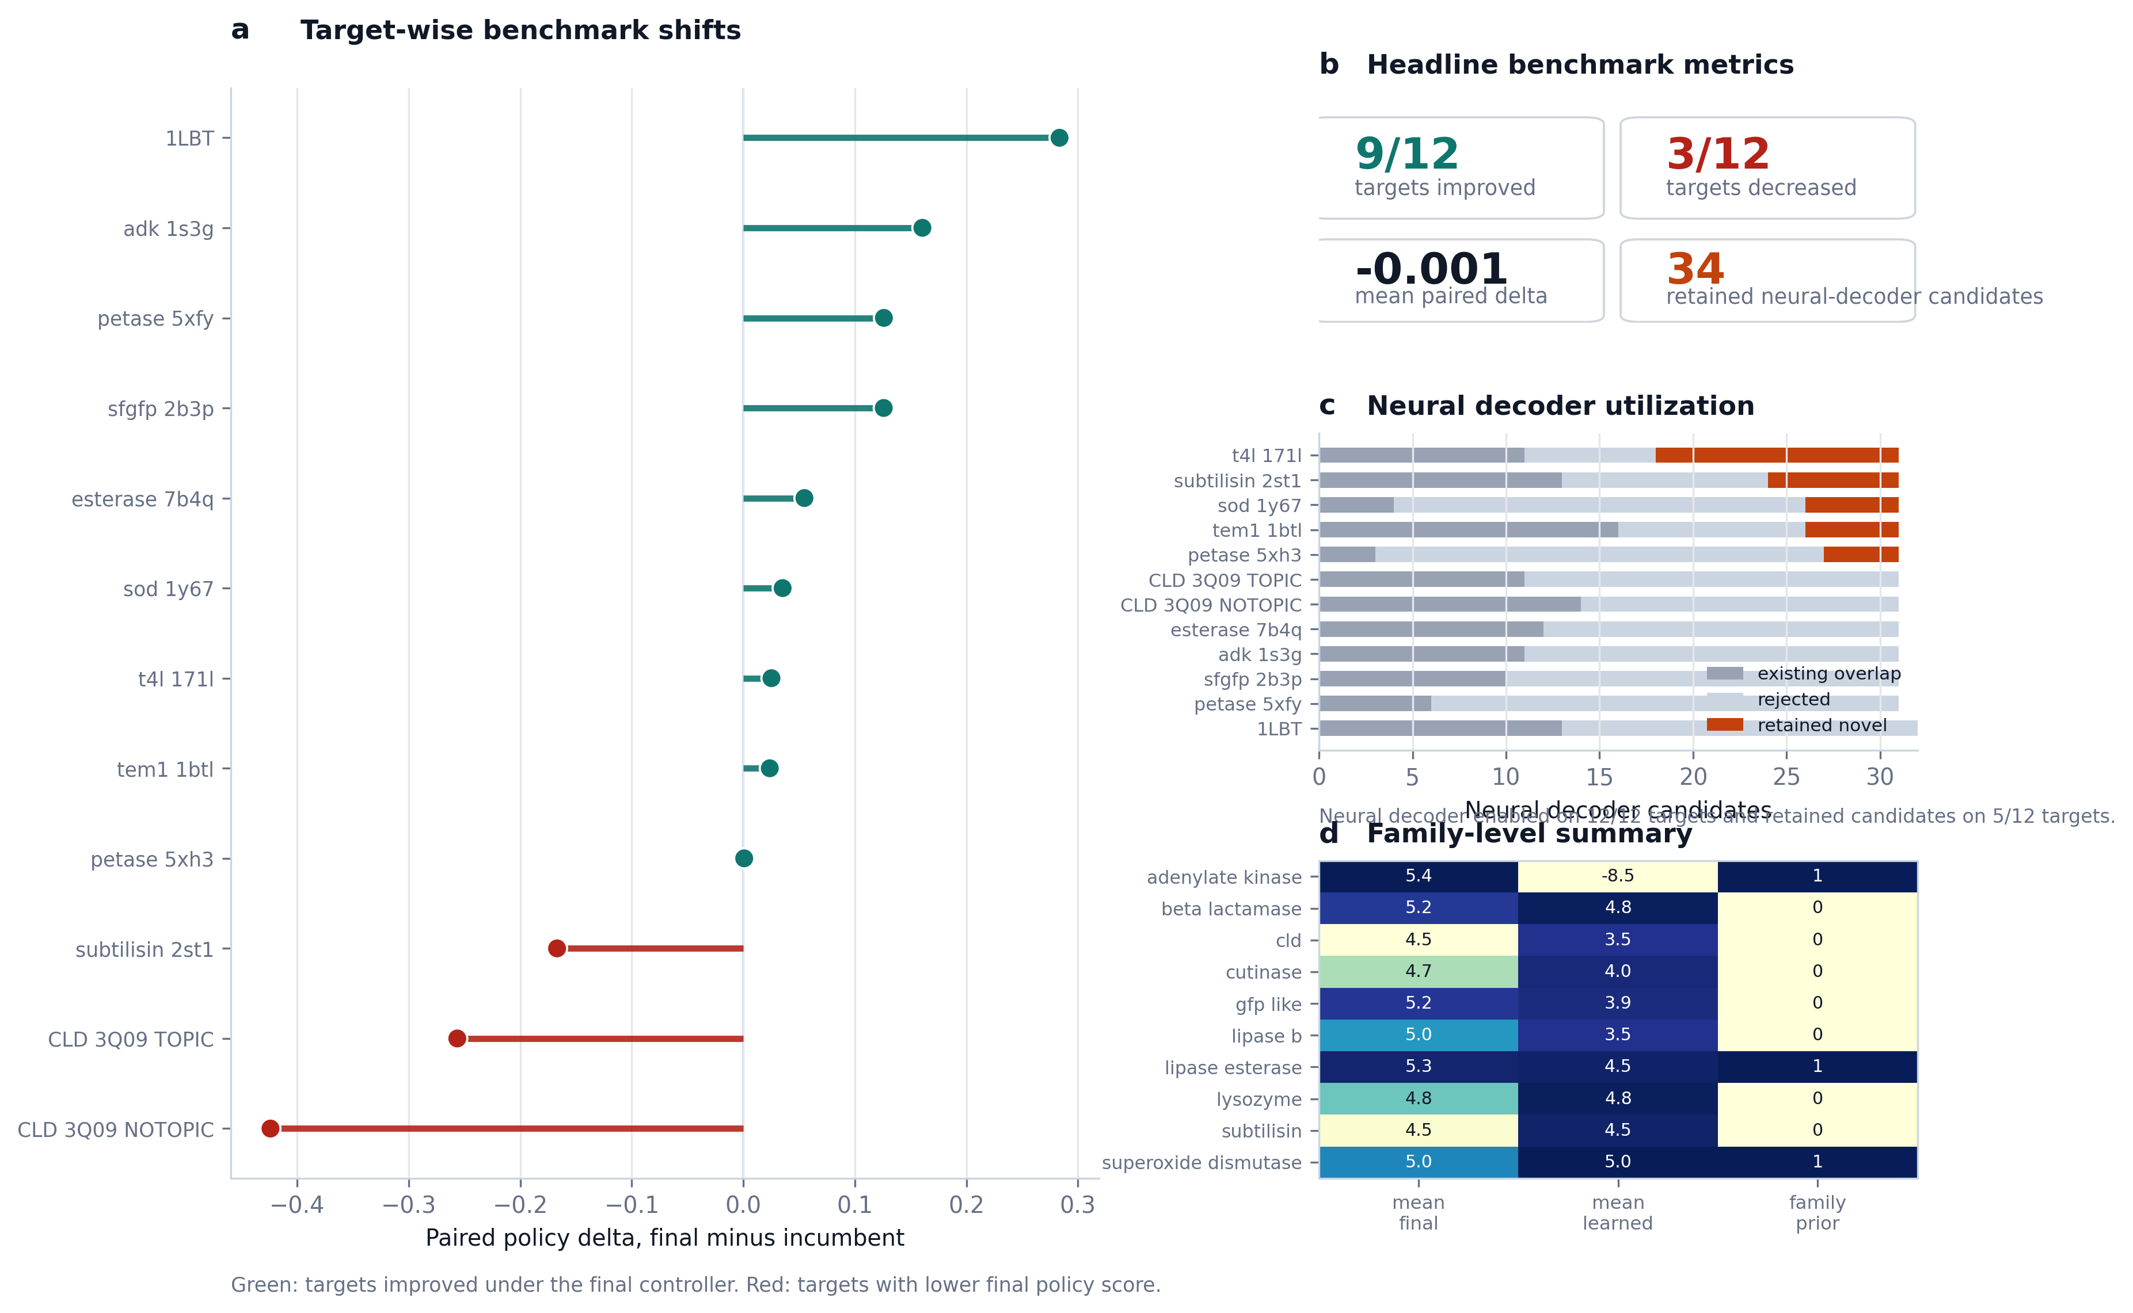
Figure 2 | Benchmark claim figure.
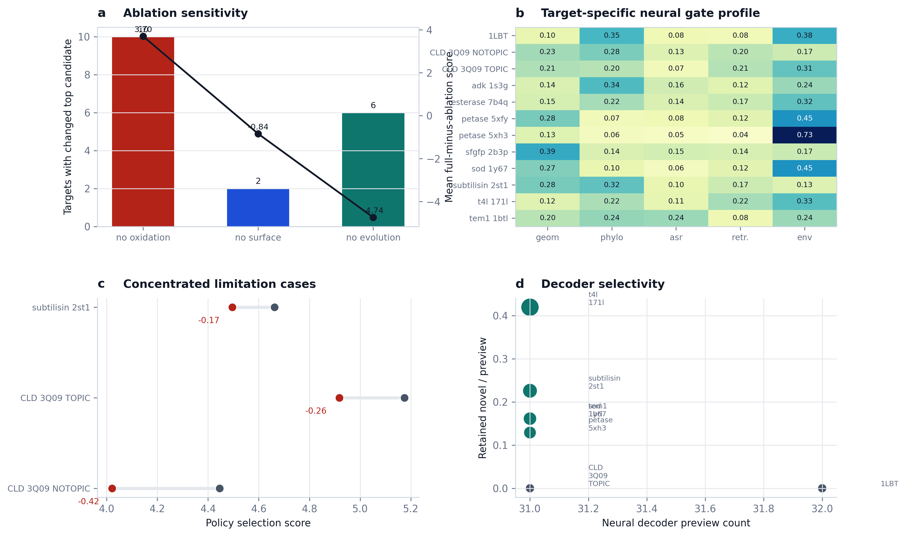
Figure 3 | Mechanism and limitation figure.
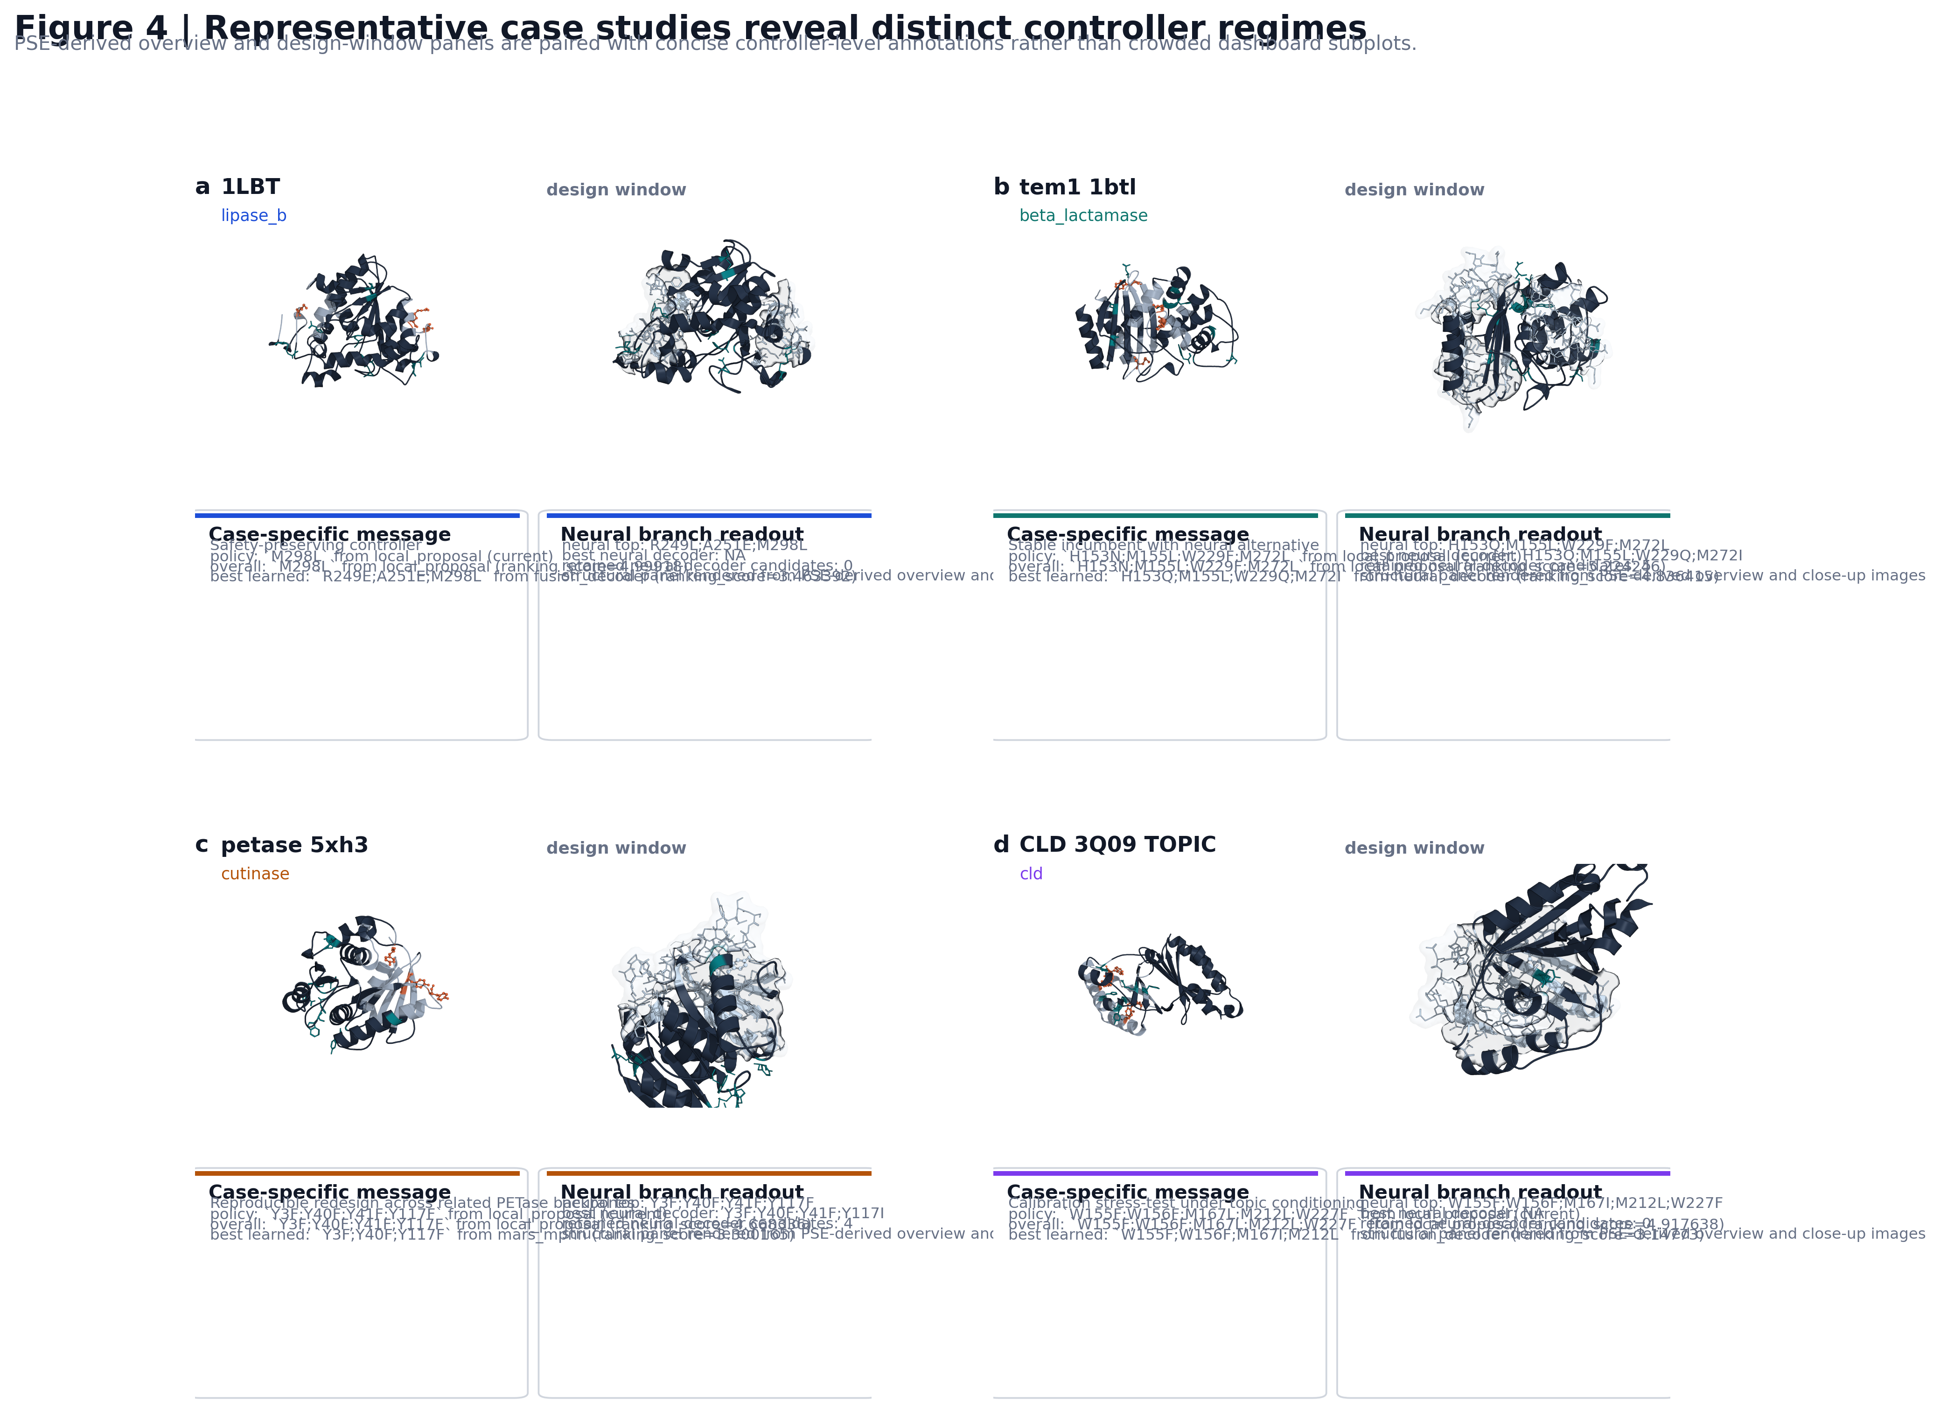
Figure 4 | PSE-derived case-study composite.
Introduction and Discussion
MARS-FIELD Introduction and Discussion Draft v1
Introduction
Protein engineering increasingly relies on computational design pipelines that combine structural analysis, sequence-derived priors, and machine-learning proposal engines. In practice, however, these components are often assembled as loosely connected modules. Structure-aware generators, profile priors, ancestral sequence reconstructions, retrieval-based templates, and engineering heuristics are frequently used in parallel or in succession, with the final decision made by a hand-tuned ranking function. This modularity has been useful for rapid iteration, but it has also created a conceptual gap: many pipelines behave as ensembles of partially redundant signals rather than as a unified learning system.
This gap is particularly limiting in realistic engineering settings, where the design objective is not merely sequence plausibility. Engineering-relevant design requires balancing backbone compatibility, evolutionary tolerability, ancestral recovery, retrieval-supported local motifs, and context-specific constraints such as oxidation risk, exposed flexibility, or environment-conditioned stress goals. These signals are heterogeneous in scale, reliability, and semantics. As a result, naïve combinations often collapse into either heuristic score stacking or generator voting, neither of which provides a satisfying algorithmic formulation.
We developed `MARS-FIELD` to address this problem. The central idea is to treat protein engineering not as a competition among candidate generators, but as an evidence-to-sequence control problem. In `MARS-FIELD`, geometric, phylogenetic, ancestral, retrieval-based, and environment-conditioned signals are projected into a shared residue field over the design positions. This field is the native decision object of the method: it defines residue-wise preferences and pairwise couplings, which are then used both to evaluate incumbent candidates and to decode new ones under engineering constraints. In this view, external generators and priors are not independent voters. They are evidence streams that shape a common residue-level decision space.
The present implementation takes a step beyond our earlier engineering approximations in two ways. First, ancestry and retrieval are no longer treated as isolated recommendation tables, but are represented as learned branches with memory structure inside the neural controller. Second, the neural branch is no longer restricted to reranking. The main benchmark path now includes a neural field decoder that generates candidates from the shared residue field itself. This makes the system meaningfully closer to an end-to-end field-controller architecture, even though full joint optimization of proposal generation, field construction, and decoding remains a future step.
Our goal in this work is therefore not to claim a perfectly end-to-end protein design foundation model. Rather, it is to demonstrate that a unified evidence-to-sequence controller can be built in a way that is mechanistically interpretable, benchmark-stable, and capable of decode-time neural proposal generation. We evaluate `MARS-FIELD` on a twelve-target benchmark spanning ten protein families and show that the final controller remains globally stable after neural decoder integration, improves paired policy score on most targets, and introduces retained novel neural-decoder candidates on a meaningful subset of the panel.
Discussion
The main conclusion of this study is that a unified residue-field controller provides a more coherent algorithmic basis for protein engineering than an ensemble of disconnected proposal branches. In the current implementation, `MARS-FIELD` integrates heterogeneous evidence streams into a shared residue field, uses a calibrated neural controller to score candidates, and activates a decode-time neural branch within the main benchmark path. This makes the system substantively different from earlier stack-and-rerank pipelines: the neural branch is now involved not only in candidate scoring, but also in proposal generation.
An important aspect of the current results is stability. Introducing a more learned controller and a decode-time neural branch could easily have destabilized the benchmark. Instead, the final controller improved paired policy score on 9 of 12 targets, decreased it on 3 targets, and produced an approximately neutral mean paired delta. We interpret this as a strong engineering result. The near-neutral mean should not be read as lack of effect; it should be read as evidence that the controller can absorb a more ambitious neural architecture without broad failure. At the same time, the fact that gains outnumber losses indicates that the new architecture is not merely complexity for its own sake.
The neural decoder statistics further support this interpretation. Neural decoding was active on all twelve targets, yet retained novel candidates appeared on only five. We view this selectivity as a virtue. A robust engineering controller should not inject novelty uniformly. Instead, it should selectively exploit neural exploration where the field is well supported and filter it out where it is not. In this sense, `1LBT` is as important as the more visibly successful targets: it shows that the neural field can be active without forcing adoption of unsafe or weak decoded alternatives.
The component ablations also reveal that the current method remains strongly grounded in engineering-relevant constraints. Oxidation-aware evidence and evolutionary context remain among the most influential components of the system, and removing them causes widespread shifts in the top candidate. This observation is important because it shows that the neural branch is not simply overwhelming the rest of the pipeline. Instead, the current controller is best understood as a neuralized integration layer sitting on top of still-essential chemical and evolutionary constraints.
Our results also clarify where the method remains limited. First, the neural field decoder is active and productive, but its retained contributions remain target-dependent. Some targets clearly benefit from decoder-derived alternatives, whereas others remain dominated by incumbent or local candidates. Second, the remaining regressions are concentrated but real. The CLD targets and subtilisin reveal that calibration between high-engineering local optima and stable final policy remains imperfect. Third, the present implementation is still not fully jointly trained across proposal generation, field construction, and decoding. The system is now close enough to call an end-to-end field-controller architecture in an engineering-honest sense, but the final research endpoint would require joint optimization rather than the current staged supervision.
These limitations point directly to the next research steps. The most obvious next direction is to replace proposal-conditioned supervision with tighter joint optimization between the field and the decoder. A second direction is to improve how the controller trades off between high local engineering signal and incumbent stability on stress-test families such as CLD. A third is to make retrieval memory and ancestry branches more directly differentiable with respect to upstream evidence construction, reducing reliance on externally prepared evidence tensors.
Even with these limitations, we believe the present implementation is already useful as both a method paper and an engineering system. Methodologically, it provides a more coherent framing of protein engineering as evidence-conditioned field control. Practically, it offers a stable controller that can absorb neural decode-time generation without losing panel-level benchmark reliability. For these reasons, `MARS-FIELD` should be viewed as a credible bridge between traditional engineering pipelines and future fully joint protein design controllers.
Related Work
MARS-FIELD Related Work and References Draft v1
Related work
`MARS-FIELD` sits at the intersection of structure-guided protein design, evolutionary prior integration, retrieval-based structural memory, and learned controller-decoder systems. The most relevant prior work can be divided into four categories.
Structure prediction and structure-conditioned sequence modeling
Modern structure-aware protein modeling has been transformed by the success of large-scale structure prediction and inverse-folding systems. AlphaFold established that high-accuracy atomic structure prediction can be achieved at scale, thereby providing a structural substrate for downstream design workflows [1]. ProteinMPNN subsequently demonstrated the power of structure-conditioned sequence design, showing that neural inverse folding can generate high-quality sequences compatible with fixed backbones [2]. Related inverse-folding approaches, including large-scale learning from predicted structures, further expanded the scope of structure-conditioned sequence modeling [3]. These works strongly motivate the use of structure-conditioned information in design, but they do not by themselves define how heterogeneous engineering evidence should be unified when the design objective extends beyond structure compatibility alone.
Retrieval-based structural comparison
Foldseek and related fast structural-search methods made it possible to retrieve local or global structural analogues at large scale [5]. For protein engineering, this retrieval capacity is highly valuable because it provides access to motif-level or neighborhood-level structural memory. However, retrieval alone does not define how structural neighbors should be transformed into a learned design controller. In `MARS-FIELD`, retrieval is therefore not treated as a stand-alone search module, but as a retrieval-memory branch whose outputs enter a shared residue-field representation.
Sequence-based protein representation learning
Sequence-based deep representation learning has already shown that general protein embeddings can support rational engineering and transfer across functional contexts [6]. These approaches established that neural protein representations can capture useful evolutionary and biochemical regularities. However, many sequence-only approaches remain relatively weak at representing residue-level structural context, local pairwise couplings, or engineering-specific constraints such as oxidation hotspots and surface liabilities. `MARS-FIELD` differs by explicitly combining structural, evolutionary, ancestral, retrieval, and engineering context in a residue-level control framework.
Ancestral sequence reconstruction and lineage-aware learning
Ancestral sequence reconstruction has long been recognized as a powerful source of stability and functional insight in protein evolution and engineering [7]. More recently, ancestry has also been used as a learning signal in modern representation-learning frameworks [8]. These developments are especially relevant to `MARS-FIELD`, because the current controller includes an explicit ancestral-lineage branch and a lineage-memory mechanism rather than treating ASR as a one-off heuristic recommendation. This allows ancestry to contribute as a structured prior within the controller rather than as an isolated preprocessing artifact.
Positioning of MARS-FIELD
The present work differs from prior pipelines in one central way: it treats heterogeneous evidence as input to a shared residue-field controller rather than as a set of independent proposal or filtering tools. In that sense, `MARS-FIELD` is closer to an evidence-conditioned control system than to a conventional structure-plus-scoring pipeline.
At the same time, we do not yet claim a fully joint protein design foundation model. The current implementation still uses staged supervision and a hybrid final policy. The contribution of `MARS-FIELD` is therefore not that it completes the final end-state of joint protein design, but that it demonstrates a credible intermediate architecture in which:
- multi-modal evidence is unified in a shared residue field
- a learned controller performs calibrated candidate selection
- a decode-time neural branch is active in the benchmark-time main path
- the resulting system remains broadly benchmark-stable
This places `MARS-FIELD` as a bridge between traditional engineering stacks and future fully joint field-generator-decoder systems.
Selected references
- Jumper, J. et al. Highly accurate protein structure prediction with AlphaFold. *Nature* **596**, 583-589 (2021).
- Dauparas, J. et al. Robust deep learning-based protein sequence design using ProteinMPNN. *Science* **378**, 49-56 (2022).
- Hsu, C. et al. Learning inverse folding from millions of predicted structures. In *Proceedings of the 39th International Conference on Machine Learning*, PMLR 162, 8946-8970 (2022).
- Lin, Z. et al. Evolutionary-scale prediction of atomic-level protein structure with a language model. *Science* **379**, 1123-1130 (2023).
- van Kempen, M. et al. Fast and accurate protein structure search with Foldseek. *Nature Biotechnology* **42**, 243-246 (2024).
- Alley, E. C. et al. Unified rational protein engineering with sequence-based deep representation learning. *Nature Methods* **16**, 1315-1322 (2019).
- Chisholm, L. O. et al. Ancestral reconstruction and the evolution of protein energy landscapes. *Annual Review of Biophysics* **53**, 127-146 (2024).
- Matthews, D. S. et al. Leveraging ancestral sequence reconstruction for protein representation learning. *Nature Machine Intelligence* **6**, 1542-1555 (2024).
Methods
MARS-FIELD Methods (Full Draft) v1
Overview
`MARS-FIELD` is formulated as a unified evidence-to-sequence controller for protein engineering. Rather than combining independent proposal engines and hand-tuned post hoc heuristics, the method projects heterogeneous evidence streams into a shared residue field over the design positions, then uses a neural controller and a constrained decoder to rank incumbent candidates and generate new ones under engineering constraints.
At the current stage, the method has three interacting layers:
- multi-modal evidence construction
- shared residue-field construction
- controller-decoder inference and calibrated selection
The present implementation is not yet a fully jointly optimized proposal-generator / field / decoder system. However, the benchmark-time main path now includes both a learned neural controller and a decode-time neural field generator, making the current system meaningfully closer to an end-to-end controller-decoder architecture than to a simple candidate reranker.
Benchmark panel and target curation
The main benchmark consists of twelve targets spanning ten protein families. Each target is defined by a local design window, a fixed wild-type structure, a wild-type sequence, a set of protected positions, and optional evolutionary, family, ancestral, or environmental prior files. The targets are instantiated through per-target YAML configuration files, and benchmark execution is driven by benchmark-level YAML manifests.
The benchmark panel includes:
- `1LBT` (`lipase_b`)
- `tem1_1btl` (`beta_lactamase`)
- `petase_5xfy` and `petase_5xh3` (`cutinase`)
- `sfgfp_2b3p` (`gfp_like`)
- `t4l_171l` (`lysozyme`)
- `subtilisin_2st1` (`subtilisin`)
- `adk_1s3g` (`adenylate_kinase`)
- `esterase_7b4q` (`lipase_esterase`)
- `sod_1y67` (`superoxide_dismutase`)
- `CLD_3Q09_NOTOPIC` and `CLD_3Q09_TOPIC` (`cld`)
Three targets use family priors (`adk_1s3g`, `esterase_7b4q`, `sod_1y67`), two use ancestral priors (`CLD_3Q09_NOTOPIC`, `CLD_3Q09_TOPIC`), and template-aware weighting is enabled for all twelve targets in the final benchmark path.
All neural training used in the benchmark is leave-one-target-out at the target level. For a held-out target `t`, the neural controller and neural field generator are trained using the remaining benchmark targets and are then applied to `t`.
Structural feature extraction and design-window definition
Each target begins with a structure-processing step that extracts per-residue geometric and engineering features from the input structure. These include:
- solvent-accessible surface area
- mean B-factor or equivalent local flexibility proxy
- minimum distance to protected positions
- disulfide participation
- glycosylation motif membership
Two engineering-relevant structural masks are then derived:
- oxidation hotspots
- flexible surface positions
Oxidation hotspots are detected using structure-derived exposure and protected-distance thresholds together with residue-type sensitivity. Flexible surface positions are detected using exposure-driven heuristics, and are subsequently merged with explicitly designable positions when required by the target configuration.
The design window is specified as the set of mutable positions declared in the target configuration. The final structure bundle therefore contains:
- wild-type sequence
- design positions
- protected positions
- structural feature table
- oxidation-hotspot set
- flexible-surface set
Phylogenetic and family priors
The phylogenetic branch uses homolog or family-aligned sequence sets to construct residue-level priors over the design positions. The current implementation supports:
- homolog profile priors
- family differential priors
- template-aware weighting
For each design position `i`, the homolog profile defines a residue distribution over the amino-acid alphabet. Family differential priors provide branch- or family-specific enrichment relative to a reference sequence population. Template-aware weighting modulates the importance of evolutionary support according to structural context, allowing the system to reweight profile evidence when local structural conditions justify stronger or weaker prior influence.
These components are represented both as explicit evidence terms in the engineering field and as inputs to the neural controller. In the current neural batch representation, evolutionary inputs include residue-level profile mass and family-differential support encoded as a per-position vector.
Ancestral lineage field
The ancestral lineage branch converts ancestral sequence reconstruction outputs into a position-wise ancestral field. For each design position `i`, the ancestral representation may include:
- posterior residue distribution
- posterior confidence
- posterior entropy
- recommendation mass
- maximum recommendation support
This branch is important because it injects lineage-derived probability structure into the residue field rather than treating ASR as a one-off hard prior. In the engineering field, ancestry contributes position-wise residue recommendations. In the neural controller, ancestry is represented as a dedicated branch whose latent site embeddings are fused with a learned lineage-memory bank.
Formally, if `p_anc(i, a)` is the ancestral posterior over amino acid `a` at site `i`, then ancestry contributes to both:
- explicit residue support in the engineering field
- latent ancestry branch input in the neural field
The current benchmark includes both ASR-free and ASR-enabled targets, allowing us to evaluate whether ancestry helps selectively rather than uniformly.
Retrieval motif atlas and prototype memory
The retrieval branch represents a structure-derived local memory rather than a simple nearest-neighbor annotation table. In the engineering field, retrieval contributes residue-level support via structure-local motif memory and local neighbor support. In the neural controller, retrieval is represented as a dedicated latent branch with a learned retrieval-memory bank.
The current retrieval input representation includes:
- residue-support distribution from retrieval neighbors
- neighborhood count
- top structural similarity
- top retrieval weight
- support sum
- unique supporting target count
These quantities are encoded as a per-position retrieval vector and then passed through a retrieval projection layer, followed by a learned prototype-memory fusion step. The purpose of this design is to avoid treating retrieval as a fixed external rule. Instead, the controller can decide when retrieval support should dominate, when it should be moderated, and when it should be ignored.
Shared residue field
The conceptual core of `MARS-FIELD` is the shared residue field. The field has two coupled components:
- a site-wise residue-energy layer `U(i, a)`
- a pairwise coupling layer `C(i, j, a, b)`
For a candidate sequence `x`, the field energy is written as:
`E(x) = sum_i U(i, x_i) + sum_(i,j in N) C(i, j, x_i, x_j)`
where `N` denotes the set of design-position pairs for which a coupling term is defined.
In the engineering field, `U(i, a)` is constructed from the unified evidence fields produced by structural, evolutionary, ancestral, retrieval, and proposal-derived evidence. Pairwise terms are constructed from proposal-derived pairwise support over top-ranked candidates and filtered by structural proximity.
In the neural field, `U(i, a)` is produced by a learned site encoder and residue-prototype scoring head, while `C(i, j, a, b)` is produced by a low-rank pairwise head conditioned on latent site embeddings and pair features.
Candidate controller architecture
The neural controller contains five evidence branches:
- geometry branch
- phylogeny branch
- ancestry branch
- retrieval branch
- environment branch
Each branch is first projected into a shared hidden dimension. The ancestry and retrieval branches are then each fused with a learned memory bank:
- lineage memory for ancestral signals
- retrieval memory for motif-atlas and neighborhood signals
The environment branch produces both an environment token and branch-specific modulation parameters. These parameters multiplicatively and additively modulate the geometry, phylogeny, ancestry, and retrieval branch embeddings before branch fusion.
Branch fusion is implemented through a learned gating mechanism. Let the branch embeddings be:
- `h_geom(i)`
- `h_phylo(i)`
- `h_asr(i)`
- `h_retr(i)`
- `h_env(i)`
Then the controller computes branch weights:
`alpha(i) = softmax(G([h_geom(i), h_phylo(i), h_asr(i), h_retr(i), h_env(i)]))`
and forms a fused site representation:
`h_i = MLP([alpha_geom(i) * h_geom(i), alpha_phylo(i) * h_phylo(i), alpha_asr(i) * h_asr(i), alpha_retr(i) * h_retr(i), alpha_env(i) * h_env(i)])`
This site representation drives:
- residue-wise unary logits
- auxiliary ancestry alignment logits
- auxiliary retrieval alignment logits
- environment reconstruction head
At the candidate level, the controller builds a candidate embedding by combining:
- residue-prototype-conditioned sequence context
- candidate-specific evidence features
- pairwise summary features
Candidate-specific features include:
- source identity
- source-group identity
- support-count context
- mutation-count context
- engineering component scores
- fusion-ranker contribution terms
- selector-prior features
- gap-to-best features
- note-derived flags
The final candidate embedding is passed to three heads:
- selection head
- engineering head
- policy head
Training objectives
The training objective is multi-term and combines direct supervision, pairwise supervision, calibration supervision, and auxiliary reconstruction losses.
1. Selection regression
The controller predicts target-wise normalized selection scores:
`L_sel = MSE(s_hat, s_norm)`
where `s_hat` is the predicted selection score and `s_norm` is the standardized target-wise selection score.
2. Engineering regression
The controller predicts standardized engineering scores:
`L_eng = MSE(e_hat, e_norm)`
where `e_norm` is the standardized `mars_score`.
3. Policy regression
A target policy score is constructed as:
`p_target = 0.30 * s_norm + 0.70 * e_norm`
and supervised using:
`L_pol = MSE(p_hat, p_target)`
4. Pairwise policy ranking
To stabilize ranking behavior, pairwise margin-style ranking supervision is applied:
`L_rank = mean softplus(-(p_hat_i - p_hat_j))`
over target pairs `(i, j)` whose target policy scores differ by at least a margin.
5. Decoder-field residue supervision
The unary field is also supervised toward the empirical residue distribution induced by high-quality candidate sequences:
`L_dec = CE(U, q_residue)`
where `q_residue` is an empirical site-wise residue distribution weighted by candidate-level policy support.
This term is critical because it pushes the field itself, not only the candidate heads, toward realistic decode-time residue preferences.
6. Recovery loss
The unary field is regularized toward wild-type recovery:
`L_rec = CE(U, x_wt)`
7. Ancestry and retrieval alignment losses
Auxiliary ancestry and retrieval heads are trained against the ancestry posterior and retrieval distribution, respectively:
- `L_asr`
- `L_retr`
8. Environment reconstruction loss
The global environment representation is trained to reconstruct the target environment vector:
`L_env = MSE(env_hat, env_target)`
9. Pairwise consistency loss
If empirical pairwise residue support is available from candidate tables, the pairwise tensor is regularized toward this empirical distribution:
`L_pair = MSE(C_hat, C_empirical)`
10. Conservative guard losses
Several controller-calibration losses are used to prevent unstable winner promotion:
- winner-guard loss
- non-decoder-guard loss
- simplicity-guard loss
- selector-anchor distillation loss
These losses serve different purposes:
- suppress obviously worse alternatives
- prevent decoder branches from overwhelming better incumbent engineering priors
- avoid needless mutation burden
- preserve the incumbent selector’s stability on hard targets
11. Gate regularization
The mean branch gate vector is regularized by:
- gate-entropy regularization
- gate-prior regularization
The gate prior depends on the presence or absence of family, template, and ASR support, encouraging the controller to shift attention according to the available biological context.
Total loss
The total loss is a weighted sum:
`L_total = λ_reg L_reg + λ_sel L_sel + λ_eng L_eng + λ_pol L_pol + λ_rank L_rank + λ_dec L_dec + λ_guard L_guard + λ_rec L_rec + λ_pair L_pair + λ_asr L_asr + λ_retr L_retr + λ_env L_env + λ_gate L_gate`
with fixed coefficients defined in the implementation.
Teacher-forced neural field decoder
The neural field decoder extends the controller from reranking to decode-time proposal generation.
For a held-out target, the pipeline:
- builds a runtime neural batch from the live target state
- trains a leave-one-target-out neural field model using all other targets
- generates neural unary and pairwise field outputs
- combines these learned outputs with evidence-derived prior fields
- decodes `neural_decoder` candidates under constrained beam search
The critical design choice is that the neural field is not decoded in isolation. Instead:
- learned unary scores are mixed with evidence-derived prior residue scores
- learned pairwise scores are mixed with prior pairwise support
This teacher-forced design is deliberate. It allows the decoder to benefit from learned structure while remaining anchored to the broader evidence regime, thereby reducing unstable or biologically implausible decode-time behavior.
The decoder produces:
- preview neural-decoder candidates
- retained novel candidates after engineering and safety filtering
- per-target neural field runtime summaries
Final hybrid selection policy
The final paper-facing controller uses a hybrid policy.
If `x_current` is the incumbent current-policy candidate and `x_neural` is the neural-policy candidate, then the final controller adopts `x_neural` only if:
- its engineering score is at least as strong as the incumbent
- its selection score does not fall more than a small tolerance below the incumbent
In the current implementation, this second tolerance is a small negative margin rather than a strict non-decrease constraint. This design reflects the current strongest honest deployment setting:
- neural rerank is active
- neural decoder is active
- but the controller remains conservative on hard targets where full neural replacement would still be risky
Evaluation protocol
The primary evaluation quantities are:
- policy selection score
- policy engineering score (`mars_score`)
- paired delta relative to the incumbent benchmark
- neural decoder utilization
Neural decoder utilization is explicitly accounted for using:
- whether the decoder was enabled
- number of preview candidates
- number of retained novel candidates
- number of rejected candidates
- best retained neural-decoder candidate
The benchmark should be interpreted as a paired engineering panel rather than a classical single-endpoint statistical trial. Accordingly, the key quantities for interpretation are:
- how many targets improve
- how many targets regress
- whether regressions are concentrated or diffuse
- whether the neural decoder contributes retained non-redundant candidates
- whether related structures retain chemically consistent winners
What this Methods section allows us to claim
With the present implementation, the strongest accurate claim is:
`MARS-FIELD` is a unified evidence-to-sequence residue-field controller with an active decode-time neural field branch in the main benchmark path.
The strongest claim it does **not yet** support is:
- fully joint proposal-generator / field / decoder optimization
That distinction should remain explicit in the final manuscript.
Figure Legends
MARS-FIELD Figure Legends v1
Figure 1 | MARS-FIELD integrates heterogeneous evidence into a shared residue field
`MARS-FIELD` is organized as a unified evidence-to-sequence controller rather than as a collection of independent proposal engines. Structural geometry, phylogenetic profiles, ancestral lineage information, retrieval-based motif memory, and environment-conditioned engineering context are first encoded as evidence streams and then projected into a shared residue field over the design positions. The native objects of this field are site-wise residue energies `U(i, a)` and pairwise coupling energies `C(i, j, a, b)`, which together define the sequence energy landscape used for controller inference and constrained decoding. The right side of the figure shows the two downstream actions performed on this field: candidate-level calibrated selection and decode-time sequence generation. The lower inset illustrates how this abstract field is instantiated on a concrete target, here represented by a compact residue-field example over selected design positions.
Figure 2 | Benchmark claim figure
This figure summarizes the benchmark-level claim of the current `MARS-FIELD` implementation. Panel a shows paired policy-score differences between the final controller and the incumbent benchmark on the twelve-target panel. Positive values indicate targets on which the final controller improved the policy score; negative values indicate targets with lower final policy scores. Panel b condenses the benchmark into headline metrics, including the number of improved targets, the number of decreased targets, the mean paired policy delta, and the total number of retained neural-decoder-derived candidates. Panel c decomposes neural decoder activity across targets into preview, rejected, and retained novel candidates, showing that decode-time neural generation is active across the panel but only selectively retained. Panel d summarizes family-level behavior, illustrating that the benchmark spans multiple protein families and prior regimes rather than a single narrow design setting.
Figure 3 | Mechanism and limitation figure
This figure explains why the current controller behaves as it does and where its limits remain. Panel a summarizes component ablations and shows that oxidation-aware and evolutionary information remain dominant constraints in the present benchmark. Panel b displays target-specific neural gate profiles, showing that different targets draw on distinct mixtures of geometry, phylogeny, ancestry, retrieval, and environment signals. Panel c focuses on the concentrated set of negative paired-delta targets and shows that the current regressions are localized rather than diffuse. Panel d quantifies decoder selectivity by comparing preview counts with retained-novel fractions across targets, illustrating that the neural decoder is not used as a blind novelty generator but as a gated, target-dependent proposal source.
Figure 4 | Representative case studies reveal distinct controller regimes
This figure uses PSE-derived structural panels to illustrate four distinct operating modes of the controller. The 1LBT panel represents a safety-preserving regime in which the incumbent solution is maintained despite active neural decoding. The TEM1 panel represents a stable-incumbent regime with a meaningful neural-decoder-derived learned alternative. The PETase panel illustrates reproducible redesign logic across two related backbones, showing that the controller can reproduce a chemically consistent solution rather than forcing novelty. The CLD panel acts as a calibration stress test, highlighting the tension between a stable incumbent and a nearby alternative favored by parts of the neural branch. Together, these panels demonstrate that `MARS-FIELD` does not operate identically across targets, but instead adapts to target-specific evidence structure and engineering context.

