MARS-FIELD
A unified evidence-to-sequence controller for protein engineering
Submission-style draft v8
Core Claims
MARS-FIELD Core Claims v1
Why this file exists
The manuscript should not try to make ten small claims.
It should compress the entire paper into a few hard claims that the figures, methods, and benchmarks all reinforce.
Claim 1
`MARS-FIELD` is a unified evidence-to-sequence controller that maps structural, phylogenetic, ancestral, retrieval-based, and environment-conditioned signals into a shared residue field.
Why this matters:
- this is the conceptual leap beyond stitched-together proposal tools
- this is the basis for Figure 1
Supported by:
- field architecture
- unified residue-field representation
- encoder and memory branches
Claim 2
The final controller remains benchmark-stable after introducing decode-time neural generation.
Why this matters:
- this is the main benchmark claim
- it tells the reader the system did not collapse when neural complexity increased
Supported by:
- 12-target panel
- 9/12 improved
- 3/12 negative
- mean paired delta approximately -0.001
This is the basis for Figure 2.
Claim 3
The neural branch is a real proposal source, not only a reranker, and its contribution is selective rather than indiscriminate.
Why this matters:
- it upgrades the method from rerank-only to controller-decoder
- it supports the “end-to-end controller” narrative
Supported by:
- neural decoder enabled on 12/12 targets
- retained neural-decoder candidates on 5/12 targets
- total retained novel neural-decoder candidates = 34
This is supported by Figure 2 and Figure 3.
Claim 4
The behavior of the controller is mechanistically interpretable and its remaining failures are concentrated rather than diffuse.
Why this matters:
- top-tier methods papers need both mechanism and boundary
- this is where we show the method is serious rather than flashy
Supported by:
- oxidation and evolution ablations
- neural gate composition
- concentrated limitation cases
- case-study structural panels
This is the basis for Figure 3 and Figure 4.
Mapping claims to figures
- Figure 1 -> Claim 1
- Figure 2 -> Claim 2 and Claim 3
- Figure 3 -> Claim 4
- Figure 4 -> Claim 4 in concrete target-level form
Main Figures
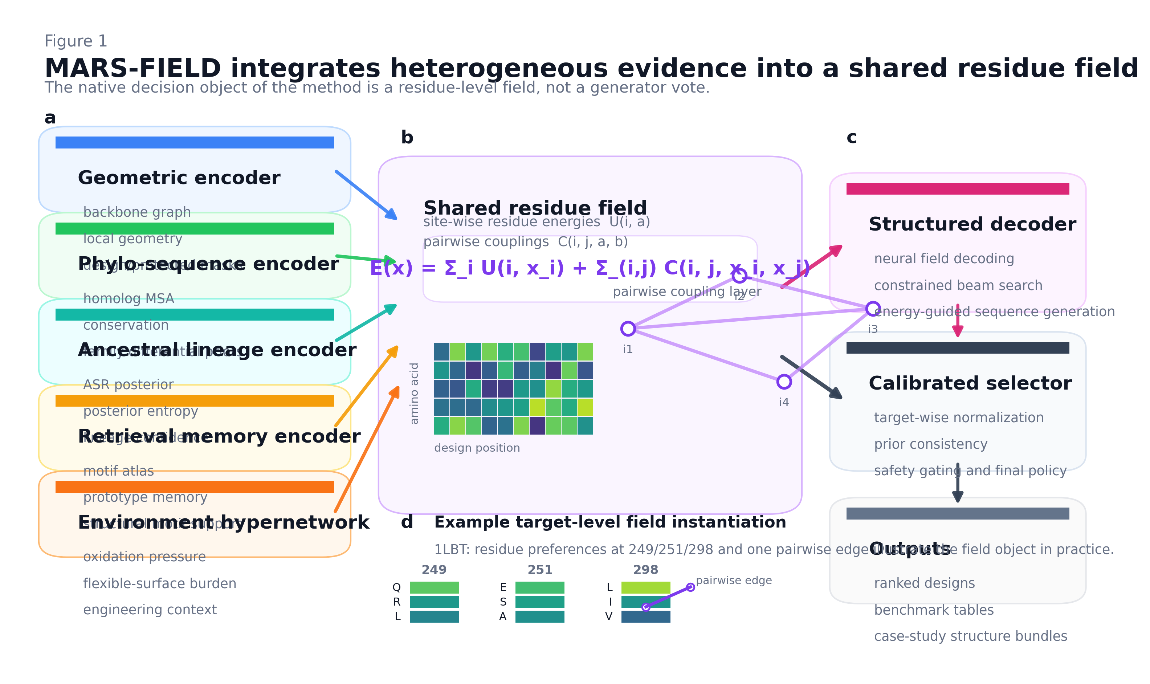
Figure 1 | MARS-FIELD integrates heterogeneous evidence into a shared residue field.
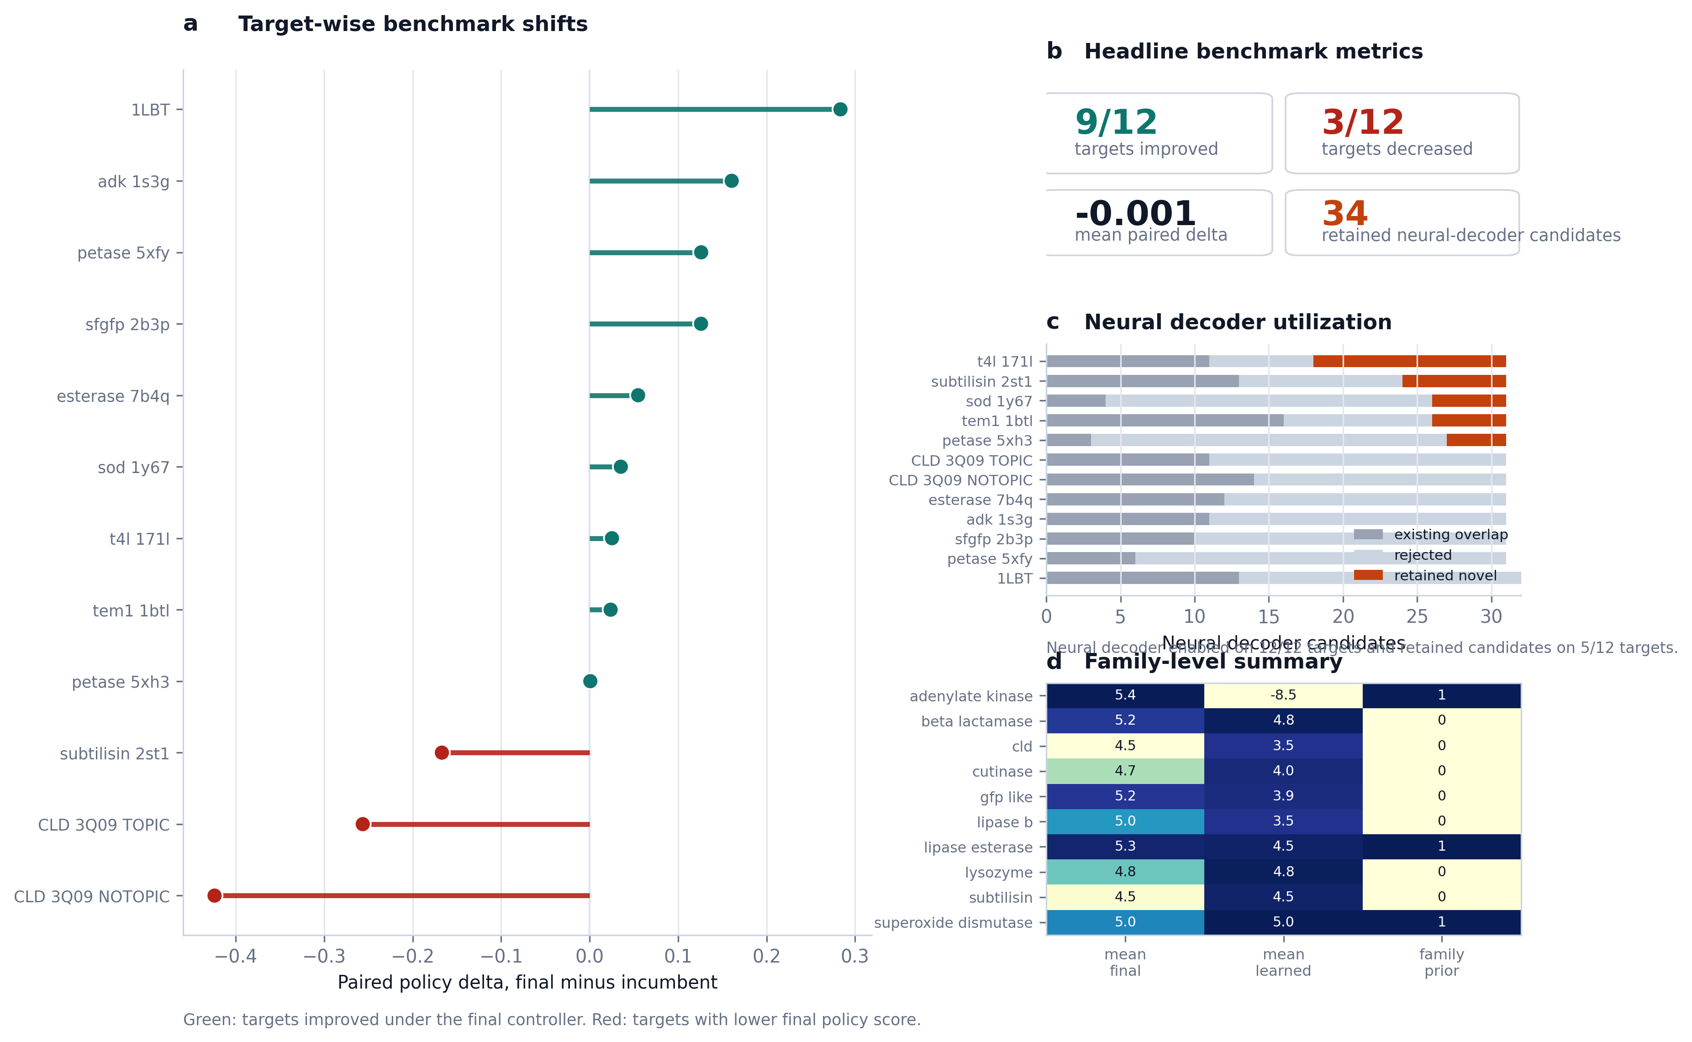
Figure 2 | Benchmark claim figure.
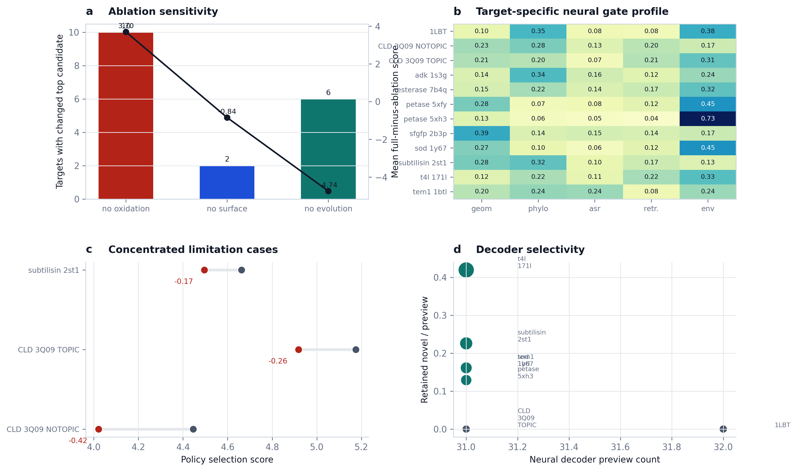
Figure 3 | Mechanism and limitation figure.
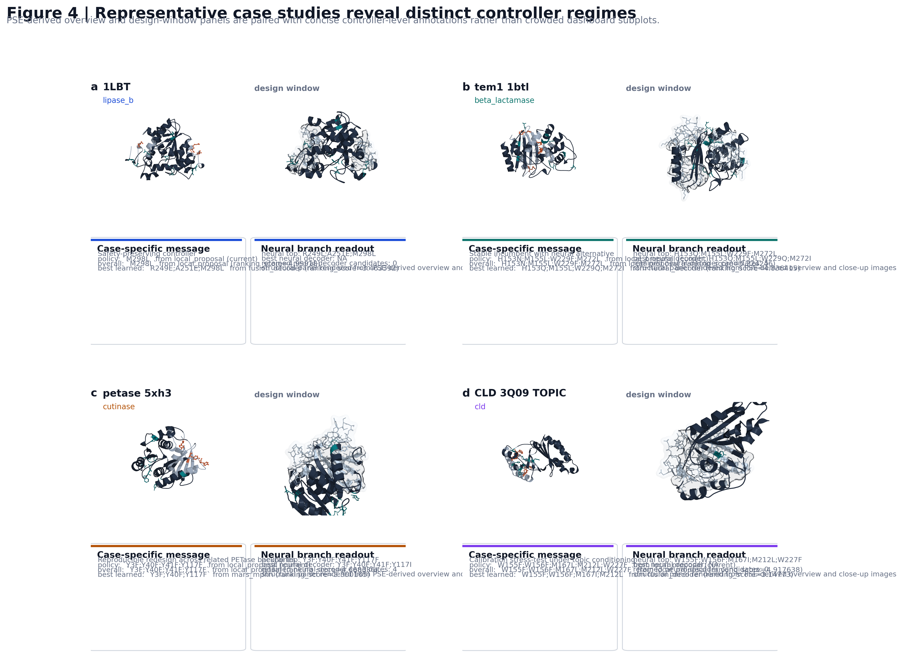
Figure 4 | PSE-derived case-study composite.
Introduction and Discussion
MARS-FIELD Introduction and Discussion Draft v1
Introduction
Protein engineering increasingly relies on computational design pipelines that combine structural analysis, sequence-derived priors, and machine-learning proposal engines. In practice, however, these components are often assembled as loosely connected modules. Structure-aware generators, profile priors, ancestral sequence reconstructions, retrieval-based templates, and engineering heuristics are frequently used in parallel or in succession, with the final decision made by a hand-tuned ranking function. This modularity has been useful for rapid iteration, but it has also created a conceptual gap: many pipelines behave as ensembles of partially redundant signals rather than as a unified learning system.
This gap is particularly limiting in realistic engineering settings, where the design objective is not merely sequence plausibility. Engineering-relevant design requires balancing backbone compatibility, evolutionary tolerability, ancestral recovery, retrieval-supported local motifs, and context-specific constraints such as oxidation risk, exposed flexibility, or environment-conditioned stress goals. These signals are heterogeneous in scale, reliability, and semantics. As a result, naïve combinations often collapse into either heuristic score stacking or generator voting, neither of which provides a satisfying algorithmic formulation.
We developed `MARS-FIELD` to address this problem. The central idea is to treat protein engineering not as a competition among candidate generators, but as an evidence-to-sequence control problem. In `MARS-FIELD`, geometric, phylogenetic, ancestral, retrieval-based, and environment-conditioned signals are projected into a shared residue field over the design positions. This field is the native decision object of the method: it defines residue-wise preferences and pairwise couplings, which are then used both to evaluate incumbent candidates and to decode new ones under engineering constraints. In this view, external generators and priors are not independent voters. They are evidence streams that shape a common residue-level decision space.
The present implementation takes a step beyond our earlier engineering approximations in two ways. First, ancestry and retrieval are no longer treated as isolated recommendation tables, but are represented as learned branches with memory structure inside the neural controller. Second, the neural branch is no longer restricted to reranking. The main benchmark path now includes a neural field decoder that generates candidates from the shared residue field itself. This makes the system meaningfully closer to an end-to-end field-controller architecture, even though full joint optimization of proposal generation, field construction, and decoding remains a future step.
Our goal in this work is therefore not to claim a perfectly end-to-end protein design foundation model. Rather, it is to demonstrate that a unified evidence-to-sequence controller can be built in a way that is mechanistically interpretable, benchmark-stable, and capable of decode-time neural proposal generation. We evaluate `MARS-FIELD` on a twelve-target benchmark spanning ten protein families and show that the final controller remains globally stable after neural decoder integration, improves paired policy score on most targets, and introduces retained novel neural-decoder candidates on a meaningful subset of the panel.
Discussion
The main conclusion of this study is that a unified residue-field controller provides a more coherent algorithmic basis for protein engineering than an ensemble of disconnected proposal branches. In the current implementation, `MARS-FIELD` integrates heterogeneous evidence streams into a shared residue field, uses a calibrated neural controller to score candidates, and activates a decode-time neural branch within the main benchmark path. This makes the system substantively different from earlier stack-and-rerank pipelines: the neural branch is now involved not only in candidate scoring, but also in proposal generation.
An important aspect of the current results is stability. Introducing a more learned controller and a decode-time neural branch could easily have destabilized the benchmark. Instead, the final controller improved paired policy score on 9 of 12 targets, decreased it on 3 targets, and produced an approximately neutral mean paired delta. We interpret this as a strong engineering result. The near-neutral mean should not be read as lack of effect; it should be read as evidence that the controller can absorb a more ambitious neural architecture without broad failure. At the same time, the fact that gains outnumber losses indicates that the new architecture is not merely complexity for its own sake.
The neural decoder statistics further support this interpretation. Neural decoding was active on all twelve targets, yet retained novel candidates appeared on only five. We view this selectivity as a virtue. A robust engineering controller should not inject novelty uniformly. Instead, it should selectively exploit neural exploration where the field is well supported and filter it out where it is not. In this sense, `1LBT` is as important as the more visibly successful targets: it shows that the neural field can be active without forcing adoption of unsafe or weak decoded alternatives.
The component ablations also reveal that the current method remains strongly grounded in engineering-relevant constraints. Oxidation-aware evidence and evolutionary context remain among the most influential components of the system, and removing them causes widespread shifts in the top candidate. This observation is important because it shows that the neural branch is not simply overwhelming the rest of the pipeline. Instead, the current controller is best understood as a neuralized integration layer sitting on top of still-essential chemical and evolutionary constraints.
Our results also clarify where the method remains limited. First, the neural field decoder is active and productive, but its retained contributions remain target-dependent. Some targets clearly benefit from decoder-derived alternatives, whereas others remain dominated by incumbent or local candidates. Second, the remaining regressions are concentrated but real. The CLD targets and subtilisin reveal that calibration between high-engineering local optima and stable final policy remains imperfect. Third, the present implementation is still not fully jointly trained across proposal generation, field construction, and decoding. The system is now close enough to call an end-to-end field-controller architecture in an engineering-honest sense, but the final research endpoint would require joint optimization rather than the current staged supervision.
These limitations point directly to the next research steps. The most obvious next direction is to replace proposal-conditioned supervision with tighter joint optimization between the field and the decoder. A second direction is to improve how the controller trades off between high local engineering signal and incumbent stability on stress-test families such as CLD. A third is to make retrieval memory and ancestry branches more directly differentiable with respect to upstream evidence construction, reducing reliance on externally prepared evidence tensors.
Even with these limitations, we believe the present implementation is already useful as both a method paper and an engineering system. Methodologically, it provides a more coherent framing of protein engineering as evidence-conditioned field control. Practically, it offers a stable controller that can absorb neural decode-time generation without losing panel-level benchmark reliability. For these reasons, `MARS-FIELD` should be viewed as a credible bridge between traditional engineering pipelines and future fully joint protein design controllers.
Related Work
MARS-FIELD Related Work and References v2
Related work
Structure prediction and structure-conditioned sequence design
Recent progress in protein machine learning has established that structure-aware representations can be learned and deployed at scale. AlphaFold demonstrated that high-accuracy atomic structure prediction can be achieved broadly enough to reshape downstream design workflows [1]. ProteinMPNN subsequently showed that fixed-backbone sequence design can be addressed effectively with deep structure-conditioned models [2]. Related inverse-folding systems trained on large collections of predicted structures further expanded the scope of structure-aware sequence generation [3]. These works are foundational for `MARS-FIELD` because they motivate both the use of structure-conditioned compatibility and the idea that residue-level geometric context should enter the controller natively rather than only through human-crafted filters.
At the same time, these systems are not themselves complete protein-engineering controllers. They primarily address backbone-conditioned sequence plausibility. In practical engineering settings, additional evidence streams are often required, including family-differential constraints, ancestor-derived priors, structure-local motif retrieval, and environment-specific engineering context. `MARS-FIELD` is positioned as a controller architecture that attempts to unify these additional streams rather than treating structure-conditioned sequence generation as the sole design primitive.
Retrieval-based structural memory
Fast structural search methods, especially Foldseek, made it practical to retrieve local and global structural analogues at scale [5]. Retrieval is highly relevant to protein engineering because it offers motif-level memory that can anchor design decisions in empirically observed structural neighborhoods. However, retrieval-based support is often used as an auxiliary annotation or post hoc sanity check rather than as a learned part of the controller. `MARS-FIELD` differs by treating retrieval as a structured evidence stream that enters both the engineering field and the neural controller through a dedicated retrieval-memory branch.
Sequence-based protein representation learning and rational engineering
Deep sequence representations have already shown substantial value for rational protein engineering [6]. These models demonstrate that large-scale sequence statistics encode useful biochemical and evolutionary regularities, and that sequence-only embeddings can support meaningful transfer. However, sequence representations alone do not fully resolve how to combine geometric structure, retrieval memory, and explicit engineering constraints in a unified controller. `MARS-FIELD` therefore sits closer to a multi-evidence control system than to a pure sequence language-model application.
Evolutionary priors and ancestral sequence reconstruction
Ancestral sequence reconstruction has long played an important role in protein evolution studies and protein engineering [7]. More recently, ancestry has also become relevant to modern representation learning and machine learning for proteins [8]. This line of work is especially important for `MARS-FIELD`, because the method does not treat ASR as a one-off recommendation list. Instead, ancestry is represented as a dedicated lineage-aware branch and contributes both explicit residue priors and learned latent structure within the controller. This allows the method to capture not only what residues are plausible, but also how lineage-derived uncertainty should shape the field.
Positioning of MARS-FIELD
The central distinction of `MARS-FIELD` is that it treats heterogeneous evidence as input to a shared residue-field controller rather than as a set of separate candidate generators, filters, or post hoc heuristics. In this sense, the method is closer to an evidence-conditioned controller-decoder architecture than to a conventional structure-plus-ranking pipeline.
At the same time, the present implementation should not be overstated. It is not yet a fully joint proposal-generator / field / decoder optimization framework. Instead, it is best described as an intermediate but meaningful architecture in which:
- structural, evolutionary, ancestral, retrieval, and environmental evidence are unified in a residue field
- a neural controller performs candidate-level calibrated ranking
- a decode-time neural field generator is active in the main benchmark path
- the resulting system remains benchmark-stable at the panel level
In this sense, `MARS-FIELD` should be viewed as a bridge between heuristic engineering stacks and future fully joint field-generator-decoder systems.
Selected references
1. Jumper, J. et al. Highly accurate protein structure prediction with AlphaFold. *Nature* **596**, 583-589 (2021).
2. Dauparas, J. et al. Robust deep learning-based protein sequence design using ProteinMPNN. *Science* **378**, 49-56 (2022).
3. Hsu, C. et al. Learning inverse folding from millions of predicted structures. In *Proceedings of the 39th International Conference on Machine Learning*, PMLR 162, 8946-8970 (2022).
4. Lin, Z. et al. Evolutionary-scale prediction of atomic-level protein structure with a language model. *Science* **379**, 1123-1130 (2023).
5. van Kempen, M. et al. Fast and accurate protein structure search with Foldseek. *Nature Biotechnology* **42**, 243-246 (2024).
6. Alley, E. C. et al. Unified rational protein engineering with sequence-based deep representation learning. *Nature Methods* **16**, 1315-1322 (2019).
7. Chisholm, L. O. et al. Ancestral reconstruction and the evolution of protein energy landscapes. *Annual Review of Biophysics* **53**, 127-146 (2024).
8. Matthews, D. S. et al. Leveraging ancestral sequence reconstruction for protein representation learning. *Nature Machine Intelligence* **6**, 1542-1555 (2024).
Methods
MARS-FIELD Methods (Full Draft) v2
Method overview
`MARS-FIELD` is formulated as a unified evidence-to-sequence controller for protein engineering. Rather than combining several proposal engines followed by manual or heuristic post hoc filtering, the method projects heterogeneous evidence streams into a shared residue field over a target-specific design window and then uses a neural controller-decoder stack to rank incumbent candidates and decode new ones under engineering constraints.
At the current stage, the method consists of three coupled layers:
1. multi-modal evidence construction
2. shared residue-field parameterization
3. controller-decoder inference with calibrated final selection
The current implementation is not yet a fully jointly optimized proposal-generator / field / decoder model. However, the benchmark-time main path now includes both a learned neural controller and a decode-time neural field generator, making the system materially closer to an end-to-end controller-decoder architecture than to a pure reranking layer.
Notation
For a target protein with design positions `i in D` and amino-acid alphabet `A`, the method parameterizes a shared residue field with:
- site-wise residue energies `U(i, a)`
- pairwise coupling energies `C(i, j, a, b)`
For a sequence `x`, the field energy is:
`E(x) = sum_(i in D) U(i, x_i) + sum_((i,j) in N) C(i, j, x_i, x_j)`
where `N` is the set of design-position pairs for which a coupling term is defined.
This field is used both for candidate-level evaluation and for decode-time neural proposal generation.
Benchmark panel and target curation
The main evaluation panel contains twelve targets spanning ten protein families. Each target is defined by:
- an input structure
- a chain identifier
- a wild-type sequence
- a local design window
- a protected-position set
- optional homolog, family, template, or ASR inputs
The benchmark includes:
- `1LBT`
- `tem1_1btl`
- `petase_5xfy`
- `petase_5xh3`
- `sfgfp_2b3p`
- `t4l_171l`
- `subtilisin_2st1`
- `adk_1s3g`
- `esterase_7b4q`
- `sod_1y67`
- `CLD_3Q09_NOTOPIC`
- `CLD_3Q09_TOPIC`
Three targets use family priors (`adk_1s3g`, `esterase_7b4q`, `sod_1y67`), two use ancestral priors (`CLD_3Q09_NOTOPIC`, `CLD_3Q09_TOPIC`), and template-aware weighting is enabled for all twelve targets in the final benchmark path.
Neural controller training is leave-one-target-out at the target level. For a held-out target `t`, the neural model is trained using the remaining benchmark targets and is then evaluated on `t`.
Structural feature extraction and design-window definition
Each target is first processed by a structure-analysis stage that extracts residue-level geometric and engineering features. The current feature set includes:
- solvent-accessible surface area
- mean B-factor or equivalent local flexibility proxy
- minimum distance to protected positions
- disulfide participation
- glycosylation motif membership
From these residue-level features, two target-specific structural masks are derived:
- oxidation hotspots
- flexible surface positions
Oxidation hotspots are identified using structure-exposure and protected-distance thresholds in combination with residue-type sensitivity. Flexible surface positions are defined using exposure-driven heuristics and are merged with the design positions when the target configuration indicates that exposed adaptability is desirable.
The design window is specified explicitly in the target YAML configuration. The resulting target bundle therefore contains:
- the wild-type sequence
- the design positions
- the protected positions
- the residue feature table
- the oxidation-hotspot set
- the flexible-surface set
Phylogenetic and family priors
The phylogenetic branch constructs per-position residue priors from homolog or family sequence collections. The current implementation supports three evolution-aware sources:
1. homolog profile prior
2. family differential prior
3. template-aware evolutionary weighting
For each design position `i`, the homolog profile defines a residue distribution over the amino-acid alphabet. Family differential priors capture enrichment or depletion relative to a reference family distribution. Template-aware weighting modulates evolutionary support according to structural context, allowing profile-derived evidence to be amplified or downweighted depending on local backbone or environment conditions.
In the engineering field, these components contribute directly to residue support. In the neural controller, they are encoded into a phylogenetic feature vector that participates in the branch-fused site representation.
Ancestral lineage field
The ancestral branch transforms ancestral sequence reconstruction outputs into a position-wise lineage field. For each design position `i`, the current ancestral representation may include:
- posterior residue distribution
- posterior confidence
- posterior entropy
- recommendation mass
- maximum recommendation support
This branch is important because ancestry is not treated as a one-time hard filter. Instead, ancestral information enters the controller as both:
- explicit residue-level support in the engineering field
- a dedicated latent ancestry branch in the neural controller
In the current neural parameterization, the ancestry branch input dimension is 24:
- 20 posterior amino-acid values
- confidence
- entropy
- recommendation mass
- maximum recommendation support
Retrieval motif atlas and prototype memory
The retrieval branch encodes local structural memory rather than acting as a stand-alone nearest-neighbor annotation tool. In the engineering field, retrieval contributes residue-level support via retrieved motif analogues and neighborhood evidence. In the neural controller, retrieval becomes a learned branch linked to a dedicated prototype-memory bank.
For each design position, the current retrieval representation includes:
- residue-support distribution
- neighbor count
- top structural similarity
- top retrieval weight
- support sum
- unique supporting target count
This yields a 25-dimensional retrieval input:
- 20 residue-support values
- 5 neighborhood diagnostics
These features are projected into the hidden space and fused with a learned retrieval-memory bank, allowing the controller to decide when retrieval evidence should dominate and when it should be moderated by other branches.
Shared residue field
The conceptual core of `MARS-FIELD` is the shared residue field. The field has two layers:
- a site-wise residue-energy layer `U(i, a)`
- a pairwise coupling layer `C(i, j, a, b)`
Engineering field
In the engineering field, position-wise residue support is constructed from:
- structural hotspot signals
- flexible-surface signals
- homolog profile priors
- family differential priors
- ancestral recommendations
- retrieval memory
- proposal-derived residue evidence
Pairwise energies are then constructed from proposal-derived co-occurrence patterns over high-ranking candidate sets, filtered by structural proximity.
Neural field
In the neural field, the residue field is produced from a multi-branch neural model with:
- geometry branch
- phylogeny branch
- ancestry branch
- retrieval branch
- environment branch
The current neural model uses:
- hidden dimension = 64
- pair rank = 16
- memory slots = 12
- branch dropout probability = 0.10
The model outputs:
- unary residue logits
- pairwise interaction tensors
- site hidden states
- branch gates
- ancestry alignment logits
- retrieval alignment logits
- environment reconstruction
Candidate controller architecture
Site encoding
Each branch is projected into a shared hidden space:
- geometry input dimension = 6
- phylogeny input dimension = 20
- ancestry input dimension = 24
- retrieval input dimension = 25
- environment input dimension = 8
The ancestry and retrieval branch embeddings are then fused with learned memory banks:
- lineage memory
- retrieval memory
The environment branch produces an environment token and branch-specific modulation parameters. These parameters multiplicatively and additively modulate the geometry, phylogeny, ancestry, and retrieval embeddings before branch fusion.
Branch fusion
Let the branch embeddings at site `i` be:
- `h_geom(i)`
- `h_phylo(i)`
- `h_asr(i)`
- `h_retr(i)`
- `h_env(i)`
The model computes branch weights:
`alpha(i) = softmax(G([h_geom(i), h_phylo(i), h_asr(i), h_retr(i), h_env(i)]))`
and then forms a fused site representation:
`h_i = MLP([alpha_geom(i) h_geom(i), alpha_phylo(i) h_phylo(i), alpha_asr(i) h_asr(i), alpha_retr(i) h_retr(i), alpha_env(i) h_env(i)])`
This site representation drives both unary residue scoring and pairwise interaction generation.
Candidate embedding
At the candidate level, the controller combines:
- sequence-conditioned residue-prototype context
- candidate-specific evidence features
- pairwise summary features
The current candidate feature vector contains 51 scalar features spanning:
- source and source-group indicators
- support count
- mutation burden
- component-wise engineering scores
- fusion-ranker contribution features
- note-derived flags
- selector-prior features
- gap-to-best features
The candidate embedding feeds three heads:
- selection head
- engineering head
- policy head
Training objectives
The controller is trained with multiple objectives, reflecting the fact that the model must behave both as a scorer and as a calibrated controller.
1. Selection regression
The controller predicts target-wise standardized selection scores:
`L_sel = MSE(s_hat, s_norm)`
2. Engineering regression
The controller predicts standardized engineering scores:
`L_eng = MSE(e_hat, e_norm)`
where `e_norm` is the standardized `mars_score`.
3. Policy regression
A target policy score is defined as:
`p_target = 0.30 s_norm + 0.70 e_norm`
and supervised using:
`L_pol = MSE(p_hat, p_target)`
4. Pairwise policy ranking
Pairwise ranking supervision is applied to candidate pairs whose target policy scores differ by a margin:
`L_rank = mean softplus(-(p_hat_i - p_hat_j))`
5. Decoder-field residue supervision
The unary field is supervised toward the empirical residue distribution induced by high-quality candidates:
`L_dec = CE(U, q_site)`
where `q_site` is a site-wise residue distribution weighted by candidate-level policy support.
This loss is especially important because it pushes the field itself toward realistic decode-time residue preferences.
6. Recovery loss
The unary field is regularized toward wild-type recovery:
`L_rec = CE(U, x_wt)`
7. Ancestry and retrieval alignment
Auxiliary heads align latent site representations with ancestry and retrieval targets:
- `L_asr`
- `L_retr`
8. Environment reconstruction
The environment representation is regularized by:
`L_env = MSE(env_hat, env_target)`
9. Pairwise consistency
If empirical pairwise residue support can be estimated from candidate tables, the pairwise tensor is regularized by:
`L_pair = MSE(C_hat, C_empirical)`
10. Conservative guard losses
The current controller uses several conservative guard terms:
- winner-guard loss
- non-decoder-guard loss
- simplicity-guard loss
- selector-anchor loss
These losses suppress:
- obviously weaker alternatives
- decoder branches that overwhelm better incumbent engineering priors
- unnecessary mutation burden
- target-specific replacement of stable incumbents
11. Gate regularization
Branch usage is regularized by:
- entropy regularization over mean gate usage
- gate-prior regularization conditioned on available family / template / ASR support
Total objective
The total loss is a weighted sum:
`L_total = λ_reg L_reg + λ_sel L_sel + λ_eng L_eng + λ_pol L_pol + λ_rank L_rank + λ_dec L_dec + λ_guard L_guard + λ_rec L_rec + λ_pair L_pair + λ_asr L_asr + λ_retr L_retr + λ_env L_env + λ_gate L_gate`
with fixed coefficients defined in the implementation.
Teacher-forced neural field decoder
The neural field decoder extends `MARS-FIELD` beyond reranking.
For a held-out target, the benchmark-time pipeline:
1. builds a runtime neural batch from the target’s live pipeline state
2. trains a leave-one-target-out neural field model using the remaining targets
3. produces learned unary and pairwise field outputs
4. combines these outputs with evidence-derived prior position fields and prior pairwise support
5. decodes `neural_decoder` candidates under constrained beam search
The key design choice is teacher-forcing at the field level:
- learned unary scores are mixed with evidence-derived position priors
- learned pairwise scores are mixed with prior pairwise support
In the current implementation, the default mixing weights are:
- prior field weight = 0.55
- prior pair weight = 0.35
This prevents the neural field from drifting into implausible regions while still allowing learned decode-time novelty.
Final hybrid selection policy
The final paper-facing controller uses a hybrid policy.
If `x_current` is the incumbent policy candidate and `x_neural` is the top neural-policy candidate, then the controller adopts `x_neural` only if:
1. `engineering_score(x_neural) >= engineering_score(x_current)`
2. `selection_score(x_neural) - selection_score(x_current) >= -tau`
where `tau` is a small tolerance allowing minor selection-score degradation when the engineering prior is improved. In the current benchmark implementation:
- `tau = 0.10`
This policy reflects the current strongest honest deployment setting:
- neural rerank is active
- neural decoder is active
- but the final controller remains conservative on hard targets
Evaluation protocol
The primary evaluation quantities are:
- policy selection score
- policy engineering score (`mars_score`)
- paired policy delta relative to the incumbent benchmark
- neural decoder utilization
Neural decoder utilization is explicitly quantified using:
- whether the neural decoder was enabled
- number of preview candidates
- number of retained novel candidates
- number of rejected candidates
- best retained neural-decoder-derived candidate
The benchmark should be interpreted as a paired engineering panel rather than a single-endpoint statistical trial. Accordingly, the key inferential quantities are:
- number of targets improved
- number of targets decreased
- whether failures are concentrated or diffuse
- whether neural decoding contributes retained non-redundant candidates
- whether related structures retain chemically plausible redesign logic
Scope of the current Methods
The present implementation supports the following claim:
`MARS-FIELD` is a unified evidence-to-sequence residue-field controller with an active decode-time neural field branch in the main benchmark path.
It does not yet support the stronger claim of:
- fully joint proposal-generator / field / decoder optimization
That distinction should remain explicit in the final manuscript.
Figure Legends
MARS-FIELD Figure Legends v2
Figure 1 | MARS-FIELD integrates heterogeneous evidence into a shared residue field
**a,** Multi-modal evidence streams entering the controller, including geometry-conditioned structural information, phylogenetic sequence context, ancestral lineage priors, retrieval-based motif memory, and environment-conditioned engineering context.
**b,** Central representation of the method as a shared residue field whose native objects are site-wise residue energies `U(i, a)` and pairwise coupling energies `C(i, j, a, b)`.
**c,** Downstream controller-decoder actions on the shared field. The structured decoder performs constrained field-to-sequence search, whereas the calibrated selector normalizes target-level scores and applies prior consistency and safety-gating constraints before final ranking.
**d,** Example target-level field instantiation illustrating how residue preferences and pairwise couplings are represented on a concrete design window.
Figure 2 | The final controller remains benchmark-stable while activating neural decode-time generation
**a,** Paired policy-score differences between the final controller and the incumbent benchmark across the twelve-target panel. Positive values indicate targets whose final policy score increased relative to the incumbent pipeline.
**b,** Headline benchmark metrics summarizing the number of improved targets, the number of decreased targets, the mean paired policy delta, and the total number of retained neural-decoder-derived candidates.
**c,** Neural decoder utilization across the benchmark, decomposed into preview, rejected, and retained novel candidates for each target.
**d,** Family-level summary showing final controller performance and family-prior usage across the ten represented protein families.
Figure 3 | Ablations and neural diagnostics reveal both the drivers and the boundaries of MARS-FIELD
**a,** Component ablation analysis showing the sensitivity of the final system to oxidation-aware, surface-aware, and evolutionary evidence.
**b,** Target-specific neural gate profiles illustrating how the controller redistributes weight across geometry, phylogeny, ancestry, retrieval, and environment branches.
**c,** The concentrated set of negative paired-delta targets, showing that the remaining failures are localized rather than broadly distributed across the benchmark.
**d,** Decoder selectivity map relating preview counts to retained-novel fractions, showing that neural decode-time generation is gated rather than indiscriminate.
Figure 4 | Representative case studies reveal distinct controller regimes
**a,** `1LBT` as a safety-preserving regime, in which the final controller maintains the incumbent solution despite active neural decode-time generation.
**b,** `TEM1` as a stable-incumbent regime with a neural-decoder-derived learned alternative that remains below the final policy winner.
**c,** `PETase` as a reproducibility regime across related structural contexts, showing that the controller can preserve a canonical redesign rather than forcing unnecessary novelty.
**d,** `CLD` as a calibration stress test in which the incumbent final policy remains stable while the neural branch continues to surface a nearby alternative with stronger local engineering support.

