MARS-FIELD
A unified evidence-to-sequence controller for protein engineering
Submission-style draft v9
Article Spine
MARS-FIELD Core Claims v2
Claim 1
`MARS-FIELD` is a unified evidence-to-sequence controller that projects structural, phylogenetic, ancestral, retrieval-based, and environment-conditioned signals into a shared residue field.
Why it matters:
- it defines the method as a field controller rather than a generator vote
- it gives the paper a clear algorithmic object
Figure anchor:
- Figure 1
Claim 2
The final controller remains benchmark-stable after neural decode-time generation is introduced into the main path.
Why it matters:
- it is the main benchmark claim
- it shows that neuralization does not destabilize the panel
Supported by:
- 12-target panel
- 9/12 targets improved
- 3/12 targets decreased
- mean paired policy delta approximately -0.001
Figure anchor:
- Figure 2
Claim 3
The neural branch is a real proposal source, not only a reranker, and its contribution is selective rather than indiscriminate.
Why it matters:
- it upgrades the system from rerank-only to controller-decoder
- it supports an end-to-end controller narrative without overclaiming full joint training
Supported by:
- neural decoder enabled on 12/12 targets
- retained neural-decoder candidates on 5/12 targets
- 34 retained novel neural-decoder candidates
Figure anchor:
- Figure 2
- Figure 3
Claim 4
Controller behavior is mechanistically interpretable and remaining failures are concentrated rather than diffuse.
Why it matters:
- it gives the paper a mechanism-and-boundary layer
- it turns regressions into explicit limitations rather than hidden weaknesses
Supported by:
- oxidation and evolution ablations
- target-specific gate profiles
- concentrated regression targets
- case-study structural panels
Figure anchor:
- Figure 3
- Figure 4
Main Figures
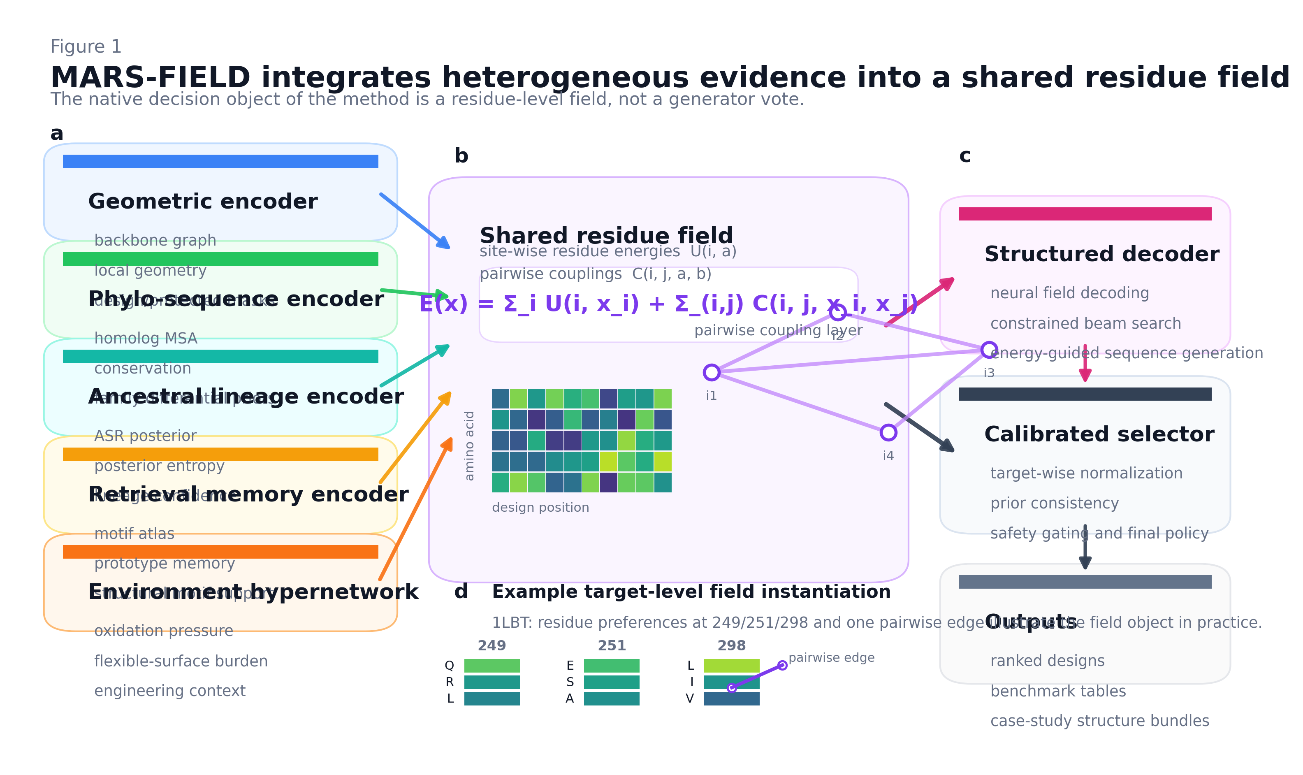
Figure 1 | MARS-FIELD integrates heterogeneous evidence into a shared residue field.
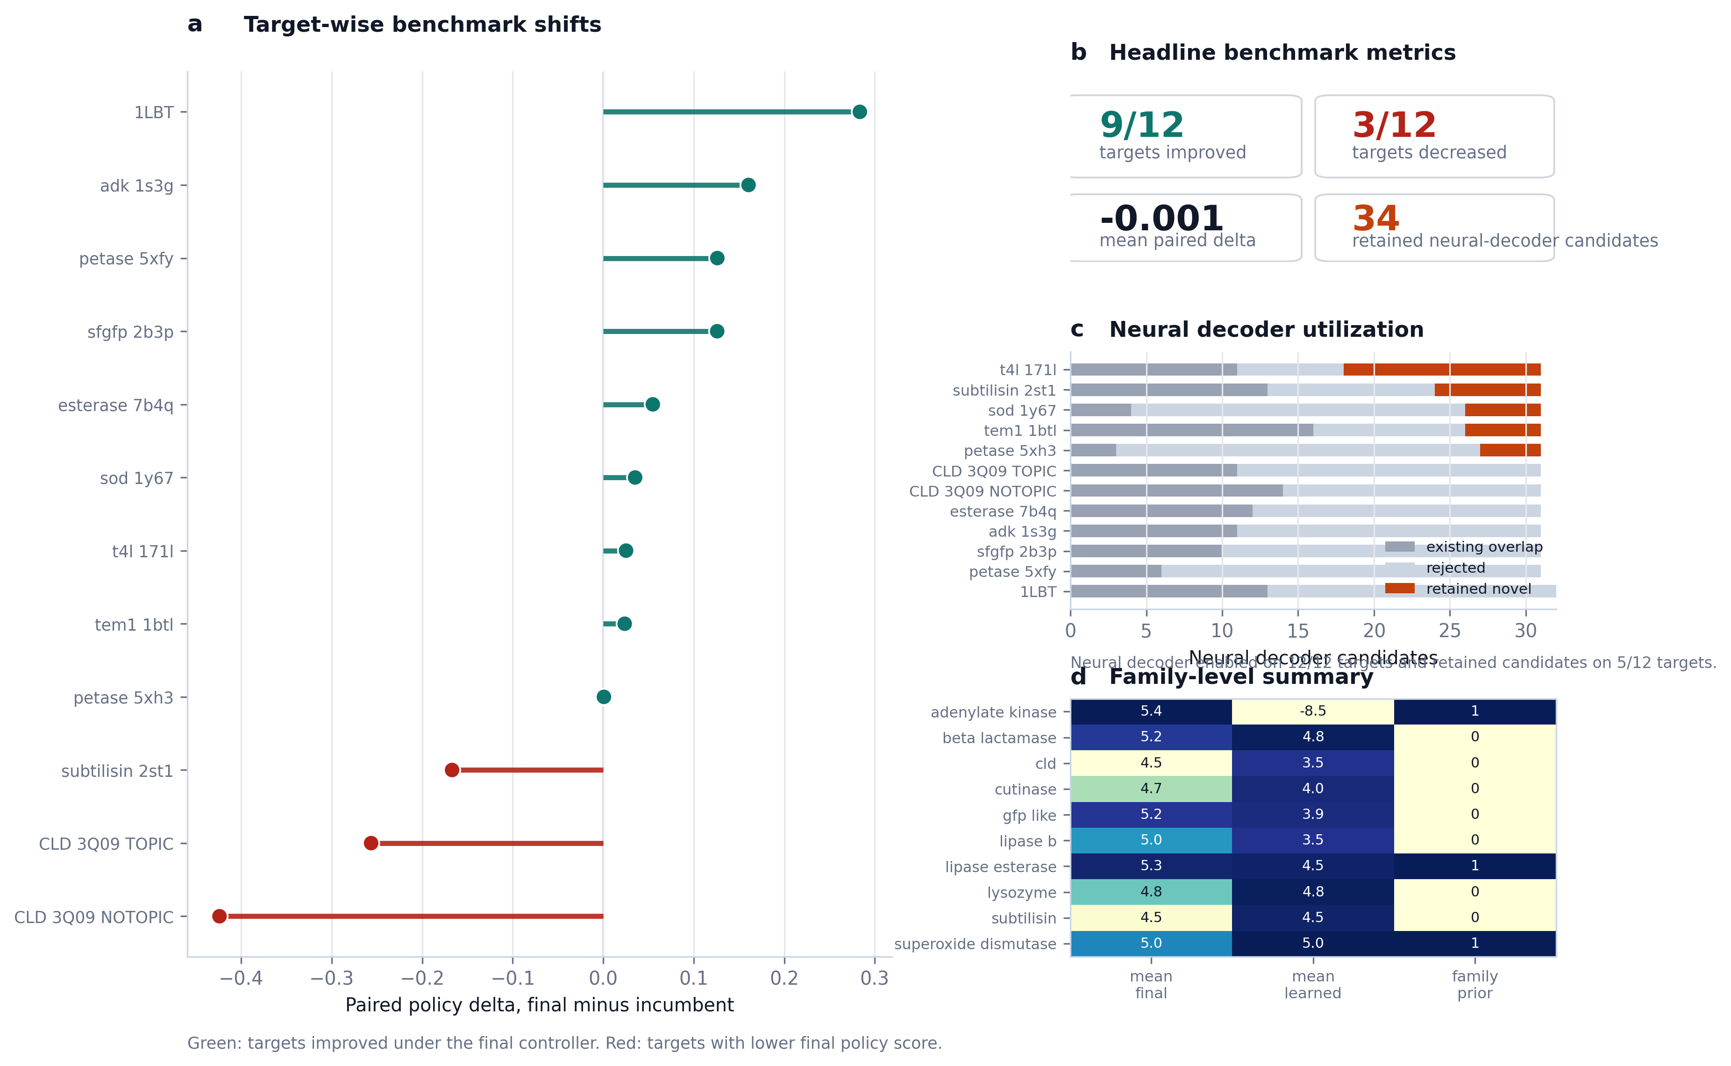
Figure 2 | Benchmark claim figure.
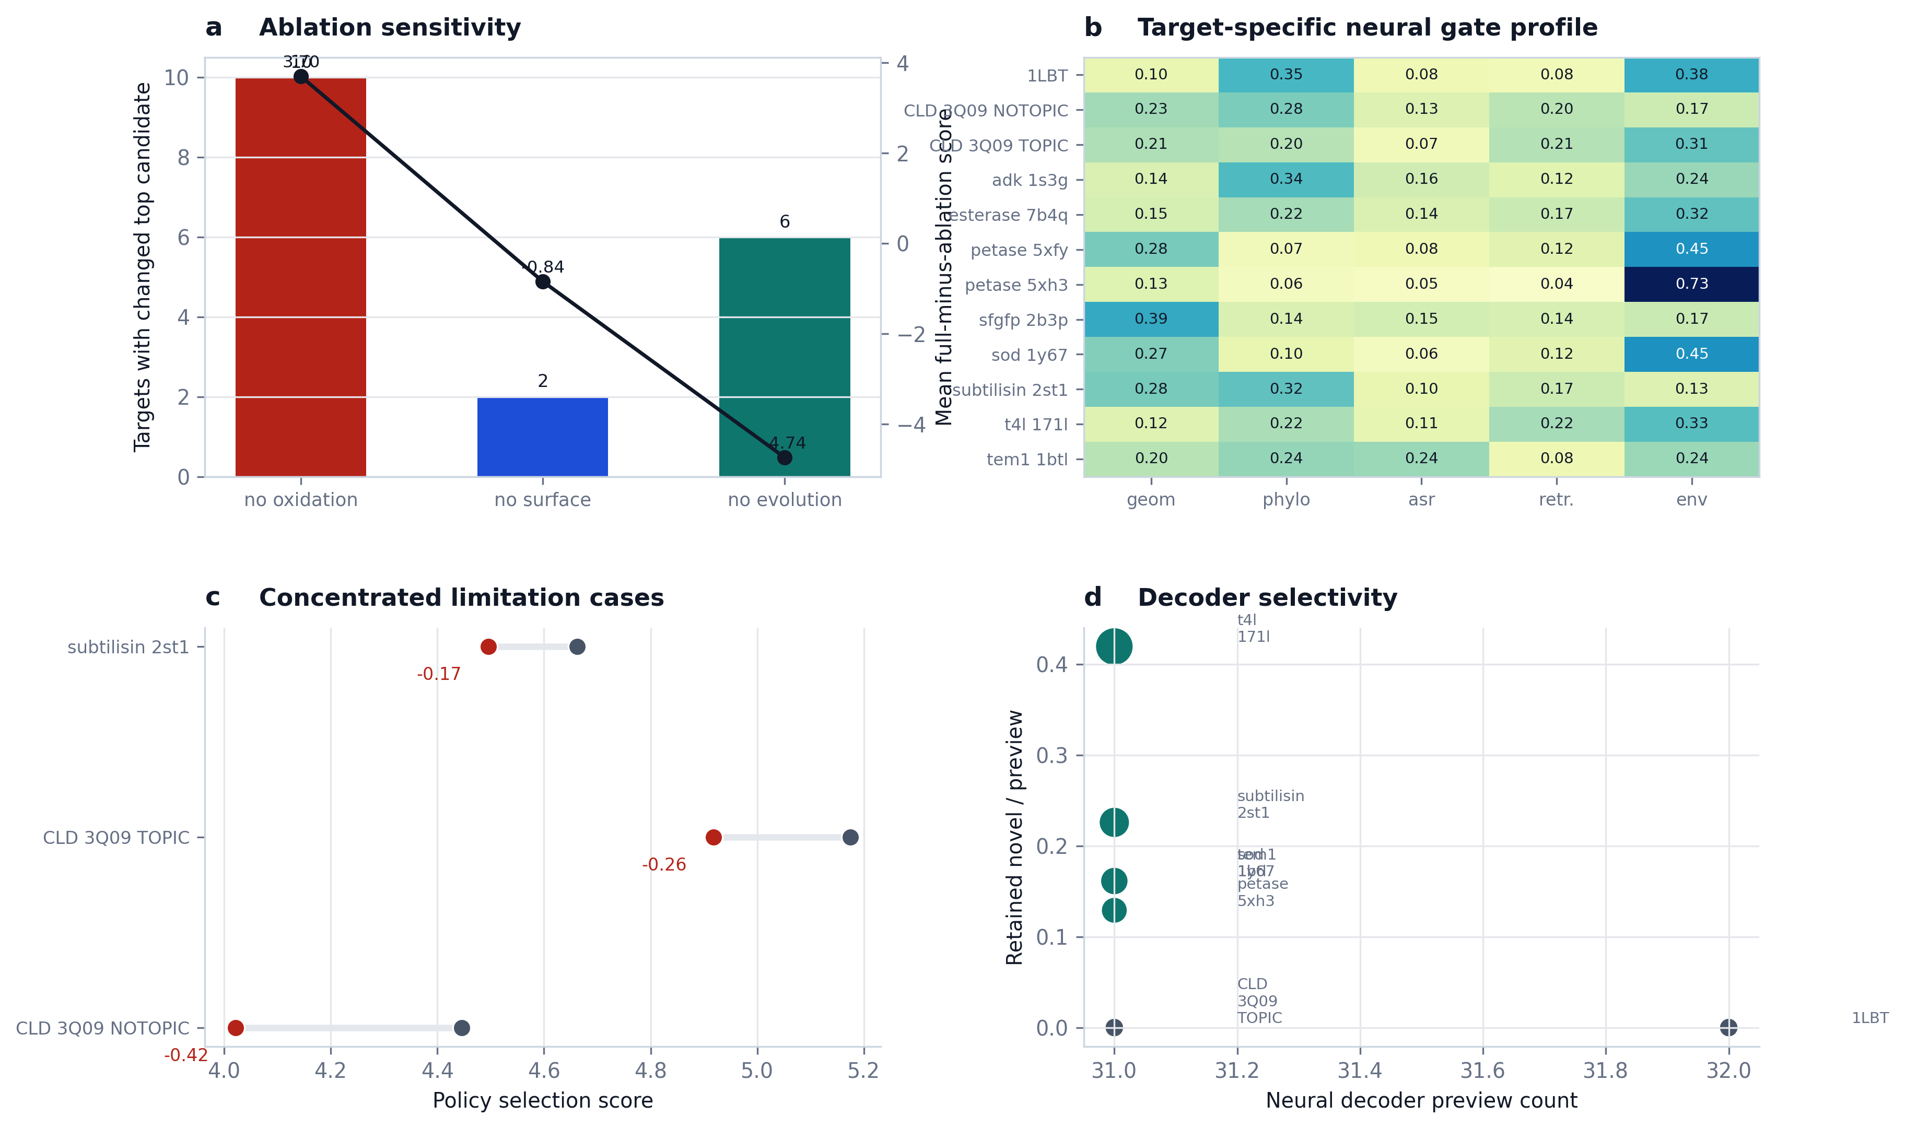
Figure 3 | Mechanism and limitation figure.
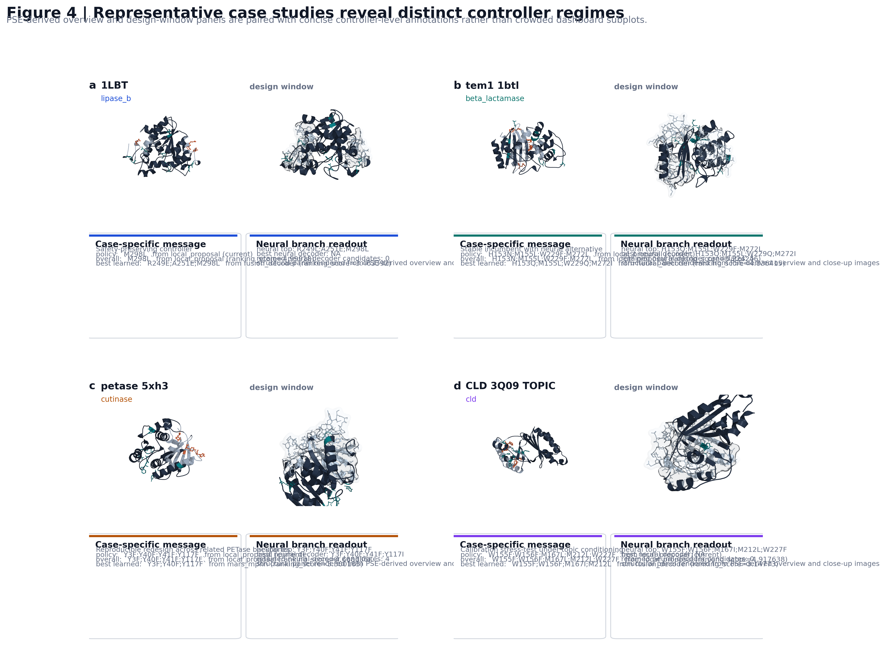
Figure 4 | PSE-derived case-study composite.
Introduction and Discussion
MARS-FIELD Introduction and Discussion Draft v2
Introduction
Protein engineering pipelines often combine structural analysis, evolutionary priors, ancestral reconstruction, and machine-learning proposal engines as loosely connected modules. This modularity is operationally useful, but it creates a conceptual weakness: the system behaves as a collection of partially redundant signals rather than as a unified controller. The problem becomes more severe when the target objective is not simply sequence plausibility but robust engineering under multiple constraints, including oxidation risk, flexible-surface burden, motif preservation, and environment-conditioned stress.
`MARS-FIELD` addresses this problem by treating protein engineering as an evidence-to-sequence control task. Structural, phylogenetic, ancestral, retrieval-based, and environment-conditioned signals are projected into a shared residue field over the design positions. This field, rather than a candidate list, is the native decision object of the method. It defines residue-wise preferences and pairwise couplings, and these quantities are used both to evaluate incumbent candidates and to decode new ones under explicit engineering constraints.
The current implementation goes beyond a rerank-only architecture in two ways. First, ancestry and retrieval are represented as learned memory-linked branches inside the controller. Second, the neural branch is active at decode time in the main benchmark path. The resulting system is therefore not only a candidate reranker, but a field-controller-decoder architecture. We do not claim that this is yet the final fully joint proposal-generator / field / decoder model. Instead, we ask whether a unified evidence-conditioned controller can already be made benchmark-stable, mechanistically interpretable, and capable of decode-time neural proposal generation.
Discussion
The main conclusion of this study is that a shared residue-field controller provides a more coherent basis for protein engineering than an ensemble of disconnected proposal branches. In the present implementation, `MARS-FIELD` integrates heterogeneous evidence streams into a common residue field, uses a calibrated neural controller to score candidates, and activates a decode-time neural branch inside the main benchmark path. This is qualitatively different from earlier stack-and-rerank pipelines because the neural branch now participates in generation as well as selection.
An important feature of the current results is stability. The final controller improves paired policy score on most targets while maintaining an approximately neutral panel-level mean delta after neural decoder integration. This indicates that a more ambitious controller-decoder architecture can be inserted into the benchmark without causing broad collapse. At the same time, retained neural-decoder candidates appear only on a subset of targets, implying that the decoder is selective rather than indiscriminate.
The remaining failures are also informative. The current regressions are concentrated in a small number of calibration-limited targets rather than distributed broadly across the panel. This is consistent with a method that is fundamentally viable but not yet fully optimized. In particular, the current implementation still relies on staged supervision and a hybrid final policy, and therefore should not be described as the final fully joint protein design model.
We therefore view `MARS-FIELD` as a bridge architecture. It is more unified than a heuristic engineering stack, more honest than a claim of fully joint optimization, and already strong enough to support a methods paper built around a shared residue-field controller, decode-time neural proposal generation, and panel-level benchmark stability.
Related Work
MARS-FIELD Related Work and References v3
Related work
Structure prediction and inverse folding
Modern protein design pipelines were transformed by large-scale advances in structure prediction and structure-conditioned sequence modeling. AlphaFold established that accurate atomic structure prediction can be achieved broadly enough to reshape downstream design workflows [1]. ProteinMPNN then showed that fixed-backbone sequence design can be solved effectively with deep structure-conditioned models [2], while large-scale inverse-folding systems trained on predicted structures further expanded the design setting [3]. These studies motivate the use of geometry-conditioned compatibility as a native modeling object, but they do not by themselves resolve how multiple non-geometric evidence streams should be unified in engineering contexts.
Retrieval-based structural memory
Foldseek and related fast structural-search systems made motif-level structural retrieval practical at large scale [5]. Such retrieval is highly valuable for protein engineering because it provides access to empirically grounded structural neighborhoods. However, retrieval is often used as an external annotation or post hoc check rather than as a learned part of a design controller. `MARS-FIELD` differs by treating retrieval as a structured evidence stream that enters both the residue field and the neural controller through a dedicated memory-linked branch.
Sequence-based representation learning and rational engineering
Sequence-based representation learning has already shown that large protein embeddings can support rational engineering and transfer across tasks [6]. These methods demonstrate that sequence statistics encode useful biochemical and evolutionary constraints. However, sequence-only representations do not, on their own, provide a natural mechanism for combining local structural context, retrieval memory, ancestry, and explicit engineering penalties in a unified controller. `MARS-FIELD` therefore sits closer to an evidence-conditioned controller-decoder framework than to a pure sequence language-model application.
Ancestral sequence reconstruction and lineage-aware learning
Ancestral sequence reconstruction has long been important in protein evolution and engineering [7]. More recently, ancestry has also been used as a learning signal in representation-learning systems [8]. This literature is particularly relevant because `MARS-FIELD` treats ancestry not as a one-off recommendation list but as a dedicated lineage-aware branch that contributes both explicit residue priors and latent controller structure.
Positioning of MARS-FIELD
The central distinction of `MARS-FIELD` is that it treats heterogeneous evidence as input to a shared residue-field controller rather than as a set of independent proposal engines or post hoc heuristics. The current implementation should not be overstated as a fully joint proposal-generator / field / decoder optimization framework. Instead, it is best viewed as an intermediate but meaningful architecture in which:
- structural, evolutionary, ancestral, retrieval, and environmental evidence are unified in a residue field
- a neural controller performs calibrated candidate-level selection
- a decode-time neural field generator is active in the benchmark-time main path
- the resulting system remains benchmark-stable at the panel level
In this sense, `MARS-FIELD` functions as a bridge between heuristic engineering stacks and future fully joint field-generator-decoder systems.
Selected references
1. Jumper, J. et al. Highly accurate protein structure prediction with AlphaFold. *Nature* **596**, 583-589 (2021).
2. Dauparas, J. et al. Robust deep learning-based protein sequence design using ProteinMPNN. *Science* **378**, 49-56 (2022).
3. Hsu, C. et al. Learning inverse folding from millions of predicted structures. In *Proceedings of the 39th International Conference on Machine Learning*, PMLR 162, 8946-8970 (2022).
4. Lin, Z. et al. Evolutionary-scale prediction of atomic-level protein structure with a language model. *Science* **379**, 1123-1130 (2023).
5. van Kempen, M. et al. Fast and accurate protein structure search with Foldseek. *Nature Biotechnology* **42**, 243-246 (2024).
6. Alley, E. C. et al. Unified rational protein engineering with sequence-based deep representation learning. *Nature Methods* **16**, 1315-1322 (2019).
7. Chisholm, L. O. et al. Ancestral reconstruction and the evolution of protein energy landscapes. *Annual Review of Biophysics* **53**, 127-146 (2024).
8. Matthews, D. S. et al. Leveraging ancestral sequence reconstruction for protein representation learning. *Nature Machine Intelligence* **6**, 1542-1555 (2024).
Methods
MARS-FIELD Methods v3
Overview
`MARS-FIELD` is a unified evidence-to-sequence controller for protein engineering. The method constructs a shared residue field over a target-specific design window, uses that field to score incumbent candidates, and decodes new candidates under explicit engineering constraints. The current implementation contains three coupled layers:
1. multi-modal evidence construction
2. residue-field construction
3. controller-decoder inference with calibrated final selection
The present system is not yet a fully joint proposal-generator / field / decoder model. However, the benchmark-time main path includes both a neural controller and a decode-time neural field generator.
Benchmark panel and target curation
The main benchmark contains twelve targets spanning ten protein families. Each target is specified by:
- an input structure
- a chain identifier
- a wild-type sequence
- a local design window
- a protected-position set
- optional homolog, family, template, or ASR inputs
The benchmark includes:
- `1LBT`
- `tem1_1btl`
- `petase_5xfy`
- `petase_5xh3`
- `sfgfp_2b3p`
- `t4l_171l`
- `subtilisin_2st1`
- `adk_1s3g`
- `esterase_7b4q`
- `sod_1y67`
- `CLD_3Q09_NOTOPIC`
- `CLD_3Q09_TOPIC`
Three targets use family priors, two use ancestral priors, and all twelve use template-aware weighting in the final benchmark path. Neural training is leave-one-target-out at the target level.
Structural feature extraction and design-window definition
For each target, the structure-analysis stage extracts residue-level geometric and engineering features, including:
- solvent-accessible surface area
- local flexibility proxy
- minimum distance to protected positions
- disulfide participation
- glycosylation motif membership
Two structural masks are then derived:
- oxidation hotspots
- flexible surface positions
The design window is read directly from the target configuration, and the resulting target bundle contains the wild-type sequence, design positions, protected positions, residue feature table, oxidation-hotspot set, and flexible-surface set.
Phylogenetic and family priors
The phylogenetic branch constructs residue priors from homolog or family sequence collections. The current implementation supports:
1. homolog profile priors
2. family differential priors
3. template-aware weighting
For each design position `i`, the homolog profile defines a residue distribution over the amino-acid alphabet. Family differential priors represent residue enrichment or depletion relative to a reference family distribution. Template-aware weighting modulates the importance of these priors according to structural context.
Ancestral lineage field
The ancestral branch converts ancestral reconstruction outputs into a position-wise lineage field. For each design position, the current representation may include:
- posterior residue distribution
- posterior confidence
- posterior entropy
- recommendation mass
- maximum recommendation support
These signals contribute both explicit residue support in the engineering field and a dedicated ancestry branch in the neural controller.
Retrieval motif atlas and prototype memory
The retrieval branch encodes local structural memory rather than acting only as a nearest-neighbor annotation tool. For each design position, the retrieval representation may include:
- residue-support distribution
- neighbor count
- top structural similarity
- top retrieval weight
- support sum
- unique supporting target count
These quantities are projected into the hidden space and fused with a learned retrieval-memory bank, allowing the controller to use retrieval as a structured evidence source.
Shared residue field
The shared residue field is the native decision object of the method. It has two components:
- site-wise residue energies `U(i, a)`
- pairwise couplings `C(i, j, a, b)`
For a sequence `x`, the field energy is:
`E(x) = sum_(i in D) U(i, x_i) + sum_((i,j) in N) C(i, j, x_i, x_j)`
The engineering field is assembled from structural, evolutionary, ancestral, retrieval, and proposal-derived evidence. The neural field is produced by a multi-branch neural model that outputs unary residue logits and pairwise interaction tensors.
Candidate controller architecture
The neural controller contains five evidence branches:
- geometry
- phylogeny
- ancestry
- retrieval
- environment
Each branch is projected into a shared hidden space. The ancestry and retrieval branches are additionally fused with learned memory banks. The environment branch produces both an environment token and branch-specific modulation parameters.
Branch fusion is implemented with learned gates. If the branch embeddings at site `i` are
`h_geom(i)`, `h_phylo(i)`, `h_asr(i)`, `h_retr(i)`, and `h_env(i)`, then:
`alpha(i) = softmax(G([h_geom(i), h_phylo(i), h_asr(i), h_retr(i), h_env(i)]))`
and the fused site representation is:
`h_i = MLP([alpha_geom(i) h_geom(i), alpha_phylo(i) h_phylo(i), alpha_asr(i) h_asr(i), alpha_retr(i) h_retr(i), alpha_env(i) h_env(i)])`
At the candidate level, the controller combines sequence-conditioned residue-prototype context, candidate-specific evidence features, and pairwise summary features. The candidate embedding feeds three heads:
- selection head
- engineering head
- policy head
Training objectives
The controller is trained with multiple objectives.
Selection regression
`L_sel = MSE(s_hat, s_norm)`
Engineering regression
`L_eng = MSE(e_hat, e_norm)`
where `e_norm` is the standardized engineering score.
Policy regression
The target policy score is defined as:
`p_target = 0.30 s_norm + 0.70 e_norm`
with supervision:
`L_pol = MSE(p_hat, p_target)`
Pairwise policy ranking
Pairwise ranking supervision is applied to candidate pairs whose target policy values differ by a margin:
`L_rank = mean softplus(-(p_hat_i - p_hat_j))`
Decoder-field supervision
The unary field is supervised toward the empirical residue distribution induced by high-quality candidates:
`L_dec = CE(U, q_site)`
Additional regularization and auxiliary losses
The current implementation also includes:
- recovery loss
- ancestry alignment loss
- retrieval alignment loss
- environment reconstruction loss
- pairwise consistency loss
- winner-guard loss
- non-decoder-guard loss
- simplicity-guard loss
- selector-anchor loss
- gate-entropy and gate-prior regularization
The total objective is a weighted sum of these terms.
Teacher-forced neural field decoder
The neural field decoder extends the system beyond reranking. For each held-out target, the benchmark-time pipeline:
1. constructs a runtime neural batch from the live target state
2. trains a leave-one-target-out neural field model using the remaining targets
3. produces learned unary and pairwise field outputs
4. combines these outputs with evidence-derived prior fields
5. decodes `neural_decoder` candidates under constrained beam search
This teacher-forced design prevents the learned field from drifting too far from biologically and engineering-wise supported regions while still allowing decode-time novelty.
Final hybrid selection policy
The final controller uses a hybrid policy. If `x_current` is the incumbent policy candidate and `x_neural` is the neural-policy candidate, then `x_neural` is adopted only if:
1. `engineering_score(x_neural) >= engineering_score(x_current)`
2. `selection_score(x_neural) - selection_score(x_current) >= -tau`
In the current benchmark implementation:
- `tau = 0.10`
This policy keeps the system conservative on hard targets while still permitting neural branch adoption when adequately supported.
Evaluation protocol
The primary evaluation quantities are:
- policy selection score
- policy engineering score
- paired policy delta relative to the incumbent benchmark
- neural decoder utilization
Neural decoder utilization is quantified by:
- whether the decoder was enabled
- preview candidate count
- retained novel candidate count
- rejected candidate count
- best retained neural-decoder-derived candidate
The benchmark is interpreted as a paired engineering panel rather than a single-endpoint statistical trial. The key quantities are therefore:
- number of improved targets
- number of decreased targets
- whether regressions are concentrated or diffuse
- whether neural decoding contributes retained non-redundant proposals
Scope
The present implementation supports the claim that `MARS-FIELD` is a unified residue-field controller with an active decode-time neural branch in the main benchmark path. It does not yet support the stronger claim of fully joint proposal-generator / field / decoder optimization.
Figure Legends
MARS-FIELD Figure Legends v3
Figure 1 | MARS-FIELD integrates heterogeneous evidence into a shared residue field
**a,** Multi-modal evidence streams entering the controller, including geometry-conditioned structural information, phylogenetic context, ancestral lineage priors, retrieval-based motif memory, and environment-conditioned engineering context.
**b,** Central representation of the method as a shared residue field defined by site-wise residue energies `U(i, a)` and pairwise couplings `C(i, j, a, b)`.
**c,** Downstream controller-decoder actions on the field. The structured decoder performs constrained field-to-sequence search, whereas the calibrated selector enforces target-wise normalization, prior consistency, and safety gating before final ranking.
**d,** Example target-level field instantiation showing how residue preferences and pairwise couplings are represented on a concrete design window.
Figure 2 | The final controller remains benchmark-stable while activating neural decode-time generation
**a,** Paired policy-score differences between the final controller and the incumbent benchmark across the twelve-target panel. Positive values indicate targets whose final policy score increased relative to the incumbent pipeline.
**b,** Headline benchmark metrics summarizing improved targets, decreased targets, mean paired policy delta, and retained neural-decoder-derived candidates.
**c,** Neural decoder utilization across the benchmark, decomposed into preview, rejected, and retained novel candidates.
**d,** Family-level summary showing final controller behavior across the represented protein families and prior regimes.
Figure 3 | Ablations and neural diagnostics reveal both the drivers and the boundaries of MARS-FIELD
**a,** Component ablation analysis showing sensitivity to oxidation-aware, surface-aware, and evolutionary evidence.
**b,** Target-specific neural gate profiles across geometry, phylogeny, ancestry, retrieval, and environment branches.
**c,** Concentrated negative paired-delta targets, illustrating that the remaining failures are localized rather than diffuse.
**d,** Decoder selectivity map relating preview counts to retained-novel fractions.
Figure 4 | Representative case studies reveal distinct controller regimes
**a,** `1LBT` as a safety-preserving regime in which the final controller maintains the incumbent solution despite active neural decoding.
**b,** `TEM1` as a stable-incumbent regime with a neural-decoder-derived learned alternative that remains below the final policy winner.
**c,** `PETase` as a reproducibility regime across related structural contexts.
**d,** `CLD` as a calibration stress test in which the incumbent remains stable while the neural branch continues to surface a nearby alternative.

