STACK VM DRAFT 2018
By James L. Walsh

The goal of this draft is to provide a basic summary of the inner working on the SVM (stack vm), and a guide on how to implement it.

Goals
The goal of this project is to create a portable, and somewhat fast virtual machine. In the end, the virtual machine should be able to run on embedded devices without kernels, or with small computers such as the Raspberry PI. The goal is to have executables compiled on one platform (ex. Windows), and run said executable on a different device with an entirely different architecture (ex. Raspberry PI). The goals of this vm have been inspired by the AMX Virtual Machine, designed for the Pawn language. However, the implementation of this vm will most likely be influenced a lot by the JVM.

Types
The vm will feature a weak, statically type system. What this means is that the instruction set is going to contain instructions made to operate on certain types (ex. ADD_INT, ADD_FLOAT), but the vm will take for granted that the values provided for the instruction are of the right type, hence the weak type system. Therefore, it will be the compiler’s job so ensure that the operations are applied to values of the correct type, and if they do not match, ensure that they are casted first.

Bytecode
Numeric values represented within the bytecode do not have to conform to any specific endianess. This means that an executable will have to be compiled using the endianess that corresponds to the platform the vm will be run on.

Primitives
In order to ensure that compilation is platform-independent, the vm will have to enforce a specific-sized primitives. Below is a list of the primitive types to be implemented, and their size in bytes. Note that it is taken for granted that a byte is constituted of eight bits, so platforms that use a different byte size won’t be compatible with the SVM. The implementation of floats or doubles has yet to be figured out!

Type | Size (in bytes) | Description
Integer | 2 | A signed whole number
Unsigned integer | 2 | A non-signed whole number
Pointer | 4 | A non-signed whole number capable of representing a memory location
Long | 8 | A signed whole number
Unsigned long | 8 | A non-signed whole number
Float | ? (TBD) | A high-precision number
Byte | 1 | A group of eight bits
Opcode | 2 | An opcode used only in the bytecode, alias of unsigned integer

Stack
As the name implies, the SVM is a full stack-based machine, meaning that it does not use any registers! For simplicity, the stack will be made of “objects”, which in reality is merely a union of the types mentioned above. The implication of this is that types that take technically take less space will end up using as much space as the type that takes the most space.

Calling convention
The SVM will feature a typical calling convention, where a frame-pointer is redefined when calling a new function. Local variables will have to be allocated on the stack before executing the function, through the PUSH_LOCALS instruction. This instruction will push n empty values onto the stack. Then, these variables will be accessible through the LOAD_LOCAL instruction. This instruction will have to specify which variable is to be loaded, using an index where zero is the first local variable.

Memory layout
The SVM will contain four memory zones, independent of each other. The first is the program itself. The second is the heap, which will be the target of dynamic allocations. The third is the stack, which holds fixed-sized objects as mentioned before. The last is the constant pool, which will hold constant values such as strings. The constant pool will be located at the start of the heap, but it shall be a strictly read-only zone.

Strings
The SVM will natively support strings, but not C-style strings. There will be no null-terminator like in C, as instead strings will be represented using a header in memory. This header will mainly contain information such as the string size, which will make string size lookups much faster. In order to use hardcoded strings, it will be the compiler’s job to ensure that the strings are loaded in the constant pool. Then, strings operations will be performed on string references loaded onto the stack, through instructions such as PUSH_PTR, which will push a pointer that points to the start of the string header, relative to the start of the heap. The output of string operations will always have to be stored in the heap afterwards, as the constant pool is made for... constant values.

Executable format
SVM executables will not only contain bytecode. The header will contain the a value indicating the size of the executable (type: long), and also the size of the constant pool (type: long). Then, the constants shall be located right after the header, only to be followed by the program itself. The implication here is that anything between the header and the address header_size + constant_pool_size will be loaded into the constants pool. Then, anything between the address header_size + constant_pool_size and the address executable_size – 1 will be loaded as the program.

Heap
The heap will be a doubly linked list of variable-sized structures known as chunks. Before each chunk a header will be placed, in order to allow for memory management. The header shall contain an integer describing how big the chunk is in bytes, a pointer to the previous chunk, and a pointer to the next chunk. In both pointers the null value is tolerated. The first byte of the heap will be reserved in order to ensure that VM_NULL is always equal to an unused memorylocation.
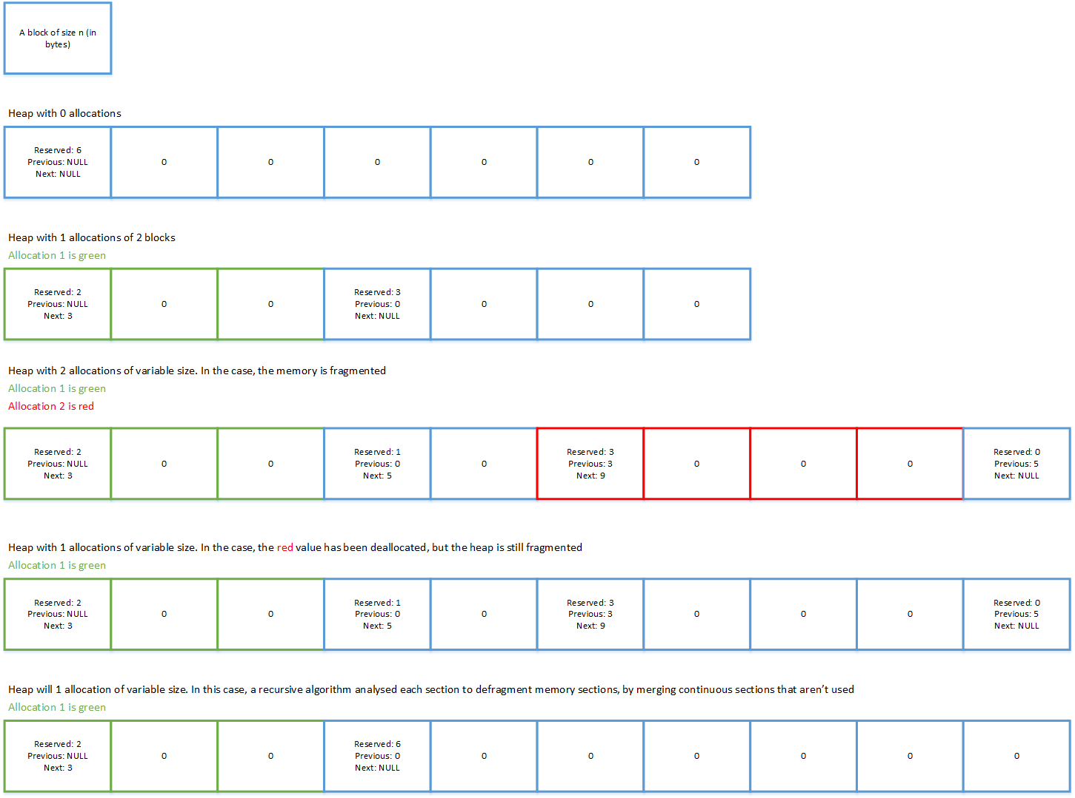
A basic implementation of heap memory.

