- Go to: http://34.57.31.2:3000/
Expected output:
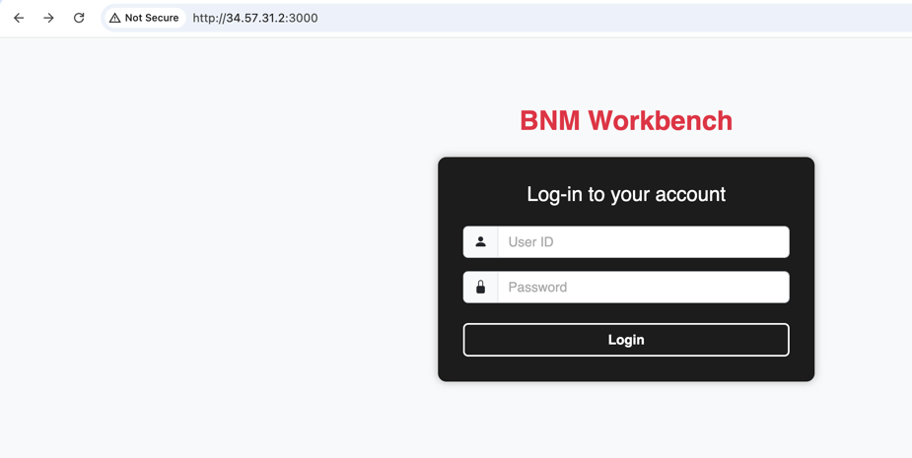
Type your userid and password. If you are new user, can just simply type a password first.
- If you are new user or the userid and password doenst match to record, this page will be promted:
- Key in your userID and password, and repeat the password and your contact email. (so far the email do nothing)
- After pressed the register, it will redirect to login page as shown in (1)
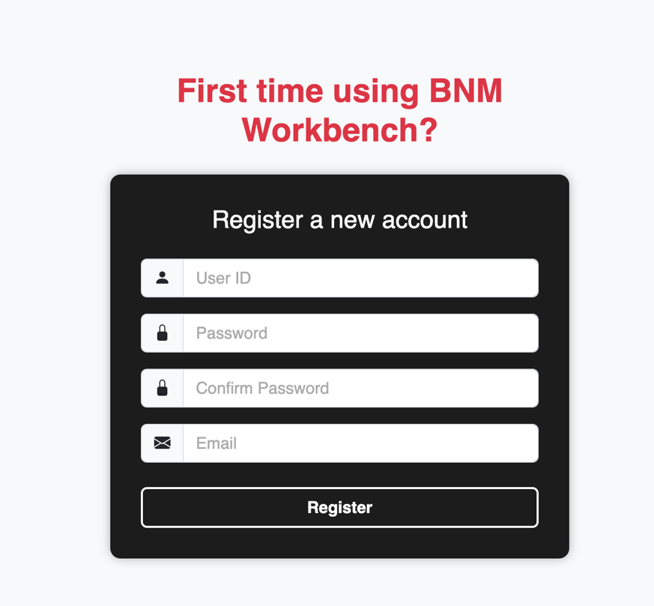

- Here are the home page after login:
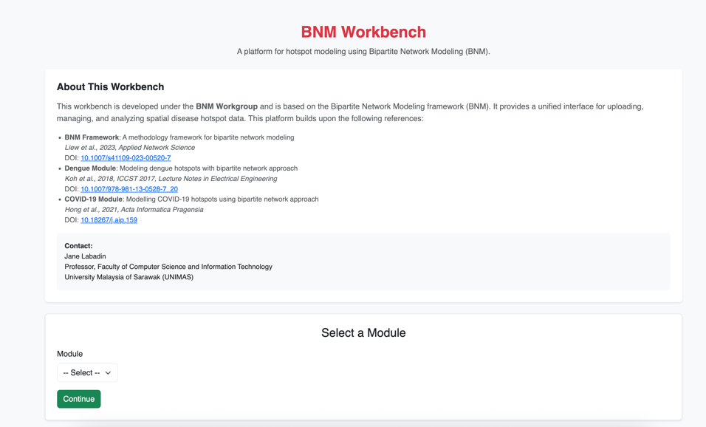
  - User can choose the BNM modules in this page (COVID-19 and Dengue):
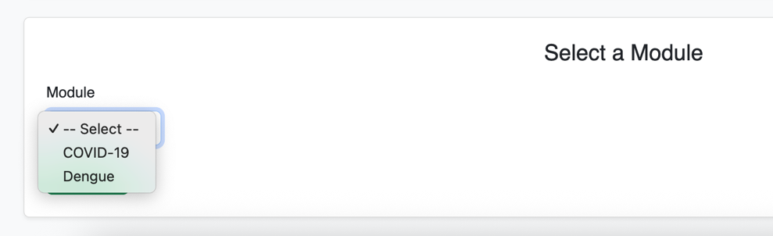
- If user choose COVID-19 module, it required user to provide two inputs
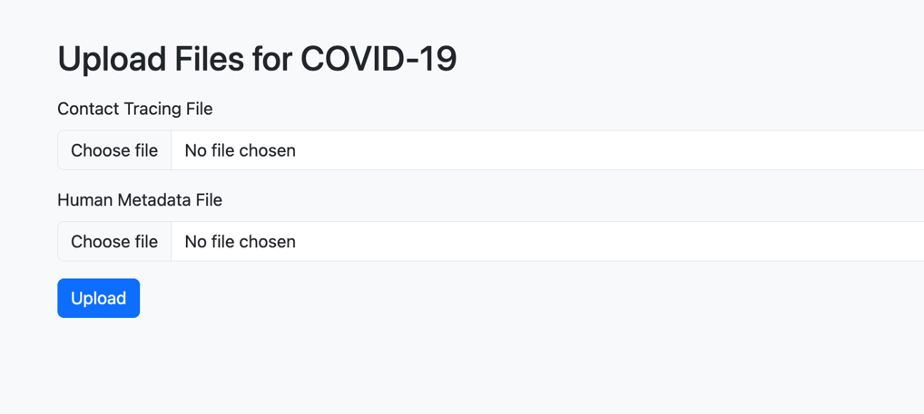
The required format and column can refer to test data:
- C_contact_tracing.txt
- C_Human_meta.txt
- A promt will show the files successfully uploaded to user folder. Then user can choose to proceed.
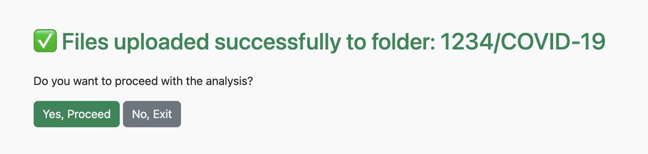

- After proceed, the page will freeze a white and redirect to the result page. Where user can download all files as ZIP or just download individual files
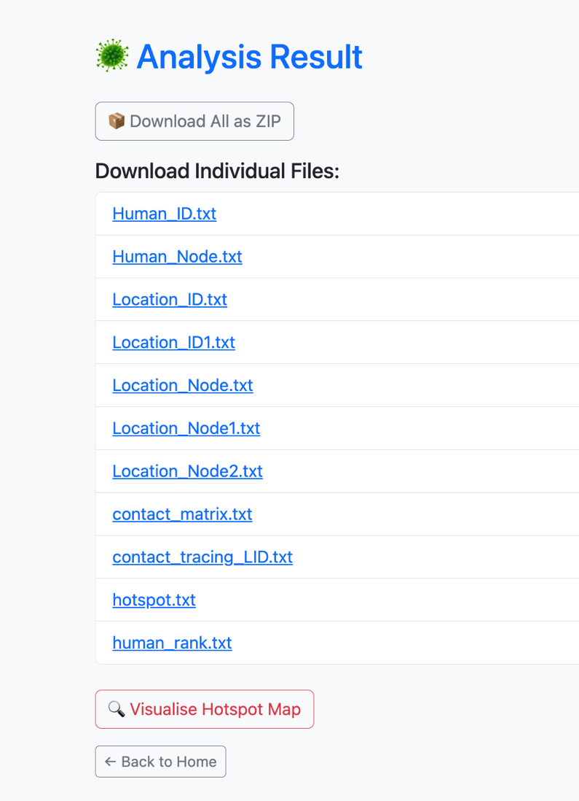
- User can visualize the output by clicking the visualize hotspot map:
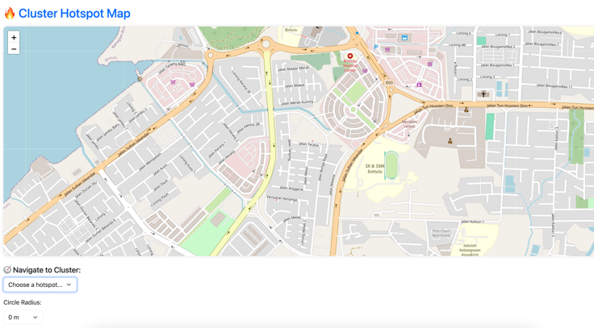
For covid-19, the location node did not perform clustering, so user can choose their radius preference (see example below: radius = 100m)
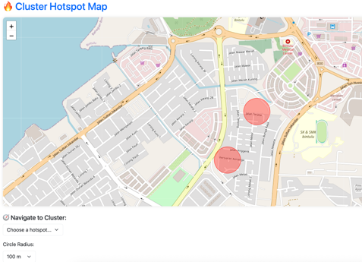

- If user select Dengue module, it will require to key in the radius for clustering the location (default 400 meter)
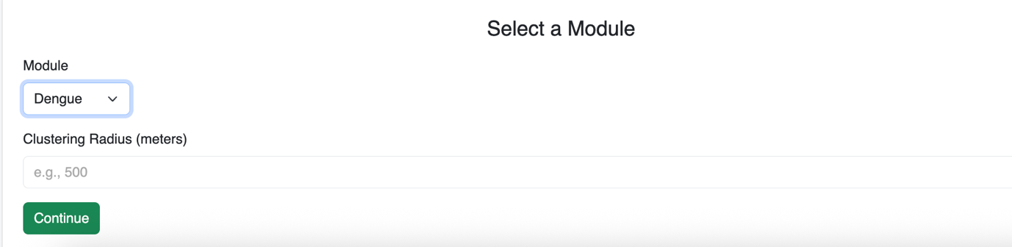
- Movement record (see test data: D_movement_list.txt) required in this module. User also can optionally provide any existing location node for clustering
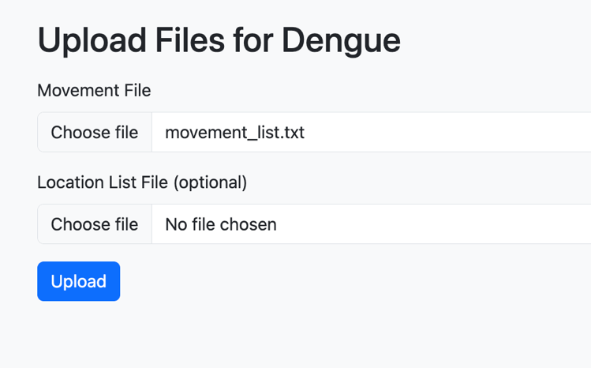

- Same as COVID-19 module, after proceed, user will be redirected to result page and user can download, or to visualize the hotspot. The radius of the location will be based on the user input in early page
