**Overview of Study**

*P* elements are DNA transposons, which when exclusively paternally inherited result in F1 sterility, i.e. when naïve females lacking *P* elements are mated with males carrying *P* elements, F1 offspring are sterile. However, we also found strains that are capable of producing fertile offspring showing variation in the severity of sterility. Our preliminary data reveals a strong association of satellite repeat dosage with this observed variation in severity of sterility. Mothers carrying high satellite repeat dosage was associated with lower F1 sterility when mated with *P* elements carrying males with high satellite dosage. So that sensitivity to F1 sterility may be due to the combination of low maternal satellite dosage with high paternal satellite dosage.

Therefore, we asked whether paternal satellite dosage influences severity of F1 sterility in the presence of *P* elements. Therefore, we mated naïve females with high/low satellite dosage to *P* elements carrying males with high and low satellite dosage in their genome **(Total crosses- 4)**. Then we observed the incidences of sterility in the F1 females.

The variables that comprise the data set are**- maternal genotype** (high/low satellite repeats), **paternal genotype** (*P-*strains with high/low satellite repeats), and **incidences of sterility**. Here, maternal genotype and paternal genotype are the explanatory variable and incidences of sterility is the response variable. All the variables in the experiment are nominal categorical variables as the categories do not have any inherent order.

**Crosses:**

1. **Cross with high paternal satellite dosage (2 crosses)**

Females with high/low satellite dosage X P-strain males with high satellite dosage

1. **Cross with low paternal satellite dosage (2 crosses)**

Females with high/low satellite repeat X P-strain males with low satellite dosage

**Null hypothesis**- The F1 sterility in presence of *P* element activity is not dependent on paternal satellite dosage i.e. the effect of maternal dosage on F1 sterility is independent of the paternal dosage.

**Alternative hypothesis-** F1 sterility in presence of *P* element activity is dependent on paternal satellite dosage i.e. the effect of maternal dosage on F1 sterility is dependent on the paternal dosage.

If F1 sterility in presence of *P* element activity is dependent on paternal satellite dosage, we predict that observed difference between females carrying high and low satellite repeats in presence of high paternal satellite dosage should disappear in presence of low paternal satellite dosage.

Therefore, I will independently perform X2 Contingency test to examine whether maternal dosage effects F1 sterility for each of the two crosses: one in presence of high paternal dosage and another in presence of low paternal dosage. For the test, the null hypothesis will be that F1 sterility is dependent on maternal dosage and alternative hypothesis will be that F1 sterility is independent on maternal dosage. If for one cross the X2 Contingency test gave a significant p-value whereas for the other cross the X2 Contingency test did not, then it means that the effect of maternal dosage on F1 sterility is dependent on the paternal dosage.

As expected from preliminary results, the two maternal genotypes should differ significantly in crosses with high paternal satellite dosage. If this difference persists even in crosses with low paternal satellite dosage, it will suggest that effect of maternal dosage on F1 sterility is not dependent on paternal satellite dosage, consistent with the null hypothesis.

For the experiment, the population was all the female flies generated from the crosses whereas, the sampling units were a subset of individual F1 females. To avoid confounding effects from genetic background variation, we used maternal strains which were isogenic except in the second chromosome centromere where the satellite repeat resides, either carrying high or low satellite dosage. All experiments were performed at a constant temperature i.e. at 25-degree Celsius incubator.

**Data Collection:**

**Assigning sampling units to treatment groups:**

The virgin females (for each of the two maternal genotypes) were collected from the stock and were randomly assigned to the two treatment groups, i.e. mated to either *P-*strain males with high satellite dosage or *P-*strain males with low satellite dosage. We crossed 10 naïve females to 10 *P-*strain males for each treatment. The newly emerged F1 females were transferred to new vial and after 3 days we screened for ovarian atrophy by dissecting their ovaries. To minimize sampling errors, we used 60 replicates or number of individual F1 females per treatment. Therefore, we will have a total of 240 (60X4) experimental units. We took 3 days old F1 offspring when they are the most fertile to avoid biases due to reproductive age.

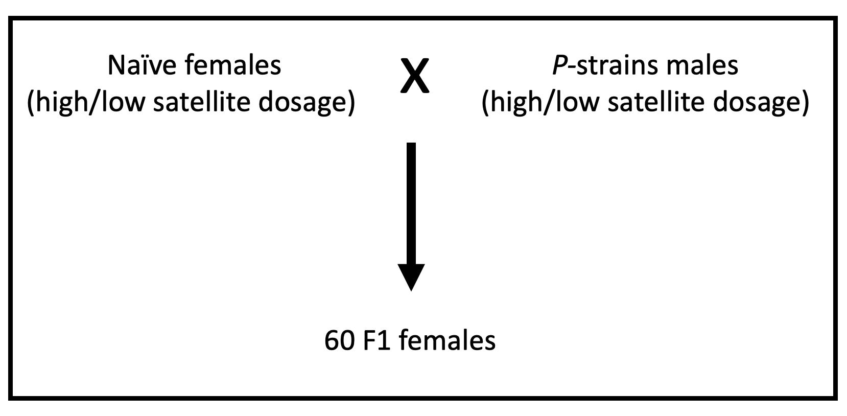

**Expected Power:**

Based on previous data (probability of success = 0.67, n = 70), the SE of the mean in our data should be approx. 0.056.

Sample size (n) = 8p´(1- p´)/D2

p´ = P1+P2/2 = (0.98+0.67)/2 = 0.825

D2 = (p1-p2)2 = 0.0961

n ~ 12.02

Hence a sample size of 12 would be required for power of 0.8 and significance level of 0.05. This amount of sample size is both realistic in terms of labor and costs.