**Objectives**

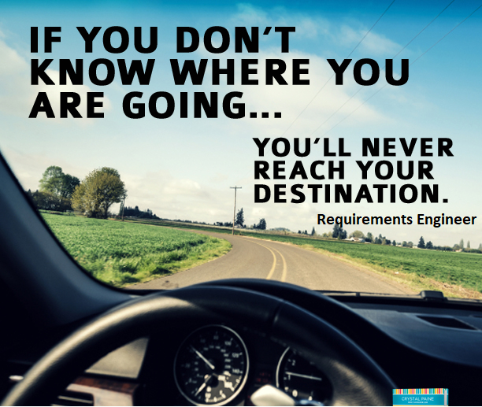

By doing this assignment, student will:

1. **Solve this assignment for yourself not for prof, not for marks.**
2. **Empowering student with self-learning skills. دعم الطالب بمهارات التعلم الذاتى (أنت المسؤول الأول عن تعليمك)**
3. Understand the importance and complexity of collecting detailed requirements about a system and negotiating requirements with the client.
4. Learn how to document requirements in an SRS document and write an enriched user story for each system functionality or use case; so that developers understand the requirements very well and develop the most accurate system for client needs and minimize re-work.
5. Practice modeling with UML diagrams

**Setup**

1. This assignment will be solved in **groups of 3 students from the same lab**. **(Again, same lab)**
2. The group will submit together **one combined** solution. **Again, the students are fully responsible of delivering ONE INTEGRATED well-formatted document. تانى بالعربى الفريق مسؤول عن تسليم وثيقة واحدة متكاملة و منسقة و ليس كل واحد يسلم قطعة منفصلة**
3. The entire group is responsible of **helping any weak member** to be able to do his/her task **by his/herself**, by providing the necessary support, knowledge, hands-on demos, etc.
4. **Only submit original work. Any copied work or AI-generated work will be penalized.**
5. **مسؤولية الفريق تضامنية عن عمله و أى غش من أى فرد سيكون مسؤولية الجميع و يخصم منهم مثل الدرجة**
6. **Please read the marking criterion very carefully to understand how you will be marked.**

**Task 1 - Project Phase 1 (5%)**

1. Read carefully Toffee project description given with this assignment
2. Contact the client representatives (Dr El-Ramly and your TA) for any questions & clarifications.
3. Read carefully the Software Requirements Specifications template given with this assignment. Read the instructions in red very carefully. Again, read the red instructions to know how fill the form. **Then delete the red parts.**
4. There is also a sample SRS for a previous project that can give guidance on how it looks like.
5. Write the SRS document of Toffee project, including all the required details and use case model and enriched user stories.
6. Upload the **draft version by 12 March 2022 as a pdf file.** Draft version should include all parts except enriched user stories. File name must be *CS251-2023-YourSection-TA-LeaderID-DraftToffeeSRSv0.0.pdf*, e.g. *CS251-2023-G5-MinaAdel-20210004-DraftToffeeSRSv0.0.pdf*
7. Upload the **final version on 20 March 2023 as a pdf file,** including all items and a **cover page with team names, IDs, emails, course name and number and document topic and title.** File name must be *CS251-2023-YourSection-TA-LeaderID-FinalToffeeSRSv0.0.pdf*, e.g. *CS251-2023-G5-MinaAdel-20210004-FinalToffeeSRSv0.0.pdf*

**Task 2 – Individual Modeling Task (3%)**

1. Each student will do these tasks for a system description taken from the book: *Object-Oriented Software Engineering: Practical Software Development using UML and Java*, 2nd edition by Timothy C. Lethbridge and Robert Laganière.
2. Student with the smallest ID will take description 1, next ID will take description 2, and biggest ID will take description 3. **Note that these descriptions might be incomplete or missing some important details that you need to search for and complete.**
3. In each task, there is an initial system description that might not complete. For this description, you are required to do the following:
4. Do some background research about this system or similar ones.
5. **Write a list of possible methods / resources / people** that can you use to collect information.
6. **Write** domain analysis of the domain of the system in **1** to **2** single space pages of font size 12.
7. **Write** a list of the **functional** requirements **and non-functional** requirements that the system should support in **1** to **2** single space pages of font size 12.
8. **Draw** a use case model of the system showing the actors and all use cases, including relations between the use cases. **Use a professional UML tool**.
9. **Draw** a class diagram for the system that shows the main model classes and control classes, the links between these classes (including link type, label and multiplicity) and the main attributes and operations in each class. **Use a professional UML tool**.
10. **List all** the tools you used and what you used them for.
11. **Description 1**: **Airline Reservation** system on page 480.

**Description 2: Small Hotel Reservation** system on page 167, problem E80.

**Description 3: Woodworking design** system on page 482.

1. Upload the draft version by 12 March 2022 as a pdf file which contains items b, c and d above. File name must be *CS251-2023-YourSection-TA-YourID-YourName-DraftSystemName.pdf.* Load full version by final deadline.

**Policy Regarding Plagiarism:**

1. تشجع الكلية على مناقشة الأفكار و تبادل المعلومات و مناقشات الطلاب حيث يعتبر هذا جوهريا لعملية تعليمية سليمة
2. ساعد زملاءك على قدر ما تستطيع و حل لهم مشاكلهم و لكن تبادل الحلول غير مقبول و يعتبر غشا.
3. أى حل يتشابه مع أى حل آخر بدرجة تقطع بأنهما منقولان من نفس المصدر سيعتبر أن صاحبيهما قد قاما بالغش.
4. قد توجد على النت حلول مشابهة لما نكتبه هنا أى نسخ من على النت يعتبر غشا يحاسب عليه صاحبه.
5. إذا لم تكن متأكدا أن فعلا ما يعد غشا فلتسأل المعيد أو أستاذ المادة.
6. فى حالة ثبوت الغش سيأخذ الطالب سالب درجة المسألة ، و فى حالة تكرار الغش سيرسب الطالب فى المقرر.

**Useful Resources**

**Class diagram building examples**

<https://www.cs.unb.ca/~wdu/cs2013f05/a4ans.htm>

<https://www.youtube.com/watch?v=wsKdiPD7W8U&list=PLS4AbOQwMQKuVO4CufKPKQdLJdgZs7k5w>

**Online modeling tools**

<https://cruise.umple.org/umpleonline/> (Draw class diagram by coding in Umple and it is auto generated)

<https://online.visual-paradigm.com/drive/#infoart:proj=0&dashboard>

https://creately.com/

**Standalone modeling tools**

<https://www.visual-paradigm.com/download/community.jsp>

<https://argouml.en.softonic.com/>

**Delivery and Assessment**

1. **Submission is accepted through Google Classroom for this course.** At least one team member should upload the work for all the team.
2. **12 March 2023. Upload draft versions of SRS and the draft version of each system model (Task 2) are put as pdf documents in one organized zip file and loaded into classroom.**
3. **20 March 2023. Upload final version in classroom.**
4. Students should add header to their file with author names, ID, emails, title and date.
5. Marking will be as follows:

**Toffee Requirements Specifications (5)**

**1.5** marks For excellent and complete SRS, using the given template

**1** marks For excellent and complete use case model

**2.5** marks For complete and detailed enriched user stories

**-0.5** For not submitting draft version

**-0.5** 0.25 for not naming the file properly and 0.25 for poor format

**-5.0** For copied or non-original report or giving yours to another group.

**Individual Modeling Task (3)**

**0.75** marks For an excellent and complete domain model

**0.75** marks For an excellent and complete requirements listing

**0.75** marks For an excellent and complete use case model

**0.75** marks Well-done and complete class diagram

**-0.5** For not submitting draft version

**-0.5** 0.25 for not naming the file properly and 0.25 for poor format

**-3.0** For copied or non-original report or giving yours to another group.