SPREAD EAGLE
Sports Betting Analytics Platform

Find the Tail. Ride the Edge.

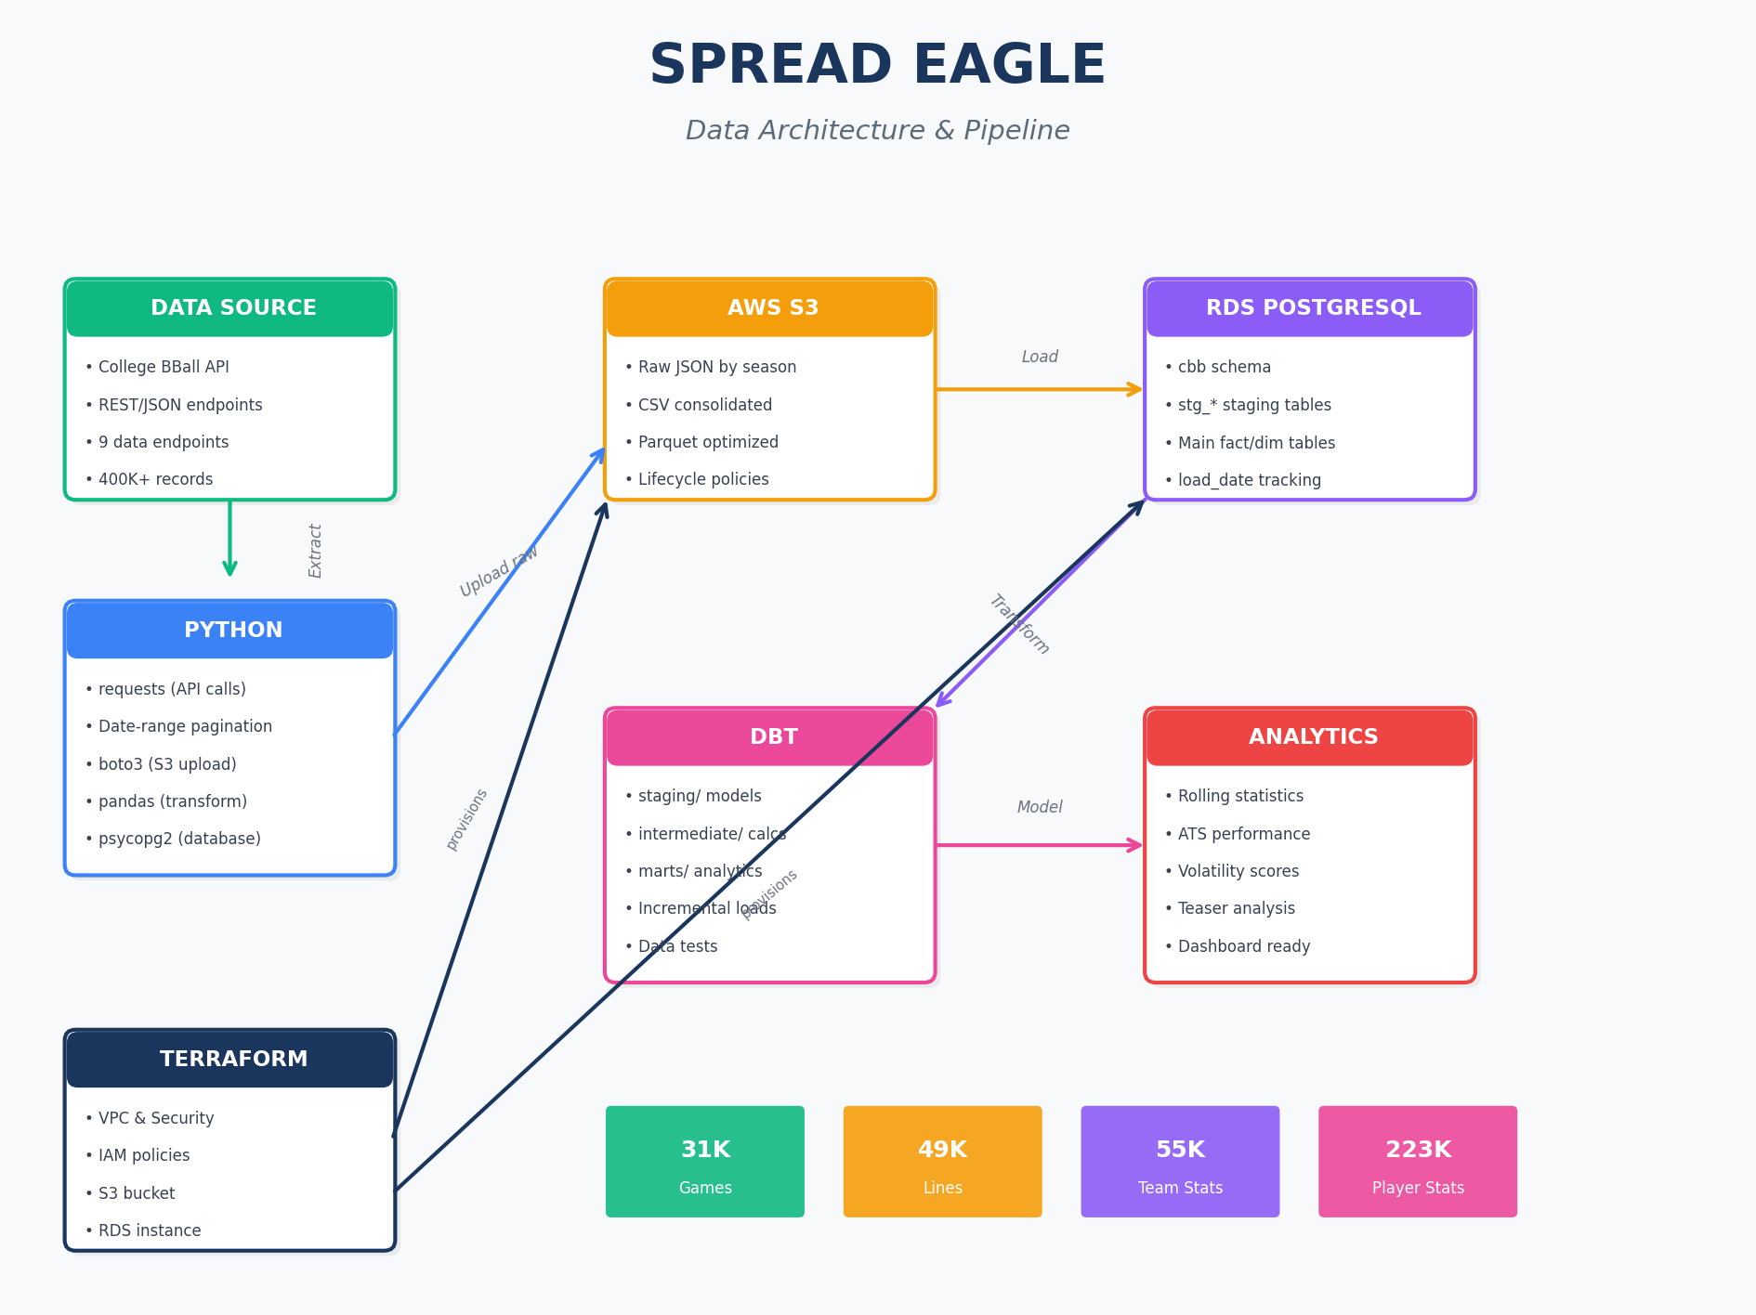

Executive Summary
Spread Eagle is a modern data analytics platform designed to identify low-volatility betting opportunities in college basketball. By analyzing historical betting lines, game statistics, and team performance metrics, the platform identifies teams that consistently play close to betting lines - creating valuable 'tail' opportunities for teaser bets.

Mission: Find teams with predictable performance against the spread, enabling data-driven betting decisions with reduced variance.

By The Numbers
31,056 | 49,153 | 55,062 | 222,594 | 5
Games | Betting Lines | Team Stats | Player Stats | Seasons

System Architecture
Spread Eagle follows a modern ELT (Extract, Load, Transform) architecture with clear separation between data ingestion, storage, and transformation layers.

Data Pipeline Flow
Data flows through six distinct stages, each optimized for its purpose:
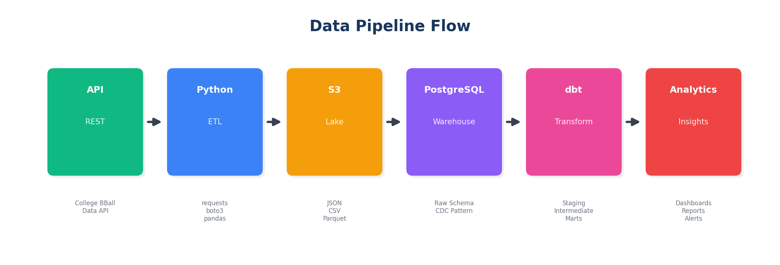

1. API EXTRACTION
College Basketball Data API provides REST endpoints with JSON responses. The API has a 3,000-record limit per request.
2. PYTHON INGESTION
Custom scripts use date-range pagination to overcome API limits. Data is fetched monthly, deduplicated, and uploaded to S3.
3. S3 DATA LAKE
Raw data stored as JSON (by season), CSV (consolidated), and Parquet (optimized). Lifecycle policies archive old data.
4. POSTGRESQL LOADING
Staging tables receive new data via COPY command. CDC pattern (INSERT ON CONFLICT) merges into main tables.
5. DBT TRANSFORMATION
SQL models calculate rolling statistics, ATS performance, volatility metrics. Incremental processing for efficiency.
6. ANALYTICS OUTPUT
Mart tables ready for dashboards, reports, and automated alerts.

Technology Stack
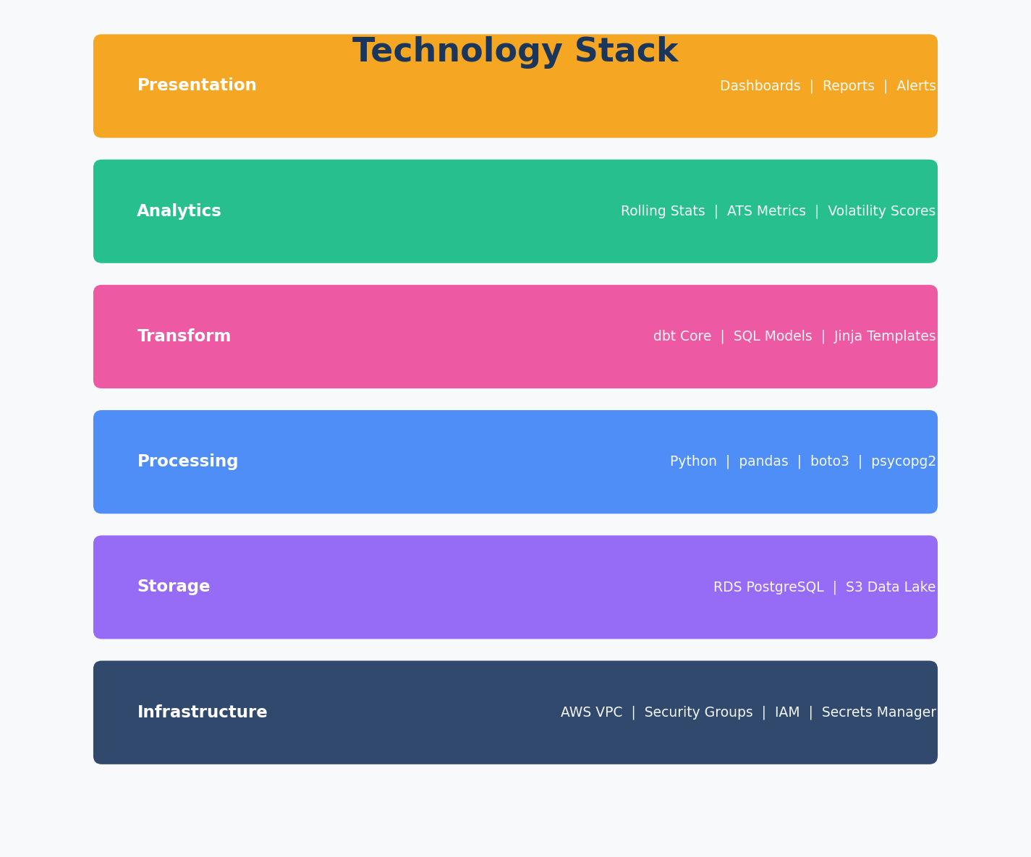

Python
Core ingestion and orchestration
- requests - API calls
- boto3 - AWS SDK
- pandas - Data manipulation
- psycopg2 - PostgreSQL driver

AWS S3
Scalable data lake storage
- JSON raw files
- CSV for analysis
- Parquet for performance
- Lifecycle policies

PostgreSQL (RDS)
Relational data warehouse
- cbb schema
- Staging tables (stg_*)
- Fact and dimension tables
- CDC with load_date tracking

dbt
Data transformation framework
- Modular SQL models
- Jinja templating
- Incremental processing
- Built-in testing

Terraform
Infrastructure as code
- VPC and networking
- RDS provisioning
- S3 bucket creation
- IAM policies

Database Schema
The database is organized into reference tables (dimensions) and transactional tables (facts):
Table | Type | Primary Key | Records
conferences | Reference | id | 34
venues | Reference | id | 979
teams | Reference | id | 1,515
games | Fact | id | 31,056
betting_lines | Fact | game_id, provider | 49,153
game_team_stats | Fact | game_id, team_id | 55,062
game_player_stats | Fact | game_id, athlete_id | 222,594
team_season_stats | Fact | team_id, season | 3,515
player_season_stats | Fact | athlete_id, team_id, season | 48,551

Analytics Features
The platform calculates key metrics for identifying betting opportunities:

Against The Spread (ATS) Analysis
actual_margin = home_score - away_score
ats_margin = actual_margin + spread
covered = (ats_margin > 0)
push = (ats_margin = 0)

Volatility Metrics
Lower volatility = more predictable performance against the spread:
ats_volatility = STDDEV(ats_margin) over last N games
consistency_score = 1 / (1 + STDDEV(ats_margin))
ou_volatility = STDDEV(total_points - over_under)

Rolling Window Features
Calculated over 3, 5, and 10 game windows:
- rolling_avg_points_scored / allowed
- rolling_avg_ats_margin
- rolling_stddev_ats_margin
- rolling_cover_rate
- rolling_avg_pace
- rolling_avg_offensive_rating / defensive_rating

Commands Reference

Full Data Load
python -m spread_eagle.ingest.cbb.run_full_load

Individual Endpoints
python -m spread_eagle.ingest.cbb.pull_conferences
python -m spread_eagle.ingest.cbb.pull_venues
python -m spread_eagle.ingest.cbb.pull_teams
python -m spread_eagle.ingest.cbb.pull_games_full
python -m spread_eagle.ingest.cbb.pull_lines_full
python -m spread_eagle.ingest.cbb.pull_team_stats_full
python -m spread_eagle.ingest.cbb.pull_game_players_full
python -m spread_eagle.ingest.cbb.pull_team_season_stats_full
python -m spread_eagle.ingest.cbb.pull_player_season_stats_full

Database Operations
# Generate DDL from CSV schemas
python -m spread_eagle.ingest.cbb.generate_ddl

# Run DDL on RDS
python -m spread_eagle.ingest.cbb.run_ddl

Infrastructure Management
cd infra/terraform/app
terraform init
terraform plan
terraform apply

# Stop RDS to save money
aws rds stop-db-instance --db-instance-identifier spread-eagle-db

# Start RDS
aws rds start-db-instance --db-instance-identifier spread-eagle-db

Roadmap

Phase 1: Foundation (Complete)
- AWS Infrastructure (Terraform)
- Data Ingestion Scripts (Python)
- S3 Data Lake
- PostgreSQL Schema (DDL)

Phase 2: Analytics (In Progress)
- dbt Staging Models
- Rolling Window Calculations
- ATS Performance Metrics
- Volatility Scoring

Phase 3: Visualization
- Dashboard (Streamlit/Dash)
- Team Comparison Tools
- Daily Line Movement Alerts

Phase 4: Expansion
- College Football (CFB)
- NFL/NBA Integration
- Live Odds API
- ML Prediction Models

