**Sukkur IBA University**

**SDS ??**

For

**Schools Hub – Bridge Between Schools and Parents**

Version1.0

Najeebullah khan, Muhammad Umair, Muhammad Daud

**Supervisor:** Dr. Muhammad Ismail

|  |  |
| --- | --- |
| *Project Code* | 20F-07 |
| *Supervisor* | Dr. Muhammad Ismail |
| *Co-Supervisor* | N/A |
| *Project Manager* | Najeebullah khan |
| *Project Team* | Najeebullah khan (023-20-0058)  Muhammad Umair (023-19-0026)  Muhammad Daud (023-20-0092) |
| *Submission Date* | 23 May 2024 |

**Supervisor Signature**

_________________

Table of Contents

1. INTRODUCTION OF DESIGN DOCUMENT: 4

1.1 Purpose: 4

1.2 Project Scope: 4

1.3 Definitions, Acronyms and Abbreviations: 5

2. DESIGN CONSIDERATION: 5

2.1 Assumptions: 6

2.2 Constraints: 6

2.2.1 Software Constraints 6

2.2.2 Hardware Constraints 7

2.2.3 Cultural Constraints 7

2.2.4 User Constraints 7

2.3. Document Convention 7

3. ARCHITECTURE OVERVIEW 7

3.1. Architecture Design Diagram 8

4. DETAILED SOFTWARE DESIGN 9

4.1. Use Case Models 9

4.2. Class Diagram 10

4.3. Sequence Diagram 12

4.4. Entity Relationship Diagram (ERD) 15

5. INTERFACE DESIGN 16

6. TEST CASES 20

# INTRODUCTION OF DESIGN DOCUMENT:

## 1.1 Purpose:

This document's purpose is to provide a high-level design framework around which to build our project which is a web platform and it will be used to revolutionize the process of selecting the desired educational institution for children by creating a comprehensive and user-friendly interface that connects schools with prospective parents.

## 1.2 Project Scope:

The project aims to develop a comprehensive web platform connecting schools with parents to simplify the school selection process. It includes school and user profiles, search and filtering capabilities, AI-based recommendations, reviews, and ratings. The project emphasizes security, scalability, and potential third-party integrations within defined boundaries, such as not endorsing specific schools and focusing on a specific geographic region initially. The project timeline will follow a phased development approach.

## 1.3 Definitions, Acronyms and Abbreviations:

NOTE: HERE WILL BE ALL DEFINITIONS, ACRONYMS AND ABBREVATIONS WHICH ARE INCLUDED IN THIS PAPER

E.g.

**SDS** – Software design specification

**SDLC** – Software design life cycle

**OS** – Operating system

# DESIGN CONSIDERATION:

* **User Experience (UX):**

The design must prioritize a user-friendly interface for parents, guardians, and schools. Intuitive navigation, clear information presentation, and responsive design are essential for a positive user experience.

* **Scalability:**

The architecture should be designed to handle potential growth in the number of schools, users, and content. Scalability measures, such as load balancing and efficient database management, should be implemented.

* **Security:**

Robust security measures are critical to protect user data and ensure platform integrity. This includes data encryption, secure user authentication, and continuous monitoring for vulnerabilities.

* **Content Moderation:**

Implement an effective content moderation system to ensure the quality and appropriateness of user-generated reviews and ratings.

* **Artificial Intelligence:**

Integration: The AI-based recommendation engine should be designed to provide personalized suggestions for schools based on user preferences and historical data.

## 2.1 Assumptions:

We have following assumptions for our system such as:

* Users will have access to a stable internet connection to use the platform effectively.
* Schools will actively create and update their profiles with accurate and up-to-date information.
* Users will provide accurate and honest reviews and ratings.
* The recommendation engine will improve over time as more data is collected and analyzed.
* Users will adhere to community guidelines and platform rules.

## 2.2 Constraints:

### 2.2.1 Software Constraints

* + - 1. The software (web application) needs to be designed using MERN with NoSQL as a database.
      2. The software will be user-friendly.
      3. The software will be interactive.
      4. The software will be deployed initially in localhost and can be shifted later on to the cloud.

### 2.2.2 Hardware Constraints

1. User should have a desktop, laptop, mobile or any other device for accessing our platform on browsers.

### 2.2.3 Cultural Constraints

1. The software product will be in the English language

### 2.2.4 User Constraints

1. All the users should be authorized

## 2.3. Document Convention

The font of the document is the Times New Roman and font size will be 12. The headings will be selected from styles i.e., Heading 1 or Heading 2. The line space is 1.5 after every heading and the text is justified.

# 3. ARCHITECTURE OVERVIEW

In our project, the architecture is every simple. It has 3 type of user which are parent/child, school, and an admin as depicted in Fig. 1. The role of parent is to find desired school for the better future of their children. Parent can use available features to filter out the desired schools that are fulfilling the needs and conditions of parents. The role of schools is to manage and update their profile up to date information. Finally, the role of admin is to manage all the school’s profile registration and also managing the end user data.

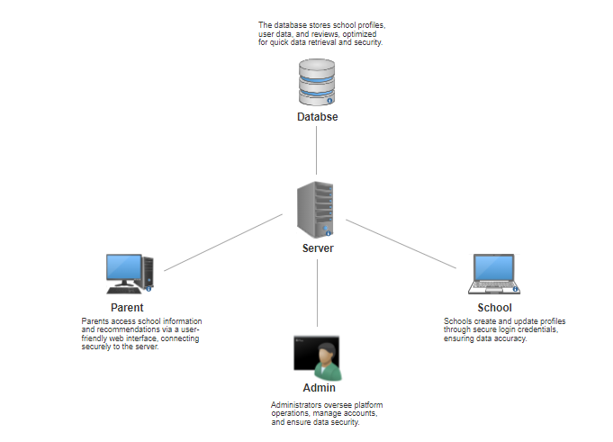

Figure 1 Architecture Overview

## 3.1. Architecture Design Diagram

The architecture design of our innovative web platform for selecting educational institutions is thoughtfully designed to deliver a robust, scalable, and user-friendly solution that bridges the gap between schools and prospective parents. This architecture (as shown in Fig. 2) encompasses a range of technologies and components to ensure the platform's efficiency, security, and seamless user experience.

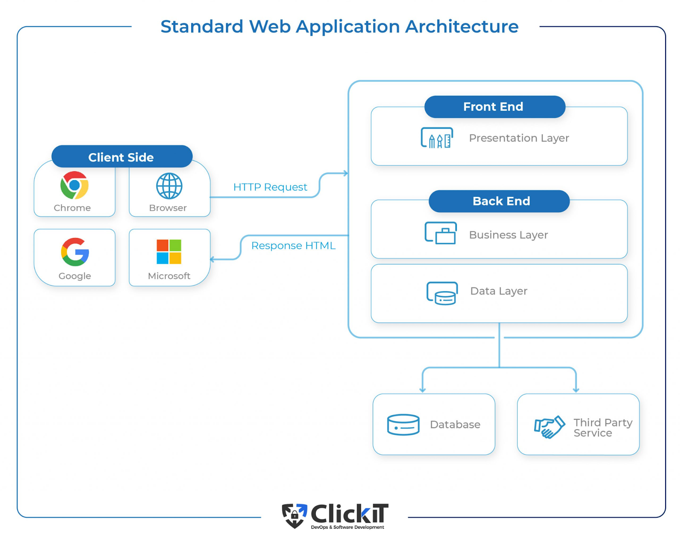

Figure 2 Web Application Architecture

# 4. DETAILED SOFTWARE DESIGN

## 4.1. Use Case Models

In our system there are three types of users, and they are parent/child, schools and admin. So, each user has different use cases, and they are shown in Fig. 3. Admin will have the main role that he will be managing every user’s account and will be able to see all information. Parents will have all access to the schools data and available features on our platform. School have access to manage and update their profiles, also can gives feedback response.

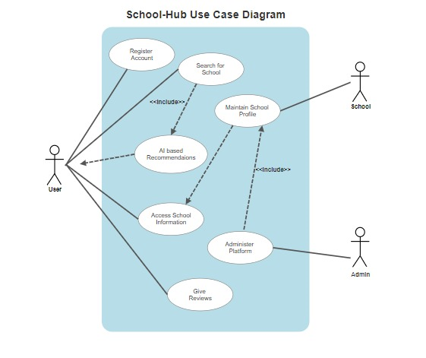

Figure 3 Use Case

## 4.2. Class Diagram

The class diagram for the educational institution selection platform illustrates the core components and relationships within the system. It primarily focuses on representing the key classes and their interactions.

This class diagram illustrates the key components of the platform, their relationships, and the central role of the User class. It serves as a foundation for the software development and helps in visualizing how data and interactions flow within the system.

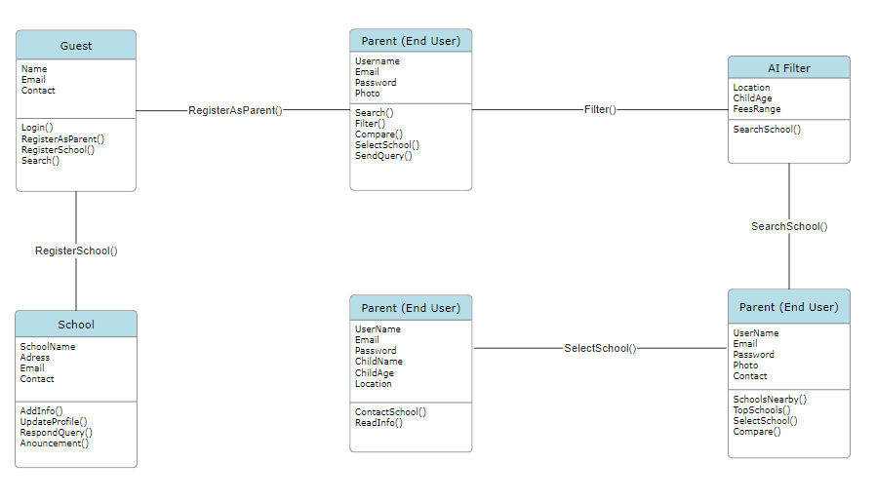Figure 4 Class Diagram

## 4.3. Sequence Diagram

Use Case Scenario: Search Desired Figure 5 Sequence Diagram of Search and Selecting School

Use Case Scenario: Login/Signup

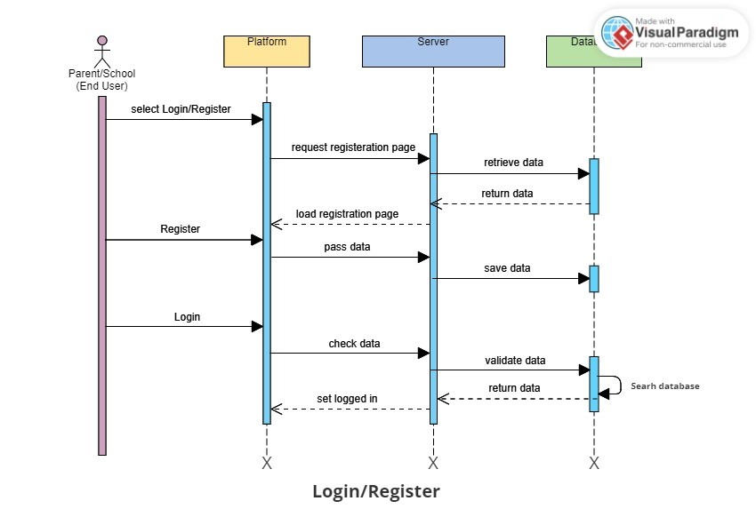

Figure 6 Sequence Diagram of Login/Register

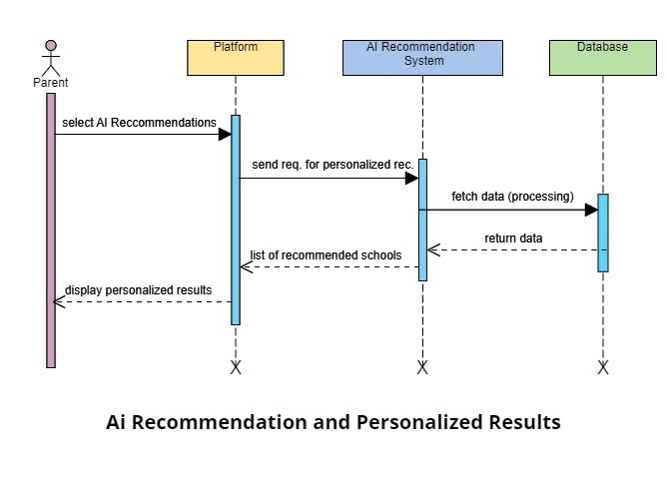Figure 7 Sequence Diagram of AI Recommendation and Personalized Results

## 4.4. Entity Relationship Diagram (ERD)

Entity-Relationship Diagram (ERD) for the School-Hub project involves identifying the entities and their attributes. Here's a simplified ERD highlighting the entities and their attributes:

* **Entities:**

**1. Parent:**

* Attributes: UserID (Primary Key), Username, Password, Email, Address.

**2. School**

* Attributes: SchoolID (Primary Key), School Name, Location, Tuition Fees.

**3. Review**

* Attributes: ReviewID (Primary Key), SchoolID (Foreign Key), UserID (Foreign Key), Comment, Date, etc.

**4. Admin**

* Attributes: AdminID (Primary Key), Username, Password, Email, etc.
* **Relationships:**
  + **User-School Interaction:** Users can select and interact with schools.

- User (1) ---< School (*)

* **User-Review Interaction**: Users can create reviews and ratings for school.

- User (1) ---< Review (1)

* **School-Review Interaction**: Schools can have multiple reviews.

- School (1) ---< Review (*)

* **School-Admin Management**: Admins manage and oversee school profiles.

- Admin (1) ---< School (*)

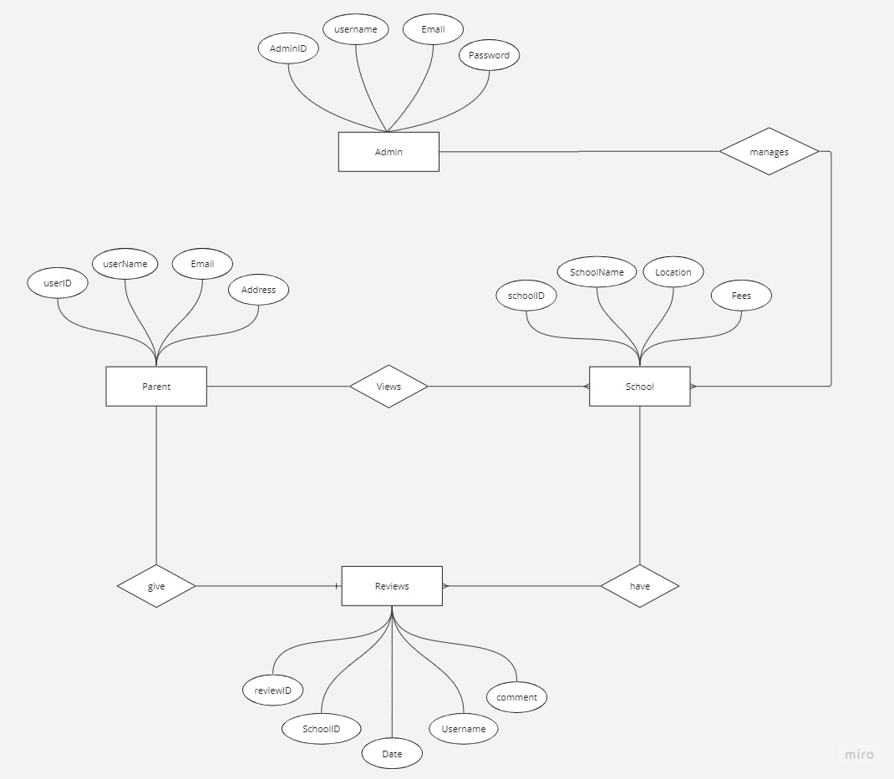

*ERD Diagram*

# 5. INTERFACE DESIGN

* **Landing page Design:**

The Landing Page is the platform's first impression, capturing the essence of its mission. It features an inviting layout with a search bar for quick access to school profiles. The design emphasizes user testimonials, etc. It provides an overview of the platform's features and benefits, encouraging users to explore further. The design is visually appealing and responsive for various devices, ensuring a strong user engagement from the outset.

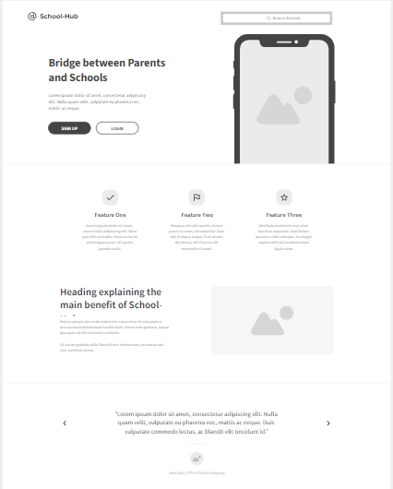

*Home Page*

* **Login/Sign up Form:**

The Login/Signup forms are the entry points for users to access the platform. The design is user-friendly, with clear fields for entering credentials or registration information. The design aims to provide a seamless and secure onboarding experience for users.

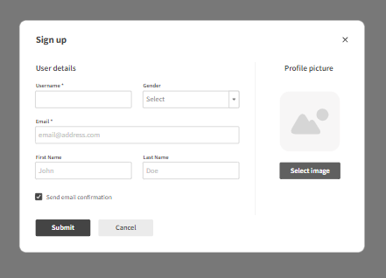

*Sign Up Page*

* **Admin’s Dashboard Design:**

The Admin Dashboard serves as the control center for system administrators. It offers a comprehensive overview of the platform's activities, user management, content moderation, and system health. The design prioritizes accessibility to system-wide data, tools for verifying and moderating school profiles, and real-time monitoring of user-generated content. It ensures that administrators can efficiently manage and maintain the platform.

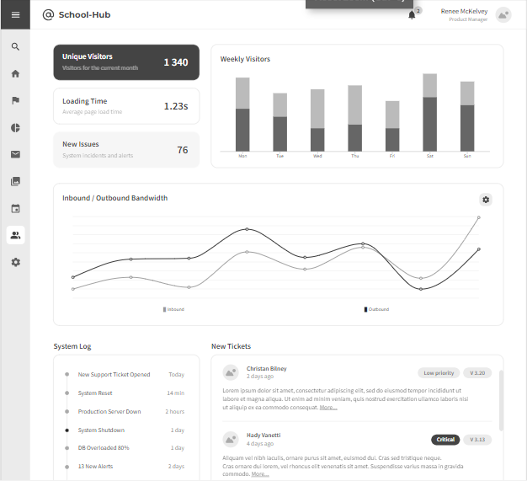

*Admin Dashboard*

* **User’s Interface Design:**

The User Dashboard is the personalized hub where parents and guardians can access their account information and manage their interactions with the platform. It provides an intuitive and organized layout for users to view school recommendations, schools near them, top rated schools, etc. The design focuses on user-centric features, making it easy for parents to find and assess schools for their children.

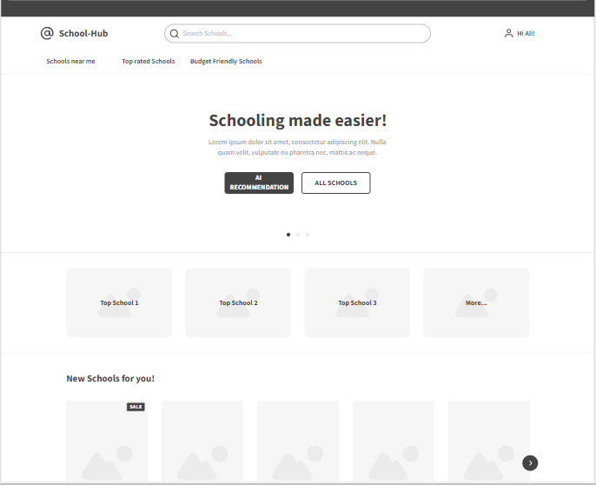

*User Interface*

# 6. TEST CASES

|  |
| --- |
| **Sign Up Test Case** |
| **Test Case ID:** T1 |
| **Module Name:** Sign Up screen |
| **Test Title:** Registering the user |
| **Description:** Test the signup page of School Hub |
| **Pre-conditions:** The user has properly filled the required fields |
|  |

|  |  |  |  |  |  |  |
| --- | --- | --- | --- | --- | --- | --- |
| **Step** | **Test Steps** | **Test Data** | **Expected Result** | **Actual Result** | **Status (Pass/Fail)** | **Notes** |
| 1 | Navigate to Signup page |  | User should be able to Signup | User is navigated to | Pass |  |
| 2 | Entered username | Username= abcd | Login Screen to be displayed | Login screen displayed  successful | Pass |  |
| 3 | Entered email | User= [example@gmail.com](mailto:example@gmail.com) |  | Signup |  |  |
| 4 | Entered password | Password: 1234 |  |  |  |  |
| 5 | Click on Signup button |  |  | Signup Successful |  |  |

**Post-conditions:**

The user’s information has successfully been added into the database and user is registered.

|  |  |
| --- | --- |
| **Log In Test Case of School Hub** | |
| **Test Case ID:** T2 | |
| **Module Name:** Login screen | |
| **Test Title:** Verify login with valid username and password | |
| **Description:** Test the login page of School-Hub |  |
| **Pre-conditions:** User has valid username and password | |

|  |  |  |  |  |  |  |
| --- | --- | --- | --- | --- | --- | --- |
| **Step** | **Test Steps** | **Test Data** | **Expected Result** | **Actual Result** | **Status (Pass/Fail)** | **Notes** |
| 1 | Navigate to login page | User= [example@gmail.com](mailto:example@gmail.com) | User should be able to login |  | Pass |  |
| 2 | Provide valid password | Password: 1234 |  |  |  |  |
| 3 |  |  |  |  |  |  |
| 4 | Click on Login button |  |  | Login Successful | Pass |  |

**Post-conditions:**

User is validated with database and successfully login to account. The account session details are logged in database.

|  |
| --- |
| **Searching for a School Test Case** |
| **Test Case ID:** T3 |
| **Module Name**: Searching School |
| **Test Title:** User Searches for a School |
| **Description:** User will Search for a School |
| **Pre-conditions:** The account session details are logged in database and main dashboard is appeared to the authentic user. |
|  |

|  |  |  |  |  |  |  |
| --- | --- | --- | --- | --- | --- | --- |
| **Step** | **Test Steps** | **Test Data** | **Expected Result** | **Actual Result** | **Status (Pass/Fail)** | **Notes** |
| 1 | Click on to the Search Bar at the top of page | keywords | User should be able to see multiple  Schools as per Search | Multiple schools appear as per Search results | Pass |  |
| 2 | User selects any available School | Selecting any  School | School info Should be displayed to the user | Detailed info page appears of selected School | Pass |  |

**Post-conditions:**

User searches for the desired School and selected one of the displayed results and the info gets displayed.