Assessment – Flow Control Lab Report
Use this template to document your work as you complete your assignment.

Your Information
Your Name: Jonathan M. Lewellen
Assignment Title: SDC260 Assessment- Flow Control
GitHub Repository:

Development Summary
Briefly describe what you completed for this assessment. Include the main files you edited and summarize how the page recommends trails based on user selections.
I linked the external JavaScript and CSS files to the main HTML document. I added three new trail objects to the array, including one featuring the student ID jonlew0997 in its name to meet the specific naming requirement. A dynamic for loop populates the HTML grid with trail cards displaying the name, difficulty, and duration of each trail. Finally, an event listener processes the form selections using conditional logic to output a specific trail recommendation into the designated aside element based on the required test parameters.

Implementation Evidence
Complete the checklist below to document the required HTML, JavaScript, and testing evidence. Add a short note when helpful.
Done | Requirement | Notes / Evidence
☐ | External stylesheet is linked correctly in the HTML file. | link rel="stylesheet" href="PA_Flow-Control_StarterFile.css">  inside <head>.
☐ | External JavaScript file is linked correctly in the HTML file. | <script src="PA_Flow-Control_StarterFile.js" defer></script> added to <head>.
☐ | Trail recommendation form includes pet radio buttons, hiking experience dropdown, and submit button. | Added <form> with <input type="radio">, <select>, and <button>.
☐ | Results area is included in an aside or other clearly identified section. | <aside id="result"> is populated by the script.
☐ | Trail array includes three additional trail objects. | Added jonlew0997 Explorer, Pine Meadow, and Canyon Pass.
☐ | One trail card includes the student ID in the trail name. | Included jonlew0997 in the 6th array object.
☐ | A loop dynamically displays all trail cards on the page. | for loop appends .card elements to #trailContainer.
☐ | Conditional logic recommends the correct trail based on pet and experience selections. | Nested if/else statements handle the 6 possible combinations.
☐ | Page layout remains clear and responsive when the browser window is resized. | The .grid and @media queries in the CSS handle responsiveness.

Trail Recommendation Testing
Test each condition and record the result that appeared in the Results area. Mark Pass only after the expected trail appears.
Test Case | Expected Recommendation | Actual Result | Pass
Pets: Yes; Experience: Low | River Walk | River Walk | ☐
Pets: Yes; Experience: Medium | Forest Loop | Forest Loop | ☐
Pets: Yes; Experience: High | Forest Loop | Forest Loop | ☐
Pets: No; Experience: Low | Lake Side Path | Lake Side Path | ☐
Pets: No; Experience: Medium | Forest Loop | Forest Loop | ☐
Pets: No; Experience: High | Rock Ridge Trail | Rock Ridge Trail | ☐

Code Reflection
- How did your loop display the trail cards on the page?

It used a for loop to go through the array, created a new div for each trail, and appended it directly to the #trailContainer.

- Which conditional statement was the most important for the trail recommendation tool, and why?
The outer if/else statement for the pets option was most important. It acted as the main filter, making it easier to check the experience level inside it without repeating code.

- How did you test that the form responded correctly to different visitor selections?
I manually tested every combination of pet and experience options in the form to make sure the correct trail appeared in the results area.
- Describe one issue you encountered or one part of the code you checked carefully.
I made sure to include e.preventDefault() on the form submission so the page wouldn't refresh and hide the recommendation.

Screenshot 1: HTML Code
Insert a screenshot showing the linked stylesheet, linked script file, form controls, and results area. The screenshot should include your computer system date and time.
Linked style & script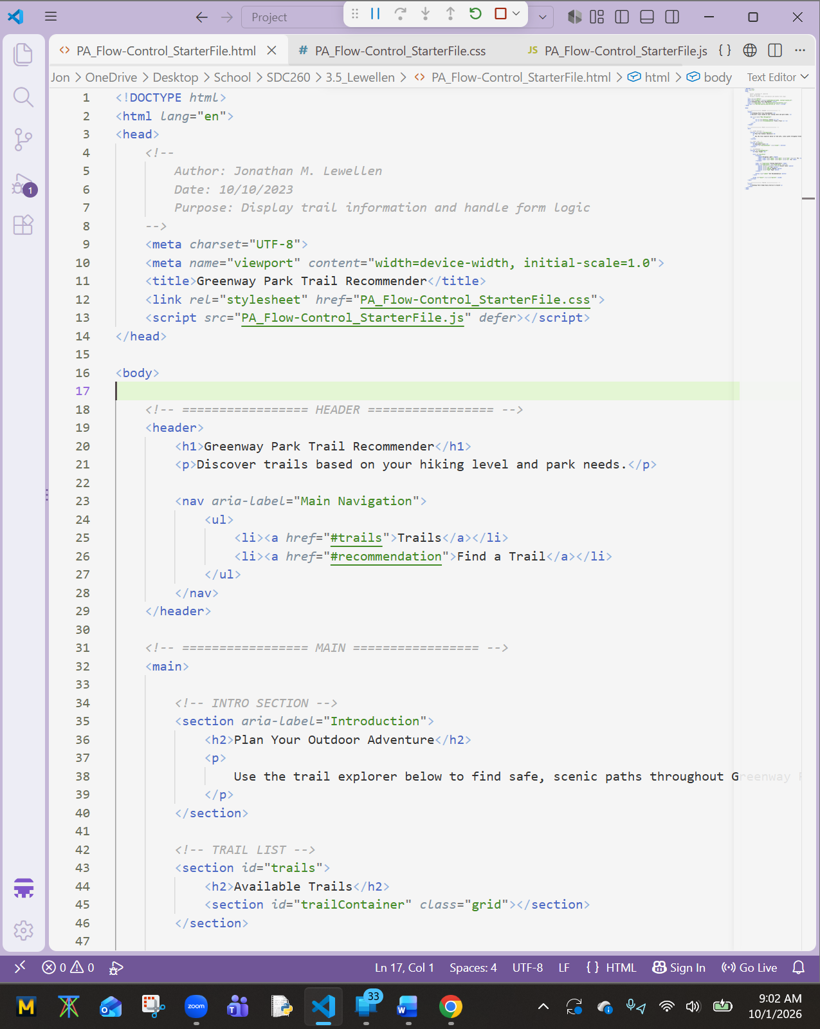form controls & results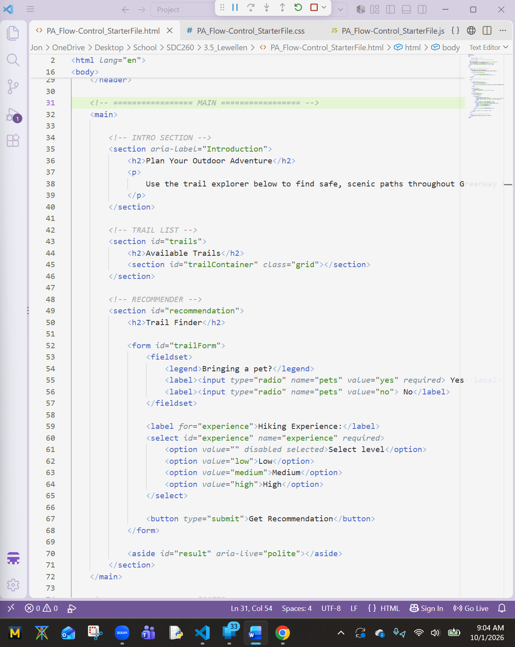

Screenshot 2 – JavaScript Code
Insert a screenshot showing the trail array, loop, conditional recommendation logic, and form interaction code. The screenshot should include your computer system date and time.
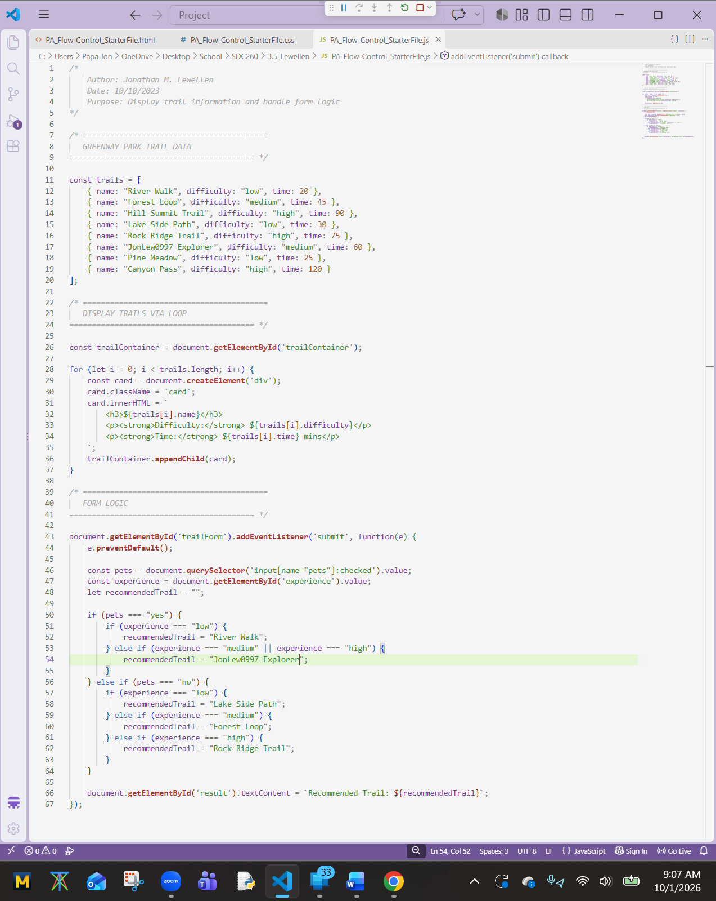

Screenshot 3 – Rendered Webpage
Insert a screenshot showing the completed webpage with trail cards and a tested recommendation result. The screenshot should include your computer system date and time.
