* Office:
  + How to organize simple account statements?
    - Use ReadTIFFs_DPI600.py
    - Step by Step
      * 1) Identify where the documents are to be saved

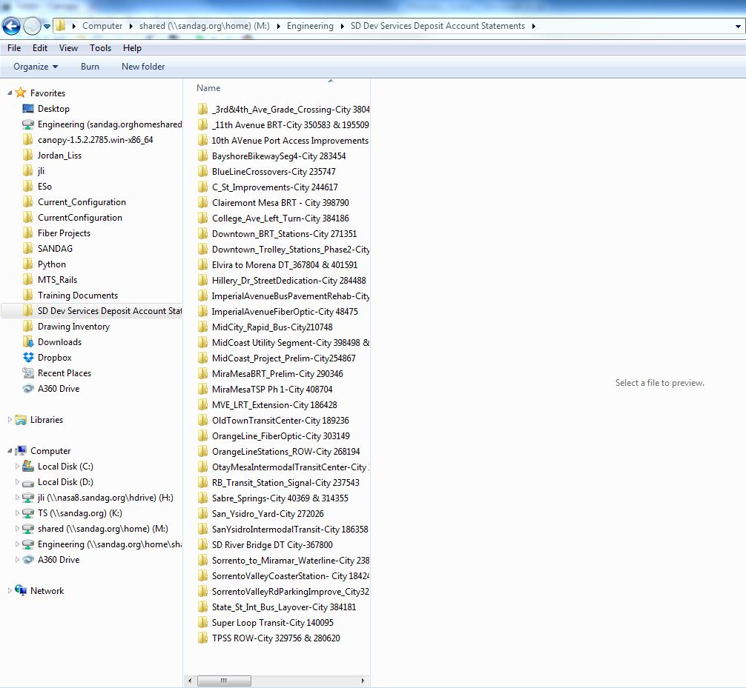

* + - * 2) Scan all the New Account Statements into a large PDF. Convert the PDf into individual TIFF files and save in a separate folder (Remember this directory). Look at line 21 in ReadTIFFs_DPI600.py for why.

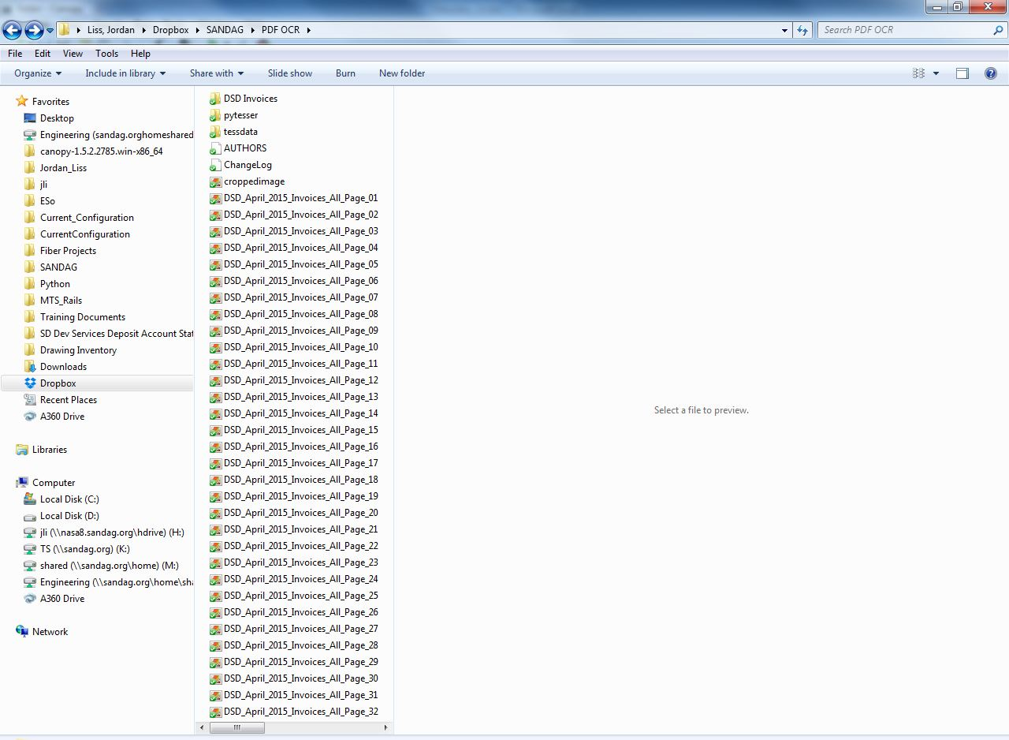

Pytesser, Tessdata and additional scripts into same folder as tiffs. Look at OCR Libraries P:\~ \Python\OCR Libraries. Place everything from this folder into the same folder as tiffs.

* + - * 3) Run ReadTIFFs_DPI600.py.
        + If the program stops before reading every tiff file. Look at the python workspace to see why. If the OCR could not read the project number correctly on the document. Look to lines 45-55 to make adjustments
        + Dates are usually the same for all the documents, so type that in manually at line 89.
      * 4) Double check where the statements were saved according to the Report.txt

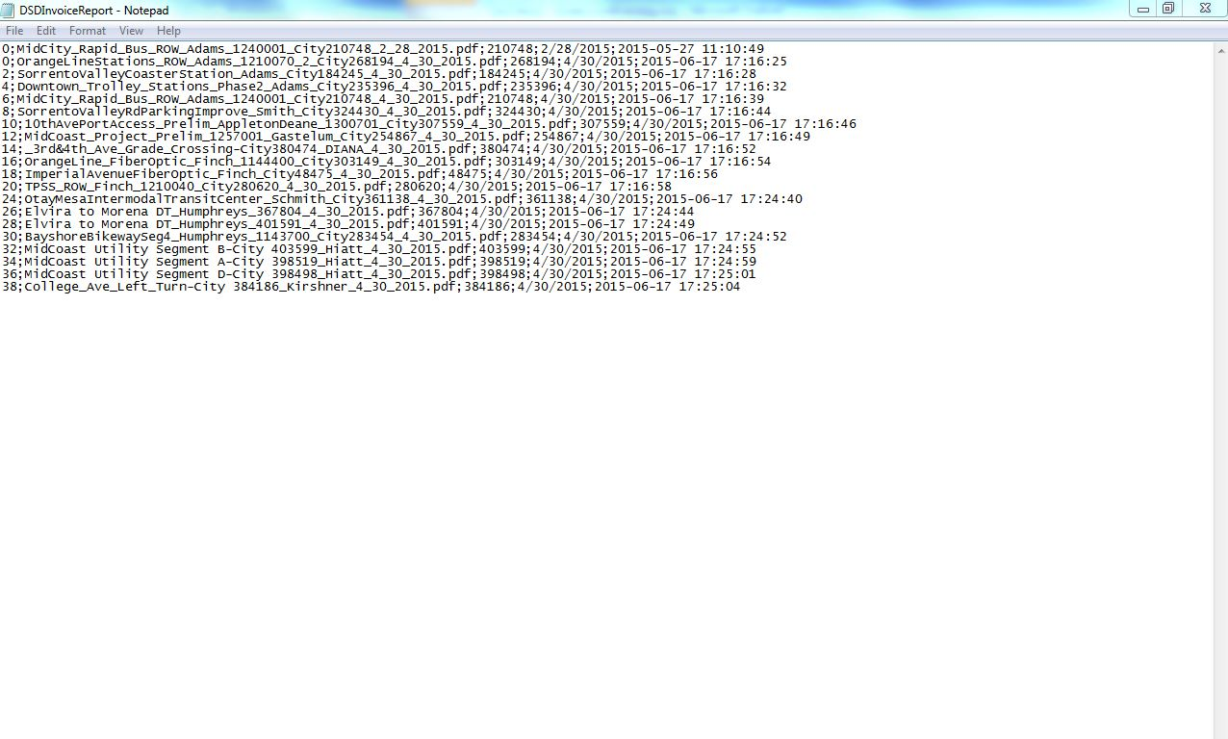

There should be a set of documents every 2 pages. Pages 23&24 were not filed (Python starts it number system from 0, thus 21 &22 were filed and so was 25&26)

* + - * 5) Double check each folder(In SD Dev Services Deposit Account Statements) to make sure the PMs handwritten on the PDFs are represented in the file name.
  + Great online resources
    - Look to Python Online resources in CurCon section.