https://www.pagosvirtualesavvillas.com.co/personal/pagos/1495
Nro: 8281
Pago
409.900

49.900

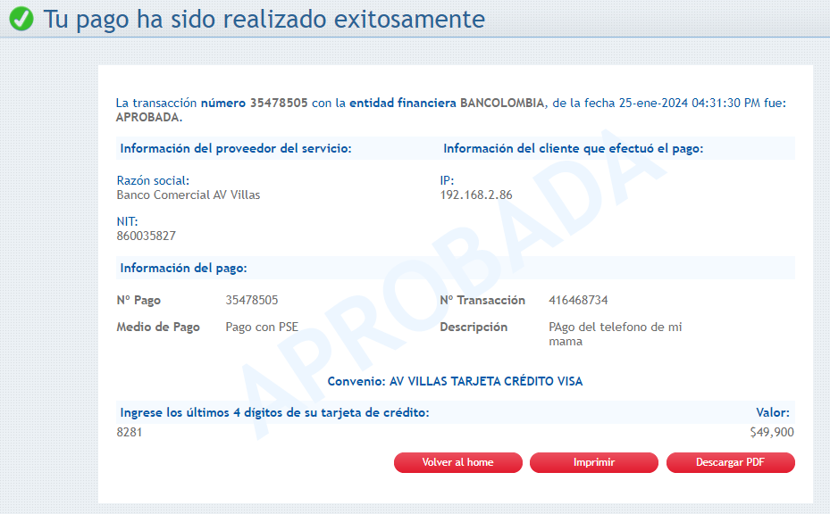

https://www.pagosvirtualesavvillas.com.co/personal/pagos/1495
falto: 360.000

