**HYDROBLEND: AN AUTOMATED NUTRIENT SOLUTION FORMULATOR FOR HYDROPONIC LETTUCE FARMING**

A Capstone Project

Presented to the Faculty of the

**COLLEGE OF INFORMATION TECHNOLOGY**

**CENTRAL BICOL STATE UNIVERSITY OF AGRICULTURE - SIPOCOT**

**Sipocot, Camarines Sur**

In Partial Fulfilment of the Requirements

For the Degree of

**BACHELOR OF SCIENCE IN INFORMATION TECHNOLOGY**

**JOHN LLOYD C. MILANAY**

**JAIRUS P. OCMER**

**May 2024**

**CHAPTER I**

**THE PROJECT AND ITS BACKGROUND**

**Introduction**

The significant growth of the human population certainly puts a greater deal of pressure on food security. Natural minerals, high-quality soil, and a longer production cycle are all necessary for traditional farming. Innovations in technology have led to the adoption of hydroponic farming techniques. Plants grown hydroponically grow faster and produce more without the need for soil. Mamata and Kavitha (2023). The agricultural industry is now using more advanced technologies than before. They use a variety of information and communication technologies, including the Internet of Things (IoT). The rapid adoption of modern technologies has impacted agriculture and other industries. Khan et. al (2021).

Hydroponic agriculture requires serious planning, preparation, and maintenance to produce crops; it goes beyond submerging plants in water and watching them grow. Careful consideration of several factors, including nutrient balance, water circulation, and environmental conditions is required when using this method. Hydroponic farmers may improve plant growth and ideal crop yields without depending on the traditional soil-based farming method by utilizing advanced technologies and monitoring systems.

Lettuce cultivation is a crucial component of modern agriculture, as it is widely used in salads and other culinary uses. Successful lettuce cultivation requires a thorough understanding of the plant's growth needs. This includes selecting appropriate lettuce varieties, improving soil conditions, and deploying effective watering systems.

However, hydroponics is becoming a more common and innovative method of lettuce farming, replacing traditional soil with nutrient-rich water solutions. Hydroponic systems provide precise control over nutrient levels, pH balance, and water distribution, leading to faster growth rates as well as larger yields. This strategy conserves water while also eliminating soil-borne illnesses, resulting in a cleaner and more controlled environment for lettuce plants. As we explore controlled environment agriculture, it appears as a promising option, enabling year-round output, protection from bad weather conditions, and resource efficiency.

The technological advancements have greatly benefited hydroponic farmers by providing them with access to remotely create nutrient solutions, and monitor status, such as the water level, pH status, and nutrient status inside the reservoir. Moreover, it also automates actions when the environmental conditions change, for instance, low/high temperature, low water level, etc. This has made farming more efficient and productive. Tagle et. al (2018).

Mr. Gerand and Mrs. Ann Peredo the owner of HydroGreens Libmanan located at Brgy. Puro-Batia, Libmanan, Camarines Sur. has been operational for 2 years. Their services extend across Libmanan, Naga, and Sipocot municipalities. They have served various establishments in the area, including Black Pepper Libmanan, Preciosa Insilada, Foodies Point, 8tea Trip Cafe, Espresso Libmanan, F&L Foods, Mang Dennis, Inkprinta Cafe, Mr. Wings Sipocot, Cbros, and Kap Onie Samgyup. Additionally, they cater to approximately 15 regular customers. HydroGreens specializes in hydroponic farming, employing both the Kratky method and the Nutrient Film Technique (NFT) method. Initially adopting the Kratky method, which requires no water pumps and sustains stagnant water for up to 2 days, they recently upgraded to the NFT System, utilizing pumps to circulate the nutrient solution through shallow channels, thereby enhancing their farming capabilities.

The formulation of the nutrient solution has three phases: first, dissolving the water-soluble nutrients (Epsom Salt, Nutrient Hydro-NPK, Calcium Nitrate, and Iron) in water; second, combining the dissolved Epsom Salt and Nutrient Hydro (NPK) to create Nutrient A; and lastly, adding the formulations of nutrient solutions A, B (Calcium Nitrate), and Iron to the water, resulting in the final product of the nutrient solution to be supplied to hydroponic crops.

After the formulation process, the solution's components, namely the pH level and the nutrient level or PPM, will be measured. If the PPM level recorded on the TDS Meter is low, one should add a nutrient solution. Conversely, if the PPM is high, water should be added to regulate and meet the standard PPM level of 880-1000 PPM. To assess acidity, the standard pH level should fall within the range of 5.5-6.0 pH. If the pH level is high, one should add a pH-down solution. Conversely, if the pH level is low, a pH-Up solution needs to be added to adjust to the standard acidity of the solution.

The following are the main problems of the HydroGreens Libmanan: first, to create an accurate water-nutrient solution, Hydroponic systems rely on a precise balance of water and nutrient solutions to ensure optimal plant growth. Inaccuracies in the formulation of these solutions can lead to nutrient deficiencies or excesses, affecting the health and yield of hydroponic crops. Second, time conflict for monitoring crops and water levels, efficient hydroponic farming requires continuous monitoring of crop health and water levels. However, the time-consuming nature of these tasks can lead to conflicts, potentially resulting in delayed responses to issues. Third, environmental conditions, Hydroponic systems are sensitive to environmental conditions, and variations can impact crop growth. Factors such as temperature and humidity must be carefully managed to maintain an optimal growing environment. and lastly the fluctuation of water solution content for hydroponic crops. Hydroponic crops rely on a stable and consistent nutrient solution. Fluctuations in solution content can lead to nutrient imbalances, affecting plant health and overall productivity.

To address several challenges faced by the client, the researchers have proposed a system that HydroGreens Libmanan can utilize to effectively resolve various issues, with particular emphasis on creating water solutions for lettuce growth. This system offers an automated solution that formulates nutrients for lettuce farming. HydroBlend comes out for its use of Internet of Things (IoT) technologies and web applications to monitor and automate nutrient management procedures. HydroBlend's advanced technologies ensure a precise and efficient supply of nutrients required for maximum lettuce growth in hydroponic systems. This not only improves the quality of lettuce produced but also simplifies the entire cultivation process for HydroGreens Libmanan, making it easier to maintain and manage.

**Objectives**

The objective is to develop a device to Automate Nutrient Solution Formulator for Hydroponic Lettuce Farming, Specifically, it aims to:

* 1. To design and develop an IoT-Based automated formulation of nutrient solution for lettuce.
  2. To measure and monitor the formulated solution content using sensors using a web application.
  3. Remotely access the temperature control such as lamps and fans.
  4. 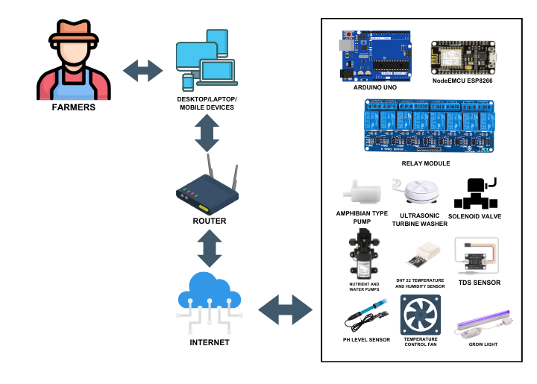Monitor hydroponic farm status such as tank level, temperature, and humidity.

Figure 1.0

**Architectural Diagram of HydroBlend: Nutrient Solution Formulator for Hydroponic Lettuce Farming**

Figure 1.0 shows the architectural diagram of HydroBlend: Automated Nutrient Solution Formulator for Hydroponic Lettuce Farming. This diagram illustrates how a user's hardware device connects to the system. A farmer can use devices such as a mobile phone, desktop computer, laptop, or tablet to access the system. In order to have access to the system. To log in, the user's device must be connected to the internet, and they must provide their authentication credentials. Using the router for internet connection, allows farmers to remotely access the system through a web browser application. Enables them to monitor real-time data and receive alerts or notifications from any location with internet access. The Arduino acts as a microprocessor, controlling the sensors, pumps, fans, and lights. To facilitate remote access via a web application, the NodeMCU connects the Arduino Uno to the router. Pumps are deployed to dispense the necessary liquids for creating the nutrient mixture. A relay module is used to connect these pumps for precise liquid dispensing and serves as a switch for temperature control. The DHT22 Sensor monitors the hydroponic farm's temperature and humidity, activating the fan or grow light when temperature changes are detected. The pH sensor measures the solution's acidity, and the Total Dissolved Solids (TDS) sensor measures the nutrient level of the solution.

**Scope and Delimitation**

The study covers the development of the automated system for HydroGreens Libmanan. This study aims to determine the effectiveness of IoT in the automation of formulating nutrient solutions for hydroponic lettuce with the integration of web applications for monitoring and remote access that ensure a precise and efficient supply for maximum growth in hydroponic systems.

The cover of this study is to automatically create actions when the sensors detect changes in the default setting of water tank level, temperature, and humidity. Additionally, it can monitor the sensor’s data in real-time and control remotely using the web application.

This system exclusively focuses on hydroponic farming, specifically the Nutrient Film Technique (NFT) method, due to its utilization of a single water tank that can be monitored using sensors. In contrast, the Kratky method requires an individual water container per set. This study does not cover other agricultural practices. The initial phase of formulating the nutrient solution involves a manual process due to the use of powder-based nutrients. During this step, the powder is carefully mixed with water to ensure thorough dissolution of the nutrients before filling into the developed device container for formulation. Lastly, exclusively HydroGreens Libmanan farmers can utilize this system because the web application is designed specifically for controlling and monitoring the IoT devices within the hydroponic farm.

**Significance of the Study**

The result of this study is expected to give great benefit to the following entities:

**Research Community.**  Can be benefit from the study by gaining insights into the automated nutrient formulation system in achieving sustainable agriculture practices.

**Agri-entrepreneur.** The developed device may be beneficial to Agri-entrepreneurs. The development of the device may help to produce crops smoothly and maximize the crop yield.

**Farm Owners.**  The use of the system will ensure that the farm will gain profit and will attain sustainability. It helps them to engage in strategic, tactical, and operational planning.

**Consumers.** The developed device may be beneficial to customers engaged in hydroponic lettuce farming. By automating this process, consumers experience consistent and reliable fresh products because hydroponic farms can operate efficiently and produce goods to meet consumers' demands, resulting in affordable prices and offering hydroponically cultivated goods to a wide range of consumers.

**Future Researchers.** This study will serve as a valuable material for student researchers for their ongoing research and as a reference for other studies.

# Definition of Terms

Important terms used in this study were defined conceptually and operationally to provide a common framework of understanding for both researchers and readers.

**Arduino:** Open-source electronics platform based on easy-to-use hardware and software. It consists of a microcontroller board that can be programmed to receive input from sensors, process data, and control various devices such as lights, motors, and other actuators. (Ismailov et al. 2022). In this study, Arduino acts as a microprocessor to send commands to sensors to gather and process data. It enables automated actions to maintain and enhance the system's efficiency and effectiveness.

**Breadboard:** A breadboard (sometimes called a plug block) is used for building temporary circuits. It is useful to designers because it allows components to be removed and replaced easily. It is useful to the person who wants to build a circuit to demonstrate its action, then to reuse the components in another circuit. Bishop.(2001).In this study the breadboard helps by letting researchers easily connect and test different electronic components, like sensors and controllers, for the hydroponic system. It's like a testing ground where they can try out different setups before finalizing the design So, basically, the breadboard is like a handy tool that helps make sure all the electronic components in the developed device work properly.

**Calcium Nitrate:** Calcium nitrate appears as white to light gray granular solid. May be either the anhydrous compound or the tetrahydrate. Used in fertilizers, explosives and pyrotechnics. National Center for Biotechnology Information (2024). In this study, It is a water-soluble nutrient used in hydroponic farming to provide essential calcium to plants, aiding in their growth and development.

**DHT22 Sensor Module:** low-cost digital temperature and humidity sensor. It uses a capacitive humidity sensor and a thermistor to measure the surrounding air, and outputs a digital signal on the data pin. DHT22 Temperature and Humidity Sensor Module, (n.d) In this study, uses DHT22 sensors with Arduino to keep track of temperature and humidity in the hydroponic setup. This helps maintain the right conditions for plants to grow well by adjusting factors like temperature and humidity as needed.

**Epsom Salt Solution:** Also known as Magnesium Sulfate is completely water soluble and specifically good for adding magnesium (10% Mg) and Sulfur (13% S) for plants. Magnesium Sulfate, Epsom Salt gives the plants a dark green color and is a great supplement for fruit plants. Epsom Salt – Philippines Aqua-Hydroponic Prime Ventures Corporation, (n.d.). In this study, it is a dissolved Epsom salt, used in hydroponic farming to provide magnesium sulfate to plants for optimal growth.

**ESP8266 NodeMCU**: The NodeMCU (Node Microcontroller Unit) is an open-source software and hardware development environment built around an inexpensive System-on-a-Chip (SoC) called the ESP8266. The ESP8266, designed and manufactured by Espressif Systems, contains the crucial elements of a computer: CPU, RAM, networking (Wi-Fi), and even a modern operating system and SDK. That makes it an excellent choice for Internet of Things (IoT) projects of all kinds. John (2022). In this study the Wi-Fi module allows remote monitoring and control of the hydroponic system, making it easier for operators to check data and adjust settings from afar. **Exhaust Fan:** It works by sucking hot or humid air out of a small, localized area, allowing fresh air to enter from elsewhere (perhaps a doorway or vent) in order to replace it. The warm air that's drawn out using an exhaust fan is then pulled through a ducting system and expelled outside. (Exhaust Fans, n.d.). In this study, it is a hardware component used to regulate temperature in hydroponic farming by activating when temperature changes are detected.

**Grow Light**: are a specialized lighting fixture designed to deliver the correct color or spectrum of light and the optimum light intensity for healthy and vigorous growth. **(**Torpey, 2024). In this study it serves as a supplement to natural light and ensures consistent and optimal lighting conditions for plant growth in the hydroponic system. This helps to promote photosynthesis, which is essential for healthy plant development, resulting in improved growth rates and higher yields of lettuce.

**IoT (Internet of Things):** This is a network of physical devices. These devices can transfer data to one another without human intervention. (Schulze 2024). In this study the sensors constantly check conditions like temperature and nutrient levels, helping create the perfect environment for lettuce growth in hydroponic systems. These sensors also trigger automatic adjustments when needed. With mobile access, users can easily monitor and manage the system over the Internet.

**Iron:** Is an essential micronutrient for almost all living organisms because of it plays critical role in metabolic processes such as DNA synthesis, respiration, and photosynthesis. (Rout & Sahoo, 2015**)**. In this study, iron (Fe) is a metallic element with the atomic number 26 and the chemical symbol Fe. It is essential for plant growth and development, playing a vital role in processes such as photosynthesis, energy transfer, and enzyme activation. In crops like lettuce, iron aids in the synthesis of chlorophyll, which is necessary for photosynthesis and overall plant vigor. Iron deficiency can result in leaf yellowing and stunted growth in lettuce plants.

**Jumper Wires:** Jumper wires are wires with a connector at both ends and are suitable for interconnecting components in a breadboard, prototype, or test circuit. They connect components without soldering. Jumper Wires – an Introduction, Applications, and Working Principles., (2022). In this study, It connects sensors to the control unit, sensors, and electronic components enabling real-time monitoring and adjustment of environmental conditions in the hydroponic system.

**LCD:** The liquid crystal display uses the property of light monitoring of liquid crystal and they do not emit the light directly. it is a flat panel display or the electronic visual display. (LCD (Liquid Crystal Display) Introduction - Example Project, 2023). In this study, It is a screen technology used in devices like phones and TVs. LCD screens can show real-time data from sensors, helping farmers monitor things like nutrient levels and temperature for better crop care.

**Nutrient Solution**: The nutrient solution acts as fertilizer, providing plants with essential nitrogen (N), phosphorus (P), and potassium (K). These elements, represented by their symbols on the periodic table, make up the main components of the solution, known as NPK. Plants have varying nutrient needs at different stages of growth, so these elements are mixed in different proportions accordingly. (NPK And Hydroponic Nutrient Solution - AGrowTronics - IIoT for Growing, 2021). In this study it is essential for lettuce crop cultivation, providing necessary nutrients for optimal plant growth in hydroponic systems.

**Nutrient Film Technique (NFT) Method:** The method by which water flow is circulated through growth tanks containing the roots of the plants. The plants absorb the nutrients through the roots, and because the stream is shallow and the roots are also suspended in the air, the roots can also absorb oxygen. (Adelmann 2023). In this study, it delivers nutrients precisely to plant roots in hydroponic systems. this ensures plants get the right amount of nutrients they need for healthy growth.

**Parts Per Million (PPM):** PPM means Parts Per Million, and it’s a unit of measurement that’s used to indicate the concentration of particles in a solution. In hydroponics, PPM measures the concentration of dissolved nutrients in the water. The correct level is crucial for proper growth and yield (Livermore, 2022). In this study, it helps by measuring the amount of nutrients in the water used for growing plants. This measurement ensures that the plants get the right balance of nutrients they need to grow well.

**PH:** Quantitative measure of the acidity or basicity of aqueous or other liquid solutions. (Britannica 2024). In this study, it is done by making sure the nutrient solution has the right acidity level for the plants to absorb nutrients properly.

**PH Sensor:** It is a scientific device that accurately measures acidity and alkalinity in water and other liquid substances. (Wang, 2023). In this study, it is a device that measures the acidity of a solution, particularly in hydroponic farming, to ensure it falls within the optimal range of 5.5-6.0 pH for plant growth.

**PH Up Solution:** pH up solutions has strong bases that raise the pH level when added. Agrotonomy and Agrotonomy (2024). In this study, it is a substance used to adjust the acidity of a nutrient solution in hydroponic farming when the pH level is below the standard range of 5.5-6.0.

**PH Down Solution:** pH down solutions has powerful acids that decrease the pH level when added. Agrotonomy and Agrotonomy (2024). In this study, it is a substance added to decrease the acidity of a hydroponic nutrient solution when the pH level is higher than the standard range of 5.5-6.0 pH.

**Pump:** It is used to transport water from one location to another. To suck water in so that it can be expelled, a pump must be able to rapidly alter pressure within a system. What Is a Water Pump and How Is It Used? (n.d.). In this study, it iis a device used to circulate the nutrient solution through channels or containers, enhancing plant growth and maximizing yields.

**Relay:** A Relay is a simple electromechanical switch. While we use normal switches to close or open a circuit manually, a Relay is also a switch that connects or disconnects two circuits. But instead of a manual operation, a relay uses an electrical signal to control an electromagnet, which in turn connects or disconnects another circuit. (Prasad, 2022). In this study, it helps by facilitating automated actions based on environmental data collected by sensors.

**Solenoid Valve:** A solenoid valve is an electromechanical device that controls the flow of a liquid or gas through a pipe or tubing system. It consists of a coil of wire, called a solenoid, which when energized creates a magnetic field that opens or closes a valve mechanism, allowing or stopping the flow of fluid. What Is a Solenoid Valve: Your Comprehensive Guide, (n.d.). In this study, the 12V solenoid valve acts as a gatekeeper for the nutrient solution in the study. It controls the flow of nutrients to the plants based on the information collected by sensors.

**NOTES**

Mamatha, V., & Kavitha, J. C. (2023, April). Remotely monitored web based smart hydroponics system for crop yield prediction using IoT. In 2023 IEEE 8th International Conference for Convergence in Technology (I2CT) (pp. 1-6). IEEE. DOI: 10.1109/I2CT57861.2023.10126337

Khan, N., Ray, R. L., Sargani, G. R., Ihtisham, M., Khayyam, M., & Ismail, S. (2021). Current progress and future prospects of agriculture technology: Gateway to sustainable agriculture. Sustainability, 13(9), 4883.

Tagle, S., Pena, R., Oblea, F., Benoza, H., Ledesma, N., Gonzaga, J., & Lim, L. A. G. (2018, November). Development of an automated data acquisition system for hydroponic farming. In 2018 IEEE 10th International Conference on Humanoid, Nanotechnology, Information Technology, Communication and Control, Environment and Management (HNICEM) (pp. 1-5). IEEE.

Ismailov, A. S., & Jo‘Rayev, Z. B. (2022). Study of arduino microcontroller board. Science and Education, 3(3), 172-179.

Bishop, O. (2001, January 1). From components to circuits. Elsevier eBooks. <https://doi.org/10.1016/b978-075065319-0/50016-1>

National Center for Biotechnology Information (2024). PubChem Compound Summary for CID 24963, Calcium nitrate. Retrieved April 5, 2024 from <https://pubchem.ncbi.nlm.nih.gov/compound/Calcium-nitrate>.

DHT22 Temperature and Humidity Sensor Module. (n.d.). Makerlab Electronics. <https://www.makerlab-electronics.com/products/dht22-temperature-humidity-sensor-module>

Epsom Salt – Philippines Aqua-Hydroponic Prime Ventures Corporation. (n.d.). <https://philprimeventures.com/product/epsom-salt-masterblend/?fbclid=IwAR0Sx_4gyQ_Iw4SOKFY0U5UnvZ1t3dYZo03CFFCIYbqHC6h596Ms_h0-iIc_aem_AV5XRNrGBm6VWSlt0Xy_lgSwV8Az6RvN_cGuo-s9i6MEV67AodMMigYhbJLvOD4NcwUlNNnOoGOAwj2o5rfp5Jyz#:~:text=Magnesium%20Sulfate%20is%20completely%20water,larger%20and%20taste%20better%2C%20sweeter>

John. (2022, March 25). NodeMCU ESP8266 Specifications, Overview and setting up. Make-It.ca. <https://www.make-it.ca/nodemcu-details-specifications/>

Exhaust fans. (n.d.). BUILD. <https://build.com.au/exhaust-fans>

Torpey, S. (2024, January 9). Grow Lighting Basics. MIGROLIGHT. <https://migrolight.com/blogs/grow-light-news/learn-grow-lighting-basics>

Schulze, J. (2024, March 29). What Is the Internet of Things (IoT)? With Examples. Coursera. <https://www.coursera.org/articles/internet-of-things>

Rout, G. R., & Sahoo, S. (2015, January 1). ROLE OF IRON IN PLANT GROWTH AND METABOLISM. Reviews in Agricultural Science. <https://doi.org/10.7831/ras.3.1>

Jumper Wires – An Introduction, Applications, and Working Principles. (2022, July 14). 3 Phase Inverter Motor Control. <https://electronicssecret.wordpress.com/2022/07/14/jumper-wires-an-introduction-applications-and-working-principles/>

LCD (Liquid Crystal Display) Introduction - Example Project. (2023, October 6). STEMpedia Education. <https://ai.thestempedia.com/example/interfacing-lcd-with-ardunio/>

Adelmann, T. (2023, January 28). What is the Hydroponic Nutrient-Film-Technique (NFT). <https://hydroplanner.com/blog/hydroponic-nutrient-film-technique-nft>

Livermore, R. (2022, November 25). What Is PPM In Hydroponics and Why it Matters. Stocking My Pantry. <https://stockingmypantry.com/what-is-ppm-in-hydroponics-and-why-it-matters/>

PH | Def inition, Uses, & Facts. (2024, March 4). Encyclopedia Britannica. <https://www.britannica.com/science/pH>

Wang, J. (2023, April 27). PH Sensor: What Is It and How Does It Work? PCB Assembly,PCB Manufacturing,PCB Design - OURPCB. <https://www.ourpcb.com/ph-sensor.html>

Agrotonomy, & Agrotonomy. (2024, January 15). pH Up and pH Down Solutions for Vertical Farming with Aeroponics. Agrotonomy. <https://agrotonomy.com/ph-up-and-ph-down/>

What Is a Water Pump and How Is It Used? (n.d.). Fresh Water Systems. <https://www.freshwatersystems.com/blogs/blog/what-is-a-water-pump-and-how-are-they-used>

Prasad, L. (2022, September 20). What is Relay? How it Works? Types, Applications, Testing. ElectronicsHub USA. <https://www.electronicshub.org/what-is-relay-and-how-it-works/>

What is a Solenoid Valve: Your Comprehensive Guide. (n.d.). Titan Fittings. https://www.titanfittings.com/articles/what-is-a-solenoid-valve-a-comprehensive-guide

**CHAPTER II**

**REVIEW OF RELATED LITERATURE AND STUDIES**

This chapter provides a comprehensive framework for our investigation, integrating relevant literature and references to facilitate the development of our proposed system. It includes reviews of existing research drawn from a range of scholarly sources including journals, websites, and related publications.

**Hydroponic Lettuce Farming**

Lettuce (Lactuca sativa) is a well-known plant worldwide due to its use for salad, soup, and vegetable curries. This plant is cultivated worldwide and is one of the most consumed green leafy vegetables in raw form for its taste and nutritive value. Noumedem, J. A. K. et. al, (2017). Lettuce helps in proper digestion, supporting liver health, reducing the risk of heart diseases and strokes, lowering cholesterol, and cancer control, protecting neurons, sleep induction, managing anxiety, reducing inflammation, and supplying antioxidants. Cervantes, C. N. et al., (2017).

Lettuce farming can be optimized through various methods such as vertical farming, traditional farming, and hydroponics. Vertical farming, as highlighted by Wiggins et al. (2020), is used primarily for leafy vegetables, such as lettuce, which are grown vertically arranged layers. This leads to a substantial increase in the number of plants per unit area. This innovative farming approach maximizes space efficiency and can significantly boost crop yields. Soil type also plays a crucial role in lettuce production, with studies indicating that lettuce is commonly grown in loam, clay-loam, and clay soils Moussa et al., (2021). The use of alterations like biochar in soil has been shown to impact the availability of heavy metals in the soil and absorption by lettuce Kim et al., (2015).

Hydroponiccultivation is a soilless crop production technique wherein plants thrive in a nutrient-rich water solution. This method eliminates the need for soil and offers the advantage of water recycling. This offers a solution to combat climate change by reducing environmental damage and species extinction caused by intensive farming. It promotes rational water use, crucial in regions facing scarcity. Hydroponic crops are profitable, easier to control, and aid in fighting hunger and enhancing food safety, especially in developing countries. Iberdrola, (2021).

According to Rathnayake, K. T., and Sharmilan, T. (2023), various innovative techniques are used in hydroponics, and each technique has a different approach to plant growth. First, The Nutrient Film Technique (NFT) System. The nutrient-rich water is distributed over bare roots on a sloping channel. Any excess water flows back into the reservoir. This technique is commonly used to grow herbs and leafy greens. Second, Deep Water Culture (DWC) immerses plants in a nutrient solution where their roots float. This solution is oxygenated using an air diffuser system. Third, Ebb and flow, also known as flood and drain, involves submerging plants in trays or containers filled with growing media, with an overflow system efficiently draining water, which then returns to the reservoir. Fourth, Drip Irrigation delivers a slow, continuous drip of nutrient solution to each plant, ensuring moisture is maintained in mediums such as perlite or coconut coir. Fifth, Aeroponics suspends plant roots in the air and mists them with a nutrient solution. Lastly, Aquaponics combines fish and plants. Fish in a tank provides nutrients to plants without soil, creating a balanced farming system.

**IoT-Based Hydroponic System**

IoT technology has been increasingly integrated into agriculture, offering innovative solutions to enhance farming practices. Several studies have explored the application of IoT in agriculture, focusing on areas such as precision farming, smart farming, and greenhouse management. Farooq et al., (2022) emphasize how IoT is revolutionizing agriculture by providing smart solutions for precision farming, greenhouse management, and livestock monitoring. This indicates a shift towards more advanced agricultural approaches facilitated by IoT technology.

Moreover, Various IoT-based platforms have been developed to facilitate controlled agricultural practices, including in the field of hydroponics Farooq et al., (2020). Perwiratama et al., (2019) developed a smart system for hydroponic farming using IoT Technology. This system helps to automate tasks, reducing the need of human labor. For instance, controlling hydroponic nutrients makes easier because the sensors can detect and collect data that will be sent to a microprocessor to create an automated action. Additionally, Iskandar et al. (2022), designed an IoT-based hydroponic nutrient automation system, which maintains plant quality and water nutrients with a 91.2% efficiency and enhances actuator functionality.

**Sensors Technology**

Hydroponic systems have undergone significant advancements with the integration of Internet of Things (IoT) technology. Researchers have focused on developing IoT-based monitoring and control systems for hydroponic plants to enable remote management of crucial parameters such as plant color, temperature, nutrient levels, and pH value of the water Untoro & Hidayah, (2022). Utilizing sensors like the DHT-22 sensor, PH-4502c, TDS sensor, and light intensity sensor, in conjunction with microcontrollers such as ESP8266 and Arduino Uno, facilitates efficient seeding maintenance and monitoring in hydroponic setups Setyowati et al., (2023); Ramsari and Hidayat, (2022). Moreover, the integration of IoT technology in hydroponics assists in automating tasks like nutrient control, moisture monitoring, and pH level, thereby reducing the necessity for manual intervention. Novianty et al., (2023)

**Web-Based Monitoring**

Several studies have focused on developing IoT-based platforms for agricultural monitoring, such as Agri-Snaps by Anas et al., (2022) and LoRa-based systems for remote monitoring of large-scale farms Ahmed et al., (2022). These systems allow for continuous data collection from a variety of IoT devices including as sensors, actuators, and drones, which improves data-driven agricultural decisions. Additionally, Mamata and Kavitha (2023), developed a Remotely monitored Web based Smart Hydroponics System for Crop Yield Prediction using IoT. This system makes use of sensors that collect data and send it to an ESP32 microprocessor. They created a web application for monitoring sensor data such as pH level, temperature and humidity, and nutrient level, as well as crop yield predictions, where farmers can enter the type of crop, the size of areas they want to grow, and the farm's location. Moreover, Gokul et al., (2021) developed an IoT-based smart hydroponic system that uses the Things Speak web application to operate actuators and monitor real-time sensor data stored in the Things Speak cloud.

**Synthesis of Related Literature and Studies**

HydroBlend: An Automated Nutrient Solution Formulator for Hydroponic Lettuce Farming This represents a significant advancement in the agricultural field. Using Internet of Things (IoT) technology, this system attempts to improve production and promote farming sustainability. Agriculture has embraced the widespread use of cutting-edge technologies in recent years, with the Internet of Things emerging as an important factor in this evolution. The synthesis of related literature and studies in this field emphasizes the growing focus and research efforts on IoT-based hydroponic lettuce farming systems.

Noumedem, J. A. K. et al. (2017) and Cervantes, C. N. et al. (2017) present an overview of Lettuce (Lactuca sativa), detailing its uses and positive impacts on health. Wiggins et al. (2020), Moussa et al. (2021), and Kim et al. (2015) highlight various methods to lettuce farming, encompassing traditional soil-based methods and the advantages of vertical farming. Iberdrola (2021) introduces hydroponic farming and its associated benefits, while Rathnayake, K. T., and Sharmilan, T. (2023) emphasizes the various techniques and procedures involved in hydroponic farming.

Farooq et al. (2022) discuss the application of Internet of Things (IoT) technology in agriculture, emphasizing its potential to improve farming operations across various fields. In a similar line, Farooq et al. (2020) emphasize several IoT-based platforms used in farming operations. Perwiratama et al. (2019) and Iskandar et al. (2022) describe the use of various sensors to monitor and collect data. When these parameters exceed predetermined limits, the sensors detect the change and send signals to the microcontroller, triggering the appropriate actions until the parameter returns to its optimal level.

According to Untoro and Hidayah (2022) identify the main parameters that should be monitored in hydroponic system. Setyowati et al. (2023), Ramsari and Hidayat (2022), and Novianty et al. (2023) emphasizes the variety of sensors used to monitor temperature, humidity, nutrient level, pH level, and light intensity, assuring the best conditions for hydroponic farming.

However, Anas et al. (2022) and Ahmed et al. (2022) emphasize on the implementation of IoT-based monitoring systems in agriculture, which collect data through multiple devices and platforms, allowing for better data-driven decision-making in farming practices. Similarly, Mamata and Kavitha (2023) and Gokul et al. (2021) point out the significance of an IoT-based hydroponic monitoring system with an integration of a web application for data collecting, crop production prediction based on user input, and real-time monitoring from a range of sensors.

In this synthesis, we will delve into existing literatures and studies related to HydroBlend: A Web-Based Automated Nutrient Solution Formulation for Hydroponic Lettuce Farming. Our analysis will encompass the technological aspects, advantages, challenges, and the broader influence of these systems on contemporary agricultural practices. This comprehensive review aims to offer valuable perspectives on the present status of the discipline and its capacity to transform crop cultivation.

**NOTES**

Noumedem, J. A. K., Djeussi, D. E., Hritcu, L., Mihasan, M., & Kuete, V. (2017). Lactuca sativa. In Medicinal spices and vegetables from Africa (pp. 437-449). Academic Press.

Cervantes, C. N., Laynesa, F. P., & Pacis, J. B. (2017). Validation and documentation of organic production systems for lettuce (Lactuca sativa) Camarines Sur, Philippines. <http://www.aatsea.org/images/conference_publications/pdf/v13_n7_1_2017_December/30_IJAT_13(7.1)_2017_Carmelita%20N.%20Cervantes_Organic%20Agriculture%20and%20Related%20Fields.pdf>

Wiggins et al. (2020) [**https://doi.org/10.3390/su12166465**](https://doi.org/10.3390/su12166465)

Iberdrola (2021). <https://www.iberdrola.com/sustainability/what-is-hydroponics-and-advantages>

Rathnayake, K. T., & Sharmilan, T. (2023) <https://www.researchgate.net/publication/376954610_Transforming_Agriculture_A_Comprehensive_Review_of_Automated_Hydroponic_Systems>

Farooq, M. S., Riaz, S., Abid, A., Umer, T., & Zikria, Y. B. (2020). Role of IoT technology in agriculture: a systematic literature review. Electronics, 9(2), 319. <https://doi.org/10.3390/electronics9020319>

Adidrana, D., Iskandar, A., Nurhayati, A., Suyatno, -., Ramdhani, M., Adam, K., Ardianto, R., & Ekaputri, C. (2022). Simultaneous Hydroponic Nutrient Control Automation System Based on Internet of Things. JOIV : International Journal on Informatics Visualization. <https://doi.org/10.30630/joiv.6.1.865>.

Untoro, M. C. and Hidayah, F. R. (2022). Iot-based hydroponic plant monitoring and control system to maintain plant fertility. INTEK: Jurnal Penelitian, 9(1), 33. <https://doi.org/10.31963/intek.v9i1.3407>

Setyowati, E., Aulia, G. I., & Riani, D. W. (2023). Narative review pemanfaatan internet-of-things untuk aplikasi seed monitoring and management system pada media tanaman hidroponik di indonesia. INFOTECH Journal, 9(1), 38-45. <https://doi.org/10.31949/infotech.v9i1.4439>

Setyowati, E., Aulia, G. I., & Riani, D. W. (2023). Narative review pemanfaatan internet-of-things untuk aplikasi seed monitoring and management system pada media tanaman hidroponik di indonesia. INFOTECH Journal, 9(1), 38-45. <https://doi.org/10.31949/infotech.v9i1.4439>

Ramsari, N. and Hidayat, T. (2022). Monitoring system and hydroponic plant automation using microcontroller internet of things based (iot). Compiler, 11(2). <https://doi.org/10.28989/compiler.v11i2.1365>

Novianty, I., Sholihah, W., & Puji Mumpuni, R. (2023). Nutrition control and moisture control in hydroponic plants based on iot (internet of things). E3S Web of Conferences, 454, 02016. <https://doi.org/10.1051/e3sconf/202345402016>

Anas, S. A., Singh, R., & Kamarudin, N. A. B. (2022). Designing an iot agriculture monitoring system for improving farmer’s acceptance of using iot technology. Engineering, Technology &Amp; Applied Science Research, 12(1), 8157-8163. <https://doi.org/10.48084/etasr.4667>

Ahmed, M. A., Gallardo, J. L., Zúñiga, M., Pedraza, M., Carvajal, G., Jara, N., … & Carvajal, R. (2022). Lora based iot platform for remote monitoring of large-scale agriculture farms in chile. Sensors, 22(8), 2824. <https://doi.org/10.3390/s22082824>

Mamatha, V., & Kavitha, J. C. (2023, April). Remotely monitored web based smart hydroponics system for crop yield prediction using IoT. In 2023 IEEE 8th International Conference for Convergence in Technology (I2CT) (pp. 1-6). IEEE.

Gokul, S., Mulla, I., Nagaraja, K., Sakthi, P., & Gp, R. (2021). Smart Hydroponic System Using IOT. SSRN Electronic Journal. <https://doi.org/10.2139/ssrn.3884824>.

**CHAPTER II**

**REVIEW OF RELATED LITERATURE AND STUDIES**

In this chapter, the research design, research methodology, data gathering strategies, system architecture, and software and hardware requirements are presented for the automated formulation of nutrient solution for efficient lettuce production.

**Research Design**

The researcher will use descriptive, experimental, and developmental methodologies to craft the intended system for this research project. Within the descriptive research design, includes data collection, thorough observation, and understanding of the identified subjects. The use of a Repeated Measures Design in experimental research enables researchers to evaluate the effectiveness of various procedures in formulating nutrient solutions for hydroponic lettuce while controlling for related factors. This design offers a robust approach to assess interventions on the quality of nutrient solutions. Collecting data from an automated nutrient solution formulator for hydroponic lettuce farming facilitates the gathering of necessary information for the design system.

Furthermore, a developmental approach will be used into the research process. This entails development, evaluation, and enhancement of procedures to ensure the efficacy and reliability of the study.

**Research Methodology**

In order to develop this capstone project, the researchers used the Rapid Application Development (RAD) methodology, which is a concept introduced to the public by James Martin in 1991, who believed that it refers to a development life cycle designed for high quality systems with faster development and lower costs than the traditional life cycle provided.

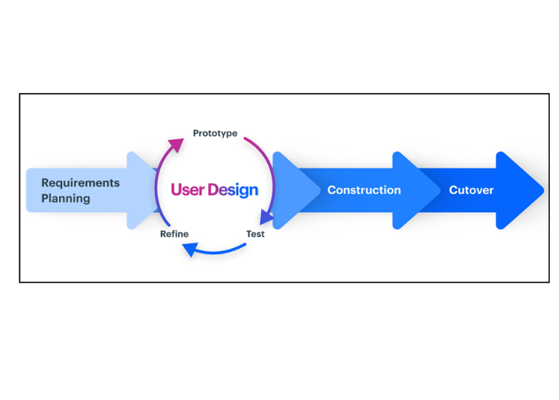To develop this capstone project, the researchers adopted the Rapid Application Development (RAD) methodology, introduced by James Martin in 1991. Martin suggested that RAD offers a development lifecycle intended to deliver high-quality systems rapidly and cost-effectively than traditional development approaches. Studies show that Rapid Application Development (RAD) provides a comprehensive method to designing systems in a shorter period of time, including a focus on prototype development. De Leon and Battung, (2021). This methodology is particularly useful in scenarios where there is a need for dynamic systems, limited development time and budget, quick access to up-to-date information, and a requirement for close interaction with end-users (Kosasi & Yuliani, 2015).

Figure 3.0

**Rapid Application Development**

**Phase 1: Requirements Planning**

In this phase, developers and clients engage in discussions to identify the project's objectives and expectations, as well as to address existing and potential challenges that must be resolved prior to and throughout the development process.

For the purpose of this research, the researchers conducted an interview with the clients. Unstructured and structured interviews with the owner of Hydroponic Lettuce Farm were done with the aim of gathering important information and to identify the problems that they encounter in Hydroponic Lettuce farm due to its time-consuming and difficulties in formulation of nutrient solution manually.

In this study, the researchers carried out interviews with the clients. conducted both unstructured and structured interviews with the owner of a Hydroponic Lettuce Farm with the goal of collecting crucial information and identifying the challenges faced in the hydroponic lettuce farming process, particularly the complex task of manually formulating nutrient solutions. After assessing the client’s issues, the researchers decided to developed an automated nutrient solution formulator for hydroponic lettuce farming. This device powered by an Arduino Uno and equipped with pumps, is designed to precisely blend nutrient solutions by dispensing exact volumes of each component into a tank. Additionally, it will utilize sensors to monitor nutrient and pH levels, as well as manage environmental conditions like temperature and humidity.

|  |  |  |
| --- | --- | --- |
| **Software** | **Minimum** | **Recommended** |
| Browser | Any browser | |
| Internet Bandwith | 2-5 Mbps | 10Mbps and above |
| Operating System | Any type of operating system for mobile devices or desktop computers. | |

Table 3.1

**Software Requirements**

Table 1 shows the software requirements required for the system to perform properly and efficiently. These requirements were found by research and suggestions from developers using the same algorithm.

|  |
| --- |
| **Hardware** |
| Arduino Uno |
| NodeMCU ESP8266 |
| TDS Nutrient Sensor |
| pH Level Sensor |
| DHT22 Temperature and Humidity Sensor |
| HC-SR04 Ultrasonic Sensor |
| 20x2 LCD |
| Relay |
| Amphibian Type Water Pump |
| Exhaust Fan |
| Strip UV Light |
| Solenoid Valve |
| Water Pump |
| Ultrasonic Turbine Washer |

Table 3.2

**Hardware Requirements**

The preceding table shows the necessary hardware components required for the development and operation of the system. Additionally, the researcher has compiled additional hardware specifications for the creation of a device intended to collect sensor data (refer to Table 3.2). This integrated hardware device includes an Arduino Uno, TDS nutrient sensor, pH level sensor, DHT22 Temperature and Humidity Sensor, and HC-SR04 Ultrasonic Distance Sensor, which are used to collect sensor data. The NodeMCU ESP8266 enables the transmission of sensor data to a web platform for remote monitoring, while a 20x2 LCD allows for on-site monitoring of current nutritional and environmental parameters. A relay controls the operation of exhaust fans, UV light strips control temperature, and amphibian-type pumps provide accurate nutrient solution dispensation. A solenoid valve controls the primary water source to be use for formulation, and a water pump that enables irrigation for hydroponic lettuce crops.

The hardware and software specifications outlined in Tables 3.1 and 3.2 were determined based on the specific requirements of the IoT-based project to ensure its proper functionality and alignment with its intended purpose. These specifications are essential for optimizing system performance, minimizing potential issues, and ensuring a smoother user experience with the application. The researchers will use both hardware and software requirements throughout the entire process of development and operation of the system.

Furthermore, the researchers created a Gantt Chart (shown in Figure 3.3) to act as a roadmap for tracking the project's progress. This application will serve as a basic project management tool, supporting the organizing and visualization of the whole project lifecycle. It will define multiple tasks, accomplishments, and connections, providing a clear timeframe for each step of the project. This visual representation will allow researchers to manage resources more effectively, identify potential challenges, and guarantee that projects move smoothly. As the study progresses, the Gantt chart will act as a dynamic guide, allowing researchers to compare progress to the established schedule.

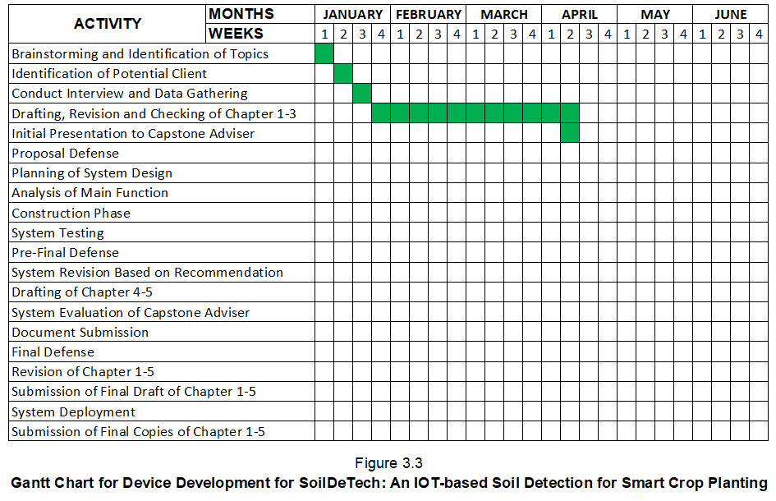

**Phase 2: Design**

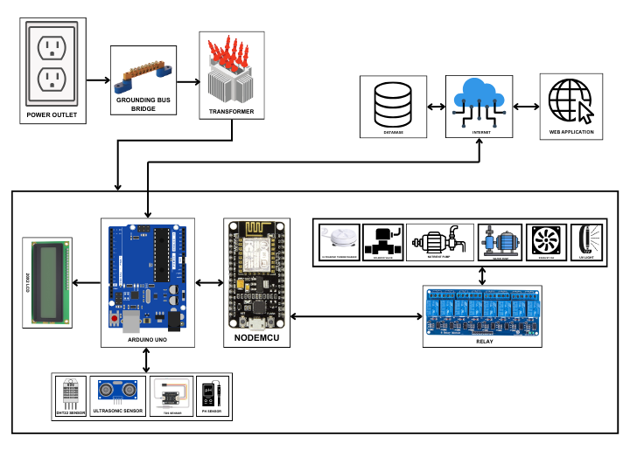 This phase contains the system architecture, outlining the components involved in the system development process. Following a thorough study of all gathered data, researchers will create a system architecture, block diagram, and data models required to forward the project's development.

Figure 3.4

**Block Diagram of HydroBlend: An Automated Nutrient Solution Formulator for Hydroponic Lettuce Farming**

The sensor is a hardware device that can collect sensory input that is interpreted and transmitted to the base station using a variety of communication protocols. In this study, we employed a variety of sensors, including the DHT22 Temperature and Humidity Sensor, Ultrasonic Distance Sensor, TDS Sensor for nutrient levels, and pH Level Sensor for acidity level. These sensors collect nutritional content and environmental data to create decision-making and 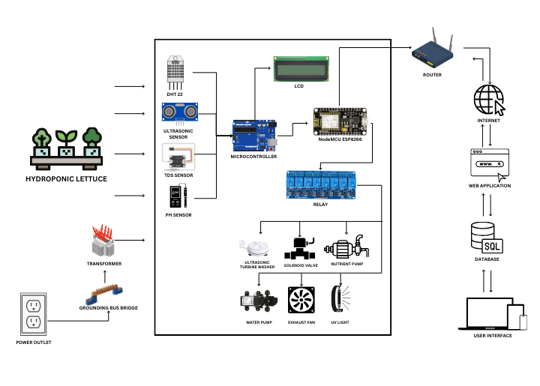automations.

Figure 3.5

**System Architecture of HydroBlend: An Automated Nutrient Solution Formulator for Hydroponic Lettuce Farming**

The diagram illustrates the collaborative operation of hardware components. The DHT22 gauges temperature and humidity within the hydroponic farm, the ultrasonic sensor measures nutrient volume in the water tank, the TDS sensor assesses nutrient levels, and the pH sensor determines the acidity of the nutrient solution. Data collected by these sensors is sent to the Arduino Uno microcontroller. The NodeMCU controls pumps, fans, and lights via relays and is responsible for data transmission to the system. The LCD provides on-site data display for user monitoring, while a web application enables remote monitoring and configuration of connected components for distant supervision. The main power source provides device functionality. The integration of IoT devices and software 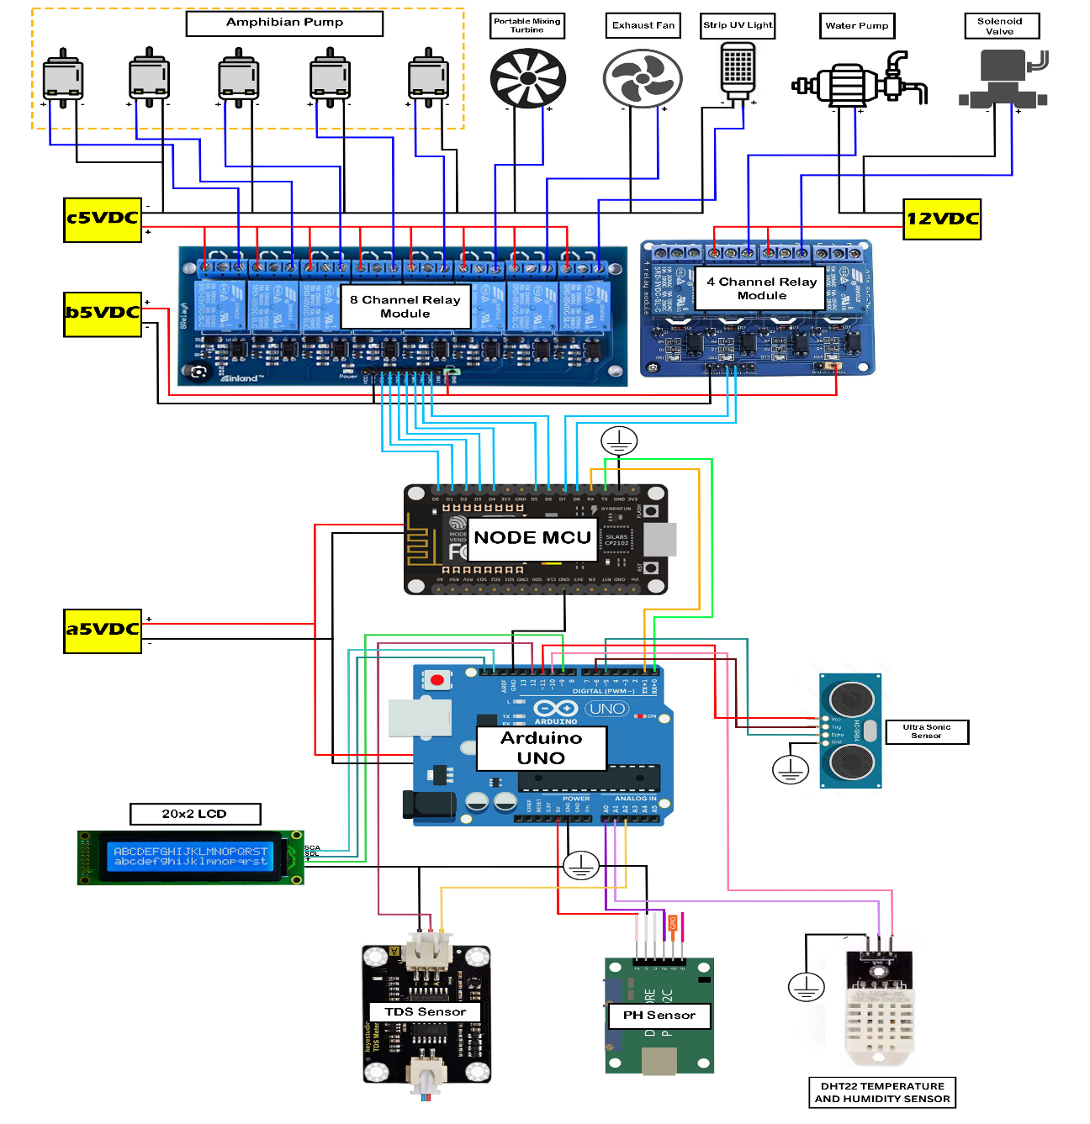applications streamline the formulation of nutrient solution for hydroponic lettuce.

Figure 3.6

**Schematic Diagram of HydroBlend: An Automated Nutrient Solution Formulator for Hydroponic Lettuce Farming**

Figure 3.6 displays the schematic diagram of the automated nutrient solution formulator for hydroponic lettuce farming, depicting the interface of relays connected to various components such as the amphibian-type nutrient pump, exhaust fan, strip UV light, water pump, solenoid valve, and ultrasonic turbine washer. These relays are linked to the NodeMCU, which in turn is connected to an Arduino Uno Microcontroller. Within the Arduino Uno connection are the LCD, TDS sensor, pH sensor, DHT22 temperature and humidity sensor, and ultrasonic sensor.

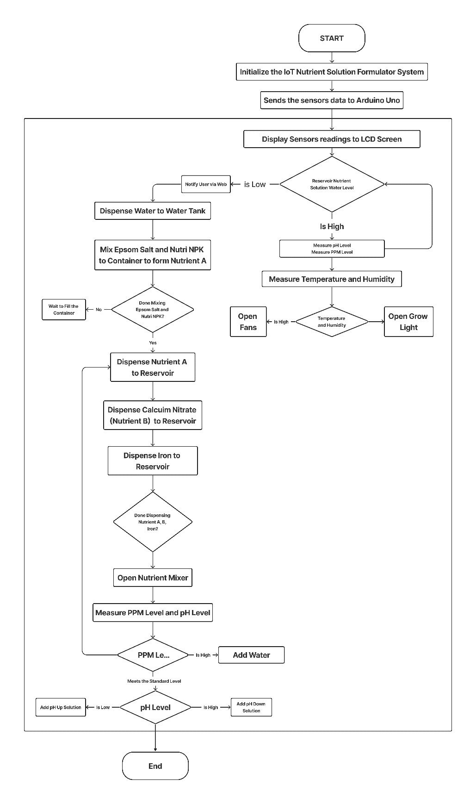

Figure 3.7

**Flowchart of HydroBlend: An Automated Nutrient Solution Formulator for Hydroponic Lettuce Farming**

Figure 3.7 shows that the automated nutrient solution formulator for hydroponic lettuce farming includes a control system that sends data to a web application that interacts with the system. To fully understand the system's comprehensive process, the researchers built the system Flowchart Diagram, which divides the specific process from the flowchart into sub-processes. The flowchart of an automated nutrient solution formulator for hydroponic lettuce  provides a useful understanding of the many components and stages involved in modern agricultural practices. This method is intended to automate traditional nutrients formulation procedures using IoT devices and a software application, resulting in greater convenience, increased crop productivity, greater profit, and better lettuce quality.

An automated nutrient solution formulator for hydroponic lettuce farming provides a significant approach to agriculture that builds on the potential of IoT technology to improve farming operations. The flowchart depicts system procedures and components, including data gathering and processing, cloud-based analysis, and user interaction. Farmers that utilize this modern technology can boost production, resource efficiency, and crop quality while minimizing manual work and costs. This system demonstrates the potential of innovation in the agriculture industry, which is important in meeting global food demand and promoting sustainable farming techniques.

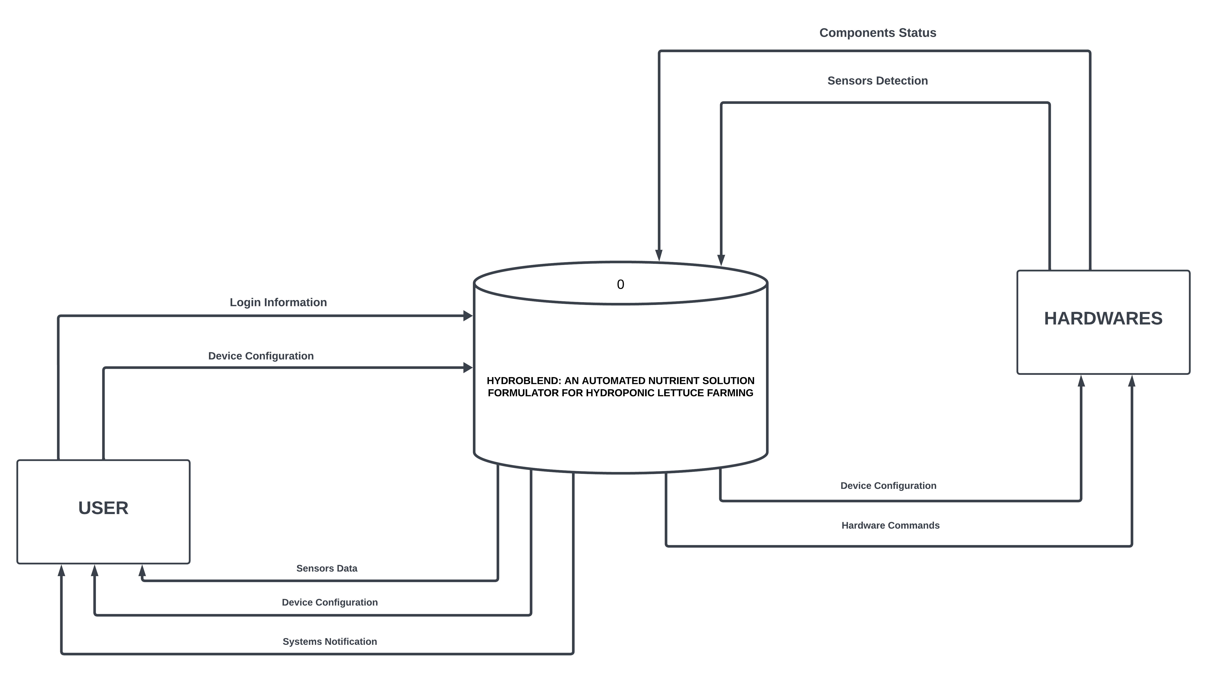Figure 3.8

**Context Diagram of HydroBlend: An Automated Nutrient Solution Formulator for Hydroponic Lettuce Farming**

Figure 3.8 depicts the interaction among the user, the system, and the hardware. Level 0 handles all the data received from both the users and the hardware, processing it accordingly. Through the hardware, data can be manipulated and processed at Level 0, which then provides the processed data back to the users.

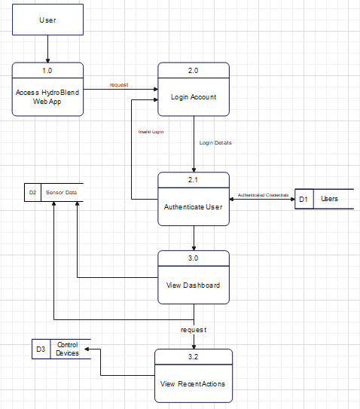Figure 3.9

**Data Flow Diagram of HydroBlend: An Automated Nutrient Solution Formulator for Hydroponic Lettuce Farming**

In figure 3.9 shows how the system works on the user side, The system allows the user to login their accounts. Upon login process, the system allows the users to view the dashboard containing data gathered by sensors and recent actions by the device.

**Phase 3: Construction**

During this stage, the building of an online research repository system began, followed by gradual refining and testing. This system was developed from a thorough documenting of client challenges and requirements. Throughout the Construction phase, developers methodically organized and structured the system's architecture and data flow model, creating a workable prototype for testing. This step makes it easier to identify and correct any mistakes that may occur, ensuring that the system runs smoothly.

Furthermore, the researchers divided this phase into several sections: quick construction preparation, program and application development, unit coding, integration, and system testing. The researchers worked collaboratively to meet and surpass the client's expectations and standards.

**Phase 4: Cutover**

During this stage, the building of an online research repository system began, followed by gradual refining and testing. This system was developed from a thorough documenting of client challenges and requirements. Throughout the Construction phase, developers methodically organized and structured the system's architecture and data flow model, creating a workable prototype for testing. This step makes it easier to identify and correct any mistakes that may occur, ensuring that the system runs smoothly.

Furthermore, the researchers divided this phase into several sections: quick construction preparation, program and application development, unit coding, integration, and system testing. The researchers worked collaboratively to meet and surpass the client's expectations and standards.

**NOTES**

(2021). E-recycle bin: an iot based model for solid waste management. International Journal of Advanced Trends in Computer Science and Engineering, 10(2), 865-873. <https://doi.org/10.30534/ijatcse/2021/561022021>

Kosasi, S. and Yuliani, I. D. A. E. (2015). Penerapan rapid application development pada sistem penjualan sepeda online. Simetris : Jurnal Teknik Mesin, Elektro Dan Ilmu Komputer, 6(1), 27. <https://doi.org/10.24176/simet.v6i1.234>