**DEVELOPMENT OF OFFICE SUPPLIES AND MATERIALS MONITORING AND INVENTORY SYSTEM WITH CLIENT SATISFACTION SURVEY**

A Capstone Project

Presented to the Faculty of the

**COLLEGE OF INFORMATION TECHNOLOGY**

**CENTRAL BICOL STATE UNIVERSITY OF AGRICULTURE - SIPOCOT**

Sipocot, Camarines Sur

In partial Fulfillment of the Requirements

For the Degree of

**BACHELOR OF SCIENCE IN INFORMATION TECHNOLOGY**

**CHRISTINE L. SALVADOR**

**JAY RODELIO V. VILLAFUERTE**

**JOHN BENEDICT A. ZAMUDIO**

**August 2024**

**CHAPTER I**

**THE PROJECT AND ITS BACKGROUND**

This chapter includes the introduction, scope and delimitation, objectives, conceptual framework, significance of the study, and the definition of terms used.

**Introduction**

Control of office supplies and material is the activity of providing all goods and services for the purposes of executing the task. The process of providing office facilities through an assessment carried out by government agencies. An organization can minimize expenses and maximize productivity by maintaining ideal stock levels through effective inventory management. Through the utilization of precise forecasting and up-to-date information, organizations can plan for demand, modify orders appropriately, and minimize wastage. By maintaining readiness for unforeseen demand and preventing the financial problems of oversupply, this balance improves general operational stability and profitability. According to Zhongli et al. (2015) due to the maturity and development of the information management technology, and the management methods become more and more scientific, which caused the computer technology, network communication technology and other related technology developed rapidly, the information system became more and more perfect. But there still exist some shortcomings for complex materials inventory management systems. Aiming at this problem, we propose the materials inventory management system based on a digital pipeline, by analyzing the important process of inventory and optimizing the process, and then take the management of the department and authority of the role, which will make it better to achieve the management of materials inventory.

The purpose of inventory and human resource management research and development inside ERP systems is to simplify and improve these processes. Employers are able to better manage staff and inventory by consolidating these tasks into a single system, which also provides real-time information and enhances overall performance. The study of Bo et al. (2021) Nowadays, more and more companies are applying total inventory management as well as human resource management as one of the core concepts of the enterprise management platform. ERP is a resource allocation platform based on information technology applications to have the advantage of advanced and comprehensive management ideas to provide planning and operation software for enterprise managers and employees.

The General Services Office (GSO) of the Local Government Unit (LGU) of Libmanan, Camarines Sur, situated in the Bicol Region of the Philippines, acts as the main office for developing and implementing the Development of Office Supplies and Materials Monitoring and Inventory System with Client Satisfaction Survey. Currently, the General Services Office (GSO) faces significant challenges associated with manual recording of office supplies and materials, including inaccuracies in inventory data, delays in processing requests, and difficulties in monitoring stock levels. These problems result in inefficient use of resources, higher administrative costs, and delays in getting important information, which makes municipal operations less efficient. Recognizing the critical need for a more efficient and accurate system, the General Services Office (GSO) understands the importance of implementing this new inventory management system. By transitioning from a manual to a digital approach, the General Services Office (GSO) can significantly reduce human errors, enhance accountability, and improve response times for supply requests. This system is essential not only for maintaining ideal stock levels but also for ensuring that all offices within the municipality have access to the necessary resources to perform their duties effectively. The current business process of the General Services Office (GSO) involves manual monitoring of office supplies, which requires considerable time and effort. Staff members must physically count and record inventory, process requests for supplies, and manually update records, often resulting in delays and inefficiencies. Furthermore, without real-time data, the General Services Office (GSO) struggles to monitor stock levels accurately, leading to shortages or overstocking of supplies.

The new inventory and monitoring system will organize these processes by providing real-time access to inventory data, allowing the General Services Office (GSO) to monitor supplies accurately and efficiently. This management system will enable precise recording, monitoring, and reporting of office supplies and materials, ensuring supplies and materials are organized, waste is minimized, and utilization is maximized. Every office will benefit from timely information on supply availability, which will enhance decision-making and operational efficiency. While other offices can monitor stock levels and issued supplies, the General Services Office (GSO) will maintain exclusive administrative control, allowing it to generate necessary inventory reports of office supplies and materials in the General Services Office (GSO).

This project helps improve service and management at the Libmanan Municipal Hall by addressing current problems and making sure all offices have what they need to do their jobs.

**Objectives:**

This project aims to develop an online platform specifically designed for managing office supplies and materials at the Libmanan Municipal Hall in Camarines Sur. Specifically, it seeks to accomplish the following:

1. Develop an automated system for real-time tracking and accurate updates of office supplies.

2. To accommodate a notification system through email.

3. To accommodate customer satisfaction through a survey.

4. To manage inventory of supplies and materials by offices.

**Scope and Delimitation**

The Development of Office Supplies and Materials Monitoring and Inventory System with Client Satisfaction Survey aims to enhance the efficiency, accuracy, and transparency of managing office supplies and materials at the General Services Office (GSO) located on Municipal Hall of Libmanan. This project will focus on developing an automated, user-friendly web-based inventory system with several key features. The system will facilitate real-time monitoring and accurate updates of office supplies and materials, providing comprehensive quarterly data reports to support better decision-making. A crucial element of the system is the notification feature that sends automated email updates when inventory levels are low, need restocking and send a supply request, ensuring inventory is managed.

Additionally, the system will include a satisfaction survey feature to gather user feedback, which will be collected and stored within the system. This will allow the General Services Office to continuously improve its services based on user input. The system will also enable different levels of access: General Services Office administrators will have full administrative rights for managing the entire inventory system, while other municipal offices or the users will have viewing access and the ability to send supply requests.

Key features of the system include real-time inventory monitoring with automatic updates, email notifications for supply request status and low inventory alerts, and a user feedback module for collecting and storing satisfaction surveys. User accounts will be managed by administrators, containing essential information for secure access and personalized notifications. The request management feature will enable users to submit and monitor supply requests, while the admin dashboard will provide a comprehensive view of user activity, productivity, and overall system status.

The system is specifically designed for the Libmanan Municipal Hall to streamline operations, improve efficiency, and ensure all offices have the necessary resources to perform their duties effectively. Delimitations of the project include that the system will not cover financial management or budgeting aspects of inventory management, will be accessible only to authorized users within the Libmanan Municipal Hall, will not include advanced analytics or integration with external suppliers, and will be dependent on the availability of a stable internet connection and basic IT infrastructure.

By clearly defining these boundaries, the project ensures a focused approach to enhancing inventory management within the Libmanan Municipal Hall while recognizing and addressing potential constraints and limitations.

**Conceptual Framework**

Figure 1 illustrates the conceptual framework of the Development of Office Supplies and Materials Monitoring and Inventory System with Client Satisfaction Survey, utilizing a website. This framework employs an Input-Process-Output (IPO) model, a common approach in systems analysis and software engineering, to delineate the information processing structures within the system.

INPUT

PROCESS

OUTPUT

* + Admin Login
  + User Login
  + Supplies and Materials Details
  + Request Items
  + Email Detail
  + Admin Profile
  + Supplies and Specification
  + Inventory
  + Satisfaction Survey
  + Email Sending
* Development of Office Supplies and Materials Monitoring and Inventory

**Conceptual Framework for Development of Office Supplies and Materials Monitoring and Inventory System with Client Satisfaction Survey**

This study focuses on enhancing office supplies and materials management within the Libmanan Municipal Hall through an optimized inventory management system. The input involves gathering requirements, understanding current inventory data, implementing automated inventory updates, and providing a notification system through email. The system will have an access control feature that gives full administrative rights to the General Services Office (GSO) administrator. Offices/Users will be able to send item requests directly to the General Services Office (GSO). This design ensures that any purchases are easily controlled, improves exchanges, and promotes the process of obtaining necessary office supplies and materials. The process includes analyzing user needs, designing user-friendly interface, developing the system with automated inventory updates, The system will have secure access control to ensure only authorized personnel have full administrative rights. Furthermore, it involves generating quarterly reports to provide essential data on inventory status and usage. The output is an efficient platform that facilitates real-time inventory updates, accurate monitoring of issued supplies, and comprehensive quarterly reports, ultimately improving resource management and operational efficiency within the municipal hall.

**Significance of the study**

This study, which will cover the development of a Development of Office Supplies and Materials Monitoring and Inventory System with Client Satisfaction Survey, will be significant for the following:

**1. Employees.** It will reduce the time needed for manual inventory checks, making supply management simpler and more effective, allowing the staff members to concentrate more on their main tasks. Employees will be able to learn and adjust to the new process more quickly because of the system's user-friendly interface, which will also reduce interruptions and increase productivity.

**2. General Services Office (GSO).** It will improve the monitoring and management of supplies, resulting in increased control and decreased waste. The General Services Office (GSO) will be able to ensure that resources are available when needed, improve the purchasing process, and produce accurate and timely reports due to the innovation.

3. **Supply Officer.** Along with reducing errors and guaranteeing accurate, latest records, the process will make inventory management simpler. Comprehensive reports will be provided for improved monitoring, and it will help with efficient supplier selections.

4. **Future Researchers.** This may serve as a valuable reference to other researchers with similar nature systems.

**Definition of Terms:**

Important terms used in this study were defined conceptually and operationally to provide a common framework of understanding for both researchers and readers.

**Satisfaction Survey.** A structured questionnaire with a focus on usefulness, effectiveness, and general satisfaction that is intended to determine users' satisfaction with the Office Supplies and Materials Inventory Monitoring System.

**Email.** A method of communication used by the General Services Office (GSO) to help employees as well as stakeholders get inventory reports and other relevant data.

**Inventory System.** A manual or digital system for keeping track of the quantity, present, and location of things in a particular inventory in this example, office supplies and materials in a given inventory.

**General Services Office (GSO).** The department within the Libmanan Municipal Hall responsible for managing office supplies, materials, and other administrative functions.

**Notes**

Bo, Z. Chunlei, T. (2021) Research and Development of Inventory Management and Human Resources in ERP.[https://doi.org/1](https://www.zotero.org/google-docs/?RYWb7a)[0.2991/ameii-15.2015.49](https://doi.org/10.2991/ameii-15.2015.49)

Zhongli, Y. Xiaodong, W. Yun, L. Xingxing, Y. (2015). The Research and Design of the Materials Inventory Management System based on the digital pipeline.[https://doi.org/1](https://www.zotero.org/google-docs/?RYWb7a)[0.2991/ameii-15.2015.49](https://doi.org/10.2991/ameii-15.2015.49)

**CHAPTER II**

**REVIEW OF RELATED LITERATURE AND STUDIES**

This chapter contains a review of relevant literature and studies gathered from various sources such as the internet and research studies that aided significantly in connecting this study.

**Inventory Management.**

The study of Sbai, et. al. (2018) Effective inventory management is essential for maintaining optimal stock levels and meeting customer demands while dealing with demand variability. The study of Shiau et al. (2017) Inventory management is crucial for manufacturing SMEs to remain competitive. This study highlights the common challenges faced by these enterprises in Johor, Malaysia, such as underproduction, stockouts, delivery delays, and discrepancies in inventory records. The research emphasizes that proper documentation, effective planning, and improving employee skills significantly enhance inventory management. By addressing these factors, SMEs can overcome inventory issues and optimize their operations. Implementing systematic inventory practices and training programs can ensure accurate records and timely deliveries, leading to improved productivity and operational efficiency for manufacturing SMEs.

The study of Santosh, et. al. (2023) The effective inventory management systems are crucial for educational institutions. This study looks at a web-based application for a college's finance department, using HTML, Bootstrap, CSS, JavaScript, PHP, Ajax, and SQL to manage financial records, transactions, and reports with a user-friendly interface and real-time updates. It reviews an inventory management system (IMS) designed to efficiently monitor supplies, purchases, and stock information. Automating these processes improves accuracy, security, and workflow, replacing manual systems with dynamic, real-time solutions. The study highlights the benefits of using automated systems for better efficiency and user experience in educational institutions.

**Email Notification Systems.**

Developing an email notification system for various applications requires a comprehensive understanding of user needs and system functionalities. Email notifications have been widely utilized across different domains, such as healthcare, education, and security, to enhance communication and streamline processes Utz, et. al. (2023). In healthcare, email notifications are used to inform patients about test results, appointment reminders, and important health alerts, improving patient engagement and care continuity. In educational settings, email notifications help in disseminating critical information, such as exam schedules, assignment deadlines, and attendance alerts, thereby enhancing the overall academic experience Prasad, et. al. (2024). In the field of security, email notifications serve as crucial tools for alerting users about unauthorized activities, potential system vulnerabilities, and real-time security breaches, ensuring timely intervention and safeguarding sensitive information Omede, et. al. (2024).

By providing real-time updates and automating communication processes, email notification systems significantly improve user engagement and operational efficiency across various sectors. Additionally, these systems can be tailored to meet specific requirements, offering customized alerts and notifications to cater to unique user needs and scenarios Utz, et. al., (2023).

**Customer Satisfaction Surveys.**

The study of Pukite, et. al. (2017) A customer satisfaction survey, which enables the management company to gain information about customer needs and control the quality of provided services, is essential for successful operation of the companies in order to maintain a high standard in one of the fundamental values -quality of customer service. The study of Dharma, et. al. (2023) Conducting client satisfaction surveys as part of the inventory system can provide invaluable feedback that is essential for continuous improvement and meeting customer expectations. By systematically gathering insights from customers, organizations can identify areas where their inventory management processes excel and where they fall short. This feedback loop plays a crucial role in enhancing service quality, as it allows companies to make informed decisions based on actual customer experiences and preferences.

Study of Sulistiyono, et. al. (2023) By grasping customer preferences and expectations through surveys, organizations can customize their offerings to effectively meet customer needs . These surveys provide direct insights that help tailor products and services, leading to improved customer satisfaction and loyalty. Understanding preferences allows businesses to prioritize features, address gaps, and innovate continuously. This approach demonstrates a commitment to customer-centricity, enhances the company’s reputation, and provides a competitive advantage by enabling quick adaptation to market changes. Ultimately, leveraging customer feedback ensures that offerings are closely aligned with customer demands, driving long-term success.

**Office Supplies Management**

The study of Castro, et. al. (2017)Supply chain management plays a vital role in ensuring the smooth flow of supplies from procurement to consumption points within an organization. According to Uzmasyah, et. al. (2022), effective office equipment management is essential for organizations to ensure resource availability and efficiency. Studies highlight the need for careful assessment to meet operational needs without excess. The research on the Regional Secretariat Organization Bureau focused on managing office supplies like paper, printer ink, and envelopes. Using a descriptive qualitative approach with interviews, the study found that proper control of office equipment reduces waste, improves inventory management, and ensures better resource allocation. These insights can help other organizations develop effective inventory control strategies to enhance efficiency and avoid overstocking or understocking supplies.

The study by Setiawan, et. al. (2024) underscores the advancement of web-based office supplies requisition applications as crucial for modernizing procurement processes in various organizations, including universities. However, challenges such as inefficient planning and ineffective implementation can hinder their success. Studies reveal issues like lack of efficiency, transparency, and discrepancies between registered and actual stock. To address these problems, the research utilized the Rapid Application Development methodology and incorporated user feedback. The resulting updated application significantly enhances the user experience, improves efficiency in office supplies requests, provides transparent status updates, and ensures accurate stock management. These improvements are expected to streamline procurement processes and better meet user needs.

**Synthesis of the Reviewed Literature and Studies**

The study of Sbai, et. al. (2018) Highlights that effective inventory management is fundamental for maintaining optimal stock levels and meeting customer demands, especially in dynamic environments. The study of Shiau, et. al. (2017) emphasizes the necessity of accurate inventory records, proper documentation, and systematic planning to mitigate issues like stockouts, overproduction, and delivery delays. These findings are reinforced by Santosh, et. al. (2023), who demonstrate the benefits of automated inventory management systems in educational institutions, noting significant improvements in accuracy, security, and workflow efficiency.

The study of Utz, et. al. (2023) reveals the important role of email notifications in various domains, enhancing communication and operational efficiency. Prasad, et. al. (2024) illustrates how email notifications are utilized in healthcare and education to inform users about critical updates, thereby improving engagement and continuity of care or academic activities. Omede, et. al. (2024) further highlights the security benefits of email notifications in alerting users to unauthorized activities and potential system vulnerabilities. The overarching consensus is that real-time email notifications streamline processes and provide timely, actionable information, tailored to specific user needs.

The study by Pukite, et. al. (2017), Dharma et al. (2023), and Sulistiyono et al. (2023) emphasize the significance of customer satisfaction surveys in gathering feedback for continuous improvement. These surveys enable organizations to understand customer preferences and expectations, leading to better service quality and enhanced customer loyalty. The feedback loop created by these surveys is essential for making informed decisions that align with customer demands, ensuring long-term success and competitive advantage.

The study ofCastro, et. al. (2017) Effective management of office supplies is crucial for ensuring resource availability and operational efficiency. Uzmasyah, et. al. (2022) highlights the importance of proper control and assessment of office equipment to reduce waste and improve resource allocation. Setiawan, et. al. (2024) emphasizes the need for modernizing procurement processes through web-based applications, addressing challenges such as planning inefficiencies and stock discrepancies. These studies collectively advocate for advanced, automated solutions to streamline office supplies management and enhance organizational efficiency.

The reviewed literature and studies highlight important aspects for developing an effective office supplies and materials monitoring and inventory system with a client satisfaction survey. These aspects include automated inventory management, real-time email notifications, systematic customer satisfaction, and efficient office supplies management. Integrating these components is essential for improving organizational operations and enhancing service quality.

**Notes**

Adi Dharma, B. and Gunawan, A. (2023). Curriculum development based on digital supply chain management in learning supplies management majoring in office administration. Jurnal Sains Dan Teknologi, 4(3), 132-137. <https://doi.org/10.55338/saintek.v4i3.993>

Castro, M. D. B. (2017). Experiencing digital works through the development of online inventory management system for bulsu supply office. Ijemr, 1(2), 1-7. <https://doi.org/10.22662/ijemr.2017.1.2.001>

Chan, S. W., Tasmin, R., Aziati, A. N., Rasi, R. Z., Ismail, F. B., & Yaw, L. P. (2017, August). Factors influencing the effectiveness of inventory management in manufacturing SMEs. In *IOP Conference Series: Materials Science and Engineering* (Vol. 226, No. 1, p. 012024). IOP Publishing.<https://iopscience.iop.org/article/10.1088/1757899X/226/1/012024/pdf>

Muhamad Ilias, N. F. I. (2021). *A web based system for lost and found items system using RFID and email notification* (Doctoral dissertation, Universiti Teknologi Mara Perlis). <https://ir.uitm.edu.my/id/eprint/45937>

Omede, E. U., Edje, A. E., Akazue, M. I., Utomwen, H., & Ojugo, A. A. (2024). Imanobas: an improved multi-mode alert notification iot-based anti-burglar defense system. Journal of Computing Theories and Applications, 1(3), 273-283. <https://doi.org/10.62411/jcta.9541>

Prasad, D. V. (2024). Real-time speech to text conversion &amp; answer evaluation. Interantional Journal of Scientific Research in Engineering and Management, 08(04), 1-5. <https://doi.org/10.55041/ijsrem30670>

Puķīte, I. and Geipele, S. (2017). Determining customer satisfaction in the real estate management sector in riga. Baltic Journal of Real Estate Economics and Construction Management, 5(1), 226-237. <https://doi.org/10.1515/bjreecm-2017-0017>

Sbai, N. and Berrado, A. (2018). A literature review on multi-echelon inventory management: the case of pharmaceutical supply chain. MATEC Web of Conferences, 200, 00013. <https://doi.org/10.1051/matecconf/201820000013>

Setiawan, J. S., Oetama, R. S., & Andersen, J. (2024). Enhancement Campus Office Supplies Requests Website Utilizing Rapid Application Development. *Journal of Information Systems and Informatics*, *6*(2), 1144-1158. https://doi.org/10.51519/journalisi.v6i2.769

Soni, S., Chandra, P., Gupta, A., Netam, D. K., Kumar, S., & Tiwary, K. Design and Implementation of Inventory Management System for University. <https://doi.org/10.55041/ijsrem30670>

Sulistiyono, S., Muksin, & Iskandar, R. (2023). Measuring the customer satisfaction to improve the product quality of premium seeds produced by bintang asia based on the customer satisfaction index (csi) dan importance performance analysis (ipa). E3S Web of Conferences, 454, 03001. <https://doi.org/10.1051/e3sconf/202345403001>

Utz, C., Michels, M., Degeling, M., Marnau, N., & Stock, B. (2023). Comparing large-scale privacy and security notifications. Proceedings on Privacy Enhancing Technologies, 2023(3), 173-193. <https://doi.org/10.56553/popets-2023-0076>

Utz, C., Michels, M., Degeling, M., Marnau, N., & Stock, B. (2023). Comparing large-scale privacy and security notifications. Proceedings on Privacy Enhancing Technologies, 2023(3), 173-193. <https://doi.org/10.56553/popets-2023-0076>

Uzmasyah, L., & Nasution, Y. S. J. (2022). Analysis of Office Supplies Control Management in Setdaprovsu Organizational Bureau. *Jurnal Ekonomi, Manajemen, Bisnis dan Akuntansi Review*, *2*(1), 21-28.<https://doi.org/10.53697/emba.v2i1.519>

**CHAPTER III**

**RESEARCH DESIGN AND METHODOLOGY**

The research design for developing a Development of Office Supplies and Materials Monitoring and Inventory System with Satisfaction Survey using a website is outlined in this chapter. It presents the design, research methodology, data gathering techniques, system architecture, and software and hardware requirements.

**Research Design**

Developing a web-based platform to manage office supplies and materials at the municipal hall is the goal of the Agile Research Design for the “Development of Office Supplies and Materials Monitoring and Inventory System with Client Satisfaction Survey”. This platform will make it easier to efficiently input inventory data and will simplify the process of monitoring and handling office supplies and materials. The General Services Office (GSO) will be able to record and monitor supplies and materials, create quarterly reports, and obtain important insights into supply utilization and needs because of the system's implementation inside Municipal Hall. Through the use of this web-based platform, the system will optimize resource allocation, increase overall operational efficiency inside the municipal hall, and improve inventory management methods in Libmanan.

**Research Methodology**

The Agile Development model was the methodology of choice for the researcher as they developed the Development of Office Supplies and Materials Monitoring and Inventory System with Satisfaction Survey. Agile Development is a software development methodology that emphasizes flexibility, adaptability, and continual improvement through repeated steps. This methodology ensures that the General Services Office (GSO) staff is actively involved in the development process by collaborating with them on a regular basis. A faster cycle made possible by the agile methodology enables efficient improvements and modifications in response to changing requirements. Using an iterative process, the development timeline can be reduced and the system may be tailored to meet the GSO's unique requirements for managing office supplies and materials at the Libmanan Municipal Hall.

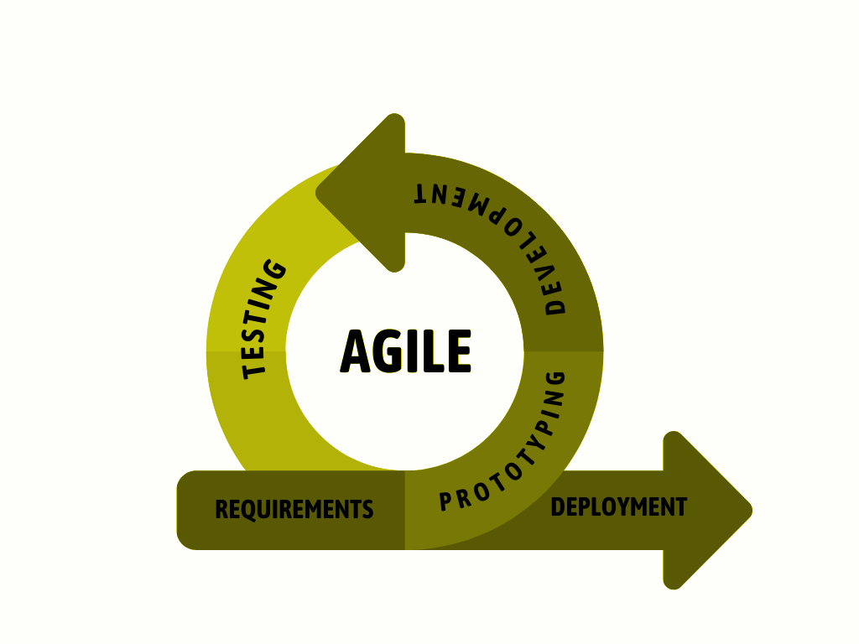

Figure 3.1

**Agile Software Development**

During the beginning phases of requirements collection and planning for the "Development of Office Supplies and Materials Monitoring and Inventory System with Satisfaction Survey," researchers interacted with many important those who matter, such as municipal administrators and employees of the General Services Office (GSO). These conversations made it clear that they had had issues with tracking office supplies and resources and managing manual inventories. After evaluating these problems, the researchers made the decision to develop an online platform that would automate and optimize these procedures. The system seeks to improve resource management and operational efficiency within the Libmanan Municipal Hall by utilizing technologies including HTML, CSS, PHP, JavaScript, XAMPP, and MySQL.

**Hardware and Software Requirements**

The requirements outlined in the table below are based on the specifications needed by the identified software to operate the system.

* Table 1.1 and Table 1.2 shows the Hardware and Software Requirements for **Development of Office Supplies and Materials Monitoring and Inventory System with Satisfaction Survey.**

Table 1.1

**Hardware Requirements**

| **Hardware** | **Minimum** | **Recommended** |
| --- | --- | --- |
| Memory (RAM) | 4GB | 8GB |
| Processor | Intel core i3 | Intel core i3 |
| Internet Connectivity | Internet Connection with at least 4G connectivity | |
| Other | Android Phone and Laptop | |

Table 1.2

**Software Requirements**

|  |  |  |
| --- | --- | --- |
| **Software** | **Minimum** | **Recommended** |
| Operating System | Windows 8 | Windows 10 |
| Android Version | Android 11 | Android 11 |
| Programming languages | HTML, PHP, JavaScript, SQL | |
| Internet | At least 5 Mbps | 10 Mbps |
| Database | MySQL/Cloud | |

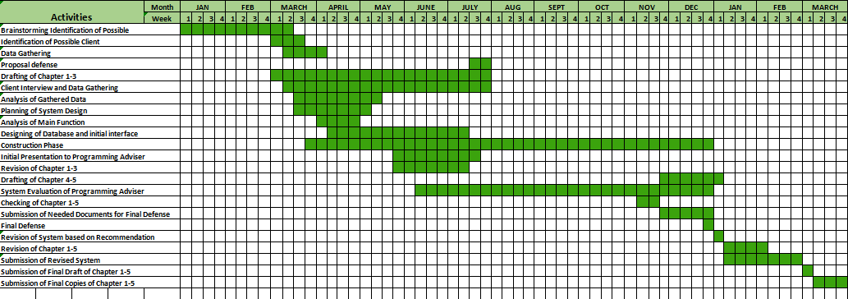**C. Development Timeline**

**Figure 3.2**

**Gantt Chart of Development of Office Supplies and Materials Monitoring and Inventory System with Satisfaction Survey.**

**Phase 2: Design**

This phase emphasizes the visualization of the system process and architecture. It focuses on user interface design and the creation of models and diagrams to illustrate how the system functions.

**System Architecture**

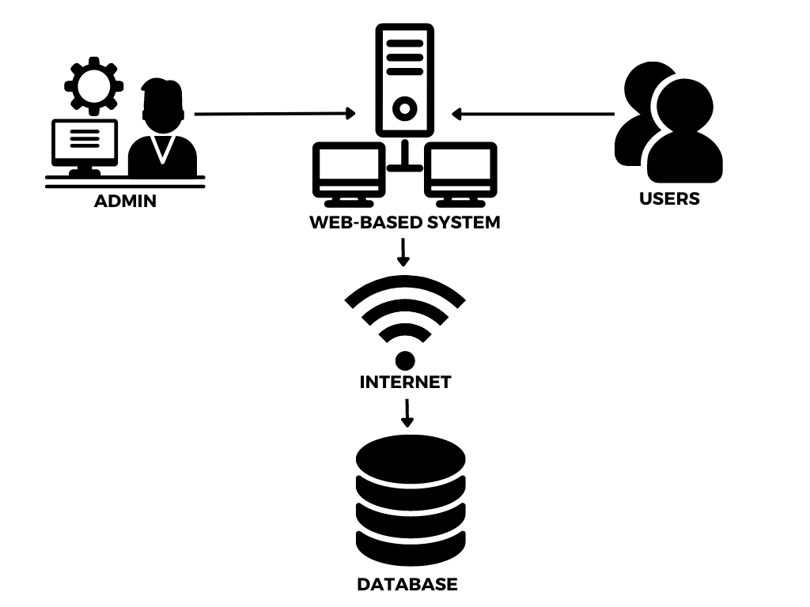

**Figure 3.3**

**Architecture Model of Development of Office Supplies and Materials Monitoring and Inventory System with Client Satisfaction Survey.**

This architectural model (figure 3.3) simplifies the Development of Office Supplies and Materials Monitoring and Inventory System with Client Satisfaction Survey by highlighting its essential components, Admin, User, Internet, Web-Based System, and Database. This clear depiction helps to visualize how these elements work together to manage office supplies and materials at the Libmanan Municipal Hall.

**Context Diagram**

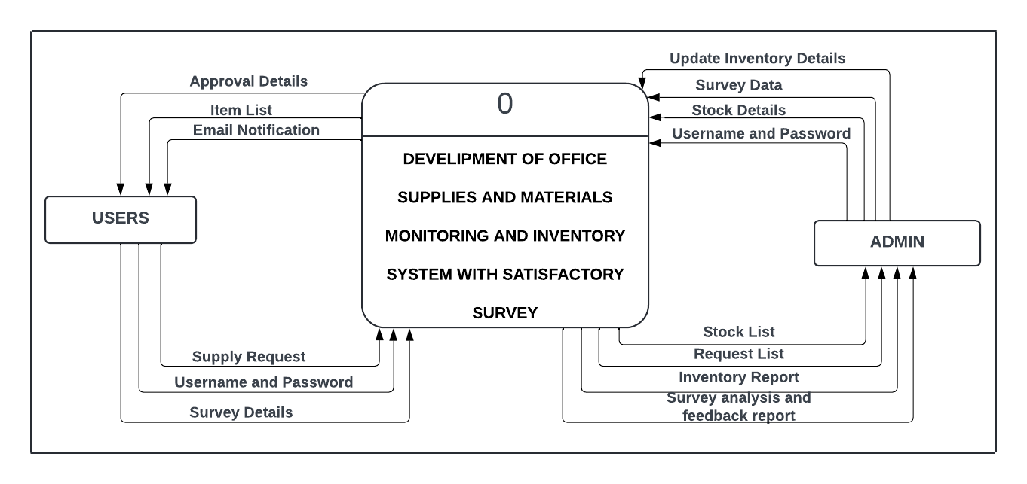 The Diagram shown in (Figure 3.4) is the Context Diagram or Level 0 Data Flow Diagram which the researchers constructed to show the interaction between the user and the system.

**Figure 3.4**

**Level 0 DFD or Context Diagram of Development of Office Supplies and Materials Monitoring and Inventory System with Client Satisfaction Survey.**

In the context of the Development of Office Supplies and Materials Monitoring and Inventory System with Client Satisfaction Survey, Figure 3.4 illustrates two key users, the General Services Office (GSO), which is the Admin, and offices for users. The Admin input and outputs are visually represented through arrows and corresponding labels. To provide a detailed perspective on the system’s functionality, the researchers have developed Level 1 Data Flow Diagram ( Figure 3.5 ), detailing the processes for each data flow within various aspects or features of the system.

**Figure 3.5**

**Part 1 Level 1 Data Flow Diagram for Development of Office Supplies and Materials Monitoring and Inventory System with Client Satisfaction Survey.**

Figure 3.5 illustrates the interactions between the admin, employees, and system users. It highlights the login process and various user-specific activities within the system. Employees can access and manage the system with certain restrictions. Admins, on the other hand, have comprehensive control over the system, allowing them to view and manage all information on the dashboard without any limitations. Users can view the dashboard, monitor inventory levels, request supplies, and provide feedback through satisfaction surveys.

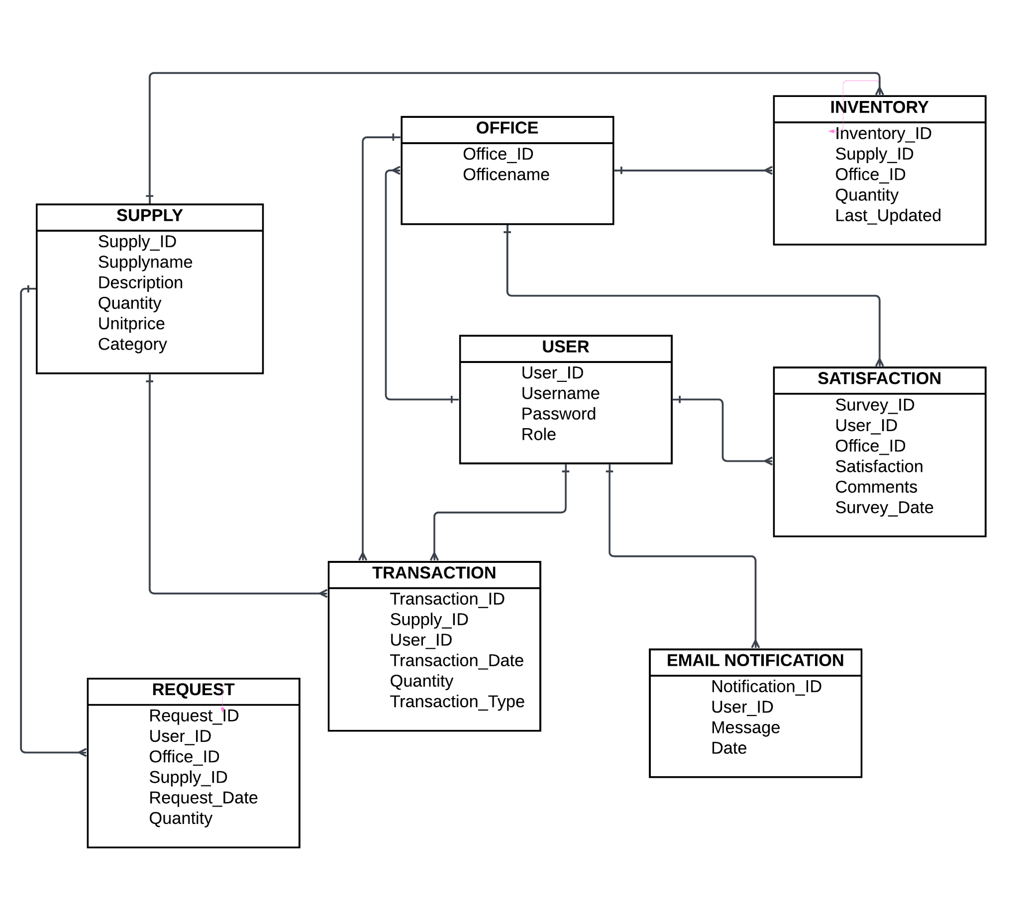

**Figure 3.6**

**Entity Relationship Diagram of Development of Office Supplies and Materials Monitoring and Inventory System with Client Satisfaction Survey.**

**NOTES**

Abrahamsson, P., Salo, O., Ronkainen, J., & Warsta, J. (2017). Agile Software Development Methods: Review and Analysis (Version 1). arXiv. <https://doi.org/10.48550/ARXIV.1709.08439>

Alsaqqa, S., Sawalha, S., & Abdel-Nabi, H. (2020). Agile Software Development: Methodologies and Trends. International Journal of Interactive Mobile Technologies (iJIM), 14(11), 246. <https://doi.org/10.3991/ijim.v14i11.13269>