**Table of Content**

1.0 Defect Detection 1

1.1 Methodology Flowchart 1

1.2 Code Explanation and Results 2

Initialization 2

Glove and Defect Detection 3

Defect Identification 5

1.3 Problems faced and solutions 7

# 1.0 Defect Detection

## 1.1 Methodology Flowchart

Figure 1 Defect Detection Flowchart

## 1.2 Code Explanation and Results

### Initialization

Figure 2 Import libraries and video capture

First of all, the developer imported the necessary libraries, defined the video size, and inputted the video data. Then, the developer started looping the video object and resizing the captured frame. The most important part is the frame conversion from BGR format to HSV format as the HSV color space is more meaningful and contains psychological color perception that eases the color segmentation process implemented to detect the gloves and defects.

### Glove and Defect Detection

Figure 3 Finding and labelling glove

Then, the developer defined the mask array range for the ‘light blue’ color glove. The defined mask was utilized in finding the glove’s contours to filter out the glove. ‘cv2.findContours’ is a method to detect the change in the image color and marks it as contour. For its parameters, ‘RETR_CCOMP’ is chosen as the retrieval mode because it stored all the retrieved contours in a two-level hierarchy, and ‘CHAIN_APPROX_SIMPLE’ is selected as the contour approximation mode because it compresses and remains the end points of the horizontal, vertical, and diagonal segments. The found contours consist of the light blue color parts which belongs to the glove part. After that, the developer drew a rectangle bounding box for the detected glove and labelled it as ‘Glove’. The following diagram shows the filtered contours with the light blue color mask

Figure 4 Color Segmentation Technique

Code line 32 shows the way to retrieve the defects within the glove. It will filter out the non-light blue color parts outside the glove’s contours and retain the non-light blue color parts within the gloves which are the defects as the detected colors are different. From the diagram above, there are three non-light blue color parts which are the result required for detecting the defect. All the found defects’ contours will then be stored in the ‘internal_cnt’ list.

### Defect Identification

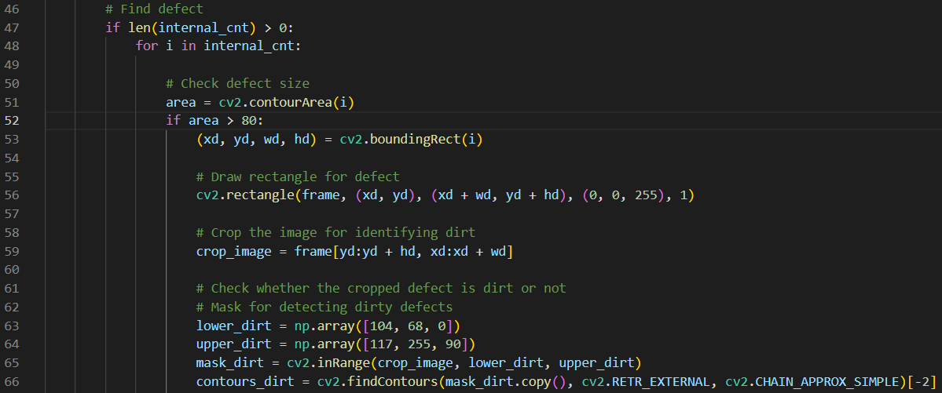

Figure 5 Finding defects in image

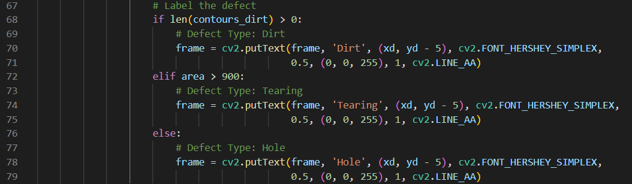

Figure 6 Labelling defects

After detecting the defect, the developer checked the defect’s color and size to define the types of the defect. There are three types of defects: Dirt, Tearing, and Hole. The program will only accept the contours with its size exceeding 80 as some small, unnecessary color difference due to the shadow can be filtered out. After that, the developer drew a rectangle bounding box for the detected defects and cropped it to check whether it belongs to ‘dirt’ or not. Mask array range for the ‘dark black’ color dirt was defined for the ‘findContours’ function. For its parameter, ‘RETR_EXTERNAL’ is chosen as the retrieval mode because it stored only the extreme outer contours in the ‘contours_dirt’ list. The defect will be defined as a dirt when there is not null in ‘contours_dirt’ list, the defect will be defined as a ‘tearing’ when the size of the defect is over 900, else the defect will be defined as a ‘hole.’ Similar to the glove, after identifying the defect types, the defects will be labelled with their types on the bounding box. The diagram below shows the three different types of defects identified in this research.

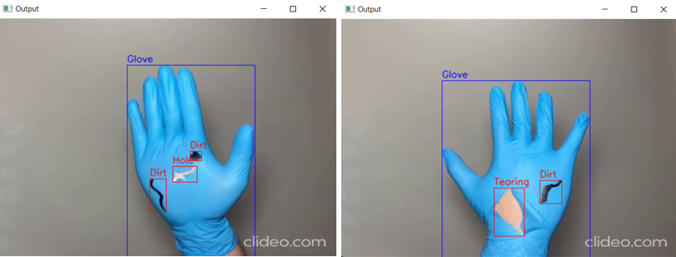

Figure 7 Three Types of Defects

## 1.3 Problems faced and solutions

During the defect detection and identification process, the developer met several problems, such as oversize video display, inaccurate color segmentation, and false positive labels of defects. As the input video data size is inconsistent that leads to the oversize of the output video frames, the developer resized all the input frame to 540 widths with 380 heights using the cv2.resize function.

Figure 8 Inaccurate Color Segmentation

The figure above shows the inaccurate color segmentation due to the incorrect defined light blue color mask array range. To solve this issue, the developer created a trackbar to adjust value range for the HSV color space using cv2.createTrackbar. The trackbar had a total of six categories, which are Hue Min, Hue Max, Saturation Min, Saturation Max, Value Min, and Value Max. As a result, the developer gained the most suitable HSV color range for the light blue color mask used in cv2.findContours function. The diagram below shows the HSV color space trackbar with the most suitable range for detecting and filtering the glove part.

Figure 9 HSV Color Space Trackbar

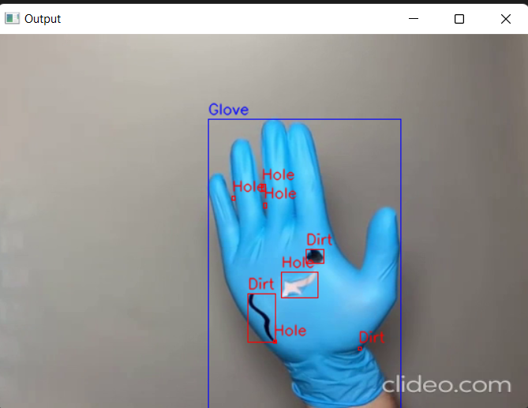

Figure 10 False Defect Labels

The diagram above shows the defect labelling with low accuracy. It is because some small defects are caused by the gloves’ shadow. Although the defect is small, the program will give it a bounding box and label it with the corresponding defect type as long as the defect is within the glove. To solve this issue, the developer created a condition to consider only the defects with size larger than 80. As a result, the small, unnecessary defect will be neglected resulting in correct labelling of the defect.