SMOOTHED PARTICLE HYDRODYNAMICS:
A PRACTICAL GUIDE

Introduction
When the sample points are fixed in space and the fluid flows past them, we speak of Eulerian approaches, such as Finite Element Method, Finite Differences. SPH however belongs to the Lagrangian approaches where the sample points move along with the fluid.

Fundamentals

Golden rules from Monaghan
- If you want to find a physical interpretation of an SPH equation, it is always best to assume the kernel is a Gaussian.
- It is best to rewrite formulae with the density placed inside operators to yield more accurate results.

Integral interpolation
From Monaghan, 1992. Any function A(r) can be interpolated by

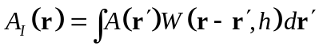 ( 2. )

where the integration is over the entire space, h is the smoothing length and W is the interpolating kernel satisfying the two properties

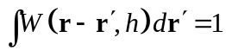 ( 2. )

and

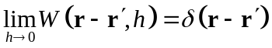 ( 2. )
.

For numerical work the integral interpolant is approximated by a summation interpolant

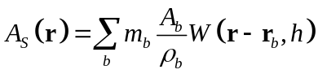 ( 2. )

where the summation index b denotes a particle label, and the summation is over all the particles.
Particle b has mass m_{b}, position r_{b}, density ρ_{b}, and velocity v_{b}. The value of any quantity A at r_{b} is denoted by A_{b}.
It is possible to construct a differentiable interpolant of a function from its values at the particles (interpolation points) by using a kernel which is differentiable. In order to obtain ∇A for example, we can use

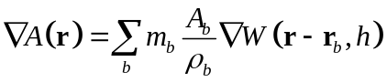 ( 2. )

though to obtain higher accuracy we use

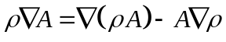 ( 2. )

Kernels
A one dimensional Gaussian kernel used in the original calculations of Gingold and Monaghan, 1977

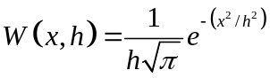 ( 2. )

Spline based function, Monaghan and Lattanzio, 1985

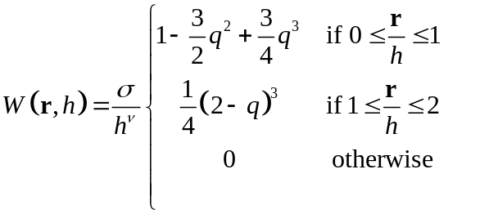 ( 2. )

where ν is the number of dimensions and σ is a normalization constant with values 2/3, 10/(7π) and 1/π for one, two and three dimensions respectively.

Super Gaussian kernel in 3D

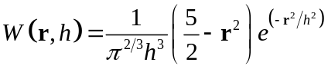 ( 2. )

this kernel is called super because the dominant errror is O(h⁴) instead of O(h²) for the traditional kernels

Equations of motion

The momentum equation
Monaghan, 1992

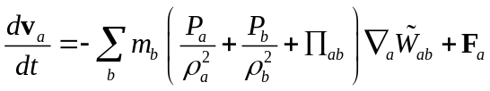 ( 3. )

where ∇_{a} denotes the gradient taken with respect to the coordinates of particle a.
In order to guarantee the conservation laws of energy, momentum and angular momentum, Hernquist and Katz, 1989 symmetrized the Kernel

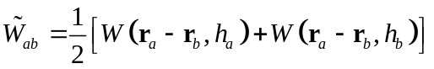 ( 3. )

Benz, 1990 symmetrized the smoothing length

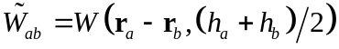 ( 3. )

where Π_{ab} is given by

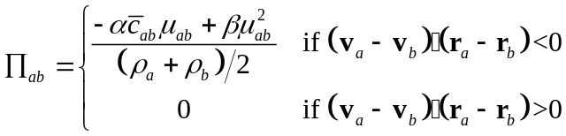 ( 3. )

and

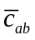 is the mean sound speed and can be calculated from

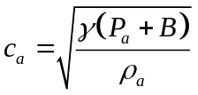 ( 3. )

where B comes from the equation of state (and has the units of pressure), discard this term if another equation of state is applied.

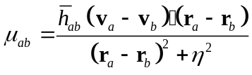 ( 3. )

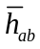 is the mean smoothing length and F_{a} is the sum of the external forces acting on particle a

With this viscosity, shock fronts are spread over ca. 3h.
The values for the viscous constants α and β are not critical and typically (for strong shocks) α = 1 and β = 2, Steinmetz and Müller, 1993 use α = 0.5 and β = 1 for other cases.
η² prevents singularities and is set to η² = 0.01h², which means that smoothing of the velocity will only take place when particle spacing is < 0.1h.

The continuity equation
Monaghan, 1992

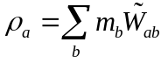 ( 3. )

Hernquist and Katz, 1989 introduced two interpretations for equation 3.. The “scatter” interpretation assumes that each particle has a mass, which is smeared out in space according to W and h. The density at any point in space is then found by summing the contributions from the density profiles of neighbouring particles. The alternative, “gather” interpretation says that the particles can be regarded as point markers in the fluid. Local properties at any point in space are obtained by sampling all neighbouring particles.
Another formulation is

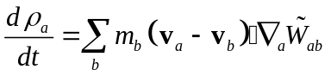 ( 3. )

This latter formula has the advantage that an initial density can be set for each particle, making it easier to deal with edges. Moreover this formulation allows for one single pass over all the particles to compute the rates of changes of all physical variables. The former formula however conserves mass exactly, which is not true for the latter one.

The thermal energy equation
Monaghan, 1992

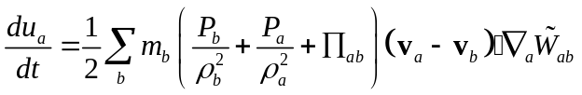 ( 3. )

Equation of state
Ideal gas with specific heat ratio γ

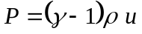 ( 4. )
Water
Roy, 1995
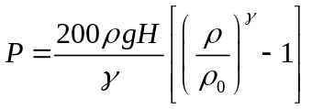 ( 4. )

with g the gravitational constant and H the maximum depth of the water

Smoothing length

h varying with time but constant in space
Steinmetz and Müller, 1993

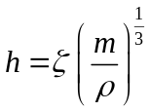 ( 5. )

where ζ is a parameter of order unit. The density, ρ can be approximated by taken the density from the previous timestep, Miyama et al., 1984.
Benz, 1990 used the following expression

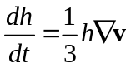 ( 5. )

in which the right hand side is rewritten using the continuity equation
Another approach is trying to keep the number of neighbouring particles within a sphere of size 2h fixed, with a certain tolerance, Herquist and Katz, 1989.
Steinmetz and Müller, 1993 proposed the following algorithm
The smoothed density and its time derivative with a smoothing length h* = h/θ with θ = 0.8.

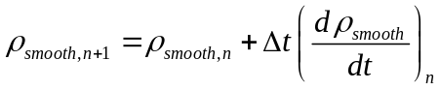 ( 5. )
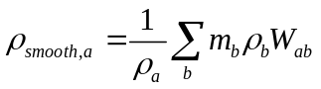 ( 5. )
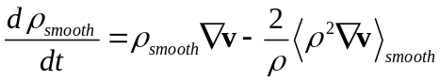 ( 5. )

The average density

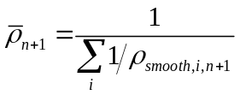 ( 5. )
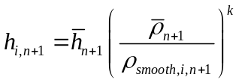 ( 5. )
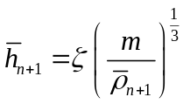 ( 5. )

Suitable values for the parameters are, ζ = 1.2 , k = 1/3 (… 1/6), ζ = 1 also gives good results but in regions of steep density gradients the mean number of neighbours can drop from typically 35 below 10, for ζ = 1.2 these values range from 50 to 20.

h varying with time and in space
Monaghan, 1992

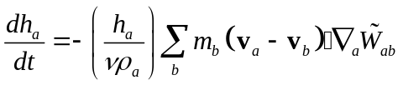 ( 5. )

In this situation momentum can be conserved is the kernel is made symmetric

Time step
Monaghan, 1992

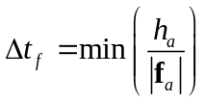 ( 6. )

for the force per unit mass and

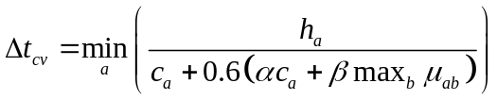 ( 6. )

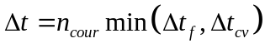 ( 6. )

where the Courant (safety) factor, n_{cour} is typically 0.25, but can be increased untill 0.4, Δt_{f} is based on the force per unit mass f, and Δt_{cv} combines the Courant and the viscous time step controls.
For a correctly chosen timestep the energy should be conserved to within 0.5 % over 400 time steps.

Following Troy, 1995

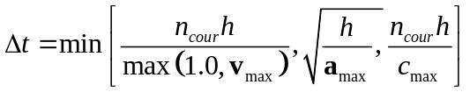 ( 6. )

Information shouldn’t travel faster than; the particles, the velocity determined by the acceleration of the flow (looking ahead), the velocity of the sound.

Time integration

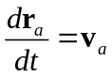 ( 7. )

Leapfrog method, which is accurate to second order in the time step.

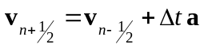

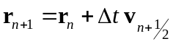

such that the predicted velocity used in the SPH equations is calculated according to

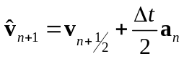

Second-order Runge Kutta (Benz, 1989)

X-tra

XSPH variant
“X” is the unknown factor, following Monaghan, 1989.

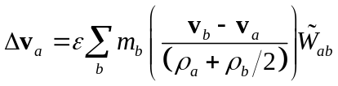 ( 8. )

ε is a constant with (0 ≤ ε ≤ 1)
This Δv_{a} must be added to the velocity for updating the positions only. The velocity used in the other SPH equations should not be increased with this term. (Roy, 1995)
Proven to be useful for the simulation of nearly incompressible fluids.

Individual time steps
Hernquist and Katz, 1989.
All individual time steps are chosen to be a power-of-two subdivision of the largest system sime step, Δt_{s} such that,

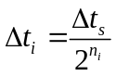 ( 8. )

where, n_{i} , a strict positive natural number, refers to the time bin of particle i and Δt_{s} is an input parameter. Particles can move to a higher time bin at the end of their own time step, but have to wait until the lower time bin is finished to step onto the train of this lower time bin.
The particle positions and the thermal energy equation are advanced with a time step

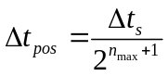 ( 8. )

where n_{max} is the largest bin currently occupied. This results in half the smallest time step since this is required for the intermediate update of the pressure for the leapfrog algorithm.
When particles change time bins their positions must be updated using

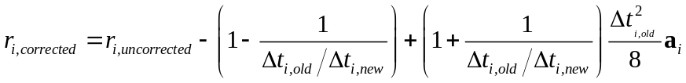 ( 8. )

Implementation

Initialization
At the start of the simulation the mass, position, velocity, and thermal energy of each particle have to be specified. The initial density must also be specified of one updates it with the incremental formula instead of the weighting of the masses.

General scheme
Following Roy, 1995.

Initialization
While (time<end_of_time)
Update rates of change:
For all particles
Calculate acceleration due to pressure gradient (equation 3.)
Calculate rate of change of thermal energy (equation 3.)
Calculate rate of change of density (equation 3.)

Handle collisions

Update positions
For all particles
Calculate XSPH velocity variant (equation 8.)

For all particles
Update position, velocity (using leap-frog integrator)
Update thermal energy
Update density

Update pressures
For all particles
Compute pressure using modified equation of state
Compute speed of sound

Calculate new time step
Time += new_timestep

Particle attributes
According to Roy, 1995
Mass m : according to m=ρV where V is the volume of one particle
Density ρ : with a small offset in the initial values
Pressure P
Thermal energy u
Position r
Velocity v
Acceleration a

Obstacles
Obstacles are implemented as surfaces that trigger repulsive forces in the particles, modelled for example by springs. They are summed for each particle a under the term F_{a}.

Data structures
In order to avoid the O(n²) dependency for the particle-particle method of the computing time on the number of particles, n, data structures are considered that allow for more efficient calculations.

Hierarchical tree
In astrophysics where self-gravity is important tree-methods are generally used.
Hernquist and Katz, 1989.
In the Barnes-Hut method space is divided into cubic cells. The root corresponds to the entire space, this cube is divided into 8 cubic cells (for 3 dimensions) which form the 8 children of the root node. This procedure is repeated for each child until each leaf contains only 1 particle. Empty branches are discarded. Essential information is calculated for each node (e.g. total mass, position of centre-of-mass…). For calculations one starts on top of the hierarchy and descends until

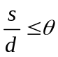

where s is the size of the current cell, d is the distance between the cell and the particle and θ is a fixed tolerance parameter.

Linked list
If the same h can be used for all particles a linked list method is more appropriate. The grid should be built up of cells with width 2h such that only neighbouring cells have to be checked.

Validation

Double shock tube problem in 1D
Woodward and Colella, 1984
The interaction of two strong shock or blast waves is simulated in one dimension. The initial state consists of three constant states of a γ = 1.4 gas in the interval 0 ≤ x ≤ 1 with reflecting boundaries on both sides. The density is unity everywhare and the pressure is assumed to be P = 1000 from x = 0 to 0.1, P = 0.01 from x = 0. to 0.9 and P = 100 from x = 0.9 to 1.
These initial conditions give rise to two shock waves propagating into the cold (i.e. low pressure) gas and two rarefraction waves moving into the hot (i.e. high pressure) gas. The Mach numbers M of the two shocks are very large in the left and right shock being M ≈ 170 and M ≈ 51 respectively.
Snapshots of the density and the velocity as a function of the position are taken at times equal to 0.010, 0.016, 0.026, 0.028, 0.030, 0.032, 0.034 and 0.038. Results can be found in Steinmetz and Müller, 1993, Woodward and Colella, 1984, Woodward 1982.

Reference
Import from ProCite
Monaghan, 1992
Gingold and Monaghan, 1977
Miyama, S.M., Hayashi, C. Narita, S., 1984, ApJ 279, 621

