# Lab 8: Direct data access

# Our goal: Practice data interpretation and plotting with messy, real-world data.

You should open and format your own Jupyter Notebook for this lab. There is helper code on GitHub for Part 3 only. You will submit this document and the code that you write for this lab via Canvas.

## Part 1: Observations of the tropical Pacific Ocean during a “normal” year

The National Oceanographic and Atmospheric Administration (NOAA) maintains several laboratories around the country for specialized atmospheric and oceanic research. Data for this exercise come from NOAA's Pacific Marine Environmental Laboratory (PMEL) (http://www.pmel.noaa.gov).

The ocean data in this exercise were collected in the tropical Pacific Ocean to help monitor the

development of El Niño and La Niña events, which are phenomena of the surface and near-surface Pacific Ocean. An array of moored buoys was established in the 1990's as part of the Tropical Atmosphere-Ocean (TAO) Project. Sensors attached to the buoys measure temperature, salinity, and other water properties from the surface to a depth of about 500 meters. Figure 1 shows the buoy locations.

pasted-image.tiff

Figure 1

**Analysing spatial variation, Part 1.** Figure 2 is a color-filled contour plot showing water temperatures in a vertical slice 500 meters deep along the equator in the tropical Pacific Ocean, during a five-day period in March 2003, a “normal" phase of ENSO. The sensors that recorded the data were located at positions marked by "X"s in Figure 2. The data were averaged meridionally (that is, along a line of longitude) across sensors located within ±2° latitude of the equator. (This plot came from the TAO web site: http://www.pmel.noaa.gov/tao/jsdisplay/.)pasted-image.tiffFigure 2

Based on the contour plot in Figure 2, fill in the following data tables for temperature vs. depth down to 500 meters **at 165°E and at 110°W longitude**. Note that the contour lines are plotted at intervals of 1°C and that the thicker contour lines correspond to temperatures of 12°, 16°, 20°, 24°, and 28°C. Rely on the contours to determine temperature and interpolate between them as needed.

| Depth [m] | Temp. [℃] at 165 E | Temp. [℃] at 110 W |
| --- | --- | --- |
| 0 |  |  |
| 25 |  |  |
| 50 |  |  |
| 75 |  |  |
| 100 |  |  |
| 150 |  |  |
| 200 |  |  |
| 250 |  |  |
| 300 |  |  |
| 400 |  |  |
| 500 |  |  |

Now use these data to create plots of the vertical temperature profile at each location using Python. Insert an image of your plot below Step 7.

* 1. Open a new notebook. Copy over the commands to import matplotlib, numpy, and xarray.
  2. Type in 3 lists with your data values. For example,

depth = (0, 25, 50, 75, 100, 150, 200, 250, 300, 400, 500)

* 1. Make a new plot. Use ax.plot(x,y), with temperature at 165 E on the x-axis and depth on the y-axis.
  2. Add a line for temperature at 110 W using a similar command.
  3. Edit the arguments in ax.plot() to choose a line color for each. Add a label for each location using the label argument. For example,

ax.plot(x, y, color=‘purple’, label=‘165 E’)

* 1. Change the axes settings so that depth increases downward.
  2. Add a legend to the plot using ax.legend(loc=‘best’).
  3. Insert an image of your plot here.

Based on your vertical profile plots and the contour plot answer the following questions:

1. How does the temperature profile differ in the eastern tropical Pacific compared to the western tropical Pacific? For example, where is the thermocline at each location?
2. Looking at your vertical temperature profiles, if the wind was blowing across the surface and causing equatorial divergence to a depth of approximately 75m, what would be the temperature of the water upwelled in the eastern tropical Pacific? What about in the western tropical Pacific?

## Part 2: Observations of the tropical Pacific Ocean during an “El Nino” yearpasted-image.tiff

Figure 3

Figure 3 is the same as figure 2, but for December of 2002, which was an El Nino year. Again, fill in the data tables and use those data to make a plot of the temperature profiles for 165°E and at 110°W longitude. Answer the questions on the next page.

| Depth [m] | Temp. [℃] at 165 E | Temp. [℃] at 110 W |
| --- | --- | --- |
| 0 |  |  |
| 25 |  |  |
| 50 |  |  |
| 75 |  |  |
| 100 |  |  |
| 150 |  |  |
| 200 |  |  |
| 250 |  |  |
| 300 |  |  |
| 400 |  |  |
| 500 |  |  |

1. Insert your plot here.
2. Describe the pattern of temperature at the surface as you move from the east side of the basin to the west side of the basin. What are the similarities or differences between this and the “normal” year from part 1?
3. How do the vertical temperature profiles for this time period differ from the “normal” year? Be sure to describe differences in both the east and west Pacific ocean. For example, is the thermocline at the same depth?  
   *Hint: Try a plot that overlays the “normal" versus El Niño profiles for each location.*
4. Looking at these El Niño year profiles, if the wind was blowing across the surface and causing equatorial divergence to a depth of approximately 75m, what would be the temperature of the water upwelled in the eastern tropical Pacific? What about in the western tropical Pacific?

## Part 3: La Niña conditions

Now, let’s access the data directly! Navigate to <https://www.pmel.noaa.gov/tao/drupal/disdel/>. You should see a screen like the one below.

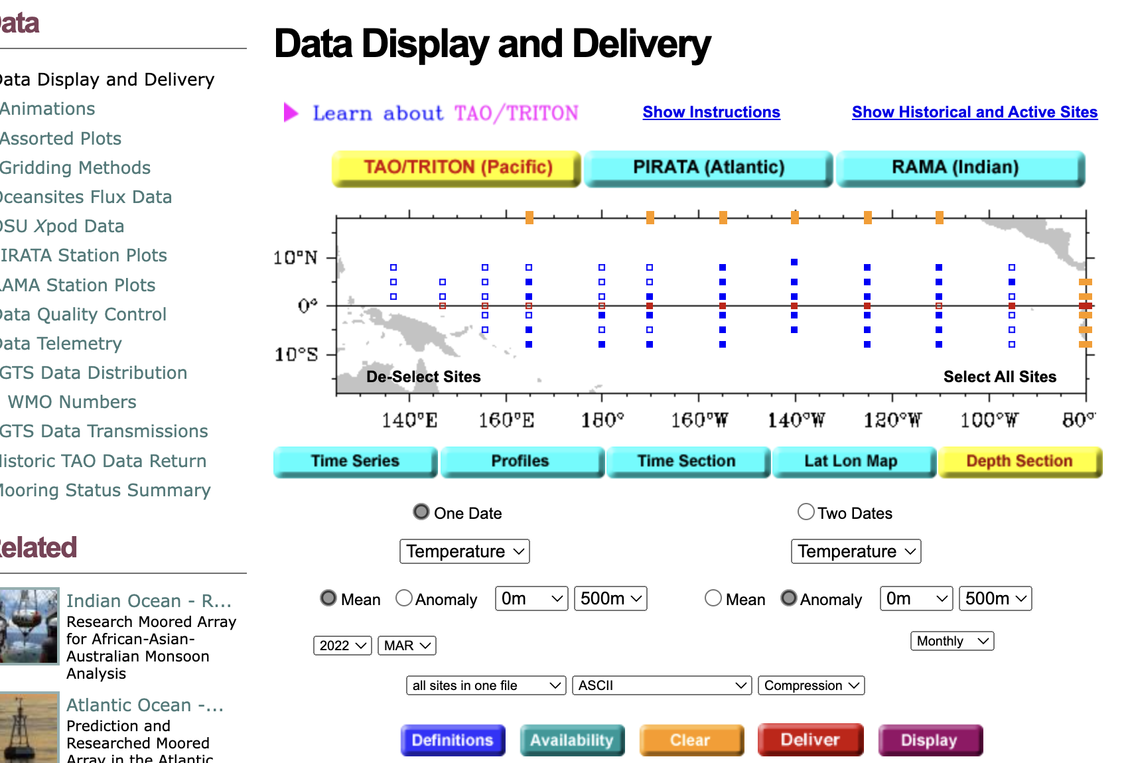

Select “TAO/TRITON”, “Depth Section”.

Then use the drop-downs to select “1999" “January" “Monthly”. January 1999 was a strong La Niña phase. Keep this page open; you will use it for two commands.

### A. Make your own contour plot

Choose “NetCDF (4-byte, CF time)” and click “Deliver”. You should see a pop-up window with several files. Right-click and select “Save link as”.

Use xarray to load this new data into your notebook. Follow the helper code to make a contour plot, filling missing data.

1. How much missing data was there? Were the missing points evenly distributed, or concentrated in specific areas? How does this affect your confidence in the contour plot?

Now, back on the TAO/TRITON page, click “Display”. You should see a pop-up with the January 1999 observations in the familiar contour plot.

1. How does your contour plot compare with the ones produced by PMEL?
2. Describe the pattern of sea surface temperature from east side to west in the basin. What are the similarities or differences between this and the “normal” year from part 1?

### B. Make your own profiles

Select the 165 E and 110 W longitudes and make temperature profiles as before. Use pt.subplots() to compare the two plots to each other (spatial differences during the same year) and to the same locations in the neutral and El Niño years we studied above.

1. How do the vertical temperature profiles for this La Niña year differ from the “normal” year? Be sure to describe differences in both the east and west Pacific ocean. For example, where is the thermocline?
2. How would you expect these differences to affect the distribution of precipitation on the nearby land areas?

### Extension: Add and analyze profiles for another location.

How do El Niño, La Niña, and neutral patterns compare in this location? How is this similar or different to other locations?