**MongoDB Task 1**

Database with products has designed:

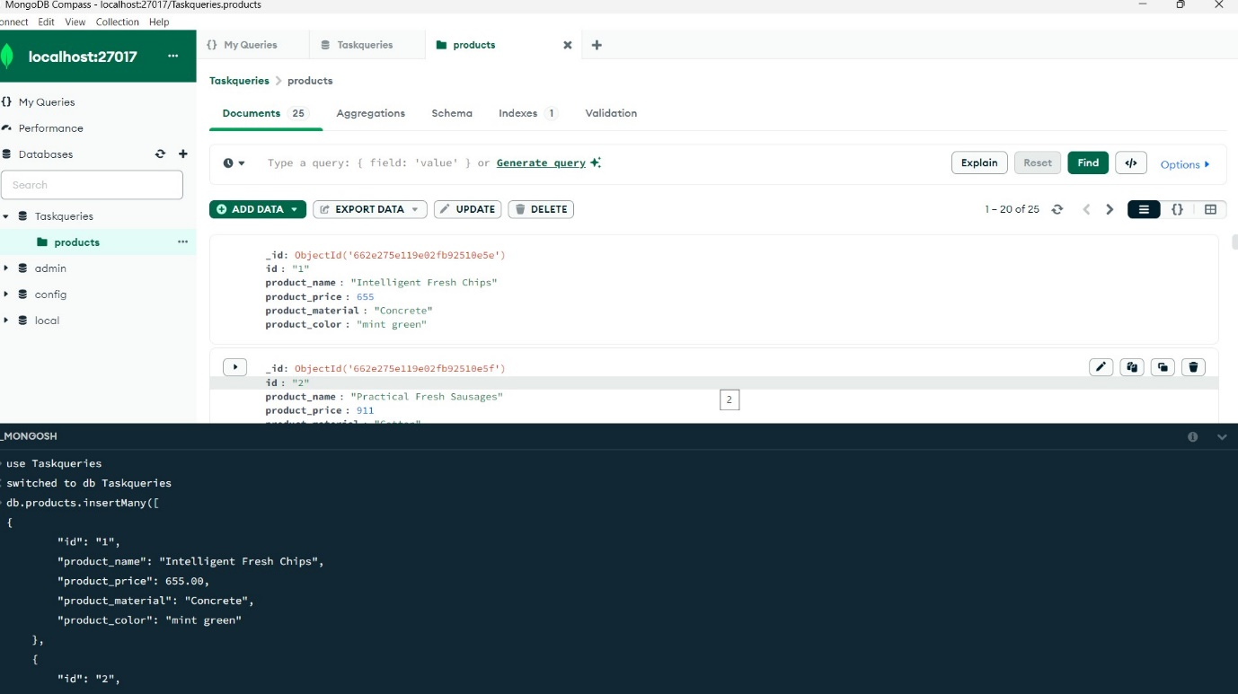

1. Find all the information about each products:

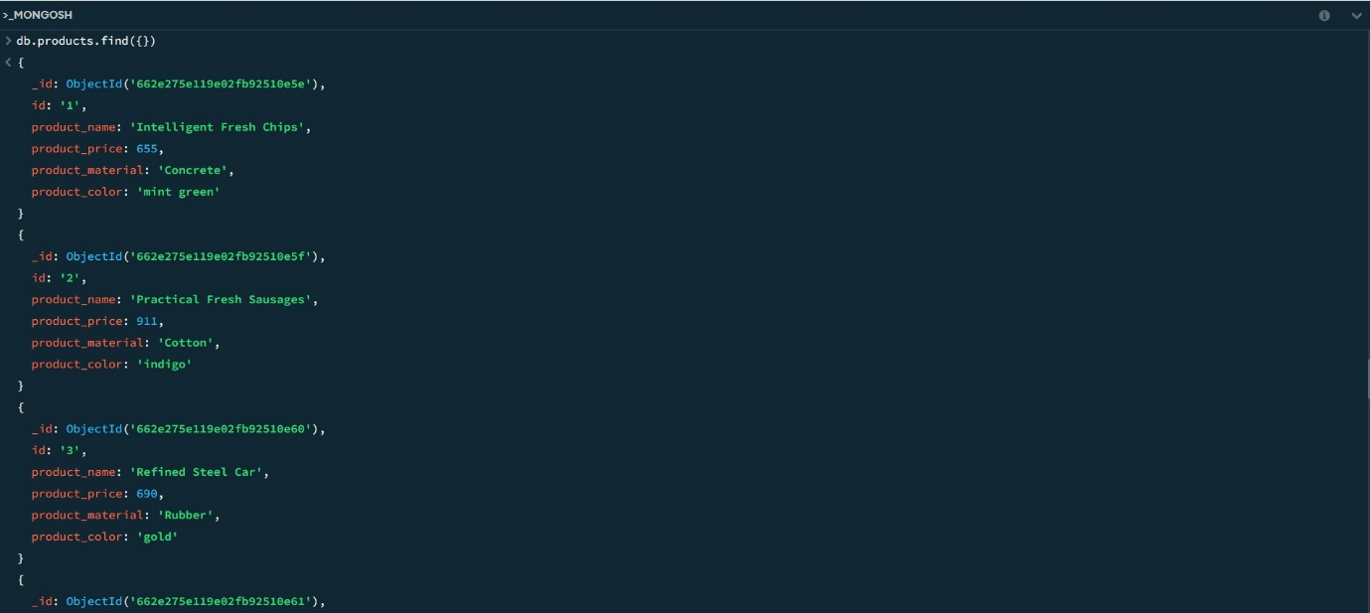

1. Find the product price which are between 400 to 800 :

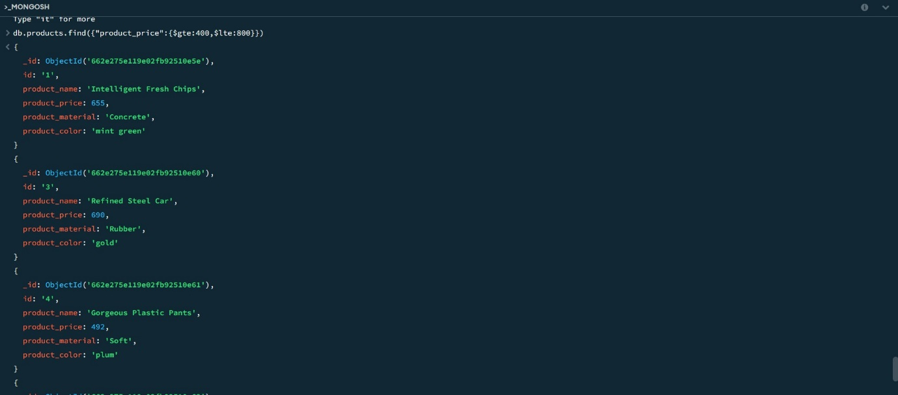

1. **Find the product price which** are **not between 400 to 600 :**

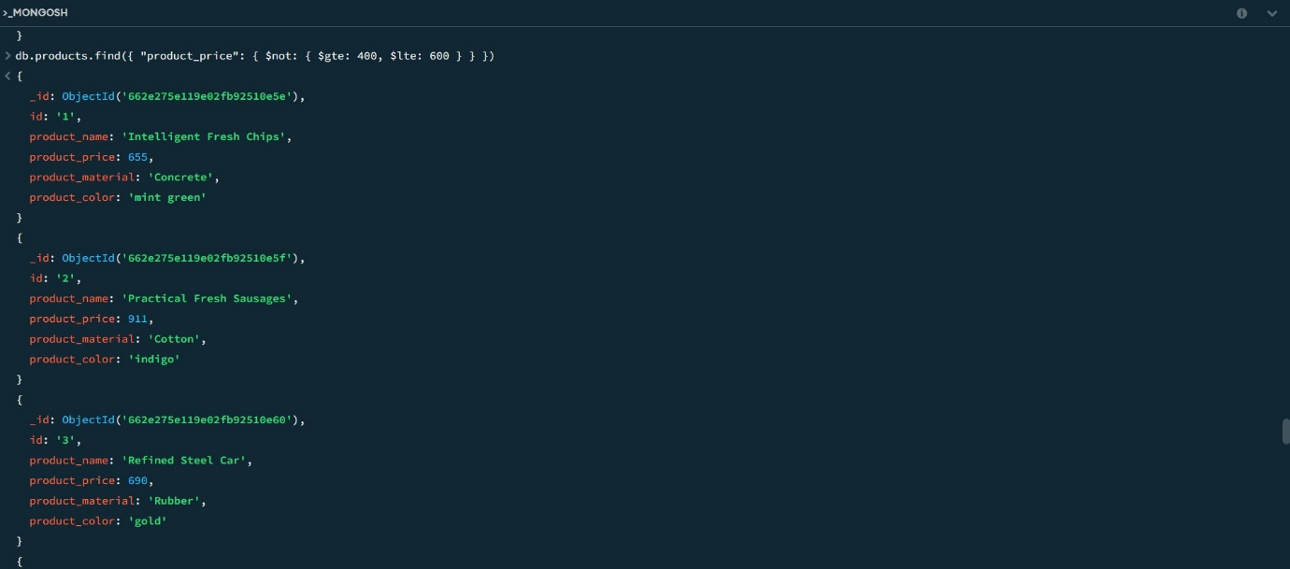

1. List the four product which are greater than 500 in price :

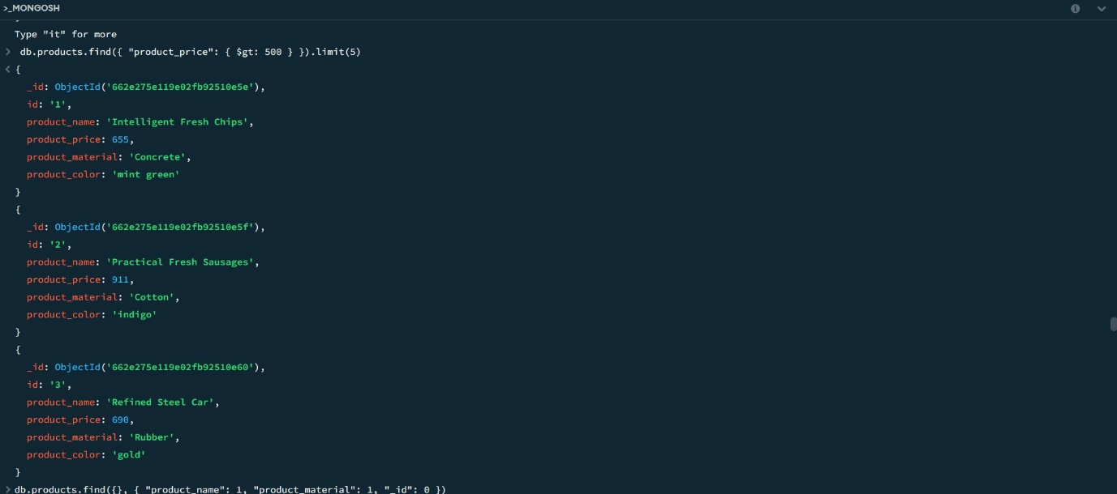

1. Find the product name and product material of each products :

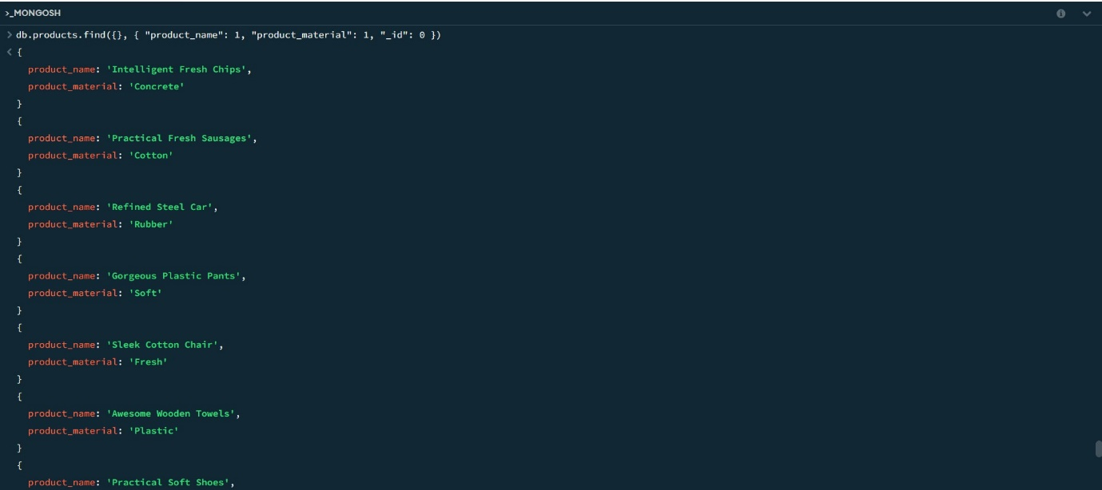

6.Find the product with a row id of 10 :

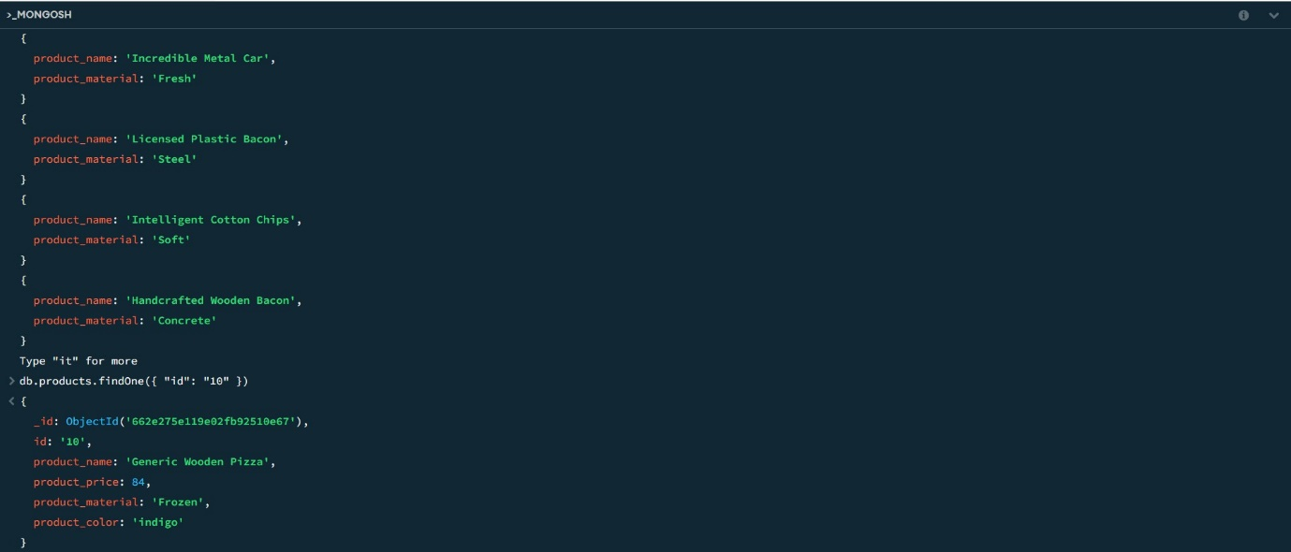

7.Find only the product name and product material :



8.Find all products which contain the value of soft in product material :

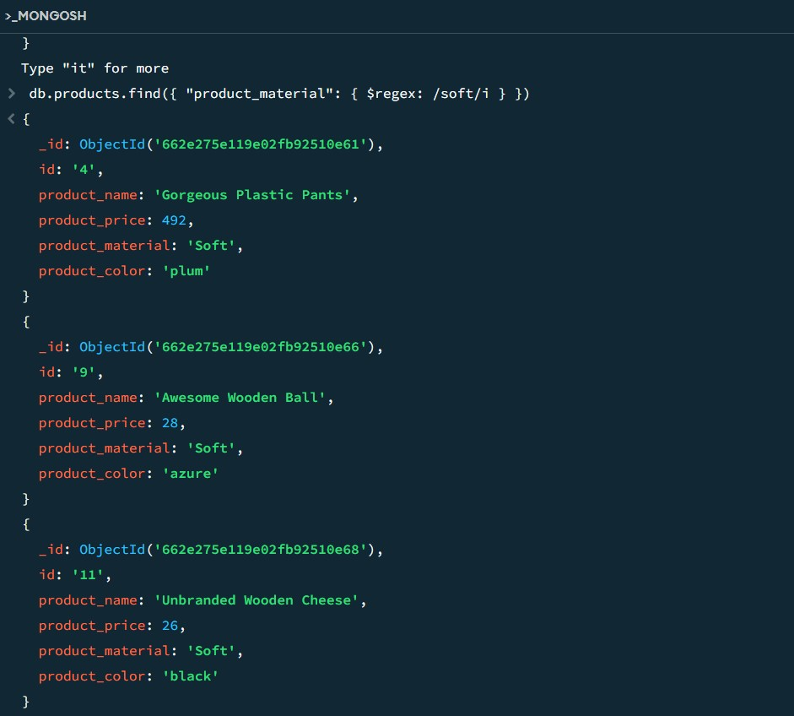

9.Find products which contain product color indigo  and product price 492.00 :

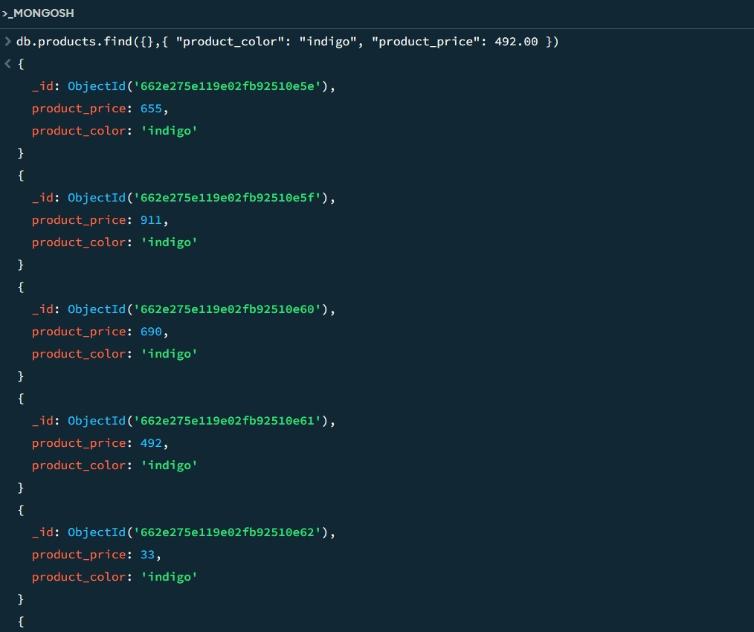

10.Delete the products which products price value are 28:

