**My SQL Task**

**Task1:Select from queries**

**a.Title from movies**

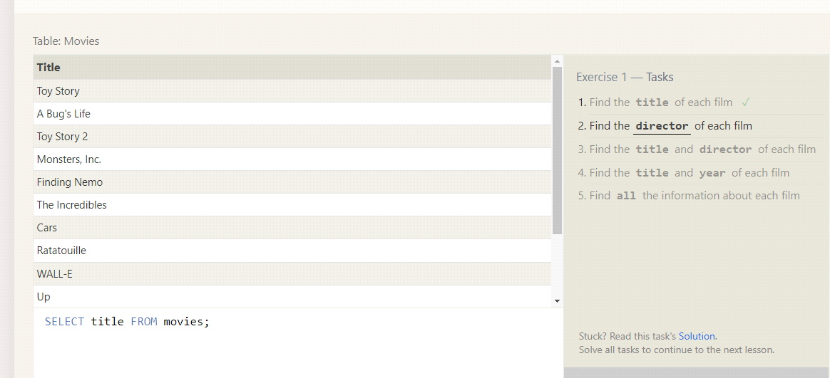

**b.Director of each film**

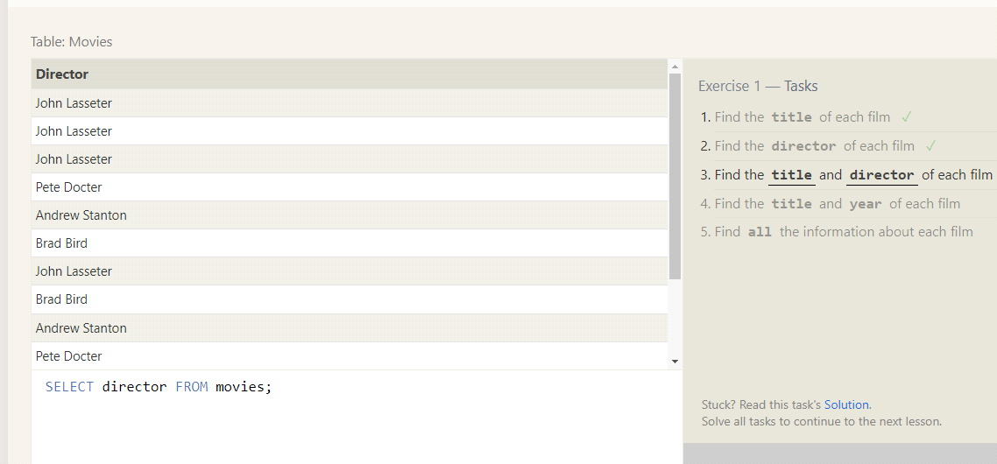

**c.Title and Director**

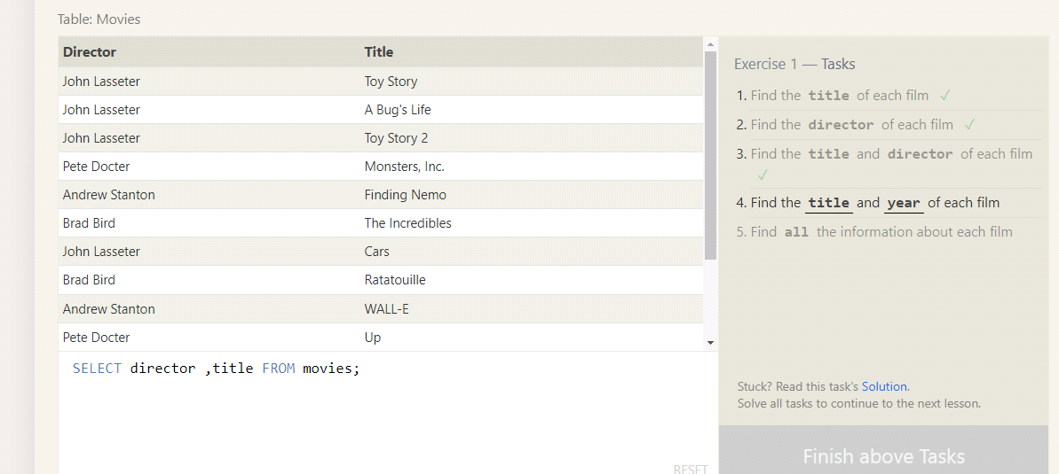

**d.Title and year**

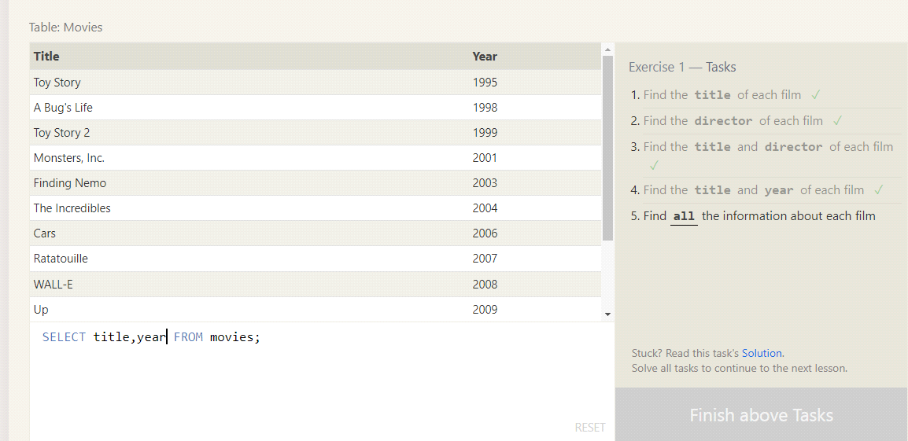

**e.Find all info**

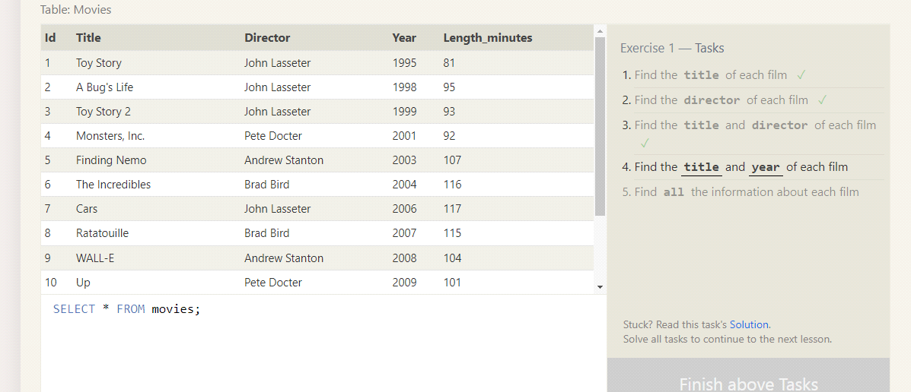

**2.Task2:Queries with constraints(Pt-1)**

**a.Movie with id=6**

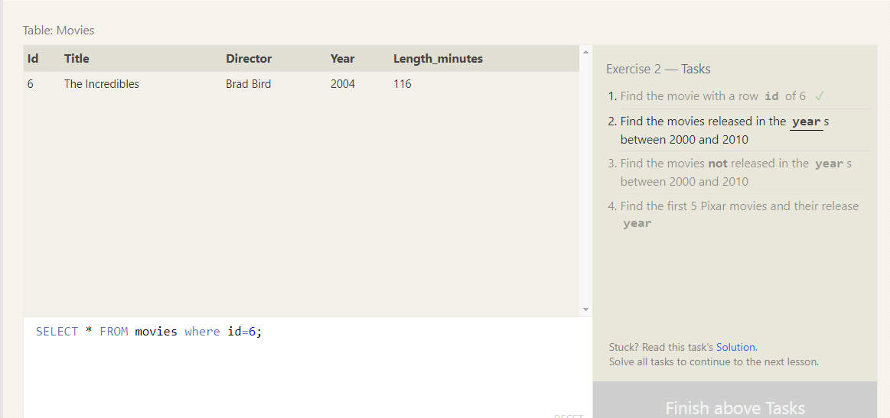

**b.Movies released in year bt 2000 and 2010**

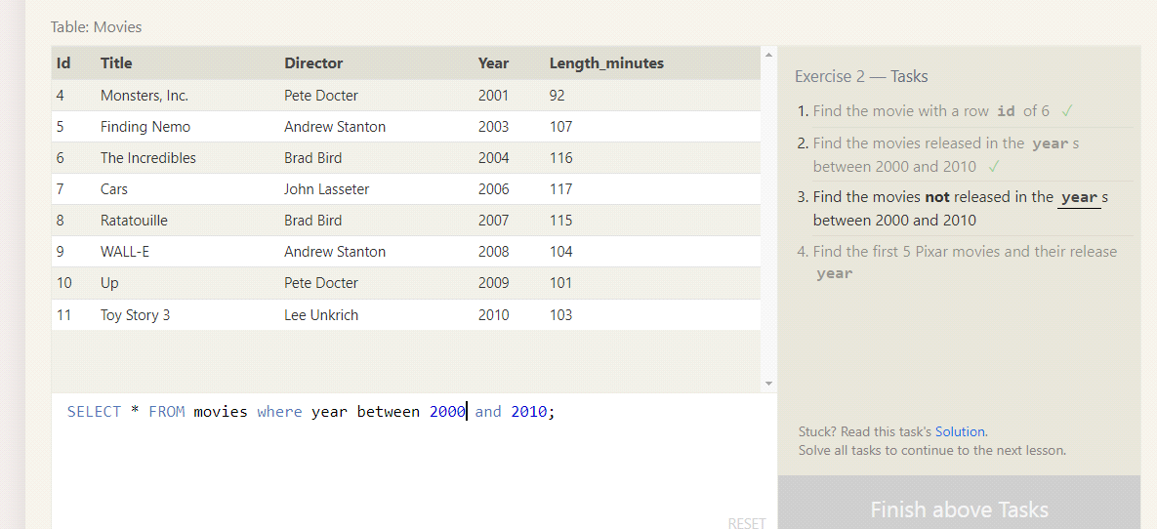

**c.Movies not released bt 2000 and 2010**

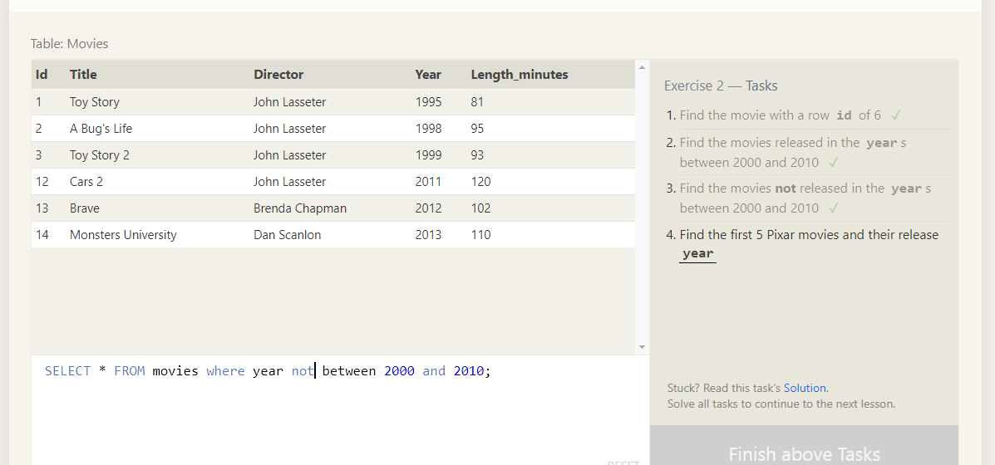

**d.First pixar movies and years**

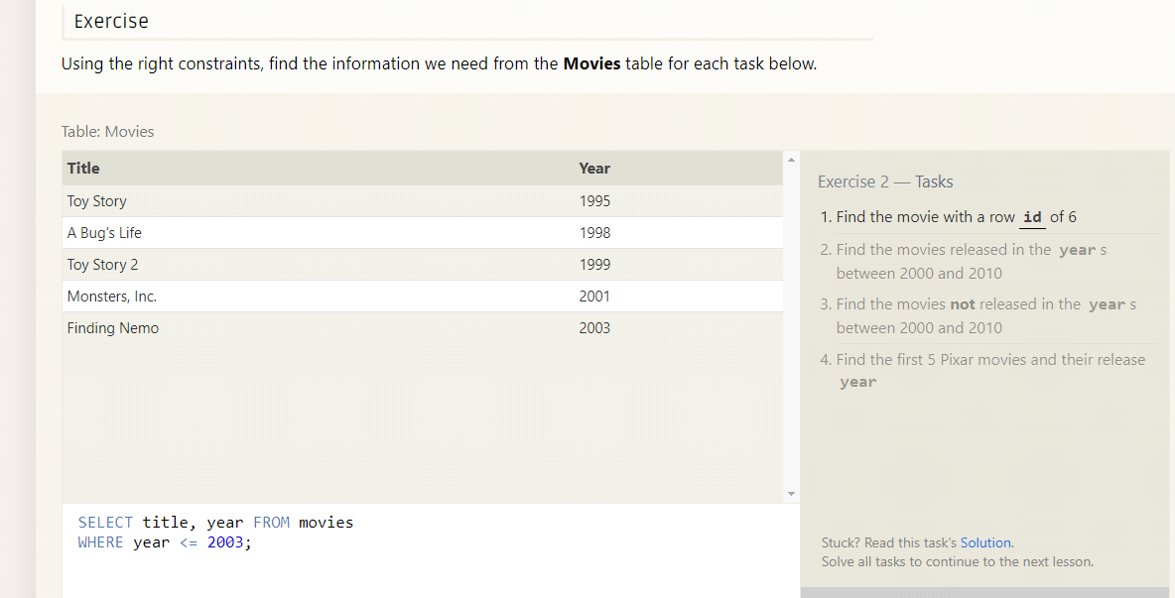

**3.Task 3:Queries with constraints(pt-2)**

**a.All Toy story movies**

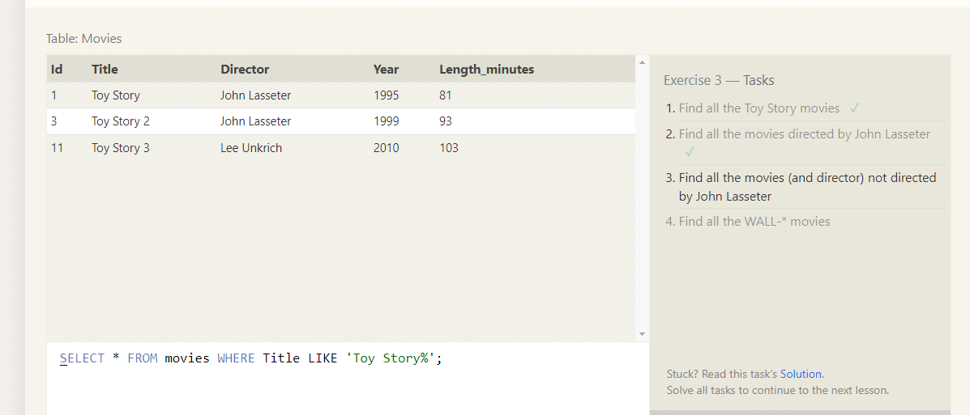

**b.Movies directed by John Lasseter**

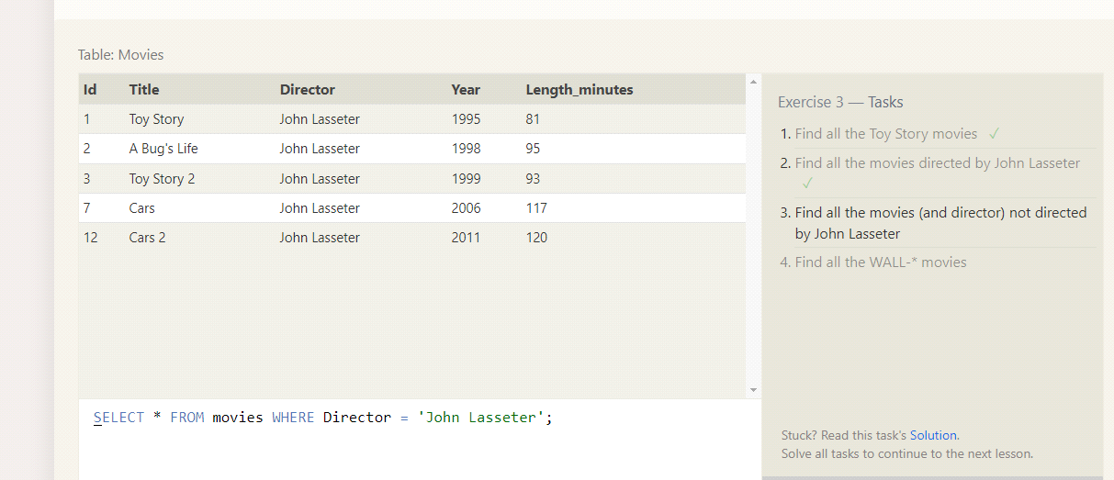

**c.Movies not directed by John Lasseter**

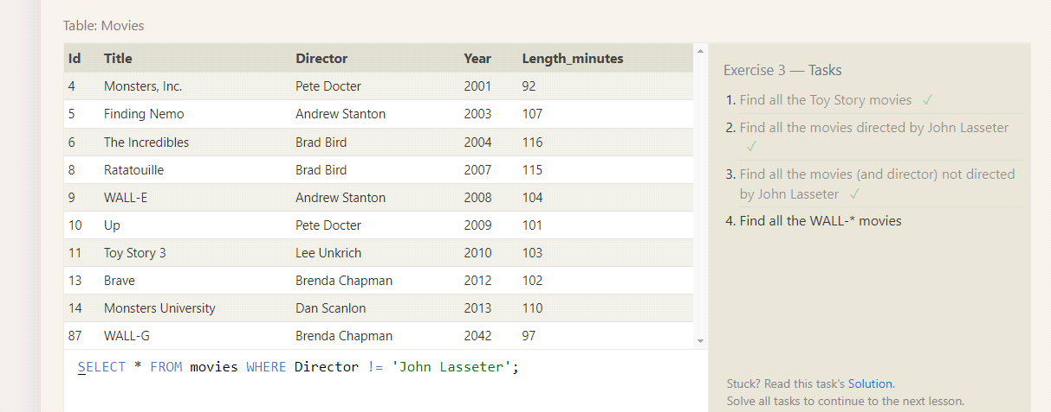

**d.Movies with Wall-\***

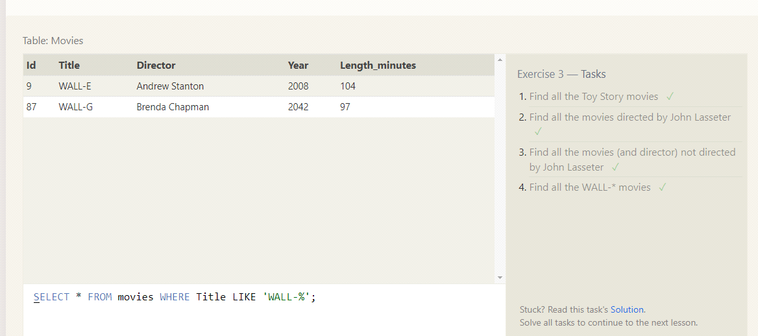

**4.Task 4:Filtering and sorting query results**

**a.Directors of pixar movies without duplicates**

**b.SELECT *FROM movies ORDER BY Year DESC LIMIT 4;**

**c.SELECT *FROM movies ORDER BY Title ASC LIMIT 5;**

**d.SELECT *FROM movies ORDER BY Title ASC LIMIT 5 OFFSET 5;**

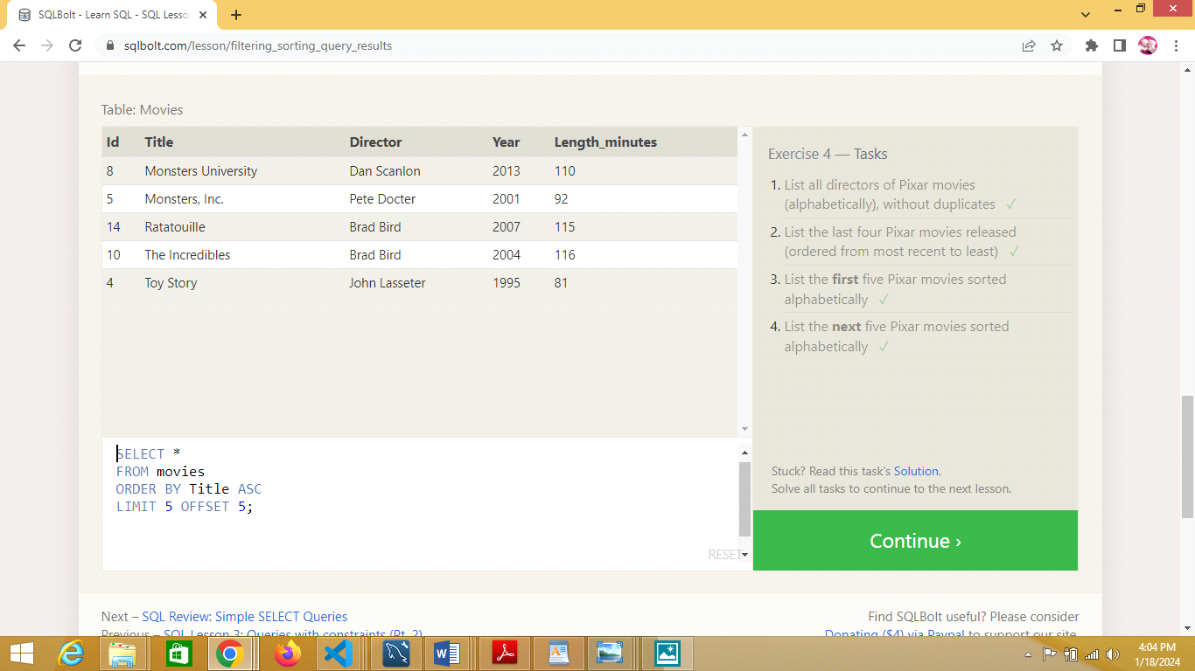

**5.Task :Simple select queries**

**a.SELECT City, Population FROM North_american_cities WHERE Country = 'Canada';**

**b.SELECT City, Latitude FROM North_american_cities WHERE Country = 'United States' ORDER BY Latitude DESC;**

**c.SELECT City, Longitude FROM North_american_cities WHERE Longitude < (SELECT Longitude FROM North_american_cities WHERE City = 'Chicago' ORDER BY Longitude ASC;**

**d.SELECT City, Population FROM North_american_cities WHERE Country = 'Mexico' ORDER BY Population DESC LIMIT 2;**

**e.SELECT City, Population FROM North_american_cities WHERE Country = 'United States' ORDER BY Population DESC LIMIT 2 OFFSET 2;**

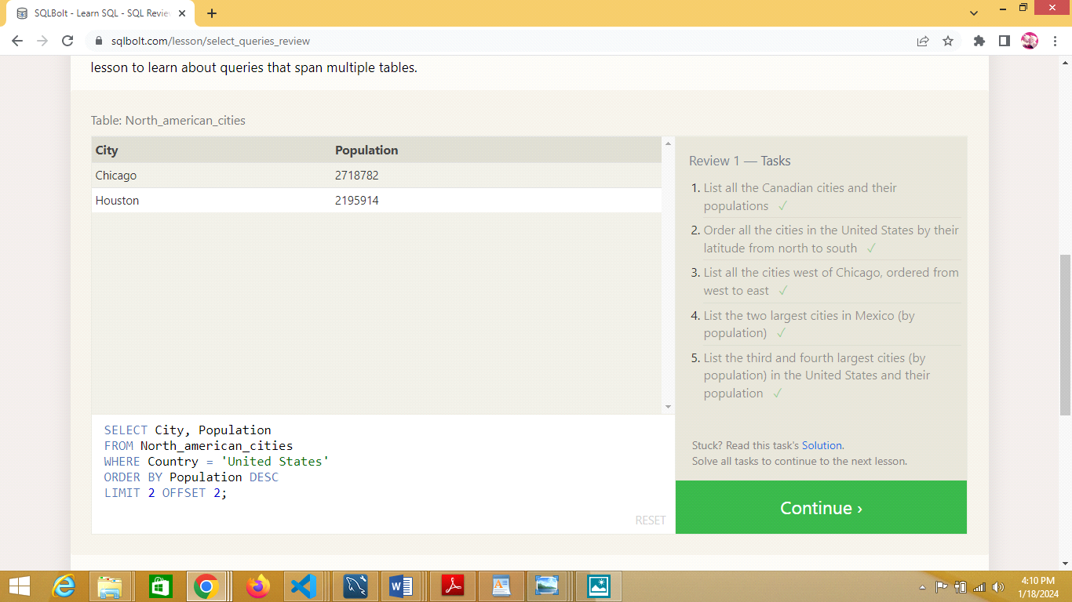

**Task 6:Multi-table queries with JOINS**

**a.SELECT Movies.Id, Title, Director, Year, Length_minutes, Domestic_sales, International_sales FROM Movies INNER JOIN BoxOffice ON Movies.Id = BoxOffice.Movie_id;**

**b.SELECT Movies.Id, Title, Director, Year, Length_minutes, Domestic_sales, International_sales FROM Movies INNER JOIN BoxOffice ON Movies.Id = BoxOffice.Movie_id WHERE International_sales > Domestic_sales;**

**c.SELECT Movies.Id, Title, Director, Year, Length_minutes, Rating FROM Movies INNER JOIN BoxOffice ON Movies.Id = BoxOffice.Movie_id ORDER BY Rating DESC;**

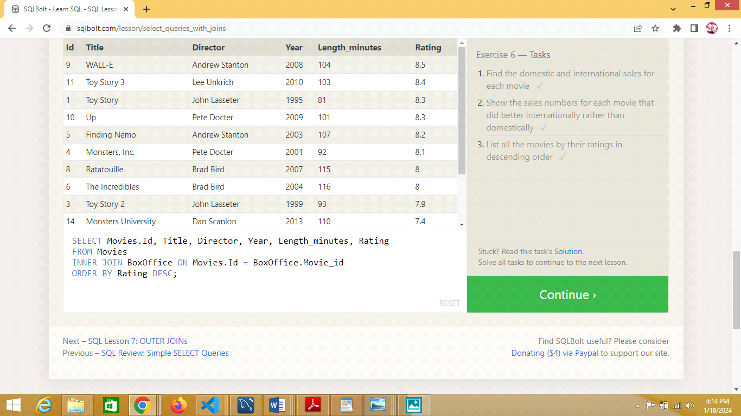

**Task 7:Outer JOINS**

**a.SELECT DISTINCT e.Building FROM Employees e LEFT JOIN Buildings b ON e.Building = b.Building_name WHERE e.Building IS NOT NULL;**

**b.SELECT b.Building_name, b.Capacity FROM Buildings b LEFT JOIN Employees e ON b.Building_name = e.Building GROUP BY b.Building_name, b.Capacity;**

**c.SELECT DISTINCT b.Building_name, e.Role FROM Buildings LEFT JOIN Employees e ON b.Building_name = e.Building;**

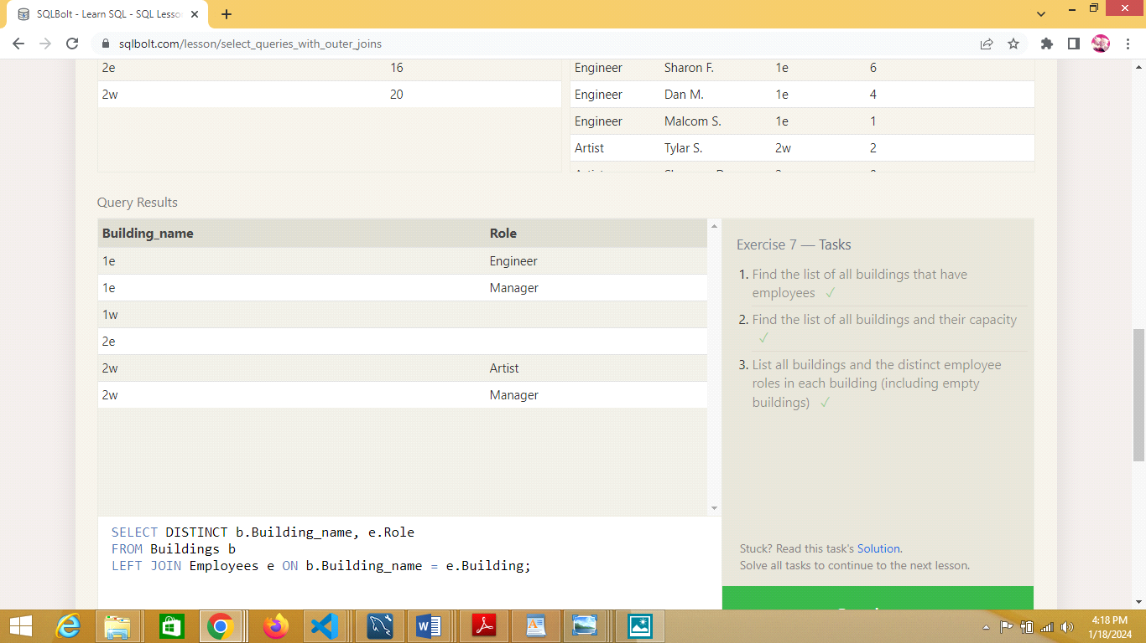

**Task 8:Short note on NULLs**

**a.SELECT Name, Role FROM Employees WHERE Building IS NULL;**

**b.SELECT Building_name FROM Buildings WHERE Building_name NOT IN (SELECT DISTINCT Building FROM Employees WHERE Building IS NOT NULL);**

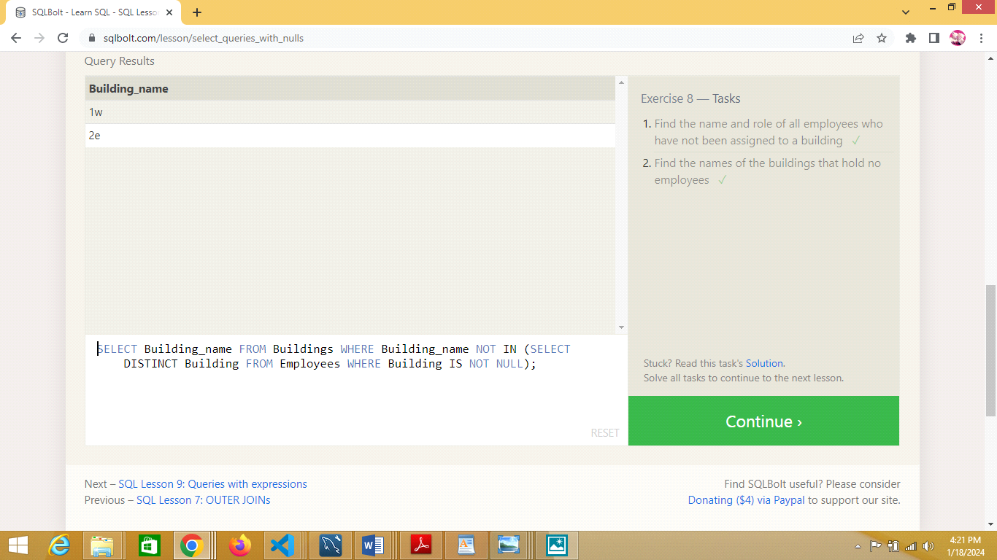

**Task 9:Queries with expressions**

**a.SELECT**

**m.Id,**

**m.Title,**

**m.Director,**

**m.Year,**

**m.Length_minutes,**

**(b.Domestic_sales + b.International_sales) / 1000000 AS combined_sales_millions FROM Movies m JOINBoxoffice b ON m.Id = b.Movie_id;**

**b.SELECT**

**m.Id,**

**m.Title,**

**m.Director,**

**m.Year,**

**m.Length_minutes,**

**b.Rating * 10 AS rating_percent FROM Movies m JOIN Boxoffice b ON m.Id = b.Movie_id;**

**c.SELECT**

**Id,**

**Title,**

**Director,**

**Year,**

**Length_minutes FROM Movies WHERE Year % 2 = =0;**

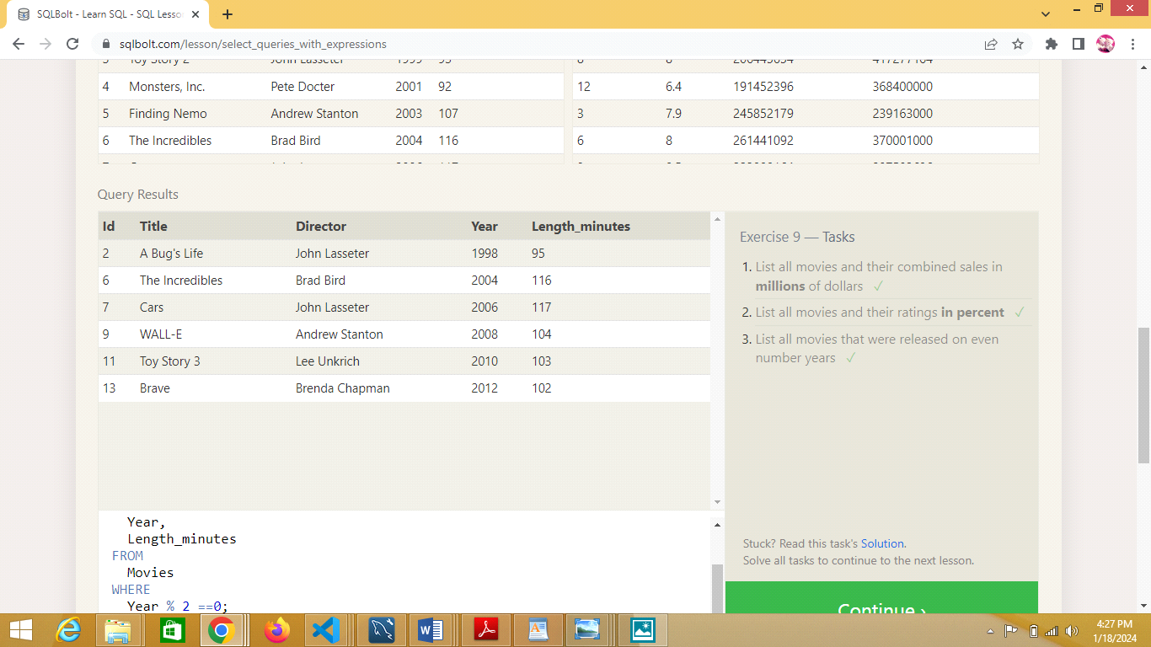

**Task 10:Queries with aggregates(pt-1)**

**a.SELECT MAX(Years_employed) AS longest_time FROM Employees;**

**b.SELECT Role, AVG(Years_employed) AS avg_years_employed FROM Employees GROUP BY Role;**

**c.SELECT Building, SUM(Years_employed) AS total_years_worked FROM Employees GROUP BY Building;**

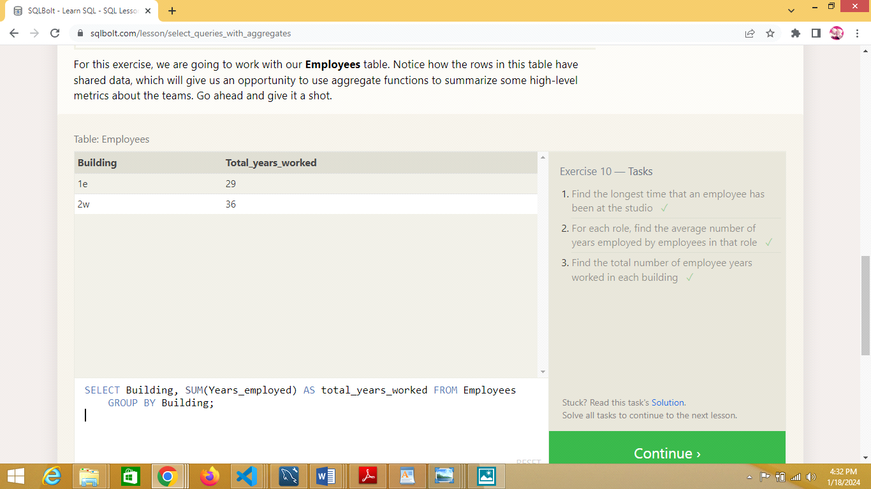

**Task 11:Queries with aggregates(pt-2)**

**a.SELECT COUNT(*) AS num_artists FROM Employees WHERE Role = 'Artist';**

**b.SELECT Role, COUNT(*) AS num_employees FROM Employees GROUP BY Role;**

**c.SELECT SUM(Years_employed) AS total_years_employed FROM Employees WHERE Role = 'Engineer';**

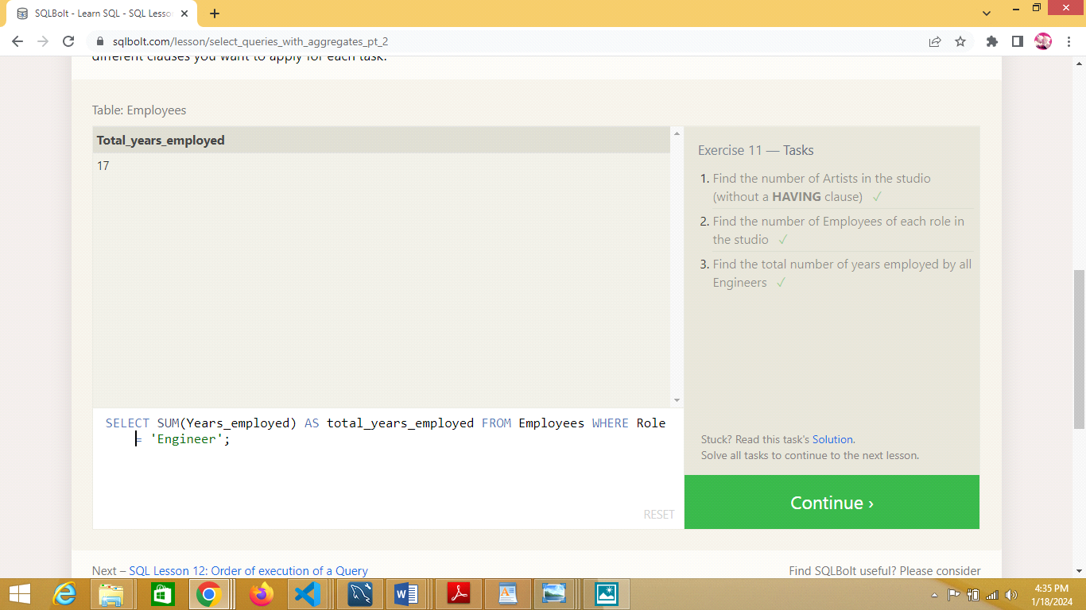

**Task 12:Order of Execution of a Query**

**a.SELECT Director, COUNT(*) AS NumMoviesDirected FROM Movies GROUP BY Director;**

**b.SELECT m.Director,**

**SUM(b.Domestic_sales + b.International_sales) AS TotalSales**

**FROM Movies m JOIN Boxoffice b ON m.Id = b.Movie_id GROUP BY m.Director;**

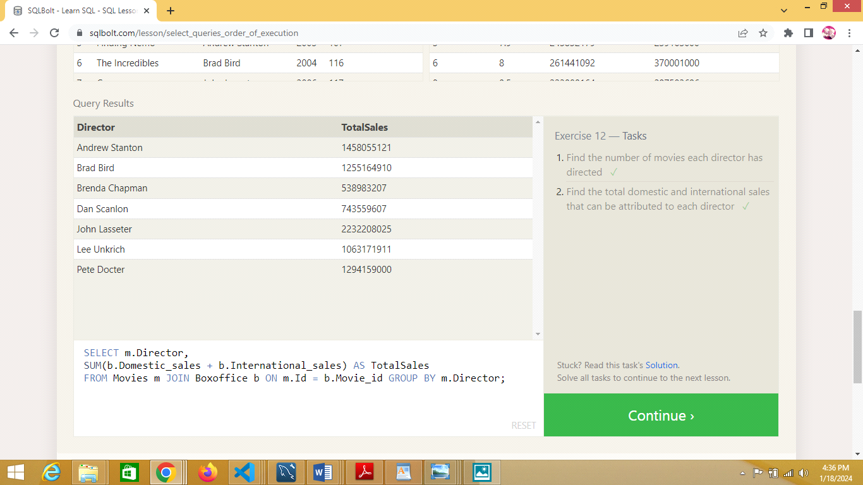

**Task 13:Inserting rows**

**a.INSERT INTO Movies (Title, Director, Year, Length_minutes)VALUES ('Toy Story 4', 'Any Director', 2023, 100);**

**b.INSERT INTO Boxoffice (Movie_id, Rating, Domestic_sales, International_sales) VALUES ((SELECT Id FROM Movies WHERE Title = 'Toy Story 4'), 8.7, 340000000, 270000000);**

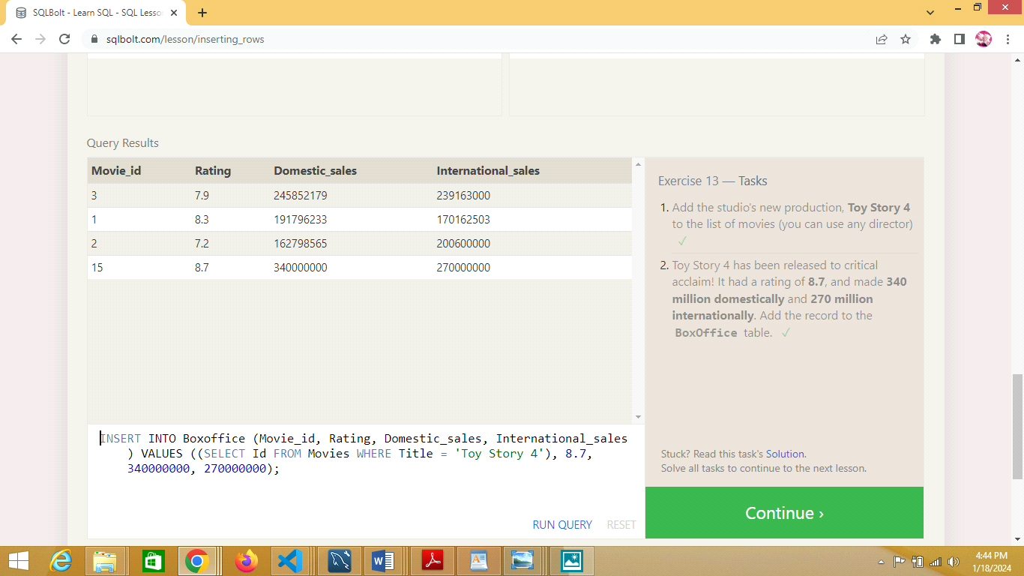

**Task 14:Updating rows**

**a.UPDATE MoviesSET Director = 'John Lasseter' WHERE Title = 'A Bug''s Life';**

**b.UPDATE Movies SET Year = 1999 WHERE Title = 'Toy Story 2';**

**c.UPDATE Movies SET Title = 'Toy Story 3', Director = 'Lee Unkrich' WHERE Title = 'Toy Story 8';**

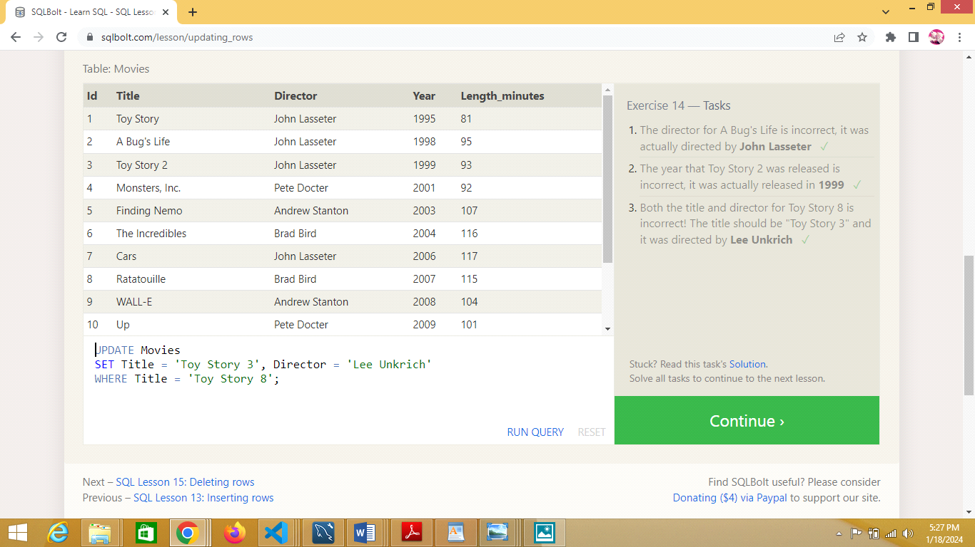

**Task 15:Deleting rows**

**a.DELETE FROM Movies WHERE Year < 2005;**

**b.DELETE FROM Movies WHERE Director = 'Andrew Stanton';**

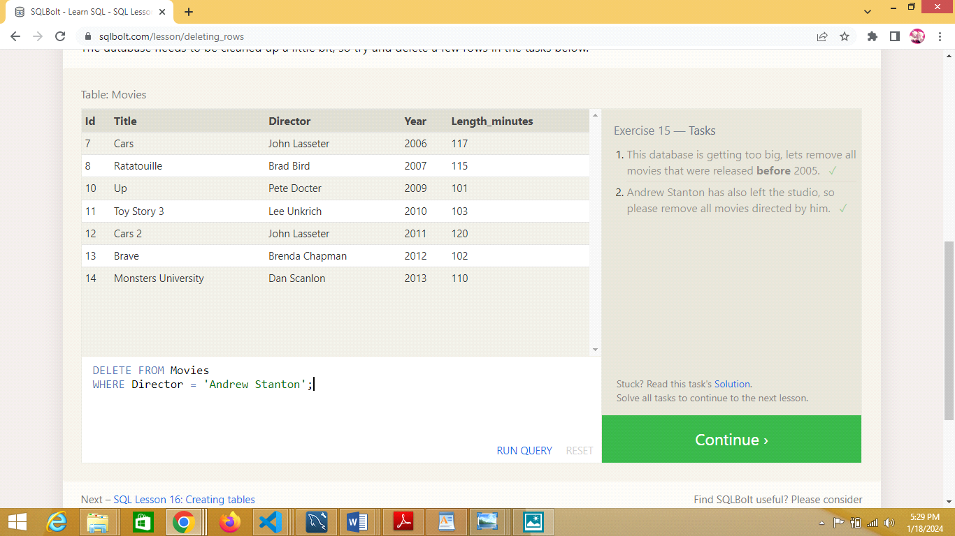

**Task 16:Creating Tables**

**a.CREATE TABLE IF NOT EXISTS Database ( Name TEXT, Version FLOAT, Download_count INTEGER );**

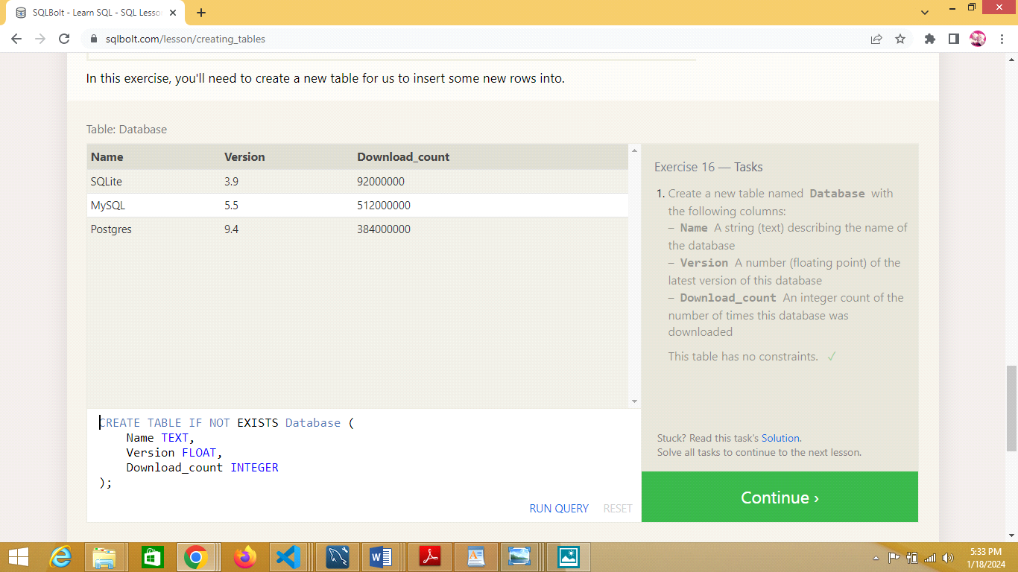

**Task 17:Altering Tables**

**a.ALTER TABLE Movies ADD Aspect_ratio FLOAT;**

**b.ALTER TABLE Movies ADD Language TEXT DEFAULT 'English';**

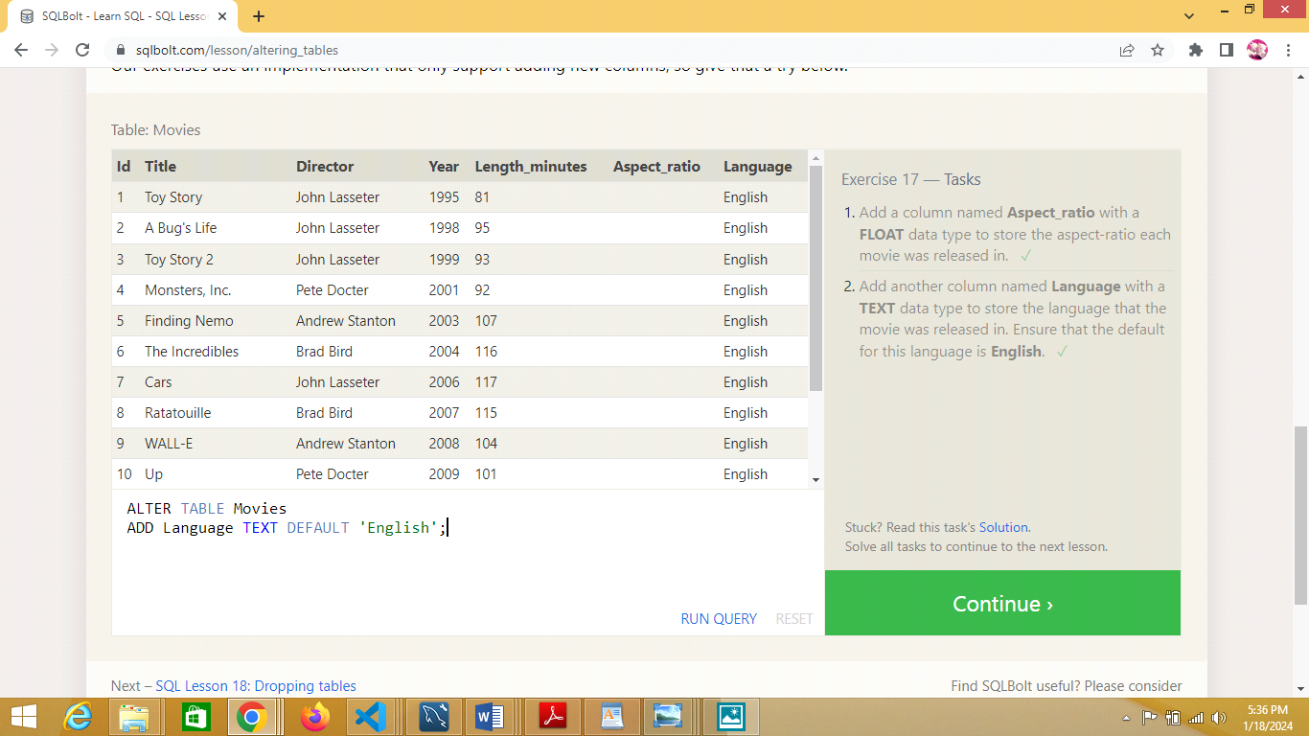

**Task 18:Dropping Tables**

**a.DROP TABLE IF EXISTS Movies;**

**b.DROP TABLE IF EXISTS BoxOffice;**



