Database Unreachable:
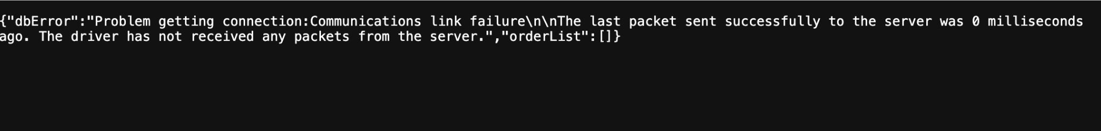
I got this error by removing a character from the jdbc:mysql://cis-linux2.temple.edu:3306 url. I fixed the error by adding the character back to it.

Database Not Authorized:
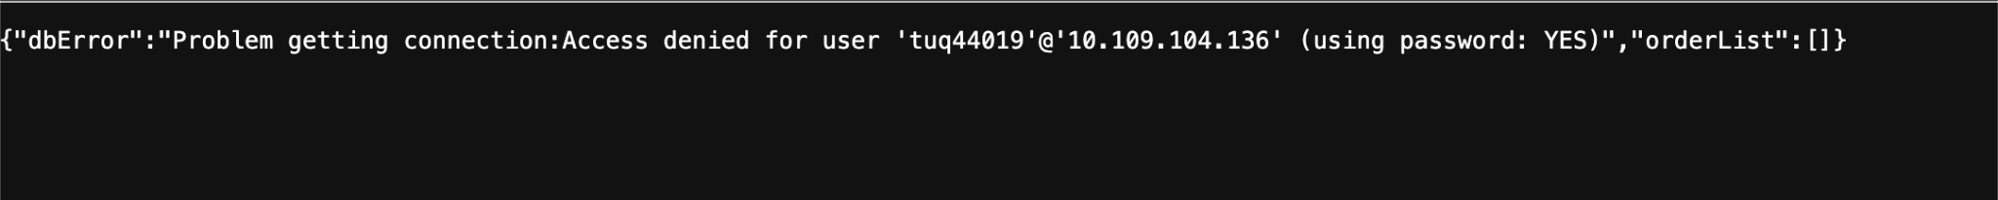
I got this error by removing a character from my database password. I fixed the error by entering the character back into the password.

Syntax Error in SQL Statement:
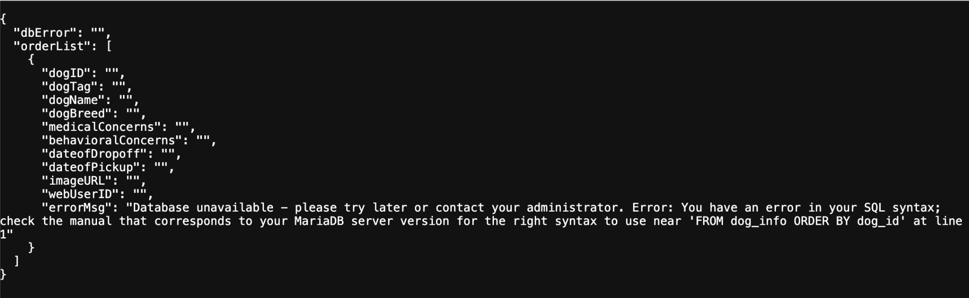
I got this error by adding a random comma to my SQL statement. I fixed the error by removing the common from the statement.

Error Extracting Data from Result Set (Bad Column Name):
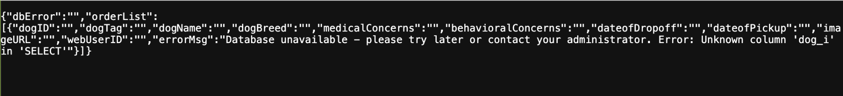
I got this error by removing a character from one of my column names. I fixed the error by adding the character back to the column name.

Error Extracting Data from Result Set (Wrong Data Type):
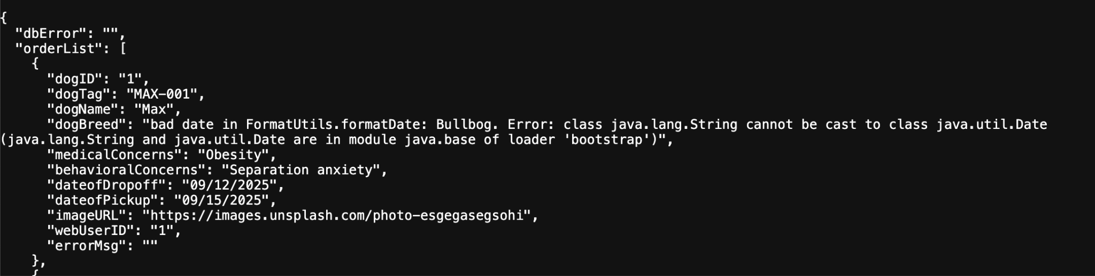
I got this error by changing the format of one of my data sets from String to Date. I fixed the error by changing the format back to String.

