AI Use Declaration Form
Course: Introduction to Artificial Intelligence
Lab Title: Lab 2 - Predictive Analytics with Machine Learning
Student Name: Janice Nutifafa Middleton-Dogbe (Cohort B)
Student ID: _______33072028_______________________________________________
GitHub Repository Link: ____https://github.com/JM-2404/lab-2-predictive-analytics.git_______________________________________
Date Submitted: ______3rd July,2026____________________________________________

1. AI Use Summary
Question | Student Response
Did you use any AI tool for this lab? | Yes
Estimated percentage of the work influenced by AI | 6%
Did you attach evidence of AI use where applicable? | Yes

2. Details of AI Use
Complete the table below for each AI tool used. Add more rows where necessary.
Name of AI Tool Used | Purpose for Using the Tool | Prompt or Instruction Given to the Tool | Part(s) of the Work Influenced by the Tool | How I Verified, Edited, or Improved the AI Output
Claude (Anthropic) | To understand the lab requirements, get a study/work plan, debug Python syntax and repetitions error, the reflections to help me know what exactly I am supposed to right and what stats is needed | "explain the content of the lab in details", "help me debug this error". | Section 1.2, section 2.2 and sect 2.4 | I ran every cell myself in VS Code, tested each TODO against the self-check assertions, traced through the pseudocode by hand to confirm I understood the logic, and fixed indentation and syntax errors that came up during testing.

3. Attachment of AI Output Evidence
Where required, attach evidence of AI use. Tick all that apply. Add more rows where necessary.
Evidence Type | Attached? (Yes, No, N/A) | File Name
AI-generated draft |  | I used an AI assistant to support debugging, preprocessing corrections, model evaluation setup, and explained how to interpretate the machine learning results in my predictive analytics assignment. All final implementation and submission decisions were reviewed and completed by me.
Prompt history
Screenshot of AI interaction | Yes | 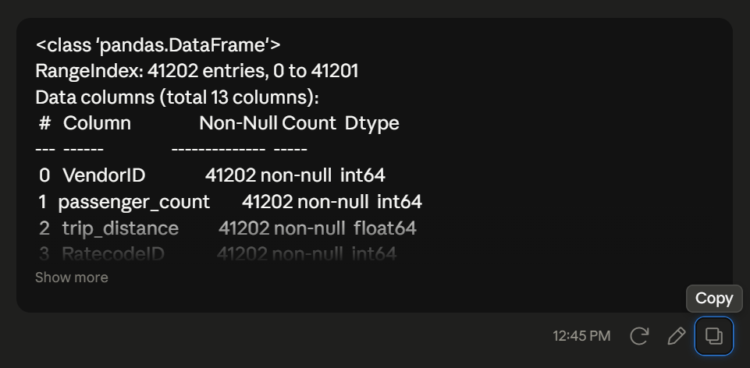
Exported AI conversation
AI-generated code snippet
Revised version showing student input

4. Student Declaration
I declare that:
Declaration Statement | Response (Yes/No)
The submitted work is my own work. | Yes
Any use of AI tools has been clearly declared in this form. | Yes
The prompts, instructions, and AI-generated outputs have been disclosed where applicable. | Yes
I reviewed, tested, edited, and improved any AI-generated content before submission. | Yes
My AI usage does not exceed 25% of the entire work. | Yes
I understand that undeclared or excessive AI use may be treated as academic misconduct. | Yes

Student Signature: _________JNMD__________________________________
Date: _________________3rd July,2026__________________________

