COS214 Practical 4

Team:
- u – Katlego Sentsho
- u23545756 – Kyle Pillay
- u25108582 – Jonathan Witter

System Description
We decided on film production for the domain. This design allows for Studios to group their films (produced or in progress of being made) into their type of film (Movie, Tv Series, Animated, ...)
Films will have states. They are either in planning/filming/editing phase or they have been released. Films are decorated with how they are accessed (viewed) by the public (such as online platforms for streaming or theaters).

UML Diagram
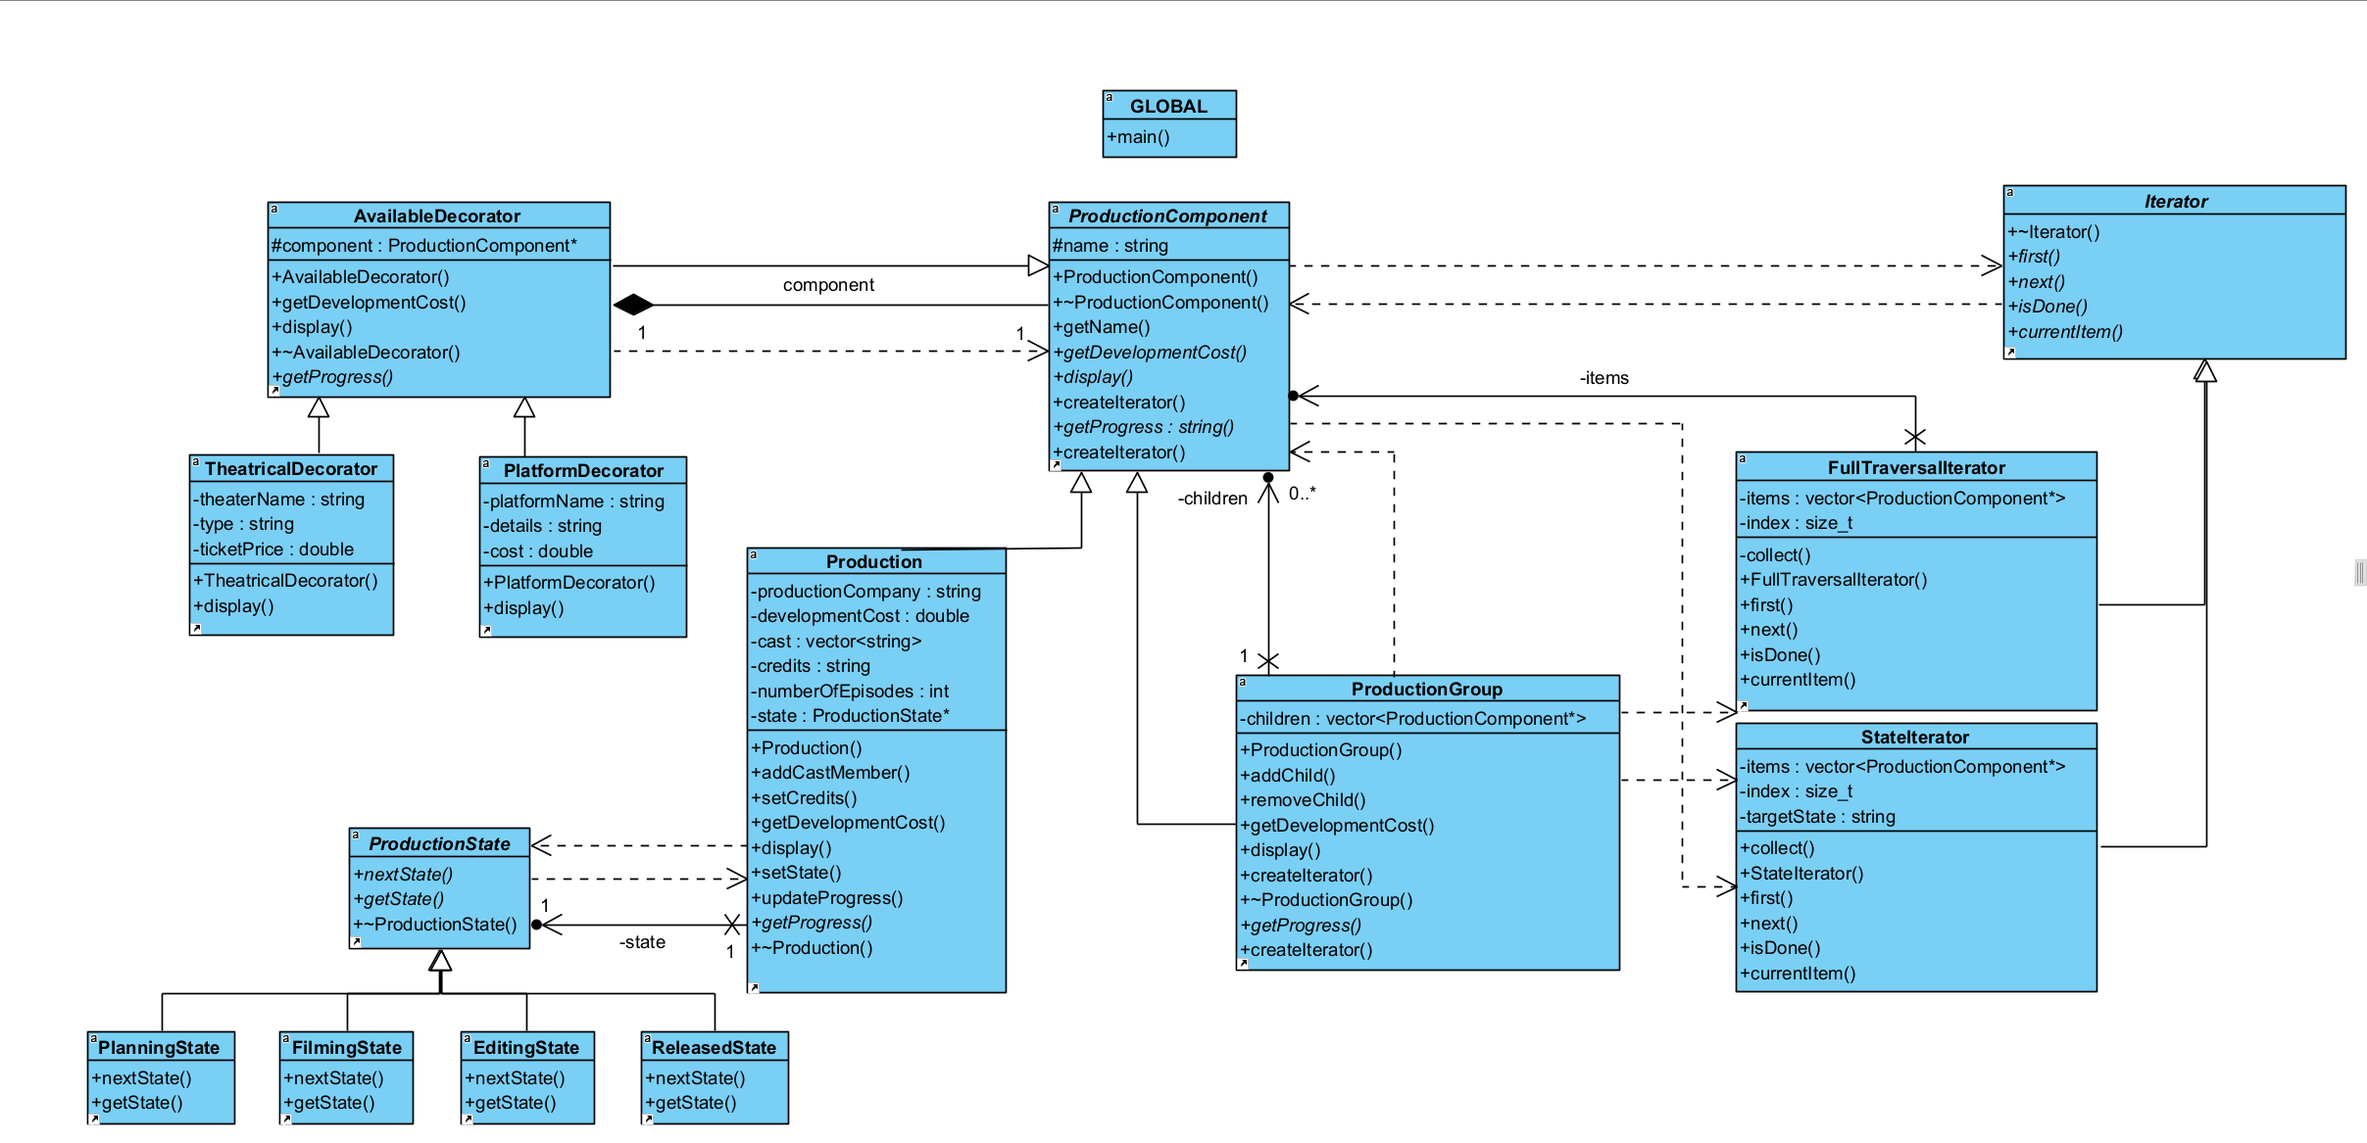

GoF Participants
Composite Design Pattern:
- Component – ProductionComponent
- Composite – ProductionGroup
- Leaf – Production

State Design Pattern:
- Context – Production
- State – ProductionState
- Concrete States – Planning, Filming, Editing, Released

Decorator Design Pattern:
- Component – ProductionComponent
- Concrete Component – Production
- Decorator – AvailableDecorator
- Concrete Decorators – TheatricalDecorator, PlatformDecorator

Iterator Design Pattern:
- Iterator – Iterator
- Concrete Iterators – FullTraversalIterator, []
- Aggregate – ProductionComponent
- Concrete Aggregates – ProductionGroup, []

Design and Ownership Rationale:
ProductionGroup owns its children by raw pointer in a std::vector<ProductionComponent*> and deletes each one in its destructor, so destroying a group cleanly cascades through its whole subtree. removeChild() deliberately hands ownership back to the caller rather than deleting internally, which is what lets main.cpp relocate or delete a node explicitly, satisfying the requirement for a meaningful structural change at runtime. Both Production (leaf) and ProductionGroup (composite) inherit from ProductionComponent, which declares getDevelopmentCost(), display(), getProgress(), and createIterator() as shared behaviour, so client code and decorators can treat a single production and an entire group identically without ever checking which one they're holding.
AvailableDecorator also owns what it wraps, holding a ProductionComponent* and deleting it in its own destructor. This means a whole chain of stacked decorators, such as two PlatformDecorators wrapped around one Production, is destroyed correctly just by deleting the outermost layer, and a fully decorated object can be dropped straight into a group's children vector with no special handling needed for cleanup.
Production owns a single ProductionState*, replacing it through setState(), which deletes the old state before assigning the new one. States are stateless data-wise, encoding only behaviour, so a fresh object is created on each transition rather than reusing shared instances, a simpler choice for a system this size.
FullTraversalIterator and StateIterator both implement the same Iterator interface but serve different purposes, one lists the entire hierarchy and the other filters leaves by lifecycle state. Both are snapshot iterators, collecting their results once at construction through a private collect() method, and both are declared friends of ProductionGroup so they can walk its private children vector directly without that vector ever being exposed to client code.
The main design challenge was making these four patterns cooperate rather than function as separate demos. Since a Production can be wrapped in decorators while sitting inside a composite tree, AvailableDecorator delegates every ProductionComponent method to the component it wraps, so decorated and undecorated productions remain fully interchangeable, and traversal, state, and cost calculations all keep working correctly no matter how many decorator layers are present.

Diagrams

Object Diagram:
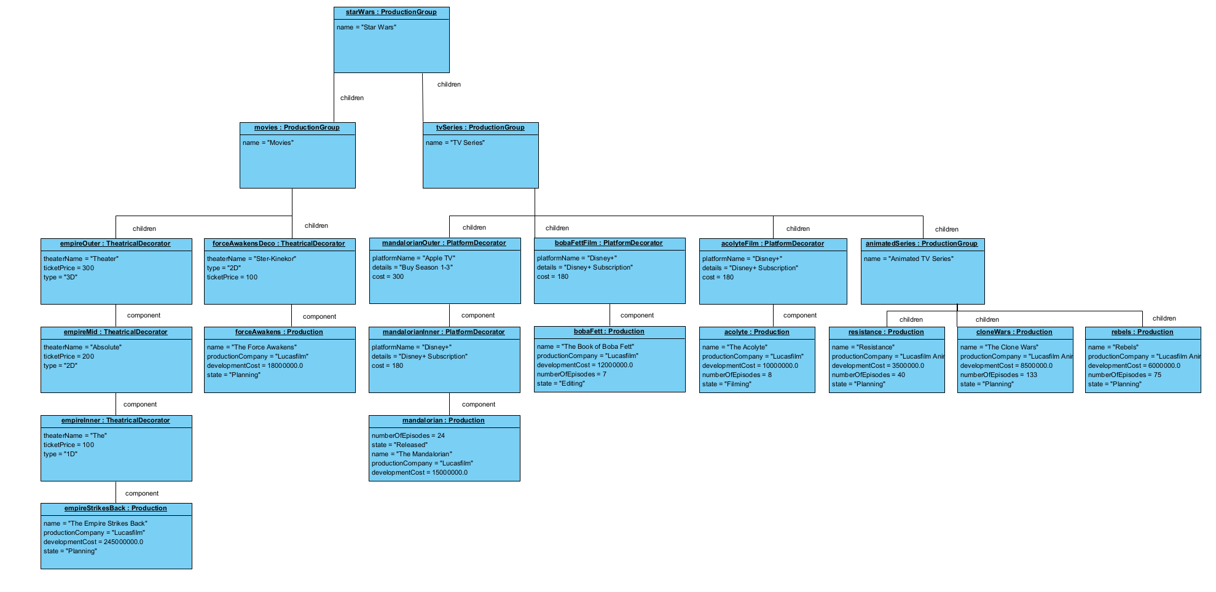

State Diagram:
Traversal Activity Diagram:
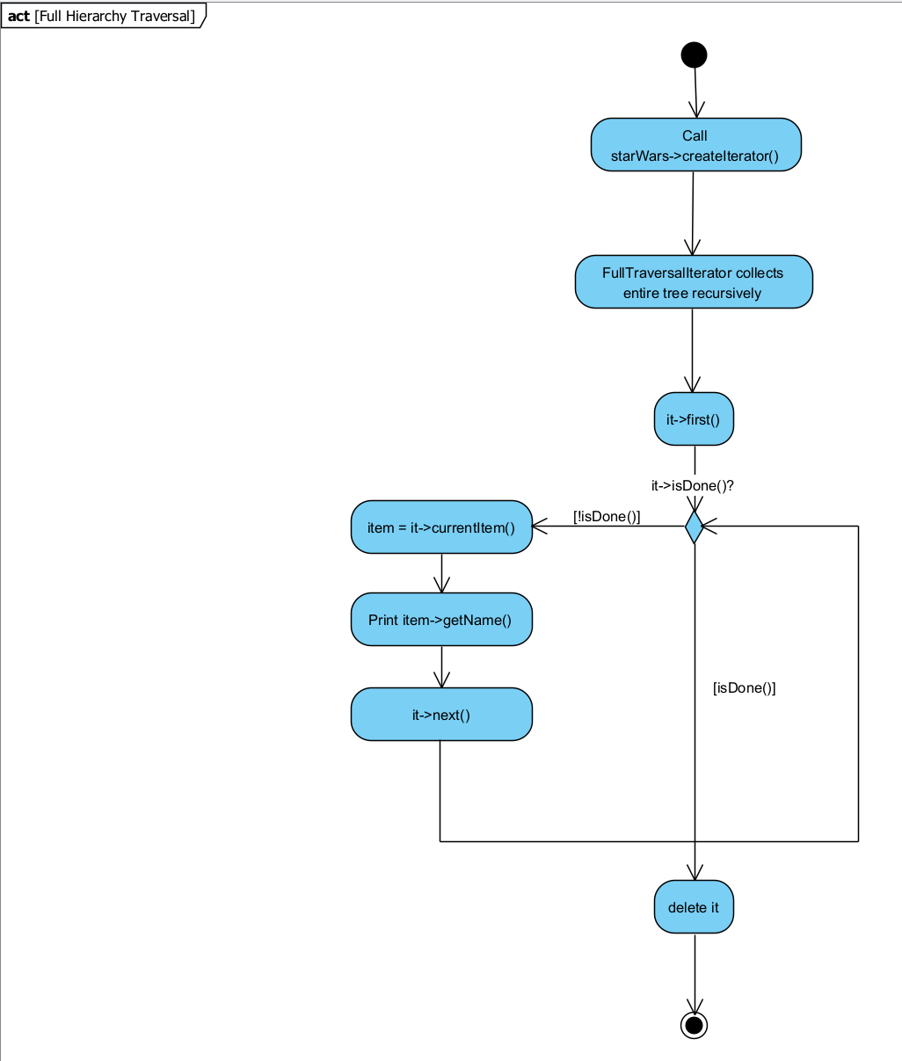
2 Activity diagrams left

Traversal Modification Policy
Our iterators use a snapshot approach rather than a live one. When FullTraversalIterator or StateIterator is created, its collect() method walks the entire composite tree once, right at construction, and copies pointers to the relevant components into its own internal vector. From that point on, first(), next(), isDone(), and currentItem() only ever look at this internal copy, never the live tree again.
This means once an iterator exists, it's frozen in time. If you add a child with addChild() or remove one with removeChild() after the iterator was created, that change simply won't show up in the iterator's results, it'll keep returning whatever it originally collected.
We chose this deliberately over a live traversal. A live traversal that kept reading directly from ProductionGroup's children vector would be vulnerable to the classic problem of modifying a container while iterating over it, especially risky in our case since main.cpp deletes removed nodes immediately after calling removeChild(). Snapshotting sidesteps that risk entirely, since the iterator's own vector is separate from the live tree, so deleting a node from the tree can't invalidate an iterator that's already finished collecting.
This approach also lets two independent traversals run over the same hierarchy at once without stepping on each other. In main.cpp, we create a full traversal and a state-filtered traversal one after another from the same root, and each one works from its own private snapshot, so neither interferes with the other or with the underlying tree.

GDB and Valgrind
GDB screenshot and valgrind showcase

GitHub
https://github.com/JM-Witter/COS214---Prac-4.git

Contributions
Each team member participated in group meeting to discuss the practical and overall design.
Each member contributed at least one of the key classes (composite, iterator, decorator, etc) and fully implemented them.
Each member also completed at least 2 of the 6 diagrams required.

- Katlego Sentsho: Composite, State Diagram, Activity Diagram, PDF work
- Kyle Pillay: Iterator, Object Diagram, State Diagram, PDF work
- Jonathan Witter: State, Decorator, UML Diagram, Activity Diagram, Docker, PDF work

Evidence:
