***Challenge Description and Rules***

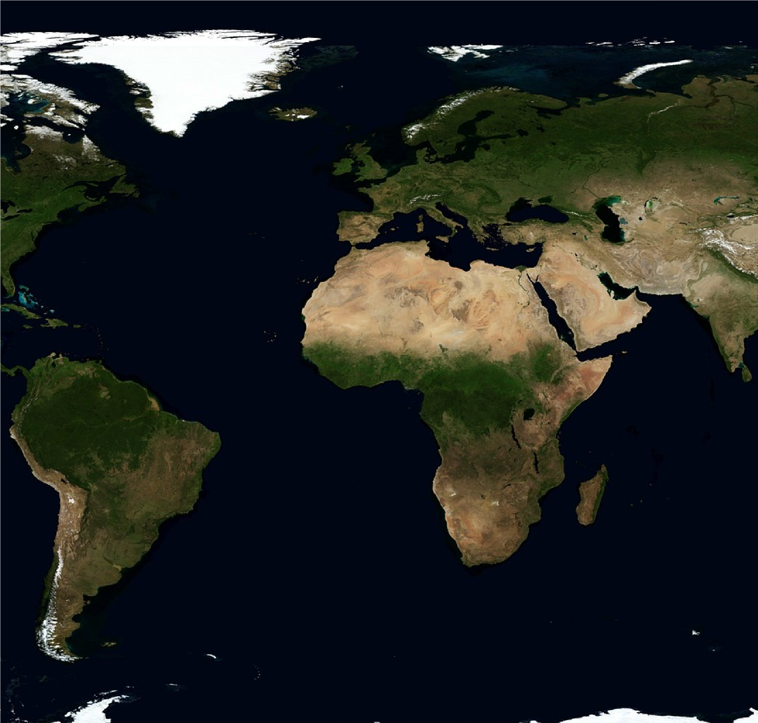

**Understanding COVID-19**

**Across the Globe**

**July - September 2020 Data Visualization Challenge**

**Sponsored by QED Group**

[t](https://www.centerforglobaldata.org/wp-login.php?action=logout&_wpnonce=58bebc99bf)



Powered by QED Group LLC.

**About the Data Challenge**

Data visualization is a powerful and dynamic way to bring attention to prominent issues all over the world.

Additionally, there is no doubt that COVID-19 has affected different countries in different ways. You don’t need to be an expert in medicine or international development to understand that several different factors go into the pandemic’s effectiveness and influence including areas like race/ethnicity, poverty, and healthcare.

These factors are different in every country so with this data challenge we hope to visualize and bring attention to the pandemic’s influence across the globe.

To truly show the diversity and variety in the pandemic’s impact, we’ve split our theme of COVID19’s global impact into two separate topics individuals can pick from.

The first topic concerns food insecurity within specific countries and the second draws comparisons between the pandemic’s economic impact on different countries with a specific focus on the economy.

**Submissions are open from July 16th to September 30.** Winners will be announced in October.

**Challenge Rules**

1. This data visualization challenge is open to any student at the Undergraduate, Graduate, or Post Grad Level. It is also open to any professional or professional team working for any company, but primarily data centric or data focused companies.
2. Undergraduate and Graduate level students will submit on the student track with their school email.
3. Professionals and Post Graduate students will submit on the professional track, professionals with any email and Post Grad Students preferably with their university email
4. You must choose some part of either of the two topics detailed on the challenge information page. This can be any aspect of either of these topics as it relates to any of the countries listed beneath each topic respectively.
5. All submissions are welcome. We are working to make sure our submission platform is customizable to any type of visualization. The default embedding functionality will be HTML iframes, for those who do have experience in this, if you want to create your own embed code, please feel free.
6. This is a data analysis, visualization and storytelling challenge, so please make sure your submissions fit into this criterion.

**Challenge Prizes**

[***Sponsored by QED Group***](https://www.qedgroupllc.com/)

**Professional Winners in Each Topic**

**1st Place:** $1000

**2nd Place:** $500

**3rd Place**: $250

**Student Winners in Each Topic**

**1st Place:** $350

**2nd Place:** $100

**3rd Place**: $50

**Provided Data**

Several data sets will be made available for use on your data visualizations that cover the countries listed within the topics below. You are free to use any other data you would like with or without this data, we just want to provide you with data and data sources that we have verified. We have also been given a few private datasets that we get to offer for this challenge to participants, but if you have other data you want to use, that is great and just make you sure you cite where it came from. View the data in detail [here](https://www.centerforglobaldata.org/understanding-covid19-across-the-globe/understanding-cv19-data/).

**Challenge Topics**

|  |
| --- |
| **Data Visualization Topic 1: Food Insecurity** |

**Background**

Food security exists when all people, at all times, have physical and economic access to sufficient, safe and nutritious food that meets their dietary needs and food preferences for an active and healthy life.

As many countries continue to take measures to stop the spread of COVID 19, border restrictions in addition to changes in labor supply due to limited migratory labor opportunities, in-country movement restrictions and social distancing are likely to impact global food security.

These changes are expected to have greater impact in countries with existing humanitarian crises and shocks such as conflict, locusts plague, inflation, and extreme weather events (e.g. flooding).

For this data visualization challenge, we would like you to explore how COVID – 19 and other shocks and stresses impact food security around the world.

**Country List**

Please select one of the following countries to serve as the context for your submission:

1. Senegal
2. Ethiopia
3. Honduras
4. Somalia
5. Egypt
6. Lebanon
7. Nigeria
8. Uganda

**Questions to Consider**

***You are not restricted to these questions; they are just meant to further elaborate on the meaning of the challenge topic. Any other ideas related to Food Security in these countries are welcome.***

1. How has COVID – 19 or other shocks and stresses (e.g. locusts plague, inflation, conflict, extreme weather) impacted the supply of widely consumed staples (e.g. rice, wheat, maize)? How have prices of these food commodities changed (if at all)?
2. What has been the impact for these shocks in low income countries such as Ethiopia, Democratic Republic of Congo, Liberia and Uganda?
3. Are the shocks impacting the poor and more vulnerable (e.g. women) differently?
4. What household characteristics affect resilience to major shocks such as COVID-19, conflict, extreme weather and how have these varied over time?
5. What are the best approaches to building and sustaining household and community resilience to withstand shocks?
6. How has the economic impact of COVID-19 affected current food security? How is it likely to affect food security in the future?

|  |
| --- |
| **Data Visualization Topic 2: Comparing**  **COVID-19 Economic Impacts** |

**Background**

In the broader context of the COVID-19 Pandemic, the world has seen a range of impacts. Countries like South Korea were able to contain and prevent the disease from having the widespread and massive growth seen in countries like China and the United States. On top of the variety of different effects of this disease, the timing of the peak infection rates and number of people contracting the disease has varied wildly. As the United States has started to find stability in the spread, countries like Brazil and India are seeing the worst of these effects within their populations.

The fluctuation and variation in the timing and impact of this disease has caused sporadic and unpredictable shocks to economies around the world. Countries are opening and closing travel, changing rules for conducting business, and constantly varying the activities that can and cannot be conducted during this time.

One of the most prevalent topics we are seeing around the world right now is job loss, and how countries are going to recover. A big part of this comparative topic, that we would like to focus on within the context of the varying impacts of COVID-19, is the varying effects on the respective economies.

**Country List**

These countries cover nearly a third of the world’s population and have seen or are currently seeing a range of different impacts of COVID-19.

1. Indian Subcontinent:
   * India
   * Sri Lanka
   * Bangladesh
   * Pakistan
2. Brazil
3. Egypt
4. Indonesia

**Questions to Consider**

1. The focus of this data visualization topic is comparison, why are some countries experiencing this pandemic so differently than others?
2. Have the responses to the pandemic been different between or within these five countries? How? What were the results of these responses?
3. Jobs are being lost worldwide at an unprecedented rate, and the economic impact of the COVID-19 Pandemic is not the same throughout each of these countries, what are the differences in these economic shocks? What responses have been and are being made to help mitigate this issue? Have they worked?
4. What cultural, socio-economic, and topographic characteristics could be playing a role in the COVID-19 pandemic? What role are they playing? How do you know?
5. Has COVID-19 impacted different groups of people (women, impoverished, minorities, etc.) in different ways? What are the differences, and are they present within some countries or between countries?

**Criteria and Judges**

**Criteria**

The goal of data visualization and presentation is to present results and insights from an analysis in a clear, honest, and effective way. A visualization, application, website, etc. that is communicating the results of data analysis should be interpretable by all target audiences, including those without an analytic background. It should have a well-defined goal and meet that goal in an impactful and memorable way. Many of us know the potential of data, but without clear, meaningful, and understandable presentation, that potential is wasted.

“There is a magic in graphs. The profile of a curve reveals in a flash a whole situation — the life history of an epidemic, a panic, or an era of prosperity. The curve informs the mind, awakens the imagination, convinces.”

* *Henry D. Hubbard (Creator of the “Chart of Atoms”, later becoming “The Periodic Table of Elements”)*

“In school we learn a lot about language and math. On the language side we learn how to put words together into sentences and stories. With math, we learn to make sense of numbers. But it’s rare that these two sides are paired. No one tells us how to tell stories with numbers … this leaves us poorly prepared for an important task that is increasingly in demand.”

- *Cole Nussbaumer Knaflic (Author of the “Storytelling with Data” series, two of the most popular guidebooks to data visualization in the world)*

“The greatest value of a picture is when it forces us to notice what we never expected to see.”

*- John Tukey (World-Renowned Statistician, Introduced the Fast Fourier Transform)*

With these ideas in mind, the criteria guiding this challenge will first ensure a valid analysis but will be evaluated based on the value of your insights, coupled with the impact that your presentation of those insights has on those who review it.

|  |  |  |
| --- | --- | --- |
| Analysis and Data Visualization Accuracy/Transparency​ **Criteria Topic**   * How valid the interpretations of the analysis are based on the type and quality of the data and analysis used * How appropriate the visualizations are to display their information, in regards to clarity and transparency (e.g. there is no attempt to mislead a viewer with modified scales, broken axes, targeted data selection, etc.)   **Guiding Questions**   * Is the analysis methodology clear and understandable? * Does the analysis methodology make sense, given the data and topic? Is it appropriate? * Are the results of the analysis accurate? * Are the visualizations used honest and appropriate? Are they misleading? Do they make sense for the findings being communicated? | **Findings and Insights**  **Criteria Topic**   * How useful the visualization is in helping to inform/solve the chosen topic or problem, or in identification of a novel perspective on the topic   **Guiding Questions**   * How relevant are the findings to the topic issue, if at all? * Are the ideas original or do they offer a new perspective? * Could these insights be valuable or helpful within the context of this issue? | Design and Storytelling/Narrative **Criteria Topic**   * How creatively and uniquely the problem is visualized by the team, as well as its overall aesthetic appeal * How effectively and clearly the visualization communicates the team’s insight/message to the audience   **Guiding Questions**   * Is the physical layout and design of the project easily interpretable? Does it align with the findings of the analysis? * Is the design and layout of the project appealing? Are the colors, shapes, and other identifiers appealing, without taking the attention away from the insights being communicated? * Does the project or presentation tell a cohesive story or narrative? Can you clearly understand how the author made his conclusions? * Is the story interesting and impactful? Did it resonate with you? Do you feel the way the author intended you to feel? * If you were asked what this project told you tomorrow morning, would you remember? Could you then relay that message to others? * If it didn’t resonate with you, could it have an impact on another group of people? Who? |

**Judges**

**Phase 2:** 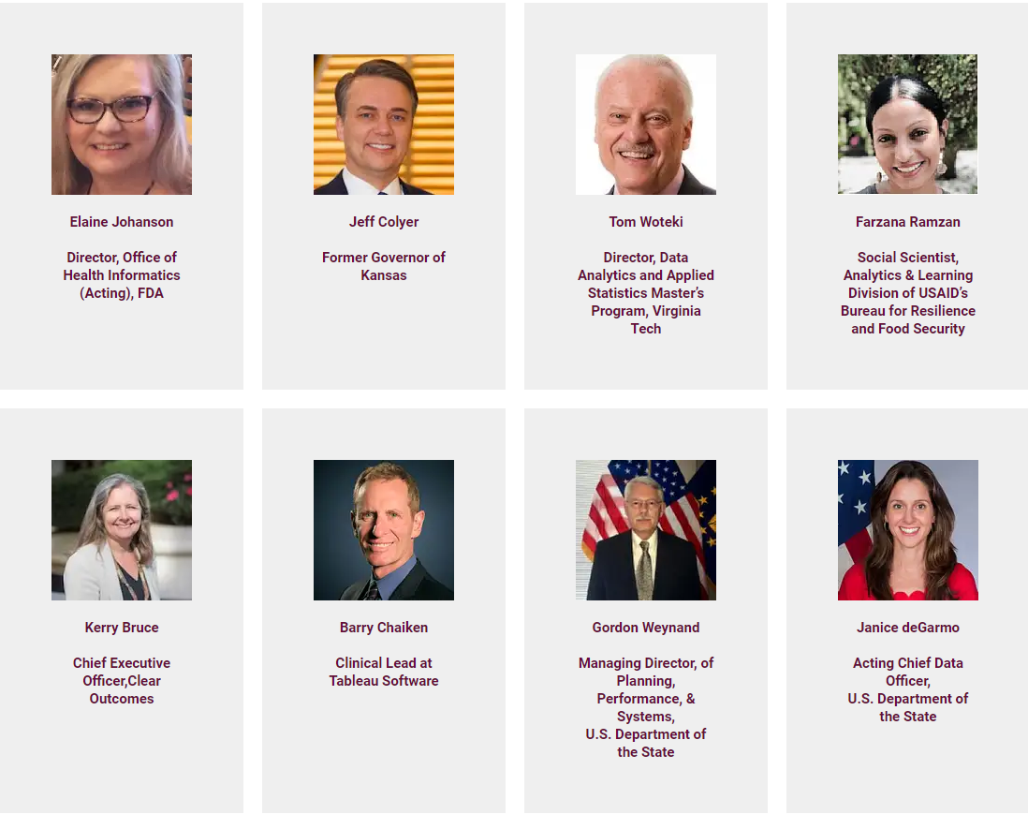

**Phase 1:**

